取消DHCP
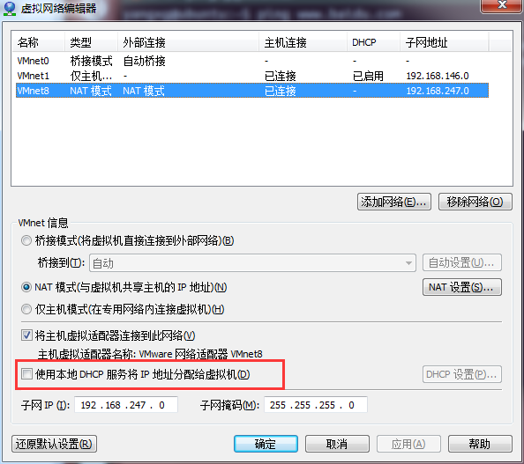

//设置IP
vi /etc/network/interfaces
# interfaces(5) file used by ifup(8) and ifdown(8)
auto lo
iface lo inet loopback
iface eth0 inet static
address 192.168.247.129
netmask 255.255.255.0
gateway 192.168.247.2
dns-nameservers 192.168.247.2
auto eth0

//重启network
/etc/init.d/networking restart

//重启虚拟机

