**Title:**

Restoration of ag-lands: a synthesis of active versus passive restoration in drylands globally.

Global comparison of active and passive restoration in drylands

**Money for nothing and your restoration for free: a synthesis of active versus passive restoration in drylands globally.**

Or

**Something for nothing: a synthesis of active versus passive restoration in drylands globally.**

**Authors:** M. Florencia Miguel1*, Scott H. Butterfield2 and Christopher J. Lortie3

**Affiliations:**

1Instituto Argentino de Investigaciones de las Zonas Áridas (UNCuyo-Gobierno de Mendoza-CONICET), Mendoza, Argentina.

2The Nature Conservancy, San Francisco, CA, United States of America.

3Department of Biology, YorkU, and NCEAS, UCSB.

*Correspondence to: fmiguel@conicet-mendoza.gob.ar

**Abstract:**

Drylands are one of the most extended and biodiverse ecosystems globally, but also face threats from land degradation and climate change. One means to lessen those impacts is through restoration. The key issues are to identify the types of restoration and the level of investment that may be necessary to see positive results. Here, a global meta-analysis of restoration in drylands was completed. We found that passive restoration practices overall led to negative outcomes, whereas active practices led to positive outcomes. Soils do not recover passively in the time horizons tested to date whilst vegetation and exclusion of grazing can promote positive outcomes. Armed with this information, restoration practitioners can focus limited resources on those practices that are likely to provide the greatest positive impact.

**One Sentence Summary:**

Active restoration practices in drylands, after agriculture retirement, led to the largest positive impacts.

**Main Text:**

Drylands, which include natural (i.e. semi-arid grasslands, shrublands and deserts) and managed ecosystems (e.g. farmlands), are one of the most extended and populated ecosystems on Earth, covering over 40% of the global land surface (*1*). These lands provide key services such as food provision (crops and livestock), carbon sequestration, biodiversity support and provision of sustainable energy (e.g. solar energy) (*1*–*3*). Regarding their physical extent and the extremely heterogeneous biomes that support, drylands are unique biodiverse rich ecosystems (*4*). However, drylands are facing severe transformation due to land-use and climate changes that may have severe impacts on the provision of ecosystem services to people and on biodiversity conservation (*5*). These degraded ecosystems would benefit from increased protection (e.g. easements) (*6*) and better land management practices (*7*), but increasingly there is a real opportunity to mitigate past impacts through restoration, both of degraded natural lands (*8*) and more intensively farmed agroecosystems (*9*).

Thus, ecological restoration represents an alternative to mitigate the degradation of ecosystems (*10*). General efforts to restore ecosystem services and biodiversity have focused on active and passive (i.e. natural recovery) types of intervention, which differ in the amount of resources invested (e.g. time, money and human assistance) (*11*). Restoration is a complicated endeavor whose impact on soils, vegetation, and wildlife can take many years to evaluate (*12*). Furthermore, the types of restoration practice adopted may imply different amount of money and timescales to evidence successful restoration of ecosystems (*11*). Although different restoration practices have been implemented in drylands around the world (*12*, *13*), to effectively and efficiently restore degraded dryland ecosystems it is needed to know what restoration practices work best. Thereby, the retirement of agricultural drylands (rangelands and croplands) offers an opportunity to evaluate and compare the effectiveness of the restoration practices implemented (*9*).

We performed a meta-analysis of 66 peer-reviewed publications that evaluated different restoration practices and outcomes (*14*, *15*). We focused the analysis on the most frequent land degradation, “agriculture”, which included both farm land (i.e. crops) and grazing land (fig. S1). To determine the effect of the restoration treatment (i.e. restoration practice) on the degraded land, we classified each study into active or passive restoration. We assigned a restoration practice to “active” if involves human activities or interventions to assist the restoration process, and to “passive” if allows for the natural recovery of systems (*16*). We then assessed the magnitude and direction of the restoration effect using the log response ratio (lrr) (*17*), a common and useful approach in ecological meta-analyses (*18*). Due to the high variability of restoration practices found in publications, we chose to group them into four categories: soil, vegetation, water addition and grazing exclusion (Table 1; table S1). We grouped restoration outcomes into four categories as well: soil, plants, animals and “habitat” (Table 1). The “habitat” category included measures of plants and soil. We used random effects models to account for the variability within the 66 peer-reviewed studies (*15*), and then applied meta-regressions to test the potential influence of two additional covariates, aridity (*19*), and the time scale of experiments (*20*).

We reviewed studies from 19 countries throughout the world (Fig.1). Active and passive restoration practices differed in their magnitude and direction of effect sizes. Overall, active restoration led to positive outcomes (lrr estimate = 0.22, 95% CI= 0.21 to 0.23) while passive restoration practices were negative (lrr estimate= -0.34, 95% CI= -0.37 to -0.31). All three categories of active restoration practices examined (soil, vegetation and water addition) were net positive and statistically significant, whereas passive soil recovery had significant negative outcomes (Table 1A, Fig. 2). Vegetation and grazing exclusion passive practices had positive effects on restoration (Table 1A, Fig. 2). Aridity and time since the restoration practice both significantly influenced the effectiveness of active practices (lrr estimatearidity= -0.01, 95% CI= -0.02 to -0.01; lrr estimatedexp.time= 0.003, 95% CI= 0.003 to 0.0035), while for passive practices just the time scale of experiments was significant (lrr estimatedexp.time= 0.01, 95% CI= 0.008 to 0.01). The negative effect of aridity on the efficacy of active practices translates in a reduction of positive restoration outcomes with increasing aridity. Within the active practices evaluated, we found that there was a positive effect on soil, plant and habitat restoration, but a negative effect on the restoration of animal communities (Table 1B). For the passive restoration practices, we found that soils will not recover on their own, but plants and habitat can recover with minimal human intervention (Table 1B).

Active and passive restoration interventions require different investments in usually limited resources such as time and money (*11*), therefore, this meta-analysis evaluate the potential effectiveness of both types of restoration within drylands globally. Overall, active restoration practices were more effective, consistently positive and had low relative variances when compared with passive restoration practices. We found that water addition had the largest and most positive impact on dryland restoration, followed by soil and vegetation practices (Table 1A). The conclusion from this meta-analysis that active restoration interventions are often required to see positive outcomes in drylands differs from a recent meta-analysis in tropical forests, that found passive natural succession is the most effective strategy to restore degraded forests (*21*). These differences are likely driven by rainfall, soil fertility and vegetation productivity which are severely constrained in dryland ecosystems (*1*).

Agricultural practices have high impacts on soil health, affecting key processes such as nutrient cycles (*22*). Moreover, the addition of synthetic inputs such us fertilizer and pesticide in conventional agriculture (*23*) state a challenge for soil and vegetation restoration after agriculture abandonment. Our results showed the restoration of soil in drylands requires the implementation of active management, whereas plants communities can regenerate naturally. On the other hand, restoration of animal communities represents another challenge; we found that active interventions performed to date did not have a positive effect on invertebrate and vertebrate community’s restoration. According to restoration from grazing, the exclusion of livestock is one of the most common and cost-efficient passive regeneration strategies implemented (*11*) (another citation). Our results showed this intervention has a positive effect in drylands restoration.

Resources are and will always be limiting for restoration and we cannot ignore minimal intervention strategies to manage drylands globally, this point may be one of the most limiting factors in restoration plans for developing countries (*1*). The present study clearly identifies that depending on the specific outcome for stakeholders, some strategies can sustain limited investments. However, active strategies are critical for more rapid, less variable, and more consistently positive efficacious interventions in drylands. Aridity and drought will continue to present challenges to recovery (*24*) and if longer and more sustained timeframes are possible, i.e. at least 2 years, restoration practices will be more viable. In summary, drylands are critical to sustaining both human and other resident populations of species globally and restoration in some form is a major path forward.

References and Notes:

1. Millennium Ecosystems Assessment (MEA), Ecosystems and Human well-being: Current State and Trends: Dryland Systems. *Isl. Press*, 1–40 (2005).

2. C. J. Lortie, A. Filazzola, D. A. Sotomayor, Functional assessment of animal interactions with shrub-facilitation complexes: A formal synthesis and conceptual framework. *Funct. Ecol.* **30**, 41–51 (2016).

3. K. Trumper, C. Ravilious, B. Dickson, Carbon in Drylands : Desertification , Climate Change and Carbon Finance. *A UNEP-UNDP-UNCCD Tech. Note Discuss. CRIC 7 , Istanbul , Turkey - 03-14 Novemb. , 2008*, 1–12 (2008).

4. M. Mortimore *et al.*, *Dryland Opportunities: A new paradigm for people, ecosystems and development* (2009; http://www.resalliance.org/3871.php).

5. J. C. Birch *et al.*, Cost-effectiveness of dryland forest restoration evaluated by spatial analysis of ecosystem services. *Proc. Natl. Acad. Sci.* **107**, 21925–21930 (2010).

6. R. Wilson *et al.*, Dryland Pastures: Establishment and Management in the Intermountain Region of Northern California. *Dryl. Pastures Establ. Manag. Intermt. Reg. North. Calif.* (2006), doi:10.3733/ucanr.8163.

7. S. Kamotho, W. Strahm, C. Wolfangel, The nature of drylands Diverse ecosystems, diverse solutions. *IUCN World Conserv. Congr.*, 1–40 (2008).

8. W. V Reid *et al.*, *Ecosystems and Human Well-being: Synthesis* (2005; https://www.millenniumassessment.org/documents/document.356.aspx.pdf).

9. C. J. Lortie, A. Filazzola, R. Kelsey, A. K. Hart, H. S. Butterfield, Better late than never: a synthesis of strategic land retirement and restoration in California. *Ecosphere*. **9**, e02367 (2018).

10. K. Suding *et al.*, Committing to ecological restoration. *Science (80-. ).* **348**, 638–640 (2015).

11. R. J. Hobbs, V. A. Cramer, Restoration Ecology: Interventionist Approaches for Restoring and Maintaining Ecosystem Function in the Face of Rapid Environmental Change. *Annu. Rev. Environ. Resour.* **33**, 39–61 (2008).

12. K. D. Holl, T. M. Aide, When and where to actively restore ecosystems? *For. Ecol. Manage.* **261**, 1558–1563 (2011).

13. J. L. Reid, M. E. Fagan, R. A. Zahawi, Positive site selection bias in meta-analyses comparing natural regeneration to active forest restoration. *Sci. Adv.* **4**, 1–4 (2018).

14. A. P. Field, R. Gillett, How to do a meta-analysis. *Br. J. Math. Stat. Psychol.* **63**, 665–694 (2010).

15. G. Schwarzer, J. R. Carpenter, G. Rücker, *Meta- Analysis with R* (Springer, New York, 2015).

16. J. Aronson, S. J. Milton, N. J. Blignautames, *Restoring Natural Capital: Science, Business, and Practice* (2007; http://er.uwpress.org/cgi/doi/10.3368/er.26.2.161), vol. 26.

17. V. Hedges, L., J. Gurevitch, P. Curtis, the Meta-Analysis of Response Ratios in. *Ecol. Soc. Am.* **80**, 1150–1156 (1999).

18. M. J. Lajeunesse, Bias and correction for the log response ratio in ecological meta-analysis. *Ecology*. **96**, 2056–2063 (2015).

19. E. De Martonne, Regions of Interior-Basin Drainage. *Geogr. Rev.* **17**, 397–414 (1927).

20. M. Borenstein, L. V. Hedges, J. P. T. Higgins, H. R. Rothstein, in *Introduction to Meta-Analysis* (2009), pp. 282–288.

21. R. Crouzeilles *et al.*, Ecological restoration success is higher for natural regeneration than for active restoration in tropical forests. *Sci. Adv.* **3**, e1701345 (2017).

22. O. Rollin, L. A. Garibaldi, Impacts of honeybee density on crop yield: A meta-analysis. *J. Appl. Ecol.*, 0–2 (2019).

23. D. Kleijn *et al.*, Ecological Intensification: Bridging the Gap between Science and Practice. *Trends Ecol. Evol.* **34**, 154–166 (2019).

24. V. Ramón Vallejo *et al.*, Perspectives in dryland restoration: Approaches for climate change adaptation. *New For.* **43**, 561–579 (2012).

25. D. Moher *et al.*, Preferred reporting items for systematic reviews and meta-analyses: The PRISMA statement (Chinese edition). *J. Chinese Integr. Med.* **7**, 889–896 (2009).

26. Rohatgi A., WebPlotDigitizer. Retrieved from https://automeris.io/ WebPlotDigitizer (2018).

27. A. Guolo, C. Varin, Random-effects meta-analysis: The number of studies matters. *Stat. Methods Med. Res.* **26**, 1500–1518 (2017).

28. R. DerSimonian, N. Laird, Meta-analysis in clinical trials. *Control. Clin. Trials*. **7**, 177–188 (1986).

29. R Core Team, R: A language and environment for statistical computing. *R Found. Stat. Comput. Vienna, Austria. URL https//www.R-project.org/.* (2018).

**Acknowledgments:** This section should start by acknowledging non-author contributions and then should provide information under the following headings:

The authors declare no competing interests. This research was funded by The Nature Conservancy, York University…S.H.B. and C.J.L. formulated the ideas, M.F.M. compiled data, C.J.L. and M.F.M. analyzed data, M.F.M. wrote the manuscript, S.H.B., C.J.L. and M.F.M. discussed, revised and corrected all versions of the manuscript, S.H.B. and C.J.L. acquired the financial support for the project.

**Data and materials availability:** Include a note explaining any restrictions on materials, such as materials transfer agreements. Note accession numbers to any data relating to the paper and deposited in a public database; include a brief description of the data set or model with the number. If all data are in the paper and supplementary materials include the sentence “All data is available in the main text or the supplementary materials.” All data, code, and materials used in the analysis must be available in some form to any researcher for purposes of reproducing or extending the analysis.

Supplementary Materials:

**Materials and Methods**

Literature search and eligible criteria

To conduct this meta-analysis, we followed the PRISMA guidelines (Preferred Reporting Items for Systematic reviews and Meta-Analyses; fig. S2) (*25*). To identify different restoration practices implemented in drylands globally and to compare the effectiveness of active and passive types of restoration, we systematically searched in the databases Scopus and Web of Science the following terms combination: [restoration* desert* vegetation*] OR [restoration* grassland* desert*] OR [restoration desert* plant*] OR [restoration "agricultural lands"] OR ["restoration techniques" desert*] OR ["passive restoration" desert* plant*] OR ["active restoration" desert* plant*] OR [revegetation abandoned desert*] OR [restoration "agricult*land*" desert* plant*] OR [restoration dryland* vegetation] OR [restoration semiarid* plant*] OR [restoration arid* plant*]. The searches were conducted in September 2018 and returned 1504 published articles.

We collected data from studies that met the following inclusion criteria: (1) research articles including results, no review articles; (2) agriculture as the main disturbance reported (crop lands and grazing lands); (3) studies with treatment (restoration practice) and control (no intervention) groups; (3) reported statistical analysis and significance of treatments. After the application of the above inclusion criteria, a total of 66 studies were included in the meta-analysis (fig. S4).

Data extraction

We extracted data of the restoration practice implemented in each study and classified them as active or passive restoration. Active restoration implies human interventions in degraded lands while passive restoration refers to the natural recovery of systems, with minimal or no interventions (*12*). As a high variety of restoration techniques were implemented globally, we grouped different practices that addressed a similar restoration goal into four main categories: soil, i.e. including those practices with soil intervention; vegetation; water addition and grazing exclusion. “Soil” and “vegetation” practices included both active and passive types of restoration, while “water addition” was classified as an active restoration practice and “grazing exclusion” as a passive restoration practice. Moreover, for each study we extracted data of the restoration outcome adopted to measure the effect of the restoration practice (*15*). We grouped the different outcomes into four general groups as well: soil, plants, animals and habitat. These four outcomes groups were measured by studies with an active restoration approach, while passive restoration studies have not evaluated the “animals” group .

We collected data of all the response variables reported in each article. For each response variable, we extracted data of mean, standard deviation and *p*-value. When these data were showed in figures, we used WebPlotDigitizer (*26*) to extract them. In addition, we collected data of the mean annual temperature and annual precipitation from the study sites of each article to calculate the aridity index (*19*) and, of the length of experiments expressed in months. The aridity index and the time scale of experiments were used as covariates in statistical models (see below).

Statistical analysis

Our main objective was to estimate the effect of restoration practices in different outcomes and to compare these effects among different practices. To account for these estimations, we performed random-effect models due to the high between-study variability (e.g. different restoration practices implemented and predictor variables evaluated) (*27*, *28*). To determine the effect of restoration treatments (restoration practice) over the control group, we calculated the log response ratio (lrr)(*17*). This effect size quantifies the log-proportional change between the means of the treatment and control group (*18*). Therefore, a negative value of log response ratio implies the effect of the control group was higher than that of the treatment, while a positive value indicates that a treatment leads to an increase in some outcome evaluated.

We examined whether the effectiveness of the restoration practices depends on the aridity (measured as the aridity index) (*19*) and on the extent of experiments (expressed in months). For each effect size we calculated the lower and upper 95% confidence intervals (CI). When the CIs did not overlap zero, we considered the effect size to be statistically significant.

For doing this, we performed meta-regression models using aridity and extent of experiments as covariates (*20*). All figures and analyses were performed using the packages tidyverse and meta in R (*29*).

**Table 1.** Start this caption with a short description of your table. Format tables using the Word Table commands and structures. Do not create tables using spaces or tab characters.

|  |  |  |
| --- | --- | --- |
| **Restoration** | **Log response ratio estimate** | **95% CI** |
| *(A)* | | |
| Active restoration practices | | |
| Soil | 0.31 | [0.30, 0.33] |
| Vegetation | 0.18 | [0.17, 0.20] |
| Water addition | 0.64 | [0.55, 0.73] |
| Passive restoration practices | | |
| Soil | -0.76 | [-0.82, -0.70] |
| Vegetation | 0.26 | [0.21, 0.32] |
| Grazing exclusion | 0.13 | [0.03, 0.24] |
| *(B)* | | |
| Active restoration outcomes | | |
| Soil | 0.22 | [0.15, 0.28] |
| Plants | 0.51 | [0.49, 0.52] |
| Habitat | 0.06 | [0.04, 0.08] |
| Animals | -0.11 | [-0.12, -0.11] |
| Passive restoration outcomes | | |
| Soil | -0.76 | [-0.82, -0.70] |
| Plants | 0.44 | [0.03, 0.85] |
| Habitat | 0.16 | [0.1, 0.22] |

Figures S1-S2

Table S1

References (1-29)

**Fig. 1.**

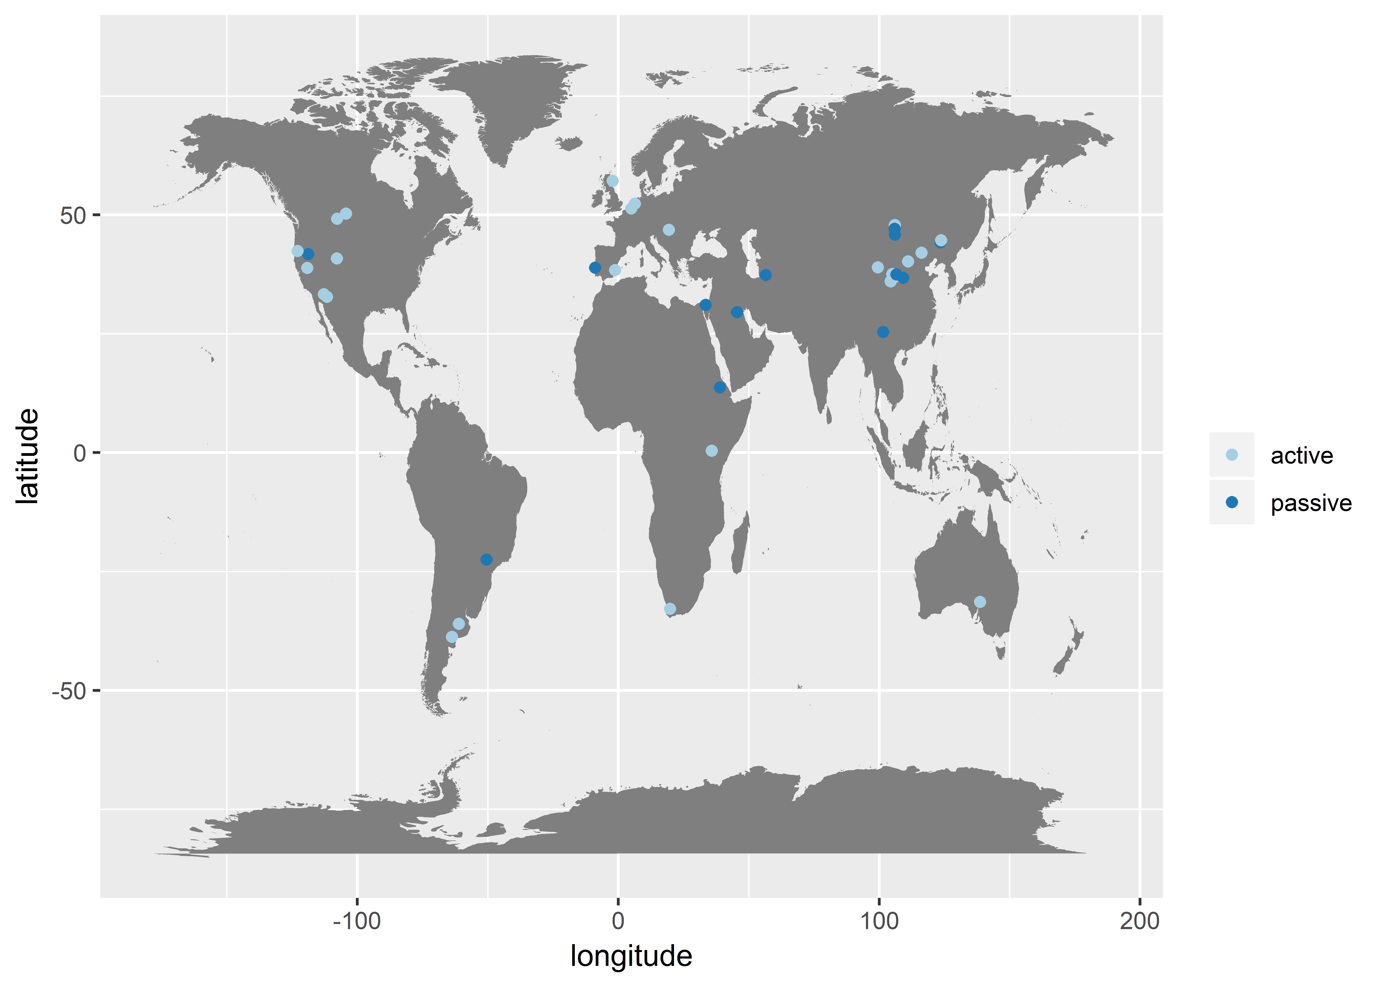

**Fig. 2.**

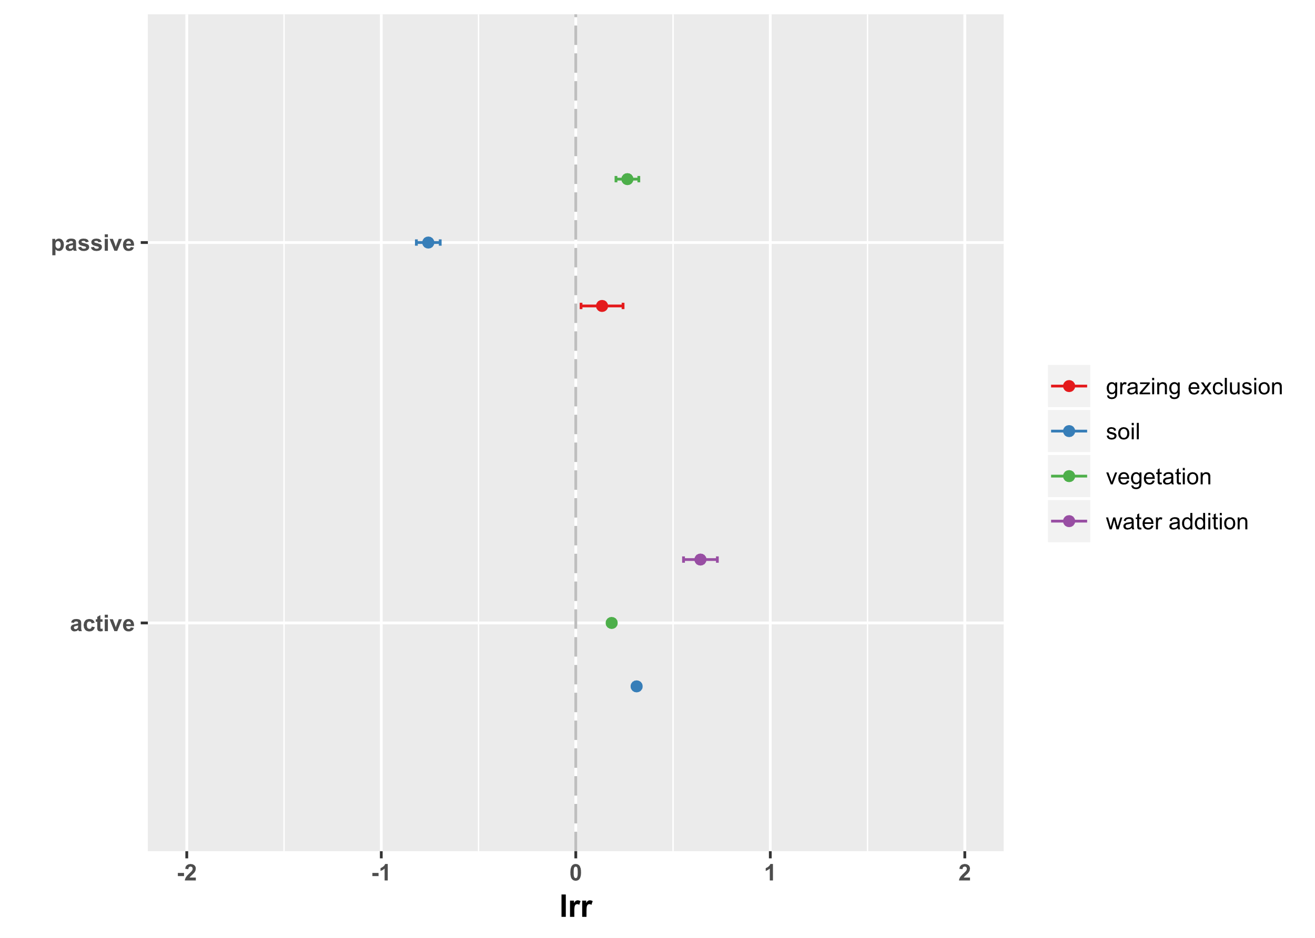

Fig. S1

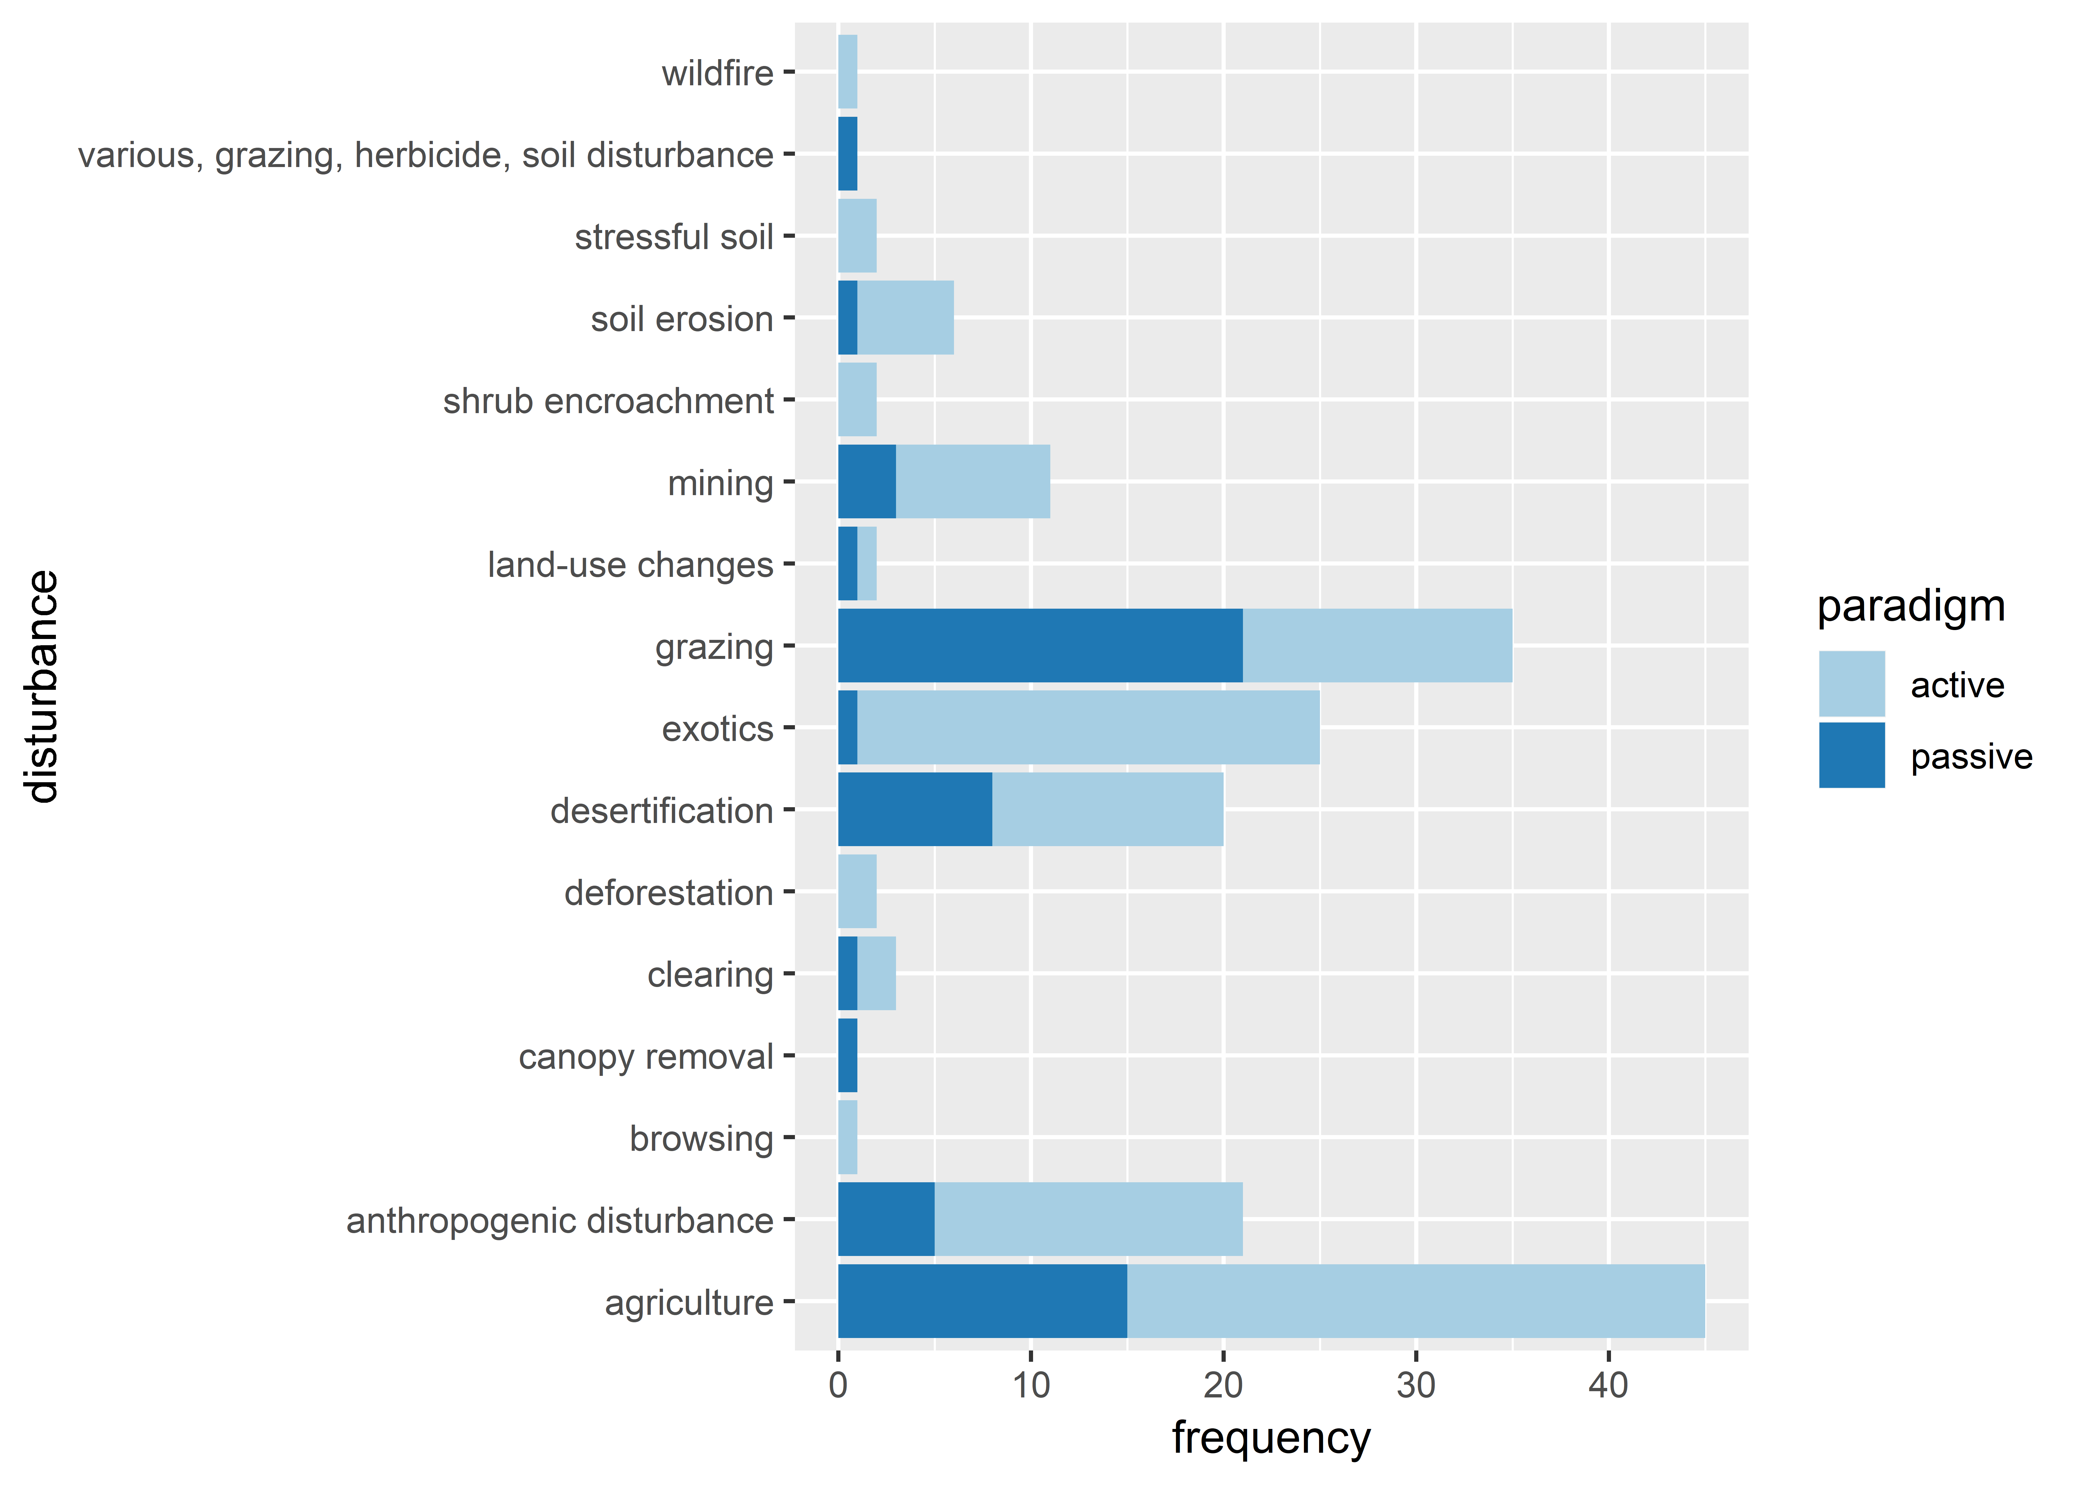

Fig. S2 PRISMA report

Table S1 list of different restoration practices and the categories made to group them ??