**Title:**

**Getting something for nothing: a synthesis of active versus passive restoration in drylands.**

**Active restoration in drylands is more effective than passive recovery.**

**Authors:** M. Florencia Miguel1*, H. Scott Butterfield2 and Christopher J. Lortie3

**Affiliations:**

1Instituto Argentino de Investigaciones de las Zonas Áridas (UNCuyo-Gobierno de Mendoza-CONICET), Mendoza, Argentina.

2The Nature Conservancy, San Francisco, CA, United States of America.

3Department of Biology, YorkU, and NCEAS, UCSB.

*Correspondence to: fmiguel@conicet-mendoza.gob.ar

**Abstract:**

Restoration is a fundamental priority for all ecosystems. Dryland ecosystems are global biodiversity hotspots and ideal to explore different categories of restoration. Agricultural intensification and land degradation pose a serious threat to biodiversity in these regions and is likely to intensify with global population growth. Using these systems as a case study, a formal synthesis including meta-analyses contrasted two general categories of restoration, active versus passive, and specific techniques to examine restoration outcomes for drylands. This synthesis included research from 19 countries, described a total of 25 interventions and examined outcomes associated with habitats and different taxa. Active restoration practices yielded significant positive outcomes for soils, vegetation, and wildlife. Passive restoration was a viable option only for some specific measures of vegetation recovery but not for soils. These findings suggest that direct interventions are critical in many ecosystems specially those experiencing severe anthropogenic pressures and environmental stress.

**One Sentence Summary:**

Active restoration in dryland ecosystems yield positive ecological outcomes for soils, vegetation, and wildlife.

A contrast of active and passive restoration methods in dryland ecosystems highlights the critical need for the adoption of active techniques to ensure positive ecological outcomes for soils, vegetation, and wildlife.

**Main Text:**

Restoration is a complex field of research and crucial in all degraded ecosystems globally (*1*), it provides multiple benefits to people that rely on fundamental services as food and water (*2*). Functional and healthy ecosystems are indispensable for the sustainability of humanity and all other forms of life (*3*, *4*) and ecological restoration links the interface between people and nature (*5*, *6*). As main categories of restoration (i.e. active or passive) differ in the total amount of resources invested (e.g. time, money and human assistance) (*7*) and these resources are likely to be scarce, we need to know what interventions generate consistent and positive outcomes that support enhanced ecosystem function and services. Dryland ecosystems are great case study to evaluate the effectiveness of restoration practices, they include natural semi-arid grasslands, shrublands, and deserts (*8*) but also encompass agricultural lands that are highly extensive systems on Earth, almost 40% of terrestrial surface experiences land conversion by agriculture (*9*, *10*). Drylands are hotspots of biodiversity and support some of the most endangered species worldwide (e.g. large herbivores in Africa) (*11*). Furthermore, a great variety of ecosystem services that contribute to people´s quality of life (*12*) as food, water, energy, carbon sequestration, cultural identity and aesthetic values (*8*), are provided by drylands (*13*). However, dryland ecosystems are some of the most degraded systems in the world (*14*); the increasing land conversion (e.g. to agriculture), land degradation, and climate change (*15*) all threaten the delivery of ecosystem services (*12*). While increased land protection (e.g. conservation easements) (*16*) and better land management practices (*17*) could benefit remaining habitat in drylands, changing conditions in general and water scarcity in particular have created an opportunity to re-claim and restore degraded agricultural drylands for plants and wildlife (*17*, *18*). Moreover, in order to seize the opportunity to restore dryland habitat, practitioners need clear guidance on which restoration practices will have the greatest positive outcomes given limited resources.

To examine restoration practices and their outcomes in dryland ecosystems globally, we performed a meta-analysis of 40 peer-reviewed publications with experimental and control groups from 19 different countries (Fig. 1). We focused on restoration within retired agricultural lands, which included both farmland (i.e. crops) and grazing natural land. Each restoration practice was classified as either active, which involves human assistance in the restoration process, or passive, which allows for natural recovery of the system (*19*). For each study we also extracted data of the restoration outcome adopted to express the response to each restoration practice (*20*). The success of restoration practices and outcomes was assessed using the log response ratio (lrr) (*21*). We grouped active restoration practices into the following three categories based on their primary focus: soil, vegetation, and water supply (Table 1A; table S1). Passive restoration practices were classified as soil, vegetation, and grazing exclusion. We evaluated active restoration outcomes across four categories: soil, vegetation, animals, and habitat (Table 1B). The habitat category was used when studies reported measures of both soil and vegetation. We evaluated passive restoration outcomes across the same three categories: soil, vegetation, and habitat (Table 1B). We used random effects models to account for the variability within the studies evaluated (*22*), and then applied meta-regressions to test the potential influence of aridity (*23*) and duration of studies.

Active restoration consistently led to positive responses (Table 1). All three specific categories of active restoration had net positive responses (Table 1A, Fig. 2); water supply was the most effective restoration practice followed by soil and vegetation active practices (Table 1A, Fig. 2). Passive vegetation recovery and grazing exclusion can also have positive effects on restoration (Table 1A, Fig. 2) but with lower effect sizes than active practices, while passive practices on soils led to negative responses (Table 1A, Fig. 2). Aridity and duration of studies following implementation both significantly influenced the effectiveness of active restoration practices (lrr= -0.01, 95% CI= -0.02 to -0.01; lrr= 0.003, 95% CI= 0.003 to 0.0035, respectively). Net effectiveness of active restoration practices decreased with increasing aridity. For passive approaches, only duration of recovery was significant (lrr= 0.01, 95% CI= 0.008 to 0.01). Typically, active restoration was positive for soils, vegetation and habitat, but not for animals’ outcomes (Table 1B). We found that soils cannot restore passively, but plants and habitat can recover (Table 1B). Findings from this synthesis support the conclusion that investment in active restoration is a more reliable strategy in meeting ecological outcomes in dryland ecosystems. In contrast, recent meta-analyses in tropical and temperate forests concluded that passive recovery through natural succession was the most effective strategy (*24*, *25*). This difference profoundly suggests that environmental limitation and stress are critical criteria to consider in weighing restoration options for an ecosystem. Rainfall, soil fertility, and productivity are severely constrained in dryland ecosystems (*8*). Furthermore, we found the success of active restoration practices decreases with aridity. The extent of land transformation and prior land use history also cannot be overlooked (*19*). Agricultural crop lands in general may need active restoration practices to overcome the former legacies of soil disturbances, nutrient inputs, and pesticides (*26*).

Resources to restore ecosystems will always be in short supply relative to need, particularly in developing countries and in those in which the reversal of the environmental deterioration is not a goal of the policy agenda (*4*). This synthesis clearly demonstrates that it is likely to get something for nothing from restoration in dryland ecosystems but that an active investment in interventions will certainly lead to more consistent positive outcomes for soils, vegetation, and habitats.

References and Notes:

1. A. F. Clewell, J. Aronson, Motivations for the restoration of ecosystems. *Conserv. Biol.* **20**, 420–428 (2006).

2. R. H. Hilderbrand, A. C. Watts, A. M. Randle, The myths of restoration ecology. *Ecol. Soc.* **10** (2005), doi:10.5751/ES-01277-100119.

3. W. V Reid *et al.*, *Ecosystems and Human Well-being: Synthesis* (2005; https://www.millenniumassessment.org/documents/document.356.aspx.pdf).

4. R. L. Chazdon *et al.*, A Policy-Driven Knowledge Agenda for Global Forest and Landscape Restoration. *Conserv. Lett.* **10**, 125–132 (2017).

5. J. Aronson, A. F. Clewell, J. N. Blignaut, S. J. Milton, Ecological restoration: A new frontier for nature conservation and economics. *J. Nat. Conserv.* **14**, 135–139 (2006).

6. S. Díaz *et al.*, The IPBES Conceptual Framework - connecting nature and people. *Curr. Opin. Environ. Sustain.* **14**, 1–16 (2015).

7. R. J. Hobbs, V. A. Cramer, Restoration Ecology: Interventionist Approaches for Restoring and Maintaining Ecosystem Function in the Face of Rapid Environmental Change. *Annu. Rev. Environ. Resour.* **33**, 39–61 (2008).

8. Millennium Ecosystems Assessment (MEA), in *Ecosystems and Human well-being: Current State and Trends* (2005; https://www.millenniumassessment.org/documents/document.291.aspx.pdf), pp. 1–40.

9. N. Ramankutty, A. T. Evan, C. Monfreda, J. A. Foley, Farming the planet: 1. Geographic distribution of global agricultural lands in the year 2000. *Global Biogeochem. Cycles*. **22**, 1–19 (2008).

10. C. M. Kennedy, J. R. Oakleaf, D. M. Theobald, S. Baruch-Mordo, J. Kiesecker, Managing the middle: A shift in conservation priorities based on the global human modification gradient. *Glob. Chang. Biol.*, 811–826 (2019).

11. E. G. Bonkoungou, Biodiversity in drylands: challenges and opportunities for conservation and sustainable use. Challenge Paper. *Glob. Drylands Initiat. UNDP Drylands Dev. Centre, Nairobi, Kenya.* (2001).

12. S. Díaz *et al.*, Assessing nature’s contributions to people. *Science (80-. ).* **359**, 270–272 (2018).

13. A. J. Castro, C. Quintas-Soriano, B. N. Egoh, Ecosystem services in dryland systems of the world. *J. Arid Environ.* **159**, 1–3 (2018).

14. R. P. White, J. Nackoney, in *World Resources Institute, Washington, D.C., USA.* (2013), pp. 1–58.

15. J. F. Reynolds *et al.*, Global Desertification: Building a Science for Dryland Development. *Science (80-. ).* **316**, 847–851 (2007).

16. R. Wilson *et al.*, Dryland Pastures: Establishment and Management in the Intermountain Region of Northern California. *Dryl. Pastures Establ. Manag. Intermt. Reg. North. Calif.* (2006), doi:10.3733/ucanr.8163.

17. R. Kelsey, A. Hart, H. Scott Butterfield, D. Vink, Groundwater sustainability in the San Joaquin Valley: Multiple benefits if agricultural lands are retired and restored strategically. *Calif. Agric.* **72**, 151–154 (2018).

18. C. J. Lortie, A. Filazzola, R. Kelsey, A. K. Hart, H. S. Butterfield, Better late than never: a synthesis of strategic land retirement and restoration in California. *Ecosphere*. **9**, e02367 (2018).

19. K. D. Holl, T. M. Aide, When and where to actively restore ecosystems? *For. Ecol. Manage.* **261**, 1558–1563 (2011).

20. J. Gurevitch, P. S. Curtis, M. H. Jones, Meta-analysis in ecology. **32**, 199–247 (2004).

21. V. Hedges, L., J. Gurevitch, P. Curtis, The Meta-Analysis of Response Ratios in Experimental Ecology. *Ecology*. **80**, 1150–1156 (1999).

22. G. Schwarzer, J. R. Carpenter, G. Rücker, *Meta- Analysis with R* (Springer, New York, 2015).

23. E. De Martonne, Regions of Interior-Basin Drainage. *Geogr. Rev.* **17**, 397–414 (1927).

24. R. Crouzeilles *et al.*, Ecological restoration success is higher for natural regeneration than for active restoration in tropical forests. *Sci. Adv.* **3**, e1701345 (2017).

25. P. Meli *et al.*, A global review of past land use, climate, and active vs. passive restoration effects on forest recovery. *PLoS One*. **12**, 1–17 (2017).

26. D. Kleijn *et al.*, Ecological Intensification: Bridging the Gap between Science and Practice. *Trends Ecol. Evol.* **34**, 154–166 (2019).

27. D. Moher *et al.*, Preferred reporting items for systematic reviews and meta-analyses: The PRISMA statement (Chinese edition). *J. Chinese Integr. Med.* **7**, 889–896 (2009).

28. Rohatgi A., WebPlotDigitizer. Retrieved from https://automeris.io/ WebPlotDigitizer (2018).

29. M. J. Lajeunesse, Bias and correction for the log response ratio in ecological meta-analysis. *Ecology*. **96**, 2056–2063 (2015).

30. R Core Team, R: A language and environment for statistical computing. *R Found. Stat. Comput. Vienna, Austria. URL https//www.R-project.org/.* (2018).

**Acknowledgments:** This section should start by acknowledging non-author contributions and then should provide information under the following headings:

The authors declare no competing interests. This research was funded by The Nature Conservancy and York University. H.S.B. and C.J.L. formulated the ideas, M.F.M. and H.S.B. compiled data, C.J.L. and M.F.M. analyzed data, M.F.M., H.S.B., and C.J.L. wrote the manuscript, H.S.B. and C.J.L. acquired the financial support for the project.

**Data and materials availability:** Include a note explaining any restrictions on materials, such as materials transfer agreements. Note accession numbers to any data relating to the paper and deposited in a public database; include a brief description of the data set or model with the number. If all data are in the paper and supplementary materials include the sentence “All data is available in the main text or the supplementary materials.” All data, code, and materials used in the analysis must be available in some form to any researcher for purposes of reproducing or extending the analysis.

Supplementary Materials:

**Materials and Methods**

Literature search and eligible criteria

PRISMA guidelines were used to structure this synthesis and meta-analysis (Preferred Reporting Items for Systematic reviews and Meta-Analyses; fig. S1) (*27*). We systematically searched Scopus and The Web of Science using the following term combinations: [restoration* desert* vegetation*] OR [restoration* grassland* desert*] OR [restoration desert* plant*] OR [restoration "agricultural lands"] OR ["restoration techniques" desert*] OR ["passive restoration" desert* plant*] OR ["active restoration" desert* plant*] OR [revegetation abandoned desert*] OR [restoration "agricult*land*" desert* plant*] OR [restoration dryland* vegetation] OR [restoration semiarid* plant*] OR [restoration arid* plant*]. The searches were done in September 2018 and returned 1504 published articles. We collected data from studies that met the following inclusion criteria: (1) research articles including results, review articles were not included; (2) agriculture as the main disturbance reported (crop and grazing lands); (3) studies with experimental (restoration practice) and control groups specifically compared; (3) reported statistical analysis and significance of treatments. After the application of the above inclusion criteria, a total of 40 studies were included in the meta-analysis (fig. S1).

Data extraction

The specific restoration practice described in each study was recorded and subsequently classified as active or passive restoration. Passive restoration refers to the natural regeneration of degraded ecosystems with minimal or not human interventions which may include the cessation of the prior disturbance, for example fencing for the exclusion of grazing (*7*). Instead, active restoration implies direct human interventions on ecosystems to assist and accelerate their restoration (*19*). The different practices that addressed a similar restoration goal were further classified into four main categories: soil, i.e. including those practices with intervention in soils; vegetation; water supply and grazing exclusion. Soil and vegetation practices included both active and passive types of restoration, water supply was classified as an active restoration practice, and grazing exclusion as passive. Moreover, for each study we extracted data of the restoration outcome adopted to estimate the mean effect and relative variation for each restoration practice reported in primary studies (*22*). We grouped the different outcomes into four general categories as well: soil, vegetation, animals and habitat. These four categories were measured by studies with an active restoration approach, while evaluation of restoration outcomes on animals was not performed in passive restoration studies.

We collected data of all the response variables reported in each article. For each response variable, we extracted the mean and standard deviation. When these data were provided in figures, we used WebPlotDigitizer (*28*) to extract values. In addition, we collected you mean looked up in WorldClim or only if it was listed in the paper? data of the mean annual temperature and annual precipitation from the study sites of each article to calculate the aridity index (*23*) and, of the duration of experiments expressed in months. The aridity index and the duration of experiments were used as covariates in statistical models.

Statistical analysis

To determine the effect of the restoration practice over the control group we calculated the log response ratio (lrr)(*21*) that quantifies the log-proportional change between the means of the two groups compared (*29*). Therefore, a negative value of the log response ratio implies the effect of the control group was higher than that of the treatment, while a positive value indicates that a treatment leads to an increase in some response evaluated. For each effect size we calculated the lower and upper 95% confidence intervals (CI), when the CIs did not overlap zero, we considered the effect size to be statistically significant. All figures and analyses were performed using the packages tidyverse and meta in R (*30*).

**Table 1.** Start this caption with a short description of your table. Format tables using the Word Table commands and structures. Do not create tables using spaces or tab characters.

|  |  |  |
| --- | --- | --- |
| **Restoration** | **lrr estimate** | **95% CI** |
| *(A)* | | |
| **Active restoration practices** | 0.22 | 0.21, 0.23 |
| Soil | 0.31 | 0.30, 0.33 |
| Vegetation | 0.18 | 0.17, 0.20 |
| Water supply | 0.64 | 0.55, 0.73 |
| **Passive restoration practices** | -0.34 | -0.37, -0.31 |
| Soil | -0.76 | -0.82, -0.70 |
| Vegetation | 0.26 | 0.21, 0.32 |
| Grazing exclusion | 0.13 | 0.03, 0.24 |
| *(B)* | | |
| **Active restoration outcomes** | | |
| Soil | 0.22 | 0.15, 0.28 |
| Vegetation | 0.51 | 0.49, 0.52 |
| Habitat | 0.06 | 0.04, 0.08 |
| Animals | -0.11 | -0.12, -0.11 |
| **Passive restoration outcomes** | | |
| Soil | -0.76 | -0.82, -0.70 |
| Vegetation | 0.44 | 0.03, 0.85 |
| Habitat | 0.16 | 0.1, 0.22 |

Figures S1

Table S1

References (1-30)

**I think figures or ok but could me better still??? Perhaps add jitter to bubbles here and make them more transparent?**

**Fig. 1.**

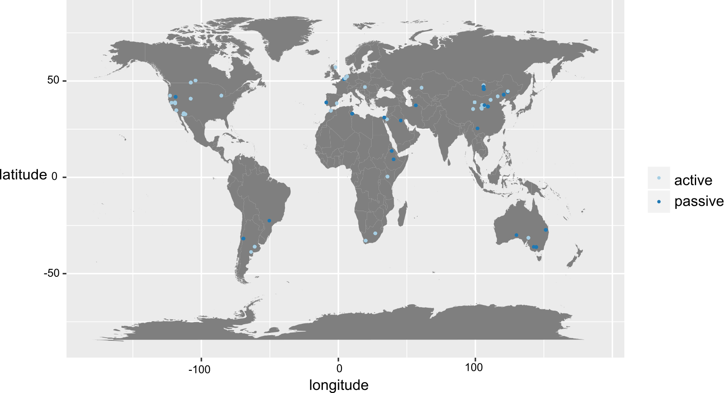

**Fig. 2.**

I think this plot does the trick.. Could be better though – ie Flor can you can pleas put the sample sizes beside each point? Also check traditional forest plots for any other ideas but this figure could be a bit more informative..

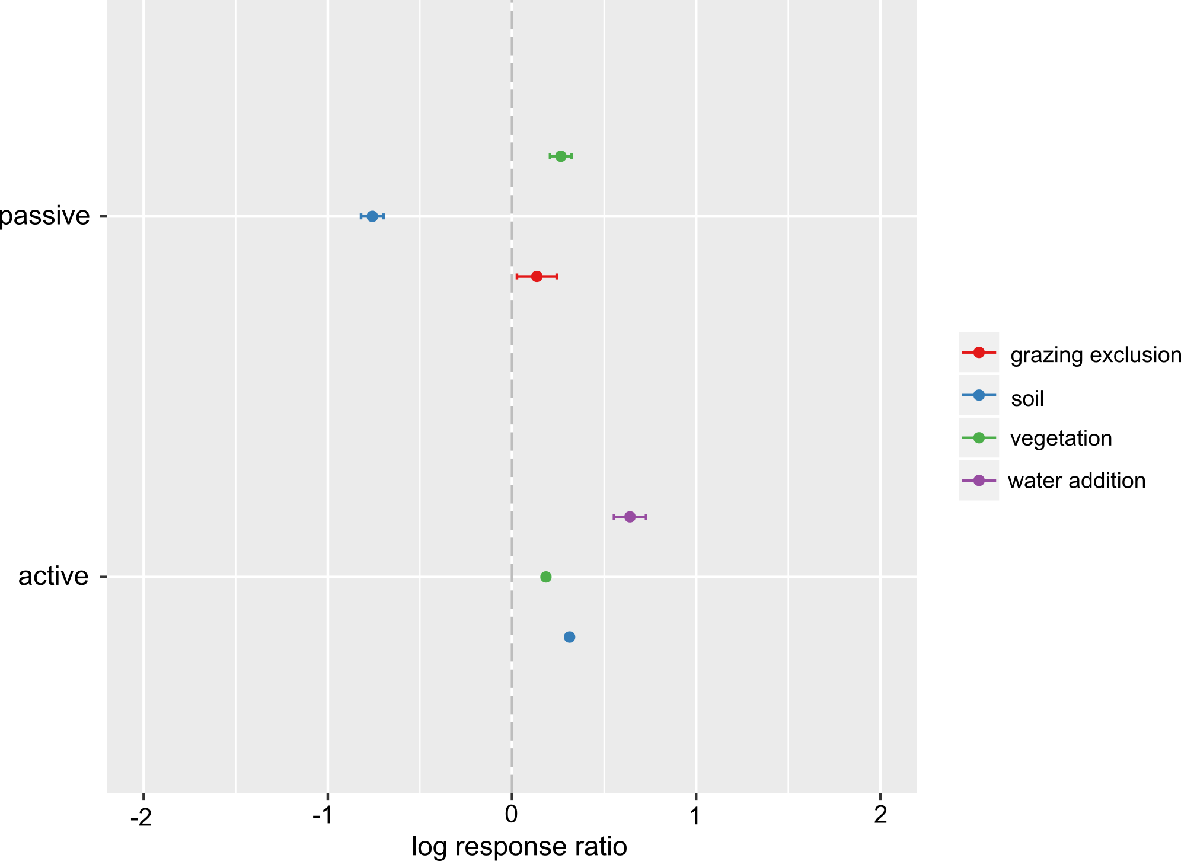

Fig. S1

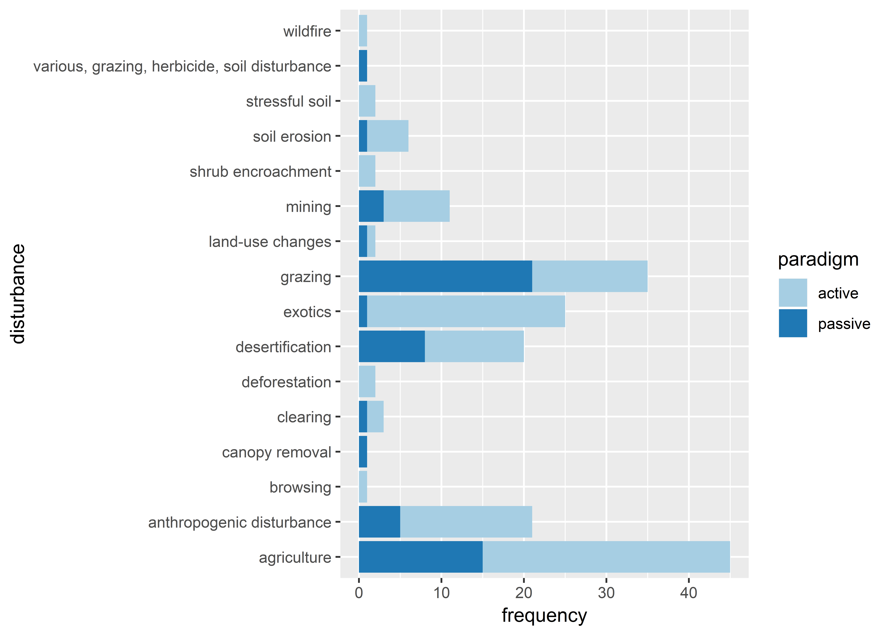

Fig. S2 PRISMA report

Table S1 list of different restoration practices and the categories made to group them ??