**Title:**

**OK TITLE IMPORTANT – we do NOT want to just say meta in drylands because that will open up opportunity for editors to say – not general enough. I think the framing of active versus passive restoration is VERY general and novel and we used drylands to show you need to compare these two categories of restoration. Active versus passive restoration is APPLICABLE to everyone in all systems – we show that is the case here using drylands.**

So my vote is

Active versus passive in title

Restoration

Drylands – sure

And if possible a bit catchy. Many options listed here but ones that have these elements are my preference.

**Getting something for nothing: a synthesis of active versus passive restoration in drylands globally.**

A global meta-analysis of restoration in dryland ecosystems. – weak…

A global synthesis of active versus passive restoration methods in drylands.

70 characters…

just thinking we can push out the title a bit and use those characters to sell the paper even more – my fav titles are the ones that highlight the main finding as well…

Active restoration in drylands more effective than passive restoration.

Restoration of ag-lands: a synthesis of active versus passive restoration in drylands globally.

**Money for nothing and your restoration for free: a synthesis of active versus passive restoration in drylands globally. Meet too! 102 characters – need to reduce**

**Money for nothing and your restoration for free: a synthesis of active versus passive restoration in drylands globally.**

Or

**Getting something for nothing: a synthesis of active versus passive restoration in drylands globally.**

**Authors:** M. Florencia Miguel1*, H. Scott Butterfield2 and Christopher J. Lortie3

**Affiliations:**

1Instituto Argentino de Investigaciones de las Zonas Áridas (UNCuyo-Gobierno de Mendoza-CONICET), Mendoza, Argentina.

2The Nature Conservancy, San Francisco, CA, United States of America.

3Department of Biology, YorkU, and NCEAS, UCSB.

*Correspondence to: fmiguel@conicet-mendoza.gob.ar

**Abstract:**

SAME – flip order – ie Really big picture first – restoration then drylands..

Restoration is a complex field of research and fundamental priority for all ecosystems. Dryland ecosystems are global biodiversity hotspots and ideal to explore the capacity for synthesis of different categories of restoration to generate desirable ecological outcomes and functions. Agricultural intensification and land degradation pose a serious threat to biodiversity in these regions and is likely to intensify with global population growth. However, water scarcity has led to reclamation opportunities in degraded agricultural lands could omit this sentenece. Using these systems globally as a case study, a formal synthesis including meta-analyses contrasted two general categories of restoration, active versus passive, and specific techniques to examine the extent that positive outcomes are a viable expectation for drylands and restoration interventions more broadly. Clunky but something like that… One brief statement if you have room in word count on literature to IMPRESS upon reader the scope of this case study synthesis….This case study synthesis included research from…. X countries or you can say virtually every dryland ecosystem globally, described a total of X different interventions, and examined outcomes associated with habitats and different taxa. Active restoration practices yielded significant positive identified outcomes for soils, vegetation, and wildlife. Passive restoration was a viable option only for some specific measures of vegetation recovery but not for soils. THEN back out again to the BIGGER picture – what is the implication of this for restoration for anyone anywhere – this is where you connect to the title if you have it written well – These findings strongly suggest that direct intervention is likely critical in many ecosystems particularly those experiences significant anthropogenic pressures and environmental stress…. Something like that.

**One Sentence Summary:**

A contrast of active and passive restoration methods in dryland ecosystems highlights the critical need for the adoption of active techniques to ensure positive ecological outcomes for soils, vegetation, and wildlife.

Ie the framing I prefer if you like? Basically do throughout paper – ie deserts are the case study.

Active restoration practices in dryland ecosystems led to the largest most positive outcomes for soils, vegetation, and wildlife.

**Main Text:**

TOPIC sentence should be restoration – again – you prefer the big picture I propose – FLIP story

Restoration is crucial in all ecosystems globally. We need to know what interventions generate consistent and positive outcomes that support enhanced ecosystem function and services. ONE more sentence defining restoration and whaty it can do – then like abstract explain why drylands are the perfect fit.. Drylands include natural semi-arid grasslands, shrublands, and deserts but also encompass agricultural lands that are some of the most extensive and biodiversity-rich systems on Earth. Ag? lands cover over 40% of the global land surface (*1*) (insert relevant citation). Drylands provide key ecosystem services, such as food provision (crops and livestock), carbon sequestration, biodiversity support and land for renewable energy development (*1*–*3*). Dryland ecosystems are also some of the systems most threatened by land conversion (e.g. to agriculture), land degradation, and climate change. (*6*), all of which threaten the delivery of ecosystem services (*7*). While increased land protection (e.g. conservation easements) (*8*) and better land management practices (*9*) could benefit remaining habitat in drylands, changing conditions in general and water scarcity in particular have created an opportunity to re-claim and restore degraded dryland agricultural lands for plants and wildlife (*10, 11*). In order to seize this opportunity to restore dryland habitat, practitioners need clear guidance on which restoration practices will have the greatest positive outcomes given limited resources. This is all OK but does not totally inspire me – I think we have said it too many papers already ☺_so my flow would be restoration first (ie move the stuff below up first). Then drylands but streamline the above a bit more and use all that but frame as a. hotspots for biodiversity b. many pressures and stressors. c. OPPOUNITY for synthesis here because of extensive need for restoration, retiring lands, and also relatively diverse set of research examining restoration – ie compared to ANY OTHER SYSTEM… think about it – forests meh add trees… ha.. ocean… lakes… etc.. deserts Are THE place to examine active versus passive restoration.

TOPIC sentence first – see above – you get the flow I propose… then develop this WAY more..

Restoration practices can be characterized as active or passive (i.e. natural recovery), which differ in the total amount of resources invested (e.g. time, money and human assistance) (*13*). The impact of individual restoration practices on soils, vegetation, and wildlife often takes many years to evaluate (*14*). Given the diversity of restoration practices that have been implemented and assessed in dryland ecosystems globally (*14*, *15*), it is crucial to evaluate their overall effectiveness to guide future restoration opportunities (11). MEH – see above edits – develop more and really sell restoration as ONE of the most critical priorities for people to consider with respect to the interface between PEOPLE, NATURE, CHANGE, and INTERVENTIONS… NATURE and Science both love the nature-people framing and we are NOT only changing drylands but we USE them as you describe and they are hotspots. SELL this.

TO be clear – we are not even SELLING – it is why I work in deserts, they are huge, used (up), changing, but also you have the OPPORTUNITY to so much for restoration… SAY this.

My two cents.. but you know I am nuts.

To examine….. NOW you have a decision to make – and this should match title… a. whether some level of passive restoration is a viable option using drylands because of their extent, diversity, and value OR b. to contrast active and passive restoration approaches using drylands including an examination of more specific categories…. C. what you have – ie what works in drylands. restoration practices and outcomes in dryland ecosystems globally, we performed a meta-analysis of 66 peer-reviewed publications (*16*, *17*) from 19 different countries (Fig. 1). We focused on restoration practices and outcomes within agricultural lands, which included both farmland (i.e. crops) and grazing/natural land (Fig. S1). We classified each restoration practice and outcome as either active, which involves human assistance in the restoration process, or passive, which allows for natural recovery of the system (*18*). We assessed the success of each restoration practice and outcome using the log response ratio (lrr) (*19*). MEH – hard to see the flow here.

We grouped active restoration practices into the following three categories based on their primary focus: soil, vegetation, and water addition (Table 1; Table S1). Passive restoration practices were classified as soil, vegetation, and grazing exclusion. We evaluated active restoration outcomes across four outcomes? Interventions?: soil, plants, animals, and habitat (Table 1). The habitat category was used to represent outcomes for integrated measures of plants and soil. We evaluated passive restoration outcomes across the same three categories: soils, plants, and habitat (Table 1). We used random effects models to account for the variability within the studies evaluated (*17*), and then applied meta-regressions to test the potential influence of aridity (*20*) and duration of studies (*21*). Again – needs another round once you decide on direction and which track changes you use from above.

Active restoration consistently led to more positive outcomes (lrr active = 0.22, 95% CI= 0.21 to 0.23 and lrr passive = -0.34, 95% CI= -0.37 to -0.31). All three specific classes? of active restoration had net positive outcomes (Table 1), but passive soil recovery overall had net negative outcomes (Table 1A, Fig. 2). Passive vegetation recovery and grazing exclusion can also positive effects on restoration outcomes but were relatively small effect sizes (citation) and had high variance?? Or just leave as is (Table 1A, Fig. 2). Aridity and duration of recovery following implementation both significantly influenced the effectiveness of active restoration practices (lrr estimatearidity= -0.01, 95% CI= -0.02 to -0.01; lrr estimatedexp.time= 0.003, 95% CI= 0.003 to 0.0035). For passive approaches, only duration of recovery was significant (lrr estimatedexp.time= 0.01, 95% CI= 0.008 to 0.01). Net effectiveness of active restoration practices decreased with increasing aridity. Typically, active restoration was positive for soils, plants and habitat, but not for animals (Table 1B). We found that soils cannot restore passively, but that plants and habitat can revise (Table 1B). We found that water addition was the most effective restoration practice, followed by soil and plant restoration practices (Table 1A).

These findings support the conclusion that investment in active restoration is a more reliable strategy in meeting ecological outcomes in dryland ecosystems. In contrast, a recent meta-analysis in tropical forests concluded that passive recovery throught natural succession was the most effective strategy (*22*). This difference profoundly suggests that environmental limitation and stress are critical criteria to consider in weighing restoration options for an ecosystem. Rainfall, soil fertility, and productivity are severely constrained in dryland ecosystems (*1*). The extent of land transformation and prior land use history also cannot be overlooked. Agricultural crop lands in general may need active restoration practices to overcome the former legacies of soil disturbances, nutrient inputs, and pesticides.(*24*). Resources to restore will always be in short supply relative to need particularly in developing countries or under a Trumpian regime (*1*). This synthesis clearly demonstartes that one can get something for nothing from restoration in dryland ecosystems but that an active investment in interventions will certainly lead to more consistent positive outcomes for soils, plants, and habitats.

References and Notes:

1. Millennium Ecosystems Assessment (MEA), Ecosystems and Human well-being: Current State and Trends: Dryland Systems. *Isl. Press*, 1–40 (2005).

2. C. J. Lortie, A. Filazzola, D. A. Sotomayor, Functional assessment of animal interactions with shrub-facilitation complexes: A formal synthesis and conceptual framework. *Funct. Ecol.* **30**, 41–51 (2016).

3. K. Trumper, C. Ravilious, B. Dickson, Carbon in Drylands : Desertification , Climate Change and Carbon Finance. *A UNEP-UNDP-UNCCD Tech. Note Discuss. CRIC 7 , Istanbul , Turkey - 03-14 Novemb. , 2008*, 1–12 (2008).

4. M. Mortimore *et al.*, *Dryland Opportunities: A new paradigm for people, ecosystems and development* (2009; http://www.resalliance.org/3871.php).

5. H. Ma, H. Zhao, United Nations: Convention to combat desertification in those countries experiencing serious drought and/or desertification, particularly in Africa. *Hum. Hered.* **33**, 1328–1382 (1994).

6. J. F. Reynolds *et al.*, Global Desertification: Building a Science for Dryland Development. *Science (80-. ).* **316**, 847–851 (2007).

7. J. C. Birch *et al.*, Cost-effectiveness of dryland forest restoration evaluated by spatial analysis of ecosystem services. *Proc. Natl. Acad. Sci.* **107**, 21925–21930 (2010).

8. R. Wilson *et al.*, Dryland Pastures: Establishment and Management in the Intermountain Region of Northern California. *Dryl. Pastures Establ. Manag. Intermt. Reg. North. Calif.* (2006), doi:10.3733/ucanr.8163.

9. S. Kamotho, W. Strahm, C. Wolfangel, The nature of drylands Diverse ecosystems, diverse solutions. *IUCN World Conserv. Congr.*, 1–40 (2008).

10. W. V Reid *et al.*, *Ecosystems and Human Well-being: Synthesis* (2005; https://www.millenniumassessment.org/documents/document.356.aspx.pdf).

11. C. J. Lortie, A. Filazzola, R. Kelsey, A. K. Hart, H. S. Butterfield, Better late than never: a synthesis of strategic land retirement and restoration in California. *Ecosphere*. **9**, e02367 (2018).

12. K. Suding *et al.*, Committing to ecological restoration. *Science (80-. ).* **348**, 638–640 (2015).

13. R. J. Hobbs, V. A. Cramer, Restoration Ecology: Interventionist Approaches for Restoring and Maintaining Ecosystem Function in the Face of Rapid Environmental Change. *Annu. Rev. Environ. Resour.* **33**, 39–61 (2008).

14. K. D. Holl, T. M. Aide, When and where to actively restore ecosystems? *For. Ecol. Manage.* **261**, 1558–1563 (2011).

15. J. L. Reid, M. E. Fagan, R. A. Zahawi, Positive site selection bias in meta-analyses comparing natural regeneration to active forest restoration. *Sci. Adv.* **4**, 1–4 (2018).

16. A. P. Field, R. Gillett, How to do a meta-analysis. *Br. J. Math. Stat. Psychol.* **63**, 665–694 (2010).

17. G. Schwarzer, J. R. Carpenter, G. Rücker, *Meta- Analysis with R* (Springer, New York, 2015).

18. J. Aronson, S. J. Milton, N. J. Blignautames, *Restoring Natural Capital: Science, Business, and Practice* (2007; http://er.uwpress.org/cgi/doi/10.3368/er.26.2.161), vol. 26.

19. V. Hedges, L., J. Gurevitch, P. Curtis, the Meta-Analysis of Response Ratios in. *Ecol. Soc. Am.* **80**, 1150–1156 (1999).

20. E. De Martonne, Regions of Interior-Basin Drainage. *Geogr. Rev.* **17**, 397–414 (1927).

21. M. Borenstein, L. V. Hedges, J. P. T. Higgins, H. R. Rothstein, in *Introduction to Meta-Analysis* (2009), pp. 282–288.

22. R. Crouzeilles *et al.*, Ecological restoration success is higher for natural regeneration than for active restoration in tropical forests. *Sci. Adv.* **3**, e1701345 (2017).

23. O. Rollin, L. A. Garibaldi, Impacts of honeybee density on crop yield: A meta-analysis. *J. Appl. Ecol.*, 0–2 (2019).

24. D. Kleijn *et al.*, Ecological Intensification: Bridging the Gap between Science and Practice. *Trends Ecol. Evol.* **34**, 154–166 (2019).

25. L. A. Garibaldi *et al.*, Policies for Ecological Intensification of Crop Production. *Trends Ecol. Evol.* **xx**, 1–5 (2019).

26. D. Moher *et al.*, Preferred reporting items for systematic reviews and meta-analyses: The PRISMA statement (Chinese edition). *J. Chinese Integr. Med.* **7**, 889–896 (2009).

27. Rohatgi A., WebPlotDigitizer. Retrieved from https://automeris.io/ WebPlotDigitizer (2018).

28. A. Guolo, C. Varin, Random-effects meta-analysis: The number of studies matters. *Stat. Methods Med. Res.* **26**, 1500–1518 (2017).

29. R. DerSimonian, N. Laird, Meta-analysis in clinical trials. *Control. Clin. Trials*. **7**, 177–188 (1986).

30. M. J. Lajeunesse, Bias and correction for the log response ratio in ecological meta-analysis. *Ecology*. **96**, 2056–2063 (2015).

31. R Core Team, R: A language and environment for statistical computing. *R Found. Stat. Comput. Vienna, Austria. URL https//www.R-project.org/.* (2018).

**Acknowledgments:** This section should start by acknowledging non-author contributions and then should provide information under the following headings:

The authors declare no competing interests. This research was funded by The Nature Conservancy and York University. H.S.B. and C.J.L. formulated the ideas, M.F.M. and H.S.B. compiled data, C.J.L. and M.F.M. analyzed data, M.F.M., H.S.B., and C.J.L. wrote the manuscript. H.S.B. and C.J.L. acquired the financial support for the project.

**Data and materials availability:** Include a note explaining any restrictions on materials, such as materials transfer agreements. Note accession numbers to any data relating to the paper and deposited in a public database; include a brief description of the data set or model with the number. If all data are in the paper and supplementary materials include the sentence “All data is available in the main text or the supplementary materials.” All data, code, and materials used in the analysis must be available in some form to any researcher for purposes of reproducing or extending the analysis.

Supplementary Materials:

**Materials and Methods**

Literature search and eligible criteria

PRISMA guidelines were used to structure this synthesis and meta-analysis (Preferred Reporting Items for Systematic reviews and Meta-Analyses; Fig. S2) (*26*). We systematically searched Scopus and The Web of Science using the following term combinations: [restoration* desert* vegetation*] OR [restoration* grassland* desert*] OR [restoration desert* plant*] OR [restoration "agricultural lands"] OR ["restoration techniques" desert*] OR ["passive restoration" desert* plant*] OR ["active restoration" desert* plant*] OR [revegetation abandoned desert*] OR [restoration "agricult*land*" desert* plant*] OR [restoration dryland* vegetation] OR [restoration semiarid* plant*] OR [restoration arid* plant*]. The searches were done in September 2018 and returned 1504 published articles. We collected data from studies that met the following inclusion criteria: (1) research articles including results, no review articles; (2) agriculture as the main disturbance reported (crop lands and grazing lands); (3) studies with treatment (restoration practice) and control (no intervention) groups; (3) reported statistical analysis and significance of treatments. After the application of the above inclusion criteria, a total of 66 studies were included in the meta-analysis (Fig. S4).

Data extraction

The specific restoration practice described in each study was recorded and subsequently classified as active or passive restoration. DEFINE what is ACTIVE and PASSIVE in a sentence here please. The different practices that addressed a similar restoration goal were further classified into four main categories: soil, i.e. including those practices with soil intervention; vegetation; water addition and grazing exclusion. “Soil” and “vegetation” practices included both active and passive types of restoration, “water addition” was classified as an active restoration practice, and “grazing exclusion” as passive. Do we need the quotation marks? Moreover, for each study we extracted data of the restoration outcome adopted to estimate the mean effect and relative variation reported for each restoration technique reported in primary studies (*17*). We grouped the different outcomes into four general groups as well: soil, plants, animals and habitat. These four outcomes groups were measured by studies with an active restoration approach, while passive restoration studies have not evaluated the “animals” group.

We collected data of all the response variables reported in each article. For each response variable, we extracted the mean and standard deviation. When these data were provided in figures, we used WebPlotDigitizer (*27*) to extract values. In addition, we collected you mean looked up in WorldClim or only if it was listed in the paper? data of the mean annual temperature and annual precipitation from the study sites of each article to calculate the aridity index (*20*) and, of the length of experiments expressed in months. The aridity index and the time scale of experiments were used as covariates in statistical models (see below).

Statistical analysis

**Table 1.** Start this caption with a short description of your table. Format tables using the Word Table commands and structures. Do not create tables using spaces or tab characters.

|  |  |  |
| --- | --- | --- |
| **Restoration** | **Log response ratio estimate** | **95% CI** |
| *(A)* | | |
| Active restoration practices | | |
| Soil | 0.31 | [0.30, 0.33] |
| Vegetation | 0.18 | [0.17, 0.20] |
| Water addition | 0.64 | [0.55, 0.73] |
| Passive restoration practices | | |
| Soil | -0.76 | [-0.82, -0.70] |
| Vegetation | 0.26 | [0.21, 0.32] |
| Grazing exclusion | 0.13 | [0.03, 0.24] |
| *(B)* | | |
| Active restoration outcomes | | |
| Soil | 0.22 | [0.15, 0.28] |
| Plants | 0.51 | [0.49, 0.52] |
| Habitat | 0.06 | [0.04, 0.08] |
| Animals | -0.11 | [-0.12, -0.11] |
| Passive restoration outcomes | | |
| Soil | -0.76 | [-0.82, -0.70] |
| Plants | 0.44 | [0.03, 0.85] |
| Habitat | 0.16 | [0.1, 0.22] |

Figures S1-S2

Table S1

References (1-31)

**I think figures or ok but could me better still??? Perhaps add jitter to bubbles here and make them more transparent?**

**Fig. 1.**

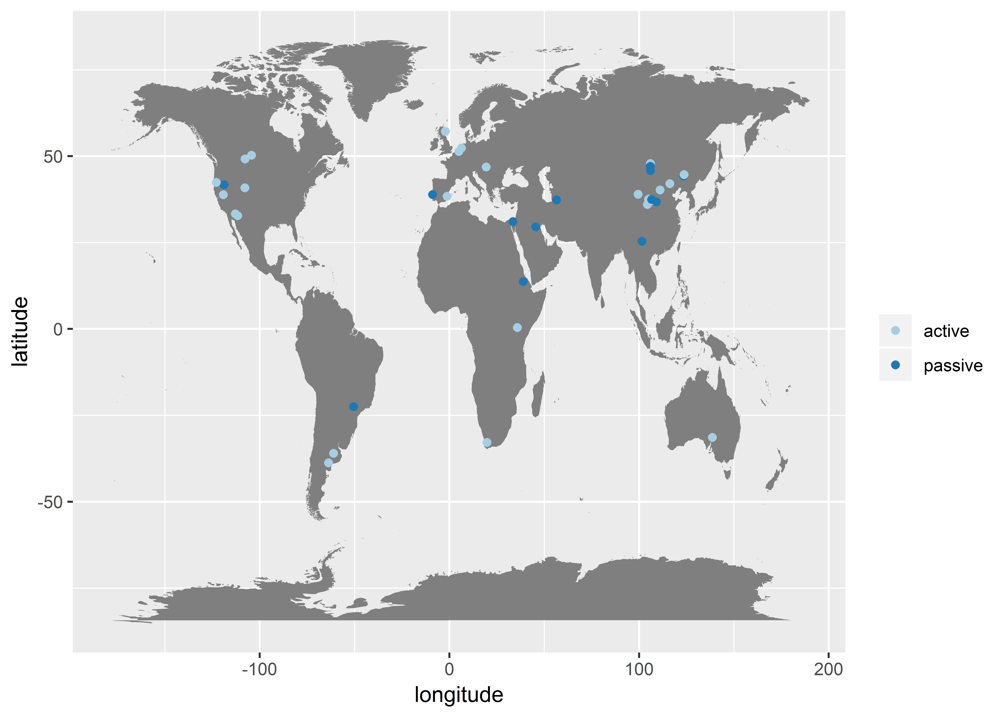

**Fig. 2.**

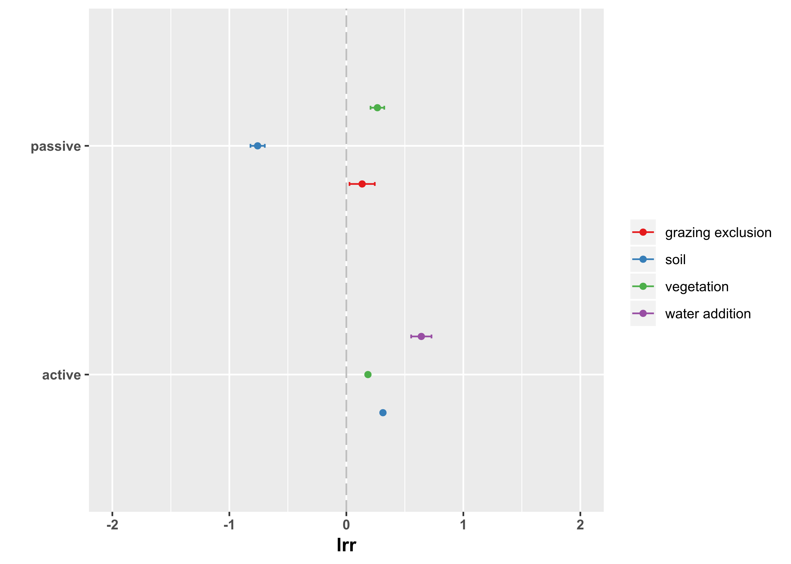

I think this plot does the trick.. Could be better though – ie Flor can you can pleas put the sample sizes beside each point? Also check traditional forest plots for any other ideas but this figure could be a bit more informative..

Fig. S1

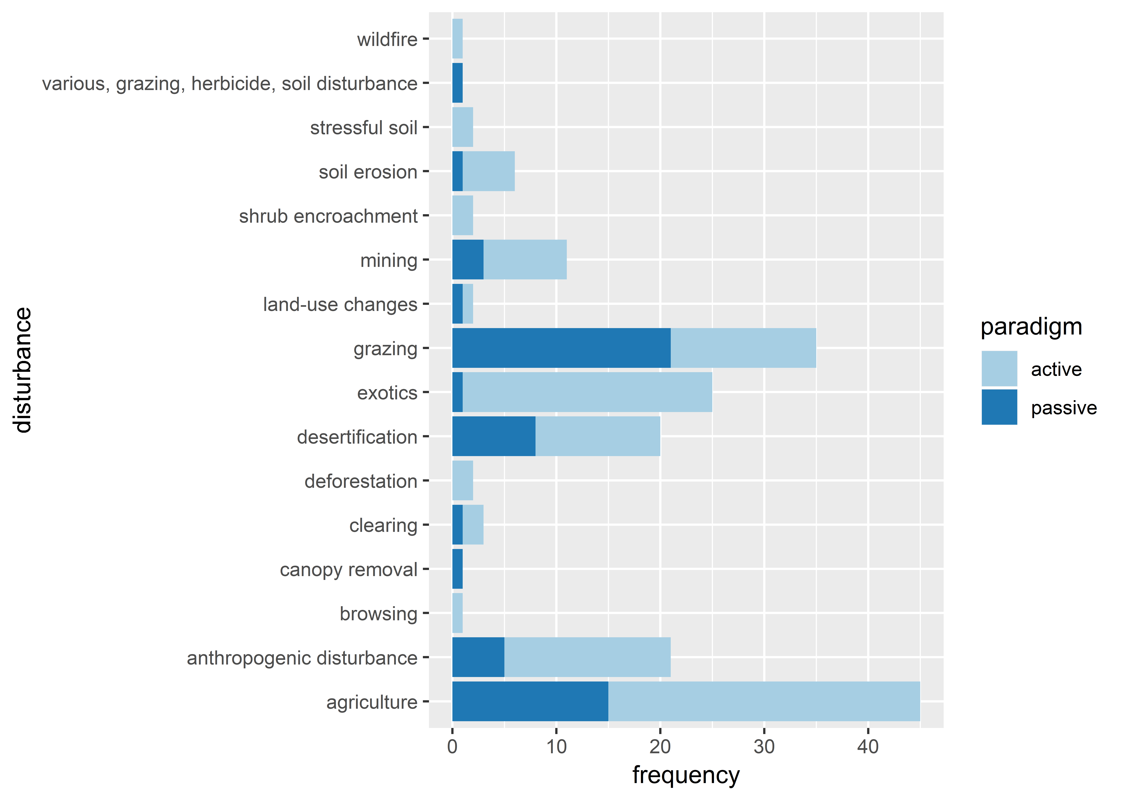

Fig. S2 PRISMA report

Table S1 list of different restoration practices and the categories made to group them ??