新闻管理系统
  - 准备工作
    - 数据库设计
执行如下SQL语句：
# 创建news数据库
CREATE DATABASE `news`;

# 新闻表：
mysql> CREATE TABLE `news`(
-> `id` INT PRIMARY KEY AUTO_INCREMENT,
-> `title` VARCHAR(50) NOT NULL DEFAULT 0,
-> `content` TEXT NOT NULL,
-> `a_id` INT UNSIGNED NOT NULL DEFAULT 0,
-> `publish` INT UNSIGNED NOT NULL
-> ) DEFAULT CHARSET=utf8;
Query OK, 0 rows affected(0.01 sec)

# 作者表
mysql> CREATE TABLE `author`(
-> `id` INT PRIMARY KEY AUTO_INCREMENT,
-> `name` VARCHAR(50) NOT NULL DEFAULT '',
-> `platform` VARCHAR(50) DEFAULT ''
-> )DEFAULT CHARSET=utf8;
Query OK, 0 rows affected(0.01 sec)

# 添加作者信息
mysql> INSERT INTO author VALUES(NULL, '百家号', '百家号自媒体'),
-> (NULL, '微信', '微信自媒体');
Query OK, 2 rows affected(0.01 sec)

从源代码包中复制静态资源到项目中。
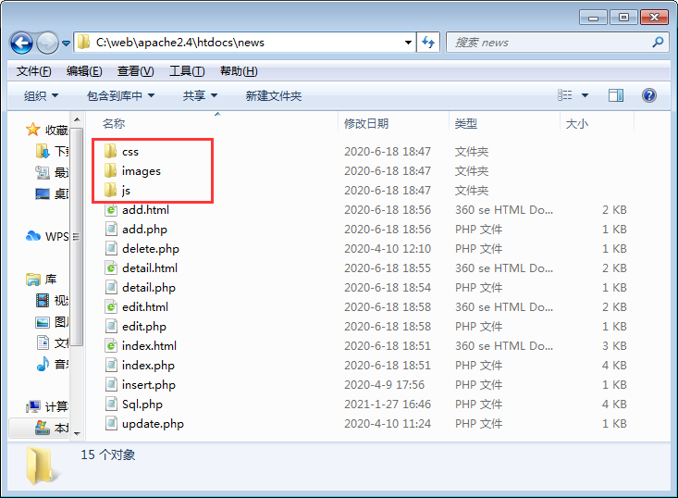
  - 功能开发
    - 添加新闻

创建add.php。

<?php
$link = mysqli_connect('localhost', 'root', '123456', 'news', '3306');
if (!$link) {
exit(mysqli_connect_error());
}
if (!mysqli_set_charset($link, 'utf8')) {
exit(mysqli_error($link));
}
// 获取作者信息
$result = mysqli_query($link, 'SELECT `id`,`name` FROM `author`');
if (!$result) {
exit(mysqli_error($link));
}
$authors = [];
while ($row = mysqli_fetch_assoc($result)) {
$authors[] = $row;
}
include 'add.html';

编写add.html。

<!DOCTYPE html>
<html>
<head>
<meta charset="UTF-8">
<title>新闻添加页</title>
<link rel="stylesheet" href="css/bootstrap.min.css">
<link rel="stylesheet" href="css/index.css">
</head>
<body>
<nav class="navbar">
<div class="container navbar-content">
<a href="javascript:;">首页</a>
<a href="add.php">添加新闻</a>
</div>
</nav>
<img src="images/bg.jpg" class="index-bg">
<div class="container">
<div class="add-news col-md-8 col-md-offset-2">
<h1>添加新闻</h1>
<form action="insert.php" method="post">
<div class="form-group">
<label for="news_title">新闻标题</label>
<input type="text" class="form-control" id="news_title" name="title">
</div>
<div class="form-group">
<label for="news_author">作者</label>
<select name="author">
<?php foreach($authors as $author):?>
<option value="<?php echo $author['id'];?>">
<?php echo $author['name'];?>
</option>
<?php endforeach;?>
</select>
</div>
<div class="form-group">
<label for="news_content">新闻内容</label>
<textarea class="form-control" rows="12" name="content"></textarea>
</div>
<button class="btn btn-primary btn-block">添加</button>
</form>
</div>
<footer class="copyright" style="border-top: none;">
Copyright 2020 All rights reserved.
</footer>
</div>
</body>
</html>

insert.php接收表单信息。
<?php
include 'Sql.php';
header('Content-type:text/html;charset=utf-8');

$title = $_POST['title'] ?? '';
$content = $_POST['content'] ?? '';
$a_id = $_POST['author'] ?? 0;

if(empty($title) || empty($content)){
header('refresh:3;url=add.php');
echo '新闻标题和内容都不能为空！';
exit;
}

$conn = connect('root','','news',$error);
if(!$conn) die($error);
$sql = "insert into news values(null,'".
$title."','".$content."',".$a_id.",".time().")";
$res = query($conn,$sql,$error);

if($res){
header('refresh:2;url=index.php');
echo '新闻：' . $title . ' 新增成功！';
}else{
header('refresh:3;url=add.php');
echo '新闻：' . $title . '新增失败！';
}

页面效果：
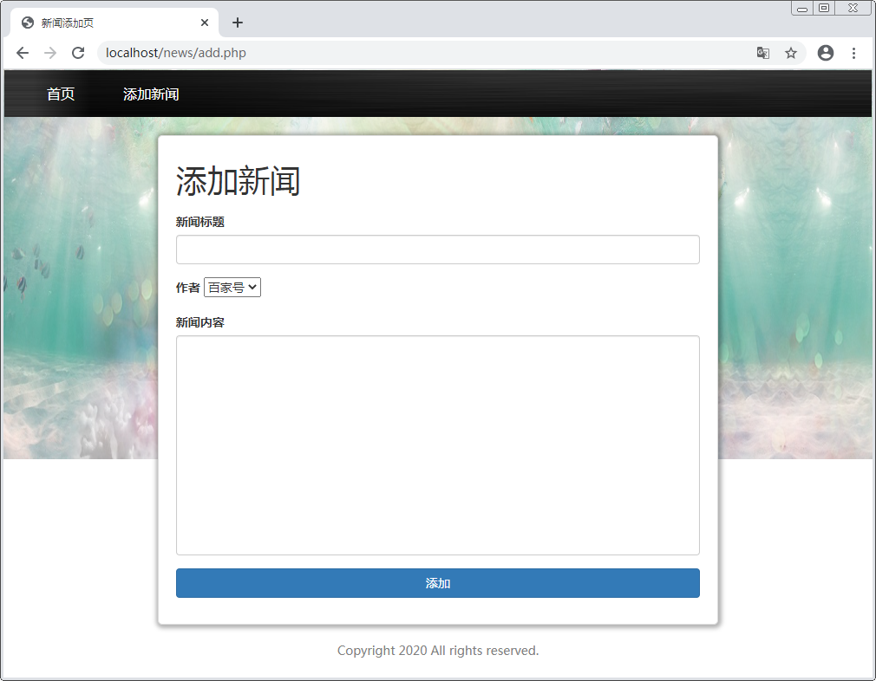
    - 封装函数
创建Sql.php，实现对数据库的封装。

<?php

function connect($user,$pass,$dbname,&$error,$host = 'localhost',$port = '3306',$charset = 'utf8'){
$conn = @mysqli_connect($host,$user,$pass,$dbname,$port);
if(!$conn){
$error = iconv('gbk','utf-8',mysqli_connect_error());
return false;
}
if(!mysqli_set_charset($conn,$charset)){
$error = mysqli_error($conn);
return false;
}
return $conn;
}

function query($conn,$sql,&$error){
$res = mysqli_query($conn,$sql);
if($res === false){
$error = mysqli_error($conn);
return false;
}
return $res;
}

function read($conn,$sql,&$error,$all = false){
$res = query($conn,$sql,$error);
if($res === false) return false;
$lists = [];
if($all){
while($row = mysqli_fetch_assoc($res)){
$lists[] = $row;
}
}else{
$lists = mysqli_fetch_assoc($res);
}
mysqli_free_result($res);
return $lists;
}
function auto_update($conn,$data,$table,&$error,$id = 0){
$set = '';
foreach($data as $k => $v){
$set .= $k . "='{$v}',";
} # title = 'title',content = 'content',
$set = rtrim($set,','); # $set : title = 'title',content = 'content'
$sql = "update {$table} set {$set} ";
if($id) $sql .= ' where id = ' . $id;
if(query($conn,$sql,$error))
return mysqli_affected_rows($conn);
else return false;
}
function auto_read($conn,$table,&$error,$where = [],$all = false){
$where_clause = ' where 1 ';
if($where){
foreach($where as $k => $v){
$where_clause .= ' and ' . $k . " = '$v' ";
} # where 1 and title = 'news' ...
}
$sql = "select * from {$table} {$where_clause}";
$res = query($conn,$sql,$error);
if($res === false) return $res;
$lists = [];
if($all){
while($row = mysqli_fetch_assoc($res)){
$lists[] = $row;
}
}else{
$lists = mysqli_fetch_assoc($res);
}
mysqli_free_result($res);
return $lists;
}

修改add.php连接数据库和查询作者信息的代码：
<?php
include 'Sql.php';

$conn = connect('root','123456','news',$error);
if(!$conn) die($error);
$sql = "SELECT id,name FROM author";
$authors = read($conn,$sql,$error,true);

include 'add.html';

修改insert.php连接数据库和保存新闻的代码：
include 'Sql.php';
$conn = connect('root', '123456', 'news', $error);
if (!$conn) {
exit($error);
}
$sql = 'INSERT INTO `news` VALUES(null, \''. $title. '\', \'' .
$content . '\',' . $a_id . ',' . time() . ')';
$res = query($conn, $sql, $error);
    - 新闻列表
创建index.php。

<?php
include 'Sql.php';
$conn = connect('root', '123456', 'news', $error);
if (!$conn) {
exit($error);
}
// 新闻列表
$sql = 'SELECT n.*,a.name FROM news n LEFT JOIN author a ON n.a_id=a.id';
$news = read($conn, $sql, $error, true);
include 'add.html';

创建index.html。

<!DOCTYPE html>
<html lang="en">
<head>
<meta charset="UTF-8">
<title>新闻列表页</title>
<link rel="stylesheet" href="css/index.css">
<script type="text/javascript" src='js/jquery-1.11.2.js'></script>
<script type="text/javascript" src='js/paging.js'></script>
</head>
<body>
<nav class="navbar">
<div class="container navbar-content">
<a href="index.php">首页</a>
<a href="add.php">添加新闻</a>
</div>
</nav>
<img src="images/bg.jpg" class="index-bg">
<div class="container">
<h1>新闻系统</h1>
<div class="news-list">
<div class="news-list-left">
<?php foreach($news as $n):?>
<div class="news-list-item">
<div class="author-time"> <span><?php echo $n['name'];?></span> 发表于 <span><?php echo date('Y-m-d h:i:s',$n['publish']);?></span> </div>
<div class="news-des">
<h3 class="news-title" style='float: left;'>
<i></i><a href="detail.php?id=<?php echo $n['id'];?>"><?php echo $n['title'];?></a>
</h3>
<div class="operate">
<a href="javascript:;">编辑</a>&nbsp;&nbsp;
<a href="javascript:;">删除</a>
</div>
<div style='clear:both'></div>
<div class="news-content-des ellipsis"><?php echo $n['content'];?></div>
</div>
</div>
<?php endforeach;?>
</div>
<div class="news-list-right">
<div class="about">
<h4>关于我们</h4>
<div class="about-des">
<p>关于我们</p>
</div>
</div>
</div>
<!-- 分页导航 -->
<footer class="copyright">Copyright 2020 All rights reserved.</footer>
</div>
</div>
</body>
</html>

页面效果：
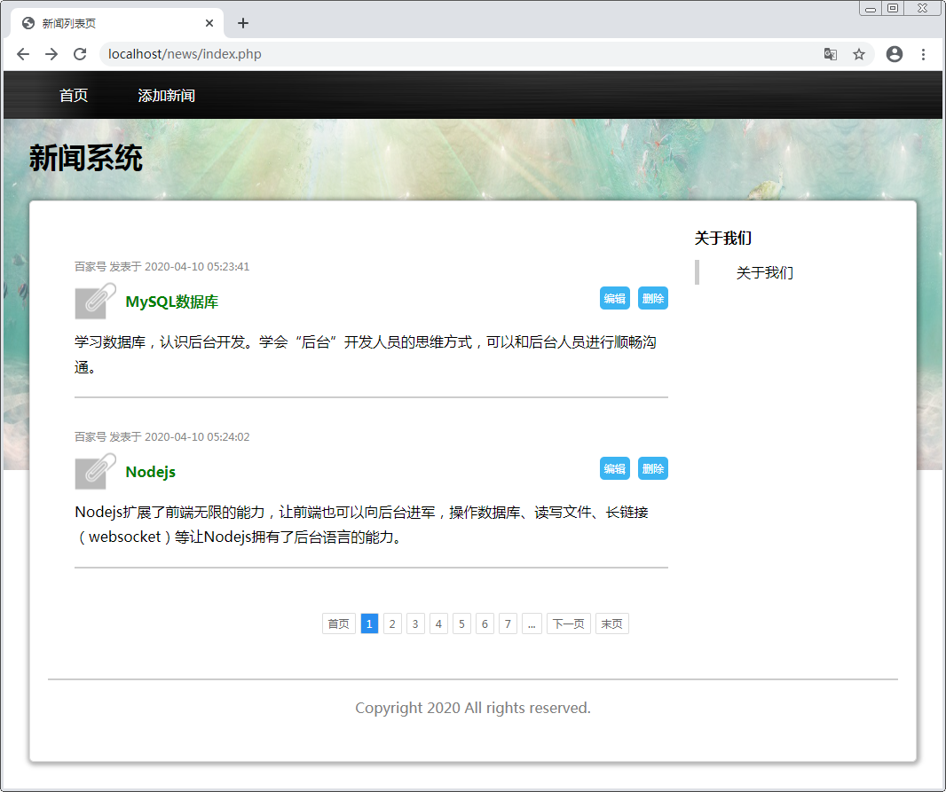
    - 编辑新闻
修改index.html，给“编辑”按钮添加链接：
<a href="edit.php?id=<?php echo $n['id'];?>">编辑</a>

创建edit.php。
<?php
$id = $_GET['id'] ?? 0;
if (!$id) {
header("Refresh:3;url={$_SERVER['HTTP_REFERER']}");
echo '当前要编辑的新闻不存在！';
exit;
}
include 'sql.php';
$conn = connect('root','123456','news',$error);
if(!$conn) {
header("Refresh:3;url=index.php");
echo $error;
exit;
}
$news = auto_read($conn,'news',$error,['id' => $id]);
if(!$news){
header("Refresh:3;url=index.php");
echo '当前要编辑的新闻不存在！';
exit;
}
include 'edit.html';

创建edit.html。

<!DOCTYPE html>
<html lang="en">
<head>
<meta charset="UTF-8">
<title>新闻修改页</title>
<link rel="stylesheet" href="css/bootstrap.min.css">
<link rel="stylesheet" href="css/index.css">
</head>
<body>
<nav class="navbar">
<div class="container navbar-content">
<a href="index.php">首页</a>
<a href="add.php">添加新闻</a>
</div>
</nav>
<img src="images/bg.jpg" class="index-bg">
<div class="container">
<div class="add-news col-md-8 col-md-offset-2">
<h1>修改新闻</h1>
<form action="update.php" method="post">
<input type="hidden" name="id" value="<?php echo $news['id'];?>">
<div class="form-group">
<label for="news_title">新闻标题</label>
<input type="text" name="title" class="form-control" id='news_title' value='<?php echo $news['title'];?>'>
</div>
<div class="form-group">
<label for="news_content">新闻内容</label>
<textarea class="form-control" name="content" rows="12"><?php echo $news['content'];?></textarea>
</div>
<button class="btn btn-danger btn-block">修改</button>
</form>
</div>
<footer class="copyright" style='border-top: none;'>Copyright 2020 All rights reserved.</footer>
</div>
</body>
</html>

页面效果：
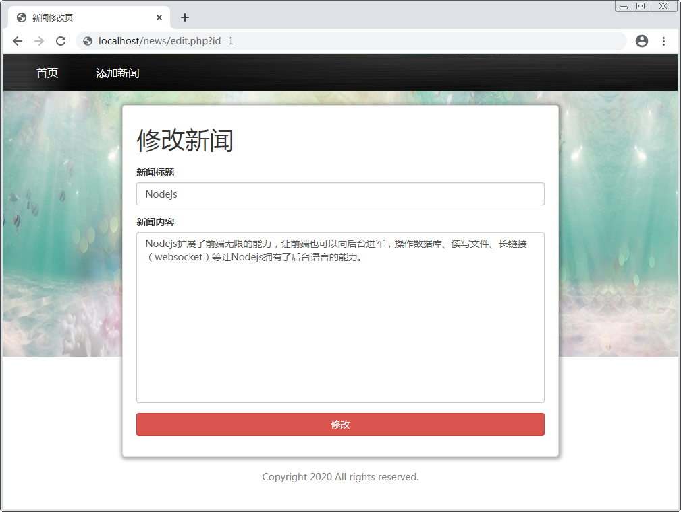

创建update.php，接收编辑后的新闻表单信息。
<?php
$id = $_POST['id'];
$data['title'] = $_POST['title'] ?? '';
$data['content']= $_POST['content'] ?? '';
if(empty($data['title']) || empty($data['content'])){
header('Refresh:3;url=edit.php?id=' . $id);
echo '标题和内容都不能为空！';
exit;
}
include 'sql.php';
$conn = connect('root','root','news',$error);
if(!$conn) {
header("Refresh:3;url=index.php");
echo $error;
exit;
}
$res = auto_update($conn,$data,'news',$error,$id);
if($res){
header('Refresh:3;url=detail.php?id='.$id);
echo '更新成功！';
exit;
}else{
header('Refresh:3;url=index.php');
echo '没有要更新的数据！';
exit;
}
    - 删除新闻
修改index.html，给“删除”按钮添加链接：
<a href="delete.php?id=<?php echo $n['id'];?>" onclick="return
confirm('你确认要删除新闻：<?php echo $n['title'];?> 吗?')">删除</a>

创建delete.php。
<?php
$id = $_GET['id'] ?? 0;
if(!$id){
header('Refresh:3;url=index.php');
echo '当前要删除的新闻不存在！';
exit;
}
include 'sql.php';
$conn = connect('root','root','news',$error);
if(!$conn) {
header("Refresh:3;url=index.php");
echo $error;
exit;
}
$sql = "delete from news where id = {$id}";
$res = query($conn,$sql,$error);
if(!$res){
header("Refresh:3;url=index.php");
echo $error;
exit;
}
if(mysqli_affected_rows($conn)){
header("Refresh:3;url=index.php");
echo '删除成功！';
exit;
}else{
header("Refresh:3;url=index.php");
echo '删除失败！';
exit;
}

    - 查看新闻
修改index.html，给新闻标题添加链接：
<a href="detail.php?id=<?php echo $n['id'];?>"><?php echo $n['title'];?></a>

创建detail.php。
<?php
header('Content-type:text/html;charset=utf-8');
$id = $_GET['id'] ?? 0;
if(!$id){
header('Refresh:3;url=index.php');
echo '非法访问！';
exit;
}
include 'Sql.php';
$conn = connect('root','123456','news',$error);
if(!$conn){
header('Refresh:3;url=index.php');
echo $error;
exit;
}
$sql = "select n.*,a.name from news n left join author a on n.a_id = a.id where n.id = {$id}";
$news = read($conn,$sql,$error);
if(!$news){
header('Refresh:3;url=index.php');
echo '您所访问的新闻不存在！';
exit;
}
include 'detail.html';

页面效果：
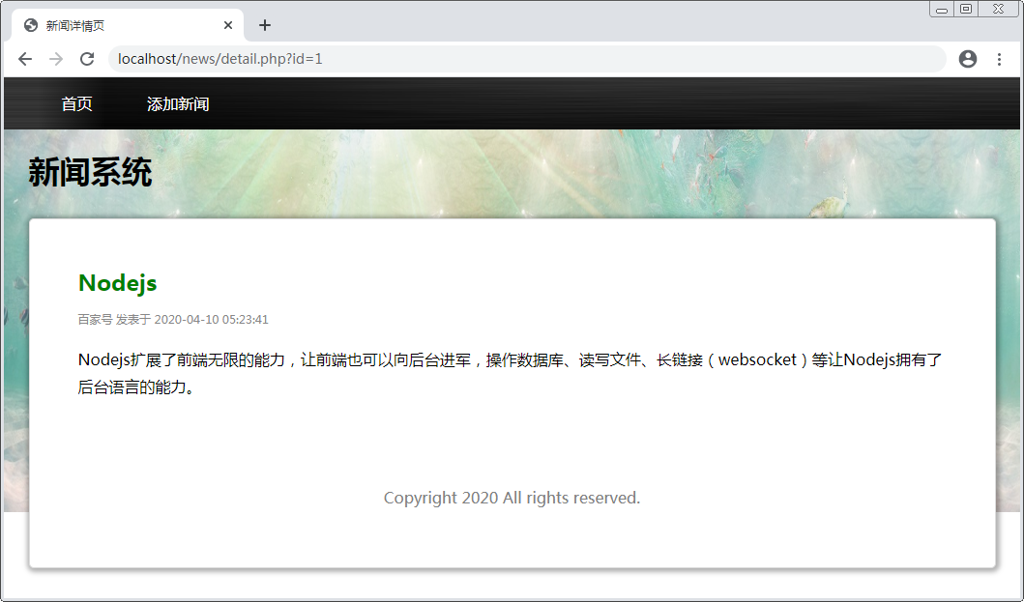
    - 分页查询
修改index.php，使用分页方法查询新闻。
$page = $_GET['page'] ?? 1;
$pagecount = 2;
include 'Sql.php';
$conn = connect('root','123456','news',$error);
if(!$conn) die($error);
$count_sql = 'select count(*) as total from news';
$res = read($conn,$count_sql,$error); # 执行
$count = $res['total'] ?? 0; # 取出记录（如果没有那就是0）
$pages = ceil($count / $pagecount); # 总页数
$offset = ($page - 1) * $pagecount;
$limit = " limit $offset,$pagecount";
$sql = "select n.*,a.name from news n left join author a on n.a_id = a.id order by n.id " . $limit;
$news = read($conn,$sql,$error,true);
$pageinfo = '';
$pageinfo .= "<a href='index.php?page=1'>首页</a>";
if($page != 1) {
$prev = $page - 1;
$pageinfo .= "<a href='index.php?page={$prev}'>上一页</a>";
}
if($pages <= 7){
for($i = 1;$i <= $pages;$i++){
if($page == $i) $pageinfo .= "<a class='current' href='index.php?page={$i}'>{$i}</a>";
else $pageinfo .= "<a href='index.php?page={$i}'>{$i}</a>";
}
}else{
if($page <= 5){
for($i = 1;$i <= 7;$i++){
if($page == $i) $pageinfo .= "<a class='current' href='index.php?page={$i}'>{$i}</a>";
else $pageinfo .= "<a href='index.php?page={$i}'>{$i}</a>";
}
$pageinfo .= "<a href ='javascript:return false;' onclick='return false;'>...</a>";
}else{
$pageinfo .= "<a href='index.php?page=1'>1</a>";
$pageinfo .= "<a href='index.php?page=2'>2</a>";
$pageinfo .= "<a href ='javascript:return false;' onclick='return false;'>...</a>";
if($page > $pages - 3){
for($i = $pages - 4;$i <= $pages;$i++){
if($page == $i) $pageinfo .= "<a class='current' href='index.php?page={$i}'>{$i}</a>";
else $pageinfo .= "<a href='index.php?page={$i}'>{$i}</a>";
}
}else{
for($i = $page - 2;$i <= $page + 2;$i++){
if($page == $i) $pageinfo .= "<a class='current' href='index.php?page={$i}'>{$i}</a>";
else $pageinfo .= "<a href='index.php?page={$i}'>{$i}</a>";
}
$pageinfo .= "<a href ='javascript:return false;' onclick='return false;'>...</a>";
}
}
}
if($page != $pages){
$next = $page + 1;
$pageinfo .= "<a href='index.php?page={$next}'>下一页</a>";
}
$pageinfo .= "<a href='index.php?page={$pages}'>末页</a>";

修改index.html，显示分页。
<div class="page">
<?php echo $pageinfo;?>
</div>

