博客管理系统（下）
  - 用户管理功能

添加用户
在sidebar.html中，给添加用户标签增加链接。

<li>
<a href="index.php?p=admin&c=user&a=add">
<img width="16" height="16" alt="icon"
src="{P}/img/icons/sidemenu/user_add.png" />添加用户
</a>
</li>

创建app\admin\controller\UserController.php，在控制器中创建add()方法。

<?php
namespace admin\controller;
use \core\Controller;

class UserController extends Controller
{
public function add()
{
$this->display('add.html');
}
}

创建视图文件app\admin\view\user\add.html。

<!DOCTYPE html>
<html>
<head>
<meta http-equiv="Content-Type" content="text/html; charset=utf-8" />
<title>添加用户</title>
<link rel="stylesheet" type="text/css" href="{P}/css/app.css" />
<script type="text/javascript" src="{P}/js/app.js"></script>
</head>
<body>
<div class="wrapper">
{include file='../public/header.html'}
<div id="main">
{include file="../public/sidebar.html"}
<div id="page">
<div class="page-title">
<div class="in">
<div class="titlebar"><h2>用户管理</h2><p>添加用户</p></div>
<div class="clear"></div>
</div>
</div>
<div class="content">
<div class="simplebox grid740" style="z-index: 720;">
<div class="titleh" style="z-index: 710;">
<h3>添加用户</h3>
</div>
<div class="body" style="z-index: 690;">
<!-- 添加用户表单 -->
</div>
</div>
</div>
</div>
<div class="clear"></div>
</div>
{include file="../public/footer.html"}
</div>
</body>
</html>

在add.html添加用户的表单：

<form id="form2" name="form2" method="post"
action="index.php?p=admin&c=user&a=insert">
<div class="st-form-line" style="z-index: 680;">
<span class="st-labeltext">用户名</span>
<input name="u_username" type="text" class="st-forminput"
style="width:510px" value="">
<div class="clear" style="z-index: 670;"></div>
</div>
<div class="st-form-line" style="z-index: 680;">
<span class="st-labeltext">密码</span>
<input name="u_password" type="text" class="st-forminput"
style="width:510px" value="">
<div class="clear" style="z-index: 670;"></div>
</div>
<div class="st-form-line" style="z-index: 680;">
<span class="st-labeltext">角色</span>
<label class="margin-right10"><input type="radio" value="0" checked
name="u_is_admin" class="uniform"/> 普通用户</label>
<label class="margin-right10"><input type="radio" value="1"
name="u_is_admin" class="uniform"/> 管理员</label>
<div class="clear" style="z-index: 670;"></div>
</div>
<div class="button-box" style="z-index: 460;">
<input type="submit" id="button" value="提交" class="st-button">
</div>
</form>

添加用户页面效果图：
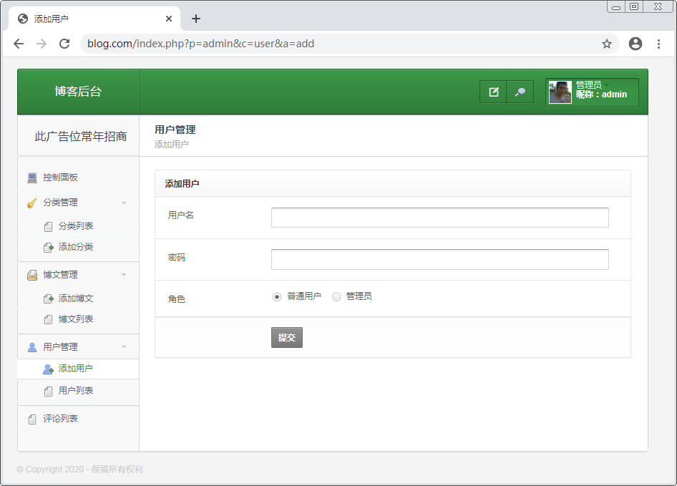

在UserController中编写insert()方法。

public function insert()
{
$data = $_POST;
if(empty(trim($data['u_username']))||empty(trim($data['u_password']
))){
$this->error('用户名和密码都不能为空！', '', '', 'add');
}
$userModel = new \admin\model\UserModel();
if($userModel->checkUsername($data['u_username'])){
$this->error('当前用户名：' . $data['u_username'] . ' 已经存在！', '',
'','add');
}
$data['u_regtime'] = time();
$data['u_password'] = md5($data['u_password']);
if($userModel->autoInsert($data)){
$this->success('用户新增成功！', '', '', 'index');
}else{
$this->error('用户新增失败！', '', '', 'add');
}
}

在UserModel.php中添加checkUsername()方法。

public function checkUsername($username)
{
$sql = "select id from {$this->getTable()}
where u_username = '{$username}'";
return $this->query($sql);
}

通过浏览器访问测试，观察添加用户功能是否可以正确执行。

用户列表
在sidebar.html中，给用户列表添加链接。

<li>
<a href="index.php?p=admin&c=user">
<img width="16" height="16" alt="icon"
src="{P}/img/icons/sidemenu/file.png"/>用户列表
</a>
</li>

在UserController中编写index()方法。

public function index()
{
$userModel = new \admin\model\UserModel();
$users = $userModel->getAllUsers();
$this->assign('users',$users);
$this->display('index.html');
}

在UserModel中添加getAllUsers()方法。

public function getAllUsers($pagecount = 5,$page = 1)
{
$offset = ($page - 1) * $pagecount;
$sql = "select id,u_username,u_is_admin,u_regtime from
{$this->getTable()} order by u_regtime desc
limit {$offset},{$pagecount}";
return $this->query($sql,true);
}

创建视图文件app\admin\view\user\index.html。

<!DOCTYPE html>
<html>
<head>
<meta http-equiv="Content-Type" content="text/html; charset=utf-8" />
<title>用户列表</title>
<link rel="stylesheet" type="text/css" href="{P}/css/app.css" />
<script type="text/javascript" src="{P}/js/app.js"></script>
</head>
<body>
<div class="wrapper">
{include file='../public/header.html'}
<div id="main">
{include file="../public/sidebar.html"}
<div id="page">
<div class="page-title">
<div class="in">
<div class="titlebar"><h2>用户管理</h2><p>用户列表</p></div>
<div class="clear"></div>
</div>
</div>
<div class="content">
<div class="simplebox grid740">
<div class="titleh"><h3>用户列表</h3></div>
<table id="myTable" class="tablesorter">
<thead>
<tr>
<th>#ID</th><th>用户名</th>
<th>角色</th><th>注册时间</th><th>操作</th>
</tr>
</thead>
<tbody><!-- 用户列表 --></tbody>
</table>
<!-- 分页 -->
</div>
</div>
</div>
<div class="clear"></div>
</div>
{include file="../public/footer.html"}
</div>
</body>
</html>

用户列表：

{foreach $users as $user}
<tr>
<td>{$user@key + 1}</td>
<td>{$user.u_username}</td>
<td>{if $user.u_is_admin}管理员{else}普通用户{/if}</td>
<td>{date('Y-m-d H:i:s',$user.u_regtime)}</td>
<td><a href="">删除</a></td>
</tr>
{/foreach}

用户列表效果图：
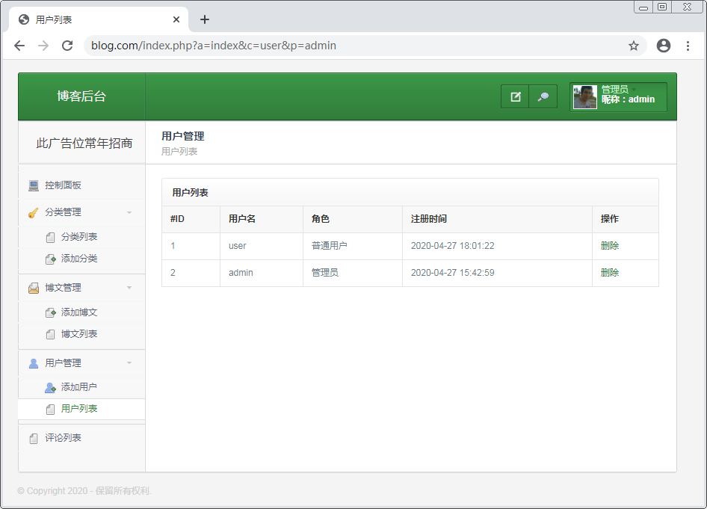

在UserController中的index()方法中接收页码和分页条数。

public function index()
{
$page = $_REQUEST['page'] ?? 1;
global $config;
$pagecount = $config['admin']['user_pagecount'] ?? 2;
……（原有代码）
}

在index()方法中，修改getAllUsers()方法，传入分页参数，在该方法后实现查询用户总数，调用分页类生成分页链接。

public function index()
{
$users = $userModel->getAllUsers($pagecount, $page);
$counts = $userModel->getCounts();
$cond = array('a'=>A,'c'=>C,'p'=>P);
$pagestr = \vendor\Page::clickPage(URL . 'index.php',$counts,
$pagecount,$page,$cond);
$this->assign('pagestr',$pagestr);
}

在index.html中显示分页链接。

<ul class="pagination">
{$pagestr}
</ul>

通过浏览器访问用户列表，查看分页功能是否可以正确运行。

删除用户
在用户列表页中给删除按钮添加链接。

<a href="index.php?p=admin&c=user&a=delete&id={$user.id}"
onclick="return confirm('确认删除当前用户：{$user.u_username}？')">删除</a>

在UserController中编写delete()方法。

public function delete()
{
$id = (int)$_GET['id'];
$userModel = new \admin\model\UserModel();
if($userModel->deleteById($id)){
$this->success('用户删除成功！', '', '', 'index');
}else{
$this->error('删除失败！', '', '', 'index');
}
}

  - 前台首页

博文首页
修改app\home\controller\IndexController.php中的index()方法。

public fuction index()
{
$category = new \home\model\CategoryModel();
$categories = $category->getAllCategories();
@session_start();
$_SESSION['category'] = $categories;
$article = new \home\model\ArticleModel();
$articles = $article->getAllArticles();
$this->assign('articles',$articles);
$this->display('index.html');
}

创建app\home\model\CategoryModel.php。

<?php
namespace home\model;
use core\Model;

class CategoryModel extends Model
{
protected $table = 'category';
public function getAllCategory()
{
$sql = "select * from {$this->getTable()} order by c_sort desc";
$category = $this->query($sql,true);
return $this->noLimitCategory($category);
}
public function noLimitCategory($category,$parent_id=0,$level=0)
{
static $list = array();
foreach ($category as $value) {
if($value['c_parent_id'] == $parent_id){
$value['level'] = $level;
$list[$value['id']] = $value;
$this->noLimitCategory($category,$value['id'],$level+1);
}
}
return $list;
}
}

创建app\home\model\ArticleModel.php。

<?php
namespace home\model;
use \core\Model;

class ArticleModel extends Model
{
protected $table = 'article';
public function getAllArticles($cond=array(), $pagecount=5, $page=1)
{
$offset = ($page - 1) * $pagecount;
$where = ' where a_is_delete = 0 and a_status = 2';
if(isset($cond['a_title'])) $where .= " and a_title like
'%{$cond['a_title']}%' ";
if(isset($cond['c_id'])) $where .= " and c_id = {$cond['c_id']}";
$sql = "select * from {$this->getTable()}
{$where} limit {$offset},{$pagecount}";
return $this->query($sql,true);
}
}

创建app\home\view\index\index.html。

<!DOCTYPE html>
<html>
<head>
<meta http-equiv="Content-Type" content="text/html; charset=utf-8"/>
<title>博文列表</title>
<link href="{P}/css/app.css" rel="stylesheet" media="screen">
<script src="{P}/js/vendor/modernizr.custom.js"></script>
<script src="{P}/js/vendor/detectizr.min.js"></script>
</head>
<body>
<div class="page-wrapper">
<div class="modal fade" id="loginModal" tabindex="-1" role="dialog">
<!-- 登录表单 -->
</div>
<div class="modal fade" id="registerModal" tabindex="-1"
role="dialog"><!-- 注册表单 -->
</div>
<!-- 导航栏 -->
<section class="page-title">
<div class="container">
<div class="inner">
<div class="column">
<div class="title"><h1>博文内容列表</h1></div>
</div>
<div class="column"></div>
</div>
</div>
</section>
<div class="container">
<div class="row">
<div class="col-lg-9 col-md-8">
<!-- 博文列表 -->
<!-- 分页 -->
</div>
<div class="col-lg-3 col-md-4">
<div class="space-top-2x visible-sm visible-xs"></div>
<aside class="sidebar">
<!-- 标题搜索框 -->
<!-- 博文分类 -- >
<!-- 最新博文 -->
</aside>
</div>
</div>
</div>
<a href="#" class="scroll-to-top-btn">
<i class="icon-arrow-up"></i>
</a>
<!-- footer -->
</div>
<!-- 静态资源文件 -->
</body>
</html>

导航栏：

<header class="navbar">
<div class="topbar">
<div class="container">
<a href="index.html" class="site-logo">博文前台</a>
<div class="nav-toggle"><span></span></div>
<div class="toolbar">
<a href="#" data-toggle="modal" data-target="#loginModal"
class="btn btn-sm btn-default btn-icon-right waves-effect
waves-light">立刻登录<i class="icon-head"></i>
</a>
</div>
</div>
</div>
</header>

footer：

<footer class="footer">
<div class="bottom-footer">
<div class="container">
<div class="copyright">
<div class="column">
<p>&copy; 2016. 保留所有权利。</p>
</div>
<div class="column"></div>
</div>
</div>
</div>
</footer>

静态资源文件：

<script src="{P}/js/vendor/jquery-2.1.4.min.js"></script>
<script src="{P}/js/vendor/bootstrap.min.js"></script>
<script src="{P}/js/vendor/waves.min.js"></script>
<script src="{P}/js/vendor/placeholder.js"></script>
<script src="{P}/js/vendor/waypoints.min.js"></script>
<script src="{P}/js/vendor/velocity.min.js"></script>
<script src="{P}/js/scripts.js"></script>

博文列表：

{foreach $articles as $art}
<article class="post-item">
<a href="index.php?a=detail&id={$art.id}" class="post-thumb
waves-effect">
<img src="{if $art.a_img}{URL}uploads/{$art.a_img}{else}{P}
/img/blog/post01.jpg{/if}">
</a>
<div class="post-body">
<div class="post-meta">
<div class="column">
<span>
<i class="icon-head"></i><a href="#">{$art.a_author}</a>
</span>
<span>在</span><span><i class="icon-ribbon"></i>
<a href="#">
{$smarty.session.category[$art.c_id].c_name}</a>
</span><span>下发布</span>
<span class="post-comments">
<i class="icon-speech-bubble"></i><a href="#">12</a>
</span>
</div>
<div class="column"><span>{date('Y-m-d',$art.a_time)}</span></div>
</div>
<h3 class="post-title">{$art.a_title}</h3>
<p>{$art.a_content}</p><a href="">点击阅读更多</a>
</div>
</article>
{/foreach}

首页效果图：

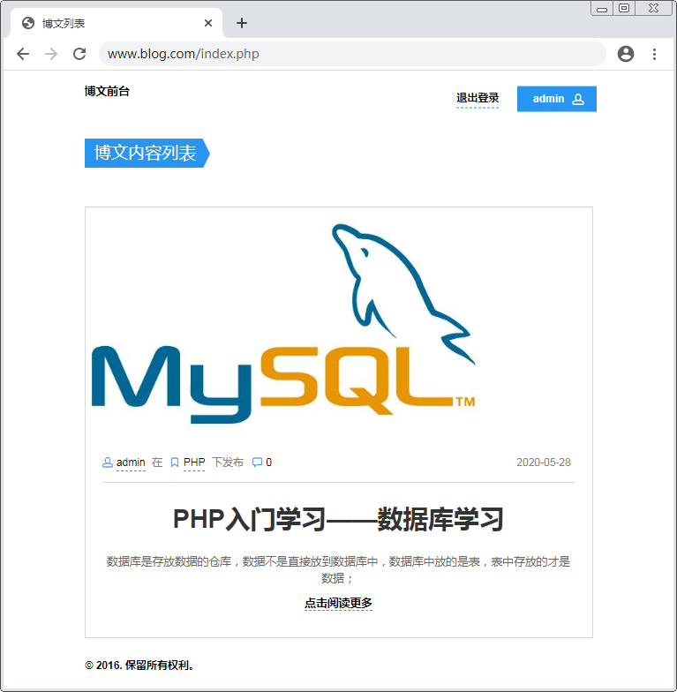

博文分类
在Index控制器的index()方法中添加获取分类下对应的博文数量。

$cate_counts = $article->getCountsByCategory();
$this->assign('cate_counts',$cate_counts);

在ArticleModel中添加getCountsByCategory()方法。

public function getCountsByCategory()
{
$sql = "select c_id,count(*) c from {$this->getTable()} where
a_is_delete = 0 and a_status = 2 group by c_id";
$res = $this->query($sql,true);
$list = array();
foreach($res as $v){
$list[$v['c_id']] = $v['c'];
}
return $list;
}

修改index.html，将查询的结果显示在页面中。

<section class="widget widget_categories">
<h3 class="widget-title"><i class="icon-ribbon"></i>分类</h3>
<ul>
{foreach $smarty.session.category as $val}
<li>
<a href="index.php?c_id={$val.id}">
{str_repeat('----',$val.level)}{$val.c_name}
<span>{$cate_counts[$val.id]|default:0}</span>
</a>
</li>
{/foreach}
</ul>
</section>

在Index控制器的index()方法中添加代码获取最新博文。

$news = $article->getNewsInfo();
$this->assign('news',$news);

在ArticleModel中添加getNewsInfo()方法。

public function getNewsInfo($limit = 3)
{
$sql = "select id,a_title,a_img_thumb from {$this->getTable()} where
a_is_delete = 0 order by a_time desc limit {$limit}";
return $this->query($sql,true);
}

修改index.html将查询的结果显示在页面中。

<section class="widget widget_recent_posts">
<h3 class="widget-title"><i class="icon-paper"></i>最新博文</h3>
{foreach $news as $new}
<div class="item">
<div class="thumb">
<a href="#">
<img src="{if $new.a_img_thumb}{URL}uploads/ {$new.a_img_thumb}
{else}{P}/img/blog/sidebar/post01.jpg{/if}" alt="Post01"></a>
</div>
<div class="info">
<h4>
<a href="#">{$new.a_title}</a>
</h4>
</div>
</div>
{/foreach}
</section>

首页右侧分类和最新文章效果图：
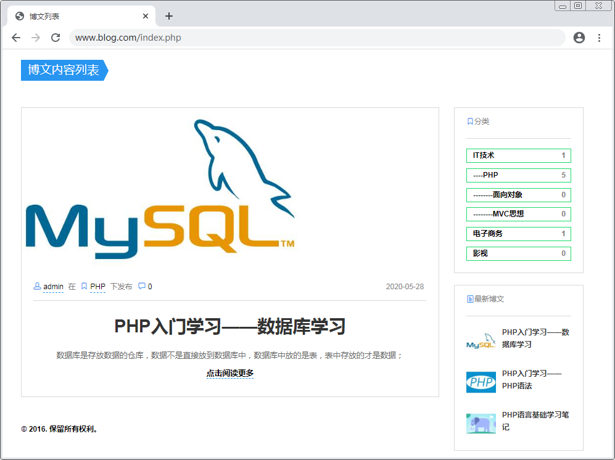

博文检索
在index.html中添加搜索框。

<section class="widget widget_search">
<form method="post" class="search-box">
<input type="text" class="form-control" name='a_title' placeholder="">
<button type="submit"><i class="icon-search"></i></button>
</form>
</section>

在IndexController中接收搜索的标题。

$cond = array();
if(isset($_GET['c_id']) && $_GET['c_id'] != 0) $cond['c_id'] =
(int)$_GET['c_id'];
if(isset($_REQUEST['a_title']) && !empty(trim($_REQUEST['a_title'])))
$cond['a_title'] = trim($_REQUEST['a_title']);

修改getAllArticles()方法，将搜索条件传入到该方法中，根据搜索条件查询博文数据。

$articles = $a->getAllArticles($cond);

将搜索条件的变量$cond发送到页面中，在页面显示用户搜索的标题。

$this->assign('cond',$cond);

在index.html中，找到搜索表单，设置<input>输入框的placeholder值。

<input type="text" class="form-control" name='a_title'
placeholder="{$cond['a_title']|default:''}">

在首页搜索博文标题，查看筛选后的博文数据是否正确。

博文分页
在IndexController的index()方法中接收分页信息。

$page = $_GET['page'] ?? 1;
global $config;
$pagecount = $config['home']['article_pagecount'] ?? 5;

修改getAllArticles()方法，传入$pagecount和$page两个参数。

$articles = $article->getAllArticles($cond,$pagecount,$page);

获取符合条件的总记录数。

$counts = $article->getCounts($cond);

在ArticleModel中添加getCount()方法，根据条件查询总记录数。

public function getCounts($cond = array())
{
$where = ' where a_is_delete = 0 and a_status = 2';
if(isset($cond['a_title']))
$where .= " and a_title like '%{$cond['a_title']}%' ";
if(isset($cond['c_id'])) $where .= " and c_id = {$cond['c_id']}";
$sql = "select count(*) c from {$this->getTable()} {$where}";
$res = $this->query($sql);
return $res['c'] ?? 0;
}

调用Page类，生成分页链接，将生成的链接发送到页面。

$pagestr = \vendor\Page::clickPage(URL . 'index.php',$counts,$pagecount,
$page,$cond);
$this->assign('pagestr',$pagestr);

在index.html中显示分页链接。

<ul class="pagination">
{$pagestr}
</ul>

  - 前台用户管理

用户登录
在index.html中添加登录表单。

<div class="modal-dialog">
<button type="button" class="close-btn" data-dismiss="modal"
aria-label="关闭"><span aria-hidden="true">&times;</span></button>
<div class="modal-content text-center">
<h4>登录</h4>
<form method="post" action="index.php?c=user&a=check">
<input type="username" name="u_username" class="form-control"
placeholder="请您填写用户名" required>
<input type="password" name="u_password" class="form-control"
placeholder="请您填写密码" required>
<div class="form-group">
<button class="btn login-btn btn-default waves-effect waves-light"
type="submit">立刻登录<i class="icon-head"></i></button>
</div>
<div class="text-left">
<span class="text-sm text-semibold">新用户?
<a href="#" data-toggle="modal" data-target="#registerModal">
立即注册</a>
</span>
</div>
</form>
</div>
</div>

创建app\home\controller\UserController.php文件。

<?php
namespace home\controller;
use core\Controller;

class UserController extends Controller
{
public function check()
{
$u_username = trim($_POST['u_username']);
$u_password = trim($_POST['u_password']);
if(empty($u_username) || empty($u_password)){
$this->error('用户名和密码都不能为空！', '', 'index','index');
}
$u = new \home\model\UserModel();
if(!$user = $u->checkUsername($u_username)){
$this->error('当前用户：' . $u_username . ' 不存在！','','index',
'index');
}
if(md5($u_password) !== $user['u_password']){
$this->error('密码错误！', '', 'index','index');
}
@session_start();
$_SESSION['user'] = $user;
$this->success('登录成功！', '', 'index','index');
}
}

创建app\home\model\UserModel.php。

<?php
namespace home\model;
use \core\Model;

class UserModel extends Model
{
protected $table = 'user';
public function checkUsername($username)
{
$username = addslashes($username);
$sql = "select * from {$this->getTable()}
where u_username = '{$username}'";
return $this->query($sql);
}
}

用户登录成功后跳转回首页，在首页中，对导航栏中的立刻登录按钮添加判断，如果用户已经登录，则显示登录的状态信息。

{if isset($smarty.session.user)}
<a href="#" class="text-sm">退出登录</a>
<a href="index.php?p=admin" class="btn btn-sm btn-default
btn-icon-right waves-effect waves-light">
{$smarty.session.user.u_username}<i class="icon-head"></i>
</a>
{else}
<a href="#" class="btn btn-sm btn-default btn-icon-right waves-effect
waves-light" data-toggle="modal" data-target="#loginModal">立刻登录
<i class="icon-head"></i>
</a>
{/if}

通过浏览器访问，测试用户登录功能，登录成功后页面导航栏的显示内容是否正确。

用户注册
在User控制器中添加captcha()方法。

public function captcha()
{
\vendor\Captcha::getCaptcha();
}

在index.html中添加注册表单。

<div class="modal-dialog">
<button type="button" class="close-btn" data-dismiss="modal"
aria-label="关闭"><span aria-hidden="true">&times;</span></button>
<div class="modal-content text-center">
<h4>注册</h4>
<form method="post" action="index.php?c=user&a=register">
<input name="u_username" type="text" class="form-control"
placeholder="请您填写用户名" required>
<input name="u_password" type="password" class="form-control"
placeholder="请您填写密码" required>
<div class="form-group">
<img src="index.php?c=user&a=captcha" width="300px" height="60px"
onclick="this.src='index.php?c=user&a=captcha&'+Math.random()">
</div>
<input name="captcha" type="text" class="form-control"
placeholder="请您填写验证码" required>
<div class="form-group">
<button type="submit" class="btn login-btn btn-default waves-effect
waves-light">立刻注册<i class="icon-head"></i></button>
</div>
<div class="text-left">
<span class="text-sm text-semibold">已注册?
<a href="#" data-toggle="modal" data-target="#loginModal">立即登录
</a></span>
</div>
</form>
</div>
</div>

在User控制器中添加register()方法。

public function register()
{
$data['u_username'] = trim($_POST['u_username']);
$data['u_password'] = trim($_POST['u_password']);
$captcha = trim($_POST['captcha']);
if(empty($captcha)){
$this->error('验证码不能为空！', '', 'inde','index');
}
if(empty($data['u_username']) || empty($data['u_password'])){
$this->back('用户名和密码都不能为空！');
}
if(!\vendor\Captcha::checkCaptcha($captcha)){
$this->back('验证码错误！');
}
$u = new \home\model\UserModel();
if($u->checkUsername($data['u_username'])){
$this->back('用户名：' . $data['u_username'] . ' 已经存在！');
}
$data['u_regtime'] = time();
if($u->autoInsert($data)){
$this->success('用户注册成功！', '', 'index','index');
}else{
$this->error('用户注册失败！', '', 'index','index');
}
}

退出登录
给退出登录按钮添加链接。

<a href="index.php?c=user&a=logout" class="text-sm">退出登录</a>

在UserController中创建logout()方法。

public function logout()
{
@session_start();
session_destroy();
$this->success('欢迎下次登录系统！', '', 'index','index');
}

  - 博文展示
在index.html中找到输出博文列表的{foreach}语句，给“点击阅读更多”按钮添加链接。

<a href="index.php?a=detail&id={$art.id}">点击阅读更多</a>

在Index控制器中创建detail()方法。

public function detail()
{
$id = (int)$_GET['id'];
$articleModel = new \home\model\ArticleModel();
$article = $articleModel->getById($id);
@session_start();
if(!isset($_SESSION['category'])){
$categoryModel = new \home\model\CategoryModel();
$category = $categoryModel->getAllCategory();
$_SESSION['category'] = $category;
}
$this->assign('article',$article);
$this->display('detail.html');
}

创建app\home\view\index\detail.html。

<!DOCTYPE html>
<html>
<head>
<title>博文内容</title>
<meta http-equiv="Content-Type" content="text/html;charset=utf-8"/>
<link href="{P}/css/app.css" rel="stylesheet" media="screen">
<script src="{P}/js/vendor/modernizr.custom.js"></script>
<script src="{P}/js/vendor/detectizr.min.js"></script>
</head>
<body>
<div class="page-wrapper">
<!-- 导航栏 -->
<section class="page-title">
<div class="container">
<div class="inner">
<div class="column">
<div class="title"><h1>博文内容</h1></div>
</div>
<div class="column"></div>
</div>
</div>
</section>
<div class="container">
<div class="row">
<!-- 博文详细内容 -->
<!-- 评论模块 -->
<a href="#" class="scroll-to-top-btn">
<i class="icon-arrow-up"></i>
</a>
<!-- footer -->
</div>
</div>
</div>
</body>
<!-- 引入静态资源 -->
</html>

导航栏：

<header class="navbar">
<div class="topbar">
<div class="container">
<a href="index.php" class="site-logo">博文前台</a>
</div>
</div>
</header>

博文详细内容：

<div class="col-lg-10 col-lg-offset-1">
<h1>{$article.a_title}</h1>
<div class="post-meta">
<div class="column">
<span>
<i class="icon-head"></i><a href="#">{$article.a_author}</a>
</span><span>在</span>
<span><i class="icon-ribbon"></i>
<a href="#">{$smarty.session.category[$article.c_id].c_name}</a>
</span><span>下发布</span>
<span class="post-comments">
<i class="icon-speech-bubble"></i><a href="#">12</a>
</span>
</div>
<div class="column"><span>{date('Y m d',$article.a_time)}</span></div>
</div>
{if $article.a_img}
<img src="{URL}uploads/{$article.a_img}" alt="Image">
{/if}
<p>{$article.a_content}</p>
<div class="column"></div>
</div>
<div class="post-tools space-top-2x"><!-- 点赞模块 --></div>

footer：

<footer class="footer">
<div class="bottom-footer">
<div class="container">
<div class="copyright">
<div class="column"><p>&copy; 2016. 保留所有权利。</p></div>
<div class="column"></div>
</div>
</div>
</div>
</footer>

静态资源文件：

<script src="js/vendor/jquery-2.1.4.min.js"></script>
<script src="js/vendor/bootstrap.min.js"></script>
<script src="js/vendor/waves.min.js"></script>
<script src="js/vendor/placeholder.js"></script>
<script src="js/vendor/waypoints.min.js"></script>
<script src="js/vendor/velocity.min.js"></script>
<script src="js/scripts.js"></script>

在index.html中找到最新博文的标题，给标题添加链接。

<a href="index.php?a=detail&id={$new.id}">{$new.a_title}</a>

  - 评论管理

数据表设计
评论表的SQL语句：

mysql>CREATE TABLE `b_comment`(
`id` INT UNSIGNED PRIMARY KEY AUTO_INCREMENT,
`c_comment` VARCHAR(50) NOT NULL COMMENT '评论内容',
`c_time` INT UNSIGNED NOT NULL COMMENT '评论时间',
`u_id` INT UNSIGNED NOT NULL COMMENT '用户id',
`a_id` INT UNSIGNED NOT NULL COMMENT '博文id'
) DEFAULT CHARSET=utf8;

创建评论表对应的模型文件app\home\model\CommentModel.php。

<?php
namespace home\model;
use core\Model;

class CommentModel extends Model
{
protected $table = 'comment';
}

发表评论
在detail.html页面中添加评论模块。

<div class="comments-area space-top-3x">
<!-- 评论列表 -->
<div class="comment-respond">
<h4 class="comment-reply-title">发布新评论</h4>
<!-- 发表评论表单 -->
</div>
</div>

发表评论的表单：

<form method="post" id="comment-form" class="comment-form"
action="index.php?c=comment&a=insert">
<input type="hidden" name="a_id" value="{$article.id}">
<div class="form-group">
<label for="cf_comment" class="sr-only">Comment</label>
<textarea name="c_comment" id="cf_comment" class="form-control
input-alt" rows="7" placeholder="输入您的评论"></textarea>
</div>
<p class="form-submit">
{if isset($smarty.session.user)}
<input name="submit" type="submit" id="submit" class="btn
btn-primary btn-block" value="发布">
{else}
<input type="button" onclick="JavaScript:return false" class="btn
btn-primary btn-block" value="请先登录">
{/if}
</p>
</form>

创建app\home\controller\CommentController.php，在控制器中创建insert()方法。

<?php
namespace home\controller;
use \core\Controller;

class CommentController extends Controller{
public function insert()
{
$data['a_id'] = (int)$_POST['a_id'];
$data['c_comment'] = trim($_POST['c_comment']);
if(empty($data['c_comment'])){
$this->back('评论不能为空！');
}
@session_start();
$data['u_id'] = $_SESSION['user']['id'];
$data['c_time'] = time();
$c = new \home\model\CommentModel();
if($c->autoInsert($data)){
$this->back('评论成功！');
}else{
$this->back('评论失败！');
}
}
}

显示评论
在IndexController的detail()方法中获取评论列表。

public function detail()
{
……（原有代码）
$c = new \home\model\CommentModel();
$comments = $c->getCommentsByArticle($id);
$this->assign('comments',$comments);
……（原有代码）
}

在CommentModel中添加getCommentsByArticle()方法。

public function getCommentsByArticle($a_id)
{
$sql = "select c.*,u.u_username from {$this->getTable()} c left join
{$this->getTable('user')} u on c.u_id = u.id where c.a_id = {$a_id}
order by c.c_time desc";
return $this->query($sql,true);
}

在detail.html中通过{foreach}输出评论列表。

<h4 class="comments-count">共有{count($comments)}条评论</h4>
{foreach $comments as $c}
<div class="comment">
<div class="comment-meta">
<div class="column">
<span class="comment-autor">
<i class="icon-head"></i><a href="#">{$c.u_username}</a>
</span>
</div>
<div class="column">
<span class="comment-date">{date('d.m.Y',$c.c_time)}</span>
</div>
</div>
<div class="comment-body"><p>{$c.c_comment}</p></div>
</div>
{/foreach}

显示评论数量
修改app\home\model\ArticleModel.php中的getAllArticles()方法。

$sql = "select a.*,c.c_count from {$this->getTable()} a
left join (select a_id,count(*) c_count from {$this->getTable('comment')}
group by a_id) c on a.id = c.a_id
{$where} limit {$offset},{$pagecount}";

修改index.html，在{foreach}标签中将评论数量“12”替换为查询出来的数据。

<a href="#">{$art.c_count|default:0}</a>

修改detail.html，在博文的发布时间前显示博文的评论数量。

<a href="#">{count($comments)}</a>

通过浏览器访问博文列表页和详细页，查看评论数量显示是否正确。

  - 后台评论管理

显示评论
在app\admin\view\public\sidebar.html页面中，给评论列表添加链接。

<li>
<a href="index.php?p=admin&c=comment">
<img width="16" height="16" alt="icon"
src="{P}/img/icons/sidemenu/file.png"/>评论列表
</a>
</li>

创建app\admin\controller\CommentController.php文件。

<?php
namespace admin\controller;
use \core\Controller;

class CommentController extends Controller
{
public function index()
{
$commentModel = new \admin\model\CommentModel();
$comments = $commentModel->getAllComments();
$this->assign('comments',$comments);
$this->display('index.html');
}
}

创建app\admin\model\CommentModel.php。

<?php
namespace admin\model;
use \core\Model;

class CommentModel extends Model
{
protected $table = 'comment';
public function getAllComments($pagecount = 5,$page = 1)
{
$offset = ($page - 1) * $pagecount;
$sql = "select c.*,u.u_username,a.a_title from {$this->getTable()}
c left join {$this->getTable('user')} u on c.u_id = u.id
left join {$this->getTable('article')} a on c.a_id = a.id
order by c.c_time desc,c.a_id desc limit {$offset},{$pagecount}";
return $this->query($sql,true);
}
}

创建视图文件app\admin\view\comment\index.html。

<!DOCTYPE html>
<html>
<head>
<meta http-equiv="Content-Type" content="text/html; charset=utf-8"/>
<title>评论列表</title>
<link rel="stylesheet" type="text/css" href="{P}/css/app.css" />
<script type="text/javascript" src="{P}/js/app.js"></script>
</head>
<body>
<div class="wrapper">
{include file='../public/header.html'}
<div id="main">
{include file="../public/sidebar.html"}
<div id="page">
<div class="page-title">
<div class="in">
<div class="titlebar"><h2>评论管理</h2><p>评论列表</p></div>
<div class="clear"></div>
</div>
</div>
<div class="content">
<div class="simplebox grid740">
<div class="titleh"><h3>评论列表</h3></div>
<table id="myTable" class="tablesorter">
<thead>
<tr>
<th>#ID</th><th>作者</th><th>内容</th>
<th>博文名</th><th>评论时间</th><th>操作</th>
</tr>
</thead>
<tbody><!-- 评论列表 --></tbody>
</table>
<!-- 分页 -->
</div>
</div>
</div>
<div class="clear"></div>
</div>
{include file="../public/footer.html"}
</div>
</body>
</html>

评论列表：

{foreach $comments as $c}
<tr>
<td>{$c.id}</td>
<td>{$c.u_username}</td>
<td>{$c.c_comment}</td>
<td>{$c.a_title}</td>
<td>{date('Y-m-d',$c.c_time)}</td>
<td><a href="">删除</a></td>
</tr>
{/foreach}

评论列表效果图：
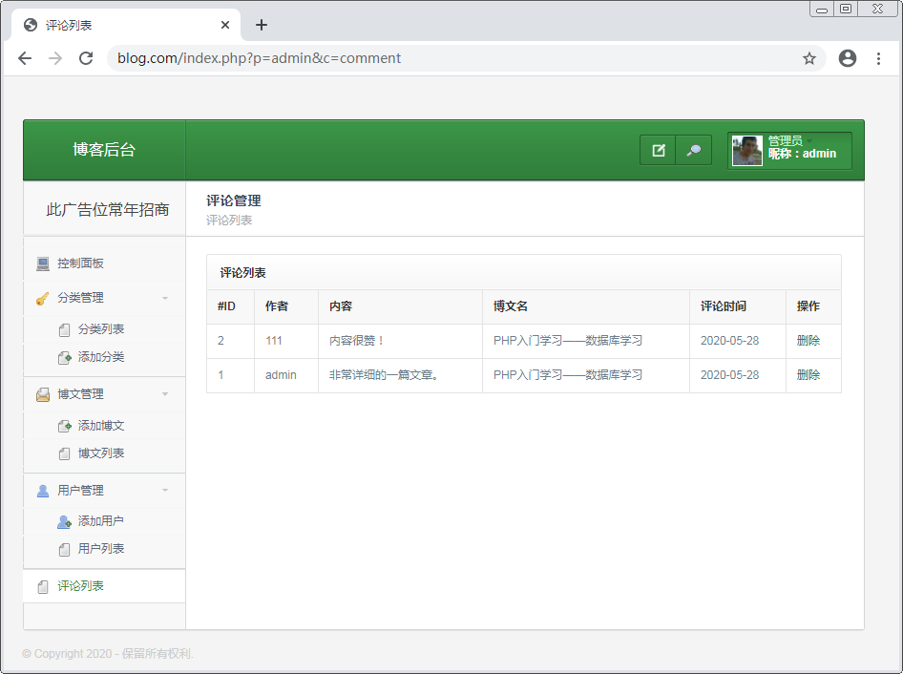

评论分页
修改CommentController.php的index()方法。

public function index()
{
$page = $_GET['page'] ?? 1;
global $config;
$pagecount = $config['admin']['comment_pagecount'] ?? 5;
$commentModel = new \admin\model\CommentModel();
$comments = $commentModel->getAllComments($pagecount, $page);
$counts = $commentModel->getCounts();
$cond = array('a'=>A,'c'=>C,'p'=>P);
$pagestr = \vendor\Page::clickPage(URL . 'index.php',$counts,
$pagecount,$page,$cond);
$this->assign('pagestr',$pagestr);
$this->assign('comments',$comments);
$this->display('index.html');
}

在CommentModel.php中添加getCount()方法获取总记录数。

public function getCounts()
{
$sql = "select count(*) c from {$this->getTable()}";
$res = $this->query($sql);
return $res['c'] ?? 0;
}

在index.html中显示分页链接。

<ul class="pagination">
{$pagestr}
</ul>

删除评论
在index.html中给删除按钮添加链接。

<a href="index.php?p=admin&c=comment&a=delete&id={$c.id}"
onclick="return confirm('确认删除当前评论？')">删除</a>

在CommentController.php中添加delete()方法。

public function delete()
{
$id = (int)$_GET['id'];
$commentModel = new \admin\model\CommentModel();
if($commentModel->deleteById($id)){
$this->success('评论删除成功！','index');
}else{
$this->error('评论删除失败！','index');
}
}

通过浏览器访问测试，观察是否可以删除评论。

