新概念英语第四册课后题答案
李延隆

答案具体的解释可以参考外研社的《新概念英语练习详解4》,四册课后题比较简单，课上时间有限，除个别题外我就不专门在课上讲解了。

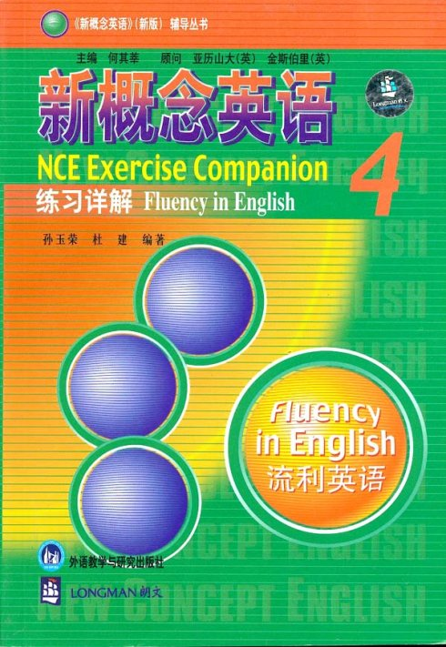

Lesson 1 CABDD BDAAC AB
Lesson 2 BCBDC ACAAD BC
Lesson 3 CABDA CDABA CD
Lesson 4 ACCAB BCDAA BD
Lesson 5 CABAB DACBB DD
Lesson 6 CACCC AAADB AA
Lesson 7 DCABA BACDA AC
Lesson 8 BDABD BAABC BC
Lesson 9 CDBAA CABAC AD
Lesson 10 CAABD CBBDC AA
Lesson 11 AABDD DADDB DD
Lesson 12 CABAC CDACA AB
Lesson 13 ACDAC BDABC AD
Lesson 14 DBDCC ACCBD BD
Lesson 15 CADCD DBACA CA
Lesson 16 ABCCA DDBAB AC
Lesson 17 BBADA BBDCD CA
Lesson 18 BABCD CDCCC BA
Lesson 19 BBCAD AABDD BC
Lesson 20 BCADC CCBDB CA
Lesson 21 BDBBA ADDAB CA
Lesson 22 CDACB ADBCD AB
Lesson 23 CADCC DCABC AC
Lesson 24 AACCB CADDA CD
Lesson 25 DBADD CACDB CA
Lesson 26 CBCBA CDDAB AC
Lesson 27 BCDCC ACCDD DA
Lesson 28 ADCDA BCADA BD
Lesson 29 CCADD CCADA BC
Lesson 30 CABDD BCCAC DC
Lesson 31 AABAD BADDC BD
Lesson 32 BDCBA DBDCA BC
Lesson 33 BDBAD BCCDC BA
Lesson 34 DCACB DACDB CA
Lesson 35 CBCAC ABBDC CD
Lesson 36 ACBCC ACCDB AC
Lesson 37 CABAC DBCDC BD
Lesson 38 CAABB ACBDD AB
Lesson 39 BCADA BDDBD BC
Lesson 40 DCDAC ADDDA DB
Lesson 41 ACACD CBBBD BC
Lesson 42 BCCBD BDADC AC
Lesson 43 DBABC CDDAC BB
Lesson 44 AAAAB BBBDC BA
Lesson 45 CADAC CACDC DC
Lesson 46 BBDBD ABCDA BD
Lesson 47 CAADB CACDB BC
Lesson 48 CCBCC CCDBA AB

