实验六 前端框架的使用

**学号：3170913022 姓名：杨春发**

**【实验目的】**

1. 掌握JQuery语法的使用方法；
2. 熟悉bootstrap框架的基本语法，并能够阅读相关代码；
3. 能够熟练阅读基于bootstrap和JQuery框架的源代码；
4. 能够通过bootstrap和JQuery框架源码进行代码移植；
5. 熟练阅读Metronic框架源码并完成移植。

**【实验内容】**

**在【实验一、二、三、四、五】的代码基础上，进行改动**，要求：

1. 基于Metronic框架完成用户登录、用户管理、用户注册等页面或功能的移植；
2. JSP页面中只能用HTML、CSS和Javascript的代码，不能再使用JSP的标记或语法；
3. 调整相关功能的代码如增删改查功能，前端代码中使用基于Ajax的方法读写数据库数据。
4. 其他Servlet代码、JavScript代码需要进行相应调整。

**【实验程序】**

**1.login.js**

var handleLogin = function() {

if ($.cookie('Snumber')!=null) {

$('#Snumber').val($.cookie('Snumber'));

}

$('.login-form').validate({

errorElement : 'span', // default input error message container

errorClass : 'help-block', // default input error message class

focusInvalid : false, // do not focus the last invalid input

rules : {

Snumber : {

required : true,

minlength : 4,

maxlength : 16

},

password : {

required : true

},

remember : {

required : false

}

},

messages : {

Snumber : {

required : "Snumber is required.",

minlength : "最小长度为4",

maxlength : "最大长度为16"

},

password : {

required : "请输入密码"

}

},

invalidHandler : function(event, validator) { // display error alert

// on form submit

$('.alert-danger', $('.login-form')).show();

},

highlight : function(element) { // hightlight error inputs

$(element).closest('.form-group').addClass('has-error');

},

success : function(label) {

label.closest('.form-group').removeClass('has-error');

label.remove();

},

errorPlacement : function(error, element) {

error.insertAfter(element.closest('.input-icon'));

},

submitHandler : function(form) {

loginformsubmit();

}

});

$('.login-form input').keypress(function(e) {

if (e.which == 13) {

if ($('.login-form').validate().form()) {

$('.login-form').submit();

}

return false;

}

});

}

function loginformsubmit() {

if ($('#remember').is(':checked')) {

$.cookie('rememberme', 'true', {

expires : 7

});

$.cookie('Snumber', $('#Snumber').val(), {

expires : 7

});

} else {

$.cookie('rememberme', null);

}

// alert("Submitted");

var postData = $(".login-form").serialize();

//alert(postData);

$.get("LoginServlet?"+postData, function(data) {

alert(data);

if (data > 0) {

alert("登陆成功");

location.href = "Index.jsp";

} else {

// alert("登录失败");

location.href = "LoginResult.jsp";

}

});}

**2.loginservlet**

package cn.xaut.servlet;

import java.io.IOException;

import java.sql.ResultSet;

import java.sql.SQLException;

import javax.servlet.ServletException;

import javax.servlet.annotation.WebServlet;

//import javax.servlet.http.Cookie;

import javax.servlet.http.HttpServlet;

import javax.servlet.http.HttpServletRequest;

import javax.servlet.http.HttpServletResponse;

import javax.servlet.http.HttpSession;

import cn.xaut.db.ConnDB;

@WebServlet("/LoginServlet")

public class LoginServlet extends HttpServlet {

private static final long serialVersionUID = 1L;

/**

* @see HttpServlet#HttpServlet()

*/

public LoginServlet() {

super();

// TODO Auto-generated constructor stub

}

/**

* @see HttpServlet#doGet(HttpServletRequest request, HttpServletResponse

* response)

*/

protected void doGet(HttpServletRequest request, HttpServletResponse response)

throws ServletException, IOException {

// TODO Auto-generated method stub

// response.getWriter().append("Served at: ").append(request.getContextPath());

doPost(request, response);

}

/**

* @see HttpServlet#doPost(HttpServletRequest request, HttpServletResponse

* response)

*/

protected void doPost(HttpServletRequest request, HttpServletResponse response)

throws ServletException, IOException {

// TODO Auto-generated method stub

// doGet(request, response);

response.setCharacterEncoding("UTF-8");

String Snumber = request.getParameter("Snumber");

String password = request.getParameter("password");

String usertype = request.getParameter("radio2");

if (!"".equals(Snumber) && !"".equals(password)&& !"".equals(usertype)) {

try {

String sql = "select * from loginsheet where Snumber='" + Snumber + "' and password='"

+ password + "' and usertype='"+usertype+"'";

ResultSet rs = ConnDB.query(sql);

rs.last();

int rowCount = rs.getRow();

rs.close();

ConnDB.close();

if (rowCount > 0) {

HttpSession session = request.getSession();

session.setAttribute("Snumber", Snumber); }

response.getWriter().print(rowCount);

} catch (SQLException e) {

e.printStackTrace();

}

}

}

}

**3.regNew.jsp**

<!DOCTYPE html>

<html lang="en">

<head>

<meta charset="utf-8" />

<title>Register an account</title>

<meta http-equiv="X-UA-Compatible" content="IE=edge">

<meta content="width=device-width, initial-scale=1.0" name="viewport" />

<meta http-equiv="Content-type" content="text/html; charset=utf-8">

<meta content="" name="description" />

<meta content="" name="author" />

<!-- BEGIN GLOBAL MANDATORY STYLES -->

<link

href="http://fonts.googleapis.com/css?family=Open+Sans:400,300,600,700&subset=all"

rel="stylesheet" type="text/css" />

<link href="assets/global/plugins/font-awesome/css/font-awesome.min.css"

rel="stylesheet" type="text/css" />

<link

href="assets/global/plugins/simple-line-icons/simple-line-icons.min.css"

rel="stylesheet" type="text/css" />

<link href="assets/global/plugins/bootstrap/css/bootstrap.min.css"

rel="stylesheet" type="text/css" />

<link href="assets/global/plugins/uniform/css/uniform.default.css"

rel="stylesheet" type="text/css" />

<!-- END GLOBAL MANDATORY STYLES -->

<!-- BEGIN PAGE LEVEL STYLES -->

<link href="assets/admin/pages/css/login.css" rel="stylesheet"

type="text/css" />

<!-- END PAGE LEVEL SCRIPTS -->

<!-- BEGIN THEME STYLES -->

<link href="assets/global/css/components.css" id="style_components"

rel="stylesheet" type="text/css" />

<link href="assets/global/css/plugins.css" rel="stylesheet"

type="text/css" />

<link href="assets/admin/layout/css/layout.css" rel="stylesheet"

type="text/css" />

<link href="assets/admin/layout/css/themes/light.css" rel="stylesheet"

type="text/css" id="style_color" />

<link href="assets/admin/layout/css/custom.css" rel="stylesheet"

type="text/css" />

<!-- END THEME STYLES -->

<link rel="shortcut icon" href="favicon.ico" />

</head>

<!-- END HEAD -->

<!-- BEGIN BODY -->

<body class="login">

<!-- BEGIN SIDEBAR TOGGLER BUTTON -->

<div class="menu-toggler sidebar-toggler"></div>

<!-- END SIDEBAR TOGGLER BUTTON -->

<!-- BEGIN LOGO -->

<div class="logo">

<a href=""> <img src="assets/admin/layout/img/logo1.png" alt="" />

</a>

</div>

<!-- END LOGO -->

<!-- BEGIN LOGIN -->

<div class="content">

<!-- BEGIN REGISTRATION FORM -->

<form class="register-form" action="" method="post">

<h3>Sign Up</h3>

<div class="alert alert-danger display-hide">

<button class="close" data-close="alert"></button>

<span> Incorrect information! </span>

</div>

<p class="hint">Enter your personal details below:</p>

<div class="form-group">

<label class="control-label visible-ie8 visible-ie9">Full

Name</label> <input class="form-control placeholder-no-fix" type="text"

placeholder="Full Name" name="username" />

</div>

<div class="form-group">

<!--ie8, ie9 does not support html5 placeholder, so we just show field title for that-->

<label class="control-label visible-ie8 visible-ie9">mailbox</label>

<input class="form-control placeholder-no-fix" type="text"

placeholder="mailbox" name="mailbox" />

</div>

<div class="form-group">

<label class="control-label visible-ie8 visible-ie9">company</label>

<input class="form-control placeholder-no-fix" type="text"

placeholder="company" name="company" />

</div>

<div class="form-group">

<label class="control-label visible-ie8 visible-ie9">telephone</label>

<input class="form-control placeholder-no-fix" type="text"

placeholder="telephone" name="iphone" />

</div>

<div class="form-group">

<label class="control-label visible-ie8 visible-ie9">usertype</label>

<select name="usertype" class="form-control">

<option value="student">student</option>

<option value="teacher">teacher</option>

<option value="manager">manager</option>

</select>

</div>

<p class="hint">Enter your account details below:</p>

<div class="form-group">

<label class="control-label visible-ie8 visible-ie9">ID</label> <input

class="form-control placeholder-no-fix" type="text"

autocomplete="off" placeholder="Snumber" name="Snumber" />

</div>

<div class="form-group">

<label class="control-label visible-ie8 visible-ie9">Password</label>

<input class="form-control placeholder-no-fix" type="password"

autocomplete="off" id="password" placeholder="password"

name="password" />

</div>

<div class="form-group">

<label class="control-label visible-ie8 visible-ie9">Enter password again</label>

<input class="form-control placeholder-no-fix"

type="password" autocomplete="off" id="rpassword"

placeholder="Re-type Your Password" name="rpassword" />

</div>

<div class="form-group margin-top-20 margin-bottom-20">

<label class="check"> <input type="checkbox" name="tnc" />

I agree to the <a href="javascript:;"> Terms of Service </a> & <a

href="javascript:;"> Privacy Policy </a>

</label>

<div id="register_tnc_error"></div>

</div>

<div class="form-actions">

<button type="button" id="register-back-btn" class="btn btn-default"

onclick="window.location='LoginNew.jsp'">Back</button>

<button type="submit" id="register-submit-btn"

class="btn btn-success uppercase pull-right">Submit</button>

</div>

</form>

<!-- END REGISTRATION FORM -->

</div>

<div class="copyright">2014 © Metronic. Admin Dashboard Template.

</div>

<!-- END LOGIN -->

<script src="assets/global/plugins/jquery.min.js"

type="text/javascript"></script>

<script src="assets/global/plugins/jquery-migrate.min.js"

type="text/javascript"></script>

<script src="assets/global/plugins/bootstrap/js/bootstrap.min.js"

type="text/javascript"></script>

<script src="assets/global/plugins/jquery.blockui.min.js"

type="text/javascript"></script>

<script src="assets/global/plugins/jquery.cokie.min.js"

type="text/javascript"></script>

<script src="assets/global/plugins/uniform/jquery.uniform.min.js"

type="text/javascript"></script>

<!-- END CORE PLUGINS -->

<!-- BEGIN PAGE LEVEL PLUGINS -->

<script

src="assets/global/plugins/jquery-validation/js/jquery.validate.min.js"

type="text/javascript"></script>

<!-- END PAGE LEVEL PLUGINS -->

<!-- BEGIN PAGE LEVEL SCRIPTS -->

<script src="assets/global/scripts/metronic.js" type="text/javascript"></script>

<script src="assets/admin/layout/scripts/layout.js"

type="text/javascript"></script>

<script src="assets/admin/layout/scripts/demo.js"

type="text/javascript"></script>

<!-- END PAGE LEVEL SCRIPTS -->

</body>

<!-- END BODY -->

</html>

**4.re.js**

var handleregister = function() {

$('.register-form').validate({

errorElement : 'span', //default input error message container

errorClass : 'help-block', // default input error message class

focusInvalid : false, // do not focus the last invalid input

ignore : "",

rules : {

username : {

required : true

},

mailbox : {

required : true,

email : true

},

company : {

required : true

},

telephone : {

required : true,

isMobile :true

},

usertype : {

required : true

},

Snumber : {

required : true

},

password : {

required : true

},

rpassword : {

required : true,

equalTo : "#password"

},

tnc : {

required : true

}

},

messages : { // custom messages for radio buttons and checkboxes

username : {

required : "Format error"

},

Snumber : {

required : "Format error"

},

password : {

required : "Format error"

},

mailbox : {

required : "Format error"

},

telephone : {

required : "Format error"

},

company : {

required : "Format error"

},

rpassword : {

required : "The two passwords are inconsistent"

},

tnc : {

required : "Please accept TNC first."

}

},

invalidHandler : function(event, validator) { //display error alert on form submit

},

highlight : function(element) { // hightlight error inputs

$(element).closest('.form-group').addClass('has-error'); // set error class to the control group

},

success : function(label) {

label.closest('.form-group').removeClass('has-error');

label.remove();

},

errorPlacement : function(error, element) {

if (element.attr("name") == "tnc") { // insert checkbox errors after the container

error.insertAfter($('#register_tnc_error'));

} else if (element.closest('.input-icon').size() === 1) {

error.insertAfter(element.closest('.input-icon'));

} else {

error.insertAfter(element);

}

},

submitHandler : function(form) {

registerformsubmit();

}

});

$('.register-form input').keypress(function(e) {

if (e.which == 13) {

if ($('.register-form').validate().form()) {

registerformsubmit();

}

return false;

}

});

function registerformsubmit() {

var postData = $(".register-form").serialize();

$.get("RegServlet?" + postData, function(data) {

alert(data);

if (data > 0) {

alert("success");

location.href = "LoginNew.jsp";

} else {

alert("fail");

location.href = "LoginResult.jsp";

}

});

}

}

jQuery(document).ready(function() {

handleregister();

});

**5.manage.js**

function showuserlist() {

$('#userlistTable').DataTable( {

ajax: {

url: 'FindServlet',

dataSrc: ''

},

columns: [

{ data: 'id' },

{ data: 'username' },

{ data: 'usertype' },

{ data: 'usertrue' },

{ data: 'email' },

{ data: 'tel' },

{ data:'company' }

]

} );

}

function init(){

$.ajax({

url:'ShowAllServlet',

type:'post',

dataType:'json',

success:function(data){

$("#userbody").html("");

$.each(data,function(i,item){

var tr = "<tr class=\"\" >";

tr += "<td>" + (i+1) + "</td>";

tr += "<td>" + item.snumber + "</td>";

tr += "<td>" + item.username + "</td>";

tr += "<td>" + item.usertype + "</td>";

tr += "<td>" + item.iphone + "</td>";

tr += "<td>" + item.company + "</td>";

tr += "<td>" + item.emailbox + "</td>";

tr += "<td><a href='javacript:;' class='btn default btn-xs purple' onclick='OpenEditForm(this)'><i class='fa fa-edit'></i> 修改 </a></td>";

tr += "<td><a href='javacript:;' class='btn default btn-xs black' onclick='DeleteUser(this)' ><i class='fa fa-trash-o'></i> 删除 </a></td></td>";

tr += "</tr>";

//alert(item.snumber);

$("#userbody").append(tr);

})

}

})

}

var isAddOrEdit = "add";

function showusers() {

alert("123");

$("#userbody").html("");

$.getJSON("FindServlet?search="+$("#search").val(), function(data) {

$.each(data, function(i) {

// alert(this.id);

var tr = "<tr class=\"\" >";

//tr += "<td><div class=\"checker\"><span class=\"\"><input type=\"checkbox\" class=\"checkboxes\" value=\"1\"/></span></div></td>";

//tr += "<td><input type=\"checkbox\" class=\"checkboxes\" name=\"checkbox\" value='" + this.teacherId + "'/></td>";

tr += "<td>" + (i + 1) + "</td>";

tr += "<td>" + this.snumber + "</td>";

tr += "<td>" + this.username + "</td>";

tr += "<td>" + this.usertype + "</td>";

tr += "<td>" + this.iphone + "</td>";

tr += "<td>" + this.company + "</td>";

tr += "<td>" + this.emailbox + "</td>";

//alert(this.Snumber);

tr += "<td><a href='javascript:;' class='btn default btn-xs purple' onclick='OpenEditForm(" + this.Snumber + ")'>";

tr += "<i class='fa fa-edit'></i> 编辑 </a></td>";

tr += "<td><a href='javascript:;' class='btn default btn-xs black' onclick='DeleteUser(" + this.Snumber + ")' >";

tr += "<i class='fa fa-trash-o'></i>删除 </a></td>";

//tr += "<td><a href='javacript:;' class='btn default btn-xs purple' onclick='EditUser(" + this.id + ")'><i class='fa fa-edit'></i> 修改 </a></td>";

//tr += "<td><a href='javacript:;' class='btn default btn-xs black' onclick='DeleteUser(" + this.id + ")' ><i class='fa fa-trash-o'></i> 删除 </a></td></td>";

tr += "</tr>";

$("#userbody").append(tr);

});

});

}

var addform = $('#Addform');

var error2 = $('.alert-danger', addform);

var success2 = $('.alert-success', addform);

// validation using icons

var handleAddValidation = function() {

// for more info visit the official plugin documentation:

// http://docs.jquery.com/Plugins/Validation

addform.validate({

errorElement : 'span', //default input error message container

errorClass : 'help-block help-block-error', // default input error message class

focusInvalid : false, // do not focus the last invalid input

ignore : "", // validate all fields including form hidden input

rules : {

Snumber : {

required : true,

minlength : 8,

maxlength : 16

},

password : {

required : true,

minlength : 8,

maxlength : 16

},

repassword : {

required : true,

minlength : 8,

maxlength : 16

},

username : {

required : true,

minlength : 2,

maxlength : 4

},

mailbox : {

required : true,

email : true

},

iphone : {

required : true,

minlength : 8,

maxlength : 13

},

company : {

required : true,

minlength : 2,

maxlength : 16

}

},

messages : {

company : {

required : "请输入单位名称",

minlength : "最小8个字符",

maxlength : "最大16个字符"

}

},

invalidHandler : function(event, validator) { //display error alert on form submit

success2.hide();

error2.show();

Metronic.scrollTo(error2, -200);

},

highlight : function(element) { // hightlight error inputs

$(element).closest('.form-group').removeClass("has-success").addClass('has-error'); // set error class to the control group

},

unhighlight : function(element) { // revert the change done by hightlight

$(element).closest('.form-group').removeClass('has-error'); // set error class to the control group

},

success : function(label) {

label.closest('.form-group').removeClass('has-error'); // set success class to the control group

},

submitHandler : function(form) {

success2.show();

error2.hide();

//form[0].submit(); // submit the form

if (isAddOrEdit == 'add') {

add();

} else {

edit();

}

}

});

}

function OpenAddForm() {

isAddOrEdit = 'add';//新增对话框标识

$('#Addform')[0].reset();

success2.hide();

error2.hide();

$('.form-group').removeClass('has-error');

$('.help-block-error').remove();

$("#addmodal").modal("show");

}

function add() {

var postData = $("#Addform").serialize();

//alert(postData);

$.post("RegServlet", postData, function(data) {

if (data == "1") {

$('#addmodal').modal('hide');

bootbox.alert("注册成功");

init();

} else

//alert("注册失败");

bootbox.alert("用户号重复，注册失败!");

}, "json");

}

function edit() {

var postData = $("#Addform").serialize();

//alert(postData);

$.post("UpdateServlet", postData, function(data) {

if (data == "1") {

$('#addmodal').modal('hide');

bootbox.alert("修改成功");

init();

} else

bootbox.alert("学号不能改变，修改失败!");

}, "json");

}

function OpenEditForm(e) {

var tr = e.parentNode.parentNode;

var Snumber=tr.cells[1].innerText;

isAddOrEdit = 'edit';//新增对话框标识

$('#Snumber').val(Snumber);

$('#Addform')[0].reset();

success2.hide();

error2.hide();

$('.form-group').removeClass('has-error');

$('.help-block-error').remove();

$('#addmodal').modal('show');

$.getJSON("FindServlet?Snumber=" + Snumber, function(data) {

//alert(data)

$.each(data, function(i) {

if (i == 0) {

$('#usertype').val(this.usertype);

$('#Snumber').val(this.snumber);

$('#password').val(this.password);

$('#repassword').val(this.password);

$('#username').val(this.username);

$('#iphone').val(this.iphone);

$('#company').val(this.company);

$('#mailbox').val(this.emailbox);

}

});

});

}

function DeleteUser(e) {

var tr = e.parentNode.parentNode;

var Snumber=tr.cells[1].innerText;

bootbox.confirm({

message : "您真的要删除此用户?",

title : "询问？",

callback : function(result) {

if (result == true) {

$.get("DeleteServlet?Snumber=" + Snumber, function(data) {

if (data > 0) {

bootbox.alert("删除成功!");

//createTable();

init();

} else

//alert("删除失败");

bootbox.alert("删除失败!");

});

}

},

buttons : {

confirm : {

label : '是',

className : 'btn-success'

},

cancel : {

label : '否',

className : 'btn-danger'

}

},

});

}

function setUserType(value) {

var radios = $("input[name='usertype']");

for (var i = 0; i < radios.length; i++) {

if (value == radios[i].value) {

radios[i].checked = true;

}

}

}

function usertypee(val) {

if (val == 'manager') {

return '管理员';

} else if (val == 'student') {

return '学生';

} else if (val == 'teacher') {

return '教师';

}

}

function page(){

var $table = $('.table-scrollable');

var currentPage = 0;//当前页默认值为0

var pageSize = 3;//每一页显示的数目

$table.bind('paging',function(){

$table.find('tbody tr').hide().slice(currentPage*pageSize,(currentPage+1)*pageSize).show();

});

var sumRows = $table.find('tbody tr').length;

var sumPages = Math.ceil(sumRows/pageSize);//总页数

var $pager = $('<div class="page"></div>');

for(var pageIndex = 0 ; pageIndex<sumPages ; pageIndex++){

$('<a href="#" id="pageStyle" onclick="changCss(this)"><span>'+(pageIndex+1)+'</span></a>').bind("click",{"newPage":pageIndex},function(event){

currentPage = event.data["newPage"];

$table.trigger("paging");

//触发分页函数

}).appendTo($pager);

$pager.append(" ");

}

$pager.insertAfter($table);

$table.trigger("paging");

//默认第一页的a标签效果

var $pagess = $('#pageStyle');

$pagess[0].style.backgroundColor="#006B00";

$pagess[0].style.color="#ffffff";

}

//a链接点击变色，再点其他回复原色

function changCss(obj){

var arr = document.getElementsByTagName("a");

for(var i=0;i<arr.length;i++){

if(obj==arr[i]){ //当前页样式

obj.style.backgroundColor="#006B00";

obj.style.color="#ffffff";

}

else

{

arr[i].style.color="";

arr[i].style.backgroundColor="";

}

}

}

jQuery(document).ready(function() {

init();

//page();

handleAddValidation();

});

**6.showAllServlet**

package cn.xaut.servlet;

import java.io.IOException;

import java.sql.ResultSet;

import java.sql.SQLException;

import java.util.ArrayList;

import java.util.List;

import javax.servlet.ServletException;

import javax.servlet.annotation.WebServlet;

import javax.servlet.http.HttpServlet;

import javax.servlet.http.HttpServletRequest;

import javax.servlet.http.HttpServletResponse;

import cn.xaut.bean.UserInfo;

import cn.xaut.db.ConnDB;

import net.sf.json.JSONArray;

/**

* Servlet implementation class ShowAllServlet

*/

@WebServlet("/ShowAllServlet")

public class ShowAllServlet extends HttpServlet {

private static final long serialVersionUID = 1L;

/**

* @see HttpServlet#HttpServlet()

*/

public ShowAllServlet() {

super();

// TODO Auto-generated constructor stub

}

/**

* @see HttpServlet#doGet(HttpServletRequest request, HttpServletResponse response)

*/

protected void doGet(HttpServletRequest request, HttpServletResponse response) throws ServletException, IOException {

// TODO Auto-generated method stub

doPost(request, response);

}

/**

* @see HttpServlet#doPost(HttpServletRequest request, HttpServletResponse response)

*/

protected void doPost(HttpServletRequest request, HttpServletResponse response) throws ServletException, IOException {

// TODO Auto-generated method stub

request.setCharacterEncoding("utf-8");

List<UserInfo> list = new ArrayList<UserInfo>();

try {

String sql = "select * from loginsheet";

ResultSet rs = ConnDB.query(sql);

while (rs.next()) {

UserInfo userinfo = new UserInfo();

userinfo.setSnumber(rs.getString("Snumber"));

userinfo.setPassword(rs.getString("password"));

userinfo.setusername(rs.getString("username"));

userinfo.setusertype(rs.getString("usertype"));

userinfo.setiphone(rs.getString("iphone"));

userinfo.setmailbox(rs.getString("mailbox"));

userinfo.setcompany(rs.getString("company"));

list.add(userinfo);

}

request.setAttribute("list", list);

rs.close(); // 关闭ResultSet

ConnDB.close(); // 关闭

} catch (SQLException e) {

e.printStackTrace();

}

response.setCharacterEncoding("utf-8");

JSONArray jsonArray = JSONArray.fromObject(list);

response.getWriter().print(jsonArray);

}

}

**7.password.jsp**

<%@ page language="java" pageEncoding="utf-8"%>

<link href="CSS/page.css" rel="stylesheet" type="text/css" />

<div class="row">

<div class="col-md-12">

<!-- BEGIN SAMPLE TABLE PORTLET-->

<div class="portlet box blue">

<div class="portlet-title">

<div class="caption">

<i class="fa fa-bell-o"></i>用户信息

</div>

<div class="tools">

<a href="javascript:;" class="collapse"> </a>

<a href="#portlet-config" data-toggle="modal" class="config"> </a>

<a href="javascript:;" class="reload"> </a>

<a href="javascript:;" class="remove"> </a>

</div>

</div>

<div class="portlet-body">

<div class="table-toolbar">

<div class="row">

<div class="col-md-8">

<div class="btn-group">

<input name="search" id="search" type="search" class="form-control" placeholder="用户号" />

</div>

<div class="btn-group">

<button id="sample_editable_search" class="btn green" onclick="finduser();">

搜索<i class="fa fa-search"></i>

</button>

</div>

</div>

<div class="col-md-4">

<div class="btn-group pull-right">

<button class="btn dropdown-toggle" data-toggle="dropdown">

Tools <i class="fa fa-angle-down"></i>

</button>

<ul class="dropdown-menu pull-right">

<li><a href="javascript:;"> Print </a></li>

<li><a href="javascript:;"> Save as PDF </a></li>

<li><a href="javascript:;"> Export to Excel </a></li>

</ul>

</div>

</div>

</div>

</div>

<div class="table-scrollable">

<table class="table table-striped table-hover" >

<thead>

<tr>

<th><i class="fa fa-briefcase"></i>序号</th>

<th class="hidden-xs"><i class="fa fa-user"></i> 用户号</th>

<th><i class="fa fa-shopping-cart"></i> 密码</th>

<th><i class="fa fa-shopping-cart"></i> 操作</th>

<th></th>

</tr>

</thead>

<tbody id="pwbody">

</tbody>

</table>

</div>

</div>

</div>

<!-- END SAMPLE TABLE PORTLET-->

</div>

<script type="text/javascript" src="assets/global/plugins/jquery-validation/js/jquery.validate.min.js"></script>

<script type="text/javascript" src="assets/global/plugins/jquery-validation/js/additional-methods.min.js"></script>

<script type="text/javascript" src="assets/global/plugins/ckeditor/ckeditor.js"></script>

<script type="text/javascript" src="assets/global/plugins/bootbox/bootbox.min.js"></script>

<script src="JS/password.js" type="text/javascript"></script>

<!-- <script src="http://ajax.aspnetcdn.com/ajax/jquery/jquery-1.11.1.min.js"></script> -->

**8.password.js**

function initp(){

$.ajax({

url:'ShowAllServlet',

type:'post',

dataType:'json',

success:function(data){

$("#pwbody").html("");

$.each(data,function(i,item){

var tr = "<tr class=\"\" >";

tr += "<td>" + (i+1) + "</td>";

tr += "<td>" + item.snumber + "</td>";

tr += "<td>" + item.password + "</td>";

tr += "<td><a href='javacript:;' class='btn default btn-xs black' onclick='repw(this)' ><i class='fa fa-trash-o'></i> 重置 </a></td></td>";

tr += "</tr>";

//alert(item.password);

$("#pwbody").append(tr);

})

}

})

}

function repw(e) {

var tr = e.parentNode.parentNode;

var Snumber=tr.cells[1].innerText;

bootbox.confirm({

message : "确认重置此密码？",

title : "询问？",

callback : function(result) {

if (result == true) {

$.get("reServlet?Snumber=" + Snumber, function(data) {

if (data > 0) {

bootbox.alert("重置成功!");

//createTable();

initp();

//window.location.reload(password.jsp);

} else

//alert("删除失败");

bootbox.alert("重置失败!");

});

}

},

buttons : {

confirm : {

label : '是',

className : 'btn-success'

},

cancel : {

label : '否',

className : 'btn-danger'

}

},

});

}

jQuery(document).ready(function() {

initp();

});

**9.reServlet**

package cn.xaut.servlet;

import java.io.IOException;

import java.sql.ResultSet;

import java.sql.SQLException;

import javax.servlet.ServletException;

import javax.servlet.annotation.WebServlet;

import javax.servlet.http.HttpServlet;

import javax.servlet.http.HttpServletRequest;

import javax.servlet.http.HttpServletResponse;

import cn.xaut.db.ConnDB;

/**

* Servlet implementation class reServlet

*/

@WebServlet("/reServlet")

public class reServlet extends HttpServlet {

private static final long serialVersionUID = 1L;

/**

* @see HttpServlet#HttpServlet()

*/

public reServlet() {

super();

// TODO Auto-generated constructor stub

}

/**

* @see HttpServlet#doGet(HttpServletRequest request, HttpServletResponse response)

*/

protected void doGet(HttpServletRequest request, HttpServletResponse response) throws ServletException, IOException {

// TODO Auto-generated method stub

request.setCharacterEncoding("utf-8");

try {

int rs=0;

String Snumber = request.getParameter("Snumber");

System.out.println(Snumber);

String sql = "update loginsheet " + "set password='" + "12345678"

+ "' where Snumber = '" + Snumber+"'";

System.out.println(sql);

rs = ConnDB.update(sql);

ConnDB.close(); // 关闭

response.setCharacterEncoding("utf-8");

System.out.println(rs);

response.getWriter().print(rs);

} catch (Exception e) {

e.printStackTrace();

}

}

/**

* @see HttpServlet#doPost(HttpServletRequest request, HttpServletResponse response)

*/

protected void doPost(HttpServletRequest request, HttpServletResponse response) throws ServletException, IOException {

// TODO Auto-generated method stub

doGet(request, response);

}

}

**10.loginresult.jsp**

<%@ page language="java" contentType="text/html; charset=UTF-8" pageEncoding="UTF-8"%>

<%@ page import="java.net.URLEncoder"%>

<!DOCTYPE html>

<html>

<head>

<meta http-equiv="Content-Type" content="text/html; charset=UTF-8">

<title>result</title>

<link href="assets/global/plugins/font-awesome/css/font-awesome.min.css" rel="stylesheet" type="text/css" />

<link href="assets/global/plugins/simple-line-icons/simple-line-icons.min.css" rel="stylesheet" type="text/css" />

<link href="assets/global/plugins/bootstrap/css/bootstrap.min.css" rel="stylesheet" type="text/css" />

<link href="assets/global/plugins/uniform/css/uniform.default.css" rel="stylesheet" type="text/css" />

<!-- END GLOBAL MANDATORY STYLES -->

<!-- BEGIN PAGE LEVEL STYLES -->

<link href="assets/admin/pages/css/login.css" rel="stylesheet" type="text/css" />

<!-- END PAGE LEVEL SCRIPTS -->

<!-- BEGIN THEME STYLES -->

<link href="assets/global/css/components.css" id="style_components" rel="stylesheet" type="text/css" />

<link href="assets/global/css/plugins.css" rel="stylesheet" type="text/css" />

<link href="assets/admin/layout/css/layout.css" rel="stylesheet" type="text/css" />

<link href="assets/admin/layout/css/themes/darkblue.css" rel="stylesheet" type="text/css" id="style_color" />

<link href="assets/admin/layout/css/custom.css" rel="stylesheet" type="text/css" />

<link href="assets/global/plugins/icheck/skins/all.css" rel="stylesheet" type="text/css" />

<!-- END THEME STYLES -->

<link rel="shortcut icon" href="assets/favicon.ico" />

</head>

<body class="login">

<!-- BEGIN SIDEBAR TOGGLER BUTTON -->

<div class="menu-toggler sidebar-toggler">

<!-- END SIDEBAR TOGGLER BUTTON -->

<!-- BEGIN LOGO -->

<div class="logo">

<div class="content">

<h3 class="form-title">登录或注册失败</h3>

</div>

</div>

</div>

</body>

</html>

**【实验截图】**

**1.登录界面**

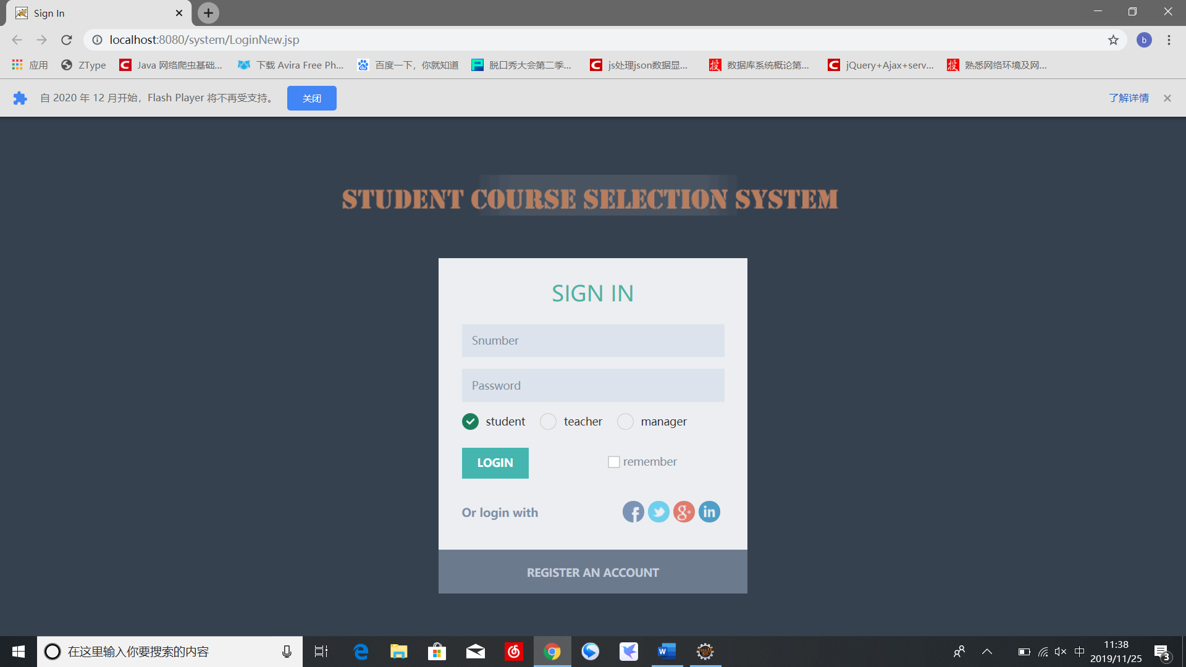

**2.登录失败界面**

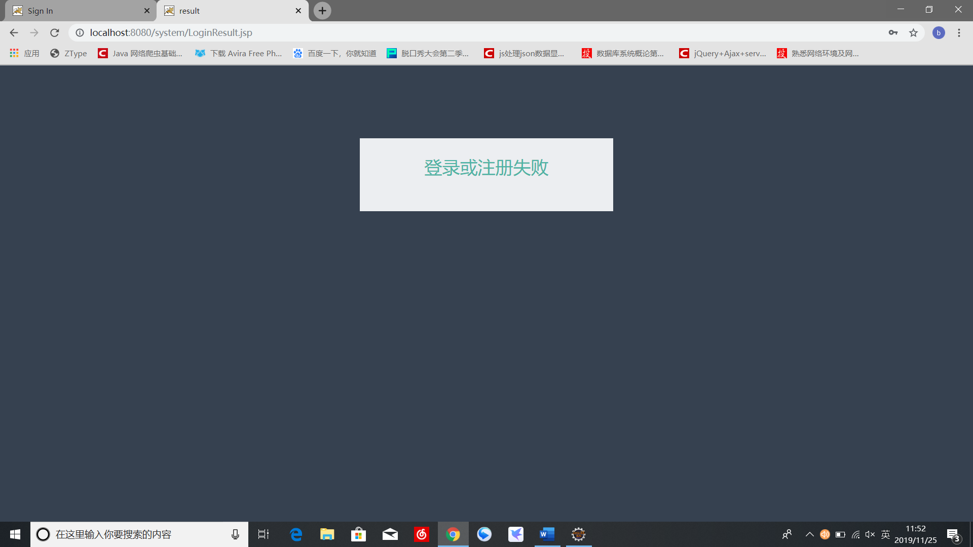

**3.注册界面**

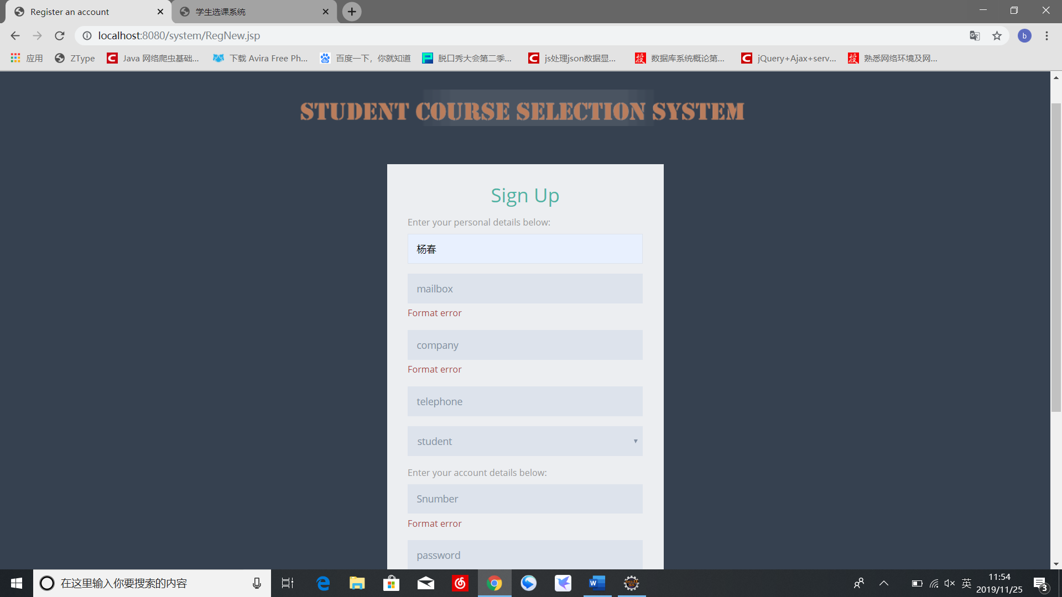

**4.查看界面**

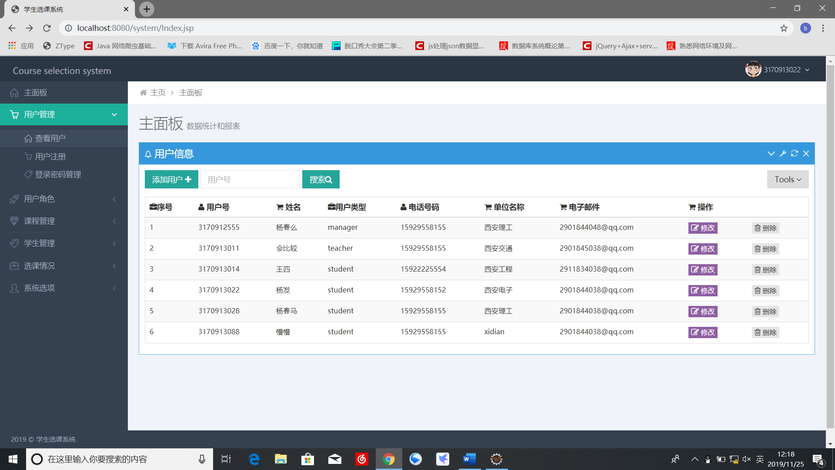

**4.1添加**

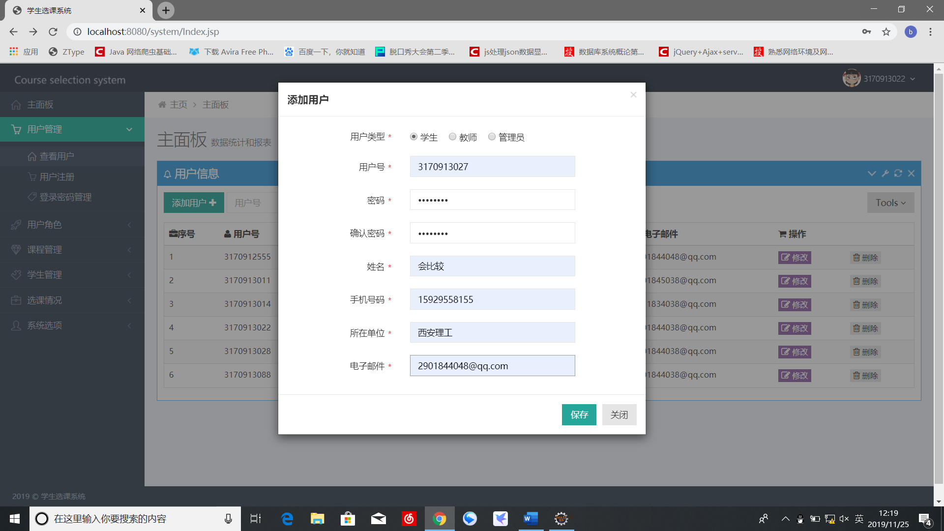

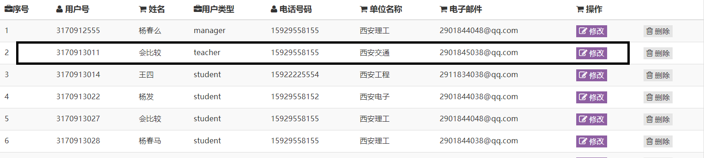

**4.2查询界面**

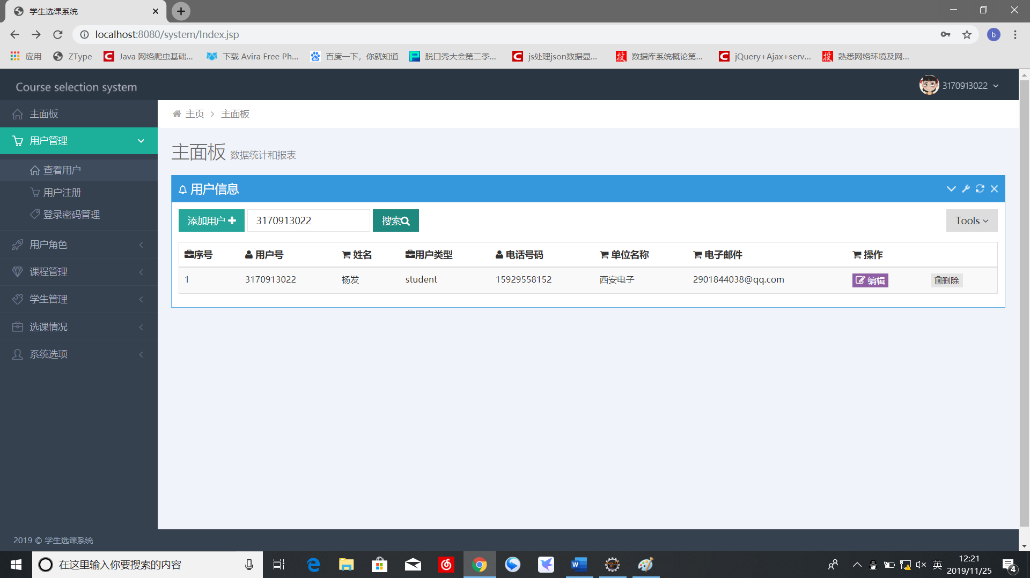

**4.3删除**

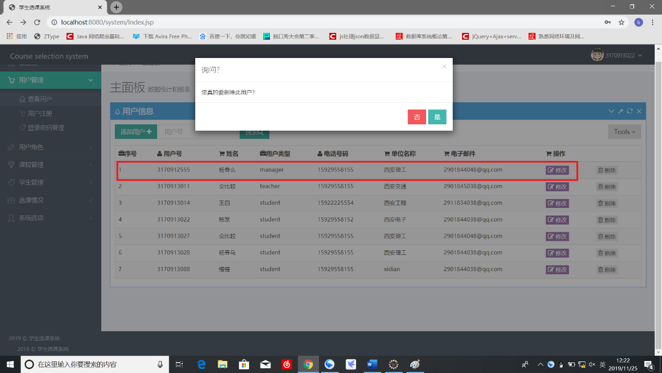

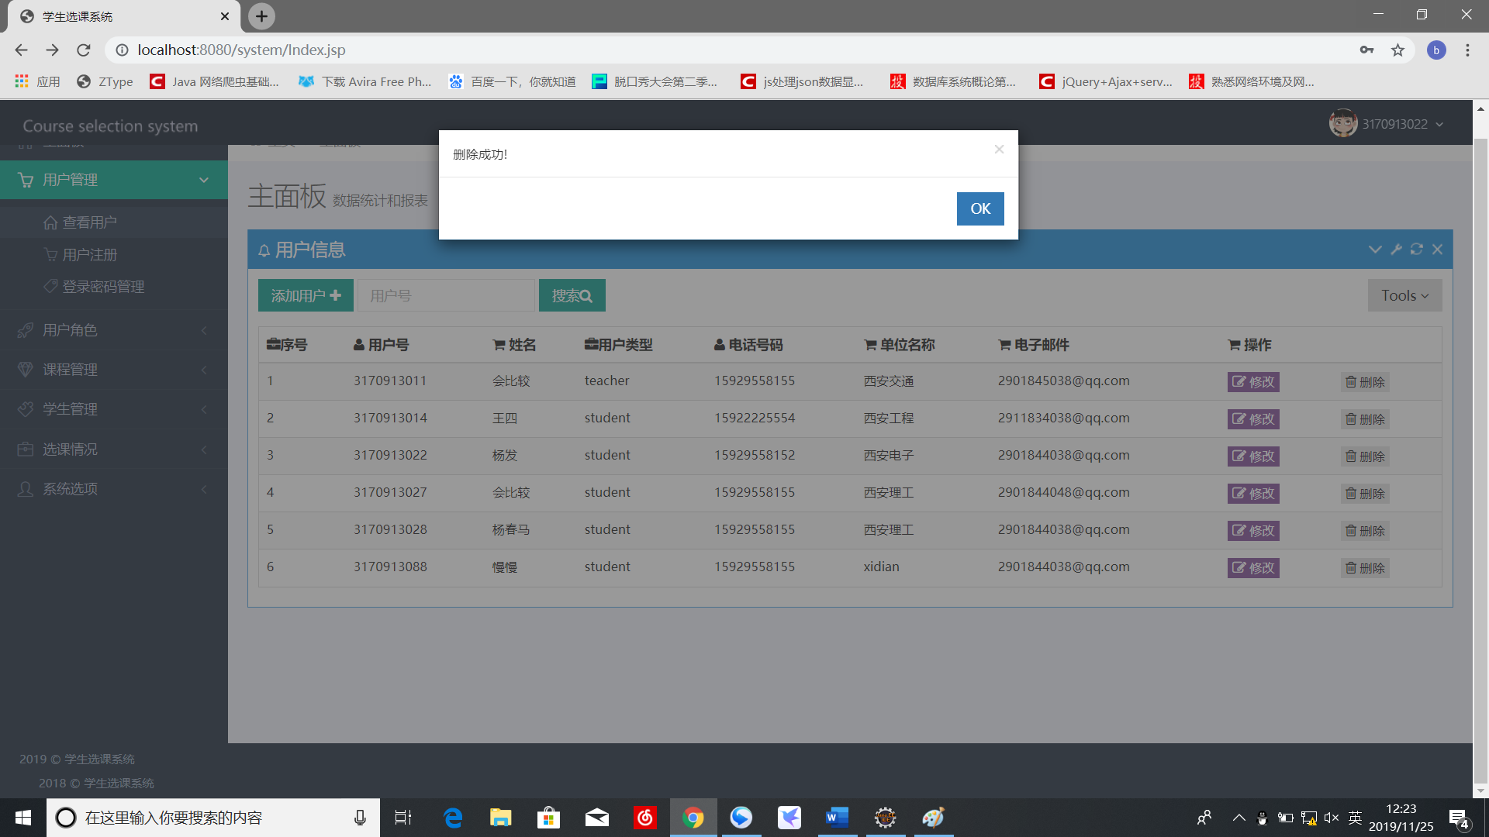

**4.3修改界面**

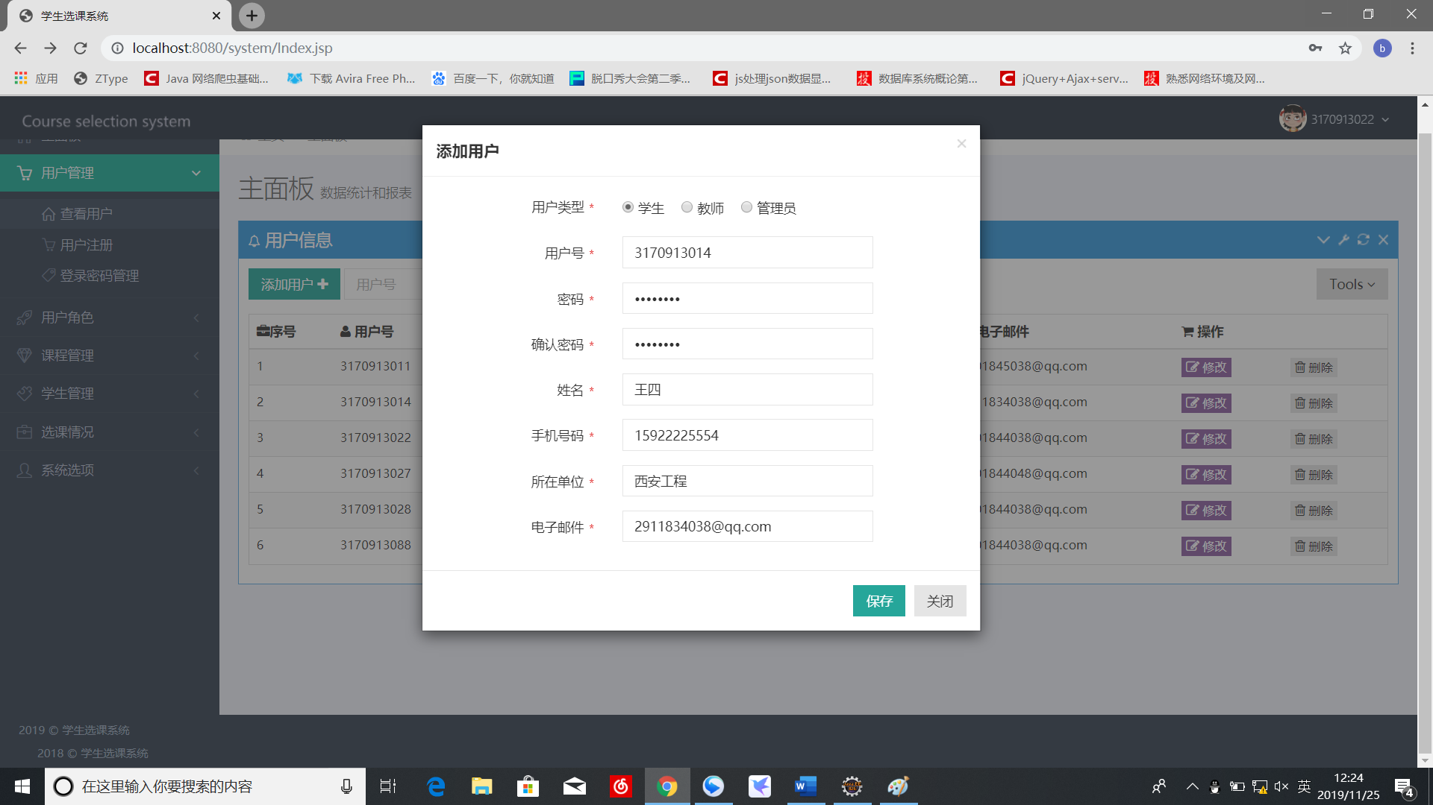

**5.密码管理界面**

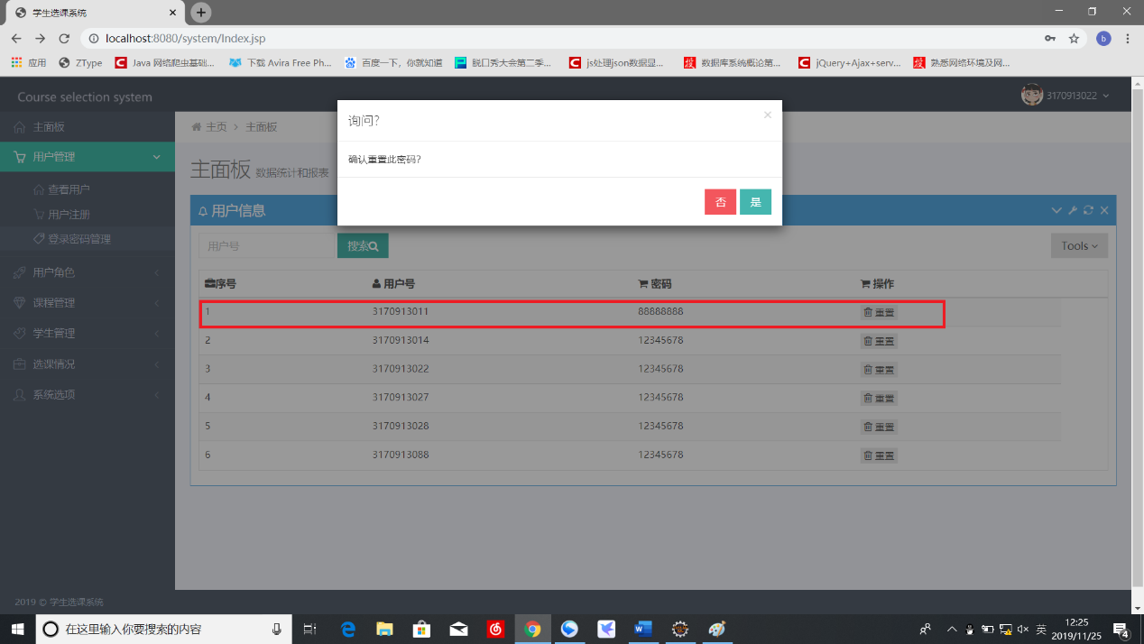

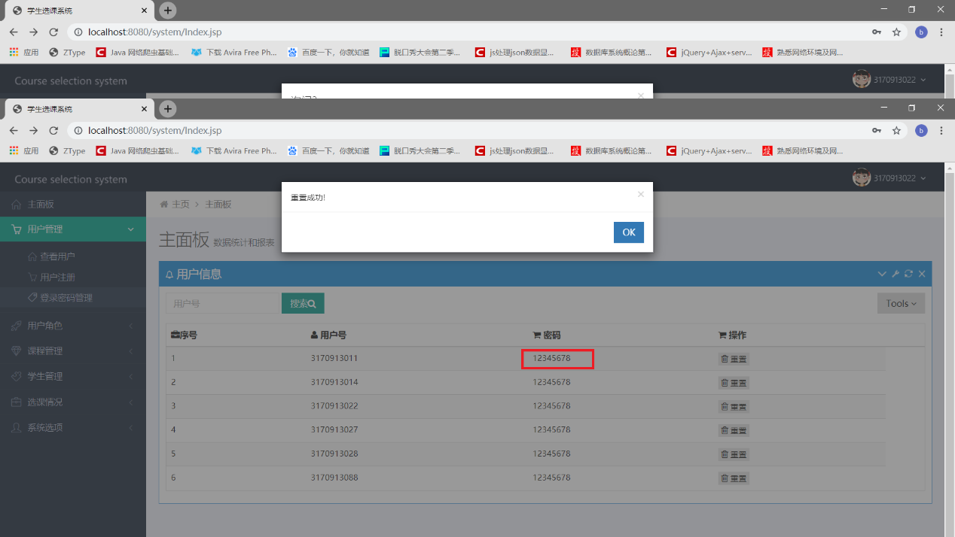

**【实验心得】**

通过本次实验，使我熟悉了Metronic框架，更学习并使用了ajax,jquery，等库，像回调函数，页面加载函数等等，在实验过程中，我克服了种种困难，最终完成了任务，使我受益匪浅