gama=0.9;

窗函数修正PSF

Pmax< 5

原图

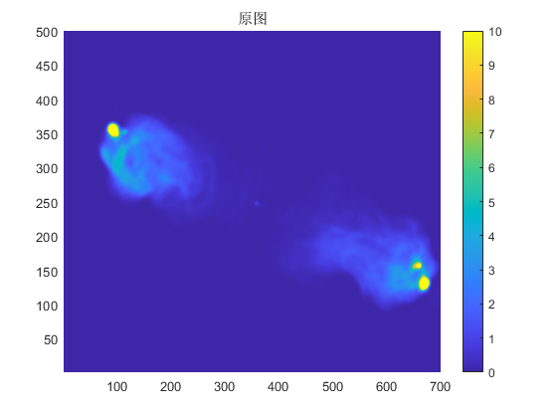

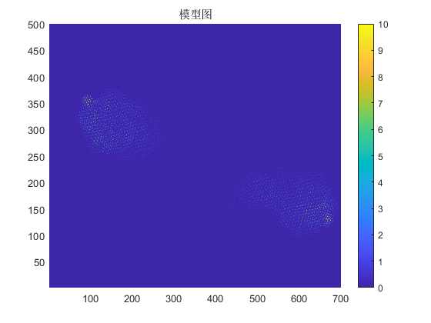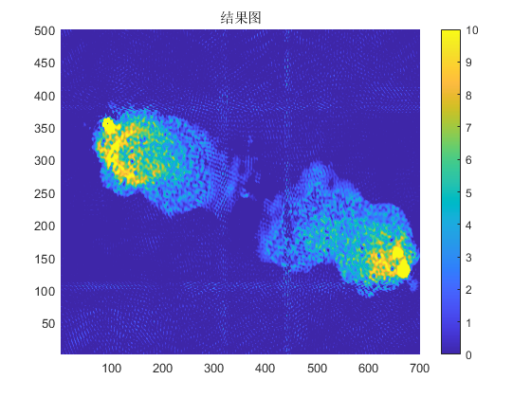

RMSE_Dirty =18.7175

RMSE_CLEAN =1.0632

RMSE_PSF =1.7514