**Statistical Analysis on Rate parameters of H2-O2 reaction system amid high pressure combustion**

Xiaobo Shen, Peng Zhao, Albert Wang, Xueliang Yang, Chung K. Law

**1 Introduction**

With combustion evolving into a more and more quantitative subject, tools of advanced experimental diagnostics and detailed numerical simulations/modeling (not the normal DNS we are familiar with) have become two major pillars of combustion research. The establishment of detailed kinetic models is the key piece that connects experiments with simulations enabling more comprehensive and complete understanding of sophisticated combustion problems. A typical combustion kinetics model consists of three parts: 1) a set of reaction rate coefficients between different species, 2) thermochemistry parameters of these species, and 3) the transport parameters of these species. The accuracy of these parameters directly determined the predictability of the kinetics model. As such, many kinetics models have been proposed in the past 30 years with different approaches to update/optimize these parameters to achieve better agreement with measured combustion properties of fuels, such as ignition delay time, laminar flame speed and species profiles. The most widely recognized of them are GRI-Mech, USC Mech II and Aramco Mech [Reference for the three mechanisms], just to name a few. The methodology have been thoroughly discussed and reviewed by Wang et al[ (Hai Wang, 2015)] and commonly include two key pieces: the preset reaction mechanism and selected optimization targets. During the development and validation mechanism, the sensitivity analysis was performed against the targets to the underlying rate coefficients (thermochemistry and transport) for identification of the important reaction pathways. The parameters (usually A factors of Arrhenius equation form) of important reactions are adjusted within corresponding bounds of uncertainty until the best agreement with the targets is achieved. Based on above principles, some optimization tools, e.g. data collaboration [12] and solution mapping [13] were developed to solve this so-called inverse problem. Sheen and Wang also built a very useful tool, Method of Uncertainty Minimization using Polynomial Chaos Expansions (MUM-PCE) to evaluate the uncertainties in the existing kinetic knowledge against the species data for hydrocarbons at experimental conditions. Turanyi et al. established a new fitting algorithm and a new method for error calculation to determine optimized values of all Arrhenius parameters (not only A factors) against both direct and indirect measurements. (need rewrite this part)

This optimization approach has been very successful and the resulted mechanisms such as GRI-Mech, USC Mech II and Aramco Mech have been widely used in various simulations, providing more comprehensive understating of combustion processes than before. However, it also has a few obvious drawbacks, the most severe of which is that it often neglects the possible contributions (sometimes even bigger) from the uncertainty/errors of other sources, and consequently misses the key issues. For example, the optimization targets often carry higher than expected systemic errors (The ignition delay measurements of H2/CO oxidation are often significantly shortened by the presence of the impurities, the famous dp/dt issue caused by the boundary layer effect can significantly shorten the measured ignition delay time as well. For laminar flame speed measurements, the errors/uncertainty of extrapolation (Prof Law, can you comment here on both counterflow and flame bomb, lewis number and insatiability). The species profiles from jet stirred reactor often suffer from the inhomogeneous mixing and ambiguous residence time issue, and also the placement of the sample port also can significantly impact the results. The flow rector speciation time history profile, always have time-shifting concerns caused by mixing and pre-ignition effects. Adding more here). Generally speaking, optimization to ignition delay time and jet stirred reactor experiment often leading leads to higher than real activity, while laminar flame speeds involves more uncertainty from fluid dynamics and transport (??) and are not ideal to quantify the reaction rate coefficients at all. (For Example, Hai Wang always optimizes his mechanism on flame speed at equivalence ratio phi=0.7 and 1.3 which surely have much bigger uncertainty than phi ~1.0. This is not going to be in the paper, but servers a simple to show the problem). Therefore, only the time-history profile from shock tubes and flow reactors can be directly used to quantify the reaction rate. The second important drawback is that reaction rate uncertainty boundary used in the model is empirical mainly based on author own experience, and many rates were given purely based on well-educated guess with no experimental measurement or high-level quantum chemistry theoretical estimation. The optimization on such high dimensional model could lead to disastrous results if sensitivity analysis on particular reactions are not significant but the rates actually are off by order(s) of magnitude. Third possible drawback is that the optimization targets can be biased. (need find a proper way to expand this claim)

Therefore, we feel there is a need to develop a more robust methodology of evaluating the values and quantifying the uncertainty of each component in the mechanism in order to avoid the aforementioned issues. The thermochemical parameters of the species is believed to have least uncertainty to contribute to model performance due to successful application of Active Thermochemical Tables (ATcT) approach in the past years [reference: Burcat thermo or Branko Ruscic paper], and therefore is out of our scope here. The uncertainty of model performance from transport parameters has been discussed by Hai Wang and others in early 2000s, and not much have been changed since then due to the lack of the experimental measurement or theoretical calculation on the binary diffusion parameters between species [Ahren Jasper and Jim Miller paper here]. The direct rate coefficients measurements, on the other hand, have been more and more accurate ever since mid-1980s due to the tremendous advances in the application of laser/light absorption technique and accurate determination of shock tube conditions, for which Hanson et al and Michael et al, as well as other pioneer devote their life long efforts. The non-intrusive real-time speciation time-history profiles from shock tubes with well-designed experimental conditions amplifies the sensitivity on the target reaction while greatly suppress others are ideal to determine the rate coefficient with small uncertainties. The reported results with different uncertainty coming from different shock tube facilities with emphasizing on different species provide exceptional resources to evaluate the rate coefficients and their uncertainties. Many of these rates have been evaluated/ compiled at least a few times by the very experienced researchers in the field of chemical kinetics [Baulch et al 1992, 1994 and 2005]. However, as stated in [Reference Baulch 2005], the rate uncertainty assignment is a***subjective assessment by the evaluators***because many measured data could differ from other by many standard deviations, and therefore in practice, the rare evaluation ends up using an expression preferred by the evaluators, or simple average of all available experimental data that were trusted by the evaluators. While the derived rates could be reasonable since those experienced researchers understood the drawbacks/advantages of most experimental techniques, the methodology was not free of their personal bias/experience and the simple average can potentially undermine the effort of more accurate experimental measurements.

To avoid a dilemma that which data to choose/trust and how to assign the uncertainties, we propose a more systematic approach to e:

1) assign weights to each measured rates at particular temperature/pressure according to their reported uncertainties yielding a weighted average rate based on statistical principles. The weighed uncertainty can be derived along with reduced chi-square to give a more realistic estimation. (experimental uncertainty) When there is lack of enough experimental data, high-level theoretical calculation results were included in the evaluation process.

2) perform weighted-least square fitting of data generated from step 1) to produce the best estimated Arrhenius equation parameters for the reaction coefficient. A new set of uncertainty obtained from the covariance matrix and assess how well the fitting could be (fitting uncertainty)

3) The overall uncertainty of the reaction coefficients are estimated as thesquare root of sum of the square of experimental uncertainty and fitting uncertainty.

4) The model/mechanism is then constructed using the data obtained from previous steps. With the constraint of the uncertainty boundary, the rate coefficients are further evaluated using the time history profiles from shock tubes and flow reactors using MUM-PCE method. When comparing to the experiments,not the ones which has the larger sensitivity but the ones with larger uncertainty times sensitivity(namely weighted sensitivity), are tuned to match the experiments.(This is inline with the concept of Wang’s 2015 paper)

5)The newly obtained rate coefficient from step 4) was then fed back to step 1) for another round of evaluation. es of re-analysis of the evaluable experimental datarate coefficients gradually minimized to produce better constraint model/mechanism.

As the simplest fuel and backbone of general combustion chemistry, H2/O2 kinetic system has been extensively studied and agreement has been reached on the key species and possible reaction pathways [GRI/USC/Burke]. In this paper, we will review the rate coefficients included in H2/O2 mechanism to demonstrate the new approach, as well as to construct a “converged” H2/O2 kinetic mechanism, by utilizing statistical analysis on directly measurement rates.

**2 Methodology**

The uncertainty assessment of all reactions in H2-O2 reaction system using statistical inference was carried out. The whole processes can be divided into a few steps:

i. Collect all available experimental kinetics data of each reaction. Different from others, we only use the data from the shock tubes and flow reactors that provides time history profiles of key speciation, considering ignition delays, flame speed, jet stirred reactor etc. are more of global measurement (indirect measurement) and the values derived from them have much higher uncertainty because of much stronger interference from other reactions, temperature/pressure variations, or even molecular transport parameters.

ii. The reaction at each temperature/pressure were evaluated using weighted average (maximum likelihood function) which values more accurate experimental measurements.

The rate measurements from different sources are regarded independent. The data from each measurement were assumed to have normal distribution. Therefore, the Maximum Likelihood Estimator (MLE) for rate measurements are expressed as follow:

Where, *xi* is the average rate of the i-th measurement (Xi), *σi*is the standard deviation of the i-th measurement (Xi), *μ* is the average rate of all measurements (X1,X2,…Xn).

The equation (1) was maximized when:

Thus,

Where, is the weighted average rate, *wi* is the weight of the i-th measured rate.

The determintation of variance (*σ*2) of the weighted average rate () is elaborated as follow:



The covariance *Cov* (*Xi*, *Xi*) equal *σi*2. As clarified above, the measurements are independent, which leads to the covariance *Cov*(*Xi*, *Xj*) = 0. Eventually, the variance (squared standard deviation) of the weighted average rate is derived in a simply form as:

iii. With the evaluated rates and the corresponding uncertainties, a weighted least square fitting was used to derive the Arrhenius parameter and their uncertainty which emphasized more on more accurate data. The uncertainties of Arrhenius parameters are derived from the covariance matrix the correlation between each are not significant. Monte Carlo simulations were employed if the correlations are so big that the uncertainty can hardly be quantified.

iv. A new mechanism was then composed of reactions in Arrhenius format with uncertainty attached.

v. An iterative process is used to refine the parameters by fitting the shock tube and flow reactor kinetics experiments with least square fitting.

The advantage of this evaluation process over others can be summarized as follow:

(1) More accurate collection of experimental data, less affected by the global measurement.

(2) Robust statistical inference foundation, more objective, and free of personal preference.

(3) Automated evolve with new experimental data adding in.

**3 Results and discussion**

**3.1** Important reactions with relatively accurate measurements

The first reaction category consists of H + O2 = O + OH (R1), H2 + OH = H2O + H (R2), H2 + O = OH + H (R3), OH + OH = H2O + O (R4). In H2-O2 combustion(even more widely hydrocarbon combustion), H+O2 = O+OH (R1) and H+O2+M =HO2+M (R2) are often ranked the first two most sensitive reactions with 6-10% uncertainty for R1 and at least 20-30% uncertainty for R2. Furthermore, the disagreement between rate measurements at high pressure is rather large. Therefore we revisited most of reported high pressure experimental data with current best understanding of the H2-O2 mechanism. Much better agreement between experiments was been achieved and the uncertainty was refined to ~20%.

These reactions in this category have relatively accurate measurements with bulk data, so that the rate evaluation could be conducted by fully statistical inference from experiments.

R1 has tremendous experimental measurements across wide temperature range, and the agreements are satisfactory. A simple statistical analysis was employed to quantify its uncertainty to ~8%. The third sensitivity reaction is often H2+OH = H2O +H (R3) and its uncertainty is quantified as ~6% using similar method as R1.

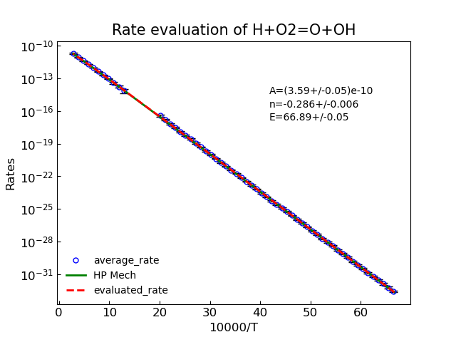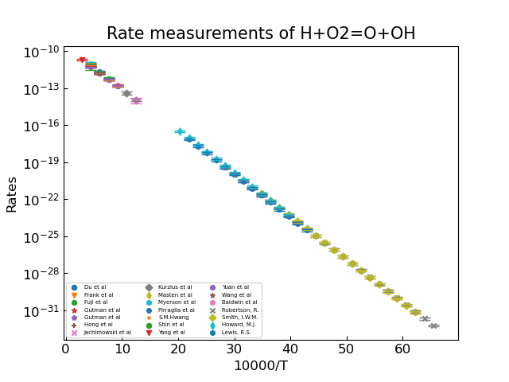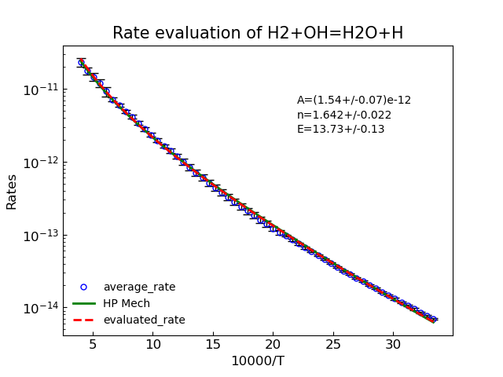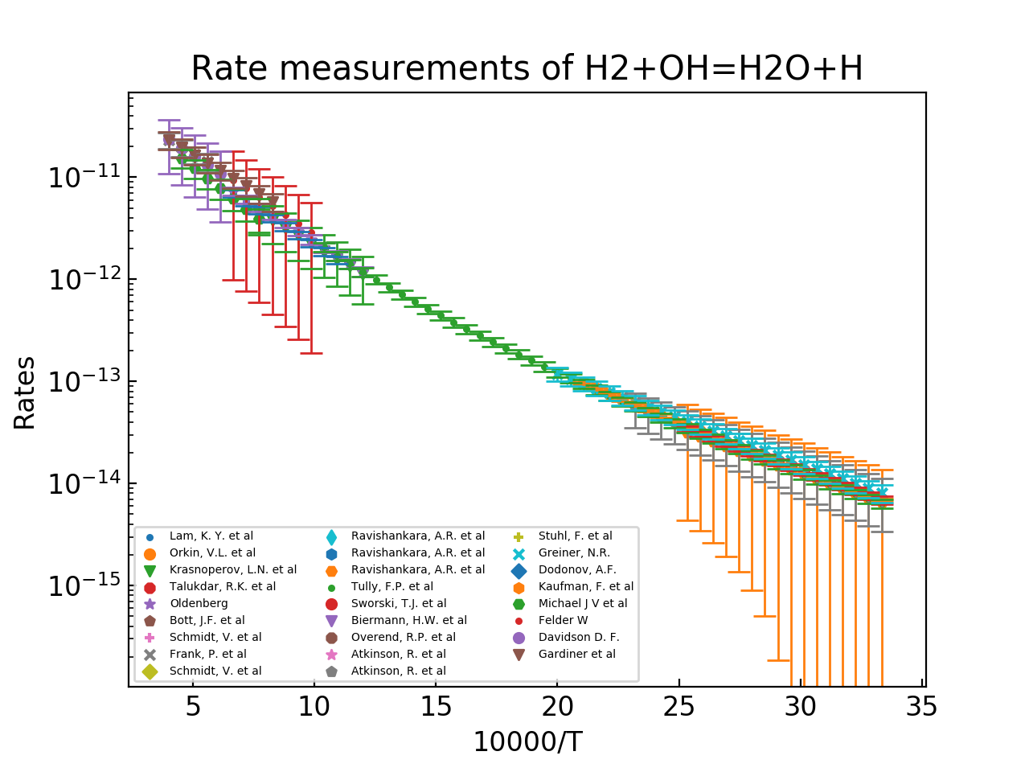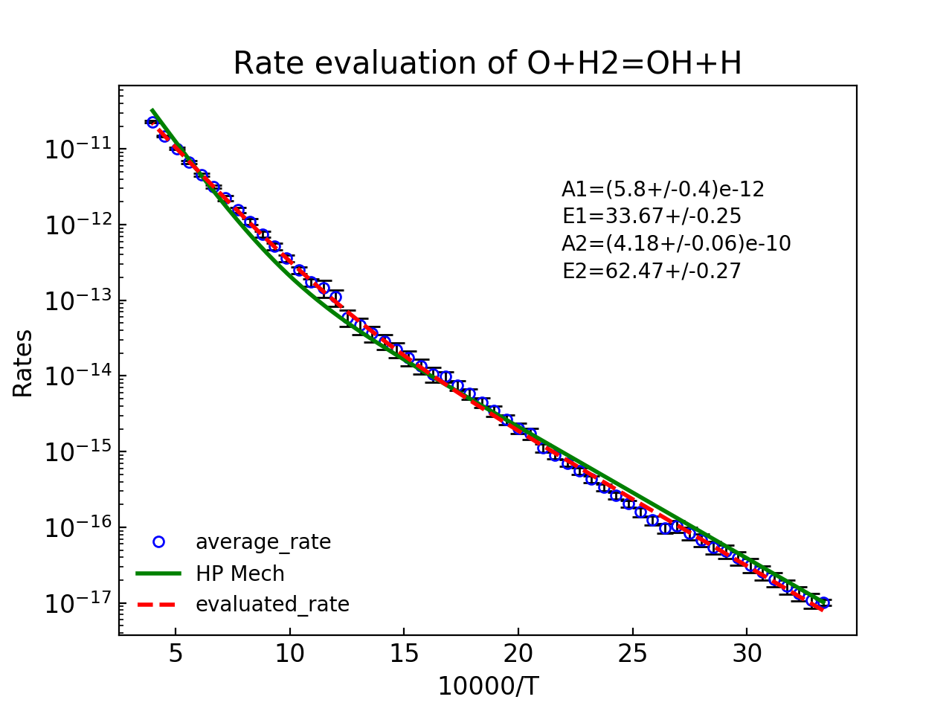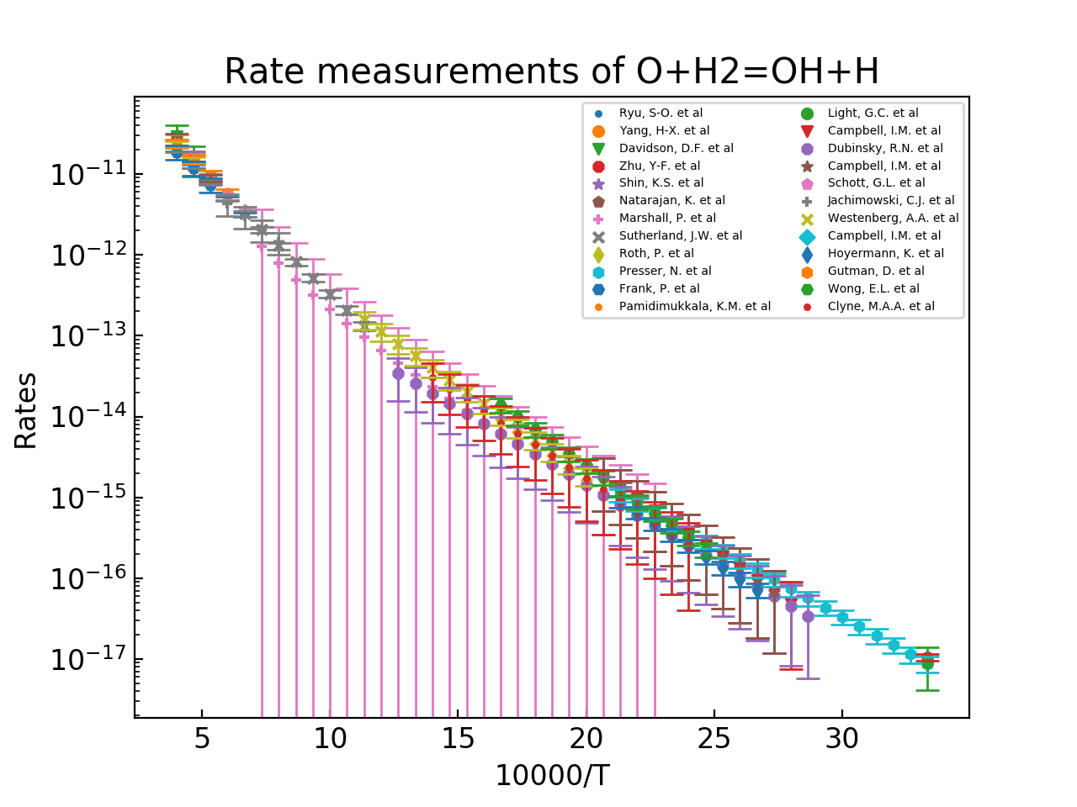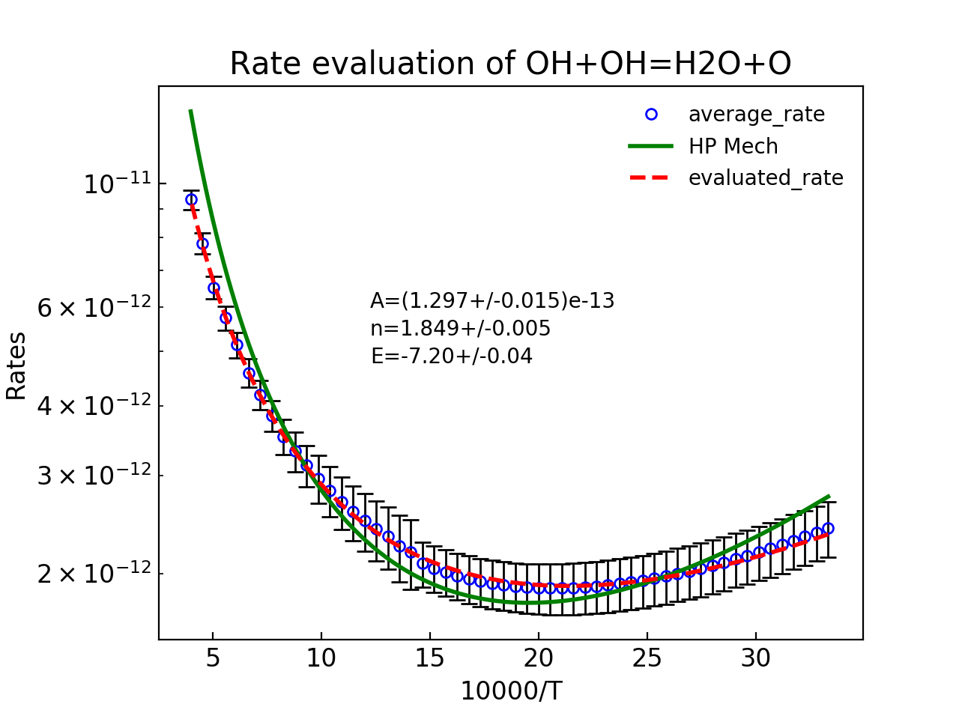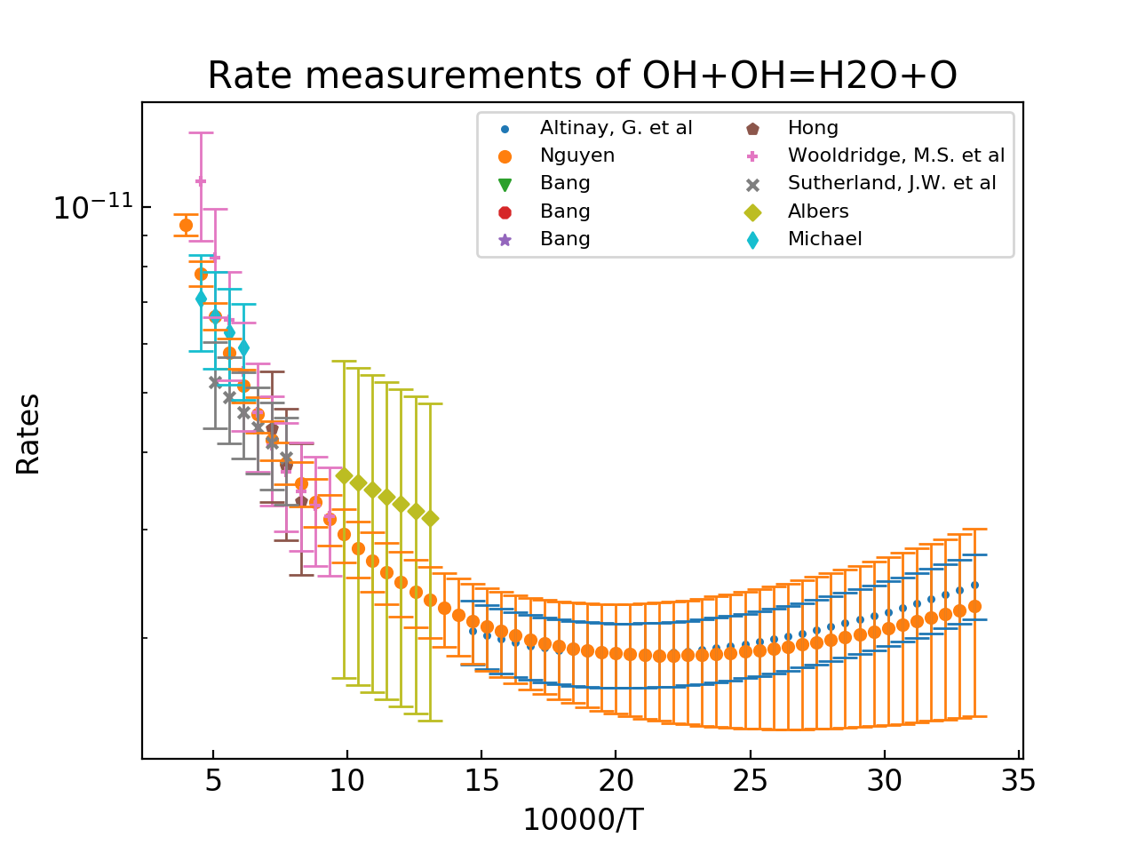

3.2 H2O2 and HO2 related reactions

HO2 and H2O2 reactions are very important in high pressure combustion but less accurate measurements were performed. Therefore, the evaluation was strengthened by theoretical calculation if necessary. This category have followed reactions:

H2O2 + H = H2 + HO2 (R5)

H2O2 + H = OH + H2O (R6)

H2O2 + O = OH + HO2 (R7)

H2O2 + OH = HO2 + H2O (R8)

H2O2+M = OH+OH+M (R9)

HO2 + H = OH + OH (R10)

HO2 + H = O + H2O (R11)

HO2 + H = H2 + O2 (R12)

HO2 + OH = H2O + O2 (R13)

HO2 + O = O2 + OH (R14)

HO2 + HO2 = H2O2 + O2 (R15)

At higher pressure, especially close to third explosion limit, reaction H2O2+H = H2 + HO2 (R5), H2O2+M = OH + OH +M (R9) and HO2+HO2 = H2O2+O2 (R15) come to play important roles. However, the experimental measurements of these reaction are sparse with bigger uncertainty associated.

For R5, we relied on theoretical guidance with limited experiments to evaluate the uncertainty within 30%-50%. R9 are also evaluated using statistical analysis methodology according to the uncertainty associated with each experimental data, similar to R2. R15 and HO2+OH = H2O +O2 are often paired with each other in experimental measurement, the tentative uncertainties were obtained using statistical analysis. The re-interpretation of the experiments were also carried out to further refine the uncertainties.

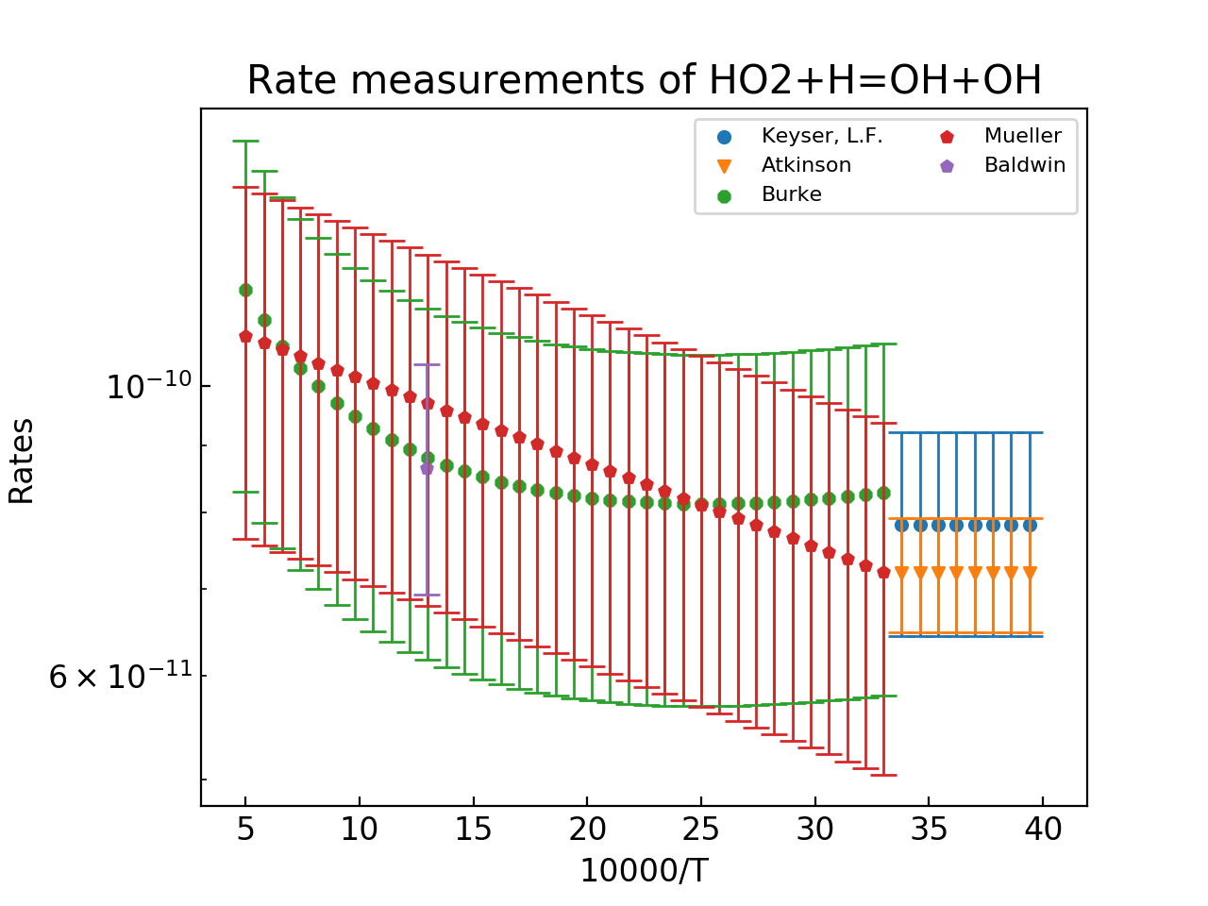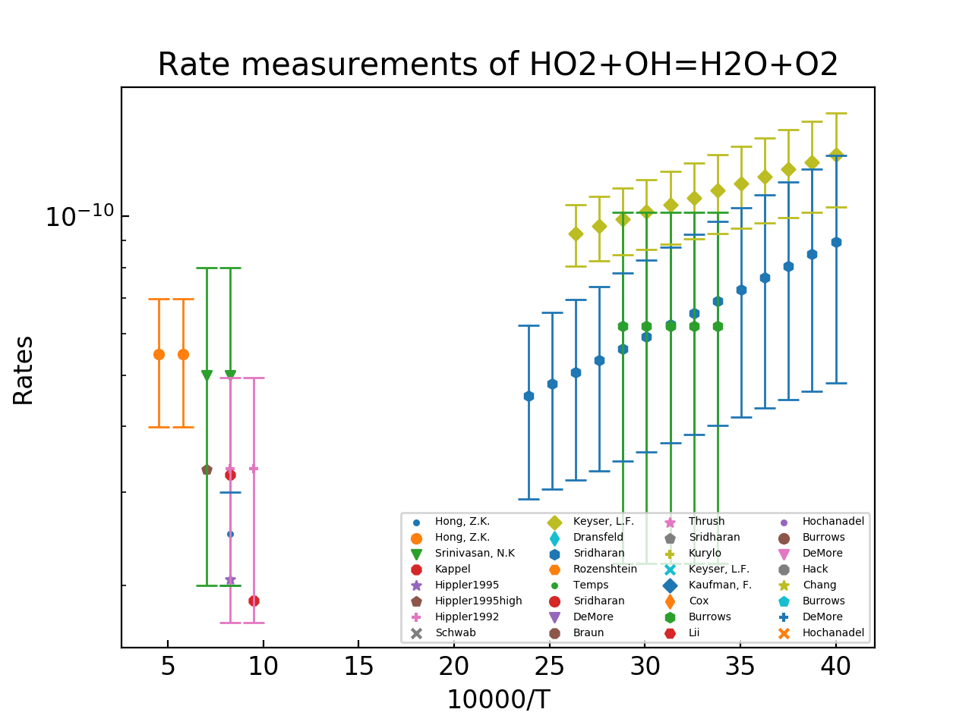

3.3 Important pressure dependent rates many measurement

Evaluate the Troe formula using high pressure limit rate from high level theory to obtain the low pressure limit rate expression and pressure broadening factor

H+O2+M =HO2+M

H+OH+M =H2O +M

H2O2+M = OH+OH+M

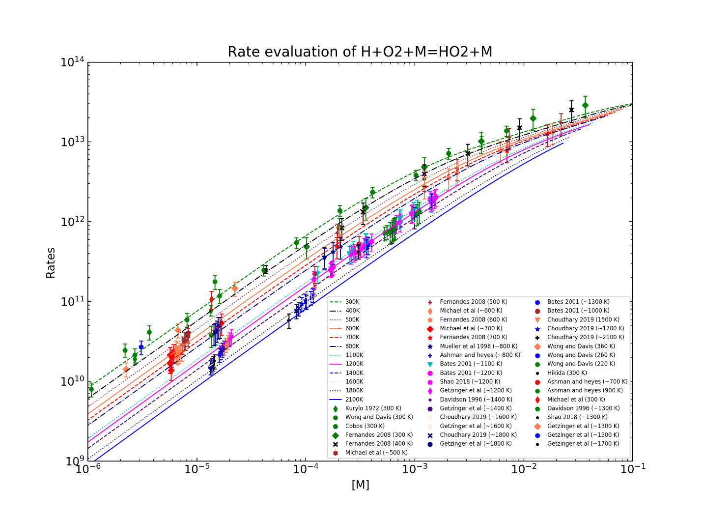

3.4 Other reactions

In this category, the reactions are not very important and were just used to complete the mechanism. Thus, we add simple theoretical estimation to improve their accuracy.

O + O + M = O2 + M

O + H + M = OH + M

H + H + M = H2 + M

3.5 Further uncertainty refinement by MUM-PCE method

With all reaction coefficient quantified with associated uncertainty, we carried out the simulation against the flow reactor speciation time-history and further refine the uncertainty using MUM-PCE method in temperature of 800-1000K and pressure of 1-20 atm which was seldom discussed before.

**References:**

[1] D.F. Davidson, J.K. Shao, R. Choudhary, M. Mehl, N. Obrecht, R.K. Hanson, Ignition delay time measurements and modeling for gasoline at very high pressures, Proceedings of the Combustion Institute 37 (2019) 4885-4892.

[2] J. Shao, R. Choudhary, D.F. Davidson, R.K. Hanson, S. Barak, S. Vasu, Ignition delay times of methane and hydrogen highly diluted in carbon dioxide at high pressures up to 300 atm, Proceedings of the Combustion Institute 37 (2019) 4555-4562.

[3] Y. Zhu, S. Li, D.F. Davidson, R.K. Hanson, Ignition delay times of conventional and alternative fuels behind reflected shock waves, Proceedings of the Combustion Institute 35 (2015) 241-248.

[4] A.P. Kelley, A.J. Smallbone, D.L. Zhu, C.K. Law, Laminar flame speeds of C5 to C8 n-alkanes at elevated pressures: Experimental determination, fuel similarity, and stretch sensitivity, Proceedings of the Combustion Institute 33 (2011) 963-970.

[5] F. Wu, C.K. Law, An experimental and mechanistic study on the laminar flame speed, Markstein length and flame chemistry of the butanol isomers, Combustion and Flame 160 (2013) 2744-2756.

[6] S. Yang, X. Yang, F. Wu, Y. Ju, C.K. Law, Laminar flame speeds and kinetic modeling of H2/O2/diluent mixtures at sub-atmospheric and elevated pressures, Proceedings of the Combustion Institute 36 (2017) 491-498.

[7] D.R. Haylett, D.F. Davidson, R.D. Cook, Z. Hong, W. Ren, S.H. Pyun, R.K. Hanson, Multi-species time-history measurements during n-hexadecane oxidation behind reflected shock waves, Proceedings of the Combustion Institute 34 (2013) 369-376.

[8] W. Ren, K.-Y. Lam, D.F. Davidson, R.K. Hanson, X. Yang, Pyrolysis and oxidation of methyl acetate in a shock tube: A multi-species time-history study, Proceedings of the Combustion Institute 36 (2017) 255-264.

[9] M. Frenklach, Systematic optimization of a detailed kinetic model using a methane ignition example, Combustion and Flame 58 (1984) 69-72.

[10] M. Frenklach, H. Wang, M.J. Rabinowitz, Optimization and analysis of large chemical kinetic mechanisms using the solution mapping method—combustion of methane, Progress in Energy and Combustion Science 18 (1992) 47-73.

[11] F.L. Dryer, F.M. Haas, J. Santner, T.I. Farouk, M. Chaos, Interpreting chemical kinetics from complex reaction–advection–diffusion systems: Modeling of flow reactors and related experiments, Progress in Energy and Combustion Science 44 (2014) 19-39.

[12] X. You, A. Packard, M. Frenklach, Process informatics tools for predictive modeling: Hydrogen combustion, 44 (2012) 101-116.

[13] B. Eiteneer, M. Frenklach, Experimental and modeling study of shock-tube oxidation of acetylene, International Journal of Chemical Kinetics 35 (2003) 391-414.

[14] X.Y. Hai Wang, Ameya V. Joshi, Scott G. Davis, Alexander Laskin, Fokion Egolfopoulos & Chung K. Law, USC Mech Version II. High-Temperature Combustion Reaction Model of H2/CO/C1-C4 Compounds, (2007).