DATA FOR GROUP:

3.2L/person/day

7200/day

for 7 days of water in tank,

**50400L**

if we make the tank bigger for safety to 51 000L, that gives enough safety and overflow space.

Cd 0.7431

This means that the tank should be

2.5m radius and 2.6m tall = 51m3, or 51000L.

this means that the pipe will be 53.77m long.

If we want to be able to pump 1 days’ worth in 1 hour,

Flow rate (Q) = 7200L/hour = 0.002m3/s

Using a Specific Pump Work (Ws) of 50J,

Power required is 100W which mean that we can use the experimentally gathered lambda value of 2.86 and Cp value of 0.008 to generate 145W off a turbine with 7.5m blades, 20RPM.

DO NOT LEAVE THIS SECTION IN THE REPORT

___________________________________________________________________________

Abstract:

Many rural and isolated towns have minimal access to clean drinking water.

This project will explore a solution to providing one such town with clean water, through a groundwater extraction and treatment system design.

For the design of our project we calculated both an experimental Drainage coefficient and a wind power coefficient.The experiment to measure these values were be conducted on an experimental rig. The drainage coefficient was be measured through running a simulation tank with measured interval of volume lost over time. The power coefficient was be measured by measuring the pitch angle and tip speed ratio using scaled blades and controlled wind speeds, and then measuring the power and rpm of the rig.

The results of these experiments was a realistic calculated drainage coefficient, pitch angle, tip speed ratio, and power coefficient.

These calculated values were then used in our design in order to provide a realistic solution to providing clean drinking water to a rural town. The calculated drainage coefficient was used to our designed tanks. Our calculated the optimal tip speed and pitch angle, and power coefficient was used to design the optimal blades to power our project.

Design Requirements:

* To help a remote rural town gain easy access to clean drinking water, through a wind powered pumping, and treating station.
* To provide the town with adequate spare parts and training in order to take care of the water station.
* To provide a design which will last for a minimum of 10 years.
* To provide a plan, design, and model, and then construct, and test our proposed water the extraction and treatment system.
* To calculate the ‘Drainage coefficient’ of a model tank.
* To calculate the ‘Power coefficient’ of a model turbine with scaled blades.
* To then use our calculated values to apply to our real world design.

Design Situation (town):

We are to supply clean drinking water to a small town on the coast of Australia, which is extremely isolated from all major cities. The environment of the town is arid, bare and flat.

The population of the town is currently 2000 people but is expected to grow by 1.2% each year due to the installation of our water system.

As we are designing a system that will work for a minimum of 10 years, we need to calculate our water usage on the town for the population at 10 years.

Calculations are as following

$Population×(1+Growth Rate){}^{Years}$

The population after 10 years will be 2253, and so all our water consumption calculations will be based on this value.

Assumptions:

As the design brief does not give all the information we need to make some educated assumptions, in order to gain all the requirements and variables for the design project.

There are two main variables for this design project; The rate of flow of water in and out of the town and the wind speed in the town" might be clearer.

So there are two areas of assumptions needed, that for water, and that for wind.

The water, based assumptions are:

That the town will have other water supplies such as a river or rainwater tanks and so we will only be providing for their drinking water needs.

The wind, based assumptions are:

The wind speed data given will not vary much for the 10 years.

This allows us to assume that the average wind speed, calculated using matlab to be 5.5m/s, will also remain constant for all 10 years.

We also will assume that the wind turbine will be able to change directions to be able to entirely face the wind.

Water usage:

It is recommended that a person on average drinks 1.8-2.6L of water a day, depending on their gender and size. (‘Water- a vital nutrient’, 2014)

As this is just a rough estimate of water usage, a safe amount for each person would be around 130%-150% of the recommended value resulting in approximately 3.2L per person.

To calculate the total volume of water the town needs every day, we take the population at 10 years and multiply it by water usage per person per day.

2253(population) x3.2 (usage per person per day) = 7210L per day

This results in the town’s usage being 7210L per day or roughly 7200L, to be used for further calculations.

Conclusion:

*Should we have a quick section about the faults.*

The tank, of capacity 51,000L, is to be made from a stainless steel material on a concrete support structure. From experiment, our calculated CD value of 0.743, …. Which when used for the tank, allowed the

The pump is designed to run from the 100W generated by the turbine, allowing a flow rate of 7200L/hour. This rate of flow validates the assumption of turbulent flow, at a Reynolds number of 6400, and will provide a constant source of water in the tank.

We measured a CP value of 0.008 from a tip-speed ratio of 2.86 and a pitch angle of 15˚. From this we determined that an appropriate size for the full scale turbine was a radius of 7.5m and a height of 30m.

Tank Module:

The tank storage component forms the most critical part of the system, providing sufficient reserves for the daily drinking water needs for the community. In situations where the pump is unable to function due to lack of power or a mechanical malfunction, the tank requires a reservoir that has adequate backup supplies to be utilised during these times. To ensure that the community continuously has a sufficient supply of water, a capacity of seven days of average usage was decided on. This design allows for ample time for repairs to the pump or other aspects of the system if needed.

As previously discussed, the daily water requirement for the village after the tenth year is 7200L. Thus, in order to accommodate seven days worth of water, the tank is required to have a minimum volume of 50400L. Using the volume equation of a cylinder:

$V=πR^{2}H$

A system of equations was constructed to determine the radii and heights that will minimise the material surface area. Hence, we decided on a height of 2.6 m and a radius of 2.5m. While it has a consistent cross sectional area throughout the height of the tank, due to its high surface area to volume ratio, thermal efficiency may be comprised (Yang, Chen, Sheng, Wang & Wang, 2016) in the tropical conditions the community is situated in. However the colouring the tank in a light shade, will mitigate the effects of heat from the environment.

Due to the nature of the funding for the project, sensitivities to costings must be considered. The material of the tank, while being cost effective, is necessary that it does not contaminate the water supply. Hence, the tank will be produced in stainless steel, which holds characteristics that will reduce reliance on the filtration process through its inert nature as well as reduce long term costs due to the strength and durability of the material (Tank Information - Tankulator, 2010). Costs regarding transportation and construction will be lowered, as prefabrication is not required as construction is possible on site. The base, being a simple concrete structure, with an internal steel structure, will be effective in supporting the mass of the tank in inclement weather.

Sensors are required in the tank, instructing the pump to both initiate and cease pumping when water levels reach defined thresholds, constantly ensuring available water for the community. We decided to place the sensor for the “on” switch 1.4m from the bottom of the tank as this ensured 4 days worth of emergency water available for the community, allowing for adequate time for any unanticipated repairs on the system. The “off” switch will be located at 2.5m, just under the top of the tank, in order to allow some space above the water level, reducing the pressure on the tank. Due to the high volume of water that is pumped into the tank, the reliance of the hysteresis system is minimised.

Pump and Pipe Module:

The pump of the design project is needed to provide a means of transporting water from the underground well to the tank, drawing power from the wind turbine. The well is situated 35 meters below ground level and the tank rests atop a 10 meter structure with a height of 2.6 meters. The pump is attached to a concrete pipe which will provide the infrastructure for the water to be transported. It is also expected that the pump will produce an inflow of water greater than the outflow of the tank draining.Thus the aim of the pump and pipe section of this design project will be to create a pump that can successfully provide a substantial flow of water while remaining within the limits of the turbine energy produced, as well as accommodate for the suspected turbulent flow by way of a low fanning friction factor in the pipe.

As the pump will be powered from the wind turbine is it suitable for the specifications of the pump to be set around the average power generated from the turbine. The pump flow rate was set to be able to pump one day’s worth of water in one hour, which equates to 7200L/hour, which in combination of the other variables, pressure head, water density and flow rate will mean that 100W is required from the turbine module, this is calculated by the equation:

$P=W{}_{S}×ρ×Q$

Where:

* Ws is the pressure head, 50J, (determined variable)
* ρ is the density of the fluid, 1000kg/m^3
* Q is the flow rate produced from the pump, 0.002m^3/s
* P is the power required to achieve the desired flow rate.

Thus this flow rate will allow the tank to fill its required amount for each day in a relatively short time which can be completed on demand if no water is presently in the tank, hence it is very unlikely that there will be any water shortage.

The pipe transporting the water to the tank from the underground well is made of concrete; it is also set to have a diameter of 0.1 meters, resulting in a water velocity of 0.064m/s. The Reynolds number of the pipe is calculated by

$Re=\frac{ρvd}{μ}$

Where:

* ρ is the density of the fluid, 1000kg/m^3
* v is the velocity of the fluid, 0.064m/s
* d is the diameter of the pipe, 0.1m
* μ is the absolute dynamic viscosity of the fluid which is given as 0.001Ns/m^2, it is also noted that the viscosity is assumed to stay constant as temperature doesn’t alter it significantly.

This gives a Reynolds Number of 6400, hence the assumption of turbulent flow is valid.

Since the pipe is constructed from concrete, this gives a roughness factor of 0.002mm, and since the diameter is 0.1 meters, therefore there is a roughness ratio of 0.02. Hence the fanning friction factor of this pipe is shown to be around 0.05, as given by the Reynolds Number vs Fanning Friction Factor graph. 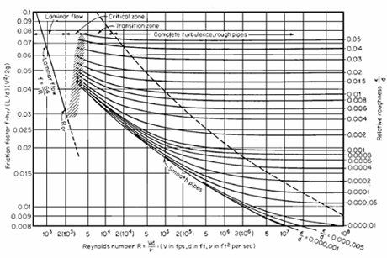

Figure ***, depicts when the tank is being filled up while also draining, it is shown that pump flow rate allows the tank to increase in volume while being drained hence in this design there will be always be a stable amount of water ready for usage. 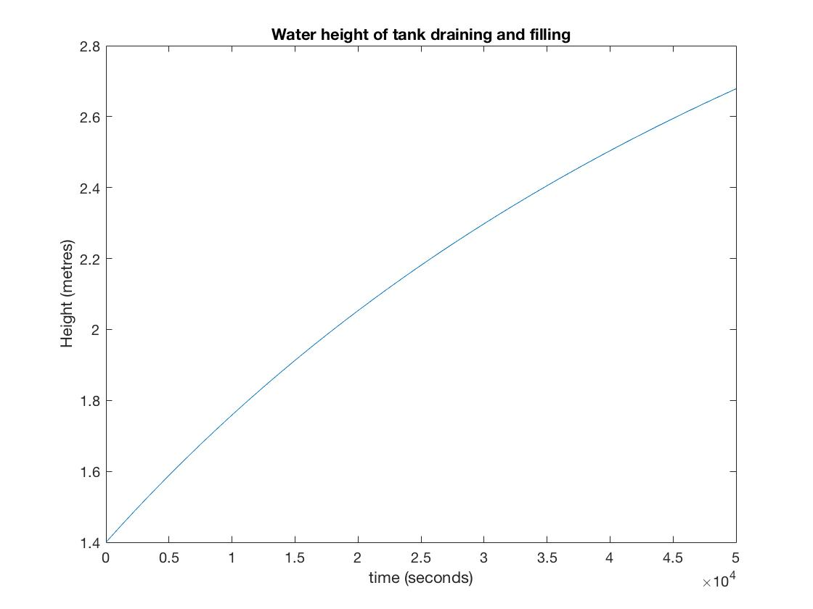

Turbine Module:

The turbine module of the project is separated into three separate areas; namely the power coefficient (CP), which can be further divided into the tip-speed ratio (𝜆) and the blade pitch angle, (𝛽); the design of the blades; and the design of the turbine and supporting structure.

The power coefficient determines how much wind energy can be converted into electricity by the turbine. The Betz Limit states that it is impossible for a wind turbine to achieve a CP value of higher than 0.59 (van Kuik, 2007), as if a system converts all of the energy from the wind, it will no longer function. The power coefficient of a turbine is determined by two functions, the tip-speed ratio and the blade pitch angle.

To measure the blade pitch angle, we placed the model turbine in a fixed location and used a fixed wind speed to make 𝜆 fixed and changed the pitch angle, measuring the power generated with each angle. This created a very easily observed trend that lower values for 𝛽 resulted in higher CP values. However lower values of 𝛽 also increase drag significantly (Cuerva-Tejero, 2012). Drag increases wear on the blades by a large amount as well as decreases the rotational speed, negatively impacting the power output of the turbine. As a result, we decided on using 15˚ for our 𝛽 value as this provided the most optimum CP values from our experiment and it isn’t too low, causing drag to become an impacting factor.

The process to measure the tip-speed ratio (𝜆), was similar to that of 𝛽. We used a fixed pitch-angle and adjusted the fan speed on the experimental rig as well as adjusted the turbine’s position to gather a variety of values for 𝜆 and measure the power output to find the corresponding CP values. The values gathered through this experiment are displayed in figure ****. For a comparison, a graph of externally gathered data is in figure ****. This shows that although our graph follows a similar curve for the tip-speed ratios tested, our values for CP are a factor of 100 off theoretical values. This is because the experimental rig was extremely hard to achieve constant wind speeds and it was difficult to make the turbine stay pointing to the fan to achieve the highest power output. The optimum values for 𝜆 and CP postulated by figure ****. are 𝜆~6 and CP~0.45. However, since we only require 100W of power as discussed above, we can take our value for 𝜆 and CP gathered on the experimental rig.

Thus, as shown on figure ****, the highest value for CP—as determined through experimental work—is 0.008 with 𝜆=2.86 and 𝛽=15˚.

The turbine blades were designed in autoCAD Inventor, based on the profile of a NREL S825 blade (figure ***.) We chose to use the S825 profile as it provided a high amount of lift with a minimum amount of drag, this means that the blade can achieve a higher CP as well as experiencing less wear through drag, leading it to last longer. Figure ** shows the relationship between the radii corresponding to the RPM limits of 10 and 25. We chose to use a radius of 7.5m as that would give 145W of power with 20RPM under average wind conditions, ie. 5.5m/s. These values give the ideal value for 𝜆=2.86 whilst providing the system with more than the required power output. Additionally, the blades are fairly small at 7.5m, which provides a very small visual impact for the community and by setting the RPM to 20, the noise impact of the turbine is reduced however by situating the turbine away from the main community a little bit this is greatly reduced (Jeffery, 2013).

For the actual turbine specifications, we concluded that glass fiber, polyester and epoxy composites were the most suitable materials for the blades and rotor components as they are strong and light. Additionally, glass fiber is cheaper than carbon fiber by a factor of about 10, making it a better choice for the turbine. Minimising weight is important as not only does it lower the cost and the physical impact, it also reduces the drag on the blades, creating less wear. The rest of the structure for the turbine will be built out of reinforced steel and concrete in order to provide a cheap and sturdy base for the turbine.

Lastly, the height of the wind turbine that we arrived on was 30m tall as that allowed 22.5m leeway underneath as well as 12.5m between the blades and the water tower. By placing the turbine at this height it allows for unobstructed wind flow as well as being low enough to prevent a large visual impact on the community.

Discussion:

The process for designing the project required a number of assumptions and tests that may not be valid for the final full scale model. These included limitations on our experimental rig as well as some erroneous assumptions about the process of scaling up the system. Limitations of the different aspects of the experiment include:

* The

APPENDIX:

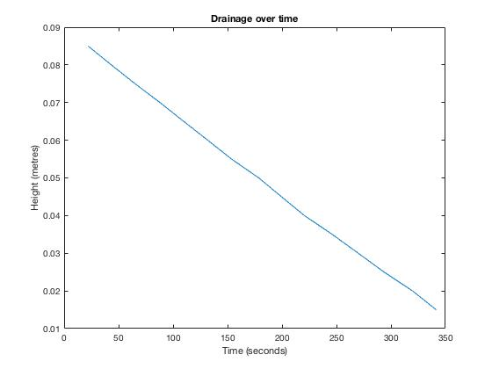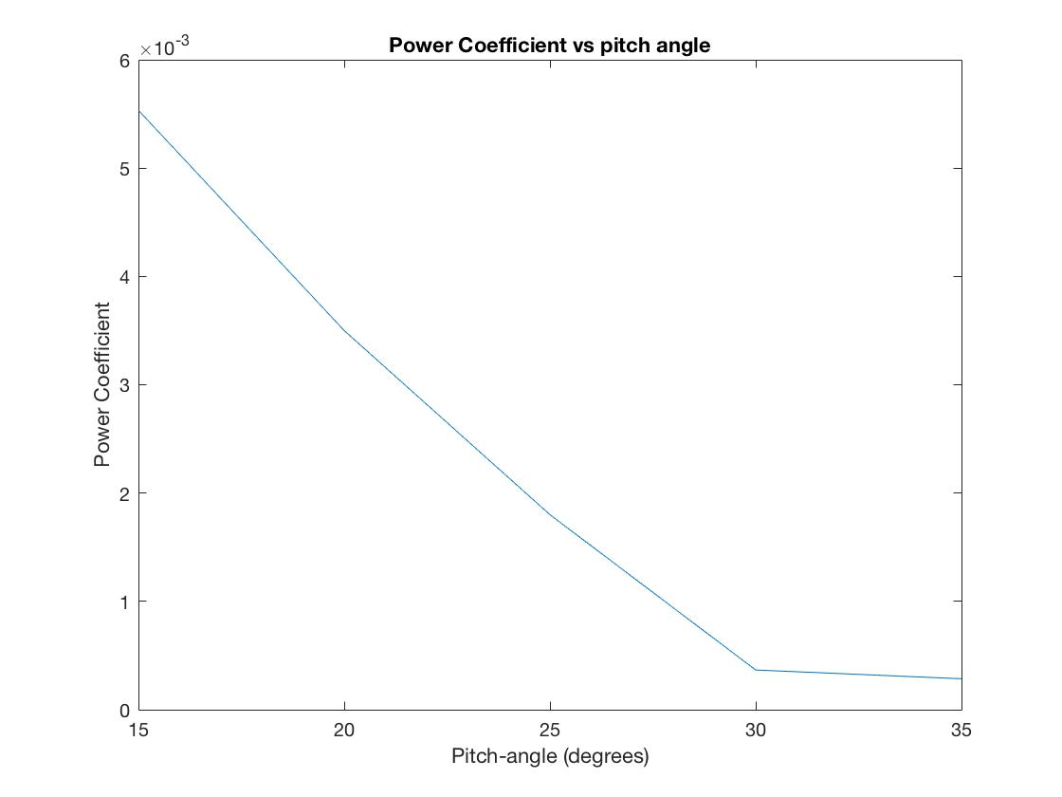

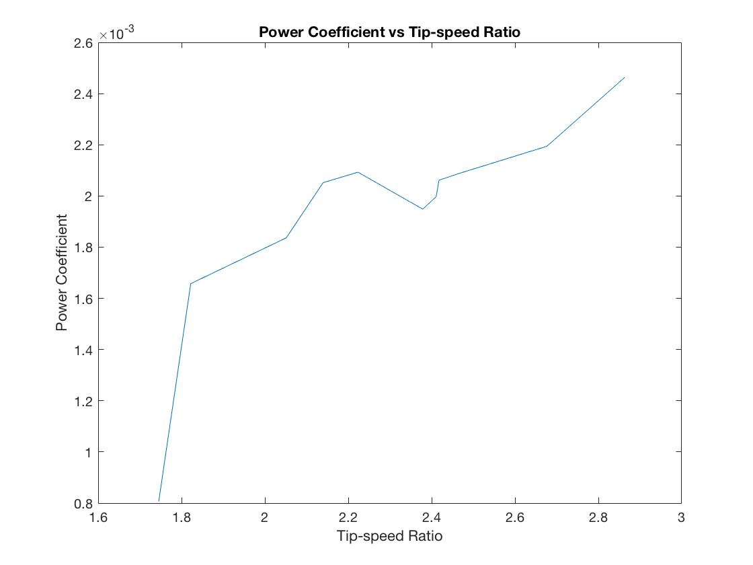

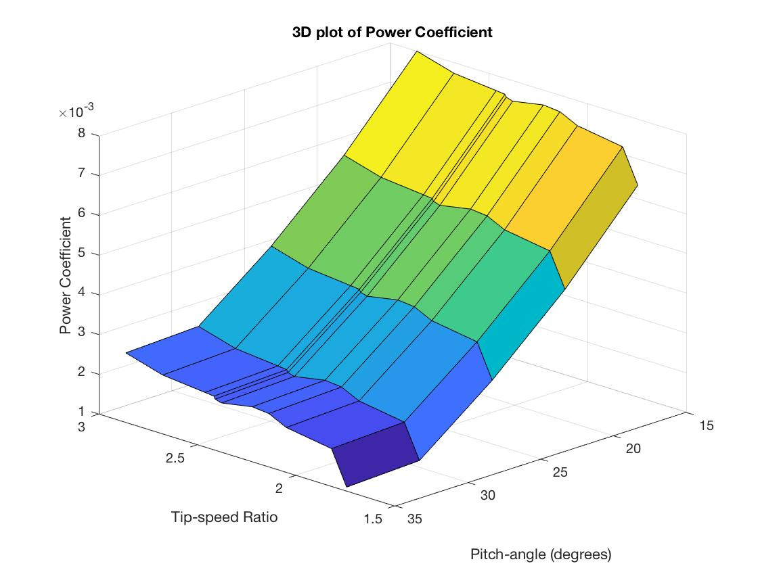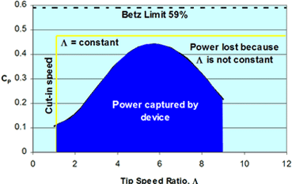

Bibliography:

van Kuik, G. (2007). The Lanchester–Betz–Joukowsky Limit. *Wind Energy, 10*. 289-291.

Magill, A. (2011). Power Output vs. Turbine Blade Pitch Angle. University of Rochester, New York, USA.

Cuerva-Tejero, A. (2012). A case study on optimum tip speed ratio and pitch angle laws for wind turbine rotors operating in yawed conditions. University of Padova, Padova, Italy.

Jeffery, R. (2013). Adverse health effects of industrial wind turbines. *Can Fam Physician*. 59(5): 473-475.

National Renewable Energy Laboratory (NREL). The S825 and S826 Airfoils. Retreived from https://wind.nrel.gov/airfoils/Documents/S825,S826_Design.pdf.

Water- a vital nutrients. (2014, May). Retrieved from https://www.betterhealth.vic.gov.au/health/healthyliving/water-a-vital-nutrient