**ENGR10004 ENGINEERING SYSTEM DESIGN 1 GROUP PROJECT FINAL REPORT**

**Workshop 3 Group 3: The Pioneers**

**ENGR10004 Engineering System Design 1 - Semester 1 2015**

**Melbourne School Of Engineering**

**University of Melbourne**

**Date of Submission: 9 June 2015**

**Abstract**

The purpose of this project is to create a water system in a remote community. A new water system is required due to high rate of population increase, which will affect the supply and cleanliness of water. The new water system compromise of three main systems: Water Tank/Storage, Wind Turbine and Water Treatment.

Creating the new water system requires basic engineering knowledge and data. Experiments are done in order to get the required data, which then be used to design the basic model of the water system. Further testing of the basic model is required to get most efficient result. Research on similar real-life water tank, wind turbine and water treatment is required to get most adaptable water system, based on the condition of the community.

Experiments were done using the experimental water rigs in order to get two important values needed for the final design: the discharge coefficient Cd and the pump flow rate Q. Experiments were also done with the miniature wind turbine to get the power coefficient CP (λ,β). These results are important in determining the materials and dimensions of the water tank and wind turbine.

The amount of water stored is essential for the water treatment, as it is required to get the volume of the CFSTR and the inactivation credit of giardia and virus. This is to ensure a safe and healthy water for the community.

In conclusion, through experimentations and research, the important data is required in order to create the design of the water system, that is adaptable to condition of the community.

Further research and experiments are required in order to get more accurate results as inconsistency of source data are the major problem in designing the water system. Using various materials and equipments in the experiments is preferable in order to get the best choice of design through comparisons.

**Table of Contents**

**Cover Page…………………………………………….... 1**

**Abstract………………………………………………….. 2**

**Table of Contents………………………………………. 3**

**Introduction……………………………………………… 4**

**Experiment Results**

**Experiment 1 ……………………………………… 5 - 6**

**Experiment 2 ……………………………………… 7 - 10**

**Experiment 3 ……………………………………… 11 - 13**

**Experiment 4 ……………………………………… 14 - 15**

**Project Design**

**Water Tank/Storage ……………………………… 16 - 19**

**Wind Turbine ………………………………………**

**Water Treatment ………………………………….. 20 - 23**

**Discusion**

**Conclusions**

**Recommendations**

**References**

**Appendix**

**Introduction**

The aim of this project is to provide a safe and clean water supply to a remote community.

The community have been using a traditional method, involving a system of ropes and buckets, to get water from an underground well. The current water system will not be able to provide enough water due to rapid increase in population. The group will be working on making a new water system, involving multiple disciplines of engineering, in order to provide a clean water system for the community that would last for at least a decade.

The new water system will involve a wind turbine, where the mechanical energy converted from the rotation of the wind blades blades due to surrounding wind, will generate electricity to power the pump placed in the underground well. The water will then be pumped to a water tank located above the ground through series of pipe. The water will then be disinfected in order to give a healthy supply of water.

Experiments will be done in a smaller scale to provide information in order to test and design a simplified model of the system. This simplified model will then be upscaled, with relevant informations of the community as considerations, to provide the perfect water system model.

The group were divided into three task-group, each representing the systems that are needed to complete the project. The water tank and Storage System is handled by Weixiao Wang and Yan Hua Mu. The Wind Turbine System is handled by Ben Ko and Dany Muhajir Sjafiie. The Water Treatment System is handled by Abner Librata and Wei Hsu. Each task-group is responsible for the experiments done in the workshop and the complete design of each system.

Regular meetings were set every week on Tuesdays at 12:00 p.m. to 14:00 p.m. at the Eastern Resource Center. These meetings were done in order to create and review the strategic plan that have been made until the end of the project, to consult about ideas regarding the each systems and discuss about the preparation for upcoming experiments..

**Experiment Results**

**Experiment 1**

**Aim**

The aim of this experiment is to determine the discharge coefficient of the provided system, in order to incorporate it into our own tank design.

**Background Theory**

When the water flows out of a tank, the height of water at any one time is given by the initial height subtracting the drainage speed times time taken. However as shape of the valves at the bottom of tanks differ, it directly affect the drainage speed.

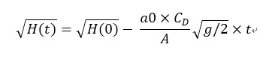

**Where;**

a) H(0); initial height

b) a0; orifice cross sectional area a0 = 0.0022 *pi

c) A; cross section area of tank A = 0.03075 m2

d) g; gravity

**Apparatus**:

* Two tanks, One structured on top of the other
* Stop watch.

**Method;**

1. Filled the top tank up to the seventh marking on tank, approximately 7 cm.
2. Opened the valve on the bottom of top tank and let water flow into the bottom tank
3. Recorement
4. Repeated the above steps 3 times for precision.

Results : (see Appendix A for further results)

**Analysis:** 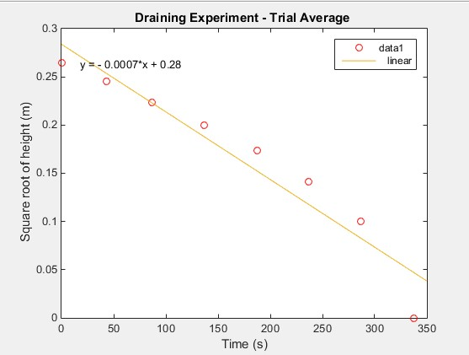

As this graph corresponds to the equation;



The equation of line of best fit must also correspond

y = 0.28 - 0.0007x

Thus it can be seen

drainage time 1.jpg

can be rearranged to

drainage 3.jpg

using the values provided above it is calculated that Cd = 0.77

From this graph it can be seen that the calculated discharge coefficient is very close to coefficient of valves of shape; sharp. Allowing for random errors it can be concluded that the valve of our tank is of similar shape as the second picture depicted; sharp.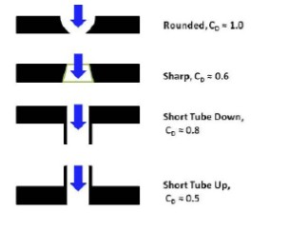

**Conclusion**

The experiment was successfully done, under just one hour, every group member participated in the experiment. The discharge coefficient was successfully calculated.

**Experiment 2**

**Aim**

The aim of this experiment is by determining the pump flow rate to create a model in matlab that accurately predicts the height of water in tank at anytime, knowing Cd (calculated in the previous Workshop)

**Background Theory**

The water storage system that is being designed involves multiple tanks. As the height of water in tanks that has flow in from another tank can be easily modelled,the first tank with pump flow in cannot be modelled yet.

In this experiment the pump will be powered to bring water from bottom tank to top. As the change of height with respect to time **(dhdt= a0*v/A)** in water drainage, thus in water pump is very similar;

Pump rate.jpg

Where Q is the pump rate, thus the gradient of the data that's collected multiplied by A will give Q

**Apparatus**

* Two tanks
* Control module
* Pump
* Powerpoint
* Stopwatch

**Method**

1. Set up the experiment by structuring one tank on top of the other (refer to picture below)
2. Filled the top tank first up to the seventh black marking on the container, approximate 7 centimeters.
3. Drained all the water from top tank to bottom.
4. Turned the control module to 9V, so the pump start pumping water from bottom tank to top
5. Recorded the time it took for the water level to rise by each centimetre increment
6. Repeated the above steps for 6V.

**Data**

|  |  |  |  |
| --- | --- | --- | --- |
| Height | 9V Time(s) | | 6V Time(s) |
| 0 | 0 |  | 0 |
| 0.01 | 35.4 |  | 54.4 |
| 0.02 | 69.4 |  | 109.2 |
| 0.03 | 99.7 |  | 169.4 |
| 0.04 | 133.4 |  | 233.4 |
| 0.05 | 166.2 |  | 296.7 |
| 0.06 | 201.9 |  | 358 |
| 0.07 | 235.7 |  | 420.4 |

**Results**

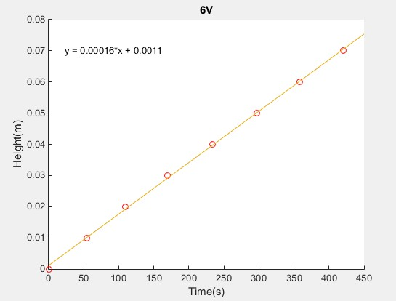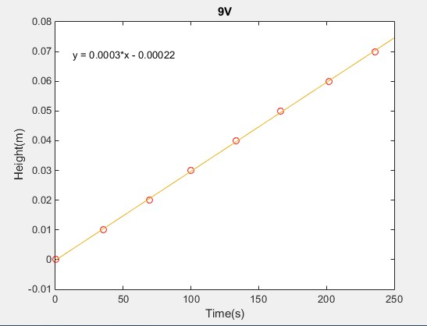

**Analysis**

As said previously that (A*dh/dt=Q), where dh/dt is the time rate of change of height.This means that the gradient of the graphs multiplied by A will give thier respective pump rate.

* A= 0.230*0.15= 0.0345 (m^2)
* 9V: 0.0345*0.0003= 0.00001035
* 6V: 0.0345*0.00016= 0.00000525

From the above calculation it can be seen that the flow rate Q of pump is directly affected by the voltage, a bigger voltage gives a faster flow rate.

**Further Application**

Knowing these key data, finally a graph of height that contains both inflow and outflow can be obtained.Using;

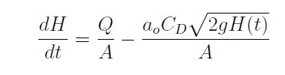

Two graphs are going to be plotted, using pump rates of 6V and 9V respectively. **As the initial outflow rate is greater than inflow rate, but height (H(t)) changes with respect to time; At one point the equation is going to equal to 0,( dh/dt= 0 ).**

The plotted graphs will be compared to see which pump rate reaches equilibrium state quicker and at which water level do they reach equilibrium state respectively. The equations of curves of best fit for both graphs do not tell much, but from the general trend of both graphs it can be seen that they reach an asymptote or a steady state.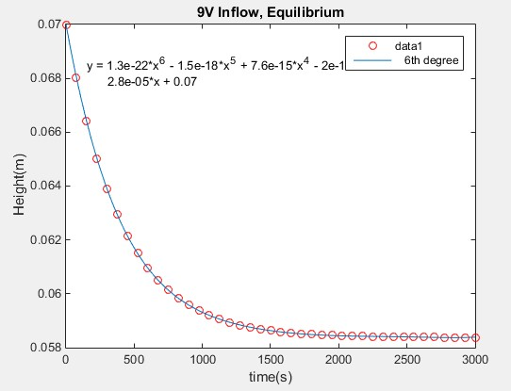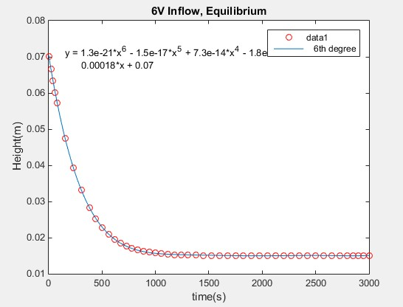

The decrease in water level eventually causes the outflow rate to equal to the inflow rate, thus reaching equilibrium point.Both pump rates causes the tank to reach equilibrium point, and intuitively it can be seen that the 9V pump causes the tank to reach equilibrium point faster at 5.8 centimetre, where 6V reaches equilibrium point at 1.5 centimetre.

**Our Design**

In our design of a pump and water storage system, a powerful pump may not be that desirable, as once the bottom tank fills up, outflow becomes zero, a lot of excess/untreated water will be left on the top tank, which is not very environmentally friendly, and stationary water increases bacterial growth.

**Conclusion**

This experiment is so far the hardest experiment we have done, it took us almost two hours. We managed to just finishing it before the workshop ends.It was thought that this workshop was be similar to last, and huge workload was unexpected, therefore alot of time was wasted at the start. However in general this workshop is quite successful, as all of the data are obtained and these data have been given some thought to, in order to make our own design better.

**Experiment 3**

**Aim**

To investigate the relationship between power coefficient CP (λ,β) and tip speed ratio λ, with constant pitch angle β

**Background Theory**

A wind turbine is able to generate power due to transformation of energy; from mechanical energy of the wind to rotational energy of the blades which is then transformed into electrical energy by the generator. Increasing the efficiency and reducing the drag of moving blade is essential to generate maximum amount of power. The power output (in Watts) of a wind turbine can be defined as:

power equation.JPG

*P =*

where:

* CP (λ,β) is the power coefficient and is dependent on the tip speed ratio λ and the pitch angle β;

lambda.PNG

* + *λ =*
  + where ω is the rotational speed of the shaft and R is the radius of the blade;
* Vw is the wind speed in m/s;
* ρ is the density of air in kg/m3;
* A is the swept area of the rotor in m2;

**Method**

Turn on the table fan and measure the wind speed Vw at 3 m/s, using the anenometer provided. Record the Voltage, Power and RPM produced by the turbine. Repeat the steps using different values of wind speed Vw with intervals of 0.5 m/s, ranging from 3 < Vw < 6.5 m/s.

**Results (see Appendix A for further results)**

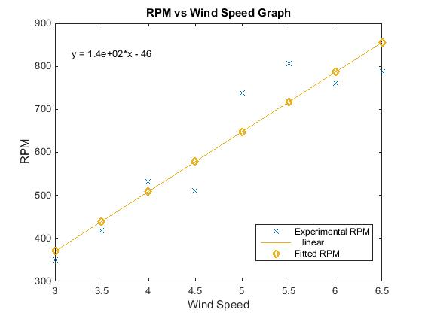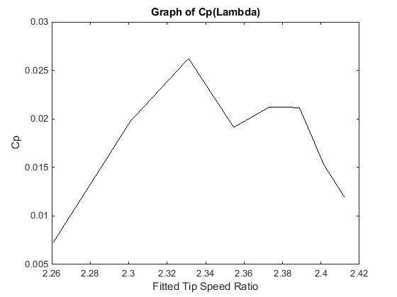

|  |  |
| --- | --- |
|  |  |
|  |  |

**Analysis**

The maximum value of CP (λ) from this experiment is 0.02623, which is relatively low. The graph of CP (λ) has similar trend to the theoretical graph but outliers can still be found. This is due to systematic and human errors in the experiment. Inconsistent wind speed is one of the major reasons why outliers can still be found.

**Experiment 4**

**Aim**

To investigate the power coefficient CP (λ,β) with various tip speed ratio λ and pitch angles β.

**Background Theory**

The background theory that is being used here is exactly the same as in Experiment 3, where to generate maximum amount of power from the wind turbine, it is required to increase the efficiency and reduce the drag of moving blade. Changing the pitch angle of the blades will reduce drag of the moving blades. Hence, a certain value of pitch angle will give a maximum power.

**Method**

Turn on the table fan and measure the wind speed Vw at 4 m/s, using the anenometer provided. Record the Voltage, Power and RPM produced by the turbine, using the brown pitch angle adaptors (15 degrees). Repeat the steps using different values of wind speed Vw with intervals of 0.5 m/s, ranging from 4 < Vw < 6.5 m/s. Repeat the steps using different pitch angle adaptors: black (20 degrees), 30 degrees (orange), 35 degrees (green).

**Results (see Appendix A for further results)**

|  |  |
| --- | --- |
|  | Cp fix.png |
|  |  |

**Analysis**

The maximum value of CP (λ, β) gotten from this experiment is 0.025665 where the value of λ and βare 0.955501 and 35 degrees respectively. As shown on the graph, there is an increasing trend of CP (λ,β) where the pitch angle β is increased. However, this value is considered not efficient as only a small amount of power generated from what expected. This is due to several systematic and human errors such as inconsistency of wind speed and low speed air were not able to cause the blades to spin, causing no power generated at certain values of λ and β. This can be improved by improving the design of the blades and using more wind speed data and trials to reduce errors in the experiment.

**Project Design**

**Water Tank/Storage**

The purpose of the designed water storage and pump system was to provide enough usable water for a remote village to survive. The designs of the water storage and pump were carried out taken considerations on the current population, population growth and average intake of water daily per person, in order to create the most efficient design possible.

The pump and storage system was designated to contain three tanks, an open tank for the pump to pump water in, a closed tank for chemical treatment and a closed tank for water storage. While the water pumping in rate or water inflow to the first tank is adjusted to be the same as the outflow rate from first to second and second to third.

The land area of the whole structure was efficiently designed to be as small as possible to leave room for future growth and expansion of the village. It is also noted that the first tank has to be situated on a 10 metres tower structure, therefore in avoidance of constant maintenance and potential danger, it also was designed to be as small as possible.

Design part of Tank system (Including Pump)

From the question

1. The remote community contains approximately 2,000 people.

2. The annual rate of the population is 1.2%

3. There is no airstrip and the distance to the nearest town of any significance is 2000 km.

4. The system should last a minimum of 10 years.

5. Water is only for drinking

6. The well is approximate 35 m deep

7. The only limitation on the height or land area that can be occupied by the complete pumping system is that the tower structure must be exactly 10 m high, with the tank sitting on top of this

8. Keep the system reactively small

*Water requirements of community*

1. How much water does a person drink per day?

The health authorities commonly recommend eight 6 – ounce glasses, which equal about 2 liters.

2. The total population of the community (for 13 years)

**2000 X (1 + 0.012) ^13 = 2335**

In order to make sure that everyone have enough water to drink, in case that someone take more than 2 liters. It is assumed that the maximum population is 2400.

3. The design of Tank

The design for the tank system is to have two separate tanks. The first one is for chemical water treatment and the second one is the water storage tank. Therefore, we can ensure the quality of our water.

How large should the size of the tank be?

The first thing to consider is that the necessity to provide enough water at any one time. Therefore, it is important to think about the emergency situation.

4. Emergency Situation

In the case of any emergency situations such as pump stopped working, or power storage broke and no electricity to drive the pump, it was thought that the tank has to provide enough water to the community for 2 days.

The reason for choosing two days is that the question mention that the community is 2000 km from other towns. 2 days is long enough for rescue. Furthermore, don’t want the tank to affect the environment and also minimize the cost. Hence the tank need to be relatively small. Otherwise 3 days or more of water would have been a much safer back up.

5. Emergency tank storage

Emergency water = time * population * the water requirement for each person

**2 * 2400 * 2 = 9600 liters**

**9600 liters = 9.6 m^3**

In another word, it is required for the storage tank to contain at least this much water at any one time.

6. The tank size & sensors

In the storage tank, there will be two sensors to control the pump. When the water touches the higher sensor the pump stop pumping water and the lower sensor is for opening the pump.

**Volume below the lower sensor:**

The volume below the lower sensor is the emergency water, that should provide at least 2 day’s water. That’s 9600 liters. Therefore, the volume should be at least 9.2 m^3.

**Volume above the higher sensor:**

Because the high sensor is the one to turn off the pump, it is important to make sure after the pump stops; the water in the chemical tank (first tank) shouldn’t fill the whole storage tank. Therefore, the volume should be the same or more as the first tank. Assumption is made to be 0.6 m ^3 (0.1 more than the chemical reactor tank of 0.5 just in case of excess water.)

**Volume between lower sensor and higher sensor:**

The volume should be fairly big. So it is not needed to turn on/off the pump in a short time, which will damage the system. Hence, the value would be 13.8 m^3 (consider about the cost and the effect to the environment)

Therefore, the total volume of our tank is

**0.6 +9.6 +13,8 = 24.0 m^3**

The tank will be a cylinder with the height of 4m.

The reason for choosing cylinder is that the shape cylinder can minimise our cost, also cylinder is easy for cleaning and repairing. (Refer to Material and Shape below)

7. Storage Tank (Close)

The storage tank is a closed tank. The reason for that is to guarantee the quality of water. A close tank can prevent it from the influence of rain and other pollution. Otherwise, the water treatment becomes meaningless.

8. Flow in (rate of pump) & flow out (rate of chemical to storage tank)

The plan for the flow in & flow out is trying to get the same flow in rate as flow out rate. Therefore, It is not needed to consider the situation when water is filling out the first tank.

To calculate the rate flow in, it is assumed that the flow rate can fill the storage tank that is the usage of water for 5 days in 2 days. In that case, the system is able to provide enough water community and slow rate gives chemical system time to do water treatment. The reason we choose 24000 liters is to give 50 liters per minute, as higher water flow is needed for the chemical reactor to produce more clean water for villager to drink.

**24000 liters/(4*3600) s = 0.834liters/s**

This is **49.8 liters/min**. Hence flow in and flow out of the chemical reactor tank will be approximated to **50 liters/min.**

Thus the flow in and out of the first tank should also **50 liters/min,** in order to achieve an equilibrium state in the first tank, so water level won’t rise above tank height.

**Designed System (Diagram)**

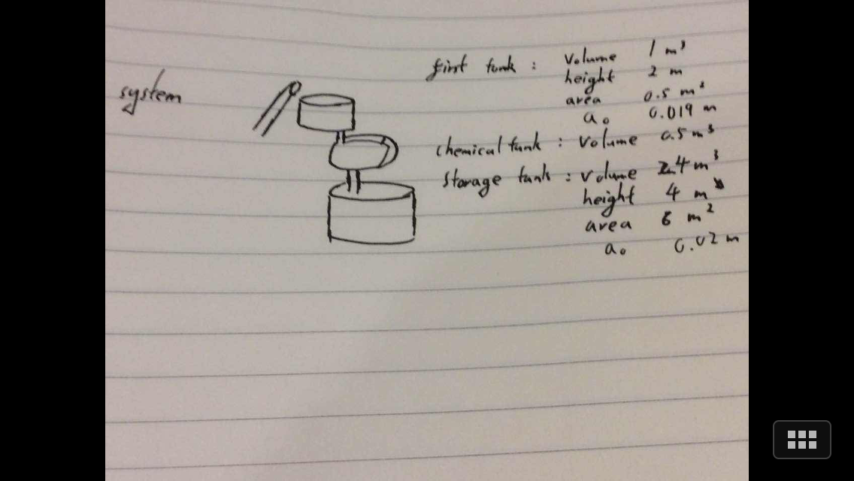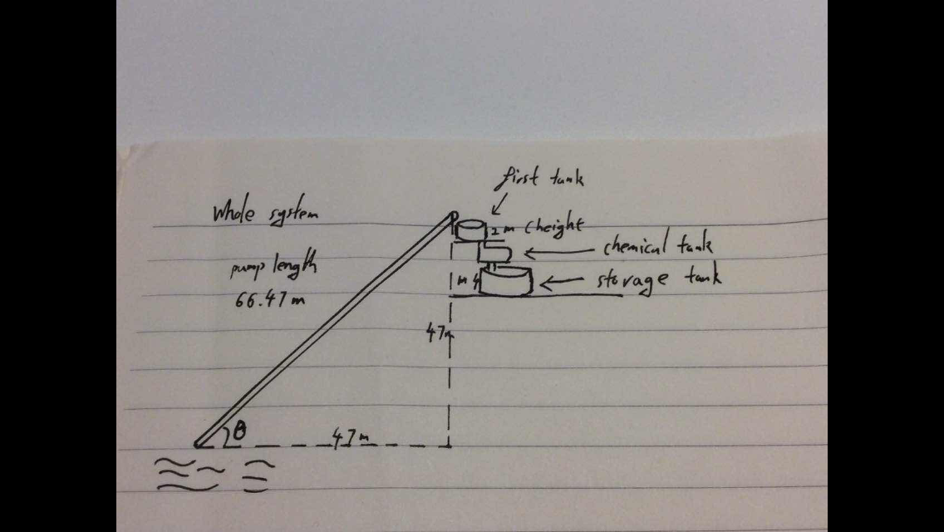

**Materials and Shape**

As the designing part comes to an end, it is important to consider the issues linked with realising the design. Two major issues that will affect the quality of water, cost and environmental impact are:

* Material of the tanks
* Shape of the tank

*Material of the tanks*

Water storage tanks are common in Australia, they are used frequently in rural areas; farms etc and regions where access to clean water is scarce. From all kinds of water tanks that are built in Australia, there is a few types of materials that seem to be more favourable than others;

* Polyethylene
* Concrete
* Steel

*Polyethylene*

Polyethylene made tanks have a few advantages over the other materials, due to its plastic nature, poly tanks can be modded into all kinds of shapes, while maintaining a very light overall weight. They are used very often in small commercial homes, where space is a concern. Poly tanks are UV stabilized, so to prevent the plastic from breaking down from sunlight and last around 15 years. It is also immensely cheap and easy to install, a common commercial tank of 22500 litres is around 2600 dollars

However despite its advantages there are a few uncertainties involved with poly tanks. Poly tanks are relatively new to the market their credibility in maintaining the quality of water is not certain. It has been reported that under full exposure of sunlight, there is a bit of odd taste to the water. It is also not environmentally friendly, after its serviceable life, it will take quite a long time to be recycled and releases toxic gas as it is being broken down.

*Concrete*

Concrete made tanks are known for its long lasting serviceable life and its ability to maintain the quality of water for a long period of time. It has great thermal mass meaning that the temperature of water inside tank are not greatly affected by high temperature and remains consistent. Concrete has been used in manufacturing water tanks for a long time and has great credibility. A normal concrete tank of 22500 litres the cost is around 4000 dollars.

Concrete is a porous material, which means a concrete tank will need proper sealing prevent minerals leaching into water. Thus concrete tanks are complicated to install and generally require a professional crew.

*Galvanised Iron*

Most steel water tanks are made from galvanised iron. Galvanised irons are coated with zinc to prevent erosion and have a typical service life around 12 years. A normal concrete tank of 22500 litres the cost is around 2800 dollars.

Even the these iron tanks are coated with zinc, they eventually still do rust and corrode, the zinc could also leach into water giving it quite a metallic taste.

**Table of Summary**

|  |  |  |  |
| --- | --- | --- | --- |
| Material | Concrete | Polyethylene | Galvanised iron |
| Service life | 20-30 years Warranty  Can last decades | 15 years | 12 years |
| Installation | Complicated | Very easy | Easy |
| Quality of Water | Possible mineral leach but can be addressed with proper sealing | Reported to add plastic taste when exposed under sunlight | Possible zinc leach adding metallic taste to water |
| Cost (22500 litre) | 4000 | 2600 | 2800 |

Considering these facts, the geological location of the village and that the water treatment and storage system is to be located above ground, concrete was chosen as the material for the designed water tanks. This is due to its long service life and ability to keep temperature of water consistent thus maintaining quality of water.

**Shape**

As the material is chosen to be concrete and the whole system is built on open ground, which eliminates the need of fitting water tanks in small unconventional spaces. There is only two shapes that can be chosen, rectangular or cylindrical. It is calculated above that 18000 litres of water will be installed in the water storage tank, this will impose quite an amount of pressure onto the water tank. A cylinder shape deals best with this pressure as its shape allows even distribution of pressure amongst all surface areas. This means that less concrete will be needed to reinforce the structure thus it costs cheaper than rectangular tanks. Cylindrical shape also maximises the volume and minimises the surface area, which means that not much land space will be occupied. Thus cylinder shape is chosen.

**Wind Turbine**

**Wind speed analysis**

Before the analysis, several assumption should be established:

·All NaN values will be treated as Wind Velocity (Vwind)= 0

·Vwind remains constants at the recording hour

·Wind will always incident the blade in same angle, from north to south according to the project document

Firstly, estimate the average wind speed (Vwind_mean) and the maximum wind speed over the year. The average wind speed can help us choose the appropriate lambda and Cp value, which lead to the RPM and power output of the turbine. The maximum wind speed (Vwind_max) can have a brief view of the possible break down.

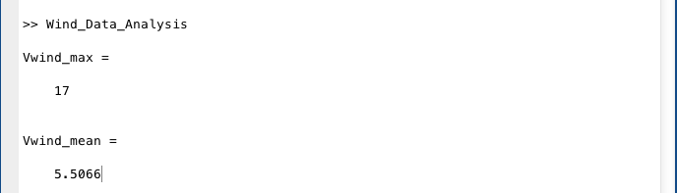

image_mean&max

Then, by the wind speed histogram (image_histogram), find out the dense area of wind speed, and have a better look in wind speed.

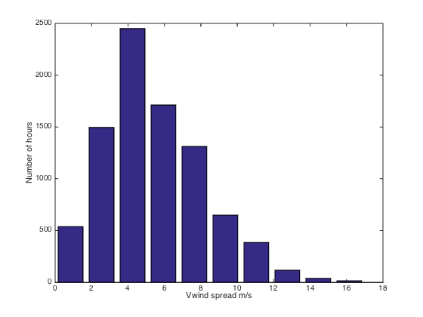

image_histogram

It is obvious that the wind speed concentrated in the range of 2.55~7.65, which means the estimated Vwind_average value will be precise.

Therefore, according to the experimental Cp value (image_Cp&lambda&beta) using pitch angle of 35 degrees:

Vwind_average = 5.5 m/s

Lambda = 0.942781

**Discussion**

After retrieving the experimental value, it is time to scale up the design.

-Design blade used in



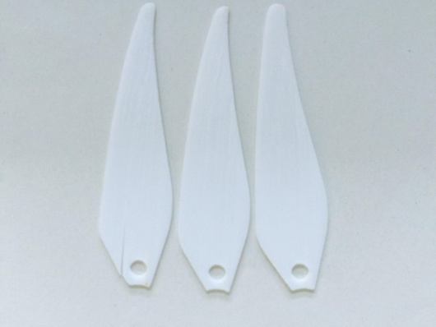

(image_designblade)

-Scaling up

Firstly, calculate the energy used per day in order to pump up 12 m3 water.

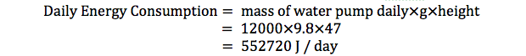The amount of energy is relatively large, and therefore 2 options are designed to satisfy the needs of the pump.

**Option 1: Direct powering**

The first option is that turbine power up the pump directly. According to the chemical team, the chemical reactor only works 4 hours per day. Therefore, in order to provide a stable (fix) in flow rate of water for the chemical reactor, the turbine have to provide enough power for the pump, which will have the pump rate equals to the flow in rate of the chemical reactor.

From the formula:

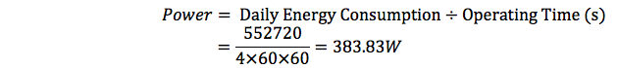

And



Therefore

It turns out that:

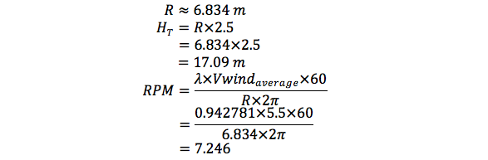Where

R is the radius of the turbine

Ht is the height of tower

RPM is the revolution per minute

Besides, there is an implied requirement that every day should have a continuous 4-hour period with an average wind speed larger or equal to Vwind_average, 5.5m/s, in order to keep the system functioning.

**Option 2: Charge a battery, which provides power to the pump continuously.**

The second option uses a battery between the turbine and the pump as energy storage. Wind turbine will operate and charge the battery continuously, as long as the wind speed is sufficient. On the other hand, the battery will provide power to the pump when the pump is working, which is 4 hours per day.

By using the same formula used above,

Therefore,



Where

R is the radius of the turbine

Ht is the height of tower

RPM is the revolution per minute

This option requires a nearly unstoppable battery (or energy storage system) in order to store enough energy for the pump operation. This means that there should be more than 1 battery in the system.

The shapes of the scale-up wind blades will be:

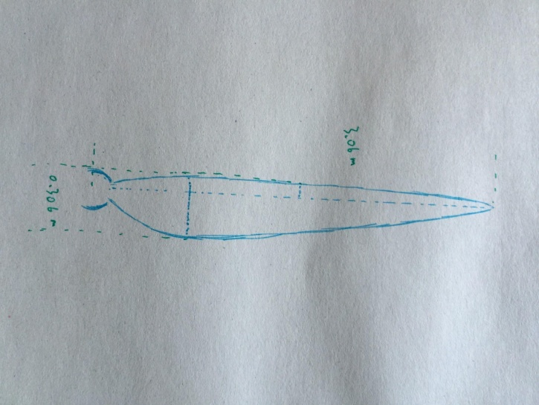

(image scale up blade)

In order to have a more complete comparison, 2 matlab files (Appendix 04) are built to simulate each option under the real world wind data. The result is shown below.

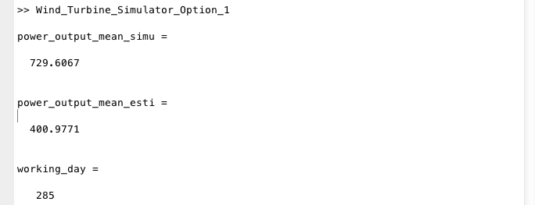

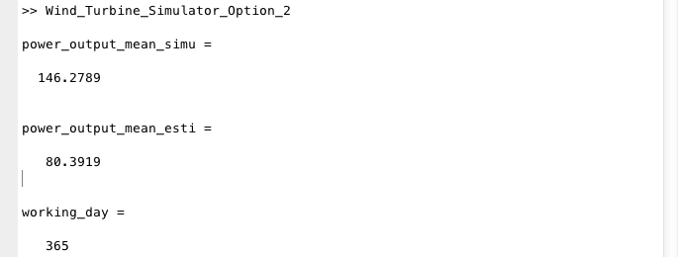

The result from matlab seems not agree to the estimated value; It has a much larger average power output than that calculated with Vwind_average. This may because that power output is proportional to cubic wind speed (Vwind), and there is a certain amount of windy days (Vwind > 10 m/s) which pulls up the power output directly. However, according to the formula:



When wind speed increases, RPM increases slightly; therefore lambda decreases and power coefficient (Cp value) falls. So my assumption of fixing lambda will not valid, and the power output may be balanced.

Here is the table that compares both options’ specifications.

|  |  |  |
| --- | --- | --- |
|  | Option 1 | Option 2 |
| Radius | 6.834 m | 3.060 m |
| Maximum width | 0.683 m | 0.306 m |
| Pitch angle | 35 degrees | 35 degrees |
| Tower height | 17.09 m | 7.650 m |
| RPM | 7.246 | 16.18 |
| Working hour | 4 hours/day | All day long |
| Power output | 399.5 W | 80.39 W |
| Operating days | 285 | 365 |

Although option 1 has a higher output and less working hours, option 2 is better and therefore used as the final design. It is smaller, lighter and therefore more feasible. The tower height required for option 1 is way too high, and it is too big for a village water pumping system. The RPM value, 16.18, falls into the range between 10 to 25 RPM, but that of option 1 only gets 7.2, which is too slow. More importantly, it can provide the sufficient energy for the pump to operate every day and there is still energy left, while option 1 can only power the pump for 286 days out of 365.

**Material**

The material that the turbine used for its blades and the structure in the experiment is plastic. However, this is not strong enough for the real life situation, and the prototype has been damaged due to our experiments. The use of material is very important since the blade is designed a 12-year working period, and any break down, especially physically break down, will be vital for this rural village. The chose of material should has several consideration:

·Strength

Since the village near seacoast, high wind shear might often appear. Besides, the lift-induced drag requires a strong material in order to prevent break down.

·Long lasted

The system is built for at least 12 years, which means the material used should have long life.

·Anti-corrosion

The air will have high humidity and saltiness, which can cause corrosion on metal. Therefore, an anti-corrosion coat or a non-corrosion material should be used for the blade.

·Weight

The weight of blades directly affects the efficiency of the wind turbine.

·Cost

The aim of the design is not only building out the system, but also using the most appropriate cost and expenses.

After the research, two materials satisfy above requirements:

·Aluminum alloy

Aluminum is one of the lightest metal that usually used in aircraft constructions, with the density of 2712 kg/m3. This lowers the blade weight. Also, aluminum oxidized so quick, that it will form an aluminum oxide layer on the outer side of the blade. This layer can prevent the inner aluminum from corrosion of air, water and chemical. Besides, it has a competitive price, which will lower our design expenses.

On the other hand however, aluminum blades has to be manufactured in factories and transported to the village since it has a melting point of 660 degrees. Also, it may start vibrating back and forth if drag is big enough, which can cause vital damage to the blade. Its conductive may also put the blade into a dangerous circumstance in this rural area since it might be the highest building in the area.

·Fiberglass (Glass fiber + plastic)

Fiberglass is a plastic material that reinforced by glass fiber. It is a lightweight polymer, with the density of 2000 kg/m3. Its polymer allows it not to corrode with acid and base, and can be easily mold under low temperature. It is a high strength material that can undergo extreme situations, and its non-conductive property may protect the system. In addition, its price is similar to aluminum price.

However, it has a low melting point and it will turn to char at high temperature. When lighting shocks the blades, they might not be able to survive, but the system will be fine.

The final choice is fiberglass. Its less restrictive molding allows on site molding, which not only makes molding more convenient, but also means that blades can be reproduced in the village with the same mold that used by the installed blades in case of vital breakdowns of the blades. It costs only 1 AUD per square meter, which is low and acceptable, and it is strong enough to operate in long time period.

**Shape**

The basic idea is to have a wider base (the side connected to the hub) and thinner tip (the side spin fastest). The base will be larger because the tip turns faster than the center (tip speed ratio), and the blades can be torn apart at high wind speed if the base is too small.

The 3D printed blade used in the experiment is flattening out, since it will be much easier to be printed. The real blade, however, will have a curved surface instead of flat one. The 3D printed blade in the experiment has a large-scale vibration (compared to its size) under low wind speed, and cause itself damaged. This might because the drag on the blade is too large, and the surface is rough. Therefore, a more aerodynamic structure should be used instead.

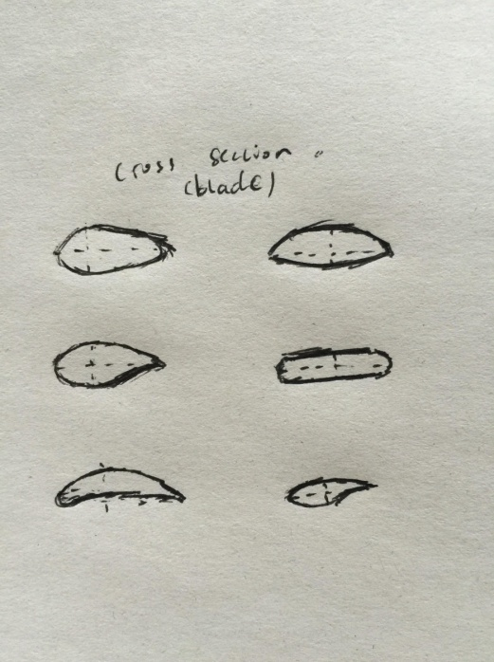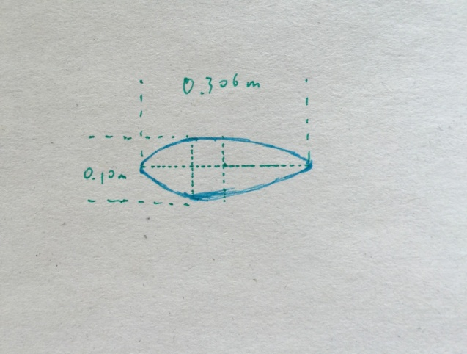

(left: researched cross section, right: used cross section)

The curved structure allows wind to pass through the turbine smoothly. This may reduce the chance of vibrating and increase the lift produced by the turbine. Besides, when dealing with wind shear, this more aerodynamic structure will have less react with it, and result in less or no damage.

**Tower**

Tower is the structure that supports the hub and blades above the ground. Similar to the blades, it has a thinker base (stands on the ground) and narrower top (connects to the hub and blades). The length of blades determines the its height with the relationship:

 This relationship ensures that the blade will have sufficient space to spin. The wind turbines that sold only, both home use and commercial, have the tower height to radius value between 2 to 3. Therefore, the choice of 2.5 as a scalar factor is acceptable.

Besides the height, the tower has an automatic “raising up – laying down” procedure. This is a machine arm placed at the base of the tower (as the graph shown). The arm device will store part of the energy while the wind turbine is working. It can automatically bring down or rise up the tower. This makes wind turbine maintenance and repair more convenient. Besides, if extreme weather occurs (such as tornado), it can lay down to the ground level height and protect the structure. This is feasible because the tower is only less than 10 meters high. In addition, several wire ropes connect the top of the tower to the ground (each with a “pulling - releasing” system). These ropes can provide extra stability to the tower, and can raise the tower manually if the machine arm goes wrong.

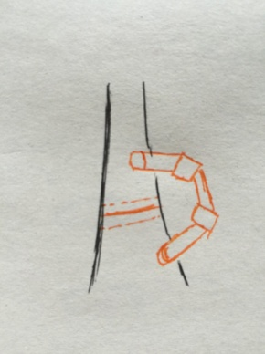

(image_machinearm, orage part)

**Water Treatment**

Villagers can’t drink water that are pumped just yet. water needs to go through water treatment process before anybody can consume it. The water treatment process requires ozone to be added into the unclean water. Ozone acts as a strong oxidizing agent that will kill all the bacteria in the water. In order to add sufficient amount of water a CFSTR tank is used to process the water and disinfect it so villagers will be able to have clean water to drink.

In the design of the water treatment tank, there are certain factors needed to be calculated to satisfy all the villagers needs. The tank material has to be acceptable as well to eliminate the probability a slog growth, resistant to climate changes and most importantly chemical reactions with water inside the tank. Taken all those factors into account. The design of water treatment process tank are conducted as follow:

1. Material of reactor tank.

4 types of materials are taken into account upon deciding on the water reactor tank material. The list of materials are : 1. Steel 2. Concrete 3.Fiberglass 4. Polyethylene.

Each material have different characteristics and therefore has its own advantages and disadvantages if used for the reactor tank. Take steel for instance, steel is capable of holding large amount of water however its corrosive properties could lead to metallic taste of water.

Concrete is a very strong and long lasting material. However, concrete secretes lime which can leak into water if it cracks. Hence giving water a pungent taste of lime. as for Fibreglass, their stiff and rigid, but relatively thin and light properties make them brittle and prone to cracking.

Therefore, Polyethylene is used as it has many beneficial factors. including its strong, lightweight,non-corrosive and flexible properties. Polyethylenes are also very easy to install due to their strength and lightness.

1. Calculation of the volume of clean water produced per day with different operating time.

The CFSTR can only operate in the range of (1hr< T(operate)<4hr) per day. It can not operate for more than 4 hours. The water flow in rate to CFSTR tank is 49.5 liters/min. With these values, using the formula [Volume of clean water = flow in rate* operating time] Range of volume clean water produced are listed below:

From These value, time of operation of the tank per day should be 3.5 hours. As a minimum of 9000 liters of water is needed to satisfy the whole village water needs for two days. The CFSTR will operate only for an hour for the third day in order to satisfy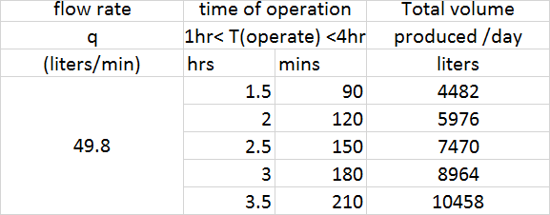

1. Calculation of the volume of reactor tank.

A range of value for the volume of tank is used in order for the system satisfy residence time must be more than 10mins. Residence time is calculated by the formula [Residence time = Volume / Flow in rate]. The following table shows how the change in volume would change the residence time.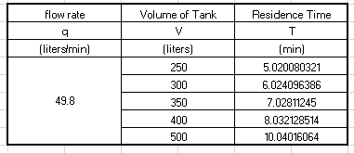

Therefore Volume of the reactor tank is 500 liters as it satisfy residence time > 10min.

1. Calculate rate constant k*

First of all, range of Temperature is selected, In this case 15,20,25,30, and 35 degree celsius. Then the half life of ozone at different temperature is determined (from workshop part A). Afterwards find k* using the formula ln(Ca/Cao)=-k* t , where (Ca) is concentration at time t, (Cao) is the initial concentration, and (t) is the half life of ozone. plugging those value in.Series of value of k* will be calculated as shown below.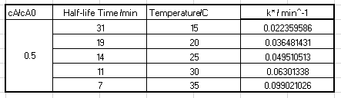

1. Calculate concentration of ozone remaining.

Use the value of flow in rate q, Volume of tank V, Initial concentration of Ozone given, and k* calculated above to measure concentration of ozone remaining using the following formula: Ca = q*Caf/(q+kV). Va 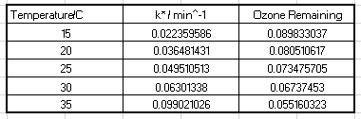

1. Calculate log inactivation credit for viruses and Giardia

Select a range of temperatures similar to that of ozone decay constant. (15,20,25,30, and 35 degree celsius) Then, use formula [Kv = 2.1744*(1.0726)^T] for rate constant of virus and formula [Kg = 1.0380*(1.0741)^T] for rate constant of Giardia.

Calculate inactivation credit by using formula:

1. For Viruses Log10(N0/N) = kv * Ca * T
2. For Giardia Log10(N0/N) = kg * Ca * T

Where Ca is ozone remaining and T is the varying temperature.

Inactivation credit for viruses must be greater than 4(log). While inactivation credit for Giardia must be greater than 3(log). The table below show the value of kgiardia and kvirus at different temperature.

From these value, as kgiardia is more than 3 and kviruses is more than 4. Our tank is able to dissolve all those bacteria present in the tank.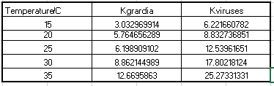

|  |  |  |  |  |  |  |  |
| --- | --- | --- | --- | --- | --- | --- | --- |
|  |  |  |  |  |  |  |  |
|  |  |  |  | |  | |  |
|  |  | |  | |  | |  |
|  |  | |  | |  | |  |
|  |  | |  | |  | |  |
|  |  | |  | |  | |  |
|  |  | |  | |  | |  |
|  |  |  |  |  |  |  |  |

**Discussion**

Water Storage:

The water storage and pumping system was designed following the criterias specified by the villagers and also conditions posed by water treatment. The whole system is designed under the assumption that it will last 13 years, thus the flow in and out and capacity of water tanks are designed to provide enough water for 2400 people in 5 days. Thus the volume of water storage tank has to be 24000 litres(calculation reveals 2335 people after 13 years, but to account for limitations of the model it is made 2400).

There are three tanks in the system, first tank where the pump pumps water into, the water in first tank then goes to chemical treatment tank and at last to storage tank. The first tank is designed to have the same volume as water treatment tank 600 litres, to save space and also for safety reason as it is on a tower. The pump in and flow out rate of first tank and chemical tank are designed to be the same, to achieve an equilibrium in water levels in both tanks, to minimise sizes of two tanks.

The distance 2000 km of this village from the closest city was a key factor in determining the reserve water. It was assumed under any unsolvable emergency situation, which results in pump stopped working, people from other cities will take at most two days to come and rescue the village. It is researched that each person should drink at least 1.5 litres a day. Thus a reserve of 9600 litres of water has to be available at anyone time. This is ensured designing the volume under low sensor 9600 litres. When water level hits low sensor the pump will start pumping water in again, thus ensuring there’s always 9600 litres reserve water.

Having a low sensor meaning also having a high sensor, as the water pumped up will go through a water treatment tank before it goes into water storage, the volume above high sensor which turns off the pump has to match volume of water treatment tank 600 litre. Therefore the volume in between two sensors can be calculated as 13800 litres.

Wind Turbine:

The main issue for the turbine design is that Cp value is way too small. According to Betz’s limit, the maximum output power is



and the current output is



The efficiency will be

The current design may only reach 2.58% of the maximum, which is not efficient enough. The reason is mainly because the Cp(lambda, beta) is too small. According to the optimal Cp-lambda graph, Cp value should reach maximum when lambda is 8. Conversely, the maximum value of lambda from the both experiments is 0.94. This shows that the experiment should be altered and improved in order to have a close-to reality lambda and Cp values.

Water treatment:

From the results above, it is clearly shown that we have optimized the amount of clean water generated under limited conditions. Regarding the volume of the tank, we are expected to generate 9000 litres of water in one day to supply the village for few days. Hence, 500 litres tank is chosen under the inflow rate 49.8 litres per minute. Regarding the disinfection, ozone is chosen because of its few advantages. One of them is that ozone is eco-friendly and another advantage is that its lethality cofficient is 10~100 times more powerful than the chlorine. we are expected to eliminate a least over 99.9% of Glardia and over 99.99% of viruses over different temperature.

Regarding the cost , despite that we are running a non-profitable project , we still have to estimate the total cost in this project. For instance, the ozone used for disinfection will certainly be left out despite of the temperature. Hence, the unreacted ozone will be included. Apart from those raw material of unreacted chemicals, there are few categories of costs have to be included such as maintenance of the machine , the personal operating the reactor etc.

**Conclusions**

Water Storage and Pump:

The design of the water storage and pump system is carefully thought through, synchronised with water treatment to save as much space as possible. The in flow from pump and outflow of both the first and chemical tank are made same to achieve equilibrium in water level, so these two water tanks do not need to ‘store’ water, thus saving cost, material and space. Key figures that are calculated from which the design is based upon are all rounded up; such as last 13 years instead of 10 years, population of 2400 instead of 2335. This is done to account for limitations in the calculation model, meaning dramatic boom in population etc.

Wind Turbine:

The wind turbine power system can be briefly presented by the image below.

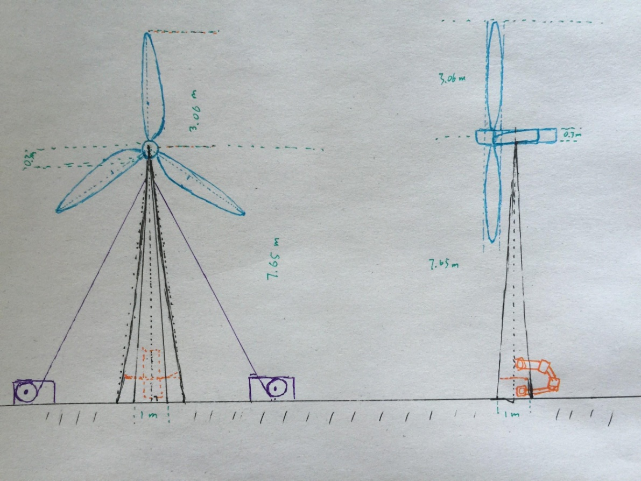

(complete wind turbine system)

In this image, purple represents the wire rope and and “raising up - laying down” system; orange represents the machine arm settled at the base of the tower; blue represents the wind turbine blades and hub; black represents the ground and the tower. The turbine will be connected to an industrial battery series, which powers the pump.

Water treatment:

To sum up, water treatment is one of the most essential processes in this project because it makes the unprocessed ground water drinkable and accessible for villagers. Similarly , chemical engineering not only processes the skills required for calculation and MATLAB, but also considerate the profits and costs economically of the project. There are some improvement we can make for this section is that postpones the operational time of the reactor to increase the efficiency and the productivity of the reactor.

**Recommendations**

For the wind turbine section, the major issues is the imprecise of the experiment. The experiment should be more precise. The apparatus used in the workshop are a typical fan and a small size of wind turbine. However, the fan produces real-life wind speed situation - a fluctuating wide-ranged wind speed. This directly cause the inaccurate RPM and output power, which cause inaccurate lambda estimation and Cp value. Therefore, a wind cave that provides more stable wind should be used instead for higher accuracy. Also, the material of the experimental blades should be as same as the designed one. Better experimental results can provide better predict on the real life situation of the wind turbine.

The main issue for water treatment would be the resident time need to be more than 10 mins. if water can stay in the tank for less than 10 mins process will be faster and more clean water will be produced at less time assuming volume of tank remains the same.

At larger flow in rate (q) would also make the system more efficient as operating time would be less in order to provide the amount of water needed to supply the whole village.

Water storage and Pump

The calculated power of pump is 91.479 Watts, which is essentially 91.479 Joules per second, which is some what high considering the situation. As wind is the only energy resource it is best to minimise as much power as possible. To minimise the power consumed by pump there is 1 very efficient way, instead of situating the pump on an angle and pumping up water on a slope. The pump could have been made 90 degrees to the well so it pumps water straight up from the well into the tank, this would minimise the pump rate and thus as power is directly proportional to it, it would minimise power use.

**References**

*Water requirement*

*http://authoritynutrition.com/how-much-water-should-you-drink-per-day/*

Bradley, K. (2011). *Water Tank comparisons for drinking water: defining clean and green.* Retrieved from <http://www.milkwood.net/2011/02/14/water-tank-comparisons-for-drinking-water-defining-clean-and-green/>

*Concrete.* (n.d.). Retrieved from <http://tankulator.ata.org.au/tank-materials-concrete.php>

*Control Algae in Drinking Water.* (n.d.). Retrieved from <http://www.coptrol.info/Coptrolspecificuse/Coptrolindrinkingwater.aspx>

*ECWA Water Treatment Process.* (n.d.). Retrieved from https://www.ecwa.org/treatmentprocess

Gunnars, K. (n.d) *How much water do u need to drink per?.* Retrieved from <http://authoritynutrition.com/how-much-water-should-you-drink-per-day/>

Ozone disinfection Comparison of disinfectant. (n.d.). Retrieved from <http://www.lenntech.com/library/ozone/comparison/ozone-disinfectants-comparison.htm>

Steel vs Concrete vs Fibreglass vs Poly Tanks. (n.d.). Retrieved from <http://www.nationalpolyindustries.com.au/info-centre/education/steel-concrete-fibreglass-poly-water-tank-material/>

Writing the introduction. (n.d). Retrieved from http://www.monash.edu.au/lls/llonline/writing/business-economics/marketing/2.2.2.xml

Water Quality and Treatment. (n.d). Retrieved from <http://www.clevelandwater.com/your-water/water-quality-and-treatment>

Water Tank Comparisons. (n.d). Retrieved from <http://www.californiaconcretewatertanks.com/Water_Tank_Comparisions.html>

**Appendix**

**Appendix A: Experiment Result**

**Experiment 1**

* Matlab codes:

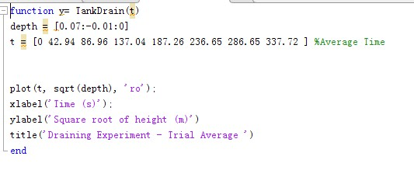

**Experiment 2**

Pump Rate 9V & 6V (Matlab Codes)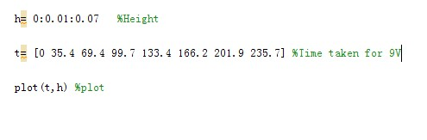

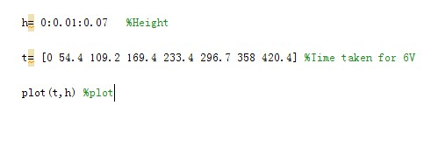

Equilibrium 9V & 6V (Matlab Codes)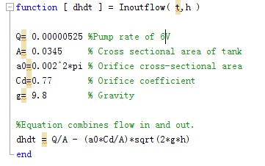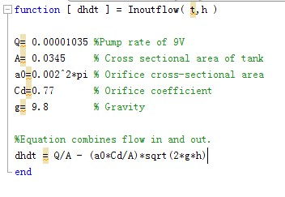

**Experiment 3**

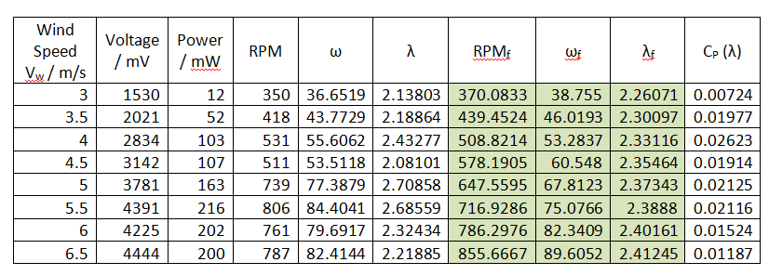

**Getting Fitted Values of RPM, ωf and λf**

* 1. Enter the data for the measured experimental data for RPM and wind speed Vw into MATLAB as row vectors **RPM** and **Vw.**
  2. Plot RPM versus Vw using the **plot (Vw, RPM, 'x' )** function. There will be a linear relationship for most of the wind speed values with some outlying values.
  3. In the Figure window, Go to "Tools" --> "Basic Fitting", select "Linear" and "Show Equations".
  4. Click on the right arrow at the bottom of the window to reveal the "Numerical Results" pane. Click on the arrow again to show the "Find y = f(x)" sub pane.
  5. Enter the variable that contains the wind speed data **Vw** into the box next to the "Evaluate" button and then click on this button.
  6. MATLAB has now recalculated the RPM points so that they lie on the linear fit line, effectively "fitting" them. Click on the "Plot Evaluated Values" button.
  7. Export the new fitted values to the workspace. Click on the "Save to workspace" button. Choose **RPM_fit** when asked to input the variable name.

**MATLAB**

**RPM = [350 418 531 511 739 806 761 787]; % Experimental RPM**

**Vw =[3:0.5:6.5]; % Wind Speed [m/s]**

**P = [12 52 103 107 163 216 202 200]; % Power Generated [mW]**

**R = 0.175; % Radius of Blade [m]**

**rho = 1.2754; % Density of Air [kg/m^3]**

**A = pi*R^2; % Swept Area [m^2]**

**w = 2*pi*RPM/60; % Experimental Rotational Speed**

**lambda = w*R./Vw; % Experimental Tip Speed Ratio**

**plot(Vw,RPM,'x'); % Graph of Experimental RPM vs Wind Speed**

**title('RPM vs Wind Speed Graph');**

**xlabel('Wind Speed');**

**ylabel('RPM');**

**legend('Experimental RPM');**

**RPMf = [370.083333333333;439.452380952381; % Fitted RPM**

**508.821428571428;578.190476190476;**

**647.559523809524;716.928571428571;**

**786.297619047619;855.666666666667]';**

**wf = 2*pi*RPMf/60; % Fitted Rotational Speed**

**lambdaf = wf*R./Vw; % Fitted Tip Speed Ratio**

**Cp =2*P*(10^-3)./((Vw.^3).*rho*A); % Power Coefficient**

**figure;**

**plot(lambdaf,Cp,'k-'); % Graph of Cp(Lambda)**

**title('Graph of Cp(Lambda)');**

**xlabel('Fitted Tip Speed Ratio (Lambda)');**

**ylabel('Cp');**

**Experiment 4**

**MATLAB**

**Vw = [4 4 4 4; %Wind Speed [m/s]**

**4.5 4.5 4.5 4.5;**

**5 5 5 5;**

**5.5 5.5 5.5 5.5;**

**6 6 6 6;**

**6.5 6.5 6.5 6.5]**

**beta = [15 20 30 35]; %Pitch Angle [degrees]**

**R = 0.102; %Radius of Blades [m]**

**rho = 1.2754; %Density of Air [kg/m^3]**

**RPM = [NaN NaN 281 NaN; %RPM**

**NaN NaN 397 NaN;**

**NaN 310 450 NaN;**

**NaN 340 485 492;**

**NaN 390 511 534;**

**NaN 408 535 555];**

**P = [NaN NaN 11 NaN; %Power Output [mW]**

**NaN NaN 22 NaN;**

**NaN 11 53 NaN;**

**NaN 12 68 89;**

**NaN 33 71 97;**

**NaN 13 80 102];**

**A = pi*R^2 %Swept Area [m^2]**

**w = 2*pi.*RPM/60; %Rotational Speed of Shaft**

**lambda = w.*R./Vw; %tip speed ratio**

**Cp =2*P*(10^-3)./((Vw.^3).*rho*A); %Power Coefficient**

**surf(beta,lambda,Cp);**

**title('Modelling Cp');**

**xlabel('Beta');**

**ylabel('Lambda');**

**zlabel('Cp');**

**Appendix B: Project Design**

**Appendix 01**

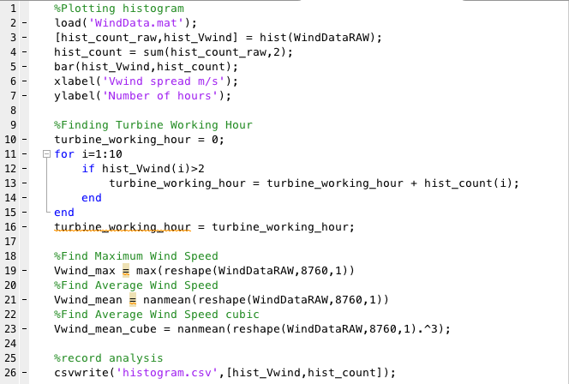

**Appendix 02**

Option 1

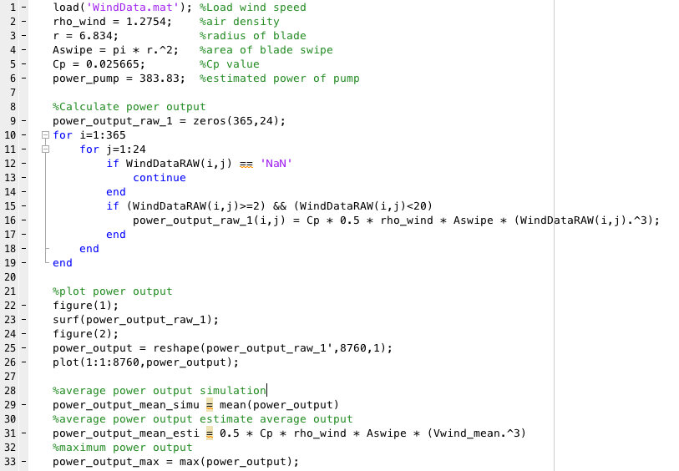

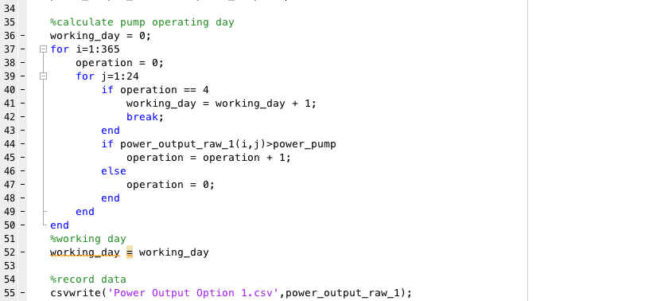

option 2

