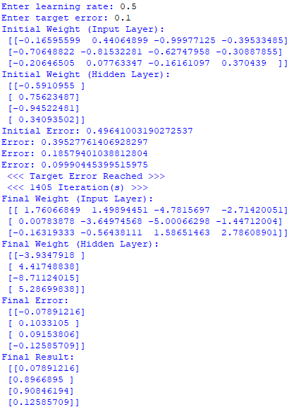

Learn Rate = 0.5, Target Error = 0.1

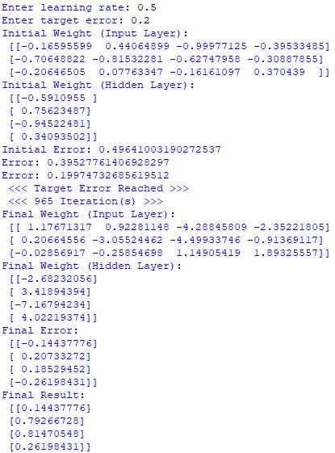

Learn Rate = 0.5, Target Error = 0.2

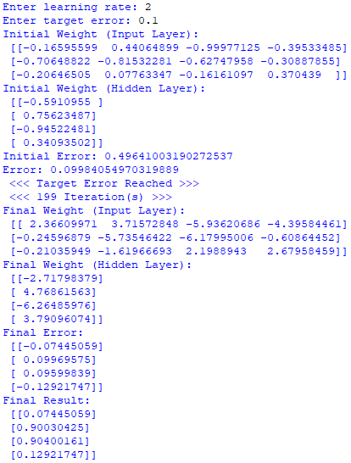

Learn Rate = 2, Target Error = 0.1

All outputs are slightly more accurate except for the 4th, which worsened.

Higher learn rate, fewer iterations needed.

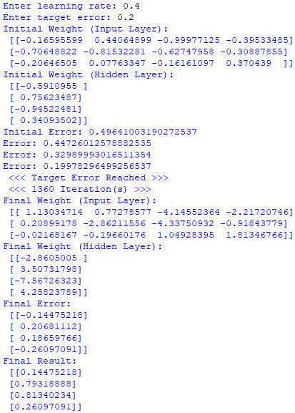

Learn Rate = 0.4, Target Error = 0.2

All outputs are slightly more accurate except for the 1st, which worsened.

Lower learn rate, more iterations needed.

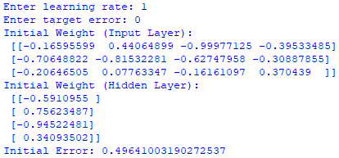

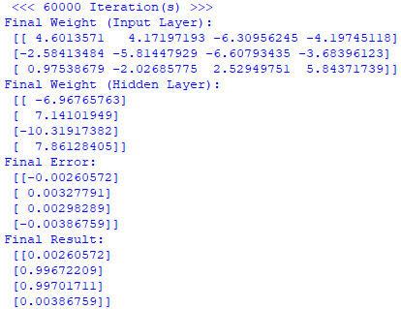

Learn Rate = 1, Target Error = 0

Maximum number of iterations reached (60000)