**Representations, consciousness memory in goal-directed behavior**

**Abstract**

Voluntary actions have been characterized as an internal, spontaneous and goal generated behavior. In volition, the presence of any external stimuli could reduce how voluntary and free an action is. This makes voluntary action very hard to study as any type of external interaction could damage the nature of the generated action. To address this limitation, in this experiment we proceed with using a problem-solving activity: Tower of London (ToL), where there is a goal state subjects are aiming for. Thanks to this, not only is the endogenous action embedded within a more general framework of problem solving, but also the actions now have an end purpose, while remaining internally driven. To further increase the resemblance of the study paradigm to daily life voluntary actions, ToL problems contained 2 different solutions, thereby participants had to make a choice of one alternative over the other when solving. In order for this selection to be voluntary, the subject needs to beware of the unrepresented action. Then a memory test was included to evaluate if even when unconscious of the alternative choice, the brain may still represent the possible choice differently from completely new combinations. The use of a goal directed multi step problem solving task followed by a memory test allows us to test if the brain remembers the unchosen action differently from others. We hypothesize that subjects will have a different memory representation for alternative choice configurations compared to new ones. This can be portrayed in the results by either obtaining a significantly higher number of false positives, where participants feel they recognize the step even though they had never seen it, or it can also be that due to memory active suppression, alternative moves may show lower false positives compared to the control. Using electroencephalogram (EEG), we measured the RP prior to Turning point (TP) or the moment of decision making, and compared the amplitude to the RP when TP has been surpassed. We expect the RP amplitude to be much greater when there is still freedom of choice as the action is inherently more voluntary.

**2. Introduction**

2. 1. Why study voluntary action

The conscious experience of ‘free will’ relies on the ability of an individual to generate actions. It embodies the power of individuals to make decisions, evaluating and choosing between different possible actions and not result from a reflex like response to a stimulus. It is commonly acknowledged by society that only ‘free willed’ or self initiated acts are conceived as being entitled to the credit or blame. Thereby studying whether our actions are controlled by ‘ourselves’ is a vital question we must ask to comprehend many human behaviors and reconsider any moral responsibilities. For instance, for an act to deserve criminal reproach, it must involve both the preceding intention and the physical action. Voluntary actions are essential for completing our daily tasks, it gives us a feeling of agency and control over our actions and their consequences, and by that a sense of responsibility of the individual with regards to our society.

On a daily basis our actions can be elicited by external factors (e.g. reflexes) , or resulted from familiar routines that are automatically executed. These are all actions that we execute routinely but remain excluded from what we consider voluntary. The process of action initiation must arise entirely from the individual without any external triggers, that is called internal generation, however this may also be an ambiguous term. (Haggard, 2019). If Internal generation was to originate from an organ within the subject, it is not always the case that the act of holding your stomach due to nausea is a volitional act. Even though it may originate from an internal organ, it was not entirely up to you the decision to do it. Thereby, it is inaccurate to conclude that voluntary actions are elicited internally, as both external and internal triggers may result in a reflex-like response. A nice example would be that of choosing what you are going to eat for today’s lunch. It seems to be an entirely free willed act, however it often involves the consideration of a wide range of external factors which you all take into consideration before making the decision. For instance, you may consider whether the food is healthy, whether it would be non-costly, and even if it would be worth the time travel, etc. As being reliant on a widespread integration of a range of external factors in a wide time context, we cannot find a direct trigger of the action, and therefore, the action is voluntary. Considering the same example of choosing a meal, it is also important that the decision is not made as a result of habit. In other words, the decision has to be made dependent on the factors and needs at the moment of the decision, instead of being an automatic response caused by the habit of always eating the same thing. (Khalighinejad et al., 2018)

For an action to be voluntary the subject must always be presented with the power of choice. The decision would not rely on free will if it didn’t involve at least two choices with equal value that the subject can choose from. In this case, we purposely designed ToL problems to contain two alternative solutions to the same problem, both are optimal solutions and possess equal value. Even though it was really hard for participants to notice the alternative, they still had the power to ‘choose otherwise’. On the other hand, we also used a guided fixed route as a control, in this case, there will be no voluntary choice, and we will expect to measure no NC of volition.

Last but not least, the action must have a purpose, that means that there is a goal that the movement wants to achieve after execution. In ToL specifically, the participants objective is to reach the goal state of the problem. In order to ensure that the action is not spontaneously generated, and has a planning process prior to execution. Participants of the study were reminded to commit to active planning, and were reminded that solving the problem in the minimum number of moves may involve monetary compensation. The creation of a standardized task with an endpoint is an example of task setting in which subjects generate their own solution to the tasks. (Shallice *et al*, 1997).

2. 2. SMA and aMCC responsible for Voluntary action

During control of voluntary actions, especially tasks which involve a structured sequence of motor moves, there are many regions within the medial frontal cortex which are implicated, including the supplementary eye field (SEF), supplementary motor area (SMA) and pre-SMA. (Sumner *et al*, 2007)

TMS stimulation of the cortical areas e.g. supplementary and pre-supplementary motor areas has produced participants the ‘urge to move’. This can be because behaviors are a product of the association between internal brain states and the actions it controls, that is called the ‘condition-action associations’. Well established associations lead to automated priming of the activation in the SMA, leading to the motor action even when the subject had no intention of making the move. but when stimulation shifts to the primary motor area, the subject will experience a feeling of uncontrolled movement seeming to be externally imposed. This demonstrates that action with different nature may be controlled by different regions of the brain (Haggard *et al*, 2017). There has also been some recent evidence indicating the same. It was recorded that medial frontal neurons in the SMA, pre-SMA and anterior cingulate cortex gradually increase or decrease in firing rate before they integrate and trigger an action onset. (Breakspear & Cunnington, 2014). For instance, fMRI data have revealed the importance of SMA in organization and preparation before onset of voluntary movements, while aMCC was shown to be more predominant in intentional motor control.

2.3 Clinical Relevance of Voluntary action studies

The prefrontal cortex plays an essential role in organizing goal directed thoughts and behaviors. Connecting reciprocally with most of the cortical and subcortical regions in the brain, the PFC plays a crucial role in several of the key cognitive functions, such as action inhibition, working memory, action monitoring, temporal coding, etc. Patients suffering from lesions in the prefrontal cortex often have impaired task setting and problem solving activities, for instance if the lesion happens in the left prefrontal cortex, the patient will perform their actions by trial-and-error rather than planning, leading them to take more moves in problem solving tasks than healthy patients (Morris *et al*, 1997). Patients with lesions in the PFC remain capable of carrying out each action individually, but when it becomes part of a sequence, they struggle or are unable to coordinate the actions in a temporally ordered manner. ToL problems have been used widely in the past to assess the ability of patients to proceed with ordered actions, since ToL portrays a clear resemblance to action planning and monitoring in daily tasks. (Szczepanski & Knight, 2014)

Other studies show that when lesions or temporary inactivation using TMS occur to the SEF or SMA regions, the patients present significant impairment of unconscious *involuntary* motor control. Lesions specific to this brain region are rare, but an example to SEF damage was patient JR who presented clear deficits to control voluntary eye movement. He lost the power to switch between saccade plans, as well as prosaccade and antisaccade eye movement toward or away from the stimulus. (Sumner & Husain, 2003)

Other clinical conditions which result as a consequence of impairment of volition, include schizophrenia, Parkinson’s disease, alien hand syndrome (AHS), etc. The symptoms of these cases often involve a lack of control of the individual over their own voluntary actions, For instance, a patient in late stages of PD presents motor dysfunction, unwanted tremor, etc (Laine & Valero-Cuervas, 2020). Brain imaging evidence, using EEG, suggests that psychogenic movements like these, present a ‘motor RP’ prior to the movement onset just like voluntary actions. In a study, participants were asked to generate free movements while being stimulated by high definition transcranial stimulation (HD-tDCs). The timing of the movement (M time) and intention movement time (W time) stated by the participants were both recorded, and interestingly, it was found that people who suffer from psychogenic movement disorders had a W time significantly closer to that of movement onset (M time). This may suggest that distorted voluntary action is a result of awareness of the action taking place just before the action takes place rather than greatly preceding the action.

On the other hand, disorders associated with decision making can also be associated with problems with conscious control of volition, for instance in Obsessive Compulsive Disorder (OCD) patients are characterized with extreme difficulty when faced between choices. The results of a study show patients specifically struggled with ambiguous choices in which risks are not clearly visible. (Frost & Shows, 1993). Brain imaging evidence has supported these results as motor cortex activation during execution and planning is often disrupted for OCD patients, often associated with a desynchronization of the alpha and beta EEG sensorimotor rhythms.

2. 5. Biomarker of Voluntary action: Readiness potential

Initially observed by Kornhuber & Deecke, by averaging across several EEG recording epochs to eliminate noise, they observed a gradual accumulation of negativity signals preceding voluntary actions. (Deecke *et al*, 1969). They named this signal: Readiness potential (RP). It was hypothesized that this ramping up of negativity is a build-up in preparation of movement and could be utilized as a biomarker to predict volitional movements (Libet *el al*, 1983). However, the interpretation is varied, some debate that RP accounts for the timing of endogenous generation of a voluntary action, when in lack of external constraint, while others account it to the planning preceding an action onset. A recent study revealed that when participants learned through reinforcement learning, the RP amplitude would gradually increase with learning, proving that RP is associated more closely with the process of ‘planning an action’, rather than endogenous generation. (Travers *et al*, 2021). There are also other interpretations which suggest the RP can be a reflection of uncertainty due to the lack of external cues to guide the action. (Seghezzi *et al*, 2019). When participants complete a task, such as Minesweeper in which they had complete freedom to decide when and whether to perform the action, MRI results showed that SMA activation was greater for free actions rather than guided actions.

This interpretation has been challenged recently, Schurger et al interpreted RP as a compilation of fluctuating neural activities that bring the motor activation closer or further from threshold. When these fluctuations bring the motor system closer to the threshold, voluntary actions are more likely to occur. When the activity of many trials is time locked to action and averaged across trials it produces a stochastic model. The model suggests thereby that there is no neural event triggering RP, instead the onset of RP is just a result of fluctuations of neural activity in the supplementary and pre-supplementary motor area hitting a threshold. (Schurger *et al*, 2012). From this perspective, we consider the following question: Are self-initiated actions elicited randomly?

One of the main purposes of this study was to dive into the nature of the RP and provide evidence that RP is not an accumulation of stochastic noises, but rather a specific, goal directed process that precedes or even triggers voluntary actions. We hypothesize that there will be a linear correlation between the magnitude of the RP and how free an action is, that is the RP of the actions measured prior to the TP would be greater than that after the TP.

RP can be interpreted as an indicator of motor preparation appearing prior to a voluntary action. However, its detection is not easy as the signal amplitude is relatively small compared to the background of other activity recorded in the EEG, thereby we normally proceed with methods to filter and process the data before averaging across many trials to obtain one RP for each participant. RP can be classified into 2 separate parts, the early and late RP. These are believed to be responsible for different stages of the motor preparation process. Early RP arises from activity in the SMA, while the later RP comes from the contralateral motor and premotor cortex. (Zhang et al, 2020)

2. 5. Executive functions in Problem Solving .

Executive functions (EFs) involve a compilation of cognitive processes, including but not limited to attention, inhibitory control, working memory, etc. They arise from the need of an individual to be able to adapt constantly and act on the constantly changing environment we are surrounded with. This higher-level order of control often involves putting together several motor actions in a temporal ordered way.

In daily life, our experience of volition comes each time we have to face alternative choices, however this can be difficult to translate into an experimental setting. One of the main issues voluntary action studies have encountered in the past is the lack of a ‘purpose of acting’. Many of the experimental paradigms have focused on studying the neural activities preceding the onset of meaningless actions. For instance, in the Kornhuber and Deecke’s experiment, participants were asked to perform free hand movements, whereas in Libet’s experiment that was turned into a wrist flex (Libet *et al*, 1983). Although individuals were given complete freedom to act whenever and as they like, there is a lacking purpose in the nature of the action which does not resemble the actions we perform in our daily life. Studying actions under this scientific setting means movements are only voluntary to a small degree. As stated by Wittgeinsten: voluntary action only becomes meaningful when it is performed in a meaningful context, involving motivation and goal (Rowe et al, 2001)

<https://www.frontiersin.org/research-topics/7935/the-neuroscientific-study-of-voluntary-action-multidisciplinary-perspectives>

To address this issue, in this study we used problem solving activities such as Tower of London and viewed volition as the means to solve the problem. During the active decision process, participants try to match the start pattern to the goal pattern of the 3 colored pegs by moving the pegs around. Voluntary choice in decision making normally involves the conscious choice of one alternative over the other so the ToL problems were purposely designed to contain 2 equally optimal solving pathways. We want to examine whether the subjects represent both alternatives when generating an internal decision. Understanding this helps us determine whether the process of decision-making is simply a result of stochastic accumulation of activity in the brain that drags us to choose one thing rather than the other, or whether the process of decision making involves prior planning and consideration of all possibilities.

To measure this, a memory test was included where participants tried to remember whether they had seen different displays of configurations by choosing between those seen before (‘Old’) or Not seen (‘New’). The displayed configurations were chosen to include one control which is the goal configuration, 2 alternative, 2 old and 2 new state configurations.

What we want to understand with this study is whether in the memory test, the unseen alternative stimuli would raise a response bias, by having greater number of false alarms on possible solutions compared to completely new configurations. This can be analyzed by using the signal detection theory and d prime. Using signal detection theory, we combine sensitivity and bias.

**3. Methods**

3.1. Participant recruitment

25 volunteers were recruited using the Institute of Cognitive Neuroscience subject data pool. Requisites of sign up were: age between 18-40 (... males, mean age=), right handed, normal or corrected to normal vision, having no history of psychiatric/psychological disorders or neurological disorders/injuries, including seizures, or any family history of seizures/epilepsy. Participants have to confirm that they are not taking any psychoactive medication, have no history of drug abuse and used any recreational drugs or alcohol 12 hours before the testing session. Participants are compensated for their time with an hourly rate of 9.5 pounds which is approved by the institution. Also, the experimental design and procedure followed the UCL research ethics committee and that of the Declaration of Helsinki.

3.2. Behavioral task and Procedure

After signing the consent form and being explained the experimental procedure, participants were placed in an electrically shielded chamber and asked to play with the behavioral task. Tower of London consists of participants moving colored pegs with keys J, K and L until reaching the goal configuration. The ToL problems were designed to include each 2 optimal paths of solving, embedding an alternative solving pattern which makes the action more voluntary as the participant makes a choice which is free and autonomous. They were told to plan out their moves as completing the problem in the minimum number of moves possible would mean monetary compensation. This was followed by a memory test after each problem, where participants had to answer either ‘old’ or ‘new’ depending on whether they thought they had seen the configuration of the pegs before. The displayed configurations were chosen to include one control which is the goal configuration, 2 alternative, 2 old and 2 new state configurations. Memory test was used to evaluate conscious thought of the alternative choice. If the participant represented the alternative choice A, but proceeded with B, in the subsequent memory test, the participant will still have a stronger memory for A, as though it remembers it, even though they had never been consciously aware about A. If this is the case we should obtain high memory false positives for the alternative move as participants feel they recognize the step. Or due to active suppression, alternative moves may show lower false positives compared to the control.

3.3. Behavioral memory test analysis

To analyze the results of the memory test, we first derived the accuracy of the goal result. We assumed that if participants were unable to identify the goal as a ‘Seen’ configuration, they were not actively engaging in the task and their answers were conceivably arbitrary. Participants with a goal accuracy lower than 50% were automatically excluded from the following analysis. Then, we proceeded to perform a d prime analysis to identify those participants that were hitting the ‘Yes’ or ‘No’ button all the way through, and. The signal detection theory relying on d prime calculation allows us to distinguish those meaningful results from those random selections from inattentive participants. The uncertainty arising from external stimuli is called perceptual noise, when the noise increases, the accuracy will decrease, meaning that response states are not able to differentiate between noise and signal trials. D prime relies on prior calculation of the z scores and a d’prime value was created for both the new vs the old trials and the alternative vs the old. The estimate of the d prime can be anything between positive, zero and negative . Then, we went on to perform a paired 2 sample t-test which produced a p value giving evidence on the significance level of the difference between the 2 population means. To ensure that the old trials were distributed unbiased, and the same results were obtained after this, we carried out a total of 3 randomizations, and carried the t test on the average of all the randomizations.

3.4. EEG task and procedure

The EEG task, on the other hand, involved setting up the EEG cap and, like the behavioral, participants played around with ToL problems which involved a Turning Point. When participants reach the TP, committing to one of the alternatives, there will no longer be freedom of choice. The aim of this design is to compare the effect of freedom of choice on the RP when the participants reach and surpass the TP of the problem. We also included an ‘externally triggered’ block where participants had instructions with each step of problem solving. These blocks were set as the baseline control for the other blocks. Conversely, for the ‘self initiated’ blocks, participants will need to plan out their actions and try to solve them.

3.5 EEG Recording

In the second experiment, participants were shielded in an electrically shielded chamber, and EEG was recorded and amplified using ______while participants were playing with the behavioral task. The EEG cap consisted of 32 channels, including Fz, Fcz, Cz, CPz, POz, F1, F2, F3, F4, FC1, FC2, C1, C2, C3, C4, CP1, CP2, P3, P4, O1 and O2. Also, we stuck HEOG bipolar electrodes to the outer canthi of each eye, and VEOG to above and below the right eye.

3.6 EEG Pre-processing

EEG data preprocessing was performed in Matlab (MathWorks, MA, USA), using the EEGLab software package (Delorme & Makeig, 2004). All data were bandpass filtered with —- and downsampled to—. Then, electrodes were referenced to average of mastoid electrodes

Recordings of RP were baseline corrected by subtracting the average signal during window form, from __ to __s before the action, with the prior assumption that RP begins 2s before action onset. Then, we proceeded to remove non-ocular artifacts; those data epochs of EEG channels exceeding the threshold of ___were rejected. This yielded an average of ___ % of trials being removed from both ‘self-initiated’ and ‘externally-triggered’ blocks. We then used Independent Component Analysis (ICA) to remove ocular artifacts from the data

3.7 EEG Analysis

**Results**

4.1 Behavioral data

The control for the experiment was the accuracy response of the goal configuration. If the participants were paying attention to the task and engaging actively, the goal correctness should be at least 50% as the goal configuration is the easiest and most straightforward to remember. Those that did not meet these standards were excluded from the dataset we later analyzed.

Signal Detection theory has been a common theoretical framework to analyze the behavioral response of humans. It takes the assumption that all stimuli are noisy and will result in overlapping trials of signal and noise distributions. Applying SDT to this study can help us evaluate the ability of participants to detect the alternative choice of solving the task. There are 4 possible outcomes depending on the answer given by the subject and the nature of the problem: ‘hit’ or when the subject correctly answered ‘new’ to ‘new’ or ‘alternative’ memory configuration; ‘miss’ when the subject answered incorrectly ‘old’ to a ‘new’ or ‘alternative’ configuration shown, ‘false alarm’ when the subject answers ‘new’ to a configuration that is ‘old’ or ‘goal’; and correct rejection when the answer is ‘old’ in the actual ‘old’ configuration. The probability of different outcomes varies depending on the placement of the decision criterion. This specific configuration of SDT assumes that the data is normally distributed in shape and of equal variance. In this study we are especially interested in detecting the number of false positives in the alternative trials. The SDT is based on the fact that detection of signals can be packed with a certain amount of uncertainty, deriving from either internal noise or external noise. The role of the criterion in the Probability of Occurrence curve (POC) is to separate the trials corresponding to: hits, misses, false alarms and correct rejections

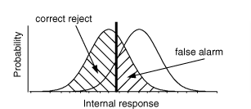

A Shapiro Wilk Test was carried out to see if the population of data collected was normally distributed. If the p-values is less than 0.05 the null hypothesis is rejected and the data tested is not normally distributed, however when the p-value is greater than 0.05, the data is interpreted as being normally distributed.

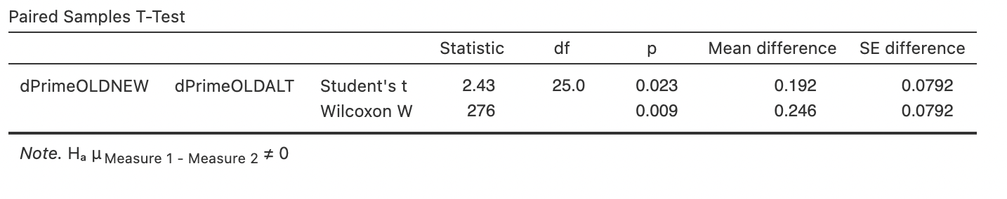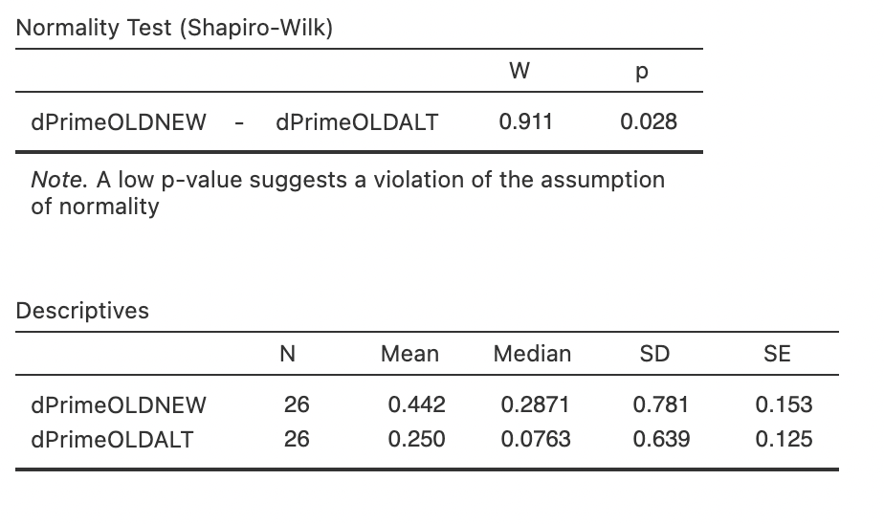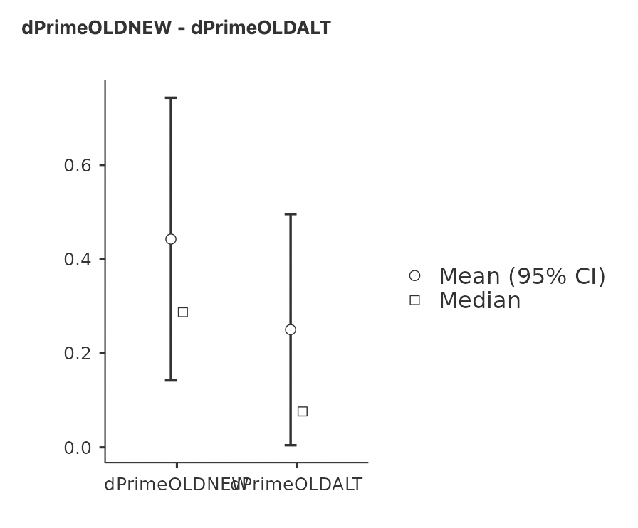

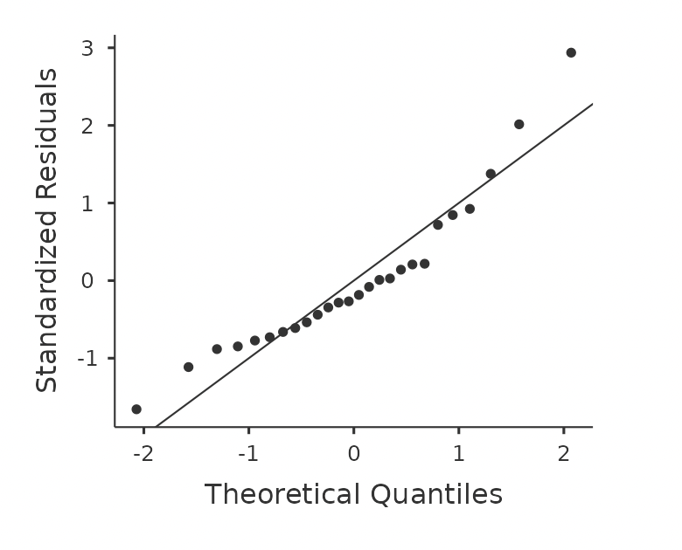

**Discussion**

Results of the study show that the difference of the alternative choice in memory is significantly higher than that of the completely irrelevant configurations. This disparity can be interpreted in 3 ways depending on the result we got applying signal detection theory. Either it can be a result of a boosted memory representation, which results in a high number of false positives. This means that participants have a strong memory representation of the alternative choice as though they had seen it before, answering ‘Old’ although they had never encountered the configuration. We suggest that their brain perhaps unconsciously represented both alternatives before choosing. In the other scenario, if we get a lower number of false positives of the alternative compared to new, it could be explained using memory suppression. As we know, voluntary action involves a decision, it is suggested that this process of decision making, selecting a choice will cause inhibition of the ‘unchosen’ option. Previous fMRI studies have provided some evidence for this, believing that action selection and stopping are regulated by the pre-supplementary motor area (pre-SMA) and inferior frontal gyrus in order to prevent conflicts between the choices (Rae *et al*, 2014). If this theory was true, when a subject made a choice to take path A they would automatically inhibit and diminish the memory representation of path B to consolidate their choice. Finally, if there is no significance difference observed (p-value>0.05), it would mean that the subject just did not notice the alternative path. The subject is not even aware that they had the freedom of choice. If that was the case, how could we explain our actions as worthy of moral implications? “We are not aware that we have the freedom of choice the moment we decide”.

The results of the memory task show that the difference is significant (p = 0.028), while also contradicting with memory suppression theory. We obtained a boosted memory representation with a high number of memory false positives, suggesting that the subject represents the alternative choice with a memory bias, believing that they had previously seen the configuration when they didn't.

Applying SDT to this study can help us evaluate the ability of participants to detect the alternative choice of solving the task. The d’ prime or discriminability index computes how discriminable the signal is from the non-signal. And confirming that the difference between the d primes of alternatives and new trials are significant, using a paired 2 sample t-test, we can conclude that indeed the memory representation of the participants for the alternative pathway is more predominant than the new configuration.

On the other hand, the EEG results provide evidence to disprove the Schurger model. The stochastic model developed by Schurger describes action generation as a consequence of spontaneous accumulation of stochastic signals (Schurger *et al*, 2012). In this context, all our decisions would be swayed by fluctuations in neural activity, thereby none of our actions could be inherently voluntary in nature. In the results, however, we recorded a significantly greater proportion of false positives for alternatives compared to new configurations, meaning that actions are not generated by random accumulation of signals. To explain this, we suggest that the participants must be either consciously or unconsciously representing both alternatives before settling on one. These observations also lead us to reconsider the nature of RP, which is backed up by results of the EEG study. The EEG recordings show that after the TP the RP amplitude is diminished significantly as a result of limitation of freedom to choose. Decision making in problem solving constitutes a critical component in voluntary action and thereby showing that RP amplitude fluctuates when crossing the TP is key evidence provided supporting RP as either a trigger or signal of that self-initiated action.

A potential future study postulated would be using TP problems involving alternatives with different values. A previous study looked at how memory and decision making interact to shape the value of the alternative no-chosen option (Biderman & Shohamy, 2021). This study gives us insights on how people would respond to decisions which involve choices with different rewards. Would the magnitude of the RP reduce due to the increased presence of external stimuli in decision making? or else, could the RP amplitude increase caused by the aggregated number of factors the individual has to consider before making a choice? Answers to this question may offer a closer comparability to real life self-initiated actions people face in everyday life, especially those which involve conscious thought and consideration of pros and cons.

Even more interesting would be to see the multivariate analysis of tracking second by second thinking process when participants see configurations during problem solving task and

The current neuroscience community believes that for each feeling, thought, action, there must be a chain of neural activity that is accompanying it, however what has made neuroscience so complicated to study is that this relationship between the mind and the brain has shown to be non-symmetrical, in other words there is not a direct relationship matching one type of neural activity with a behavioral outcome, a little like gene mapping. The result of a gene knockout may affect other areas of the molecular pathway which we did not intend to change. For this reason, it is a limitation of the study as we cannot know whether RP is solely a biomarker for Voluntary action or if it is also in control of other mental functions, however the timing evidence of RP clearly preceding each voluntary action, along with this experiment's results provide evidence that RP amplitude varies significantly depending on freely the action is generated.

**Bibliography**

Biderman, N., Shohamy, D. Memory and decision making interact to shape the value of unchosen options. Nat Commun 12, 4648 (2021). <https://doi.org/10.1038/s41467-021-24907-x>

Rae, C. L., Hughes, L. E., Weaver, C., Anderson, M. C., & Rowe, J. B. (2014). Selection and stopping in voluntary action: A meta-analysis and combined fMRI study. *NeuroImage*, *86*, 381–391. https://doi.org/10.1016/j.neuroimage.2013.10.012

Fried, I., Haggard, P., He, B. J., & Schurger, A. (2017). Volition and Action in the Human Brain: Processes, Pathologies, and Reasons. The Journal of Neuroscience, 37(45), 10842–10847. <https://doi.org/10.1523/JNEUROSCI.2584-17.2017>

Haggard, P. (2019). The Neurocognitive Bases of Human Volition. Annual Review of Psychology, 70(1), 9–28. <https://doi.org/10.1146/annurev-psych-010418-103348>

Khalighinejad, N., Schurger, A., Desantis, A., Zmigrod, L., & Haggard, P. (2018). Precursor processes of human self-initiated action. *NeuroImage*, *165*, 35–47. <https://doi.org/10.1016/j.neuroimage.2017.09.057>

Nguyen, V. T., Breakspear, M., & Cunnington, R. (2014). Reciprocal Interactions of the SMA and Cingulate Cortex Sustain Pre Movement Activity for Voluntary Actions. The Journal of Neuroscience, 34(49), 16397–16407. <https://doi.org/10.1523/JNEUROSCI.2571-14.2014>

Sumner, P., Nachev, P., Morris, P., Peters, A. M., Jackson, S. R., Kennard, C., & Husain, M. (2007). Human Medial Frontal Cortex Mediates Unconscious Inhibition of Voluntary Action. Neuron, 54(5), 697–711. <https://doi.org/10.1016/j.neuron.2007.05.016>

Sumner, P., & Husain, M. (2008). At the Edge of Consciousness: Automatic Motor Activation and Voluntary Control. *The Neuroscientist*, *14*(5), 474–486. https://doi.org/10.1177/1073858408314435

Szczepanski, S. M., & Knight, R. T. (2014). Insights into Human Behavior from Lesions to the Prefrontal Cortex. *Neuron*, *83*(5), 1002–1018. <https://doi.org/10.1016/j.neuron.2014.08.011>

Travers, E., Friedemann, M., & Haggard, P. (2021). The Readiness Potential reflects planning-based expectation, not uncertainty, in the timing of action. *Cognitive Neuroscience*, *12*(1), 14–27. <https://doi.org/10.1080/17588928.2020.1824176>

Zhang, L., Zhang, R., Yao, D., Shi, L., Gao, J., & Hu, Y. (2020). Differences in Intersubject Early Readiness Potentials Between Voluntary and Instructed Actions. Frontiers in Psychology, 11. <https://doi.org/10.3389/fpsyg.2020.529821>