武汉纺织大学

Java应用开发课程设计

采用MyBatis框架实现基于DAO设计模式的图书馆系统

学 院： 数学与计算机学院
班 级： 软件工程11801
姓 名： 杨洋
学 号： 1804240703
指导老师： 聂刚
成 绩：
完成日期： 2020年6月20日

目 录
1 需求分析 1
2 系统设计 5
4 系统测试 47
5 系统总结 54

1 需求分析
采用MyBatis框架实现基于DAO设计模式的图书馆系统。用户角色划分为读者、管理员。读者角色可以进行登陆，查询图书，借阅图书，归还图书，查询借阅记录，修改密码，
图书馆管理员可以进行登陆，图书增加，图书修改，图书删除，读者增加，读者修改，读者删除，借阅查询，借阅统计功能。

1.1用户登陆
当程序运行时，显示如下菜单,选择身份进行登录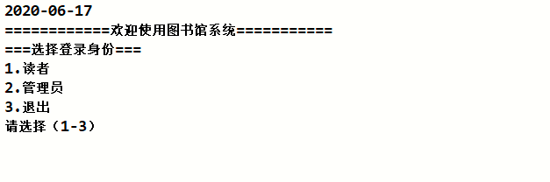

1.2主菜单

1.2.1 读者主菜单
当读者名及读者密码正确时，进入系统相应读者主界面，如下：
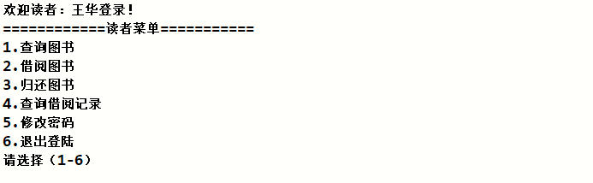如果输入1-6以外的选择，则显示提示信息“选择无效请重新输入”后，返回读者主菜单。

1.2.2 读者主菜单
当读者名及读者密码正确时，进入系统相应读者主界面，如下：
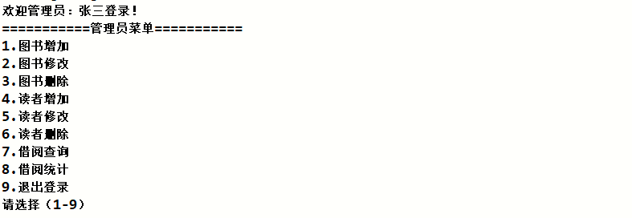
如果输入1-9以外的选择，则显示提示信息“选择无效请重新输入”后，返回管理员主菜单。

1.3各项功能

读者功能：

1.3.1 查询图书
当选择1时，显示“输入书名进行查询：”，用户输入书名则显示图书的条形码号、图书名称、图书入库时间：
否则，提示“图书不存在！”后退回读者主菜单。

1.3.2 借阅图书
当选择2时，显示“输入书名进行查询：”，如果没有相应图书，则显示“图书不存在！请退出后重新输入图书名”，图书存在时，显示格式如下：

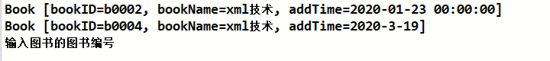
输入要借阅的图书条形码号进行借阅，若条形码号输入错误，显示“图书条形码号不存在！”退回主菜单。若输入正确，自动生成借阅记录流水号及yyyy-MM-dd格式借阅日期填入新记录，归还日期自动填入“0”，增加至借阅记录表。显示“借阅成功”，否则显示“借阅失败”。后退回读者主菜单。

1.3.3 归还图书
当选择3时，系统根据读者信息查询读者是否有待归还的书籍。若无，则显示“没有待归还的图书！”若有，则显示未归还的借阅记录
输入正确流水号，系统自动按yyyy-MM-dd格式生成归还日期替换“归还时间”的“0”标识，提示“归还成功”，否则提示“归还失败”。后退回读者主菜单。

1.3.4 查询借阅记录
当选择4时，系统根据读者信息自动显示读者的借阅记录
或显示“无借阅记录！”。后返回读者主菜单。

1.3.5 修改密码
当选择5时，显示如下

输入更改的密码。修改后显示“修改成功！”。否则显示“修改失败！”。后退回读者主菜单。

1.3.6退出登陆
当选择6时，退回到选择登录身份菜单。
管理员功能：

1.3.1图书增加
选择1时，显示
输入条形码号和图书名称后，系统生成新的图书记录，并按yyyy-MM-dd格式填入增加日期，提示“增加成功”。否则提示“增加失败”。后退回管理员主菜单。

1.3.2图书修改
当选择2时，显示
输入要修改的图书的条形码号，若输入错误，显示“图书条形码号不存在！”，退回主菜单。输入正确则显示
输入新的图书名称。修改成功提示“修改成功”，否则提示“修改失败”。图书条形码号作为图书主键标志，和图书入库时间都不予修改权利。后退回管理员主菜单。

1.3.3 图书删除
当选择3时，显示
输入正确的条形码号后，系统删除表中对应条形码号图书记录，显示“删除成功！”，输入条形码号不正确，则提示“删除失败！”。后退回管理员主菜单。

1.3.4 读者增加
当选择4时，显示

输入相应信息后，系统自增生成读者ID，将信息填入新记录插入数据库读者表，显示“增加成功！”否则提示“增加失败！”。后退回管理员主菜单。

1.3.5读者修改
当选择5时，显示“输入待修改的读者ID：”，输入待操作的正确ID，若输入错误，提示“不存在该读者ID！”，输入正确，显示
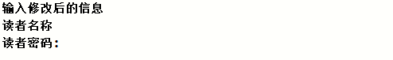
输入相应信息，后系统进行修改操作，显示“修改成功！”否则显示“修改失败！”。后退回主管理员菜单。
1.3.6 读者删除
当选择6时，显示
输入后系统进行删除操作，显示“删除成功！”，否则显示“删除失败！”。

1.3.7借阅查询
当选择7时，显示提示，根据提示选择要根据1-5哪种记录信息进行查询（输入1-4以外数字显示“选择无效!无记录！”自动退回主菜单）。
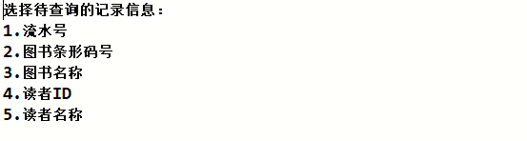
按正确格式（流水号、读书ID为纯数字）输入相应信息，系统成功查询返回符合条件的借阅记录，按“流水号，图书条形码号，图书名称，借阅读者ID，借阅读者名称，借阅时间，归还时间”格式显示，如下
否则，显示“无借阅记录！”。后自动返回管理员主菜单。
1.3.8 借阅统计
当选择8时，显示提示，根据提示选择要根据1-4哪种记录信息进行统计（输入1-4以外数字显示“选择无效!无记录！”自动退回主菜单）。
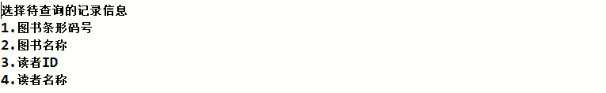
按正确格式（流水号、读书ID为纯数字）输入相应信息，系统成功查询返回符合条件的借阅记录数目，如下
否则显示“无记录！”，后自动退回管理员主菜单。
1.3.9 退出菜单
当选择9时，退回到选择登录身份菜单。

2 系统设计

2.1用户用例图
系统分为读者、图书馆管理员两个角色，各角色的用户用例如下图2-1所示：
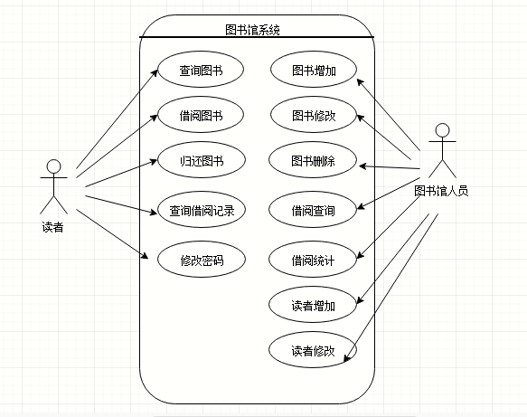
图2-1 用户用例图

2.2 ER图
数据库设计4张表，图书表，读者表，管理员表，借阅记录表，对应的ER图如图3-1所示。
%3CmxGraphModel%3E%3Croot%3E%3CmxCell%20id%3D%220%22%2F%3E%3CmxCell%20id%3D%221%22%20parent%3D%220%22%2F%3E%3Cmysql.table%20entity.table.tableName%3D%22uses%22%20label%3D%22uses%22%20id%3D%222%22%3E%3CmxCell%20style%3D%22swimlane%3BfontStyle%3D0%3BchildLayout%3DstackLayout%3Bhorizontal%3D1%3Bhtml%3D1%3BstartSize%3D26%3BfillColor%3D%23b0e3e6%3BhorizontalStack%3D0%3BresizeParent%3D1%3BresizeParentMax%3D0%3BresizeLast%3D0%3Bcollapsible%3D1%3BmarginBottom%3D0%3BswimlaneFillColor%3D%23ffffff%3Balign%3Dcenter%3BfontSize%3D13%3BstrokeColor%3D%230e8088%3Brounded%3D0%3Bshadow%3D1%3Bcomic%3D0%3Bglass%3D0%3BgradientDirection%3Dsouth%3BgradientColor%3D%23ffffff%3B%22%20vertex%3D%221%22%20connectable%3D%220%22%20parent%3D%221%22%3E%3CmxGeometry%20x%3D%2260%22%20y%3D%2250%22%20width%3D%22310%22%20height%3D%22130%22%20as%3D%22geometry%22%2F%3E%3C%2FmxCell%3E%3C%2Fmysql.table%3E%3Cmysql.column%20entity.column.tableName%3D%22uses%22%20entity.column.name%3D%22userName%22%20entity.column.dataType%3D%22VARCHAR%22%20entity.column.PK%3D%22true%22%20label%3D%22%26lt%3Bimg%20title%3D%26quot%3BPrimary%20Key%26quot%3B%20src%3D%26quot%3Bimg%2Fdb%2Fkey1.png%26quot%3B%20width%3D%26quot%3B16%26quot%3B%20height%3D%26quot%3B16%26quot%3B%20align%3D%26quot%3Btop%26quot%3B%26gt%3B%26amp%3Bnbsp%3B%26lt%3Bfont%20size%3D%26quot%3B1%26quot%3B%20face%3D%26quot%3BTahoma%26quot%3B%26gt%3B%26lt%3Bspan%20style%3D%26quot%3Bfont-size%3A%2013px%26quot%3B%26gt%3B%26lt%3Bb%26gt%3Bid%20int%20primary%20key%26lt%3B%2Fb%26gt%3B%26lt%3B%2Fspan%26gt%3B%26lt%3B%2Ffont%26gt%3B%22%20entity.column.oldName%3D%22id%22%20entity.column.datalen%3D%2220%22%20entity.column.decimals%3D%22%22%20entity.column.autoIncreament%3D%22%22%20entity.column.unsigned%3D%22%22%20entity.column.bin%3D%22%22%20entity.column.ascii%3D%22%22%20entity.column.unicode%3D%22%22%20entity.column.unique%3D%22%22%20entity.column.isNotNull%3D%22NOT%20NULL%22%20entity.column.defaultValue%3D%22%22%20entity.column.comment%3D%22%22%20entity.column.enum%3D%22%22%20entity.column.set%3D%22%22%20entity.column.enumSetValue%3D%22%22%20id%3D%223%22%3E%3CmxCell%20style%3D%22text%3Bhtml%3D1%3BstrokeColor%3Dnone%3BfillColor%3Dnone%3BspacingLeft%3D4%3BspacingRight%3D4%3Boverflow%3Dhidden%3Brotatable%3D0%3BportConstraint%3Deastwest%3BfontSize%3D12%3BverticalAlign%3Dmiddle%3B%22%20vertex%3D%221%22%20parent%3D%222%22%3E%3CmxGeometry%20y%3D%2226%22%20width%3D%22310%22%20height%3D%2226%22%20as%3D%22geometry%22%2F%3E%3C%2FmxCell%3E%3C%2Fmysql.column%3E%3Cmysql.column%20entity.column.tableName%3D%22uses%22%20entity.column.name%3D%22chrName%22%20entity.column.datalen%3D%2220%22%20entity.column.dataType%3D%22VARCHAR%22%20label%3D%22%26lt%3Bimg%20title%3D%26quot%3BPrimary%20Key%26quot%3B%20src%3D%26quot%3Bimages%2Fspacer.gif%26quot%3B%20width%3D%26quot%3B16%26quot%3B%20height%3D%26quot%3B16%26quot%3B%20align%3D%26quot%3Btop%26quot%3B%26gt%3B%26amp%3Bnbsp%3B%26lt%3Bfont%20size%3D%26quot%3B1%26quot%3B%20face%3D%26quot%3BTahoma%26quot%3B%26gt%3B%26lt%3Bspan%20style%3D%26quot%3Bfont-size%3A%2013px%26quot%3B%26gt%3B%26lt%3Bb%26gt%3Bname%20varchar(10)%26lt%3B%2Fb%26gt%3B%26lt%3B%2Fspan%26gt%3B%26lt%3B%2Ffont%26gt%3B%22%20entity.column.oldName%3D%22name%22%20entity.column.decimals%3D%22%22%20entity.column.autoIncreament%3D%22%22%20entity.column.unsigned%3D%22%22%20entity.column.bin%3D%22%22%20entity.column.ascii%3D%22%22%20entity.column.unicode%3D%22%22%20entity.column.PK%3D%22false%22%20entity.column.unique%3D%22%22%20entity.column.isNotNull%3D%22%22%20entity.column.defaultValue%3D%22%22%20entity.column.comment%3D%22%22%20entity.column.enum%3D%22%22%20entity.column.set%3D%22%22%20entity.column.enumSetValue%3D%22%22%20id%3D%224%22%3E%3CmxCell%20style%3D%22text%3Bhtml%3D1%3BstrokeColor%3Dnone%3BfillColor%3Dnone%3BspacingLeft%3D4%3BspacingRight%3D4%3Boverflow%3Dhidden%3Brotatable%3D0%3BportConstraint%3Deastwest%3BfontSize%3D12%3BverticalAlign%3Dmiddle%3B%22%20vertex%3D%221%22%20parent%3D%222%22%3E%3CmxGeometry%20y%3D%2252%22%20width%3D%22310%22%20height%3D%2226%22%20as%3D%22geometry%22%2F%3E%3C%2FmxCell%3E%3C%2Fmysql.column%3E%3Cmysql.column%20entity.column.tableName%3D%22uses%22%20entity.column.name%3D%22password%22%20entity.column.datalen%3D%2250%22%20entity.column.dataType%3D%22VARCHAR%22%20label%3D%22%26lt%3Bimg%20title%3D%26quot%3BPrimary%20Key%26quot%3B%20src%3D%26quot%3Bimages%2Fspacer.gif%26quot%3B%20width%3D%26quot%3B16%26quot%3B%20height%3D%26quot%3B16%26quot%3B%20align%3D%26quot%3Btop%26quot%3B%26gt%3B%26amp%3Bnbsp%3B%26lt%3Bfont%20size%3D%26quot%3B1%26quot%3B%20face%3D%26quot%3BTahoma%26quot%3B%26gt%3B%26lt%3Bspan%20style%3D%26quot%3Bfont-size%3A%2013px%26quot%3B%26gt%3B%26lt%3Bb%26gt%3Bname%20varchar(10)%26lt%3B%2Fb%26gt%3B%26lt%3B%2Fspan%26gt%3B%26lt%3B%2Ffont%26gt%3B%22%20entity.column.oldName%3D%22chrName%22%20entity.column.decimals%3D%22%22%20entity.column.autoIncreament%3D%22%22%20entity.column.unsigned%3D%22%22%20entity.column.bin%3D%22%22%20entity.column.ascii%3D%22%22%20entity.column.unicode%3D%22%22%20entity.column.PK%3D%22false%22%20entity.column.unique%3D%22%22%20entity.column.isNotNull%3D%22%22%20entity.column.defaultValue%3D%22%22%20entity.column.comment%3D%22%E5%AF%86%E7%A0%81%22%20entity.column.enum%3D%22%22%20entity.column.set%3D%22%22%20entity.column.enumSetValue%3D%22%22%20id%3D%225%22%3E%3CmxCell%20style%3D%22text%3Bhtml%3D1%3BstrokeColor%3Dnone%3BfillColor%3Dnone%3BspacingLeft%3D4%3BspacingRight%3D4%3Boverflow%3Dhidden%3Brotatable%3D0%3BportConstraint%3Deastwest%3BfontSize%3D12%3BverticalAlign%3Dmiddle%3B%22%20vertex%3D%221%22%20parent%3D%222%22%3E%3CmxGeometry%20y%3D%2278%22%20width%3D%22310%22%20height%3D%2226%22%20as%3D%22geometry%22%2F%3E%3C%2FmxCell%3E%3C%2Fmysql.column%3E%3Cmysql.column%20entity.column.tableName%3D%22uses%22%20entity.column.name%3D%22role%22%20entity.column.datalen%3D%2220%22%20entity.column.dataType%3D%22VARCHAR%22%20label%3D%22%26lt%3Bimg%20title%3D%26quot%3BPrimary%20Key%26quot%3B%20src%3D%26quot%3Bimages%2Fspacer.gif%26quot%3B%20width%3D%26quot%3B16%26quot%3B%20height%3D%26quot%3B16%26quot%3B%20align%3D%26quot%3Btop%26quot%3B%26gt%3B%26amp%3Bnbsp%3B%26lt%3Bfont%20size%3D%26quot%3B1%26quot%3B%20face%3D%26quot%3BTahoma%26quot%3B%26gt%3B%26lt%3Bspan%20style%3D%26quot%3Bfont-size%3A%2013px%26quot%3B%26gt%3B%26lt%3Bb%26gt%3Bname%20varchar(10)%26lt%3B%2Fb%26gt%3B%26lt%3B%2Fspan%26gt%3B%26lt%3B%2Ffont%26gt%3B%22%20entity.column.oldName%3D%22chrName%22%20entity.column.decimals%3D%22%22%20entity.column.autoIncreament%3D%22%22%20entity.column.unsigned%3D%22%22%20entity.column.bin%3D%22%22%20entity.column.ascii%3D%22%22%20entity.column.unicode%3D%22%22%20entity.column.PK%3D%22false%22%20entity.column.unique%3D%22%22%20entity.column.isNotNull%3D%22%22%20entity.column.defaultValue%3D%22%22%20entity.column.comment%3D%22%E8%A7%92%E8%89%B2%22%20entity.column.enum%3D%22%22%20entity.column.set%3D%22%22%20entity.column.enumSetValue%3D%22%22%20id%3D%226%22%3E%3CmxCell%20style%3D%22text%3Bhtml%3D1%3BstrokeColor%3Dnone%3BfillColor%3Dnone%3BspacingLeft%3D4%3BspacingRight%3D4%3Boverflow%3Dhidden%3Brotatable%3D0%3BportConstraint%3Deastwest%3BfontSize%3D12%3BverticalAlign%3Dmiddle%3B%22%20vertex%3D%221%22%20parent%3D%222%22%3E%3CmxGeometry%20y%3D%22104%22%20width%3D%22310%22%20height%3D%2226%22%20as%3D%22geometry%22%2F%3E%3C%2FmxCell%3E%3C%2Fmysql.column%3E%3Cmysql.table%20entity.table.tableName%3D%22product%22%20label%3D%22product%22%20id%3D%227%22%3E%3CmxCell%20style%3D%22swimlane%3BfontStyle%3D0%3BchildLayout%3DstackLayout%3Bhorizontal%3D1%3Bhtml%3D1%3BstartSize%3D26%3BfillColor%3D%23b0e3e6%3BhorizontalStack%3D0%3BresizeParent%3D1%3BresizeParentMax%3D0%3BresizeLast%3D0%3Bcollapsible%3D1%3BmarginBottom%3D0%3BswimlaneFillColor%3D%23ffffff%3Balign%3Dcenter%3BfontSize%3D13%3BstrokeColor%3D%230e8088%3Brounded%3D0%3Bshadow%3D1%3Bcomic%3D0%3Bglass%3D0%3BgradientDirection%3Dsouth%3BgradientColor%3D%23ffffff%3B%22%20vertex%3D%221%22%20connectable%3D%220%22%20parent%3D%221%22%3E%3CmxGeometry%20x%3D%2260%22%20y%3D%22210%22%20width%3D%22310%22%20height%3D%22130%22%20as%3D%22geometry%22%2F%3E%3C%2FmxCell%3E%3C%2Fmysql.table%3E%3Cmysql.column%20entity.column.tableName%3D%22product%22%20entity.column.name%3D%22barcode%22%20entity.column.dataType%3D%22VARCHAR%22%20entity.column.PK%3D%22true%22%20label%3D%22%26lt%3Bimg%20title%3D%26quot%3BPrimary%20Key%26quot%3B%20src%3D%26quot%3Bimg%2Fdb%2Fkey1.png%26quot%3B%20width%3D%26quot%3B16%26quot%3B%20height%3D%26quot%3B16%26quot%3B%20align%3D%26quot%3Btop%26quot%3B%26gt%3B%26amp%3Bnbsp%3B%26lt%3Bfont%20size%3D%26quot%3B1%26quot%3B%20face%3D%26quot%3BTahoma%26quot%3B%26gt%3B%26lt%3Bspan%20style%3D%26quot%3Bfont-size%3A%2013px%26quot%3B%26gt%3B%26lt%3Bb%26gt%3Bid%20int%20primary%20key%26lt%3B%2Fb%26gt%3B%26lt%3B%2Fspan%26gt%3B%26lt%3B%2Ffont%26gt%3B%22%20entity.column.oldName%3D%22id%22%20entity.column.datalen%3D%2210%22%20entity.column.decimals%3D%22%22%20entity.column.autoIncreament%3D%22%22%20entity.column.unsigned%3D%22%22%20entity.column.bin%3D%22%22%20entity.column.ascii%3D%22%22%20entity.column.unicode%3D%22%22%20entity.column.unique%3D%22%22%20entity.column.isNotNull%3D%22NOT%20NULL%22%20entity.column.defaultValue%3D%22%22%20entity.column.comment%3D%22%22%20entity.column.enum%3D%22%22%20entity.column.set%3D%22%22%20entity.column.enumSetValue%3D%22%22%20id%3D%228%22%3E%3CmxCell%20style%3D%22text%3Bhtml%3D1%3BstrokeColor%3Dnone%3BfillColor%3Dnone%3BspacingLeft%3D4%3BspacingRight%3D4%3Boverflow%3Dhidden%3Brotatable%3D0%3BportConstraint%3Deastwest%3BfontSize%3D12%3BverticalAlign%3Dmiddle%3B%22%20vertex%3D%221%22%20parent%3D%227%22%3E%3CmxGeometry%20y%3D%2226%22%20width%3D%22310%22%20height%3D%2226%22%20as%3D%22geometry%22%2F%3E%3C%2FmxCell%3E%3C%2Fmysql.column%3E%3Cmysql.column%20entity.column.tableName%3D%22product%22%20entity.column.name%3D%22productName%22%20entity.column.datalen%3D%2250%22%20entity.column.dataType%3D%22VARCHAR%22%20label%3D%22%26lt%3Bimg%20title%3D%26quot%3BPrimary%20Key%26quot%3B%20src%3D%26quot%3Bimages%2Fspacer.gif%26quot%3B%20width%3D%26quot%3B16%26quot%3B%20height%3D%26quot%3B16%26quot%3B%20align%3D%26quot%3Btop%26quot%3B%26gt%3B%26amp%3Bnbsp%3B%26lt%3Bfont%20size%3D%26quot%3B1%26quot%3B%20face%3D%26quot%3BTahoma%26quot%3B%26gt%3B%26lt%3Bspan%20style%3D%26quot%3Bfont-size%3A%2013px%26quot%3B%26gt%3B%26lt%3Bb%26gt%3Bname%20varchar(10)%26lt%3B%2Fb%26gt%3B%26lt%3B%2Fspan%26gt%3B%26lt%3B%2Ffont%26gt%3B%22%20entity.column.oldName%3D%22name%22%20entity.column.decimals%3D%22%22%20entity.column.autoIncreament%3D%22%22%20entity.column.unsigned%3D%22%22%20entity.column.bin%3D%22%22%20entity.column.ascii%3D%22%22%20entity.column.unicode%3D%22%22%20entity.column.PK%3D%22false%22%20entity.column.unique%3D%22%22%20entity.column.isNotNull%3D%22%22%20entity.column.defaultValue%3D%22%22%20entity.column.comment%3D%22%22%20entity.column.enum%3D%22%22%20entity.column.set%3D%22%22%20entity.column.enumSetValue%3D%22%22%20id%3D%229%22%3E%3CmxCell%20style%3D%22text%3Bhtml%3D1%3BstrokeColor%3Dnone%3BfillColor%3Dnone%3BspacingLeft%3D4%3BspacingRight%3D4%3Boverflow%3Dhidden%3Brotatable%3D0%3BportConstraint%3Deastwest%3BfontSize%3D12%3BverticalAlign%3Dmiddle%3B%22%20vertex%3D%221%22%20parent%3D%227%22%3E%3CmxGeometry%20y%3D%2252%22%20width%3D%22310%22%20height%3D%2226%22%20as%3D%22geometry%22%2F%3E%3C%2FmxCell%3E%3C%2Fmysql.column%3E%3Cmysql.column%20entity.column.tableName%3D%22product%22%20entity.column.name%3D%22price%22%20entity.column.datalen%3D%229%22%20entity.column.dataType%3D%22DECIMAL%22%20label%3D%22%26lt%3Bimg%20title%3D%26quot%3BPrimary%20Key%26quot%3B%20src%3D%26quot%3Bimages%2Fspacer.gif%26quot%3B%20width%3D%26quot%3B16%26quot%3B%20height%3D%26quot%3B16%26quot%3B%20align%3D%26quot%3Btop%26quot%3B%26gt%3B%26amp%3Bnbsp%3B%26lt%3Bfont%20size%3D%26quot%3B1%26quot%3B%20face%3D%26quot%3BTahoma%26quot%3B%26gt%3B%26lt%3Bspan%20style%3D%26quot%3Bfont-size%3A%2013px%26quot%3B%26gt%3B%26lt%3Bb%26gt%3Bname%20varchar(10)%26lt%3B%2Fb%26gt%3B%26lt%3B%2Fspan%26gt%3B%26lt%3B%2Ffont%26gt%3B%22%20entity.column.oldName%3D%22price%22%20entity.column.decimals%3D%222%22%20entity.column.autoIncreament%3D%22%22%20entity.column.unsigned%3D%22%22%20entity.column.bin%3D%22%22%20entity.column.ascii%3D%22%22%20entity.column.unicode%3D%22%22%20entity.column.PK%3D%22false%22%20entity.column.unique%3D%22%22%20entity.column.isNotNull%3D%22%22%20entity.column.defaultValue%3D%22%22%20entity.column.comment%3D%22%22%20entity.column.enum%3D%22%22%20entity.column.set%3D%22%22%20entity.column.enumSetValue%3D%22%22%20id%3D%2210%22%3E%3CmxCell%20style%3D%22text%3Bhtml%3D1%3BstrokeColor%3Dnone%3BfillColor%3Dnone%3BspacingLeft%3D4%3BspacingRight%3D4%3Boverflow%3Dhidden%3Brotatable%3D0%3BportConstraint%3Deastwest%3BfontSize%3D12%3BverticalAlign%3Dmiddle%3B%22%20vertex%3D%221%22%20parent%3D%227%22%3E%3CmxGeometry%20y%3D%2278%22%20width%3D%22310%22%20height%3D%2226%22%20as%3D%22geometry%22%2F%3E%3C%2FmxCell%3E%3C%2Fmysql.column%3E%3Cmysql.column%20entity.column.tableName%3D%22product%22%20entity.column.name%3D%22supply%22%20entity.column.datalen%3D%2220%22%20entity.column.dataType%3D%22VARCHAR%22%20label%3D%22%26lt%3Bimg%20title%3D%26quot%3BPrimary%20Key%26quot%3B%20src%3D%26quot%3Bimages%2Fspacer.gif%26quot%3B%20width%3D%26quot%3B16%26quot%3B%20height%3D%26quot%3B16%26quot%3B%20align%3D%26quot%3Btop%26quot%3B%26gt%3B%26amp%3Bnbsp%3B%26lt%3Bfont%20size%3D%26quot%3B1%26quot%3B%20face%3D%26quot%3BTahoma%26quot%3B%26gt%3B%26lt%3Bspan%20style%3D%26quot%3Bfont-size%3A%2013px%26quot%3B%26gt%3B%26lt%3Bb%26gt%3Bname%20varchar(10)%26lt%3B%2Fb%26gt%3B%26lt%3B%2Fspan%26gt%3B%26lt%3B%2Ffont%26gt%3B%22%20entity.column.oldName%3D%22price%22%20entity.column.decimals%3D%22%22%20entity.column.autoIncreament%3D%22%22%20entity.column.unsigned%3D%22%22%20entity.column.bin%3D%22%22%20entity.column.ascii%3D%22%22%20entity.column.unicode%3D%22%22%20entity.column.PK%3D%22false%22%20entity.column.unique%3D%22%22%20entity.column.isNotNull%3D%22%22%20entity.column.defaultValue%3D%22%22%20entity.column.comment%3D%22%22%20entity.column.enum%3D%22%22%20entity.column.set%3D%22%22%20entity.column.enumSetValue%3D%22%22%20id%3D%2211%22%3E%3CmxCell%20style%3D%22text%3Bhtml%3D1%3BstrokeColor%3Dnone%3BfillColor%3Dnone%3BspacingLeft%3D4%3BspacingRight%3D4%3Boverflow%3Dhidden%3Brotatable%3D0%3BportConstraint%3Deastwest%3BfontSize%3D12%3BverticalAlign%3Dmiddle%3B%22%20vertex%3D%221%22%20parent%3D%227%22%3E%3CmxGeometry%20y%3D%22104%22%20width%3D%22310%22%20height%3D%2226%22%20as%3D%22geometry%22%2F%3E%3C%2FmxCell%3E%3C%2Fmysql.column%3E%3Cmysql.table%20entity.table.tableName%3D%22saleDetail%22%20label%3D%22saleDetail%22%20id%3D%2212%22%3E%3CmxCell%20style%3D%22swimlane%3BfontStyle%3D0%3BchildLayout%3DstackLayout%3Bhorizontal%3D1%3Bhtml%3D1%3BstartSize%3D26%3BfillColor%3D%23b0e3e6%3BhorizontalStack%3D0%3BresizeParent%3D1%3BresizeParentMax%3D0%3BresizeLast%3D0%3Bcollapsible%3D1%3BmarginBottom%3D0%3BswimlaneFillColor%3D%23ffffff%3Balign%3Dcenter%3BfontSize%3D13%3BstrokeColor%3D%230e8088%3Brounded%3D0%3Bshadow%3D1%3Bcomic%3D0%3Bglass%3D0%3BgradientDirection%3Dsouth%3BgradientColor%3D%23ffffff%3B%22%20vertex%3D%221%22%20connectable%3D%220%22%20parent%3D%221%22%3E%3CmxGeometry%20x%3D%22480%22%20y%3D%2280%22%20width%3D%22280%22%20height%3D%22208%22%20as%3D%22geometry%22%2F%3E%3C%2FmxCell%3E%3C%2Fmysql.table%3E%3Cmysql.column%20entity.column.tableName%3D%22saleDetail%22%20entity.column.name%3D%22lsh%22%20entity.column.dataType%3D%22VARCHAR%22%20entity.column.PK%3D%22true%22%20label%3D%22%26lt%3Bimg%20title%3D%26quot%3BPrimary%20Key%26quot%3B%20src%3D%26quot%3Bimg%2Fdb%2Fkey1.png%26quot%3B%20width%3D%26quot%3B16%26quot%3B%20height%3D%26quot%3B16%26quot%3B%20align%3D%26quot%3Btop%26quot%3B%26gt%3B%26amp%3Bnbsp%3B%26lt%3Bfont%20size%3D%26quot%3B1%26quot%3B%20face%3D%26quot%3BTahoma%26quot%3B%26gt%3B%26lt%3Bspan%20style%3D%26quot%3Bfont-size%3A%2013px%26quot%3B%26gt%3B%26lt%3Bb%26gt%3Bid%20int%20primary%20key%26lt%3B%2Fb%26gt%3B%26lt%3B%2Fspan%26gt%3B%26lt%3B%2Ffont%26gt%3B%22%20entity.column.oldName%3D%22id%22%20entity.column.datalen%3D%2220%22%20entity.column.decimals%3D%22%22%20entity.column.autoIncreament%3D%22%22%20entity.column.unsigned%3D%22%22%20entity.column.bin%3D%22%22%20entity.column.ascii%3D%22%22%20entity.column.unicode%3D%22%22%20entity.column.unique%3D%22%22%20entity.column.isNotNull%3D%22NOT%20NULL%22%20entity.column.defaultValue%3D%22%22%20entity.column.comment%3D%22%22%20entity.column.enum%3D%22%22%20entity.column.set%3D%22%22%20entity.column.enumSetValue%3D%22%22%20id%3D%2213%22%3E%3CmxCell%20style%3D%22text%3Bhtml%3D1%3BstrokeColor%3Dnone%3BfillColor%3Dnone%3BspacingLeft%3D4%3BspacingRight%3D4%3Boverflow%3Dhidden%3Brotatable%3D0%3BportConstraint%3Deastwest%3BfontSize%3D12%3BverticalAlign%3Dmiddle%3B%22%20vertex%3D%221%22%20parent%3D%2212%22%3E%3CmxGeometry%20y%3D%2226%22%20width%3D%22280%22%20height%3D%2226%22%20as%3D%22geometry%22%2F%3E%3C%2FmxCell%3E%3C%2Fmysql.column%3E%3Cmysql.column%20entity.column.tableName%3D%22saleDetail%22%20entity.column.name%3D%22barcode%22%20entity.column.datalen%3D%2210%22%20entity.column.dataType%3D%22VARCHAR%22%20label%3D%22%26lt%3Bimg%20title%3D%26quot%3BPrimary%20Key%26quot%3B%20src%3D%26quot%3Bimages%2Fspacer.gif%26quot%3B%20width%3D%26quot%3B16%26quot%3B%20height%3D%26quot%3B16%26quot%3B%20align%3D%26quot%3Btop%26quot%3B%26gt%3B%26amp%3Bnbsp%3B%26lt%3Bfont%20size%3D%26quot%3B1%26quot%3B%20face%3D%26quot%3BTahoma%26quot%3B%26gt%3B%26lt%3Bspan%20style%3D%26quot%3Bfont-size%3A%2013px%26quot%3B%26gt%3B%26lt%3Bb%26gt%3Bname%20varchar(10)%26lt%3B%2Fb%26gt%3B%26lt%3B%2Fspan%26gt%3B%26lt%3B%2Ffont%26gt%3B%22%20entity.column.oldName%3D%22barcode%22%20entity.column.decimals%3D%22%22%20entity.column.autoIncreament%3D%22%22%20entity.column.unsigned%3D%22%22%20entity.column.bin%3D%22%22%20entity.column.ascii%3D%22%22%20entity.column.unicode%3D%22%22%20entity.column.PK%3D%22false%22%20entity.column.unique%3D%22%22%20entity.column.isNotNull%3D%22%22%20entity.column.defaultValue%3D%22%22%20entity.column.comment%3D%22%22%20entity.column.enum%3D%22%22%20entity.column.set%3D%22%22%20entity.column.enumSetValue%3D%22%22%20id%3D%2214%22%3E%3CmxCell%20style%3D%22text%3Bhtml%3D1%3BstrokeColor%3Dnone%3BfillColor%3Dnone%3BspacingLeft%3D4%3BspacingRight%3D4%3Boverflow%3Dhidden%3Brotatable%3D0%3BportConstraint%3Deastwest%3BfontSize%3D12%3BverticalAlign%3Dmiddle%3B%22%20vertex%3D%221%22%20parent%3D%2212%22%3E%3CmxGeometry%20y%3D%2252%22%20width%3D%22280%22%20height%3D%2226%22%20as%3D%22geometry%22%2F%3E%3C%2FmxCell%3E%3C%2Fmysql.column%3E%3Cmysql.column%20entity.column.tableName%3D%22saleDetail%22%20entity.column.name%3D%22productName%22%20entity.column.datalen%3D%2250%22%20entity.column.dataType%3D%22VARCHAR%22%20label%3D%22%26lt%3Bimg%20title%3D%26quot%3BPrimary%20Key%26quot%3B%20src%3D%26quot%3Bimages%2Fspacer.gif%26quot%3B%20width%3D%26quot%3B16%26quot%3B%20height%3D%26quot%3B16%26quot%3B%20align%3D%26quot%3Btop%26quot%3B%26gt%3B%26amp%3Bnbsp%3B%26lt%3Bfont%20size%3D%26quot%3B1%26quot%3B%20face%3D%26quot%3BTahoma%26quot%3B%26gt%3B%26lt%3Bspan%20style%3D%26quot%3Bfont-size%3A%2013px%26quot%3B%26gt%3B%26lt%3Bb%26gt%3Bname%20varchar(10)%26lt%3B%2Fb%26gt%3B%26lt%3B%2Fspan%26gt%3B%26lt%3B%2Ffont%26gt%3B%22%20entity.column.oldName%3D%22productName%22%20entity.column.decimals%3D%22%22%20entity.column.autoIncreament%3D%22%22%20entity.column.unsigned%3D%22%22%20entity.column.bin%3D%22%22%20entity.column.ascii%3D%22%22%20entity.column.unicode%3D%22%22%20entity.column.PK%3D%22false%22%20entity.column.unique%3D%22%22%20entity.column.isNotNull%3D%22%22%20entity.column.defaultValue%3D%22%22%20entity.column.comment%3D%22%22%20entity.column.enum%3D%22%22%20entity.column.set%3D%22%22%20entity.column.enumSetValue%3D%22%22%20id%3D%2215%22%3E%3CmxCell%20style%3D%22text%3Bhtml%3D1%3BstrokeColor%3Dnone%3BfillColor%3Dnone%3BspacingLeft%3D4%3BspacingRight%3D4%3Boverflow%3Dhidden%3Brotatable%3D0%3BportConstraint%3Deastwest%3BfontSize%3D12%3BverticalAlign%3Dmiddle%3B%22%20vertex%3D%221%22%20parent%3D%2212%22%3E%3CmxGeometry%20y%3D%2278%22%20width%3D%22280%22%20height%3D%2226%22%20as%3D%22geometry%22%2F%3E%3C%2FmxCell%3E%3C%2Fmysql.column%3E%3Cmysql.column%20entity.column.tableName%3D%22saleDetail%22%20entity.column.name%3D%22price%22%20entity.column.datalen%3D%229%22%20entity.column.dataType%3D%22DECIMAL%22%20label%3D%22%26lt%3Bimg%20title%3D%26quot%3BPrimary%20Key%26quot%3B%20src%3D%26quot%3Bimages%2Fspacer.gif%26quot%3B%20width%3D%26quot%3B16%26quot%3B%20height%3D%26quot%3B16%26quot%3B%20align%3D%26quot%3Btop%26quot%3B%26gt%3B%26amp%3Bnbsp%3B%26lt%3Bfont%20size%3D%26quot%3B1%26quot%3B%20face%3D%26quot%3BTahoma%26quot%3B%26gt%3B%26lt%3Bspan%20style%3D%26quot%3Bfont-size%3A%2013px%26quot%3B%26gt%3B%26lt%3Bb%26gt%3Bname%20varchar(10)%26lt%3B%2Fb%26gt%3B%26lt%3B%2Fspan%26gt%3B%26lt%3B%2Ffont%26gt%3B%22%20entity.column.oldName%3D%22productName%22%20entity.column.decimals%3D%222%22%20entity.column.autoIncreament%3D%22%22%20entity.column.unsigned%3D%22%22%20entity.column.bin%3D%22%22%20entity.column.ascii%3D%22%22%20entity.column.unicode%3D%22%22%20entity.column.PK%3D%22false%22%20entity.column.unique%3D%22%22%20entity.column.isNotNull%3D%22%22%20entity.column.defaultValue%3D%22%22%20entity.column.comment%3D%22%22%20entity.column.enum%3D%22%22%20entity.column.set%3D%22%22%20entity.column.enumSetValue%3D%22%22%20id%3D%2216%22%3E%3CmxCell%20style%3D%22text%3Bhtml%3D1%3BstrokeColor%3Dnone%3BfillColor%3Dnone%3BspacingLeft%3D4%3BspacingRight%3D4%3Boverflow%3Dhidden%3Brotatable%3D0%3BportConstraint%3Deastwest%3BfontSize%3D12%3BverticalAlign%3Dmiddle%3B%22%20vertex%3D%221%22%20parent%3D%2212%22%3E%3CmxGeometry%20y%3D%22104%22%20width%3D%22280%22%20height%3D%2226%22%20as%3D%22geometry%22%2F%3E%3C%2FmxCell%3E%3C%2Fmysql.column%3E%3Cmysql.column%20entity.column.tableName%3D%22saleDetail%22%20entity.column.name%3D%22count%22%20entity.column.datalen%3D%229%22%20entity.column.dataType%3D%22INT%22%20label%3D%22%26lt%3Bimg%20title%3D%26quot%3BPrimary%20Key%26quot%3B%20src%3D%26quot%3Bimages%2Fspacer.gif%26quot%3B%20width%3D%26quot%3B16%26quot%3B%20height%3D%26quot%3B16%26quot%3B%20align%3D%26quot%3Btop%26quot%3B%26gt%3B%26amp%3Bnbsp%3B%26lt%3Bfont%20size%3D%26quot%3B1%26quot%3B%20face%3D%26quot%3BTahoma%26quot%3B%26gt%3B%26lt%3Bspan%20style%3D%26quot%3Bfont-size%3A%2013px%26quot%3B%26gt%3B%26lt%3Bb%26gt%3Bname%20varchar(10)%26lt%3B%2Fb%26gt%3B%26lt%3B%2Fspan%26gt%3B%26lt%3B%2Ffont%26gt%3B%22%20entity.column.oldName%3D%22price%22%20entity.column.decimals%3D%22%22%20entity.column.autoIncreament%3D%22%22%20entity.column.unsigned%3D%22%22%20entity.column.bin%3D%22%22%20entity.column.ascii%3D%22%22%20entity.column.unicode%3D%22%22%20entity.column.PK%3D%22false%22%20entity.column.unique%3D%22%22%20entity.column.isNotNull%3D%22%22%20entity.column.defaultValue%3D%22%22%20entity.column.comment%3D%22%22%20entity.column.enum%3D%22%22%20entity.column.set%3D%22%22%20entity.column.enumSetValue%3D%22%22%20id%3D%2217%22%3E%3CmxCell%20style%3D%22text%3Bhtml%3D1%3BstrokeColor%3Dnone%3BfillColor%3Dnone%3BspacingLeft%3D4%3BspacingRight%3D4%3Boverflow%3Dhidden%3Brotatable%3D0%3BportConstraint%3Deastwest%3BfontSize%3D12%3BverticalAlign%3Dmiddle%3B%22%20vertex%3D%221%22%20parent%3D%2212%22%3E%3CmxGeometry%20y%3D%22130%22%20width%3D%22280%22%20height%3D%2226%22%20as%3D%22geometry%22%2F%3E%3C%2FmxCell%3E%3C%2Fmysql.column%3E%3Cmysql.column%20entity.column.tableName%3D%22saleDetail%22%20entity.column.name%3D%22operator%22%20entity.column.datalen%3D%2220%22%20entity.column.dataType%3D%22VARCHAR%22%20label%3D%22%26lt%3Bimg%20title%3D%26quot%3BPrimary%20Key%26quot%3B%20src%3D%26quot%3Bimages%2Fspacer.gif%26quot%3B%20width%3D%26quot%3B16%26quot%3B%20height%3D%26quot%3B16%26quot%3B%20align%3D%26quot%3Btop%26quot%3B%26gt%3B%26amp%3Bnbsp%3B%26lt%3Bfont%20size%3D%26quot%3B1%26quot%3B%20face%3D%26quot%3BTahoma%26quot%3B%26gt%3B%26lt%3Bspan%20style%3D%26quot%3Bfont-size%3A%2013px%26quot%3B%26gt%3B%26lt%3Bb%26gt%3Bname%20varchar(10)%26lt%3B%2Fb%26gt%3B%26lt%3B%2Fspan%26gt%3B%26lt%3B%2Ffont%26gt%3B%22%20entity.column.oldName%3D%22count%22%20entity.column.decimals%3D%22%22%20entity.column.autoIncreament%3D%22%22%20entity.column.unsigned%3D%22%22%20entity.column.bin%3D%22%22%20entity.column.ascii%3D%22%22%20entity.column.unicode%3D%22%22%20entity.column.PK%3D%22false%22%20entity.column.unique%3D%22%22%20entity.column.isNotNull%3D%22%22%20entity.column.defaultValue%3D%22%22%20entity.column.comment%3D%22%22%20entity.column.enum%3D%22%22%20entity.column.set%3D%22%22%20entity.column.enumSetValue%3D%22%22%20id%3D%2218%22%3E%3CmxCell%20style%3D%22text%3Bhtml%3D1%3BstrokeColor%3Dnone%3BfillColor%3Dnone%3BspacingLeft%3D4%3BspacingRight%3D4%3Boverflow%3Dhidden%3Brotatable%3D0%3BportConstraint%3Deastwest%3BfontSize%3D12%3BverticalAlign%3Dmiddle%3B%22%20vertex%3D%221%22%20parent%3D%2212%22%3E%3CmxGeometry%20y%3D%22156%22%20width%3D%22280%22%20height%3D%2226%22%20as%3D%22geometry%22%2F%3E%3C%2FmxCell%3E%3C%2Fmysql.column%3E%3Cmysql.column%20entity.column.tableName%3D%22saleDetail%22%20entity.column.name%3D%22saleTime%22%20entity.column.datalen%3D%22%22%20entity.column.dataType%3D%22DATETIME%22%20label%3D%22%26lt%3Bimg%20title%3D%26quot%3BPrimary%20Key%26quot%3B%20src%3D%26quot%3Bimages%2Fspacer.gif%26quot%3B%20width%3D%26quot%3B16%26quot%3B%20height%3D%26quot%3B16%26quot%3B%20align%3D%26quot%3Btop%26quot%3B%26gt%3B%26amp%3Bnbsp%3B%26lt%3Bfont%20size%3D%26quot%3B1%26quot%3B%20face%3D%26quot%3BTahoma%26quot%3B%26gt%3B%26lt%3Bspan%20style%3D%26quot%3Bfont-size%3A%2013px%26quot%3B%26gt%3B%26lt%3Bb%26gt%3Bname%20varchar(10)%26lt%3B%2Fb%26gt%3B%26lt%3B%2Fspan%26gt%3B%26lt%3B%2Ffont%26gt%3B%22%20entity.column.oldName%3D%22count%22%20entity.column.decimals%3D%22%22%20entity.column.autoIncreament%3D%22%22%20entity.column.unsigned%3D%22%22%20entity.column.bin%3D%22%22%20entity.column.ascii%3D%22%22%20entity.column.unicode%3D%22%22%20entity.column.PK%3D%22false%22%20entity.column.unique%3D%22%22%20entity.column.isNotNull%3D%22%22%20entity.column.defaultValue%3D%22%22%20entity.column.comment%3D%22%22%20entity.column.enum%3D%22%22%20entity.column.set%3D%22%22%20entity.column.enumSetValue%3D%22%22%20id%3D%2219%22%3E%3CmxCell%20style%3D%22text%3Bhtml%3D1%3BstrokeColor%3Dnone%3BfillColor%3Dnone%3BspacingLeft%3D4%3BspacingRight%3D4%3Boverflow%3Dhidden%3Brotatable%3D0%3BportConstraint%3Deastwest%3BfontSize%3D12%3BverticalAlign%3Dmiddle%3B%22%20vertex%3D%221%22%20parent%3D%2212%22%3E%3CmxGeometry%20y%3D%22182%22%20width%3D%22280%22%20height%3D%2226%22%20as%3D%22geometry%22%2F%3E%3C%2FmxCell%3E%3C%2Fmysql.column%3E%3CmxCell%20id%3D%2220%22%20value%3D%221..n%22%20style%3D%22edgeStyle%3DentityRelationEdgeStyle%3BfontSize%3D12%3Bhtml%3D1%3BendArrow%3DERoneToMany%3BstrokeWidth%3D2%3BstrokeColor%3D%236c8ebf%3BexitX%3D1%3BexitY%3D0.25%3BentryX%3D0%3BentryY%3D0.5%3B%22%20edge%3D%221%22%20source%3D%224%22%20target%3D%2214%22%20parent%3D%221%22%3E%3CmxGeometry%20relative%3D%221%22%20as%3D%22geometry%22%2F%3E%3C%2FmxCell%3E%3CmxCell%20id%3D%2221%22%20value%3D%221..n%22%20style%3D%22edgeStyle%3DentityRelationEdgeStyle%3BfontSize%3D12%3Bhtml%3D1%3BendArrow%3DERoneToMany%3BstrokeWidth%3D2%3BstrokeColor%3D%236c8ebf%3BexitX%3D1%3BexitY%3D0.5%3BentryX%3D0%3BentryY%3D0.5%3B%22%20edge%3D%221%22%20source%3D%228%22%20target%3D%2216%22%20parent%3D%221%22%3E%3CmxGeometry%20relative%3D%221%22%20as%3D%22geometry%22%2F%3E%3C%2FmxCell%3E%3C%2Froot%3E%3C%2FmxGraphModel%3E
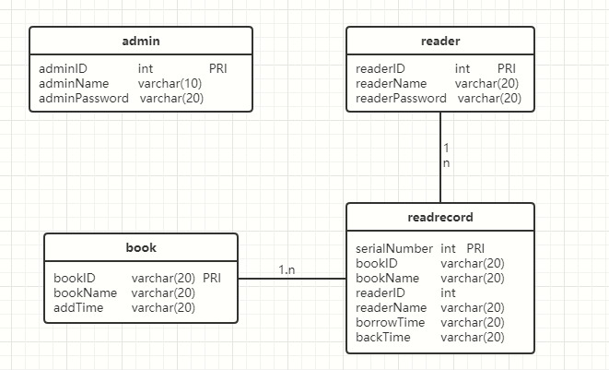
图3-1 数据库ER图

2.3 UML类图（Class Diagram）
对于用户功能模块，共设计如下3个类。
- VO实体类User：与数据库结构进行映射的类。主要由属性，setter, getter方法组成，VO类中的属性与表中的字段相对应，每一个VO类的对象都表示表中的每一条记录
- DAO接口IUserDAO：主要定义操作的接口，定义一系列数据库的原子性操作，例如增删改查（通常称为CRUD）等。
- 业务逻辑实现类UserService：对于数据层的原子操作进行整合。还要负责数据库的打开与关闭（不管是否出异常，数据库都要关闭）

各类的结构及类之间的关系如图2-5所示：
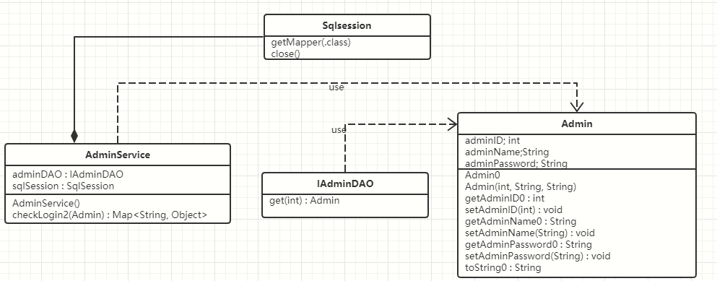图2-5 管理员功能类图
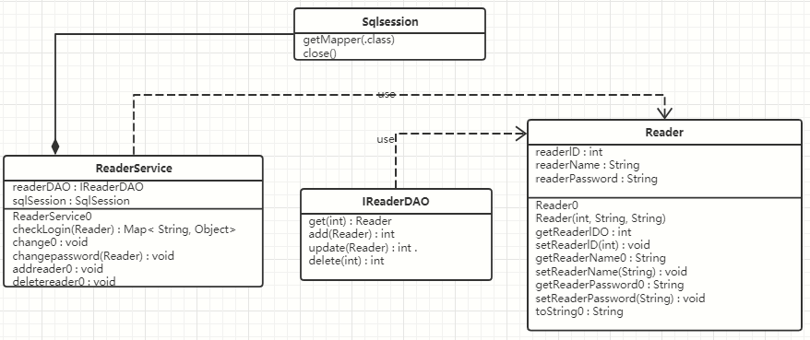
图2-6 读者功能类图
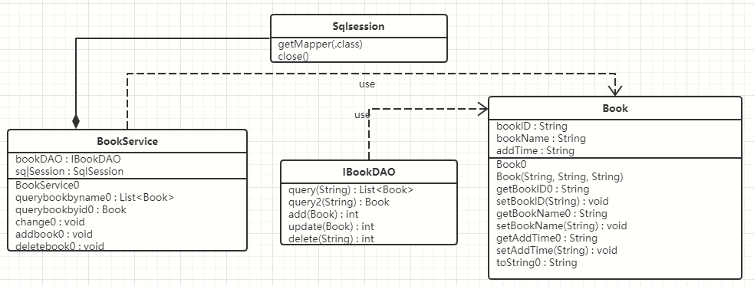
图2-7 图书功能类图
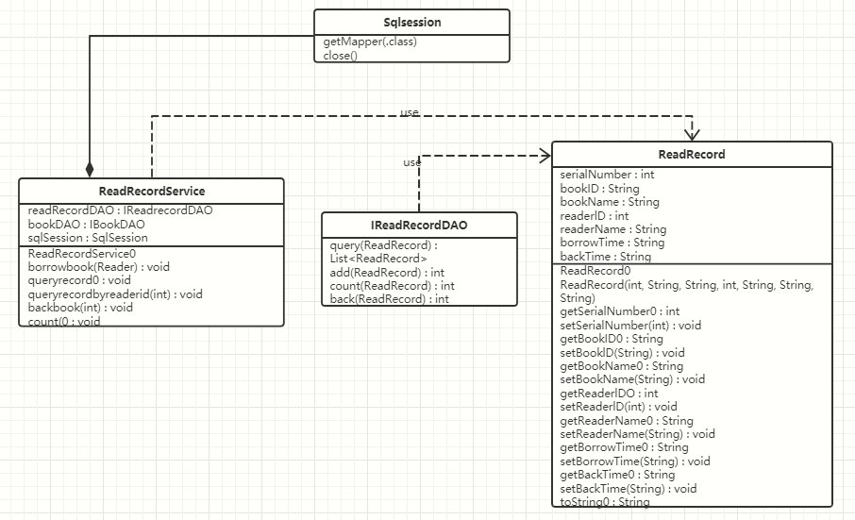
图2-8 借阅记录功能类图

2.4 UML时序图（Sequence Diagram）

2.4.1 读者登录
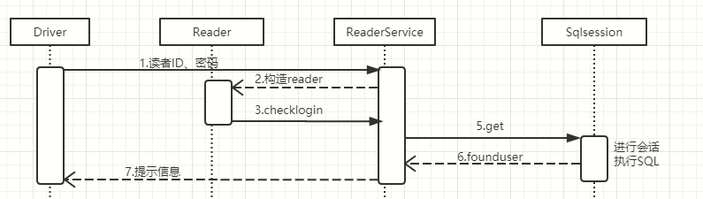

2.4.2 查询图书
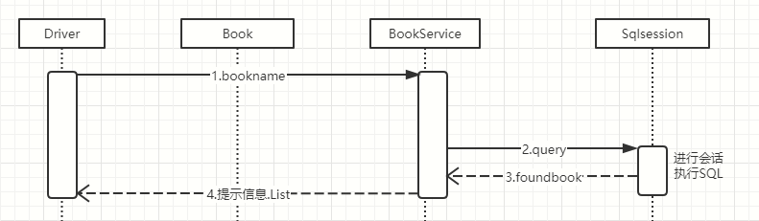
2.4.3 借阅图书
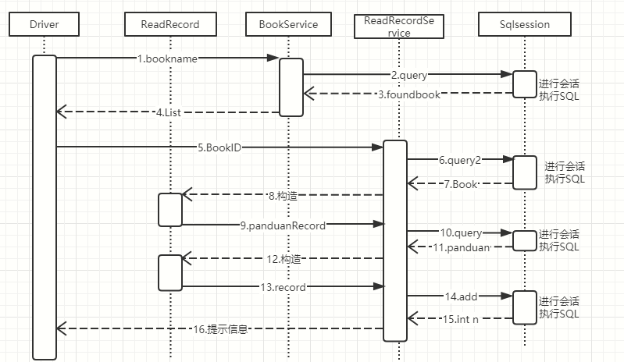
2.4.4 归还图书
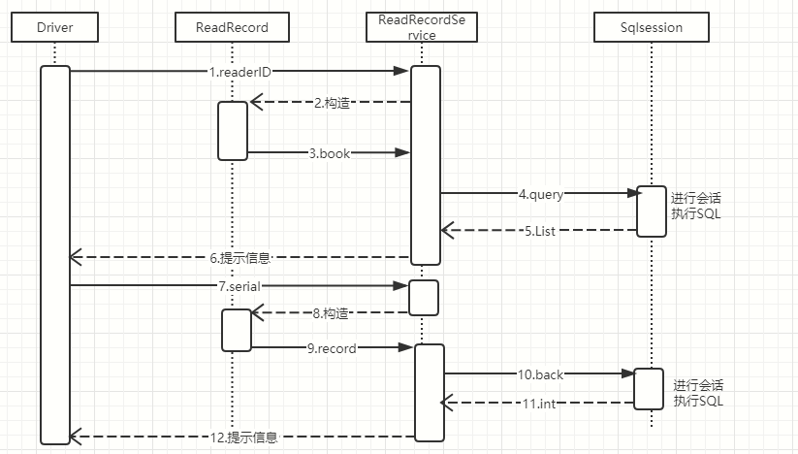
2.4.5 查询借阅记录
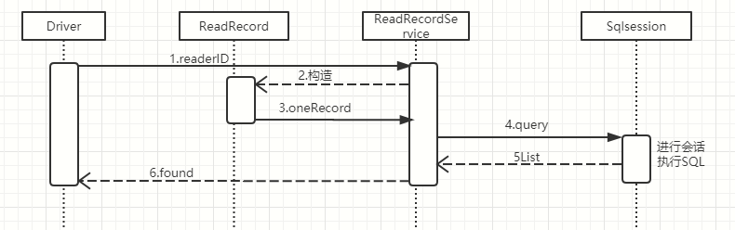

2.4.6 修改密码
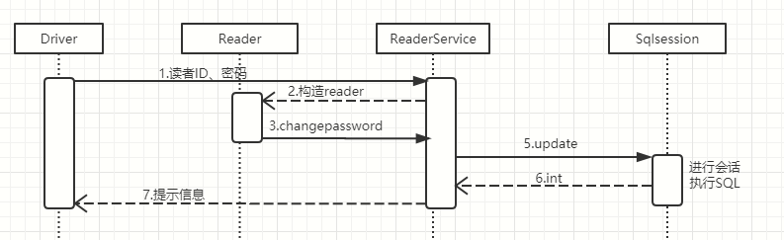2.4.7 管理员登录
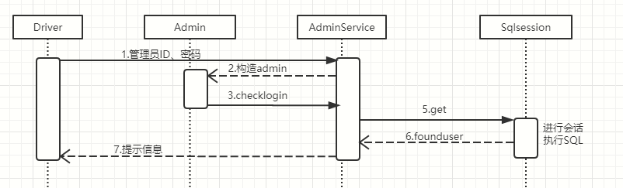
2.4.8 图书增加
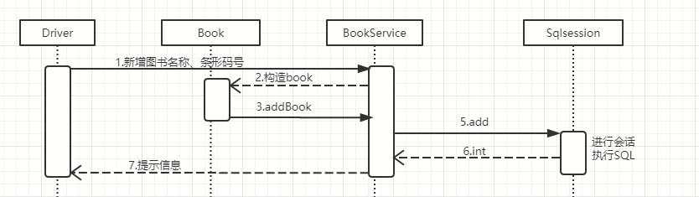
2.4.9 图书修改
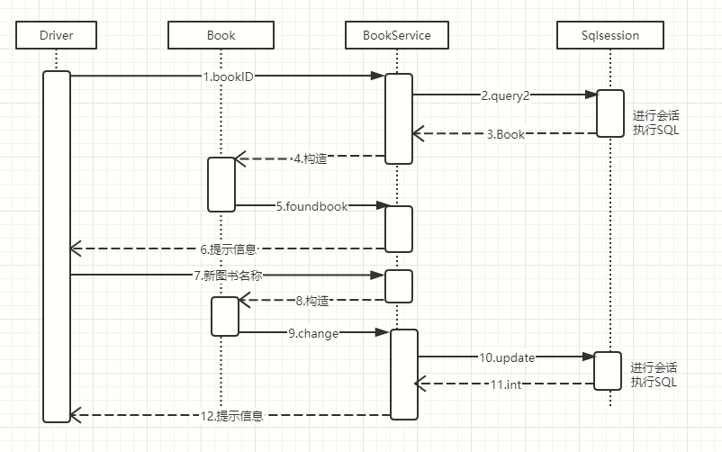
2.4.10 图书删除
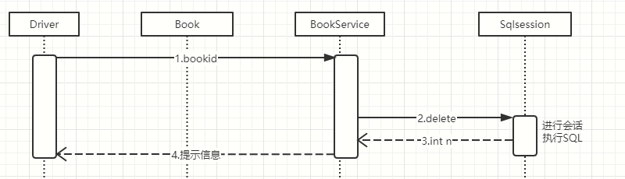
2.4.11 读者增加
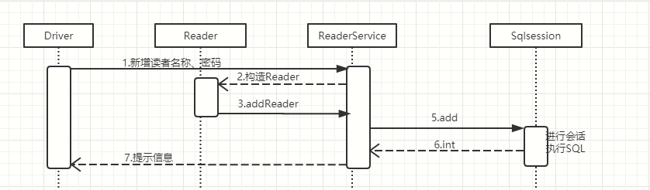

2.4.12 读者修改
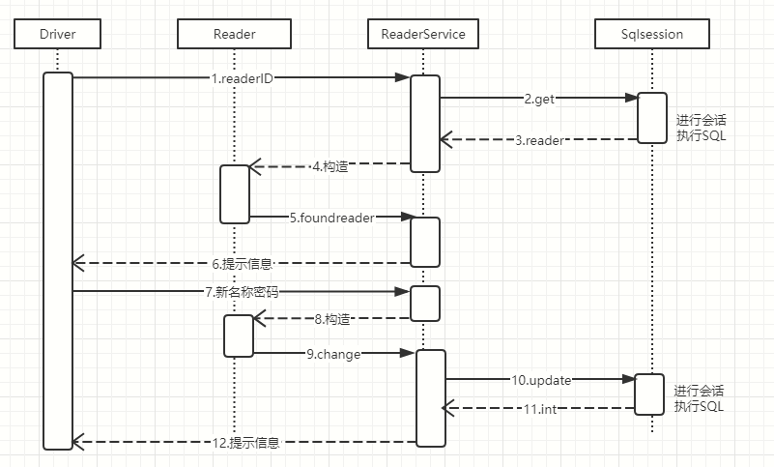
2.4.13 读者删除
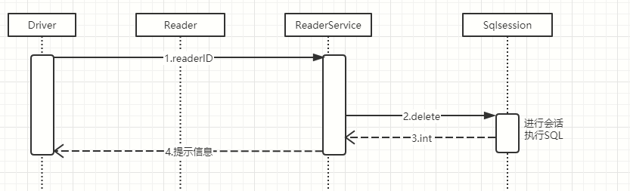
2.4.14 借阅查询
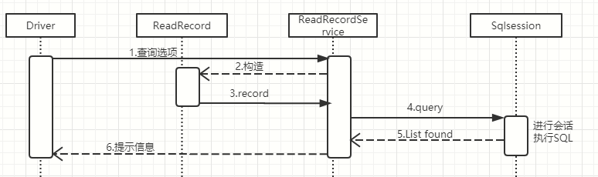
2.4.15借阅统计
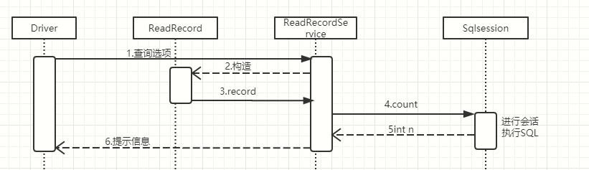

2.5 UML活动图（Activity Diagram）

2.5.1 读者登陆
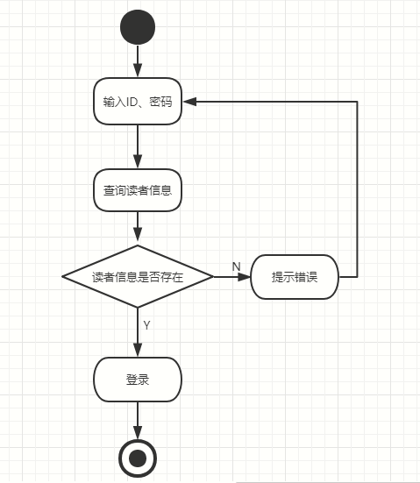

2.5.2 查询图书
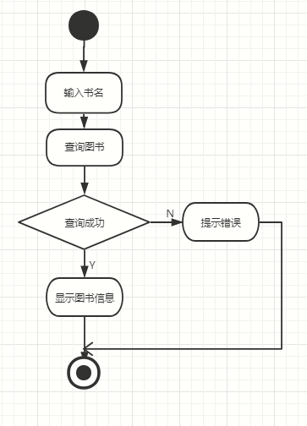

2.5.3 借阅图书
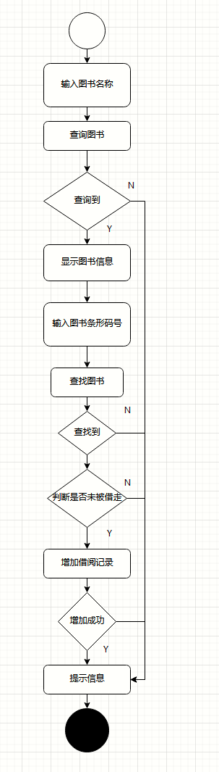

2.5.4 归还图书
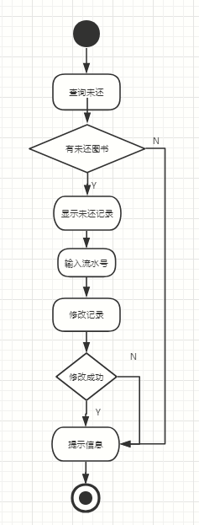
2.5.5 查询借阅记录
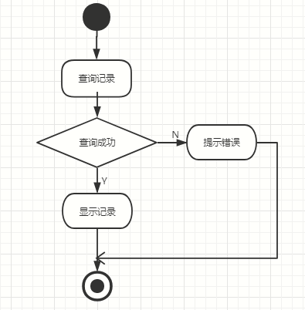
2.5.6 修改密码
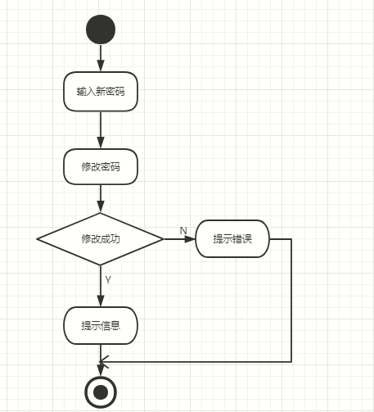
2.5.7 管理员登录
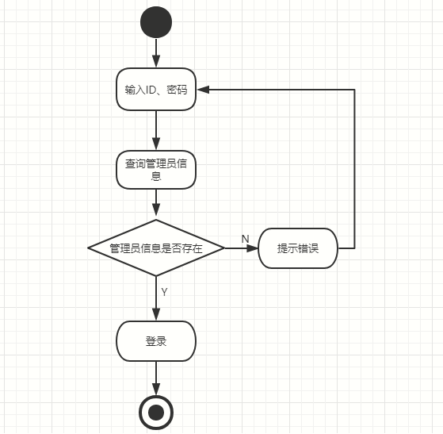

2.5.8 图书增加
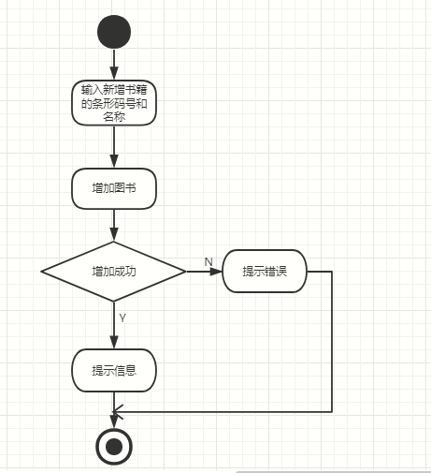
2.5.9 图书修改
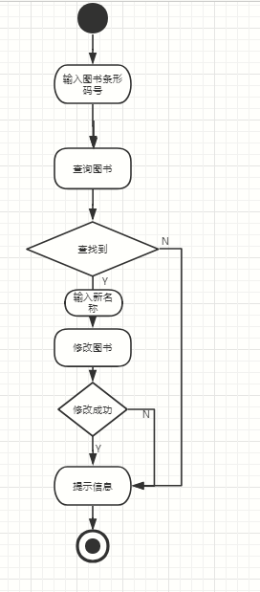
2.5.10 图书删除
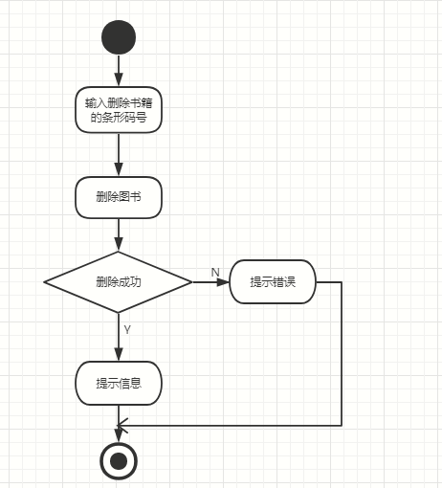
2.5.11 读者增加
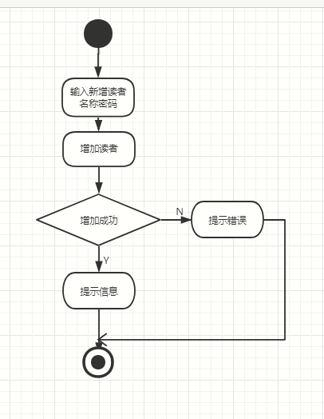
2.5.12 读者修改
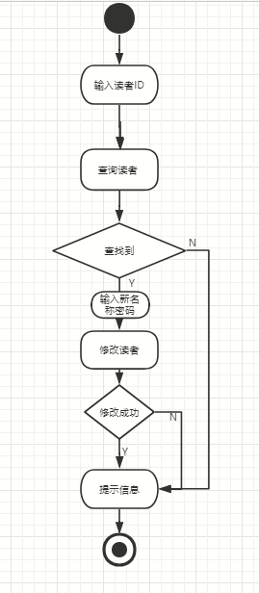
2.5.13 读者删除
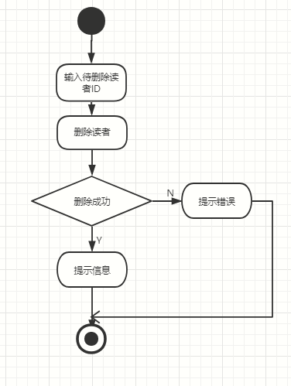
2.5.14 借阅查询
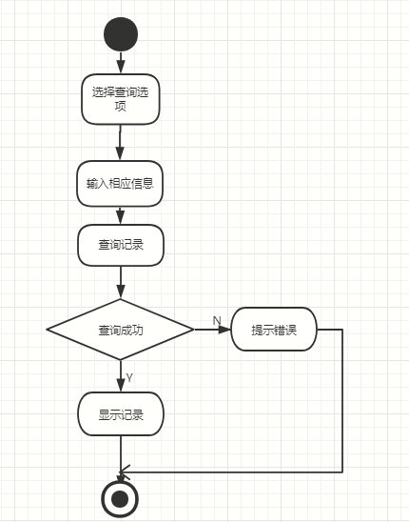
2.5.15 借阅统计

3 系统实现

3.1 项目结构
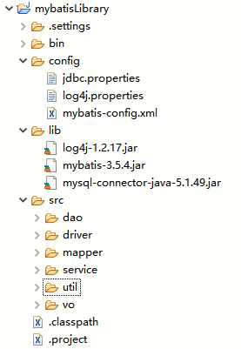

3.2 配置文件

3.2.1 jdbc.properties文件
DBDriver=com.mysql.jdbc.Driver
DBUrl=jdbc:mysql://localhost:3306/library?useUnicode=true&characterEncoding=utf-8
DBUser=root

DBPassword=root

3.2.2 log4j.properties文件
log4j.rootLogger=DEBUG, stdout
log4j.appender.stdout=org.apache.log4j.ConsoleAppender
log4j.appender.stdout.layout=org.apache.log4j.PatternLayout

log4j.appender.stdout.layout.ConversionPattern=%5p [%t] - %m%n

3.2.3 mybatis-config.xml文件
<?xml version="1.0" encoding="UTF-8"?>
<!DOCTYPE configuration
PUBLIC "-//mybatis.org//DTD Config 3.0//EN"
"http://mybatis.org/dtd/mybatis-3-config.dtd">
<!-- 根标签 -->
<configuration>
<!-- 指定资源文件 -->
<properties resource="jdbc.properties"></properties>
<!-- 设置Mybatis的log实现为LOG4J -->
<settings>
<setting name="logImpl" value="LOG4J" />
</settings>
<!-- 环境，可以配置多个，default：指定采用哪个环境 -->
<environments default="Driver">
<!-- id：唯一标识 -->
<environment id="Driver">
<!-- 事务管理器，JDBC类型的事务管理器 -->
<transactionManager type="JDBC" />
<!-- 数据源，池类型的数据源 -->
<dataSource type="POOLED">
<property name="driver" value="${DBDriver}" />
<property name="url" value="${DBUrl}" />
<property name="username" value="${DBUser}" />
<property name="password" value="${DBPassword}" />
</dataSource>
</environment>
</environments>

<!-- 配置mapper映射文件 -->
<mappers>
<mapper resource="mapper/AdminMapper.xml" />
<mapper resource="mapper/ReaderMapper.xml" />
<mapper resource="mapper/BookMapper.xml" />
<mapper resource="mapper/ReadRecordMapper.xml" />

</mappers>

</configuration>
3.3VO类
3.3.1Reader.java
package vo;
public class Reader {
private int readerID;
private String readerName;
private String readerPassword;
public Reader() {
super();
// TODO Auto-generated constructor stub }
public Reader(int readerID, String readerName, String readerPassword) {
super();
this.readerID = readerID;
this.readerName = readerName;
this.readerPassword = readerPassword;
}
public int getReaderID() {
return readerID;
}
public void setReaderID(int readerID) {
this.readerID = readerID;
}
public String getReaderName() {
return readerName;
}
public void setReaderName(String readerName) {
this.readerName = readerName;
}
public String getReaderPassword() {
return readerPassword;
}
public void setReaderPassword(String readerPassword) {
this.readerPassword = readerPassword;
}
@Override
public String toString() {
return "Reader [readerID=" + readerID + ", readerName=" + readerName + ", readerPassword=" + readerPassword
+ "]";
}
}
3.3.2 Admin.java
package vo;
public class Admin {
private int adminID;
private String adminName;
private String adminPassword;
public Admin() {
super();
// TODO Auto-generated constructor stub
}

public Admin(int adminID, String adminName, String adminPassword) {
super();
this.adminID = adminID;
this.adminName = adminName;
this.adminPassword = adminPassword;
}

public int getAdminID() {
return adminID;
}

public void setAdminID(int adminID) {
this.adminID = adminID;
}

public String getAdminName() {
return adminName;
}

public void setAdminName(String adminName) {
this.adminName = adminName;
}

public String getAdminPassword() {
return adminPassword;
}

public void setAdminPassword(String adminPassword) {
this.adminPassword = adminPassword;
}

@Override
public String toString() {
return "Admin [adminID=" + adminID + ", adminName=" + adminName + ", adminPassword=" + adminPassword + "]";
}
}
3.3.3 Book.java
package vo;
import java.util.Date;
public class Book {
private String bookID;
private String bookName;
private String addTime;
public Book() {
super();
// TODO Auto-generated constructor stub
}
public Book(String bookID, String bookName, String addTime) {
super();
this.bookID = bookID;
this.bookName = bookName;
this.addTime = addTime;
}
public String getBookID() {
return bookID;
}
public void setBookID(String bookID) {
this.bookID = bookID;
}
public String getBookName() {
return bookName;
}
public void setBookName(String bookName) {
this.bookName = bookName;
}
public String getAddTime() {
return addTime;
}
public void setAddTime(String addTime) {
this.addTime = addTime;
}
@Override
public String toString() {
return "Book [bookID=" + bookID + ", bookName=" + bookName + ", addTime=" + addTime + "]";
}

}
3.3.4 ReadRecord.java
package vo;
import java.util.Date;
public class ReadRecord {
private int serialNumber;
private String bookID;
private String bookName;
private int readerID;
private String readerName;
private String borrowTime;
private String backTime;
public ReadRecord() {
super();
// TODO Auto-generated constructor stub
}
public ReadRecord(int serialNumber, String bookID, String bookName, int readerID, String readerName,
String borrowTime, String backTime) {
super();
this.serialNumber = serialNumber;
this.bookID = bookID;
this.bookName = bookName;
this.readerID = readerID;
this.readerName = readerName;
this.borrowTime = borrowTime;
this.backTime = backTime;
}
public int getSerialNumber() {
return serialNumber;
}
public void setSerialNumber(int serialNumber) {
this.serialNumber = serialNumber;
}
public String getBookID() {
return bookID;
}
public void setBookID(String bookID) {
this.bookID = bookID;
}
public String getBookName() {
return bookName;
}
public void setBookName(String bookName) {
this.bookName = bookName;
}
public int getReaderID() {
return readerID;
}
public void setReaderID(int readerID) {
this.readerID = readerID;
}
public String getReaderName() {
return readerName;
}
public void setReaderName(String readerName) {
this.readerName = readerName;
}
public String getBorrowTime() {
return borrowTime;
}
public void setBorrowTime(String borrowTime) {
this.borrowTime = borrowTime;
}
public String getBackTime() {
return backTime;
}
public void setBackTime(String backTime) {
this.backTime = backTime;
}
@Override
public String toString() {
return "ReadRecord [serialNumber=" + serialNumber + ", bookID=" + bookID + ", bookName=" + bookName
+ ", readerID=" + readerID + ", readerName=" + readerName + ", borrowTime=" + borrowTime + ", backTime="
+ backTime + "]";
}

}

3.4 DAO接口类

3.4.1IReaderDAO.java

package dao;

import java.util.Date;

import java.util.List;

import vo.Reader;

public interface IReaderDAO{

public Reader get(int readerID);

public int add(Reader reader);

public int update(Reader reader);

public int delete(int readerID);

}

3.4.2 IAdminDAO.java
package dao;
import java.util.Date;
import java.util.List;
import vo.Admin;

public interface IAdminDAO{

public Admin get(int adminID);

}
3.4.3 IBookDAO.java
package dao;
import java.util.Date;
import java.util.List;
import vo.Book;
public interface IBookDAO{
public List<Book> query(String bookName);
public Book query2(String bookID);
public int add(Book book);
public int update(Book book);
public int delete(String bookID);
}

3.4.4 IReadRecordDAO.java
package dao;
import java.util.Date;
import java.util.List;
import vo.ReadRecord;;

public interface IReadrecordDAO{
public List<ReadRecord> query(ReadRecord record);
public int add(ReadRecord readRecord);
//借阅统计
public int count(ReadRecord readRecord);
public int back(ReadRecord record);
}

3.5 接口映射文件

3.5.1ReaderMapper.xml
<?xml version="1.0" encoding="UTF-8"?>
<!DOCTYPE mapper
PUBLIC "-//mybatis.org//DTD Mapper 3.0//EN"
"http://mybatis.org/dtd/mybatis-3-mapper.dtd">
<mapper namespace="dao.IReaderDAO">
<select id="get" parameterType="int" resultType="vo.Reader">
select * from reader where readerID = #{readerID}
</select>
<update id="update" parameterType="String" >
update reader
<set>
<if test="readerName != null">readerName=#{readerName},</if>
<if test="readerPassword != null">readerPassword=#{readerPassword},</if>
</set>
where readerID=#{readerID}
</update>
<delete id="delete" parameterType="int">
delete from
reader
where readerID=#{readerID}
</delete>
<insert id="add" parameterType="vo.Reader">
insert into reader
values(#{readerID},#{readerName},#{readerPassword})
</insert>
</mapper>
3.5.2 AdminMapper.xml
<?xml version="1.0" encoding="UTF-8"?>
<!DOCTYPE mapper
PUBLIC "-//mybatis.org//DTD Mapper 3.0//EN"
"http://mybatis.org/dtd/mybatis-3-mapper.dtd">
<mapper namespace="dao.IAdminDAO">
<select id="get" parameterType="int" resultType="vo.Admin">
select * from admin where adminID = #{adminID}
</select>
</mapper>
3.5.3 BookMapper.xml
<?xml version="1.0" encoding="UTF-8"?>
<!DOCTYPE mapper
PUBLIC "-//mybatis.org//DTD Mapper 3.0//EN"
"http://mybatis.org/dtd/mybatis-3-mapper.dtd">
<mapper namespace="dao.IBookDAO">
<select id="query" parameterType="String" resultType="vo.Book" flushCache="true">
select * from book where bookName = #{bookName}
</select>
<select id="query2" parameterType="String" resultType="vo.Book">
select * from book where bookID = #{bookID}
</select>
<update id="update" parameterType="vo.Book">
update book
<set>
<if test="bookName != null">bookName=#{bookName},</if>
</set>
where bookID=#{bookID}
</update>
<delete id="delete" parameterType="String">
delete from
book
where bookID=#{bookID}
</delete>
<insert id="add" parameterType="vo.Book">
insert into book
values(#{bookID},#{bookName},#{addTime})
</insert>
</mapper>
3.5.4 ReadRecordMapper.xml
<?xml version="1.0" encoding="UTF-8"?>
<!DOCTYPE mapper
PUBLIC "-//mybatis.org//DTD Mapper 3.0//EN"
"http://mybatis.org/dtd/mybatis-3-mapper.dtd">
<mapper namespace="dao.IReadrecordDAO">
<select id="query" parameterType="vo.ReadRecord" resultType="vo.ReadRecord">
select *
from readrecord
<where>
<if test="serialNumber!=0">
and serialNumber = #{serialNumber}
</if>
<if test="bookID!=null">
and bookID = #{bookID}
</if>
<if test="bookName!=null">
and bookName = #{bookName}
</if>
<if test="readerID!=0">
and readerID = #{readerID}
</if>
<if test="readerName!=null">
and readerName = #{readerName}
</if>
<if test="borrowTime!=null">
and borrowTime = #{borrowTime}
</if>
<if test="backTime!=null">
and backTime = #{backTime}
</if>

</where>
</select>
<update id="back" parameterType="vo.ReadRecord">
update readrecord
<set>
backTime=#{backTime},
</set>
where serialNumber=#{serialNumber}
</update>

<insert id="add" parameterType="vo.ReadRecord">
insert into readrecord(serialNumber,bookID,bookName,readerID,readerName,borrowTime,backTime)
values(#{serialNumber},#{bookID},#{bookName},#{readerID},#{readerName},#{borrowTime},#{backTime})
</insert>
<select id="count" parameterType="vo.ReadRecord" resultType="int">
select count(*)
from readrecord
<where>

<if test="bookID!=null">
bookID like #{bookID}
</if>
<if test="bookName!=null">
bookName like #{bookName}
</if>
<if test="readerID!=0">
readerID like #{readerID}
</if>
<if test="readerName!=null">
readerName like #{readerName}
</if>

</where>
</select>
</mapper>
3.6 工具包Util

3.6.1 MybatisUtils.java
package util;

import java.io.IOException;
import java.io.InputStream;

import org.apache.ibatis.io.Resources;
import org.apache.ibatis.session.SqlSession;
import org.apache.ibatis.session.SqlSessionFactory;
import org.apache.ibatis.session.SqlSessionFactoryBuilder;
public class MybatisUtils {
private static SqlSessionFactory sqlSessionFactory;
public MybatisUtils() {
super();
}
/*
* SqlSessionFactory一旦被创建,应该在应用执行期间都存在.在应用运行期间不要重复创建多次
*/
static {
String resourse = "mybatis-config.xml";
try {
InputStream inputStream = Resources.getResourceAsStream(resourse);
sqlSessionFactory = new SqlSessionFactoryBuilder().build(inputStream);
} catch (IOException e) {
e.printStackTrace();
}
}
public static SqlSession getSqlSession() {
// 如果不设置参数或者参数为false就是手动提交事务，参数设置为true就是自动提交事务
SqlSession sqlSession = sqlSessionFactory.openSession();
return sqlSession;
}
}

3.7 服务层

3.7.1 ReaderService.java

package service;

import java.util.HashMap;
import java.util.Map;
import java.util.Scanner;

import org.apache.ibatis.session.SqlSession;

import util.MybatisUtils;
import vo.Reader;

public class ReaderService {
private dao.IReaderDAO readerDAO = null;
private SqlSession sqlSession = null;

public ReaderService() {
this.sqlSession = MybatisUtils.getSqlSession();
this.readerDAO = sqlSession.getMapper(dao.IReaderDAO.class);
}

// 读者登录检查
public Map<String, Object> checkLogin(vo.Reader reader) throws Exception {
Map<String, Object> mapResult = new HashMap<String, Object>();
try {
vo.Reader foundUser = this.readerDAO.get(reader.getReaderID());
if (foundUser == null) {
mapResult.put("code", 1);
mapResult.put("msg", "用户名不存在！");
} else {
if (!foundUser.getReaderPassword().equals(reader.getReaderPassword())) {
mapResult.put("code", 1);
mapResult.put("msg", "密码不正确！");
} else {
mapResult.put("code", 0);
mapResult.put("msg", "登录成功！");
mapResult.put("user", foundUser.getReaderName());
}
}
} catch (Exception e) {
mapResult.put("code", 1);
mapResult.put("msg", e.getMessage());
}
finally{sqlSession.close();}
return mapResult;
}
//修改除ID外的读者信息
public void change(){
Scanner scan=new Scanner(System.in);
try {
System.out.println("输入待修改的读者ID：");
vo.Reader foundUser = this.readerDAO.get(scan.nextInt());
if(foundUser!=null) {
System.out.println("输入修改后的信息\n读者名称\n读者密码:");
vo.Reader reader=new vo.Reader(foundUser.getReaderID(),scan.next(),scan.next());
int n=this.readerDAO.update(reader);
sqlSession.commit();

if (n==0) {
System.out.println("修改失败！");
}
else {

System.out.println("修改成功！");

}
}
else {
System.out.println("不存在该读者ID！");
}
} catch (Exception e) {
e.printStackTrace();
}
finally{sqlSession.close();}

}
//修改读者密码
public void changepassword(vo.Reader reader){
Scanner scan=new Scanner(System.in);
try {
System.out.println("输入修改后的信息\n读者密码:");
vo.Reader reader2=new vo.Reader(reader.getReaderID(),null,scan.next());
int n=this.readerDAO.update(reader2);
sqlSession.commit();

if (n==0) {
System.out.println("修改失败！");
}
else {

System.out.println("修改成功！");

}
} catch (Exception e) {
e.printStackTrace();
}
finally{sqlSession.close();}

}
//增加读者
public void addreader(){
Scanner scan=new Scanner(System.in);
System.out.println("输入增加的读者信息:读者名称:\n读者密码:\n");
vo.Reader reader=new vo.Reader(0,scan.next(),scan.next());
try {

int n=this.readerDAO.add(reader);
sqlSession.commit();

if (n==0) {
System.out.println("增加失败！");
}
else {
System.out.println("增加成功！");

}
} catch (Exception e) {
e.printStackTrace();
}
finally{sqlSession.close();}

}
//删除读者
public void deletereader(){
Scanner scan=new Scanner(System.in);
System.out.println("输入待删除的读者ID：");
int readerID=scan.nextInt();
try {

int n=this.readerDAO.delete(readerID);
sqlSession.commit();

if (n==0) {
System.out.println( "删除失败！");
}
else {
System.out.println("删除成功！");

}
} catch (Exception e) {
e.printStackTrace();
}
finally{sqlSession.close();}

}

}

3.7.2 AdminService.java
package service;

import java.util.HashMap;
import java.util.Map;

import org.apache.ibatis.session.SqlSession;

import dao.IAdminDAO;
import util.MybatisUtils;

public class AdminService {
private dao.IAdminDAO adminDAO = null;
private SqlSession sqlSession = null;

public AdminService() {
this.sqlSession = MybatisUtils.getSqlSession();
this.adminDAO = (IAdminDAO) sqlSession.getMapper(IAdminDAO.class);
}

// 登录检查，Map形式返回检查结果
public Map<String, Object> checkLogin2(vo.Admin admin) throws Exception {
Map<String, Object> mapResult = new HashMap<String, Object>();

try {
vo.Admin foundUser = this.adminDAO.get(admin.getAdminID());
if (foundUser == null) {
mapResult.put("code", 1);
mapResult.put("msg", "用户名不存在！");
} else {

if (!foundUser.getAdminPassword().equals(admin.getAdminPassword())) {
mapResult.put("code", 1);
mapResult.put("msg", "密码不正确！");
} else {
mapResult.put("code", 0);
mapResult.put("msg", "登录成功！");
mapResult.put("user", foundUser.getAdminName());
}
}
} catch (Exception e) {
mapResult.put("code", 1);
mapResult.put("msg", e.getMessage());
}
finally{sqlSession.close();}
return mapResult;
}
}

3.7.3 BookService.java
package service;

import java.text.DateFormat;
import java.text.SimpleDateFormat;
import java.util.Date;
import java.util.HashMap;
import java.util.List;
import java.util.Map;
import java.util.Scanner;
import org.apache.ibatis.session.SqlSession;
import util.MybatisUtils;
import vo.Book;

public class BookService {
private static dao.IBookDAO bookDAO = null;
private static SqlSession sqlSession = null;

public BookService() {
this.sqlSession = MybatisUtils.getSqlSession();
this.bookDAO = sqlSession.getMapper(dao.IBookDAO.class);
}
//根据书名查询图书，List返回
public static List<Book> querybookbyname()throws Exception{
System.out.println("输入书名进行查询：");
Scanner scan=new Scanner(System.in);
String bookName=scan.next();
List<Book> foundBook = null;
try {
foundBook = bookDAO.query(bookName);
if (foundBook.size()==0) {
System.out.println("图书不存在！");
} else {
for(Book ss:foundBook) {
System.out.println(ss.toString());}
}
} catch (Exception e) {
// TODO Auto-generated catch block
e.printStackTrace();
}
finally{sqlSession.close();}
return foundBook;

}
//根据书编号查询图书，Book返回
public static Book querybookbyid(){
System.out.println("输入图书的图书编号");
Scanner scan=new Scanner(System.in);
String bookID=scan.next();
Book foundBook = null;
try {
foundBook = bookDAO.query2(bookID);
if (foundBook == null) {
System.out.println("图书条形码号不存在！");
}
} catch (Exception e) {
// TODO Auto-generated catch block
e.printStackTrace();
}
finally{sqlSession.close();}
return foundBook;
}
//修改图书名称
public void change() throws Exception {
Scanner scan=new Scanner(System.in);
vo.Book foundBook=querybookbyid();
if(foundBook!=null) {
System.out.println("输入修改后的图书名称:");
vo.Book book=new vo.Book(foundBook.getBookID(),scan.next(),null);
int n=this.bookDAO.update(book);
sqlSession.commit();
if (n==0) {
System.out.println("修改失败！");
}
else {
System.out.println("修改成功！");
}
}
sqlSession.close();

}
//增加图书
public void addbook() throws Exception {
Scanner scan=new Scanner(System.in);
System.out.println("输入待增加的图书信息\n图书条形码号:\n图书名称:\n");
try {
Date date =new Date();
DateFormat format=new SimpleDateFormat("yyyy-MM-dd HH:mm:ss");
String time=format.format(date);
vo.Book book=new vo.Book(scan.next(),scan.next(),time);
int n=this.bookDAO.add(book);
sqlSession.commit();
if (n==0) {
System.out.println( "增加失败！");
}
else {

System.out.println("增加成功！");

}
}
catch (Exception e) {
e.printStackTrace();
}
finally{sqlSession.close();}
}
//删除图书，Map形式返回检查结果
public void deletebook() throws Exception {
Scanner scan=new Scanner(System.in);
System.out.println("输入待删除的图书条形码号\n图书条形码号:");
try {
int n=this.bookDAO.delete(scan.next());
sqlSession.commit();
if (n==0) {
System.out.println("删除失败！");
}
else {

System.out.println("删除成功！");
}
}
catch (Exception e) {
e.printStackTrace();
}
finally{sqlSession.close();}
}
}

3.7.4 ReadRecoedService.java
package service;
import java.text.DateFormat;
import java.text.SimpleDateFormat;
import java.util.Date;
import java.util.HashMap;
import java.util.List;
import java.util.Map;
import java.util.Scanner;
import org.apache.ibatis.session.SqlSession;
import util.MybatisUtils;
import vo.Book;
import vo.ReadRecord;
import vo.Reader;

public class ReadRecordService {
private dao.IReadrecordDAO readRecordDAO = null;
private dao.IBookDAO bookDAO=null;
private SqlSession sqlSession = null;
public ReadRecordService() {
this.sqlSession = MybatisUtils.getSqlSession();
this.readRecordDAO = sqlSession.getMapper(dao.IReadrecordDAO.class);
this.bookDAO = sqlSession.getMapper(dao.IBookDAO.class);
}

// 借阅图书
public void borrowbook(vo.Reader reader) throws Exception{
//查找要借阅的书籍
List<vo.Book> found =BookService.querybookbyname();
try {
if(found.size()!=0) {
Book found2 =service.BookService.querybookbyid();
//输入所借书目的条形码号正确
if(found2!=null) {
vo.ReadRecord panduanrecord=new vo.ReadRecord(0,found2.getBookID(),null,0,null,null,"0");
List<vo.ReadRecord> panduan=this.readRecordDAO.query(panduanrecord);
//图书未被借走
if(panduan.size()==0) {
Date date =new Date();
DateFormat format=new SimpleDateFormat("yyyy-MM-dd");
String time=format.format(date);
//增加借书记录
ReadRecord record=new ReadRecord(0,found2.getBookID(),found2.getBookName(),reader.getReaderID(),reader.getReaderName(),time,"0");
int n = this.readRecordDAO.add(record);
sqlSession.commit();
if (n == 0) {
System.out.println("借阅失败！");
} else {
System.out.println("借阅成功！");
}
}else {
System.out.println("图书已被借阅！");
}
}
}

else {
System.out.println("请退出后重新输入图书名");
}
} catch (Exception e) {
e.printStackTrace();

}
finally{sqlSession.close();}
}
//根据已知记录信息查询借阅记录
public void queryrecord(){
Scanner scan=new Scanner(System.in);
System.out.println("选择待查询的记录信息：\n1.流水号\n2.图书条形码号\n3.图书名称\n4.读者ID\n5.读者名称");
int n=scan.nextInt();
vo.ReadRecord record=null;
if(n==1)record=new ReadRecord(scan.nextInt(),null,null,0,null,null,null);
else if(n==2)record=new ReadRecord(0,scan.next(),null,0,null,null,null);
else if(n==3)record=new ReadRecord(0,null,scan.next(),0,null,null,null);
else if(n==4)record=new ReadRecord(0,null,null,scan.nextInt(),null,null,null);
else if(n==5)record=new ReadRecord(0,null,null,0,scan.next(),null,null);
else System.out.println("选择无效请重新输入");
try {
List<vo.ReadRecord> found = this.readRecordDAO.query(record);
if (found.size()==0) {
System.out.println("无借阅记录！");
} else {
for(ReadRecord ss:found) {
System.out.println(ss);}
}
} catch (Exception e) {
e.printStackTrace();
}
finally{sqlSession.close();}
}
//根据读者id查询借阅记录
public void queryrecordbyreaderid(int readerid){
vo.ReadRecord oneRecord=new ReadRecord(0,null,null,readerid,null,null,null);
try {
List<vo.ReadRecord> found = this.readRecordDAO.query(oneRecord);
if (found.size()==0) {
System.out.println("查询失败！");
} else {
for(ReadRecord ss:found) {
System.out.println(ss);}
}
} catch (Exception e) {
e.printStackTrace();
}
finally{sqlSession.close();}
}

//归还图书
public void backbook(int readerID){
try {
vo.ReadRecord book=new ReadRecord(0,null,null,readerID,null,null,"0");
List<vo.ReadRecord> found=this.readRecordDAO.query(book);
//还有未归还的图书
if(found.size()!=0) {
System.out.println(found.toString());
System.out.println("\n输入待归还记录的流水号");
//输入记录流水号，更改归还时间
Scanner scan=new Scanner(System.in);
int serial=scan.nextInt();
Date date =new Date();
DateFormat format=new SimpleDateFormat("yyyy-MM-dd");
String time=format.format(date);
ReadRecord record=new ReadRecord(serial,null,null,0,null,null,time);
int n = this.readRecordDAO.back(record);
sqlSession.commit();
if (n == 0) {
System.out.println("归还失败！");
} else {
System.out.println("归还成功！");
}
}else {
System.out.println("没有待归还的图书！");
}
} catch (Exception e) {
e.printStackTrace();
}
finally{sqlSession.close();}
}
//进行借阅统计
public void count(){
Scanner scan=new Scanner(System.in);
System.out.println("选择待查询的记录信息\n1.图书条形码号\n2.图书名称\n3.读者ID\n4.读者名称");
//选择需要统计的项目
int n=scan.nextInt();
vo.ReadRecord record=null;
if(n==1)record=new ReadRecord(0,scan.next(),null,0,null,null,null);
else if(n==2)record=new ReadRecord(0,null,scan.next(),0,null,null,null);
else if(n==3)record=new ReadRecord(0,null,null,scan.nextInt(),null,null,null);
else if(n==4)record=new ReadRecord(0,null,null,0,scan.next(),null,null);
else System.out.println("选择无效!");
try {
int count=this.readRecordDAO.count(record);

if (count==0) {
System.out.println( "无记录！");
}
else {
System.out.println("统计数目："+count);
}
} catch (Exception e) {
e.printStackTrace();
}
finally{sqlSession.close();}
}
}

3.8 用户界面libraryDriver.java

package driver;
import java.text.DateFormat;
import java.text.SimpleDateFormat;
import java.util.Date;
import java.util.HashMap;
import java.util.Map;
import org.junit.Test;
import java.util.Scanner;
import service.AdminService;
import service.BookService;
import service.ReadRecordService;
import service.ReaderService;
import vo.ReadRecord;
import vo.Reader;
public class libraryDriver {
public static void main(String[] args) throws Exception{
ReaderService readerService = new ReaderService();
AdminService adminService = new AdminService();
BookService bookService = new BookService();
ReadRecordService readRecordService=new ReadRecordService();
int choice=menu();
while(choice!=3) {
switch(choice) {
case 1:login(1);break;
case 2:login(2);break;
default:System.out.println("选择无效请重新输入");
}
choice=menu();
}
}
public static int menu() {
int choice;
Scanner scan=new Scanner(System.in);
Date date =new Date();
DateFormat format=new SimpleDateFormat("yyyy-MM-dd");
String time=format.format(date);
System.out.println(time);
System.out.println("============欢迎使用图书馆系统===========");
System.out.println("===选择登录身份===");
System.out.println("1.读者");
System.out.println("2.管理员");
System.out.println("3.退出");
System.out.println("请选择（1-3）");
choice=scan.nextInt();
return choice;
}
public static int menu1() {
int choice1;
System.out.println("============读者菜单===========");
System.out.println("1.查询图书");
System.out.println("2.借阅图书");
System.out.println("3.归还图书");
System.out.println("4.查询借阅记录");
System.out.println("5.修改密码");
System.out.println("6.退出登陆");
System.out.println("请选择（1-6）");
Scanner scan=new Scanner(System.in);
choice1=scan.nextInt();
return choice1;
}
public static int menu2() {
int choice2;
System.out.println("===========管理员菜单===========");
System.out.println("1.图书增加");
System.out.println("2.图书修改");
System.out.println("3.图书删除");
System.out.println("4.读者增加");
System.out.println("5.读者修改");
System.out.println("6.读者删除");
System.out.println("7.借阅查询");
System.out.println("8.借阅统计");
System.out.println("9.退出登录");
System.out.println("请选择（1-9）");
Scanner scan=new Scanner(System.in);
choice2=scan.nextInt();
return choice2;
}
public static void login(int s) throws Exception{
Scanner scan=new Scanner(System.in);
ReaderService readerService = new ReaderService();
ReadRecordService readRecordService=new ReadRecordService();
BookService bookService=new BookService();
AdminService adminService = new AdminService();
System.out.println("输入登陆信息：\nID:\n密码:");
//输入登陆信息
int ID=scan.nextInt();
String password=scan.next();
//读者身份登录成功
if(s==1) {
vo.Reader reader=new Reader(ID,null,password);
Map<String, Object> map =readerService.checkLogin(reader);
if(map.get("code").equals(0)) {
System.out.println("欢迎读者："+map.get("user")+"登录！");
int choice=menu1();
while(choice!=6) {
switch(choice) {
case 1:bookService.querybookbyname();break;
case 2:readRecordService.borrowbook(reader);break;
case 3:readRecordService.backbook(ID);break;
case 4:readRecordService.queryrecordbyreaderid(ID);break;
case 5:readerService.changepassword(reader);break;
default:System.out.println("选择无效请重新输入");
}
choice=menu1();
}
int choice1=menu();
while(choice1!=3) {
switch(choice1) {
case 1:login(1);break;
case 2:login(2);break;
default:System.out.println("选择无效请重新输入");
}
choice1=menu();
}
}else {
System.out.println(map.get("msg"));
}

}else { //管理员身份登录
vo.Admin admin=new vo.Admin(ID,null,password);
Map<String, Object> map = adminService.checkLogin2(admin);
if(map.get("code").equals(0)) {
System.out.println("欢迎管理员："+map.get("user")+"登录！");

int choice=menu2();
while(choice!=9) {
switch(choice) {
case 1:bookService.addbook();break;
case 2:bookService.change();break;
case 3:bookService.deletebook();break;
case 4:readerService.addreader();break;
case 5:readerService.change();break;
case 6:readerService.deletereader();break;
case 7:readRecordService.queryrecord();break;
case 8:readRecordService.count();break;
default:System.out.println("选择无效请重新输入");

}
choice=menu2();
}
int choice1=menu();
while(choice1!=3) {
switch(choice1) {
case 1:login(1);break;
case 2:login(2);break;
default:System.out.println("选择无效请重新输入");
}
choice1=menu();
}
}else {
System.out.println(map.get("msg"));
}
}
}
}

4 系统测试
4.1 登录入口
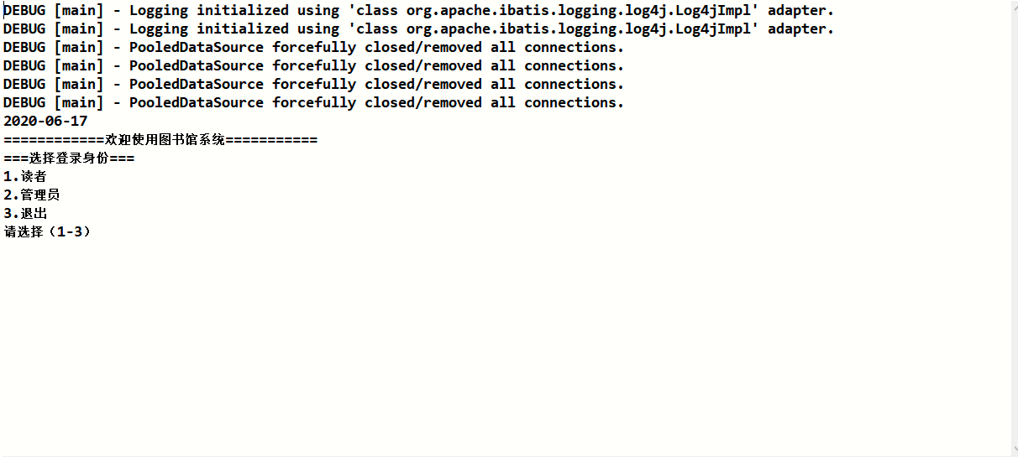
4.2读者登录
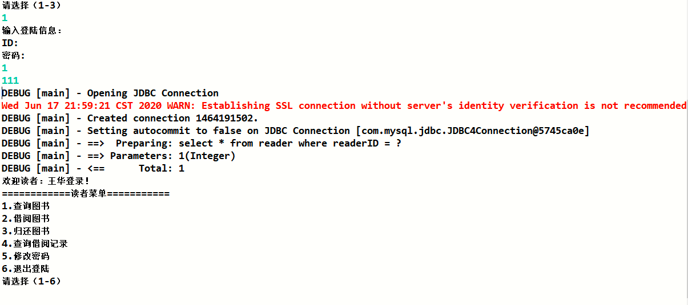
4.3 查询图书

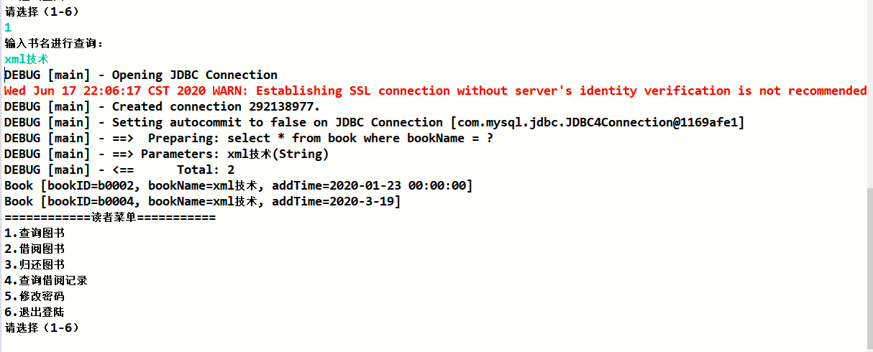
4.4借阅图书
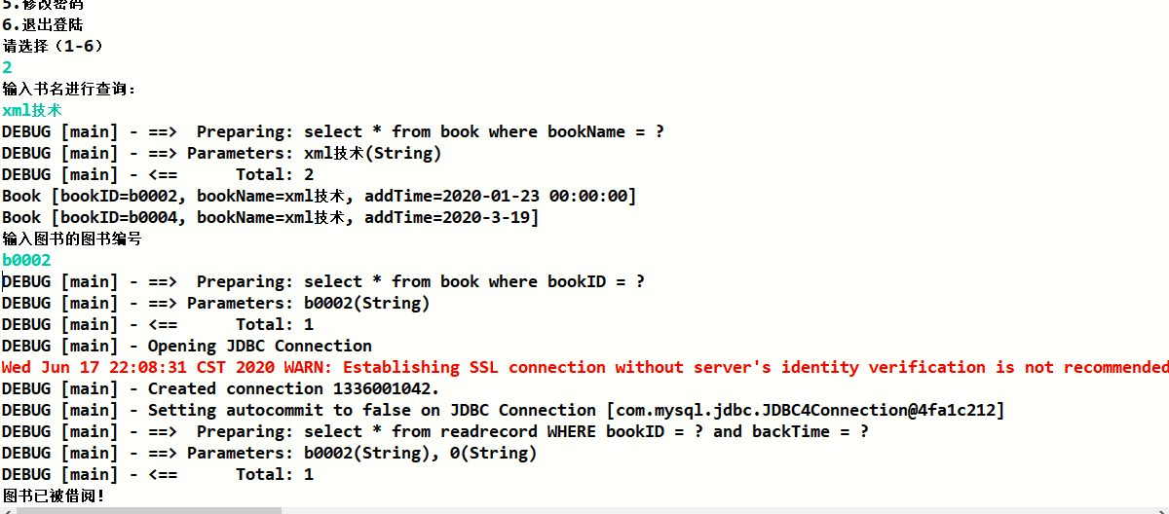
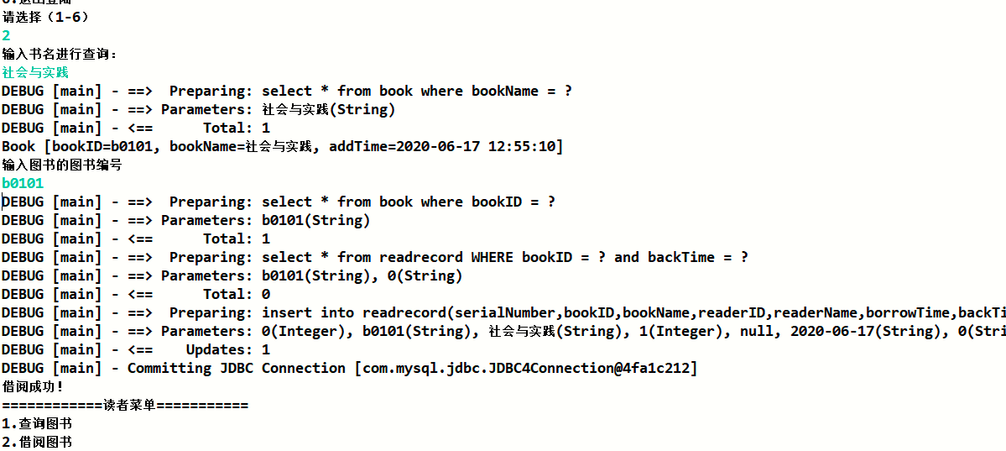
4.5 归还图书
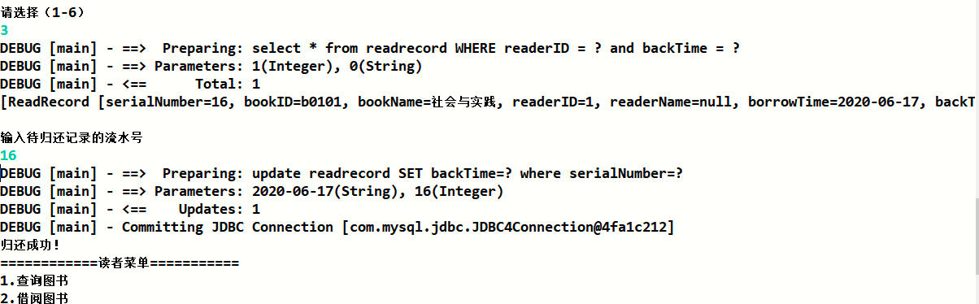
4.6 查询借阅记录
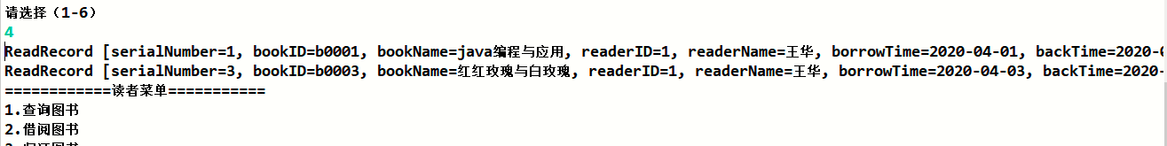
4.7 修改密码
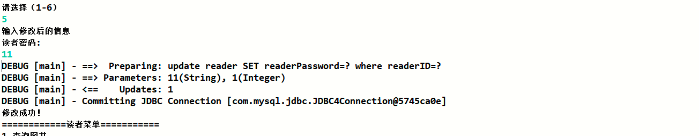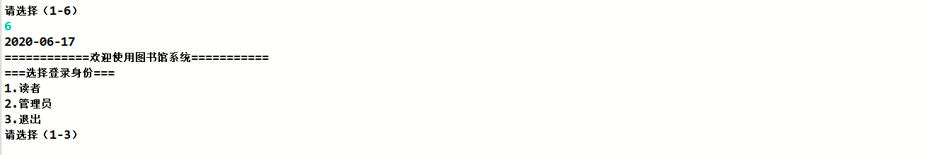
4.8 管理员登录
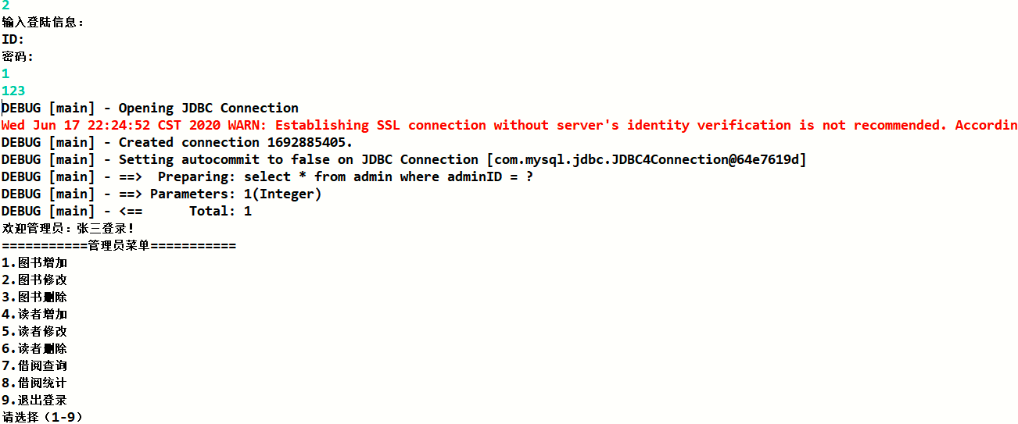
4.9 图书增加
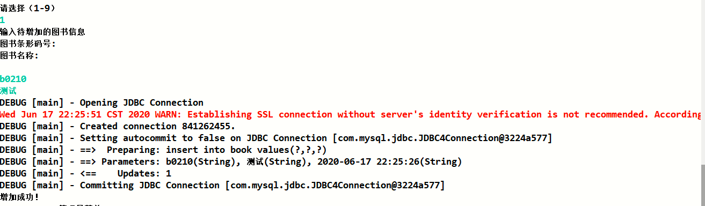
4.10 图书修改
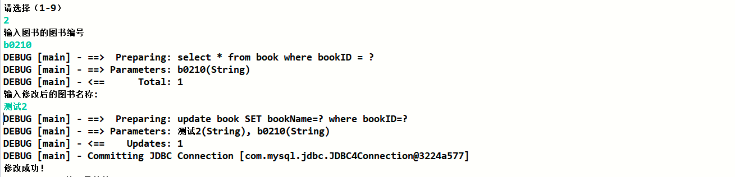
4.11 图书删除
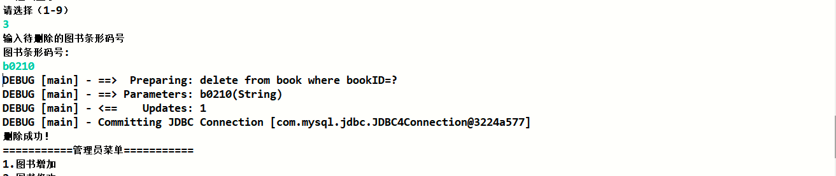
4.12 读者增加
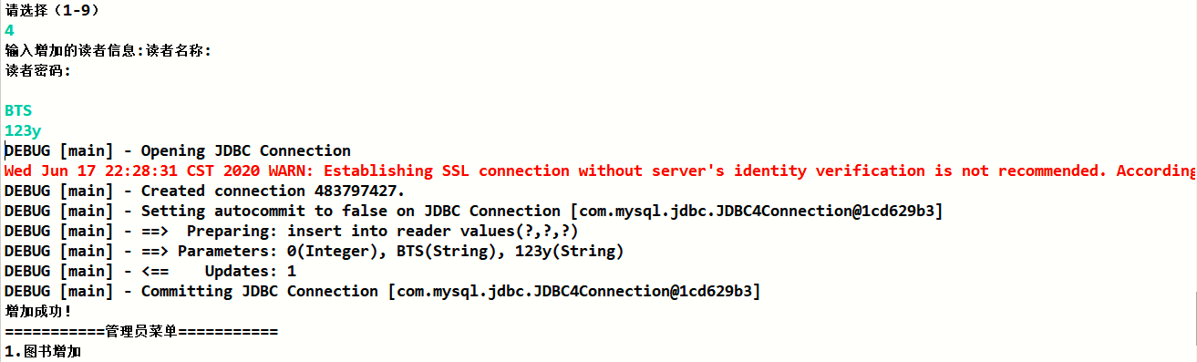
4.13 读者修改
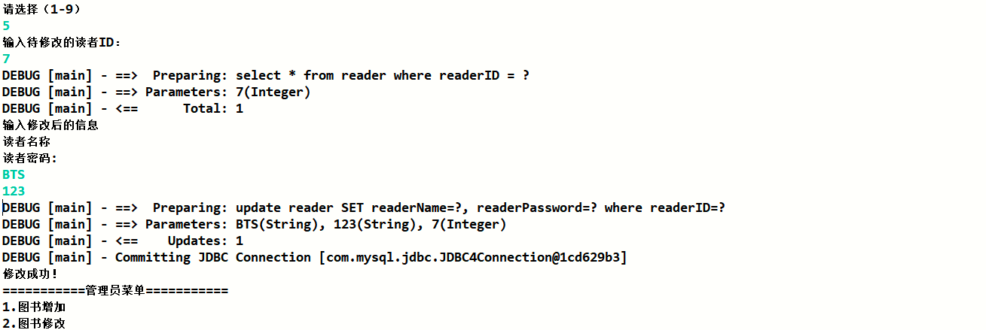
4.14 读者删除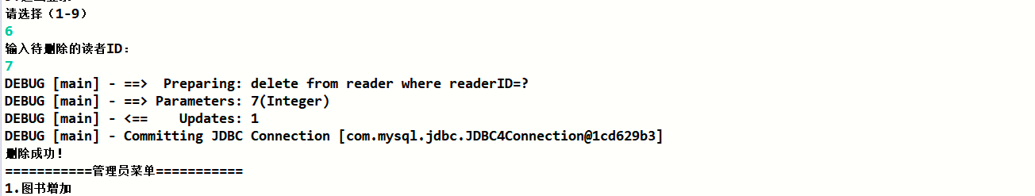
4.15 借阅查询
4.15.1 按流水号查询
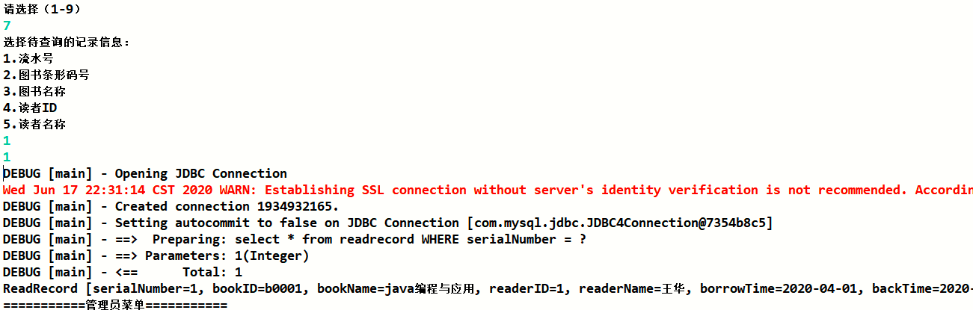
4.15.2 按图书条形码号查询
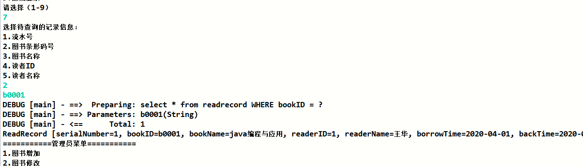
4.15.3 按图书名称查询
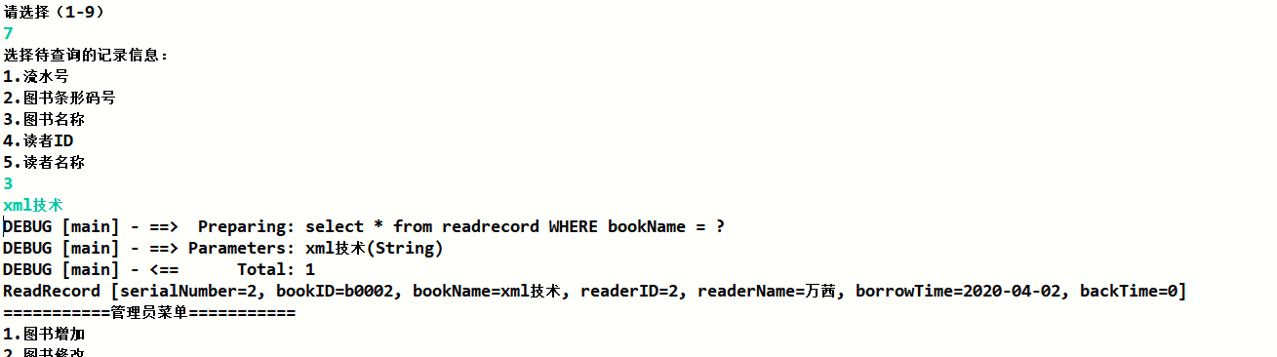
4.15.4 按读者ID查询
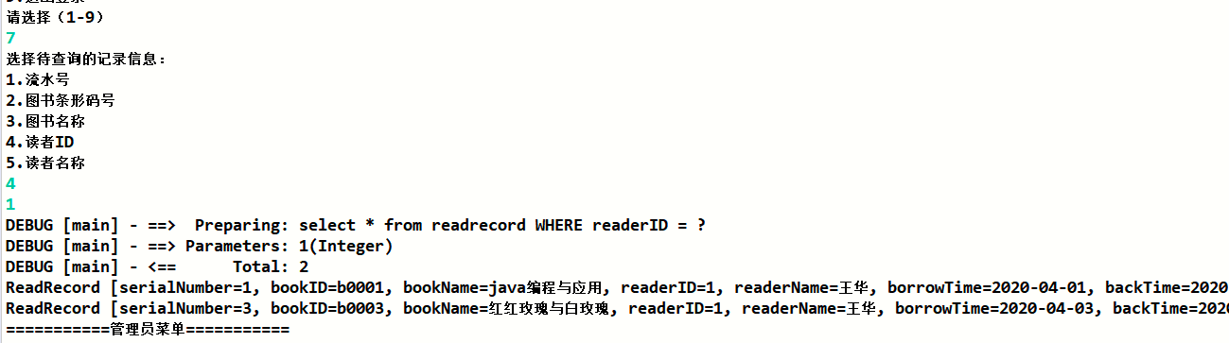
4.15.5 按读者名称查询
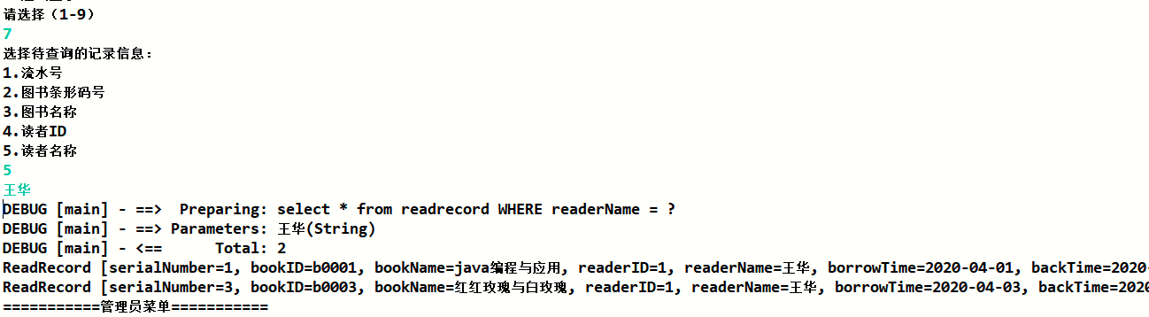
4.16 借阅统计
4.16.1 按图书条形码号统计
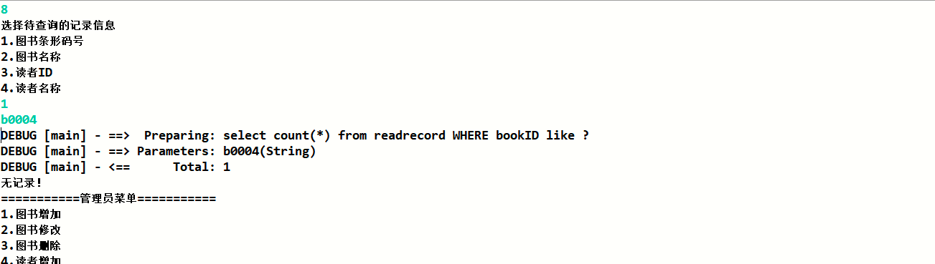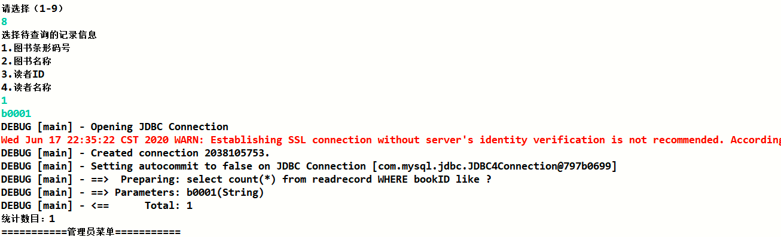
4.16.2 按图书名称统计
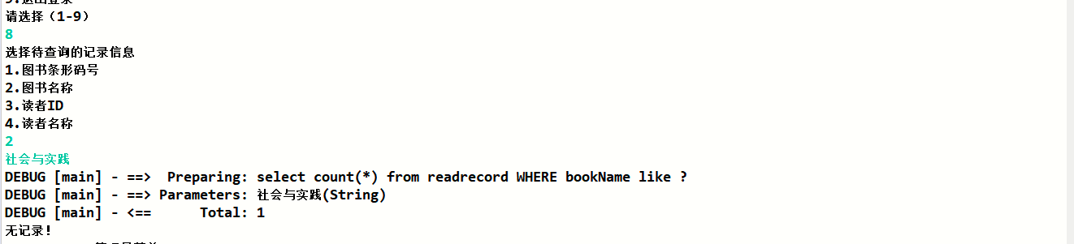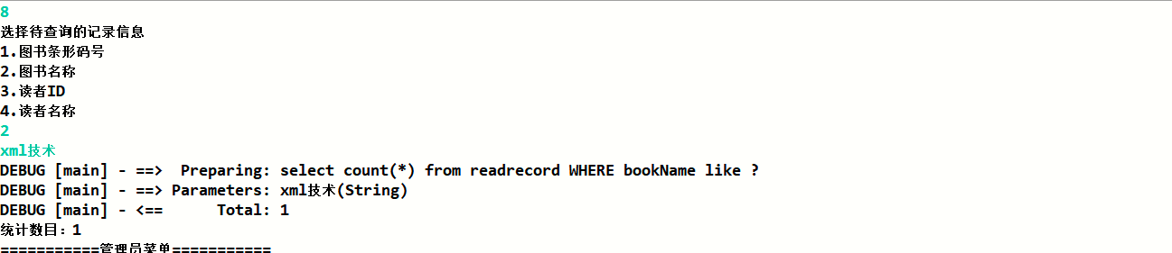
4.16.3 按读者ID统计
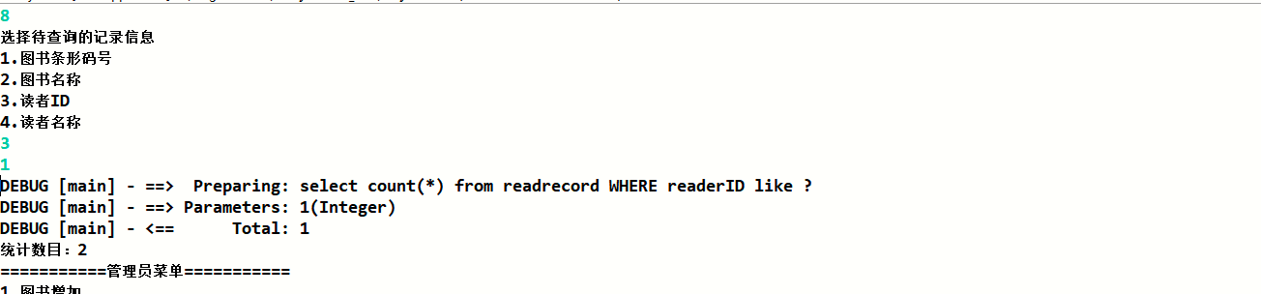
4.16.4 按读者名称统计
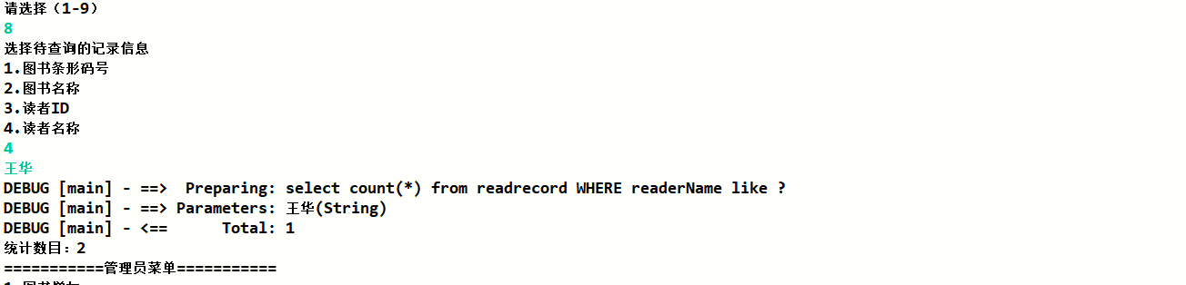

5 系统总结
本次课程设计中遇到了一些问题，如修改数据后返回结果成功，但数据库信息未修改、修改增加数据出现死锁等，在网络上的一些博客、论坛里找到了对应的解决办法，加深了对Mybatis框架的理解，熟悉了解决相关问题的方法。系统还存在功能不够人性化、较为简单等问题。以后要进一步加深对java编程语言的学习，多尝试各种框架的系统设计，在java学习的道路上越走越远。

