Aussie Kids Charity
Website layout promotion
- Layout exhibition
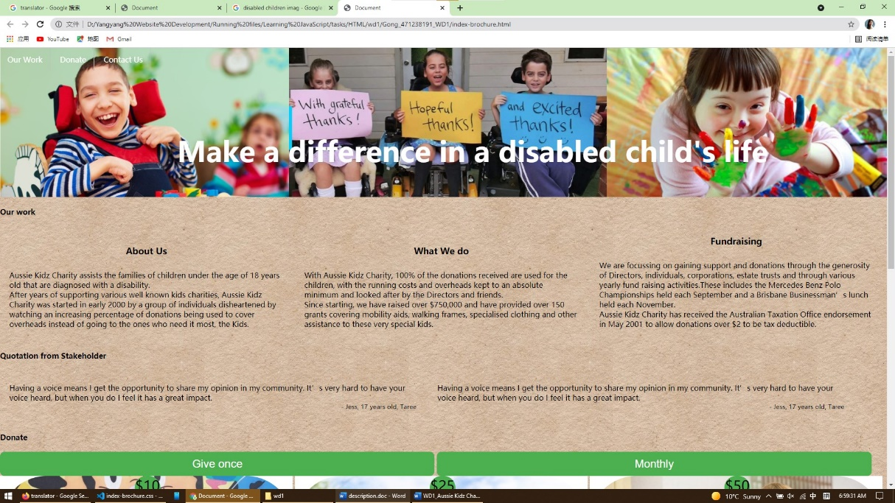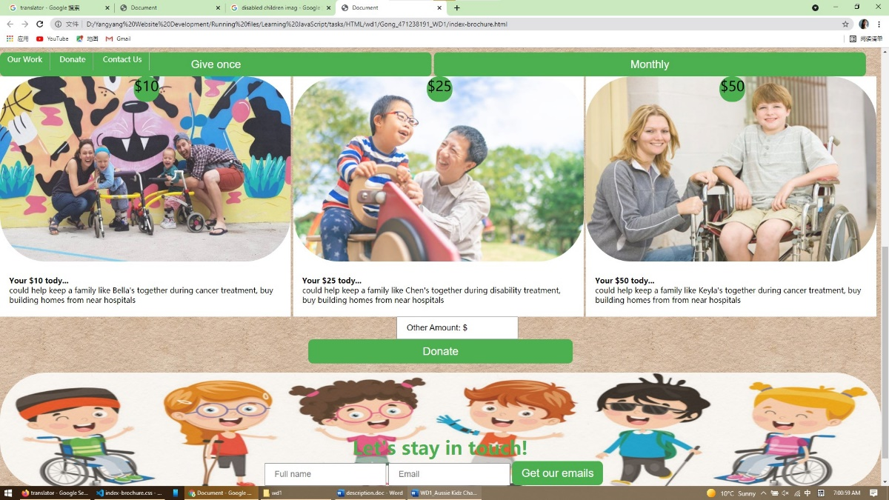
- Design concept
- Happy
- All images contain smiles. Users feel they are doing something good for others.
- Thankfulness
- Most images express the thankfulness gratitude from the children and families.
- In “donate” section, words show what changes the donation amount will make.
- User-friendly
- Navigation bar is always fixed to top and links to relative sections.
- All buttons have the same green color.
- All input text has explicitly outlined and incorporated images.
- Meet requirements
- Disabled children
- All images include disabled children and families.
- Last cartoon image shows different sorts of disability.
- Show client’s brief
- Centered and bold “Make a difference in a disabled child’s life”.
- List client’s work in first page.
- Encourage donation
- Navigation menu directly links to “donate” section.
- Donation types and amounts show obviously.
- Provide “other amount”.
- Any contact deserved
- Navigation menu directly links to “contact” section.
- Get users’ email.
- Provide all contact details.
- Encourage direct donation.

