91年交大資科 數位系統詳解

Part 1. Multiple-choice question ( 42 points total)

1. Which of the following Boolean function cannot be realized by using the four (2 p-type and
2 n-type) transistors used in the implementation of a CMOS NAND gate?
(A) F=A’B’ (B)F=AB (C) F=A’ (D) F=A

【解答】（B）
F=A’B’=(A+B)’：NOR
F=A’B’=A’：NOR, 令B=0
F=(A’)’
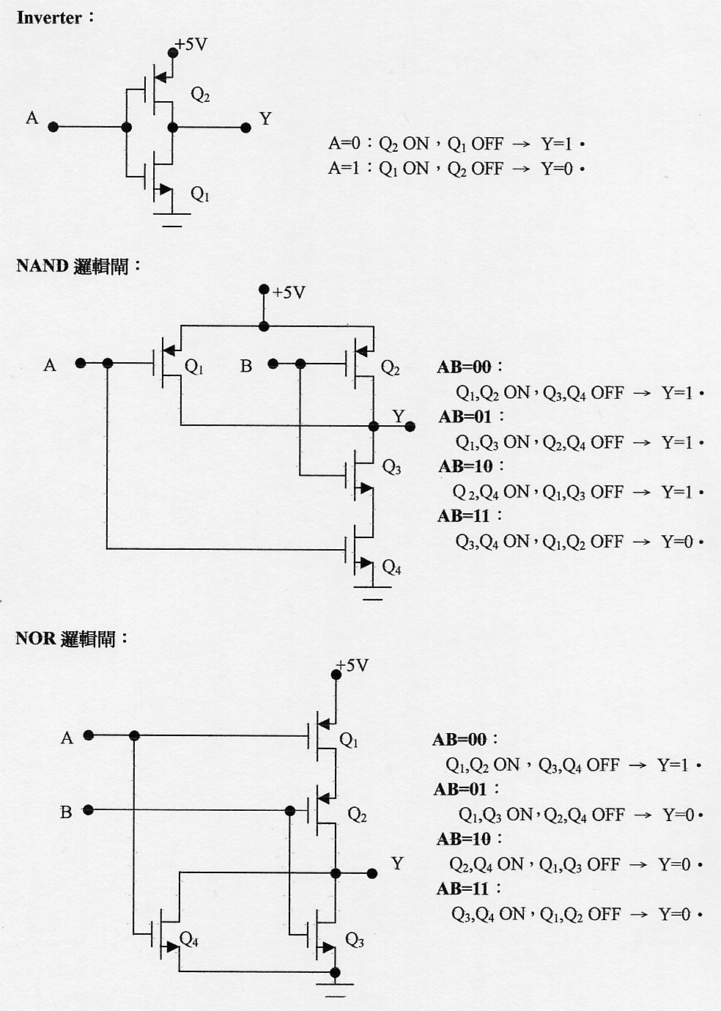

2. Which of the following sum terms is not a necessity in the sum of products simplification of
(B+D)(A’+B+C’)(A+C+D’)
(A) AB (B) BD’ (C) AC’D (D) A’CD

【解答】(X)
AB CD | 00 | 01 | 11 | 10
00 | 0 | 0 | 1 | 0
01 | 1 | 0 | 1 | 1
11 | 1 | 1 | 1 | 1
10 | 0 | 1 | 0 | 0
Sum of products = AB +BD’+A’CD+AC’D

3. How many essential prime implicants are there for F(A,B,C,D) = Σm(0,1,3,11,13,15),
d(A,B,C,D) =Σm(7,8,9,10,12,14)?
(A) 2 (B) 3 (C) 4 (D) 5

【解答】(B)
AB CD | 00 | 01 | 11 | 10
00 | 1 | 1 | 1 | 0
01 | 0 | 0 | X | 0
11 | X | 1 | 1 | X
10 | X | X | 1 | X
Prime implications：A（8, 9, 10, 11, 12, 13, 14, 15）、CD（3, 7, 11, 15）、B’C’（0, 1, 8, 9）
Essential prime implicants：
A（8, 9, 10, 11, 12, 13, 14, 15）、CD（3, 7, 11, 15）、B’C’（0, 1, 8, 9）

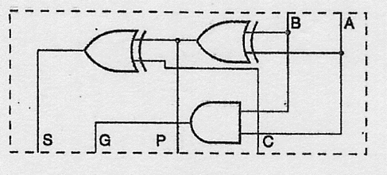
4.

Consider a 4-bit Carry Lookahead Adder which has a C₀ input and uses four Partial Full Adders
(like the one shown in the above figure). In the carry lookahead circuit, what is the fan-in of the
OR gate whose output is C₃?
(A) 2 (B) 3 (C) 4 (D) 5

【解答】(C)
Carry Lookahead Adder：以四位元為例‧
令P_{i}=A_{i}'B_{i}+A_{i}B_{i}'=A_{i}⊕B_{i}
G_{i}=A_{i}B_{i}
則C_{i}=G_{i}+P_{i}G_{i-1}
故：C₁=G₀+P₀C₀
C₂=G₁+P₁C₁=G₁+P₁（G₀+P₀C₀）=G₁+P₁G₀+P₁P₀C₀
C₃=G₂+P₂C₂=G₂+P₂G₁+P₂P₁G₀+P₂P₁P₀C₀
C₄=G₃+P₃C₃=G₃+P₃G₂+P₃P₂G₁+P₃P₂P₁G₀+P₃P₂P₁P₀C₀

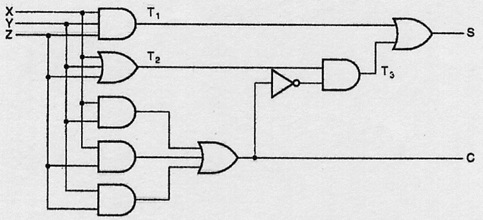
5.

Which of the following input (X,Y,Z) change will take the shortest time for output S to change?
(A) 000→001 (B) 001→011 (C) 011→001 (D) 111→110

【解答】(D)
001→011、011→001：c change → T₃ change → s changes，五個Logic gates之delay。
000→001：T₂ change → T₃ change → s changes，三個Logic gates之delay。
111→110：T₁ change → s changes，兩個Logic gates之delay。[T₂ chang,但T₃ 並沒有change]

6. Consider the design of combinational circuit using a 2-to-4 line decoder. What is the minimum
number of external gates required to implement a circuit that accepts a 2-bit number and
generates a 4-bit binary number output equal to the square of the input number.
(A) 0 (B) 1 (C) 2 (D) 3

【解答】(C)
最小項解碼器加上OR閘：可實現最小項之和(Sum of minterms)之數位電路‧
最大項解碼器加上AND閘：可實現最大項之積(Product of maxterms)之數位電路‧
示例：以解碼器設計全加器(Full adder)，規格如下：
輸入信號有三：被加數位元X，加數位元Y，前級進位C_{IN}‧
輸出信號有二：和值S，下級位進位C_{OUT}‧
真值表為：
X | Y | C_{IN} |  | S | C_{OUT}
0 | 0 | 0 |  | 0 | 0
0 | 0 | 1 |  | 1 | 0
0 | 1 | 0 |  | 1 | 0
0 | 1 | 1 |  | 0 | 1
1 | 0 | 0 |  | 1 | 0
1 | 0 | 1 |  | 0 | 1
1 | 1 | 0 |  | 0 | 1
1 | 1 | 1 |  | 1 | 1
全加器：S =Σ_{m}﹙1,2,4,7﹚=m₁+m₂+m₄+m₇=Π_{M}﹙0,3,5,6﹚=M₀‧M₃‧M₅‧M₆
C_{OUT}=Σ_{m}﹙3,5,6,7﹚=m₃+m₅+m₆+m₇=Π_{M}﹙0,1,2,4﹚=M₀‧M₁‧M₂‧M₄
X 2² 0
Y 2¹ 1 S
C_{IN} 2⁰ 2
3
4
5 C_{OUT}
6
7

X 2² 0
Y 2¹ 1 S
C_{IN} 2⁰ 2
3
4
5 C_{OUT}
Enable E 6
7

A | b | F₁ | F₂ | F₃ | F₄
0 | 0 | 0 | 0 | 0 | 0
0 | 1 | 0 | 0 | 0 | 1
1 | 0 | 0 | 1 | 0 | 0
1 | 1 | 1 | 0 | 0 | 1
F₁：2-4 decoder+OR gate、F₁：2-4 decoder+OR gate。
F₃：接地即可、F₄：接到輸入信號b即可。

7. Given that there is a single bit error occurred in one of the parity check bits. Identify the
erroneous check bit of the 12-bit Hamming code word( b1,b2,…,b12): 0011 1000 0100.
(A) P₁ (B) P₂ (C) P₄ (D) P₈

【解答】
參閱下述說明：
利用hamming code傳送訊息時，如果傳送過程中有一bit產生錯誤，則可以自動更正‧
（A）現有一要傳送之資料串為〝1100001〞（註：位置編號由右至左），請寫出經hamming
code編碼後，傳送之資料串‧
（B）現收到一資料串〝01001010110〞，請解碼為原7－bit之資料串‧

C₄ C₃ C₂ C₁ |  | 代表意義
0 0 0 0 | 0 | 所接收到之Ｐ₁₁～Ｐ₁資料正確無誤
0 0 0 1 | 1 | Ｐ₁位元錯誤
0 0 1 0 | 2 | Ｐ₂位元錯誤
0 0 1 1 | 3 | Ｐ₃位元錯誤
0 1 0 0 | 4 | Ｐ₄位元錯誤
0 1 0 1 | 5 | Ｐ₅位元錯誤
0 1 1 0 | 6 | Ｐ₆位元錯誤
0 1 1 1 | 7 | Ｐ₇位元錯誤
1 0 0 0 | 8 | Ｐ₈位元錯誤
1 0 0 1 | 9 | Ｐ₉位元錯誤
1 0 1 0 | 10 | Ｐ₁₀位元錯誤
1 0 1 1 | 11 | Ｐ₁₁位元錯誤

（A）：
資料串〝1100001〞中插入同位元：
Ｐ₁₁Ｐ₁₀Ｐ₉Ｐ₈Ｐ₇Ｐ₆Ｐ₅Ｐ₄Ｐ₃Ｐ₂Ｐ₁
1 1 0 Ｐ₈ 0 0 0 Ｐ₄ 1 Ｐ₂Ｐ₁
P₈⊕P₉⊕P₁₀⊕P₁₁＝P₈⊕0⊕1⊕1＝0 ——→ P₈＝0‧
P₄⊕P₅⊕P₆⊕P₇＝P₄⊕0⊕0⊕0＝0 ——→ P₄＝0‧
P₂⊕P₃⊕P₆⊕P₇⊕P₁₀⊕P₁₁＝P₂⊕1⊕0⊕0⊕1⊕1＝0 ——→ P₂＝1‧
P₁⊕P₃⊕P₅⊕P₇⊕P₉⊕P₁₁＝P₁⊕1⊕0⊕0⊕0⊕1＝0 ——→ P₁＝0‧
故傳送之資料串為11000000110‧
（B）：Ｐ₁₁Ｐ₁₀Ｐ₉Ｐ₈Ｐ₇Ｐ₆Ｐ₅Ｐ₄Ｐ₃Ｐ₂Ｐ₁
0 1 0 0 1 0 1 0 1 1 0
C₄＝P₈⊕P₉⊕P₁₀⊕P₁₁＝0⊕0⊕1⊕0＝1‧
C₃＝P₄⊕P₅⊕P₆⊕P₇＝0⊕1⊕0⊕1＝0‧
C₂＝P₂⊕P₃⊕P₆⊕P₇⊕P₁₀⊕P₁₁＝1⊕1⊕0⊕1⊕1⊕0＝0‧
C₁＝P₁⊕P₃⊕P₅⊕P₇⊕P₉⊕P₁₁＝0⊕1⊕1⊕1⊕0⊕0＝1‧
C₄C₃C₂C₁＝1001，故P₉有錯‧
更正為：01101010110，原資料串為：0111011

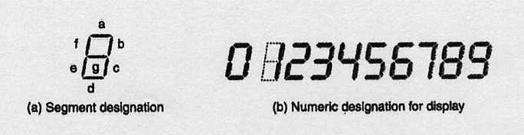
8.

Consider the seven-segment display shown above, what is the maximum number of the segments
which can be kept off while all the numeric values can still be determined correctly?
(A) 1 (B) 2 (C) 3 (D) 4

【解答】(B)
[Hamming distance為1]：
a：1、7；
b：6、8；
e：8、9；
f；3、9；
g：0、8；

9. Determine the functional behavior of the following circuit. What kind of the circuit is it?
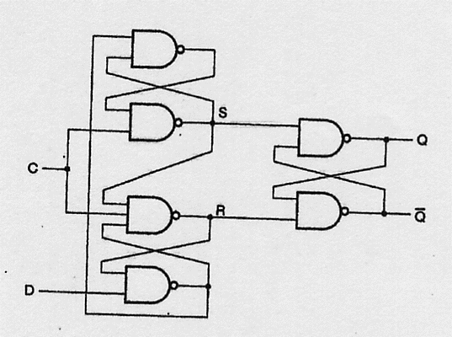

(A) A D latch with 0 control (B) A D latch with 1 control
(C) a positive-edge-triggered D flip-flop (D) A negative-edge-triggered D flip-flop

【解答】(C)
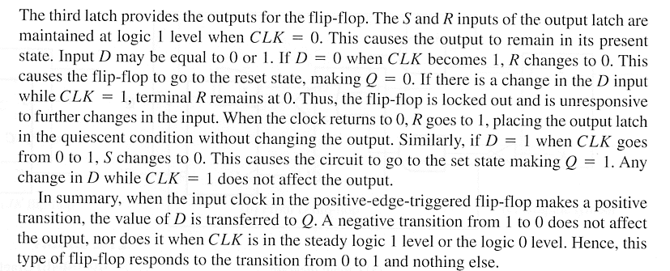

10. which of the following statements is not correct?
(A) Because of possible unreliable operation, the output of a latch cannot be applied directly
or through combinational logic to the input of the same or another latch when all the
latches are triggered by a single clock signal.
(B) The D latch is transparent, since its input value can be seem from the outputs.
(C) In a flip-flop, before an output can change, the path from its inputs to its outputs is broken.
(D) Since the change of the outputs are to be separated from the control by the inputs, the
maximum hold time should be longer than the minimum propagation delay time.

【解答】(A)
可以，Synchronous sequential circuit。

11. How many flip-flops will be complemented in a 12-bit binary ripple counter to reach the
next count after 000111111111?
(A) 7 (B) 8 (C) 9 (D) 10

【解答】(D)
000111111111 → 001000000000

12. Construct a 12-bit serial-parallel counter, using three 4-bit parallel counters. What is the
maximum number of AND gates in a chain that a signal must propagate through in the
12-bit counter?
(A) 3 (B) 4 (C) 5 (D) 6

【解答】(C)
Counter內進位輸出之電路：Q₃
4-bit parallel counter Q₂ 進位
進位 Q₁
4-bit parallel counter Q₀
進位
Clock 4-bit parallel counter
進位

13. Which of the following statements is not correct?
(A) A barrel shifter with 2^{n} input and output requires 2^{n} multiplexers, each having 2^{n} data inputs
and n selector inputs.
(B) Many three-state buffer outputs can be connected together to from a bit line of a bus, and
this bus is implemented using only one level of logic gates.
(C) The reduction in hardware that occurs for a signal bus in place of dedicated multiplexers
results in limitations on simultaneous transfers.
(D) None of the above.

【解答】(D)
Barrel Shifter：A hardware device that can shift or rotate a data word by any number of bits in
a single operation. It is implemented like a multiplexers, each output can be connected to any
input depending on the shift distance.
A₅ A₄ A₃ A₂ A₁ A₀
Q Q Q Q Q Q

D D D D D D
CLK

S₁ S₁ S₁ S₁ S₁ S₁ S₁
S₀ S₀ S₀ S₀ S₀ S₀ S₀
3 2 1 0 3 2 1 0 3 2 1 0 3 2 1 0 3 2 1 0 3 2 1 0

I₅ I₄ I₃ I₂ I₁ I₀

S₁ | S₀ | 執行運算
0 | 0 | 載入，並入
0 | 1 | 保持不變
1 | 0 | 右移一位元
1 | 1 | 右移二位元

three-state buffer： I₀ I₁ I₂ I₃

decoder
2¹ 0
2⁰ 1
2
3 F

14. A system is to have the following set of register transfers, implemented using buses:
C1: R0 ← R4 C3: R2 ← R3, R0 ← R3
C2: R3 ← R0, R1 ← R4, R4 ← R0 C4: R2 ← R4, R4 ← R2
What is the minimum number of buses that can be used to implement the set of transfers?
(A) 1 (B) 2 (C) 3 (D) 4

【解答】(C)
C2: R3 ← R0
R1 ← R4
R4 ← R0

Part Ⅱ( 12 points total)
( i ) (6 pts) Obtain the truth table of a combinational circuit which takes a BCD digit (A, B, C, D)
and generates an excess-3 digit (E, F, G, H) which gives the 9’s complement of the input.
Assume that input combinations not corresponding to decimal digit give don’t care outputs.
( ii ) (6pts) Obtain the simplest PLA implementation of Boolean functions E and F which uses the
least number of product terms.

【解答】
( i ) truth table：
A | B | C | D |  | E₃ | E₂ | E₁ | E₀ |  | E | F | G | H
0 | 0 | 0 | 0 |  | 0 | 0 | 1 | 1 |  | 1 | 1 | 0 | 0
0 | 0 | 0 | 1 |  | 0 | 1 | 0 | 0 |  | 1 | 0 | 1 | 1
0 | 0 | 1 | 0 |  | 0 | 1 | 0 | 1 |  | 1 | 0 | 1 | 0
0 | 0 | 1 | 1 |  | 0 | 1 | 1 | 0 |  | 1 | 0 | 0 | 1
0 | 1 | 0 | 0 |  | 0 | 1 | 1 | 1 |  | 1 | 0 | 0 | 0
0 | 1 | 0 | 1 |  | 1 | 0 | 0 | 0 |  | 0 | 1 | 1 | 1
0 | 1 | 1 | 0 |  | 1 | 0 | 0 | 1 |  | 0 | 1 | 1 | 0
0 | 1 | 1 | 1 |  | 1 | 0 | 1 | 0 |  | 0 | 1 | 0 | 1
1 | 0 | 0 | 0 |  | 1 | 0 | 1 | 1 |  | 0 | 1 | 0 | 0
1 | 0 | 0 | 1 |  | 1 | 1 | 0 | 0 |  | 0 | 0 | 1 | 1
1 | 0 | 1 | 0 |  | X | X | X | X |  | X | X | X | X
1 | 0 | 1 | 1 |  | X | X | X | X |  | X | X | X | X
1 | 1 | 0 | 0 |  | X | X | X | X |  | X | X | X | X
1 | 1 | 0 | 1 |  | X | X | X | X |  | X | X | X | X
1 | 1 | 1 | 0 |  | X | X | X | X |  | X | X | X | X
1 | 1 | 1 | 1 |  | X | X | X | X |  | X | X | X | X
( ii ) 參閱下述說明：
示例：Implement the following Boolean functions with a PLA‧
F₁(A,B,C)=Σ_{m}(0,1,2,4)；F₂(A,B,C)=Σ_{m}(0,5,6,7)
以卡諾圖求出：
F₁=A'B'+A'C'+B'C' ，F₁'=AB+AC+BC
F₂=A'B'C'+AC+AB ，F₂'=AB'C'+A'C+A'B
以F₁'，F₂求解：
積項 | 輸入 |  |  | 輸出
 | A | B | C | F₁ | F₂
A'B'C' | 0 | 0 | 0 | – | 1
AC | 1 | – | 1 | 1 | 1
AB | 1 | 1 | – | 1 | 1
BC | – | 1 | 1 | 1 | –
 |  |  |  | C | T | T/C

Part Ⅲ (14 points total) Use the truth table for the BCD-to-Seven-Segment Decoder shown below.
( i ) (5pts) Implement the Boolean function a with 4×1 MUX (by connecting A and B to selection
inputs S1 and S0, respectively) and some external gates.
( ii ) (9 pts) identify the smallest set of sum terms which is required in the simplest product-of-sums
implementation of Boolean functions e, f, and g, together.

Truth Table for BCD-to-Seven-Segment Decoder
───────────────────
BCD Input Seven-Segment Decoder
───── ───────────
A B C D a b c d e f g
───────────────────
0 0 0 0 1 1 1 1 1 1 0
0 0 0 1 0 1 1 0 0 0 0
0 0 1 0 1 1 0 1 1 0 1
0 0 1 1 1 1 1 1 0 0 1
0 1 0 0 0 1 1 0 0 1 1
0 1 0 1 1 0 1 1 0 1 1
0 1 1 0 1 0 1 1 1 1 1
0 1 1 1 1 1 1 0 0 0 0
1 0 0 0 1 1 1 1 1 1 1
1 0 0 1 1 1 1 1 0 1 1
All other inputs 0 0 0 0 0 0 0

【解答】
( i )
AB | a | b | C | D | e | f | g
00 | a = C+D’ | b = 1 | c = C’+D | D = C+D’ | e = D’ | f = C’D’ | g = C
01 | a = C+D | b = (C⊕D)’ | c = 1 | D = C⊕D | e = CD’ | f = (CD)’ | g = (CD)’
10 | a = 1 | b = 1 | c = 1 | D = 1 | e = D’ | f = 1 | g = 1
11 | a = X | b = X | c = X | D = X | e = X | f = X | g = X
七個多工器：分別產生a, b, c, d, e, f, g七個輸出信號。
a多工器之四個輸入端分別接上：
I₀ = C+D’
I₁ = C+D
I₂ = 1
I₃ = X
b～g多工器之四個輸入端可仿a多工器推出。
參閱下述說明：
示例：以多工器設計全加器(Full adder)，規格如下：
輸入信號有三：被加數位元X，加數位元Y，前級進位C_{IN}‧
輸出信號有二：和值S，下級位進位C_{OUT}‧
真值表為：

X | Y | C_{IN} |  | S | C_{OUT}
0 | 0 | 0 |  | 0 | 0
0 | 0 | 1 |  | 1 | 0
0 | 1 | 0 |  | 1 | 0
0 | 1 | 1 |  | 0 | 1
1 | 0 | 0 |  | 1 | 0
1 | 0 | 1 |  | 0 | 1
1 | 1 | 0 |  | 0 | 1
1 | 1 | 1 |  | 1 | 1
以8×1多工器設計全加器：
0 0 0 0
1 1 0 1
1 2 0 2
0 3 S 1 3 C_{OUT}
1 4 0 4
0 5 1 5
0 6 1 6
1 7 1 7
S₂ S₁ S₀ S₂ S₁ S₀

X
Y
C_{IN}
以4×1多工器設計全加器：
S(X,Y,C_{IN})可表示為X'Y'S(0,0,C_{IN})+X'YS(0,1,C_{IN})+XY'S(1,0,C_{IN})+XYS(1,1,C_{IN})：
因S(X,Y,C_{IN})=X'Y'C_{IN}+X'YC_{IN}'+XY'C_{IN}'+XYC_{IN}
故S(0,0,C_{IN})= C_{IN}，S(0,1,C_{IN})=C_{IN}'，S(1,0,C_{IN})=C_{IN}'，S(1,1,C_{IN})=C_{IN}‧
C_{OUT}(X,Y,C_{IN})可表示為X'Y'+X'YC_{OUT}(0,1,C_{IN})+XY'C_{OUT}(1,0,C_{IN})+XYC_{OUT}(1,1,C_{IN})：
因C_{OUT}(X,Y,C_{IN})=XY+XC_{IN}+YC_{IN}
故C_{OUT}(0,0,C_{IN})=0，C_{OUT}(0,1,C_{IN})=C_{IN}，C_{OUT}(1,0,C_{IN})=C_{IN}，C_{OUT}(1,1,C_{IN})=1+C_{IN}+C_{IN}=1‧

C_{IN} 0 0 0
1 C_{IN} 1 C_{OUT}
2 S 2
3 1 3
S₁ S₀ S₁ S₀
X
Y

函式F(A,B,C,D)可表示為：
A'B'‧F(0,0,C,D)＋A'B‧F(0,1,C,D)＋AB'‧F(1,0,C,D)＋AB‧F(1,1,C,D)
若以4×1的多工器實現F函式，且將輸入AB作為多工器的選擇信號，則電路如下：
F(0,0,C,D) 0
F(0,1,C,D) 1 F(A,B,C,D)
F(1,0,C,D) 2
F(1,1,C,D) 3
S₁ S₀
A
B

( ii )
e, e’, f, f’, g’, g函式以卡諾圖化簡[選擇：e, e’之一、f, f’之一、g’, g之一]，
即可求出the smallest set of sum terms which is required in the simplest product-of-sums
implementation of Boolean functions e, f, and g, together.

Part Ⅳ (10 points) Design a clocked sequential circuit using D flip-flops that operates according
to the following state diagram. Draw the logic diagram of the circuit.
0/0
1/1 00 1/0
0/0
1/0 01 11
0/0 1/1
11
0/0

【解答】
參閱下述說明：
Design a counter using 3 D flip-flops that generates the following sequence：
0 → 1 → 2 → 4 → 6 → 0 → ……
If an unused state is given,your circuit should be able to adjust itself to enter one of the above
states(i.e,0,1,2,4,6)after some pulses‧

現在狀態 次一狀態 正反器輸入
Q2 Q1 Q0 Q2 Q1 Q0 D2 D1 D0
0 0 0 0 0 1 0 0 1
0 0 1 0 1 0 0 1 0
0 1 0 1 0 0 1 0 0 self-correcting
0 1 1 × × × 1 0 0
1 0 0 1 1 0 1 1 0
1 0 1 × × × 0 0 0
1 1 0 0 0 0 0 0 0
1 1 1 × × × 0 0 0
D2＝Q2'Q1＋Q2Q1'Q0'
D1＝Q2'Q1'Q0＋Q2Q1'Q0'
D0＝Q2'Q1'Q0'

Part Ⅴ (10 points) Design a BCD counter using T flip-flop. Draw the logic diagram of the
counter.

【解答】
參考下述說明，只要把計數順序改為0→1→2→3→4→5→6→7→8→9→0即可：
示例：使用T正反器，設計如下計數順序之計數電路(Counter)：0→1→2→4→5→6‧
繪狀態圖(State Diagram)：
001 010
000 100
110 101

由激勵表，決定正反器輸入之布林函數：
現在狀態 |  |  |  | 次一狀態 |  |  |  | 正反器輸入
A | B | C |  | A | B | C |  | T_{A} | T_{B} | T_{C}
0 | 0 | 0 |  | 0 | 0 | 1 |  | 0 | 0 | 1
0 | 0 | 1 |  | 0 | 1 | 0 |  | 0 | 1 | 1
0 | 1 | 0 |  | 1 | 0 | 0 |  | 1 | 1 | 0
0 | 1 | 1 |  | X | x | x |  | X | x | x
1 | 0 | 0 |  | 1 | 0 | 1 |  | 0 | 0 | 1
1 | 0 | 1 |  | 1 | 1 | 0 |  | 0 | 1 | 1
1 | 1 | 0 |  | 0 | 0 | 0 |  | 1 | 1 | 0
1 | 1 | 1 |  | X | x | x |  | X | x | x
T_{A}=B，T_{B}=B+C，T_{C}=B'‧
繪電路圖：
A B C
Q Q Q
CLK CLK CLK
T_{A} T_{B} T_{C}

Part Ⅵ (12 points) Design a 4-bit arithmetic circuit with two selection variables S1 and S0 that
generates the following arithmetic operations. Draw the logic diagram for a single bit state.
───────────────────────
S1S0 Cin = 0 Cin = 1
───────────────────────
00 F = A + B(add) F = A+ B+1
01 F = A(transfer) F = A + 1(increment)
10 F = B’(complement) F= B’ + 1(negate)
11 F = A + B’ F = A + B’ + 1(subtract)
───────────────────────

【解答】
A A B’ A B all 0’s all 0’s B’

0 1 2 3 2¹ 0 1 2 3 2¹ S1
2⁰ 多工器 2⁰ S0

n-bit parallel adder C_{in} Cin

F

