91年 研究所 系統程式(OS)詳解
91年台大計算機系統(OS)詳解 2
91年海洋資科計算機系統(OS)詳解 5
91年台科大資工作業系統詳解 9
91年北科大資工作業系統詳解 14
91年政大資科計算機系統(OS)詳解 18
91年淡江資工計算機系統(OS)詳解 25
91年中原資工計算機系統(OS)詳解 29
91年中央資工作業系統詳解 36
91年交大資工計算機系統(OS)詳解 43
91年清大資工計算機系統(OS)計概詳解 47
91年逢甲資工系統程式詳解 52
91年靜宜資管系統程式詳解 63
91年健康管理資管系統程式詳解 74
91年暨南資工計算機系統(OS)詳解 80
91年暨南資管作業系統詳解 84
91年雲科大電資計算機系統(OS)詳解 92
91年成大電機系統程式詳解 95
91年南師資教所資訊專業科目(OS)計概詳解 105
91年中山資工作業系統與資料結構詳解 107
91年東華資工作業系統與計組(OS)詳解 111

91年台大 計算機系統(OS) 詳解

1. (10%) In the hierarchical storage structure, the same data could appear in different levels of the
storage system. A multiprocessor environment could even complicate the problems. Please
explain the cache coherency problem in a multiprocessor environment. Should we solve it
without considering any hardware issue? Explanation is needed.

【解答】
主記憶體
Global memory

Cache Cache Cache

CPU CPU CPU

MESI：於多處理機系統中，用來確保資料一致性的protocol‧
M：modified，cache的內容與主記憶體已不一致，available only in this cache‧
E：exclusive，cache的內容與主記憶體一致，not present in any other cache‧
S：shared，cache的內容與主記憶體一致，may be present in another cache‧
I：invalid，cache的這個line word沒有存入資料（或指令）‧
資料一致性：
Bus watching with WT（Snoopy cache controller）：Write invalidate‧
偵測到寫入動作，將此位址通知各cache，令此cache word為無效‧
Hardware transpancy：Write broadcast‧
寫入cache的電路並接，寫入一個，即全部被寫入（WB）‧

2. (15%) Spin locking is a way to implement semaphores. Please use the concepts of spin locking to
implement the wait and signal operations of binary semaphores. You MUST ensure that no
starvation and no deadlock could occur.

【解答】
忙碌等待(Busy Waiting)：回轉鎖定(Spin Lock), 不斷由中央處理器測試某個條件是否成立。

Spin lock wastes CPU cycle.

Wait operator：
if s＞0 then s＝s－1；
else (wait on s)；

Signal operator：
if (one or more process are waiting on s)
then (let one of these process proceed)；
else s＝s＋1；

test-and-set與swap只能保証mutual exclusion與progress不能確保bounded。某些process
可能會有starvatic現象。加入queue的排隊行為，即可保証bounded waiting：
Wait：
waiting〔i〕＝true；
key＝true；
while waiting〔i〕&& key do
key＝test-and-set (lock)；
waiting〔i〕＝false；

Signal；
j＝i＋1 mod n；
while (j !＝i)&&(～waiting〔j〕) do
j＝j＋1 mod n；
if j＝i then lock＝false；
else waiting〔j〕＝false；

3. (10%) Free disk space can be kept track of using a free list or a bit map. Suppose that dis address
require A bits. For a disk with D blocks, F of which are free, state the condition under which the
free list uses less space than the bit map.
For A having the value 32 bits, express your answer as a percentage of the disk space that must
be free.

【解答】
Free-space management：追蹤disk free area的方法。
‧bit vector：
‧每一block以一個bit表示free或used。
‧Linked list（free list）：
‧link together all the free disk block, keeping a pointer to the first block in a special location on the disk and caching it in memory.
The first block contains a pointers to the next free disk block, and so on.

bit vector：需D位元。
Linked list（free list）：需A*F位元。
Condition（free list uses less space than the bit map）：A*F＜D。
若A having the value 32 bits：32*F＜D－－→F/D＜1/32。

4. (15%) Consider the following page reference string:
3,2,1,4,3,2,5,3,2,3,4,1,4,3,5,3,4,2,1,2
If FIFO replacement algorithm is used, show the states of memory at the times just after each
memory references, and the number of page faults would occur for the following systems:
(a) A system with 3 frames of memory
(b) A system with 4 frames of memory
(c) Show the working set of the system at the times just after of the memory references, assuming
the window size of the working set is 3

【解答】

(a) FIFO(First-In-First-Out)：選擇最早進入memory的page.
reference string：3,2,1,4,3,2,5,3,2,3,4,1,4,3,5,3,4,2,1,2
frame數：3
 | 3 | 2 | 1 | 4 | 3 | 2 | 5 | 3 | 2 | 3 | 4 | 1 | 4 | 3 | 5 | 3 | 4 | 2 | 1 | 2
1. | 3 | 3 | 3 | 4 | 4 | 4 | 5 |  |  |  | 5 | 5 |  | 3 | 3 |  | 3 | 2 | 2
2. |  | 2 | 2 | 2 | 3 | 3 | 3 |  |  |  | 4 | 4 |  | 4 | 5 |  | 5 | 5 | 1
3. |  |  | 1 | 1 | 1 | 2 | 2 |  |  |  | 2 | 1 |  | 1 | 1 |  | 4 | 4 | 4
page fault：14次
(b) FIFO(First-In-First-Out)：選擇最早進入memory的page.
reference string：3,2,1,4,3,2,5,3,2,3,4,1,4,3,5,3,4,2,1,2
frame數：4
 | 3 | 2 | 1 | 4 | 3 | 2 | 5 | 3 | 2 | 3 | 4 | 1 | 4 | 3 | 5 | 3 | 4 | 2 | 1 | 2
1. | 3 | 3 | 3 | 3 |  |  | 5 | 5 | 5 |  |  | 5 | 4 |  | 4 | 4 |  | 4 | 1
2. |  | 2 | 2 | 2 |  |  | 2 | 3 | 3 |  |  | 3 | 3 |  | 5 | 5 |  | 5 | 5
3. |  |  | 1 | 1 |  |  | 1 | 1 | 2 |  |  | 2 | 2 |  | 2 | 3 |  | 3 | 3
4 |  |  |  | 4 |  |  | 4 | 4 | 4 |  |  | 1 | 1 |  | 1 | 1 |  | 2 | 2
page fault：13次
(a) FIFO(First-In-First-Out)：選擇最早進入memory的page.
reference string：3,2,1,4,3,2,5,3,2,3,4,1,4,3,5,3,4,2,1,2
working set：
 | 3 | 2 | 1 | 4 | 3 | 2 | 5 | 3 | 2 | 3 | 4 | 1 | 4 | 3 | 5 | 3 | 4 | 2 | 1 | 2
1. | 3 | 3 | 3 | 4 | 4 | 4 | 5 |  |  |  | 5 | 5 |  | 3 | 3 |  | 3 | 2 | 2
2. |  | 2 | 2 | 2 | 3 | 3 | 3 |  |  |  | 4 | 4 |  | 4 | 5 |  | 5 | 5 | 1
3. |  |  | 1 | 1 | 1 | 2 | 2 |  |  |  | 2 | 1 |  | 1 | 1 |  | 4 | 4 | 4

91年海洋 資工 計算機系統(OS) 詳解

5. Consider a system consisting of m resources of the same type, being shared by n processes.
Resources can be requested and released by processes only one at a time. Show that the system
is deadlock-free if the following two conditions hold：(10%)
(a) The maximum need of each process is between 1 and m resources.
(b) The sum of all maximum needs is less than m+n.

【解答】
Available〔j〕＝k：有k個resource r_{j}可使用
Max〔i〕〔j〕＝k：Process Pi最多可擁有k個resource r_{j}.
Allocation〔i〕〔j〕＝k：已經分配k個resource r_{j}給P_{i}
Need〔i〕〔j〕＝k：Process P_{i}未來還需要k個resource r_{j}
Request〔i〕〔j〕＝k：Process Pi正提出request，需求k個resource r_{j}。
(a). ΣMax_{i}＜m+n（i = 1～n）
(b). Max_{i}≧1 for all i
Proof：Need_{i} = Max_{i} - Allocation_{i}
If there exists a deadlock state then：
(c). ΣAllocation_{i} = m（i = 1～n）
Use (a) to get：ΣNeed_{i}+ΣAllocation_{i} =ΣMax_{i}＜m+n
Use (c) to get：ΣNeed_{i}+m＜m+n
Rewrite to get：ΣNeed_{i}＜n
This implies that there exists a process P_{i} such that Need_{i} = 0. Since Max_{i}≧1 it follows that P_{i}
has at least one resource that it can release. Hence the system cannot be in a deadlock state.

6. An operating system supports a paged virtual memory, using a central processor with a cycle time
of 1 microsecond. It costs an additional a microsecond to access a page other than then current
one. Pages have 1000 words, and the paging device is a drum that rotates at 3000 revolutions per
minute and transfers 1 million words per second. The following statistical measurements were
obtained from the system：
1. 1 percent of all instructions executed accessed a page other than the current page.
2. Of the instructions that accessed another page, 80 percent accessed a page already in memory.
3. When a new page was required, the replaced page was modified 50 percent of the time.
Calculate the effective instruction time on this system, assuming that the system is running one
Process only, and that the processor is idle during drum transfers.(12%)

【解答】
存取磁碟資料之access time：seek time+rotational time+transfer time
seek time：0
rotational time：(60*1000)/3000 = 20ms，20ms/2 = 10ms
transfer time：(1000/1000000)*1000 = 1ms
存取磁碟資料之access time：11ms
Access another page, 發生page fault, replaced page沒有modified：只read一次requested
page，無須將replaced page寫回磁碟。
Access another page, 發生page fault, replaced page was modified：先將replaced page寫回
磁碟，再read一次requested page。

Effective instruction time：
0.99*1us+0.01*0.8*2us+0.01*0.2*0.5*(11ms+2us)+0.01*0.2*0.5*(22ms+2us)
事件 | 機率 | Access time
Access current page | 0.99 | 1 us
Access another page, hit(沒發生page fault) | 0.01*0.8 | 2 us
Access another page, 發生page fault, replaced page沒有modified | 0.01*0.2*0.5 | 11ms
Access another page, 發生page fault, replaced page was modified | 0.01*0.2*0.5 | 22ms

7. Please depict the execution sequence after a page fault occurred.(8%)

【解答】
只把正執行的page載入memory，其它部份仍停留在disk裏，page table記錄那些page
己載入memory. 於DAT時，位址轉換失敗(尚未載入)，發出內部中斷給CPU(page fault)，
於中斷服務程式(ISR)中，載入所須之page並更新page table，再重新執行發出中斷的指令。
virtual memory是管理memory的技術，包括有：
DAT , page fault、memory management、file handling、I/O handling、process scheduling。

8. Consider the following diagram where several network devices(Ethernet switches, Ethernet hubs)
and hosts are connected by 100 base-T cables.
a. What would you do to connect a switch and a host and to connect a hub with a switch? Explain
the type of cable(straight-through or cross-over)and the type of port in the device you use.(5%)
b. What happens after host A has sent a packet to host B, say a Ping packet?
Explain the detail scenario.(15%)
Host A Hub C Switch E

Host B Hub D Switch F

【解答】

a.
There are two sorts of ethernet twisted-pair cable with 8-pin RJ45 connectors at both ends:
straight-through: where each pin is connected to the same pin at the other end;
cross-over: where pins (1,2) are connected to (3,6) at the other end, and vice-versa.
For a normal stand-alone cable modem connecting to a normal ethernet NIC in a PC, you need
a straight-through cable, because cable modem RJ45 sockets are normally wired as if they
were hub sockets. Many cable modems are sold with an appropriate cable provided in the box.
As an exception to the general rule, the cable modem in certain Pace digital TV set top boxes
requires a cross-over cable to connect to a normal ethernet NIC in a PC. In these cases the
RJ45 socket will be marked X-over on the back panel. If it is not so marked, use a
straight-through cable.
When connecting a cable modem to the specially designated WAN port of a router (for instance),
a straight-through ethernet cable is usually required.
With other configurations, the general rule is that NIC-to-hub needs a straight-through cable,
but NIC-to-NIC and hub-to-hub require cross-over cables.
Computer -> router or switch uses a straight-through cable
Computer -> Computer uses a cross-over cable.
Router or switch -> router or switch uses cross-over unless an uplink port is used.

When two devices need to communicate over a full-duplex (transmit and receive) twisted pair
link using the same connector at each end; a problem arises. If all devices used a similar
pin-out you would be unable to establish link because you would be trying to transmit and
receive on the same pair of wires. To connect two devices that are pinned identically the wire
pairs in the cable must be "Crossed Over". The problem is that not all protocols that use RJ-45
Cat 5 type cabling have the same active pairs of wires (i.e. Ethernet and Token Ring use
different active pin configurations but both can use CAT 5 RJ-45 cabling).
To deal with this issue the IEEE came up with a standard that put the cross-over (referred to as
MDI-X: media dependent interface/cross-over) inside certain types of devices and straight
through (referred to as MDI: media dependent interface) in others. Devices such as NIC cards
(referred to as DTEs: data terminating equipment) were pinned with an MDI configuration
and devices they are typically connected to such as switches/hubs were pinned MDI-X: thus
eliminating the need for cross-over cabling.
In effect, the IEEE standard only minimizes the need for cross-over cables; it does not eliminate
it. There are many cases where DTEs are connected to other DTEs, hubs are connected to other
hubs/switches, etc. A cross-over cable must be used to facilitate these connections. HERE IS
THE IMPORTANT PART: media converters can be deployed at an end station, at a hub or
switch, so there will be cases where an MDI is needed and others where an MDI-X is required.

Figure 1: Hub or Switch to DTE
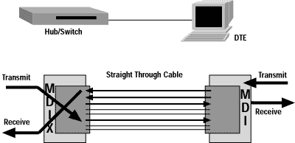
Figure 2: Switch to Converter to DTE with straight through cable
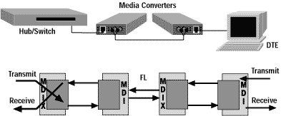
Figure 3: Switch to Converter to DTE with cross-over cable
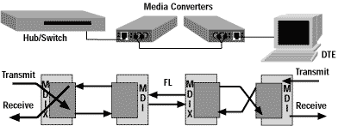

b.
要ping的Host在相同網域：Host A pings host B using ICMP, and B replies.
(1)因為A不知到B的位置，所以對其subnet的機器做broadcast，等待B的回應。
(2)B收到A的broadcast ，回應A其位置所在。
(3)A對B做ping的動作。
(4)C回ping reply給A。
packet的動作如下：
eth_type eth_src eth_dst ip_type ip_src ip_dst
(1) ARP Eth_A Eth_ IP_A IP_C
(2) ARP Eth_C Eth_A IP_C IP_A
(3) IP Eth_A Eth_C icmp ping IP_A IP_C
(4) IP Eth_C Eth_a replies IP_C IP_A

要ping的Host在不同網域：因在不同網域，需經由gateway對另一端的subnet做broadcast。
等得知B的位置後，A再直接pingB，接下來的動作則相同網域一樣。
(1)A對B送一ping的動作，結果發現沒有回應，就往G(Gateway)送。
(2)Gateway對另一端的subnet做broadcast動作，等待B的回應。
(3)B回應gateway其位置。
(4)Gateway知會A，讓A知道B在那裡。
(5)A對B做ping的動作，但須先經由ping G的動作。
(6)經由G對B做ping的動作。
(7)B回應一ping reply給G。
(8)G再將ping reply給A。
packet的動作如下：
eth_type eth_src eth_dst ip_type ip_src ip_dst
(1) ARP Eth_D Eth_G IP_D IP_C
(2) ARP Eth_G broadcast IP_D IP_C
(3) ARP Eth_C Eth_G IP_C IP_D
(4) ARP Eth_G Eth_D IP_C IP_D
(5) IP Eth_D Eth_G icmp ping IP_D IP_C
(6) IP Eth_G Eth_C icmp ping IP_D IP_C
(7) IP Eth_C Eth_G replies IP_C IP_D
(8) IP Eth_G Eth_D replies IP_C IP_D
ICMP：由於TCP/IP是一個開放式的網路環境，動態性極高，不易確定對方是否連上網路，
或是離開網路，所以在傳遞資料封包之前，要確定對方是否存在，以及路由路徑是否
可靠，就變得非常重要。
ICMP的目的，就是能夠檢測網路的連線狀況，也能確保連線的準確性，其功能主要有﹕
偵測遠端主機是否存在。
建立及維護路由資料。
重導資料傳送路徑。
資料流量控制。
ping程式是利用ICMP通訊協定，本地端用戶對遠端機器送出ICMP_EchoRequest
（ICMP Type=8）的訊息，如果遠端機器存在的話，它會回送一個ICMP_EchoReply
的訊息，另外，tracert或traceroute也都屬於ICMP協定。

91年台科大 資工 作業系統 試題詳解

1. Write out three conditions under which a running process will be forced to give up CPU use.
(10%)

【解答】
process從running狀態進入waiting, ready或terminate狀態的原因：
EXIT SVC (正常completion).
error abort.
timer time out.
I/O request (start I/O operation).
resource request (等待〝free memory〞).
等待進入critical section (P-operator).

2. Which of the variables, u, v, w, x, y, in the program below are sharable among the threads created
during program execution?(10%)
static int u, int v,
main(void){
static int w, int x;
… //threads creating
for( , , ){
static int y, int s,
…
}
}

【解答】
u, v, w, x：對[… //threads creating]而言，為Global variables，故是sharable。

3(a). For a real-time operating system, which of the memory management methods, contiguous
allocation, plaging, segmentation, and demand paging, is most troublesome to use? (5%)
3(b). If demand paging is used for memory management on a two-address instruction-set computer,
and operands and instruction itself may straddle two pages, how many pages at least a process
must be allocated before it can be run?(5%)
3(c). With demand-paged memory management, why keeping a pool of free frames (i.e., page
buffering) can be used to speed up page replacement?(5%)

【解答】
a. demand paging
hard real time：保證critical task能complete on time‧
不見有一般用途的作業系統支援此種hard real time系統
soft real time：critical real time的task有較高的priority‧
一般用途的作業系統所支援的即時系統，為soft real time‧
real time系統與time sharing系統不能並存於同一作業系統：
real time系統為non-preemptive，因preemptive排程很難預測程式的response time‧
而time sharing系統為preemptive（round-robin排程）‧
virtual memory is almost never found on real time system‧
b. instruction跨頁，兩個operands也都跨頁，共需六個分頁才能執行此道指令。

c. Keep pool of free frames, allocate immediately from pool, then move victim(page fault時
被選為replaced之page) to pool. Copy victim out.
Thus seldom have to wait for both read and write. Also keep page ids of frames in pool, then
may not need to reread page.
A pool of page frames can improve the performance of the page replacement algorithm in
several ways：a) it allows dirty pages to the written to disk in the background; b) it allows
bursts of write traffic to be accommodated without much performance degradation; c) it allows
new page frames to be made available without overhead; d) it can soften the impact of a poor
page frames placement algorithm by acting as a victim cache; and e) it allows better disk
scheduling.

4. Suppose that the following processes arrive for execution at the times indicated. Each process
will run the listed amount of time. In answering the questions, base all decisions on the
information you have at the time the decision must be made.
Process | Arrival Time | Burst Time
P1 | 0.0 | 6
P2 | 0.4 | 4
P3 | 0.8 | 2
(a) What is the average waiting time for these processes with the FCFS scheduling
algorithm?(5%)
(b) What is the average waiting time for these processes with the preemptive SJF scheduling
algorithm?(5%)
(c) What is the average waiting time for these processes with the Round-Robin scheduling
algorithm and time slice, 3?(5%)

【解答】
Suppose that the following processes arrive for execution at the times indicated. Each process
will run the listed amount of time.
Process Arrive Time Burst Time
P1 0 25
P2 0.8 18
P3 1.2 5
a. What is the turnaround time of each process using FCFS, SRTF（preemptive SJF）, and
RR（quantnm = 3）scheduling？
b. What is the waiting time of each process for each of scheduling algorithms in part a？
【解答】turnaround time=完成時間- 抵達時間，wait time：turnaround time - burst time‧
FCFS：
Process | Arrive  Time | Burst  Time |  | 0～  25 | 25～43 | 43～48 |  | Start  Time | End  Time | Turnaround  Time | Wait  Time
P1 | 0 | 25 |  | ▃▃ |  |  |  | 0 | 25 | 25 | 0
P2 | 0.8 | 18 |  |  | ▃▃ |  |  | 25 | 43 | 42.2 | 24.2
P3 | 1.2 | 5 |  |  |  | ▃▃ |  | 43 | 48 | 46.8 | 41.8
SRTF：
Process | Arrive  Time | Burst  Time |  | 0～  0.8 | 0.8～  1.2 | 1.2～  6.2 | 6.2～  23.8 | 23.8～  48 |  | Start  Time | End  Time | Turnaround  Time | Wait  Time
P1 | 0 | 25 |  | ▃▃ |  |  |  | ▃▃ |  | 0 | 48 | 48 | 23
P2 | 0.8 | 18 |  |  | ▃▃ |  | ▃▃ |  |  | 0.8 | 23.8 | 23 | 15
P3 | 1.2 | 5 |  |  |  | ▃▃ |  |  |  | 1.2 | 6.2 | 5 | 0

RR：
Process | Arrive  Time | Burst  Time |  | 0 | 3 | 6 | 9 | 12 | 15～17 | 17～20  23～26  29～32  35～38  41～48 | 20～23  26～29  32～35  38～41 | Start  Time | End  Time | Turn-  around  Time | Wait  Time
P1 | 0 | 25 |  | ▃ |  |  | ▃ |  |  | ▃ |  | 0 | 48 | 48 | 23
P2 | 0.8 | 18 |  |  | ▃ |  |  | ▃ |  |  | ▃ | 3 | 41 | 40.2 | 22.2
P3 | 1.2 | 5 |  |  |  | ▃ |  |  | ▃ |  |  | 6 | 17 | 15.8 | 10.8

5. Which of the following instructions are privileged?(10%)
a. Set value of timer.
b. Read the clock
c. Clear memory
d. Turn off interrupts
e. Switch from user to kernel mode
f. Switch from kernel to user mode
g. Read from kernel memory
h. Write into kernel memory

【解答】
privileged instructions：a, c, d,e, f, g, h
Dual Mode Operation and Privileged Instructions：
CPU operates in two states：
Supervisor mode：
All instructions may be executed.
This is a privileged mode.
Only parts of the OS run in this mode.
User threads never run directly in this mode.
User mode：
Some instructions are ``privileged.''
Attempt to execute a privileged instruction results in a trap.
User threads execute in this mode.
Examples of privileged instructions:：I/O instructions, halt, reset, mask interrupts,
set interval timer, set status register, and modify page table registers.
Schema of System operation：
System powered on; in supervisor mode.
System boots, kernel initializes, still in supervisor mode.
System enters user mode to run user threads.
Should there be a user mode instruction to enter supervisor mode?
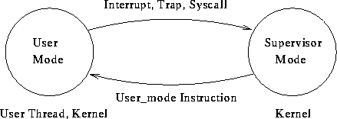

Privileged Instruction Set for
Enabling and disabling interrupts
Switching processor between processes
Accessing memory protection registers
Doing I/O
Halting CPU and controlling its operation
Most computers operate in more than one mode：supervisor or kernel mode、user mode。
Switch from user to supervisor mode can be caused by：
User process calls the OS：supervisor call or system call.
An interruption occurs.
An error condition occurs in a user process.
The process attempts to execute a privileged instruction.
Switching mode back to user mode is also by means of an privileged instruction.

6. Suppose that a disk has 200 cylinders numbered to 199, and the head is at cylinder 53.
The disk has a queue of pending requests in the following order.(10%)
98, 183, 37, 122, 65, 67
Starting from the current head position, what is the total distance in cylinders that the disk arm
moves to satisfy all of the requests for each of the following disk-scheduling algorithms?
a. FCFS
b. SSTF
c. SCAN
d. Elevator

【解答】
Suppose that a disk drive has 200 cyclinders, numbered 0 to 199. The drive is currently
serving a request at cylinder 143, and the previous request was at cylinder 125. The queue of
pending requests, in FIFO order, is：
80, 147, 91, 177, 168, 150, 100, 175, 135
What are the head movement sequences and total number of head movements needed and to
satisfy these requests for each of the following four disk-scheduling algorithms？
（a）SSTF（b）SCAN（c）C-SCAN（d）LOOK

（a）SSTF順序：143，147，150，135，168，175，177，100，91，80
SSTF：（147－143）＋（150－147）＋（150－135）＋（168－135）＋（175－168）
＋（177－175）＋（177－100）＋（100－91）＋（91－80）
（b）SCAN順序：143，147，150，168，175，177，199，135，100，91，80
SCAN：（147－143）＋（150－147）＋（168－150）＋（175－168）＋（177－175）
＋（199－177）＋（199－135）＋（135－100）＋（100－91）＋（91－80）
（c）C-SCAN順序：143，147，150，168，175，177，199，0，80，91，100，135
C-SCAN：（147－143）＋（150－147）＋（168－150）＋（175－168）＋（177－175）
＋（199－177）＋（199－0）＋（80－0）＋（91－80）＋（100－91）＋（135－100）
（d）LOOK順序：143，147，150，168，175，177，135，100，91，80：
LOOK：（147－143）＋（150－147）＋（168－150）＋（175－168）＋（177－175）
＋（177－135）＋（135－100）＋（100－91）＋（91－80）

Consider a disk queue with requests for I/O blocks on cylinders
98, 37, 122, 14, 124, 65, 67
in the order. Assume the disk head is initially at cylinder 53. The FCFS scheduling has a total
disk head movement of _____ cylinders. The SSTF（Shortest Seek Time First）scheduling has
a total disk head movement of _____ cylinders. In the SCAN scheduling, we assume the disk
arm is moving toward cylinder 0, then the SCAN scheduling has a total disk head movement of
_____ cylinders.

FCFS：（98－53）＋（98－37）＋（122－37）＋（122－14）＋（124－14）
＋（124－65）＋（67－65）
SSTF：（65－53）＋（67－65）＋（67－37）＋（37－14）＋（98－14）
＋（122－98）＋（124－122）
SCAN：（53－37）＋（37－14）＋（14－0）＋（65－0）＋（67－65）
＋（98－67）＋（122－98）＋（124－122）

7. Order the following in terms of overhead cost. (15%)
a. timer interrupt service without context switching
b. user level thread context switch
c. kernel level thread switch
d. procedure call
e. process context switch
f. page fault
g. system call

【解答】
f＞e＞a＞g＞d＞c＞b

8. Consider the following program fragments. What are the values that x can take on during the
execution of the following threads, assuming x is initialized to 0?
Thread 1:{ for(i=0;i<10;i++)x=x+2;}
Thread 2:{ for(j=0;j<10;j++)x=x-1;}

【解答】
Thread 1:{ for(i=0;i<10;i++)x=x+2;}：讓x加2，共加10次，最多加20。
Thread 2:{ for(j=0;j<10;j++)x=x-1;}：讓x減1，共減10次，最多減10。
Thread 1與Thread 2之各次動作（加2，減1）可能交錯執行，------Race Condition！
10次加法運算與10次減法運算，都有可能確實執行或因交錯而等同沒執行：
10次減法運算等同沒執行：x值為20。
10次加法運算等同沒執行：x值為-10。
x值：-10～20。

91年北科大 資工 作業系統 試題詳解

1. State why each of the following is incorrect.
a. SRT(Shortest-Remaining-Time)always has a lower average response time than SJF
(Shortest-Job-First).（6%）
b. Because SJF give preference to short jobs, it is useful in time-sharing.（6%）

【解答】
a. 短程式優先之效能僅反映在average turnaround time與average waiting time上，與average
response time無關。
縱然是問always has a lower average turnaround time，因考慮preemption(SRT)所額外增加
的Context Switching(程式切換執行)之Overhead時間，SRT不見得有較短的average
turnaround time。
b. Time-Sharing系統追求的性能是average response time，與SJF give preference to short jobs
無關(有較佳的average turnaround time)。

2. Give brief answers to each of the following questions.
a. In what sense is SCAN fairer than SSTF(Shortest-Seek-Time-First)？（6%）
b. In what sense is C-SCAN(Circular-SCAN) fairer than SCAN？（6%）
c. What is the relationship between FIFO and clock page replacement algorithms？（6%）

【解答】
a.
SSTF：Shortest Search Time First。
response time變動性最大，不適用於interactive system.
SCAN：類似雨刷（正下雨中），掃除積雪（正下雪中）。
request queue為dynamic
改變磁頭方向時，近磁頭的request較少，遠離磁頭端的request應較多。
中間地帶的request較受優待。
b.
C-SCAN：視track循環串連，僅單方向執行read/write動作，回程中不執行read/write動作。
各request的等待時間較SCAN法均勻；但單方向read/write，較浪費。
c. clock page replacement algorithm：
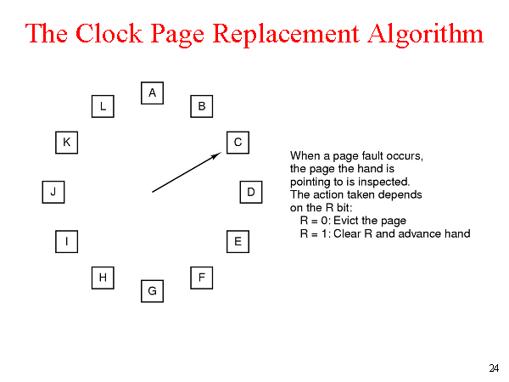

``clock'' replacement -- first-in not used first-out. This variation of FIFO replacement replaces
blocks which have not been used in the recent past (as determined by the ``clock'') before
replacing other blocks. The order of replacement of those blocks is FIFO。
Clock Algorithm：To increase fairness (and improve performance) start search for candidate page
where previous search ended--Clock Algorithm. This algorithm does not divide pages into
classes nor does it use the modify bit in making decisions (although a such an algorithm could
be constructed). Like advancing a clock hand through the pages.
if (R == 0) replace
else reset R
advance hand

3. What is RMS(Rate Monotonic Scheduling)？（15%）

【解答】
The rate monotonic algorithm (RMA) is a procedure for assigning fixed priorities to tasks to
maximize their "schedulability." A task set is considered schedulable if all tasks meet all
deadlines all the time. The algorithm is simple：
Assign the priority of each task according to its period, so that the shorter the period the
higher the priority.
A means of scheduling the time allocated to periodic hard-deadline real-time users of a resource.
The users are assigned priorities such that a shorter fixed period between deadlines is associated
with a higher priority.
Rate monotonic scheduling provides a low-overhead, reasonably resource-efficient means of
guaranteeing that all users will meet their deadlines provided that certain analytical equations are
satisfied during the system design. It avoids the design complexity of time-line scheduling and
the overhead of dynamic approaches such as earliest-deadline scheduling.

4. Consider a paged logical address space(composed of 32 pages of 2K bytes each) mapped into a
1-Mbyte physical memory space.
a. What is the format of the processor’s logical address？（5%）
b. What is the length and width of the page table(disregarding the “access rights” bits)？（5%）
c. What is the effect on the page table if the physical memory space is reduced by half？（5%）

【解答】
a. page number：5 bits(2⁵ = 32 pages)，page offset：11 bits(2¹¹ = 2K bytes each)。
the processor’s logical address：
5 bits：page number | 11 bits：page offset
b. length：32 pages需有32 entries，
width：5(page number)+9(frame number)+valid bit(???)+dirty bit(???) = 14 bits。
physical address：2²⁰ = 1-Mbytes，frame number：20-11 = 9 bits。
c. physical memory space is reduced by half：frame number：19-11 = 8 bits。
physical address：2¹⁹ = 512K bytes，frame number：19-11 = 8 bits。
Length不變：32 pages需有32 entries，
Width變為：5(page number)+8(frame number)+valid bit(???)+dirty bit(???) = 13 bits。

5. Give brief definitions of each of the following terms.（5% each）
a. ciphertext b. soft real time system c. race condition d. table fragmentation
e. reentrant code f. monolithic kernel g. inverted page table h. gang scheduling

【解答】
a. ciphertext：即enciphered data，對未授權的使用者或閱讀者來說其意義是隱蔽的資料。
加密後的資料。
b. soft real time system：Real-Time System的特性是強調時間的正確性，即在時間內若沒
完成任務將會有嚴重的影響，一般被用在特定範圍的控制裝置。Real-Time System分為
Hard和Soft兩種，Hard Real-Time System藉著限制task的delay time來保證重要的即時
任務能準時完成；而Soft Real-Time System則給予重要的即時任務比其他task更高的
優先權，使其一直執行完畢為止，但不能限期完成。大部分的Real-Time System都結合
Hard和Soft兩種特性，而且是以embedded的型態應用在許多的領域中。
c. race condition：可modifiable的sharable resource不能由兩個process同時使用---
mutual exclusion；必須一個process用完，另一process才能使用；存取shared modifiable
資料之程式段落必須一氣呵成，不與other process交錯執行(critical section)。
Critical section problem definition：演算法須滿足下述三個條件：
mutual exclusion、progress、bounded waiting。
d. table fragmentation：Table fragmentation is the situation that develops when a table has been
created with an INITIAL and NEXT extent sizes which are too small for the amount of data
that is subsequently loaded into the table. In essence, the table ends up with a large number of
extents rather than just a few.
e. reentrant code：process每次被呼叫，均會create對應之activation record，以儲存此process
之環境參數、local variables等等‧
於multiprogramming環境下，reentrance的process無須執行完，即可被另一job重新
呼叫，也可被多個job同時呼叫而互不相干‧
process執行過程不得modify self code，且每次被呼叫都有對應的activation record‧
f. monolithic kernel：
使用者

Kernel 含檔案管理、目錄、行程管理等‧

傳統的、中央集權式‧
唯一可能的優點是performance，訊息的傳遞可能較快‧
但此優點不具決定性，因尚有其它重要的考慮因子，且微量的傳遞時間通常可忽略‧
Microkernel：
使用者 file server process server directory server

Kernel Kernel Kernel Kernel

網路
Kernel只提供最基本的服務，而由user-level的server提供大部分的作業系統服務‧
只提供最基本的服務，如：
module間相互通信之能力‧
基本的memory management功能‧
少量的低層次process management及scheduling功能‧
低層次的輸入輸出工作‧
優點：高度模組化，flexibility高‧

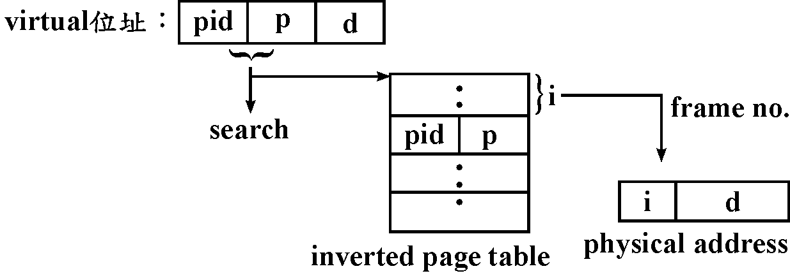
g. inverted page table：

one entry－each frame，sorted by frame no., but lookups occur on page no.
page table以associative address製作。
反置分頁表(Inverted Page Tables)：
雖然虛擬位址空間是龐大的,但是實際的page frame數量卻非如此,然而目前記憶體仍在
gigabyte的範圍內, 因此就以此來設計出page table, 是為以實際記憶體而非虛擬記憶體
組成的機器(如IBM System/38 HP Spectrum).
第i個entry存有此page目前佔據 page frame i的資訊, 在此page table中entry的數目
因此等於實際記憶體中page frame的數量.
Inverted page table通常與associative memory一起使用, 在page中找得到資料, 則不需要
inverted page 禤? 則不需要inverted page table, 若是有page fault, 則必需在page table中
找一個在目前記憶體中, virtual page number與virtual page相mach的entry.
要加快search table的速度, 可以為整個page table entry建一個hash function.
假如需要的page不在memory中, 則要藉著OS來找尋所要的page, 因此需要一個傳統的
page table, 此table可能在硬碟中
h. gang scheduling：The Gang Scheduler supports concurrent CPU assignment to the components
of parallel jobs and timesharing of the parallel machine resources on an assortment of
computers including the Cray T3D, Cray J90, Compaq Alpha clusters, and BBN TC2000.
It does so with preemptive processor scheduling. By suspending, resuming, and moving jobs
within available processors, the Gang Scheduler provides a high level of parallelism, timely
response for interactive computing, and long run times for production computing.

91年 政大 資科 計算機系統(OS) 詳解

1. (a) (3 points) What resources are used when a thread is created ?How do they differ from those
used when a process is created?
(b) (3 points) What are two differences between user-level threads and kernel-level threads?
(c) (4 points) Describe the actions taken by a kernel to context switch between kernel-level
threads?

【解答】
Per thread items： | Per process items：
Program counter | Address space
Stack | Global variables
Register set | Child processes
Child threads | Timers
State | Signals
 | Semaphores
 | Open files
 | Accounting information
Thread：Light weighted process
Different execution sequencing of the same code and data. That is, two threads of a process run
the same code and share the same data：PC、register set、stack。
Different thread of the same process are collectively called a task：cheap creation and context
switching、have similar problem（synchronization）as in shared-memory multiprocessing.
Heavy weight process（the ordinary process）：A single thread task，expensive creation and
context switching.
Thread：
efficiency：fast context switching、cheap creation、when one thread is blocked, other thread can
still proceed（even when we have only one process）‧
natural decomposition of work：one thread for one task‧
easy access to shared data‧
Thread is similar to a process：creation child thread、block and synchronize‧
User-level thread：
Implement thread within a user process，The user process "context switch" these threads by
itself，No OS intervention is required。
Very fast context switching，
Will block if one of the thread blocks in system call when the OS is single threaded, since
these threads are invisible to the scheduler (the OS only sees the user process)。
System-level thread：Schedule-able entity by the OS，relatively slow context switching。
The advantages of kernel-level threads over user-level threads are：
supports multiprocessors‧
possibly smoother scheduling, since the same scheduler（the kernel's）handles both threads and
other Unix processes‧
no special action needed to make blocking system call suspend only the calling thread, not all
threads of the process‧
as a consequence of the above, more efficient I/O and timer-based operations‧

The disadvantages are：
more expensive context switches between threads, at least when blocking on conditions and
mutexes，thread creation is more expensive。
由上面的比較可以清楚的發現 kernel-level 是一個比較好的選擇，也算是發展的趨勢。
For kernel threads, they have a small data structure and a stack. Switching between kernel threads
requires only save the data structure and stack of the old thread, and load the saved data structure
and stack for the new thread, and does not require changing memory access information.

A kernel may first save all the CPU registers（including program counter, stack pointer）and
the data structure of the old thread in the address space of the task containing the old thread, and
decide which thread will run next, then load all the CPU registers and the data structure of the
new thread, and continue to execute the new thread.
For user-level threads, hey contain a stack and a program counter, no kernel resources are
required. The kernel is not involved in scheduling these user-level threads. Switching among
them need only change the program counter and the stack pointer。

2. The dining-philosophers problem is considered to be a classic synchronization problem. It is a
simple representation of the need to allocate sereral resources among several processes in a
deadlock-and starvation-free manner. One simple solution is to represent each chopstick by a
semaphore. A philosopher tries to grab the chopstick by executing wait operation on that
semaphore；she (or he ) releases her chopsticks by executing the signal operation on the
appropriate semaphores. Thus, the shared data are
semaphore chopstick [5]；
where all the elements of chopstick are initialized to 1. The structure of philosopher i is shown as
the following：
do{
wait(chopstick[i]);
wait(chopstick[i+1]% 5)；
…..
eat
…..
signal(chopstick[i])；
signal(chopstick[(i+1) % 5])；
…..
think
…..
} while(1);
(a) (3 points) Why we reject the above program codes to solve the dining-philosophers
problem?
(b) (7 points) Please show a correct program structure to solve the dining-philosophers
problem using high-level synchronization con-struct monitor?

【解答】

a. 哲學家進餐問題
repeat
p(chopstick〔i〕)；
p(chopstick〔i＋1 mod 5〕)；
‧‧‧eat‧‧‧
v(chopstick〔i〕)；
v(chopstick〔i＋1 mod 5〕)；
‧‧‧think‧‧‧
until false；
‧可以避免相鄰兩哲學家同時eat：mutual exclusion。
但可能發生deadlock：五位哲學家同時抓取左側筷子（p(chopstick〔i〕)－成功，但抓取右側筷子（p(chopstick〔i＋1 mod 5〕)）－永無休止的等待。
‧解決：只允許四位哲學家褣入用餐。
先判斷左右兩側均無人使用筷子時，才去抓取筷子（須在critical section中完成）。
將哲學家編號，奇數哲學家先取左側筷子再取右側筷子，而偶數哲學家先取右側再取左側的筷子。
‧可解決deadlock，但仍有starvation（遲滯）。
b. 哲學家進餐問題
program dining-philosopher-examples；
type dining-philosophers＝monitor
var state：array〔0‥4〕of (thinking, hungry, eating)；
var self：array〔0‥4〕of condition；
procedure entry pickup (i：0‥4)；
begin
state〔i〕：＝hungry；
test（i）；
if state〔i〕≠eating
then self〔i〕.wait；
end；
procedure entry putdown（i：0‥4）；
begin
state〔i〕：＝thinking；
test（i－1 mod 5）；
test（i－1 mod 5）；
end；
procedure test（k：0‥4）；
begin
if state〔k－1 mod 5〕≠eating and state〔k〕＝hungry and state〔k＋1 mod 5〕≠eating
then begin
state〔k〕：＝eating；
self〔k〕.signal；
end；
Begin
for i：＝0 to 4
do state〔i〕：＝thinking；
end.

宣告dp的資料型態為dining-philosophers，宣告五個哲學家程序
philosopher i , i＝0, 1, 2, 3, 4；且哲學家闆題可敘述如下：
var dp：dining-philosophers
procedure philosopher 0；
begin
dp.pick(0)；
…eating…
dp.putdown(0)；
…thinking…
end；
：
：
procedure philosopher 4；
begin
dp.pick (4)；
…eating…
dp.putdown (4)；
…thinking…
end；
Begin
parbegin
philosopher 0；
philosopher 1；
：
philosopher 4；
parend
end.

3. A page-replacement algorithm should minimize the number of page faults. We can do this
minimization by distributing heavily used pages evenly over all of memory, rather than having
them compete for a small number of page frames. We can associate with each page frame a
counter of the number of pages that are associated with that frame. Then, to replace a page , we
search for the page frame with the page frame with the smallest counter. Define a
page-replacement algorithm using this basic ideas. Specifically address the problems of :
i. what the initial value of the counters is,
ii. when counters are increased,
iii. when counters are decreased,
iv. how the page to be replaced is selected.
(a) (5 points) How many page faults occur for your algorithm for the following reference string,
for five page frames? 1,2,3,4,5,3,4,1,6,7,8,7,8,9,7,8,9,5,4,5,4,2
(b) (5 points) What is the minimum number of page faults for an optimal page-replacement
strategy for the reference string in part (a) with four page frames? Is it the page faults number
the same as (a)’s, please comments on (a) and (b)’s results?

【解答】
LFU (Least Frequently Used)：每一page均有一counter，每次reference，counter加1。
選最小值者替換之。

LFU（Least Frequently Used）page replacement：選使用最少次的page替換。
Keep a counter of the number of references that have been made to each page,and replaces the
page with the smallest count。
每頁有個counter，每被reference一次，counter + 1，counter最小的先被replace。
此法對剛從磁碟被放進memory的page不利。
（1）剛載入memory的page：initial value為0。
（2）每次page frame被reference，counter + 1。
（3）page被移出memory（page out to disk）：counter清除為0。
（4）page-replacement algorithm選擇counter最小的先被replace。
LFU：reference string：page fault次數：12次
 | 1 | 2 | 3 | 4 | 5 | 3 | 4 | 1 | 6 | 7 | 8 | 7 | 8 | 9 | 7 | 8 | 9 | 5 | 4 | 5 | 4 | 2
Frame 1 | 1 | 1 | 1 | 1 | 5 |  |  | 5 | 6 | 6 | 8 |  |  | 8 |  |  |  | 8 |  |  |  | 8
Frame 2 |  | 2 | 2 | 2 | 2 |  |  | 1 | 1 | 7 | 7 |  |  | 7 |  |  |  | 7 |  |  |  | 7
Frame 3 |  |  | 3 | 3 | 3 |  |  | 3 | 3 | 3 | 3 |  |  | 9 |  |  |  | 5 |  |  |  | 2
Frame 4 |  |  |  | 4 | 4 |  |  | 4 | 4 | 4 | 4 |  |  | 4 |  |  |  | 4 |  |  |  | 4
OPT：reference string：page fault次數：11次
 | 1 | 2 | 3 | 4 | 5 | 3 | 4 | 1 | 6 | 7 | 8 | 7 | 8 | 9 | 7 | 8 | 9 | 5 | 4 | 5 | 4 | 2
Frame 1 | 1 | 1 | 1 | 1 | 1 |  |  |  | 6 | 6 | 8 |  |  | 8 |  |  |  |  | 8 |  |  | 8
Frame 2 |  | 2 | 2 | 2 | 5 |  |  |  | 5 | 5 | 5 |  |  | 5 |  |  |  |  | 5 |  |  | 2
Frame 3 |  |  | 3 | 3 | 3 |  |  |  | 3 | 7 | 7 |  |  | 7 |  |  |  |  | 4 |  |  | 4
Frame 4 |  |  |  | 4 | 4 |  |  |  | 4 | 4 | 4 |  |  | 9 |  |  |  |  | 9 |  |  | 9

4. (a) (5 points) Consider a system that supports the strategies of contiguous, linked, and indexed
allocation, What criteria should be used in deciding which strategy is best utilized for a
particular file?
(b) (5 points) A UNIX i-node has 10 disk addresses for data blocks, as well as the addresses of
single, double, and triple indirect blocks. If each of these holds 512 disk addresses, what is
the size of the largest file that can be handled, assuming that a disk block is 2K?

【解答】
a.
‧Contiguous allocation：有extrnal gragmentation，須執行compaction。
‧file成長，disk space（連續的free space）放不下：
‧terminate program，重來，重allocate較大的hole。
‧copy到較大的free hole去，然後release原先占用的disk space。
‧若已知file所須的amount of space，但此amount是slowly grows ouer a long period：
雷同於internal fragmentation。
‧modified contiguous allocation：一開始allocate一個contiguous chunk of space，不夠時
再add另一個contiguous chunk of space－extent。
‧Linked allocation：
‧沒有external fragmentation，無須compact disk space。
‧對sequential access file，此法相當有效，但對direct access file，則效率低。
‧浪費儲存pointer的disk space。
‧cluster：節省所須的pointer（節省space），提昇disk的throughput（較少的磁頭移動），
但造成了internal fragmentation（cluster為partially full時）。
‧可使用double linked list以提高reliability。

‧Indexed allocation：把linked allocation的pointer集中放在一個block－index block。
‧可以direct access。
‧沒有external fragmentation，size declaration問題。
‧浪費儲存pointer的indexed block。
‧UNIX系統採用indexed allocation。
‧index block越小，對small file才沒有浪費（避免存一大堆NULL pointer）；
但對large file而言，當pointer存不進一個index block時，以下列方法解決：
‧linked scheme：多個index block串成linked list。
‧multilevel index：多一層index指向index block在哪裏？
‧combined scheme：如UNIX系統的inode。
b.
Inode：12個direct block pointers。
1個single indirect block pointers。
1個double indirect block pointers。
1個triple indirect block pointers。

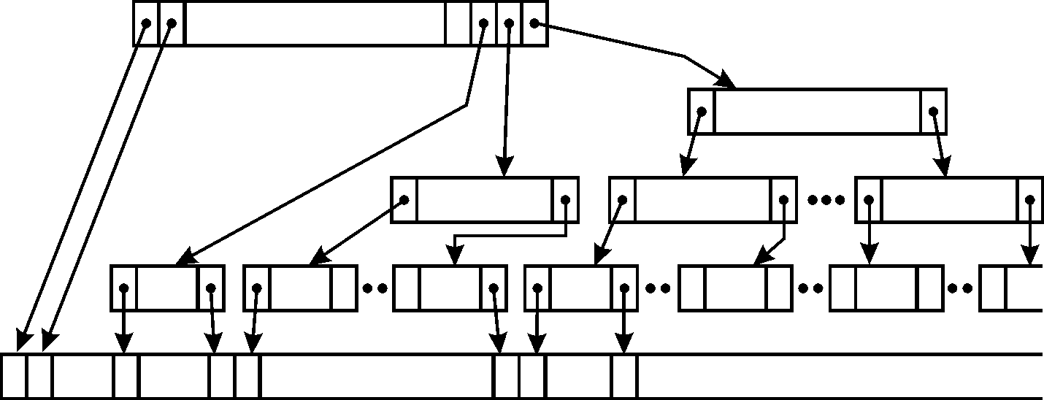

Inode：15個pointer；前12個指向direct block ── 48K。
single indirect block：1024個 ── 2²²。
double indirect blcok：1024×1024個 ── 2³²。
triple indirect block：(1024)³個 ── 2⁴²。
(block有4K bytes大小；pointer須使用4個bytes。)

5. Consider the operating systems that support three domains (user₁:…user₃) and three objects：
file F1, file F2, file F3. user₁ is the owner of file F1, user₂ is the owner of file F2, user₃ is the
owner of file F3. Furtheromore, the operating systems allow user₁ to do the domain switch to
user₂ and user₂ to do the domain switch to user₃. The control right in access (user₂, user₃) was
also included in the access matrix.
(a) (5 pionts) How would you denote this protections scheme in access matrix?
(b) (5 points) How would you implement of (a)’s access matrix in access control list (ACL)?

【解答】
a.
 | F1 | F2 | F3 | Domain 1 | Domain 2 | Domain 3
Domain 1 | Read, Write, Execute |  |  |  | Enter
Domain 2 |  | Read, Write, Execute |  |  |  | Enter
Domain 3 |  |  | Read, Write, Execute

b.
F1：（user1, *, RWX）
F2：（user2, *, RWX）
F3：（user3, *, RWX）

91年淡江資工 計算機系統(OS) 詳解

1.如下圖, 一個process會有如下七個狀態, 請詳述其中標示為1至6的狀態轉換(transition)
為何? 及其發生的條件為何? 儘可能舉例說明。(30%)
Activate Dispatch
New
Adnit Admit (5)

Blocked Ready Running Exit
Ready (2) Timeout Release

(4) (3) (6) Event Occurs
Blocked Blocked
Suspension (1)

【解答】
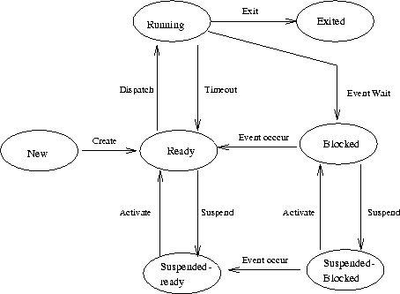

Process States：
The major states a process experiences throughout its existence are：
active, or running
ready to run, but temporarily stopped because another process in running,
blocked, waiting for data from another process (i.e., waiting for I/O)
Process Operations：
The set of operations on processes includes：
create a process
activate a process
suspend a process
terminate a process
Process Creation：
A process is created by an existing process (Parent/Child). It could be created by a service,
as a new batch job, or an interactive login.

Process Suspension：
A process starts a time consuming I/O operation, or is swapped out, or makes a spontaneous
request to sleep, or is blocked in a synchronization operation. When a process is suspended,
it is on some queue, namely the queue of all the processes waiting for the same resources.
As a result of the suspension, the process is swapped from memory to secondary storage,
this will save memory space for processes capable to run, usually processes with higher
priority in the ready queue take up the processor next.
Process Termination：
Once we have created a child process, there are two possibilities. Either the parent process
exits before the child, or the child exits before the parent. When a child process exits, it is
not immediately cleared off the process table. Instead, a signal is sent to its parent process,
which needs to acknowledge it's child's death, and only then the child process is completely
removed from the system. In the duration before the parent's acknowledgment and after the
child's exit, the child process is in a state called "zombie"
Process Scheduling Concepts：
There are two ways in which processes can stop: voluntarily stop, or be forced to stop.
If there is a mechanism to stop processes, then the scheduling is preemptive, otherwise it is
non-preemptive or cooperative. MS-DOS, OS2 and Windows use non-preemptive schedulers.
Windows NT and Unix use preemptive schedulers. To keep the CPU busy as much as possible,
whenever a process blocks, it should be replaced. To only allow a process to run for a
maximum amount of time, timer interrupts can be set to stop the process.

A five-state process model：New, Ready, Running, Blocked, Exit.
New：A process has been created，not yet been admitted to the pool of executable processes.
Ready：Processes that are prepared to run if given an opportunity. That is, they are not
waiting on anything except the CPU availability.
Running：The process that is currently being executed.
Blocked：A process that cannot execute until a specified event ( IO ) completionoccurs.
Exit：A process that has been released by OS either after normal termination or after abnormal
termination (error).
Process Transitions：
Ready --> Running：When it is time, the dispatcher selects a new process to run.
Running --> Ready：the running process has expired his time slot.
the running process gets interrupted because a higher priority process is in the ready state.
Running --> Blocked：When a process requests something for which it must wait a service
that the OS is not ready to perform、an access to a resource not yet available、initiates I/O
and must wait for the result、waiting for a process to provide input (IPC).
Blocked --> Ready：When the event for which it was waiting occurs
Process suspension：
Many OS are built around (Ready, Running, Blocked) states. But there is one more state that
may aid in the operation of an OS - suspended state.
When none of the processes occupying the main memory is in a Ready state, OS swaps one of
the blocked processes out onto to the Suspend queue.
When a Suspended process is ready to run it moves into “Ready, Suspend” queue.
Thus we have two more state: Blocked_Suspend, Ready_Suspend.
Blocked_suspend：The process is in the secondary memory and awaiting an event.
Ready_suspend：The process is in the secondary memory but is available for execution as soon
as it is loaded into the main memory.

2. 如果以Semaphore來解決Finite-Buffer Producer/Consumer Problem的演算法時需要用到
三個Semaphores如下所示，假設給予Producer所須之append()函式及Consumer所須
take()函式，請詳細說明此三個Semaphores在演算法中的作用為何?(10%)
並請完成Producer/Consumer的演算法(20%)
Program | producer, consumer, append, take；
const | b：buffer(size of buffer := k)；
var | n：semaphore(:= 0)
 | s：semaphore(:= 1)
 | e：semaphore(:= k)
 | in, out：pointers of buffer；
procedure append(v)  begin  b[in]:= v；  in := (in+1) mod k；  end |  | procedure take()  begin  w:= b[out]；  out := (out+1) mod k；  return w；  end
procedure producer；  begin  repeat  ???  ???  forever  end； |  | procedure consumer；  begin  repeat  ???  ???  forever  end；

Begin(*main program*)
parbegin
producer；consumer；
parend
end.

【解答】
n：semaphore(:= 0)：full，counting semaphore，buffer已存進幾筆資料。
s：semaphore(:= 1)：mutex，binary semaphore，進入Critical Section之Mutual Exclusion
管制。
e：semaphore(:= k)：empty，counting semaphore，buffer尚有多少空位。

procedure producer；
begin
repeat
p(e)；
p(s)；
append(v)；
V(s)；
V(n)；
forever
end；

Procedure consumer；
begin
repeat
p(n)；
p(s)；
v:= take()；
V(s)；
V(e)；
forever
end；

‧Bounded buffer的正確solution.
full, empty作為counting semaphore.
mutex作為binary semaphore
type item＝‧‧‧；
var buffer＝‧‧‧；
full, empty, mutex：semaphore；
nextp, nextc：item；
begin
full：＝0；empty：＝n；mutex：＝1；
parbegin
producer. repeat
…produce an item in nextp…
p(empty)；
p(mutex)；
‥add nextp to buffer‥
V(mutex)；
V(full)；
until false；
consumer. repeat
p(full)；
p(mutex)；
‥remove an item from buffer to nextc‥
V(mutex)；
V(empty)；
…consume the item in nextc…
until false；
parend；
end；

91年中原資工 計算機系統(OS) 詳解

1. (6%) There are two kinds of kernels in operating systems: micro kernel and monolithic kernel.
Micro kernel provides as few services as possible while monolithic kernel provides most services
itself. List and explain the advantages of each kernel.

【解答】
各類型real-time應用系統的排程，依需求不同排程演算法也有所不同。
如硬體偵測到event發生，立刻執行對應之處理程式（ISR，中斷驅動）；或定時掃描event
是否發生？（Timer interrupt, polling）。
Monolithic OS：把下列功能全放在一個龐大的OS內，反應遲鈍也無適應不同需求之彈性‧
程序管理（process management）：排程（process scheduling）‧
記憶體管理（memory management）：動態記憶體配置，虛擬記憶體‧
設備管理（device management）：互鎖（dead lock），競賽（race）‧
資訊管理（information management）：檔案系統‧

Microkernel OS：OS只包含最基本的功能，而把process scheduling、memory management、
file management等功能置放於user server，可依不同的需求安裝不同的排程演算法、
memory management、file management‧

Monolithic operation system：

使用者

Kernel ：含檔案、目錄及行程管理‧

傳統的，中央集權式‧
唯一可能的優點是Performance，訊息的傳遞可能較快，但此優點不具決定性（尚有其他
重要因素，且微量的傳遞時間通常可忽略）。

Micro kerneloperation system：

使用者 file server process server directory server

Kernel Kernel Kernel Kernel

網路
Kernel只提供最少的服務，而由user-level的server提供大部分的作業系統的服務‧
只提供最少的服務，如：
module之間相互通訊的功能‧
基本的memory management功能‧
少量低層次的process management及scheduling功能‧
低層次的Input / Output‧
優點：高模組化、flexibility高。

2. (10%)
(a) List and explain at least four shared-variable methods for synchronization.

(b) List and explain at least three message passing methods for synchronization.

(c) Explain why synchronization in distribute systems is based on message passing.

【解答】

(a)
1. Peterson algorithm，Dekker's algorithm，Bakery algorithm（N個process的race condition）。

2. CS之hardware solution（基本指令）：fetch-and-add, test-and-set(IBM 370),

XCHG(Intel 80×86)。

3. Semaphor：CS之supervisor call解法。

4. Abstract data type或class (物件導向)加入高階語言的語法中，即定義資料，

也定義在資料上執行的程序：critical region , monitor兩種。

(b)
message system：loosely coupled system, distributed system, multicomputer.
receive ( )─wait，send ( )─signal.
rendezvous, zero capacity buffer：必須等待receive( )之process到達，send( )之process才可
繼續往下執行，如Ada方式
直接通訊：須指明process id，如：
send (P, message)：send a message to process P.
receive (Q, message)：receive a message from process Q.
間接通訊：透過系統的mailbox，如：
send (A, message)：send a message to mailbox A.
receive (A, message)：receive a message from mailbox A.
經由公眾網路傳遞：如網際網路之TCP/IP Protocol。

(c)
分散式記憶體多處理器系統是指同一台機器裡有多顆CPU， 且各自擁有私屬的記憶體
(Local Memory)。分散式記憶體多處理器系統又稱為巨量多處理器電腦(Massive Parallel
Processors，簡稱MPP)。MPP架構是由數個CPU及記憶體之模組以某種拓樸學(Topology)
的方式連接而成。在MPP電腦系統架構裡，每一個含CPU及私屬記憶體(Local memory)
的子系統皆為各自獨立，整個系統也是由單一作業系統管理。每一個處理器模組(Processor
Module = CPU + Local Memory)內的記憶體都是各自獨立作業，CPU與CPU之間只能靠
訊息傳遞(Message Passing)的方式來溝通。由於每個CPU幾乎都具有完整的電腦架構，
所以它們都各自執行其工作，只有透過彼此之間的通訊，才有辦法互相協調、互助合作，
一般常聽說的MIMD就是指這種「多重指令、分散資料」的模式。這種電腦系統可以連結
的CPU個數相當多，可以到達512個、1024個或更多。在MPP上做平行計算比較複雜，
必須把程式用到的資料和計算工作做適當的切割，把不同的資料區塊分別傳送到各個CPU
的記憶體裡，然後各個CPU自行計算放在該CPU所屬記憶體裡的資料。如果要使用到
其他CPU所屬記憶體所存放的資料時，就要經由CPU間的網路從該CPU取得該項資料後，
才能夠繼續計算下去。
在MPP電腦系統上做平行計算必須使用訊息傳送(Message Passing)語言來撰寫，有PVM
(Parallel Virtual Machine)和MPI(Message Passing Interface)等多種。
對使用者而言使用MPP的缺點是程式的開發及平行化非常困難，尤其是要熟悉訊息傳遞
(Message Passing)的系統函式庫，即使利用軟體解決分散式記憶體程式問題，平行運算效果
也不甚理想。但其優點是整個系統之擴充性非常高。

3. A process can allocate and de-allocate memory from its heap using malloc() and free() in most
systems. When malloc() is called, the heap is searched for a free and big enough segment that is
then divided into an allocated segment (at the beginning) and a free segment. When free() is
called, the corresponding segment should merge with its neighboring segments, when they are
free.
(a)(8%) Now suppose a process has an initially empty heap of 17KB. The process issues the
following memory calls (pi is a pointer)：
p1 = malloc(5KB)
p2 = malloc(6KB)
p3 = malloc(3KB)
free(p2)
p4 = malloc(2KB)
free(p3)
p5 = malloc(2KB)
Show what the heap is like after the above calls, using best-fit and worst-fit algorithms.
(b)(6%) Give the drawbacks of the best-fit and worst-fit algorithms. Can these drawbacks be
identified from part (a) above?
(c)(4%) What will happen if the process issues the following calls after those in part (a) above?
p6 = malloc(3KB)
p7 = malloc(5KB)

【解答】
(a)
best-fit：p1 = malloc(5KB)
起點位址 | Size | Free/Allocated
0 | 5KB | Allocated | p1
5K | 12KB | Free
P2 = malloc(6KB)
起點位址 | Size | Free/Allocated
0 | 5KB | Allocated | p1
5K | 6KB | Allocated | p2
11K | 6KB | Free
P3 = malloc(3KB)
起點位址 | Size | Free/Allocated
0 | 5KB | Allocated | p1
5K | 6KB | Allocated | p2
11K | 3KB | Allocated | p3
14K | 3KB | Free
free P2
起點位址 | Size | Free/Allocated
0 | 5KB | Allocated | p1
5K | 6KB | Free
11K | 3KB | Allocated | p3
14K | 3KB | Free

p4 = malloc(2KB)
起點位址 | Size | Free/Allocated
0 | 5KB | Allocated | p1
5K | 6KB | Free
11K | 3KB | Allocated | p3
14K | 2KB | Allocated | p4
16K | 1KB | Free
free(p3)
起點位址 | Size | Free/Allocated
0 | 5KB | Allocated | p1
5K | 9KB | Free
14K | 2KB | Allocated | p4
16K | 1KB | Free
p5 = malloc(2KB)
起點位址 | Size | Free/Allocated
0 | 5KB | Allocated | p1
5K | 2KB | Allocated | p5
7K | 7KB | Free
14K | 2KB | Allocated | p4
16K | 1KB | Free
worst-fit：p1 = malloc(5KB)
起點位址 | Size | Free/Allocated
0 | 5KB | Allocated | p1
5K | 12KB | Free
P2 = malloc(6KB)
起點位址 | Size | Free/Allocated
0 | 5KB | Allocated | p1
5K | 6KB | Allocated | p2
11K | 6KB | Free
P3 = malloc(3KB)
起點位址 | Size | Free/Allocated
0 | 5KB | Allocated | p1
5K | 6KB | Allocated | p2
11K | 3KB | Allocated | p3
14K | 3KB | Free
free P2
起點位址 | Size | Free/Allocated
0 | 5KB | Allocated | p1
5K | 6KB | Free
11K | 3KB | Allocated | p3
14K | 3KB | Free
p4 = malloc(2KB)
起點位址 | Size | Free/Allocated
0 | 5KB | Allocated | p1
5K | 2KB | Allocated | p4
7K | 4KB | Free
11K | 3KB | Allocated | p3
14K | 3KB | Free

free(p3)
起點位址 | Size | Free/Allocated
0 | 5KB | Allocated | p1
5K | 2KB | Alolocated | p4
7K | 10KB | Free
p5 = malloc(2KB)
起點位址 | Size | Free/Allocated
0 | 5KB | Allocated | p1
5K | 2KB | Allocated | p4
7K | 2KB | Allocated | p5
9K | 8KB | Free
(b)
best fit：易造成多塊不連續之零碎空間（fragment），但可保留大塊之連續空間。
worst fit：不易造成多塊不連續之零碎空間（fragment），但無法保留大塊之連續空間。
但在本題之例子中，看不出上述之一般性。
(c)
best fit：p6 = malloc(3KB)
起點位址 | Size | Free/Allocated
0 | 5KB | Allocated | p1
5K | 2KB | Allocated | p5
7K | 3KB | Allocated | p6
10K | 4KB | Free
14K | 2KB | Allocated | p4
16K | 1KB | Free
p7 = malloc(5KB)
找不到5KB之連續空間，reject此request！
worst-fit：p6 = malloc(3KB)
起點位址 | Size | Free/Allocated
0 | 5KB | Allocated | p1
5K | 2KB | Allocated | p4
7K | 2KB | Allocated | p5
9K | 3KB | Allocated | p6
12K | 5KB | Free
p7 = malloc(5KB)
起點位址 | Size | Free/Allocated
0 | 5KB | Allocated | p1
5K | 2KB | Allocated | p4
7K | 2KB | Allocated | p5
9K | 3KB | Allocated | p6
12K | 5KB | Allocated | p7

4. Suppose that we have 5 processes for execution. The priority, arrival time, and behavior of each
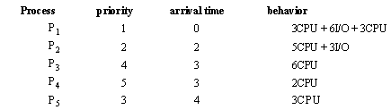
process is in the following table:
All the time in this problem is given in milliseconds. Process P1 consists of a period of CPU
computation (3ms), followed by a period of I/O operation (6ms), and then a period of CPU
computation(3ms). Scheduling decisions are made based on the information available at the time
that the decisions must be made.
(a)(8%) Give two Gantt charts to illustrate the scheduled execution of these processes using
(i) Round Robin (quantum = 2 ms) and
(ii) preemptive priority (a smaller priority number implies a higher priority).
(b)(8%) Calculate the average turnaround time for every process under each of the scheduling
algorithms in part a) above.

【解答】
(a)(b)
Round Robin(quantum = 2 ms)：
Process |  | 0 | 2 | 4 | 6 | 8 | 10 | 11 | 13 | 15 | 16 | 17 | 19 | 21 |  | Start Time | End Time
P1 |  | ▃ |  |  |  |  | ▃ |  |  |  |  |  | ▃ | ▃ |  | 0 | 22
P2 |  |  | ▃ |  |  |  |  | ▃ |  |  | ▃ |  |  |  |  | 2 | 17
P3 |  |  |  | ▃ |  |  |  |  | ▃ |  |  | ▃ |  |  |  | 4 | 19
P4 |  |  |  |  | ▃ |  |  |  |  |  |  |  |  |  |  | 6 | 8
P5 |  |  |  |  |  | ▃ |  |  |  | ▃ |  |  |  |  |  | 8 | 16
turnaround time =完成時間-抵達時間
Process |  | 抵達時間 | End Time |  | turnaround time
P1 |  | 0 | 22 |  | 22
P2 |  | 2 | 17 |  | 15
P3 |  | 3 | 19 |  | 16
P4 |  | 3 | 8 |  | 15
P5 |  | 4 | 16 |  | 12
average turnaround time = （22+15+16+15+12）/5

preemptive priority：
Process |  | 0 | 3 | 8 | 9 | 12 | 14 | 20～21 |  | Start Time | End Time
P1 |  | ▃ |  |  | ▃ |  |  |  |  | 0 | 12
P2 |  |  | ▃ |  |  |  |  |  |  | 3 | 8
P3 |  |  |  |  |  |  | ▃ |  |  | 14 | 20
P4 |  |  |  |  |  |  |  | ▃ |  | 20 | 22
P5 |  |  |  | ▃ |  | ▃ |  |  |  | 8 | 14

turnaround time =完成時間-抵達時間
Process |  | 抵達時間 | End Time |  | turnaround time
P1 |  | 0 | 12 |  | 12
P2 |  | 2 | 8 |  | 6
P3 |  | 3 | 20 |  | 17
P4 |  | 3 | 22 |  | 19
P5 |  | 4 | 14 |  | 10
average turnaround time = （12+6+17+19+10）/5

91年中央資工 系統程式 詳解

1. What is the Virtual Round-Robin (VRR)?
Please explain its purposes and functions in details.(10%)

【解答】
Round-Robin：
Time Quantum for Round Robin：
must be substantially larger than the time required to handle the clock interrupt and dispatching
should be larger than the typical interaction (but not much more to avoid penalizing I/O
bound processes)
Round Robin: critique：
Still favors CPU-bound processes
A I/O bound process uses the CPU for a time less than the time quantum and then is blocked\
waiting for I/O
A CPU-bound process run for all its time slice and is put back into the ready queue (thus
getting in front of blocked processes)
A solution：virtual round robin
When a I/O has completed, the blocked process is moved to an auxiliary queue which gets
preference over the main ready queue
A process dispatched from the auxiliary queue runs no longer than the basic time quantum
minus the time spent running since it was selected from the ready queue

2. (a) Please draw a figure to show the relation between the CPU utilization and the degree of
multiprogramming in a virtual system and explain it briefly.
(b) Is it always true that giving a process more memory page frames will reduce the process
page fault? You must use an example to explain your answer.(15%)

【解答】
(a)
為了使CPU的utilization↑ multiprogramming degree↑ 每一程式分配到
的frame數目↓ page fault次數↑ CPU的閒置時間↑（因多做了
page in / page out，皆為虛功） CPU的utilization↓ 為了使CPU的
utilization↑ 再增加multiprogramming degree……，
這種情形會導致所謂的thrashing（猛移、崩潰）‧
thrashing：
每一程式分配到的frame數目太少（或因替換策略不當），page fault太過頻繁，導致
CPU utilization太低‧
應降低multiprogramming degree(swap out process到磁碟)，使各process分配到的frame
數增加，則發生page fault的頻率就會降低‧

CPU的utilization
thrashing

multiprogramming degree

(b)
Belady's anomaly：
分配到的frame數增加，page fault次數理應減少但FIFO的replacement策略可能發生
frame數增加page fault也隨之增加的怪異現象。
示例：reference string：0 , 1 , 2 , 3 , 0 , 1 , 4 , 0 , 1 , 2 , 3 , 4.
frame數：3.
 | 0 | 1 | 2 | 3 | 0 | 1 | 4 | 0 | 1 | 2 | 3 | 4
1. | 0 | 0 | 0 | 3 | 3 | 3 | 4 |  |  | 4 | 4
2. |  | 1 | 1 | 1 | 0 | 0 | 0 |  |  | 2 | 2
3. |  |  | 2 | 2 | 2 | 1 | 1 |  |  | 1 | 3
page fault：9次
fframe數目改為4：
 | 0 | 1 | 2 | 3 | 0 | 1 | 4 | 0 | 1 | 2 | 3 | 4
1. | 0 | 0 | 0 | 0 |  |  | 4 | 4 | 4 | 4 | 3 | 3
2. |  | 1 | 1 | 1 |  |  | 1 | 0 | 0 | 0 | 0 | 4
3. |  |  | 2 | 2 |  |  | 2 | 2 | 1 | 1 | 1 | 1
4. |  |  |  | 3 |  |  | 3 | 3 | 3 | 2 | 2 | 2
page fault：10次
Stack algorithm：以stack存page no，每當reference，就將此page no.移到stack的top.
替換時，選擇stack的bottom予以替換。
frame＝n即stack top有n個page存在memory frame，故frame＝n時所載入之pages必然
是frame＝n＋1時所載入pages之subset，故不會發生Belady's anomaly, optimal策略與
LRU策略均屬之。

3. Describe the wait-die and wound-wait protocols for deadlocks prevention.(10%)

【解答】
wait-die scheme：non-preemtion‧
P_{i}欲request P_{j}已佔用之resource：P_{i} → P_{j}‧
若P_{i}的timestamp較小(較年老)，則允許P_{i}等待，P_{i} → P_{j}成立‧
若P_{i}的timestamp較大(較年輕)，則不允許P_{i}等待，P_{i} die(rollback)‧
不會有starvation現象‧
wound-wait scheme：preemtion‧
P_{i}欲request P_{j}已佔用之resource：P_{i} → P_{j}‧
若P_{i}的timestamp較小(較年老)，則P_{J} rollback,即P_{J} wound，P_{i}強取P_{J} 之resources‧
若P_{i}的timestamp較大(較年青)，則允許P_{i}等待，P_{i} → P_{j}成立‧
不會有starvation現象‧
被rollback的process不再assign新的timestamp，因此被rollback的process會變得
較年老‧

4. Consider a file currently consisting of 100-blocks. Assume that the file control block( and the
index block, in the case of indexed allocation) is already in memory. Calculate how many disk
IO operations are required for contiguous, linked, and indexed(single-level) allocation strategies,
if, for one block, the following conditions hold. In the contiguous-allocation case, assume that
there is no room to grow in the beginning to be added is stored in memory.(15%)
a. The block is added at the beginning.
b. The block is added in the middle.
c. The block is removed from the beginning.

【解答】
a. The block is added at the beginning.
b. The block is added in the middle.
c. The block is added in the end.
d. The block is removed from the beginning.
e. The block is removed from the middle.
f. The block is removed from the end.
 | Contiguous | Linked | Indexed
a | 201 | 1 | 1
b | 101 | 52 | 1
c | 1 | 3 | 1
d | 198 | 1 | 0
e | 98 | 52 | 0
f | 0 | 100 | 0

5. Explain the task of a compiler-compiler such as YACC.(10%)

【解答】
Compiler-Compiler：
輸入為lexical rule, grammar rule, semantic rule等語法規則。
輸出為lexical analyzer (scanner), parser, code generator等compiler routine.
故此為一compiler產生器
YACC (Yet-Another Compiler-Compiler)：parser generator
LEX (lexical analyzer)：scanner generator.

YACC (Yet Another Compiler-Compiler)是由S.C.Johnson在1970年代所完成的一個UNIX
的工具程式，它的主要功能是以一種簡易的方式，讓使用者設計出一個語法分析程式
(syntax parsing program)。YACC將一個由特定規格說明檔案，轉換為相對應的C程式輸出，
程式設計師再將輸出的C 程式編譯之後，以產生相對應的語法分析應用程式。
一個完整的 YACC 規格說明程式包含了三個部份：宣告(declaration)、轉換規則(translation
rules)和C語言副程式(supporting C-routines) 。
在上面的規則說明以『%%』符號分為三部份，第二部份轉換規則是YACC檔案的核心
部份，這個部份是採 BNF的語法，不過某些token要在第一部份事先宣告(如加減乘除的
運算符號)。利用這個YACC規則說明檔，可產生出能分析一個簡單的實數運算式的
C語言程式。

6. Explain the following terms：(10%)
(a) virtual machines (b) RISC and CISC (c) Backus-Naur Form and Chomsky Normal Form

【解答】
(a) virtual machines：
Nonvirtual machine： Virtual machine：

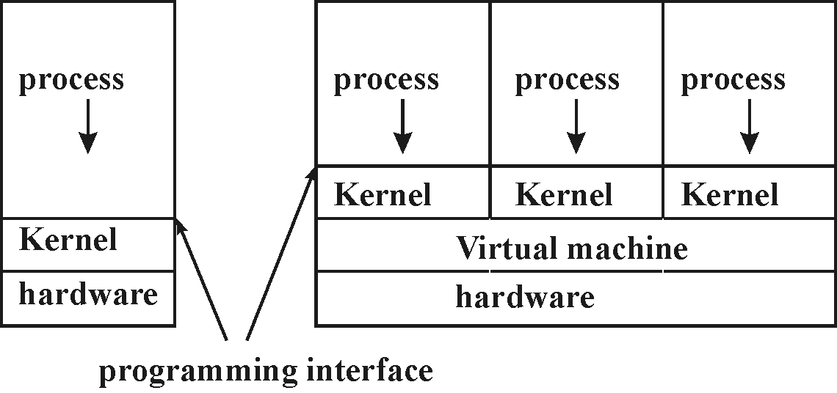

‧Virtual machine：提供interface that is identical to the underlying bare hardware，而每一個
process is provided with a (virtual) copy of the underlying computer.
‧The resources of physical computer are shared to create the virtual machines.
CPU scheduling：share CPU.
virtual memory and memory management：share memory.
spooling and file system：virtual I/O devices.
‧Kernel控制hardware以create一組system calls, system program可以使用system calls或hardware instructions, and in some ways these programs do not differentiate between these two.
application programs要存取hardware (memory, I/O, …)時，一定要經由Kernel的system calls；雖是不同的machine, 但可藉由Kernel提供相同功能的system calls，故OS can be used to make different machines appear to have the same characteristics.
‧多個process以為在不同的hardware上執行，但藉由virtual machine提供不同hardware (OS)所提供的system calls，即virtual machine將不同computer的system calls對應(map)到同樣的hardware上，使得real hardware只有一種，但各個process卻認為在不同的hardware上執行。
(b) RISC and CISC
 | RISC(reduced instruction set computer) | CISC(complex instruction set computer)
指令數目 | 少，低於100道‧ | 200～300道以上‧
指令功能 | 簡單，register-to-register operation，  LOAD/STORE machine‧ | 複雜‧  有如同計算CRC碼之複雜指令‧
指令格式 | 固定，運算碼及各運算元可平行解碼，速度快‧ | 不固定，循序解碼‧
指令長度 | 固定，常見為32位元‧ | 不固定‧
定址模式 | 4～8種左右‧ | 約10種以上‧
控制單元 | Hardwired control‧ | Microprogramming control‧
指令管線 | 每道指令執行流程類似，管線單純‧ | 各指令執行流程差異極大，管線複雜‧
管線hazard | Compiler偵測，插入NOP指令解決‧ | 硬體偵測，硬體解決；  suspension或internal forwarding‧
複雜程度 | 控制單元約佔整個CPU複雜度之10%‧  multiple overlapped register windows‧  built-in cache‧ | 控制單元約佔整個CPU複雜度之60%‧

(c) Backus-Naur Form and Chomsky Normal Form
BNF is an example of a metalanguage language used to describe another language such as a
programming language and which utilize the following metasymbols and boldface as follows:
Metasymbol | Meaning
::= | is defined to be
| | alternatively, or
<something> | <something> is to be replaced by its definition
something
A word written in boldface is called a terminal or token indicating an indivisible language element allowing no further replacements.
Language syntax is often described in formal BNF and sometimes followed by programming
examples. Syntax is the collection of statements formed by following a set of rules that
differentiate valid from invalid programs.
Example:
<identifier> ::= <letter> | _<letter> | <identifier ><letter> | <identifier ><digit > | <identifier >_
reads as "An identifier is defined to be a letter, or a letter preceded by an underscore, or an
identifier followed by a letter, or an identifier followed by a digit, or an identifier followed by an
underscore." Observe that it is a recursive definition.
Additional symbols used in EBNF:
Symbol | Meaning
[something] | 0 or 1 occurrence of something, i.e. optional
{something} | 0 or more occurrence of something
( this | that ) | grouping; either this or that
Example: <identifier> ::= [ _ ]<letter> { <letter> | <digit> | [ _ ] }

A formal grammar is in Chomsky Normal Form iff all production rules are of the form:
A -> BC
A -> α
where A, B and C are nonterminal symbols and α is a terminal symbol.
Every grammar in Chomsky Normal is context-free, and conversely, every context-free grammar
which does not generate the empty string can be transformed into an equivalent one which is in
Chomsky Normal Form.
The Chomsky Normal Form of a context-free grammar is important because it yields efficient
algorithms.

7. What is DLL(Dynamic Linking Library)? How does it work?
What does the system provide?(10%)

【解答】
dynamic-link library (DLL，動態連結程式庫)：
Microsoft Windows 系列作業系統的提供的功能，讓可執行副程式 (通常是服務某個特殊
函數或一組函數) 可以分開儲存成副檔名為 .dll 的檔案，只有在其他程式呼叫其中的函數
時才會載入。 這樣的做法不僅使得程式執行所需的記憶體量減少，也可以重複使用程式碼。

. A file of procedures residing on disk that is available to an executing program so that relevant
procedures can be read into memory and executed at run time. The advantage is that the
executables are smaller, the link libraries can be shared, and providing the interface remains
unchanged, can be updated without recompiling the application. Although extra time is spent
in disk input/output, *disk chching and faster disk subsystems make this a valuable technique.

8. What is program relocation? How to assemblers be implemented for program relocation?(10%)

【解答】
Relocation：已知程式的載入位址，將程式內使用到位址的地方對應到正確的address。
‧assembler組譯時不知程式將被載入的實際位址（所以pseudo指令：ORG 0或START 0）。
‧載入時，與實際載入位址有關的位址常數或直接定址須作修正－static relocation，由loader
完成。
‧執行時，程式code也可在memory內移動位置，所須的address translation由硬體完成
（base register, relocation register, page table等）－dynamic relocation。
‧PC-relative定址法於relocation時毋須修正。
‧direct定址法於relocation時以modification修正：
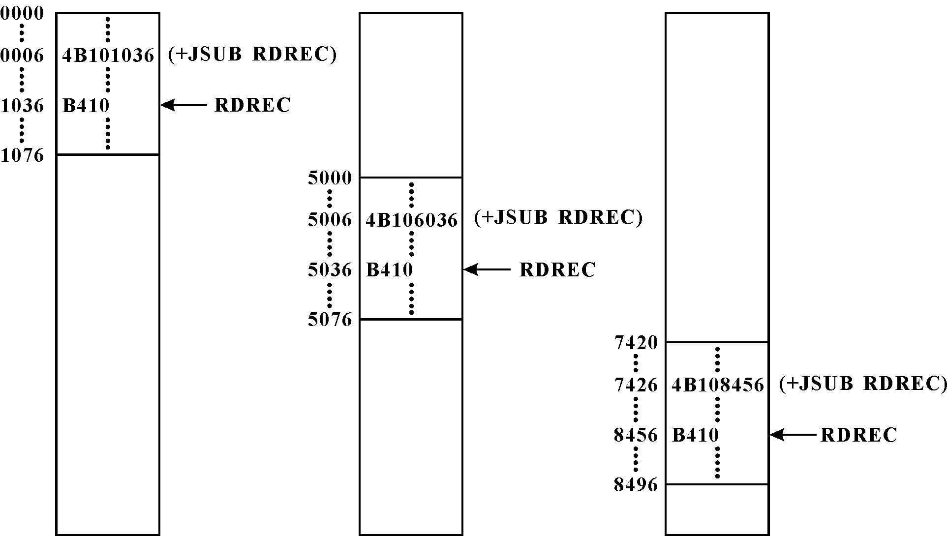

9. An interrupt is a signal that causes a computer to alter its normal flow of instruction execution.
Describe the basic process of interrupt handling.(10%)

【解答】
CPU接受INTR可罩遮式外部中斷要求，下列條件須同時滿足：
1‧目前指令執行完畢‧ 2‧中斷致能旗號致能（IF enable）‧
3‧INTR信號出現‧ 4‧優先較高的NMI沒有出現‧
中斷向量（vector）：
不同的中斷原因，CPU有不同的處理方式，即須執行不同的中斷服務程式（ISR：
interrupt service routine），中斷向量用來讓CPU快速找到中斷服務程式的進入點‧
各I/O設備各有其中斷向量，於中斷認知週期（interrupt acknowledge cycle）傳送給CPU‧

中斷程序：
1‧I/O設備發出信號，要求中斷CPU‧
2‧中斷控制器檢查此中斷要求是否被遮罩？若沒有被遮罩，則向CPU發出INTR
（中斷要求信號）
3‧CPU若接受INTR，則回送INTA（認知信號），進行INTA週期（讀取中斷向量）‧
4‧中斷控制器處理優先權，送出優先權最高者INTR之中斷向量給CPU‧
5‧CPU藉由中斷向量計算出ISR（中斷服務程式）的進入點，呼叫（CALL）ISR‧
（存入被中斷程式的程式計數器於堆疊，將ISR的進入點載入程式計數器）‧
6‧ISR執行完畢，以IRET指令返回被中斷之程式‧

位址匯流排
CPU 控制匯流排
資料匯流排

INTA INTR

data ready
INTR I/O設備

中斷控制器

INTA data ready
I/O設備

91年交大 資工 計算機系統(OS) 詳解
Part A. Operating Systems

1. (5%) Some microprocessors provide a CPU mode known as single-step,in which the CPU
executes a trap after every instruction. What is the single-step mode useful for?

【解答】
single-step：作為debugging之用。
於80x86中：single-step執行之啟動：設定PSW暫存器之TF旗標為1，即進入single-step
mode。single-step mode：每執行完任一道指令後，CPU就trap到INT 1之內部中斷服務
程式（ISR）去執行。

2. (5%) A semaphore S is an integer variable that, apart from initialization, is accessed only through
two standard atomic operations：wait and signal. The classical definitions of the two operations
are：
wait(S)： Signal(S)：
while S<=0 do no-op; S:=S+1;
S:=S-1;
Which part of the code, in both operations, must be executed without interruption?

【解答】
於wait(S)中：S<=0之真假判定與S:=S-1動作必須一氣呵成，不得被中斷。
於Signal(S)中：S:=S+1動作（讀出S、S加1、寫回S）必須一氣呵成，不得被中斷。

3 .(15%) The following is two-process bakery algorithm that is a solution to the critical section
problem. The common data structures are:
var choosing :array[0…1] of boolean;
number: array[0…1] of integer;
Initially, these data structures are initialized to false and 0, respectively. For convenience, we
define the following notation:
1. (a,b)<(c,d) if and only if a<c or [(a=c) and (b<d)].
2. max(a,b) returns an integer that is the maximum of a and b.
The structure of process Pi is:
repeat
1 choosing[ i ] :=true;
2 number[ i ] : =max(number[ i ], number[ j ])+1;
3 choosing[ i ]:=false;
4 while choosing[ j ] do no-op;
5 while number[ j ]= 0 and (number[ j ],j)<(number[ i ],i) do no-op
6 ……Critical Section……
7 number[ i ] :=0
until false;
In the code above, if Pi is P0 then (i=0) and (j=1). Likewise, if Pi is P1 then (i=1) and (j=0).
(a) (5%) Give a sequence of events of the processes executing the two-process bakery algorithm
in which both processes obtain the same value for number when they complete line 2.
(b) (10%) Suppose we modify the algorithm by deleting lines 1,3 and 4.
Let’s call the modified code bad-bakery algorithm. Give a sequence of events of the processes
executing the bad-bakery algorithm in which P1 enters critical section first, and at a later time
while P1 remains in critical section P0 also enters critical section.

【解答】
(a).選號碼（line 2）並非critical有可能P1與P0兩個rocess交錯執行，因而選到同號。
(b).
P1與P0兩個rocess交錯執行，P1先離開（選到1號），P0還在
2 number[ i ] : = max(number[ i ], number[ j ])+1;
這道敘述執行中，但max(number[ i ], number[ j ])+1已做完（也選到1號），但尚未存入
number[ 0 ]，此時number[ 0 ] 仍為0。

P1先離開（選到1號）直到執行這道敘述：
5 while number[ j ]= 0 and (number[ j ],j)<(number[ i ],i) do no-op
可進入Critical Section。

P1在Critical Section尚未離開，此時P0執行完
2 number[ i ] : = max(number[ i ], number[ j ])+1;
這道敘述，往下執行直到執行這道敘述：
5 while number[ j ]= 0 and (number[ j ],j)<(number[ i ],i) do no-op
因(number[j], j)＜(number[i], i)之比較，P_{i}與P_{j}選到同號且j＜i，也可進入Critical Section。

4. (6%) Draw a diagram to illustrate and describe how the “paging with TLB” mechanism works.
(Note: TLB stand for “translation look-aside buffer”)

【解答】
TLB：translation look-aside buffers‧page table的cache，一般以associative register製成‧

uirtual address： 主記憶體：
p d process A之page table：

ptbr： ＋ f
page table base register miss

f d process A之程式或資料：

hit 欲存取之指令或資料
TLB：

page no. frame no.

5. (4%) For increasing the performance of a file system, several approaches have been proposed.
(a) (2%) What is the “disk striping” approach?
(b)(2%) How does this approach work?

【解答】

擁有快速讀取及寫入的能力但並沒有容錯的能力。
這種模式的磁碟陣列是指藉由多個磁碟的存取動作，進而成為一個磁碟群組，也就是說
假如系統有三顆硬碟，那麼其一連串的資料是由三顆硬碟同時作存取的動作。這樣的組合
可以提高其系統的效能，但是唯一的缺點就是無容錯的能力

RAID0：就是所謂的Disk Striping（磁碟機條狀分佈），存取效能最高，但不具備資料備份
功能及安全性。簡單的說是把幾個硬碟串成一個大硬碟，資料在寫入前會被切割為更小的
區塊，分別依序寫入陣列中的每一個硬碟，可提供高頻寬，但其中的一顆硬碟損毀，資料
就報銷了。
RAID1：將資料由一顆硬碟映射至另一顆同一陣列上的硬碟（Disk Mirroring），簡單說就是
把資料完全複製到另一顆硬碟上去（存兩遍），這樣的模式提高了系統的信賴度。硬碟容量
利用率只剩下一半。
RAID：redundancy array of inexpensive disks.
‧disk stripping（interleaving）：
block→拆成多個subblocks→subblocks存放在separate disk.
可transfer subblock inparallel.
若各disk synchronized，則在between subblcok-access之間（來自不同disk）沒有latency.

‧RAID：
‧提升performance，因多個disk可parallel進行。
提高reliability，因有parity block或data duplication.
提高price-performance ratio.
‧RAID level 0：data stripping.
將資料依序存入two or more磁碟（interleaving方式），沒有執行error detection.
沒有執行error detection.
‧RAID level 1：transparent mirroring.
‧disk mirroring：一個disk control card接兩個disk，兩disks內容完全相同。
‧disk duplexing：兩個disk接在不同的disk control card上，兩disk內容完全相同。

6 (6%) For protection, the “setuid” approach can be used.
(a) (3%) Explain how this approach works.
(b) (3%) Give a usage example.

【解答】
setuid：將執行檔執行時的權限變成和執行檔所有人相同. 普通執行檔執行時, 權限是
執行者的權限, 這樣的話很多程式都不能跑(如：你不能修改/etc/passwd, 所以不能變更
密碼.). 而如果setuid, 該檔又是root所有, 這種執行檔就有root權限了. (像passwd程式
就是靠這個改密碼的). 不過setuid反過來也可能是系統安全的主要漏洞.)
特殊的檔案權限：Setuid
在執行程式時，程式執行的身份為啟動該程式的user，若設為setuid，則該程式在執行身份
就改為該程式的Owner。
通常Setuid(Set user id)的情況會發生在使用者需要root的權限時發生，意謂著這支程式
必須要有root的權力才能做相關的動作。例如線上改密碼程式，一般人都可以執行它，
但是這支程式需setuid，其權限應該是-rwsr-xr-x，表示在執行時是以root身份執行，能夠
更改某使用者的密碼，但是setuid有時是系統上安全的漏洞，在管理上必須嚴格控管具有
setuid權限的檔案。

7 (9%) A hard disk may have some bad sectors and several approaches have been proposed to solve
this problem.
(a) (3%) What is the “sectors sparing” approach?
(b) (3%) How can this approach affect the performance of the operating system’s disk scheduling
algorithm?
(c) (3%) “Sector slipping”is an approach proposed to solve the above performance problem.
Explain how this approach works.

【解答】
(a)
Sector sparing is a method whereby the system keeps a small pool of spare disk sectors and uses
them in place of sectors that are detected as bad. Normally, formatting detects and marks the bad
sectors, sparing them out.
(b)
Invalidate optimization by OS’s disk scheduling
(c)
Sector slipping：
formatting：
劃分sector、存入ECC（error correcting code）。
logical formatting：write an initial, blank directory onto the disk, install a FAT, inode或
free-space list等。
IDE driver：利用format命令發現有bad block，設定FAT entries to tell the allocation routine
不要使用這些bad blocks。
SCSI driver：keep a list of bad blocks, initialized during physical format and updated over
the life of the disk.若有request to bad blocks, controller自動將此request轉換成
"the replacement sector's address"，此謂之slipping或forwarding。

91年清大資工所 計算機系統(OS) 詳解

1. (10%)
a.(5%) Whiat is asynchronous I/O?
b.(5%) If asynchronous I/O is performed on a high-speed I/O device , the CPU will need 2
microseconds (for example)to respond to each interrupt, with interrupts arriving from the I/O
device at every 4 microseconds (for example). That would not leave much time for process
execution. How do modern computer stems solve this problem?

【解答】
a. I/O設備與CPU間資料傳輸速度有極大的差異，無法under在同一Clock下工作，
各有各自之Clock，稱為asynchronous I/O；資料之存取須經握手式(handshake)
控制信號之溝通後，始能進行‧
二線握手式：Source發動‧
data line
Source Destination
data ready 信號
acknowledge信號
data line

data ready 信號

acknowledge信號
b. high-speed I/O device；would not leave much time for process execution：
I/O方式請從中斷I/O改成DMA I/O，可讓本由軟體執行之Data transfer(佔用CPU時間)
改由硬體執行(DMA Controller)，就可保留much time for process execution。。
三種I/O方式：
Data ready的偵測 | Data transfer（資料搬動）
軟體 | 軟體 | Program controlled I/O
軟體 | 硬體 | 無此種I/O方式
硬體 | 軟體（即ISR） | 中斷I/O
硬體 | 硬體 | DMA I/O
中斷I/O：
I/O設備的data ready信號即中斷要求信號，於中斷服務程式中，進行資料之搬動‧
應用於即時（real-time）系統，如自動控制系統，飛彈導航系統等‧
反應快，但資料搬動如Polling I/O一般，由CPU執行程式進行，故速度慢‧
DMA I/O：
適用於資料量大、且產生速度快的I/O設備上，如CRT畫面之更新，Disk-I/O等‧
反應快，資料搬動也快‧
data ready、data transfer均由硬體處理‧

2. (5%) What is the dispatch latency of an operation system?

【解答】
Process Dispatch Latency：Process dispatch latency is the time from the occurrence of an external
interrupt until the process awaiting that interrupt is able to run. Dispatch latency includes the
time spent in recognizing an external interrupt, executing the interrupt handler, waking the
process that is waiting for the interrupt, performing a context switch to that process, and for the
process to exit the kernel where it can begin executing application code.
The term dispatch latency describes the amount of time it takes for a system to respond to a
request for a process to begin operation. With a scheduler written specifically to honor
application priorities, realtime applications can be developed with a bounded dispatch latency.

3. (10%)
a. (5%)In an acyclic-graph directory structure, several directories may share a common
sub-directory. If a sub-directory is asked to be deleted, we only remove a correspondent link
without deleting it, unless it is not a shared one. What is the simplest way to determine whether
a sub-directory is shared or not when it is asked to be deleted
b. (5%)Does your answer in (a) work for a general graph directory structure?
Please explain briefly.

【解答】
a. Deleting a link or file：File may have many pathnames, many filenames
What Should be done about file links to the file ?
Search for them and delete them as well ?
Preserve the file until all the links are deleted
For hard links, decrement reference count and only delete when reference count is zero ?
Keep reference list of all links ?
b. General Graph Directory Structure：deleting a file
Reference counts don’t always work with cycles
Requires garbage collection
Go through entire file system
Mark all entries that point to a real , existing file
Traverse file system again to free unmarked entries

4. (5%)We call a grammar an ambiguous grammar if there are more than one parse tree for a given
string of tokens. The following grammar is an ambiguous grammar. Pease rewrite it to an
unambiguous one.
<S> → d | <F>
<F> → a<S>b<S>
<F> → a<S>

【解答】
<S> → d | <F>
<F> → a<S><F’>
<F’> → b<S> | ε

‧Left-factoring：
‧將文法之production rule轉換成能被recursive-descent的方式處理，即延遲作決定
（選which production rule）之時間。
‧A→αβ1｜αβ2 改成：A→αA'
A'→β1｜β2
例：S→iEtS｜iEtSeS｜a
E→b
改成：
S→iEtSS'｜a
S'→eS｜ε
E→b

5. (10%) The heap memory has been commonly used for dynamic memory allocation in modern
operating systems.Please
a. (3%) explain the usage of heap.
b. (3%) describe the definition of heap fragmentation and its cause.
c. (4%) propose a solution for heap fragmentation.

【解答】
堆積是程式當中所使用的記憶體，它和堆疊 (stack) 不同的是，堆疊通常是以先進後出的
規則來存取資料，所以堆疊必須有固定的大小及位置，而堆積則沒有此類限制，它可以
在程式的執行過程中動態配置。
記憶體配置（allocation）：
靜態配置（static allocation）：
於編譯（compiling）時配置，如外部變數（全域）‧
效率高，使用直接定址；彈性低，無法使用於遞迴內‧
堆疊配置（stack allocation）：
進入副程式時配置，如自動變數（區域）‧
副程式結束時，釋放（release）還給作業系統‧
程式執行時有配置（allocation）、釋放（deallocation）之overhead；可執行遞迴程式‧
堆積配置（heap allocation）：
於程式執行時配置，屬於外顯式動態變數（dynamic variable）‧
使用指標（pointer）存取動態變數‧
配置：new，malloc；釋放：dispose，free‧
Internal Fragment：大小為m的Job存放在大小為n的（n≧m）的Partition，剩下來的（n-m）
未使用空間（不能再被使用）稱為Internal Fragment‧
External Fragment：Free Partition仍可被使用，但Job都太大，無法存入，造成此Partition
閒置，稱之為External Fragment‧

Common Heap：for programs and (user) data.
System Heap：system tables, device definition data, system workspace.
User Heap：maintained sub-area of and within previously allocated common heap blocks.

Compaction（或稱為Garbage Collection）：減輕MVT記憶體配置之External Fragment‧
將各Process移位，讓External Fragment集中在一起，使能容納另一個Process‧
Garbage collection：
automatic memory management involves the reclamation of previously allocated but no
longer used storage，possibly long after is was allocated，and without an explicit call to free‧
Garbage collection演算法：
mark and sweep：又稱為reference count，分為marking phase及collecting phase‧
stop-and-copy：將記憶體分為兩部分（two space），已marked，立刻copy到另一半‧
generational：最近存取過的，搬到permanent storage，可降低marking之時間‧

Heap Management：
For instance, starting with an empty (transient) heap memory a first job, 'A', was executed,
allocating some space at "area A":
- free - | area A
Another job, 'B', executes, allocating some workspace at "area B", and the next at "area C":
- free - | area C | area B | area A
After 'B' was done, and removed from memory, the system deallocates its memory, relinking it
to the list of available heap memory:
- free - | area C | - free - | area A
Another job, 'D', executes, with a very modest memory allocation which fits into the empty
space left by 'B':
- free - | area C | - free - | D | area A
The next job, 'E', need a huge area, allocated at "area E":
area E | area C | - free - | D | area A
Now 'A' allocates some additiona space, filling up the gap left from 'B': area E | area C | more A | D | area A
The "heap fragmentation" now comes to effect if job 'A' terminates:
area E | - free - | S | D | - free -
Another job of about the same size as 'E' would fit into the remaining memory if its
requirements could have been splitted into two pieces. - Which OS does not permit, thus
inhibiting that jobs invocation.
Without the further allocation for some system program, 'S', maybe a new device definition, or
just the maintanance memory blocks allocated by a directory device handler when accessing an
until then unused drive, the consecutive space would have been restored after removal of job
'D'. This is the situation commonly known as "heap fragmentation", which by normal means is
not recoverable .
The system itself does not provide any means of control over the heap fragmentation.
Only the user has some limited control by allocating memory areae and executing jobs in a
carefully selected manner. Further, the device tables can be put together at low memory by
calling, for instance, a procedure which reads the directories of the devices which are planned
to be used most frequently, as one of the very first actions immediately after the systems
startup.

6. (10%)Consider the following page-reference string:
1,3,2,5,6,7,2,4,5,2,5,3,1,2
How many page faults would occur with each of the three page replacement algorithms if there
are 4 frames in the system? Here we assume that all frames are initially empty.
(3%) LRU replacement
(3%) FIFO replacement
(4%) Optimal replacement

【解答】
(a) LRU(Least Recently Used)：選擇最久未被reference到的page
reference string：1,3,2,5,6,7,2,4,5,2,5,3,1,2
frame數：4
 | 1 | 3 | 2 | 5 | 6 | 7 | 2 | 4 | 5 | 2 | 5 | 3 | 1 | 2
1. | 1 | 1 | 1 | 1 | 6 | 6 |  | 6 | 5 |  |  | 5 | 5
2. |  | 3 | 3 | 3 | 3 | 7 |  | 7 | 7 |  |  | 3 | 3
3. |  |  | 2 | 2 | 2 | 2 |  | 2 | 2 |  |  | 2 | 2
4. |  |  |  | 5 | 5 | 5 |  | 4 | 4 |  |  | 4 | 1
page fault：10次
(b) FIFO(First-In-First-Out)：選擇最早進入memory的page.
reference string：1,3,2,5,6,7,2,4,5,2,5,3,1,2
frame數：4
 | 1 | 3 | 2 | 5 | 6 | 7 | 2 | 4 | 5 | 2 | 5 | 3 | 1 | 2
1. | 1 | 1 | 1 | 1 | 6 | 6 |  | 6 |  | 6 | 5 | 5 | 5
2. |  | 3 | 3 | 3 | 3 | 7 |  | 7 |  | 7 | 7 | 3 | 3
3. |  |  | 2 | 2 | 2 | 2 |  | 4 |  | 4 | 4 | 4 | 1
4. |  |  |  | 5 | 5 | 5 |  | 5 |  | 2 | 2 | 2 | 2
page fault：1次
(c) Optimal：選擇未來最長一段時間內不會reference到的page.
理論上的最佳值，用來比較實用方法之效率。
reference string：1,3,2,5,6,7,2,4,5,2,5,3,1,2
frame數：4
 | 1 | 3 | 2 | 5 | 6 | 7 | 2 | 4 | 5 | 2 | 5 | 3 | 1 | 2
1. | 1 | 1 | 1 | 1 | 6 | 7 |  | 4 |  |  |  |  | 4
2. |  | 3 | 3 | 3 | 3 | 3 |  | 3 |  |  |  |  | 1
3. |  |  | 2 | 2 | 2 | 2 |  | 2 |  |  |  |  | 2
4. |  |  |  | 5 | 5 | 5 |  | 5 |  |  |  |  | 5
page fault：8次

91年 逢甲 資工 系統程式

1. please describe the following interesting or unusual features of the Microsoft MASM
assembler. (10%)
(a) Data segments (b) Jump instructions (c) Forward references.

【解答】
(a) Data segments：一群明確界定且彼此功能相關之資料元值的集合稱之，資料元值係以
其在該集合中的次序位置來辨識。資料段由資料段標記起始，而由資料段結束符號結尾。
可能為一個服務性資料段或是使用者資料段。
Segment Registe：
This 8086 CPU has four 16-bit segment registers, CS, DS, SS, ES. The segment registers
contain the base addresses (starting location) of the memory segments, and they are
immediately addressable for code (CS), data (DS & ES), and stack (SS) memory.
CS (Code Segment)：The CS register points to the current code segment, which contains
instruction to be fetched. The default location memory space for all instruction is 64K. The
initial value of CS register is 0FFFFh.
DS (Data Segment) : The DS register points to the current data segment, which generally
contains program variables. The DS register initialize to 0000H.
SS (Stack Segment ) : The SS register points to the current stack segment, which is for all stack
operations, such as pushes and pops. The stack segment is used for temporary space. The SS
register initialize to 0000H.
ES (Extra Segment) : The ES register points to the current extra segment which is typically for
data storage, such as large string operations and large data structures. The DS register initialize
to 0000H.
(b) Jump instructions：An instruction that can directly set the program counter.
Of course, we need to be able to tell the processor what to set the program counter to.
So jump instruction needs a parameter --- target address.
指令約可分成下列數類：
一.資料傳送(data transfer)類 --- 發生在registers之間，register與memory之間.
二.邏輯(logic)類 --- 實現邏輯運作, 發生在registers之資料上, 或register與memory間
之資料, 例如：AND, OR, 或XOR.
三.分枝(branch)類 --- 變更執行順序(execution sequence), 例如: jump, routine call, 及
return instruction.
四.堆疊(stack)及機器控制(machine control)類 --- 維持堆疊及內部控制旗幟(flags).
五.算術(arithmetic)類 --- 例如：加, 減, 乘, 除, 加一, 減一, 左右移位, 左右旋轉等等.
(c) Forward references：Often one has to refer to an object which has not been declared before.
Language people call this forward referencing and it is inherently necessary for textual
languages which base on text streams.

2. What is a compiler-compiler? What is the main advantage of using a compiler-compiler?
Please describe a sample tool of compiler-compiler?(10%)

【解答】
Compiler-Compiler：
輸入為lexical rule, grammar rule, semantic rule等語法規則。
輸出為lexical analyzer (scanner), parser, code generator等compiler routine.
故此為一compiler產生器.

YACC (Yet-Another Compiler-Compiler)：parser generator
LEX (lexical analyzer)：scanner generator.
YACC(Yet Another Compiler-Compiler)是由S.C.Johnson在1970年代所完成的一個UNIX
的工具程式，它的主要功能是以一種簡易的方式，讓使用者設計出一個語法分析程式。
YACC 將一個由特定規格說明檔案，轉換為相對應的C程式輸出，程式設計師再將輸出
的C 程式編譯之後，以產生相對應的語法分析應用程式。一個完整的YACC規格說明
程式包含了三個部份：宣告(declaration)、轉換規則(translation rules)和C語言副程式
(supporting C-routines)。
在上面的規則說明以『%%』符號分為三部份，第二部份轉換規則是YACC檔案的核心
部份，這個部份是採BNF的語法，不過某些元素(token)要在第一部份事先宣告(如加減
乘除的運算符號)。利用這個YACC規則說明檔，可產生出能分析一個簡單的實數運算式
的C語言程式。
Main advantage of using YACC is：lower life-cycle cost. After a number of years of maintenance
by a series of authors, it will obviously be helpful that the YACC grammar is much smaller
textually and laid out in BNF-like precision. It's easy to find any construct and understand it,
and it's sometimes easier to tweak it or insert new syntax.

3. Assume the array declaration
T：ARRAY[1..5, 1..100] of INTEGER
Translate the following statements into quadruples and perform elimination of common
subexpressions on the result. (12%)
K:=J-1;
FOR I：1 TO 5 DO
BEGIN
T[I,J]:=K*K
J:=J+K;
T[I,J]:=K*K-1;
END

【解答】
Elimination of common subexpressions：
K:=J-1;
FOR I：1 TO 5 DO
BEGIN
Temp:=K*K
T[I,J]:=Temp
J:=J+K;
T[I,J]:=Temp-1;
END
Invariant computation移出迴圈：
K:=J-1;
FOR I：1 TO 5 DO
Temp:=K*K
J:=J+K;
BEGIN
T[I,J]:=Temp
T[I,J]:=Temp-1;
END

Assuming the array declaration
C：ARRAY[-10..10,2..12]OF INTEGER
Generate quadruples for the statement：D[I,J]:=0

假設D陣列的儲存為row-major，且INTEGER佔用2 words，
則D〔I，J〕的儲存位置為：〔（I＋10）×11＋J－2〕×2
operation op1 op2 result
＋ I ＃10 temp1
× temp1 ＃11 temp2
＋ temp2 J temp3
－ temp3 ＃2 temp4
× temp4 ＃2 temp5
：＝ ＃0 D〔temp5〕

4. Please depict the approaches of distributed operating systems and symmetric processing
operating systems. What would be the difference between a distributed operating system and
a symmetric processing operating system running on a loosely coupled multiprocessor? (18%)

【解答】
symmetric multiprocessing - multiple processors all running the same operating system and
communicating with each other to increase processing speed.
assymmetric multiprocessing - multiple processors controled by a single processor, to keep the
single processor running at high utilization. This is very common and used in I/O controllers.
distributed systems - multiple computers linked together in a loosely coupled configuration with
the intention of sharing resources, increasing speed, increasing reliability, and allowing
communications. A network is an example of this configuration.

SYMMETRIC MULTI-PROCESSING MODEL(SMP)：
In a symmetric multiprocessing model (often abbreviated as SMP) all the processors share
identical copy of the same operating system, memory, I/O resources, and the copies of the
operating system communicate with one another as needed. Since all processors in an SMP
server must be able to access all system resources simultaneously, operating systems are
deeply involved in the quality of an SMP implementation. Indeed, enabling a kernel to
effectively manage large numbers of processors has traditionally presented an extraordinary
and tedious challenge for operating-system developers.

Distributed: Divides computation up among several computers. The computers do not share
memory or a clock; they communicate with each other over communication lines (e.g.,
high-speed bus, telephone line).
Symmetric processing treats all processors as equals; I/O can be processed on any of them.
Asymmetric processing designates one CPU as the master, which is the only one capable of
performing I/O; the master distributes computational work among the other CPUs.
advantages: Multiprocessor systems can save money, by sharing power supplies, housings, and
peripherals. Can execute programs more quickly and can have increased reliability.
disadvantages: Multiprocessor systems are more complex in both hardware and software.
Additional CPU cycles are required to manage the cooperation, so per-CPU efficiency goes
down.

Multiprocessor Operating Systems：
Two possible types of multiprocessor architecture：
In a loosely coupled system, each processor has its own logical address space and its own local
memory (and possibly other resources). The processors can communicate with each other, but
each can directly access only its own local memory.
In a tightly coupled system, all processors share the same logical address space, and there is a
common memory that can be accessed by all processors. These types of multiprocessor
organization are sometimes referred to as distributed memory systems and shared memory
systems. However, it is possible to have an organization in which the memory is physically
distributed but logically shared.

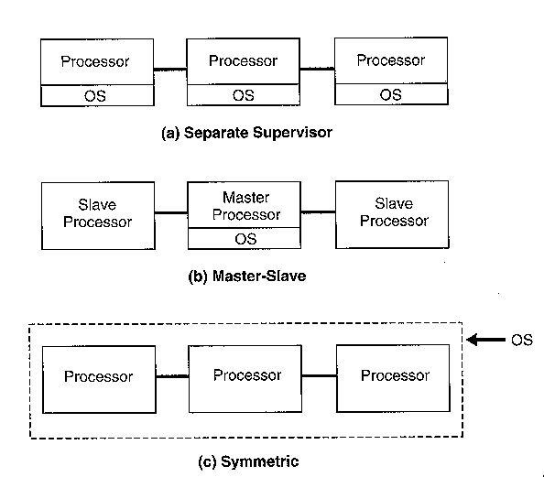
The three basic types of multiprocessor operating system：
1.In a seperate supervisor system, each processor has its own operating system. There are some
common data structures that are used to synchronize communication between the processors.
However, each processor acts largely as an independent system. Seperate supervisor ssytems
are relatively simple, and failure of one processor need not affect the others. However, the
independence between processors make it difficult to perform parallel execution of a single
user job.

2.In a master-slave system, one "master" processor performs all resource management and
other operating system functions. This processor completely contols the activities of the
"slave" processors, which execute user jobs. Essentially, the slave processors are treated as
resources to be scheduled by the master. Thus it is possible to assign several slave processor
to execute a user job in parallel. This type of operating system is rather similar to the
single-processor systems. Synchronization is easy, because all resources are controlled by the
master processor. The most significant problem with master-slave multiprocessing systems is
the balanced use of resources. The master processor might be overloaded by requests for
operating system services.

Any hardware failure in the master processor causes the entire system to stop functioning.
3.Symmetric processing allows any processor to perform any function required by the
operating system or by user program. Since all processors have the ability to perform the same
sets of functions, the potential bottlenecks of a master-slave system are avoided. In addition,
the failure of any one processor will not necessarily cause the entire system to fail. The other
processors can continue to perform all the required functions.

In a symmetric multiprocessing system, different part of the operating system can be executed
simultaneously by the different processors. Because of this, such a system may be significantly
more complicated and more difficult to design that the other types of operating systems. All
processors must have access to all the data structures used by the operating system. However,
the processors deal with these data structures independently of one another, and problems can
arise if two processors attempt to update the same structure at the same time. Symmetric
multiprocessing systems must provide some mechanism for controlling access to critical
operating system tables and data structures beccause two different processors might perform
request operations simultaneously. The solution usually requires a special hardware feature that
allows one processor to seize control of a critical resource, locking out all other processors in a
single step.

Distributed Operating Systems：
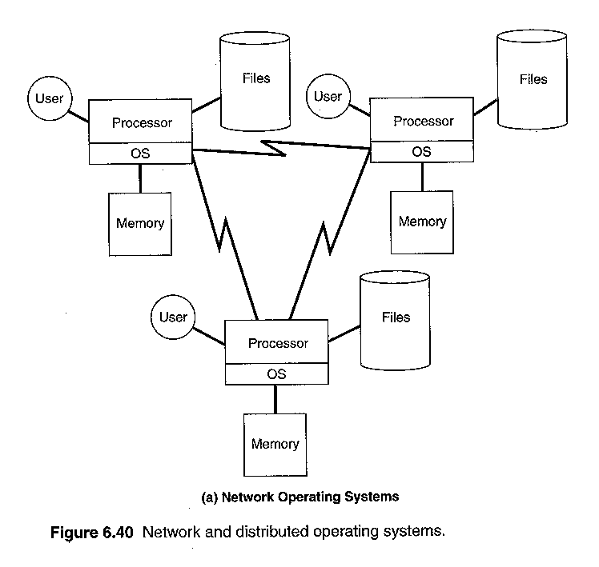
Two different approaches to operating systems for a network of computers：
Each machine on the network has its own independent operating system. These operating
systems provide a communication interface that allows various types of interactioin via the
network, A user of such a system aware of the existence of the network. He or she may login
to remote machine, copy files from one machine to another, etc. This approach is often called a
network operating system.Except for the network interface id quite similar to those found on a
single-computer system.
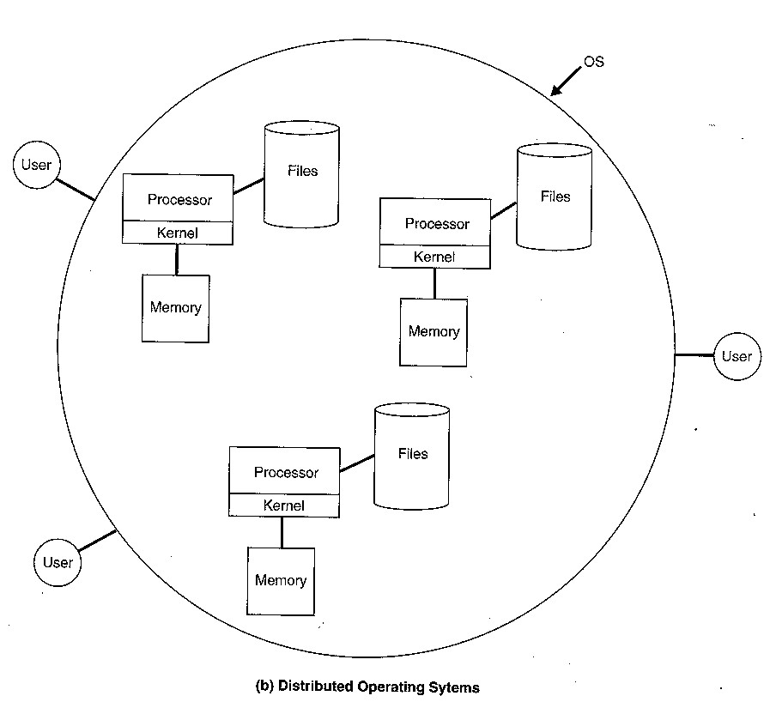

A distributed operating system represents a more complex type of network organization. This
kind of operating system manages hardware and software resources so that a user views the
entire network as a single system. The user is not aware of which machine on the network is
actually running a program or where the resources being used are actually located. In fact,
many such systems allow programs to run on several processors at the same time.

Distributed operating systems have many advantages over traditional systems：
The sharing of resources between computers is made easier.
A distributed system can provide improved performance by distributing the load between
computers and executing parts of a task concurrently on several processors.
The system can be more reliable, because the failure of one component need not affect the rest
of the system. Likewise, adding additional processors or other resources can improve
performance without requiring a major change in the system configuration.

5. There are four different structures to design Operating Systems. They are monolithic systems,
layered systems, virtual machines, and client-server systems. Please specify the operation of
these designs.(16%)

【解答】
OS Structure：
1. Monolithic Systems (The Big Mess)：
collection of linked functions
two modes (of CPU):
user - some instructions, including I/O, are not allowed
kernel (or supervisor) - all instructions allowed
basic organisation
main program
service functions
utility functions
eg. IBM's mainframe OS's (MVS etc)
2. Layered Systems：
OS tasks divided into layers
each layer performs one task
higher layers do not worry about how lower layers perform their tasks
eg, THE System layers:
5: system operator
4: user programs
3: I/O
2: operator-process communication
1: memory and paging
0: multiprogramming
3. Virtual Machines：
OS separated into two main components:
hardware and multiprogramming
extended machine
Main part of OS copied for each user
Different users can run different OS
each user has their own virtual machine
eg. IBM's MVS (Multiple Virtual Storage)

4. Client-server model：
most of OS implemented as series of user processes (services)
file service
memory service
terminal service
kernel simply calls service depending on client (user program) request
minimal kernel
easier to debug
easy to extend to distributed OS
critical services still run in kernel, eg. I/O
eg. UNIX

6. Five batch jobs A through E, arrive at a computer center at almost the same time. They have
estimated running times of 20, 12, 4, 8, 16 seconds. Their priorities are 3, 5, 2, 1, 4, respectively,
with 5 being the highest priority. For each of the following scheduling algorithms, determine the
mean process turnaround time. Ignore processes switching overhead.
(a) Round robin,
(b) Priority scheduling
(c) First-come, first-served(run in order 20, 12, 4, 8, 16)
(d) Shortest job first
For (a), assume that the system is multi-programmed, and that each job gets its fair share of the
CPU. For (b) through (d), it assumes that only one job at a time runs, until it finishes. All jobs
are completely CPU bound. (12%)

【解答】
Consider the following set of processes, with the length of the CPU-burst time given in ms：
Process | Burst Time | Priority
P1 | 13 | 3
P2 | 1 | 2
P3 | 3 | 1
P4 | 1 | 4
P5 | 5 | 2
The processes are assumed to have arrived in the order P1,P2,P3,P4,P5，all at time 0‧
a.Draw four Gantt charts illustrating the execution of these processes using FCFS,SJF,a
nonpreemptive priority(smaller priority number impliesa a higher priority)，and
RR(quantum=1)scheduling‧
b.What is the turnaround time of each process for each of the scheduling algorithm in part a？
c.What is the waiting time of each process for each of the scheduling algorithm in part a？
(a).
FCFS：
Process | Burst Time |  | 0 | 13 | 14 | 17 | 18～22 |  | Start Time | End Time
P1 | 13 |  | ▃▃ |  |  |  |  |  | 0 | 13
P2 | 1 |  |  | ▃▃ |  |  |  |  | 13 | 14
P3 | 3 |  |  |  | ▃▃ |  |  |  | 14 | 17
P4 | 1 |  |  |  |  | ▃▃ |  |  | 17 | 18
P5 | 5 |  |  |  |  |  | ▃▃ |  | 18 | 23

SJF：
Process | Burst Time |  | 0 | 1 | 2 | 5 | 10～22 |  | Start Time | End Time
P1 | 13 |  |  |  |  |  | ▃▃ |  | 10 | 23
P2 | 1 |  | ▃▃ |  |  |  |  |  | 0 | 1
P3 | 3 |  |  |  | ▃▃ |  |  |  | 2 | 5
P4 | 1 |  |  | ▃▃ |  |  |  |  | 1 | 2
P5 | 5 |  |  |  |  | ▃▃ |  |  | 5 | 10
nonpreemptive priority：
Process | Burst Time | Priority |  | 0 | 3 | 4 | 9 | 22～22 |  | Start Time | End Time
P1 | 13 | 3 |  |  |  |  | ▃▃ |  |  | 9 | 22
P2 | 1 | 2 |  |  | ▃▃ |  |  |  |  | 3 | 4
P3 | 3 | 1 |  | ▃▃ |  |  |  |  |  | 0 | 3
P4 | 1 | 4 |  |  |  |  |  | ▃▃ |  | 22 | 23
P5 | 5 | 2 |  |  |  | ▃▃ |  |  |  | 4 | 9
RR：
Process | Burst  Time |  | 0 | 1 | 2 | 3 | 4 | 5 | 6 | 7 | 8 | 9 | 10 | 11 | 12 | 13 | 14 | 15～  22 |  | Start  Time | End  Time
P1 | 13 |  | ▃ |  |  |  |  | ▃ |  |  | ▃ |  |  | ▃ |  | ▃ |  | ▃ |  | 0 | 23
P2 | 1 |  |  | ▃ |  |  |  |  |  |  |  |  |  |  |  |  |  |  |  | 1 | 2
P3 | 3 |  |  |  | ▃ |  |  |  | ▃ |  |  | ▃ |  |  |  |  |  |  |  | 2 | 10
P4 | 1 |  |  |  |  | ▃ |  |  |  |  |  |  |  |  |  |  |  |  |  | 3 | 4
P5 | 5 |  |  |  |  |  | ▃ |  |  | ▃ |  |  | ▃ |  | ▃ |  | ▃ |  |  | 4 | 15
(b).(c).
turnaround time=完成時間-抵達時間，wait time：turnaround time-burst time
FCFS：
Process |  | Start Time | End Time |  | turnaround time | wait time
P1 |  | 0 | 13 |  | 13 | 0
P2 |  | 13 | 14 |  | 14 | 13
P3 |  | 14 | 17 |  | 17 | 14
P4 |  | 17 | 18 |  | 18 | 17
P5 |  | 18 | 23 |  | 23 | 18
SJF：
Process |  | Start Time | End Time |  | turnaround time | wait time
P1 |  | 10 | 23 |  | 23 | 10
P2 |  | 0 | 1 |  | 1 | 0
P3 |  | 2 | 5 |  | 5 | 2
P4 |  | 1 | 2 |  | 2 | 1
P5 |  | 5 | 10 |  | 10 | 5
nonpreemptive priority：
Process |  | Start Time | End Time |  | turnaround time | wait time
P1 |  | 9 | 22 |  | 22 | 9
P2 |  | 3 | 4 |  | 4 | 3
P3 |  | 0 | 3 |  | 3 | 0
P4 |  | 22 | 23 |  | 23 | 22
P5 |  | 4 | 9 |  | 9 | 4

RR：
Process |  | Start Time | End Time |  | turnaround time | wait time
P1 |  | 0 | 23 |  | 23 | 10
P2 |  | 1 | 2 |  | 2 | 1
P3 |  | 2 | 10 |  | 10 | 7
P4 |  | 3 | 4 |  | 4 | 3
P5 |  | 4 | 15 |  | 15 | 10

7. Resources come in two typed：preemptable and nonpreemptable.
Please describe the characteristics of each resource and also give two examples. (10%)

【解答】
Resources come in two types：
Preemptable, meaning that the resource can be taken away from its current owner (and given
back later). An example is memory.
Non-preemptable, meaning that the resource cannot be taken away. An example is a printer.

Resources come in two flavors：preemptable and nonpreemptable.
A preemptable resource is one which can be allocated to a given process for a period of time,
then be allocated to another process and then be reallocated to the first process without any ill
effects.
Examples of preemptable resources include：memory、buffers、CPU、array processor.
A nonpreemptable resource cannot be taken from one process and given to another without side
effects. One obvious example is a printer: certainly we would not want to take the printer away
from one process and give it to another in the middle of a print job.
Examples of nonpreemptable resources include：printer、card reader、plotter.

8. Consider a swapping system in which memory consists of the following hole sizes in memory
order. 10K, 4K, 20K, 18K, 7K, 9K, 12K, 15K. The successive segment requests are
7K,11K, 15K, 9K, and 3K. (12%)
(a) What order of holes are taken for first fit?
(b) For best fit?
(c) For worst fit? And
(d) For next fit?

【解答】
partition以容納process：
best fit：足夠大的partition中，選最小的partition
first fit：選第一個夠大的partition.
worst fit：選擇最大的partition.
next fit：選下一個夠大的partition.

Consider three different schemes in memory allocation, First-fit, Best-fit, and Worst-fit.
Give memory partitions of 100K, 500K, 200k, 300K, and 600K (in order), and processes of
210K, 410K, 110K, and 420K (in order), which algorithm makes the best use of memory?

【解答】Best-fit‧

First-fit：420K之process無法執行‧
原先partition大小 | 至入之process大小 | 剩下之partition大小
100K |  | 100K
500K | 210K, 110K | 180K
200K |  | 200K
300K |  | 300K
600K | 410K | 190K
Best-fit：所有process均能執行‧
原先partition大小 | 至入之process大小 | 剩下之partition大小
100K |  | 100K
500K | 410K | 90K
200K | 110K | 90K
300K | 210K | 90K
600K | 420K | 180K
Worst-fit：420K之process無法執行‧
原先partition大小 | 至入之process大小 | 剩下之partition大小
100K |  | 100K
500K | 410K | 90K
200K |  | 200K
300K |  | 300K
600K | 210K, 110K | 280K

If at time t=0,the free memory partitions of a system are given as following：
Address Free space
0K 100K
150K 200K
400K 150K
600K 250K
900K 50K
For the following memory request:
Process Arrival time Memory required
P1 0 120K
P2 5 100K
P3 10 50K
P4 15 150K
P5 20 50K
Show the memory allocation at time t=25 for the following allocation algorithms:
a. First-fit b. Best-fit
【解答】
（a）First-fit：
p1 p2 p3 p4 p5
0K ：100K 0K：100K
150K：200K 150K：120K 270K：50K
400K：150K 400K：150K
600K：250K 600K：50K
900K：50K

Free memory：
320K：30K
650K：200K
900K：50K
（b）Best-fit：
p1 p2 p3 p4 p5
0K ：100K 0K：100K
150K：200K 150K：150K 300K：50K
400K：150K 400K：120K
600K：250K
900K：50K 270K：50K
Free memory：
520K：30K
650K：250K

91年 靜宜 資管 系統程式

1.（20%）Answer ‘O’ for correct statements and ‘X’ for incorrect ones.
a. Both paging and segmentation have the advantage that different processes can share
common program code.
b. A disk with larger storage space could reduce the probability of thrashing.
c. A TLB(translation look-aside buffer) in memory management unit is used for memory
protection.
d. Round-Robin CPU scheduling algorithm may cause starvation of some process.
e. For dynamic linking, control sections are linked together during the execution time.
f. Program relocations are necessary in loading a program for the instructions that use relative
addressing mode like program-counter relative addressing or base-relative addressing.
g. The UNIX file system uses contiguous allocation of disk blocks for a file.
h. It is possible for a non-preemptive process to be interrupted.
i. Regular expression could be used for defining the scanner of a compiler while context-free
grammar is required for defining the parser of a compiler. However, a context-free grammar
could also be used for defining the scanner.
j. MS-DOS uses the dual-mode operation to protect the kernel and I/O systems.

【解答】
a. Both paging and segmentation have the advantage that different processes can share
common program code.
Ans：X
分頁法與分段法之比較：
 | 分頁法 | 分段法
長度 | 固定大小（fixed length） | 不定長度（variable length）
位址空間 | 線性位址（one dimensional） | Two dimensional address
DAT | 分頁號碼—→  frame號碼（取代） | 段號碼＋offset—→  基底位址＋offset
Protection | 不容易 | 佳
Sharing | 不容易 | 佳
Fragment | Internal fragment | External fragment
繫結 (Linking) | 靜態（status linking） | 動態（dynamic linking）
載入（Loading） | 動態（dynamic loading） | 動態（dynamic loading）
b. A disk with larger storage space could reduce the probability of thrashing.
Ans：X
Thrashing：每一程式分配到的frame數目太少（或因替換策略不當），page fault太過頻繁，
導致CPU utilization太低‧
與main meory之size有關，但與disk容量多寡無關。
c. A TLB(translation look-aside buffer) in memory management unit is used for memory
protection.
Ans：X
TLBS：translation look-aside buffers.由associative register製成，即〝page table的cache〞。
是為了speed up記憶體資料之存取，與memory protection無關。

virtual address：
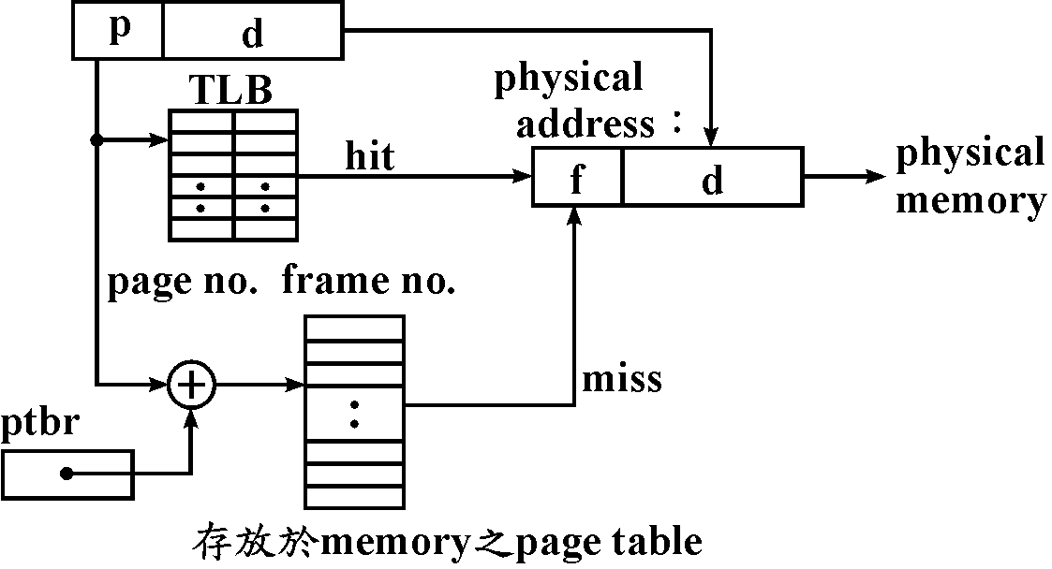

d. Round-Robin CPU scheduling algorithm may cause starvation of some process.
Ans：X
RR排程：Round-Robin，preemptive的排程；
FCFS的preemption版本(FCFS不會有 starvation)。
僅適用於short-term scheduling；選擇time quantum (peterson建議)：有80%的jobs，
其CPU burst time比time quantum來得短。
time quantum很大→RR近似於FCFS。
time quantum很小→overhead增加，因context-switching頻繁。
e. For dynamic linking, control sections are linked together during the execution time.
Ans：O
Dynamic linking：執行時，才進行linking.
demanded segmentation：dynamic linking, dynamic relocation, dynamic loading.
oop語言：dynamic binding.
Linking的時機：
執行時 -- dynamic linking.
載入時 -- linking loader(DLL).
載入前 -- linkage editor.
f. Program relocations are necessary in loading a program for the instructions that use relative
addressing mode like program-counter relative addressing or base-relative addressing.
Ans：X
Relocation：assembler組譯時不知程式將被載入的實際位址，載入時，與實際載入位址
有關的位址常數或直接定址須作修正－static relocation，由loader完成。
執行時，程式code也可在memory內移動位置，所須的address translation由硬體完成
（base register, relocation register, page table等）－dynamic relocation。
PC-relative定址法於relocation時毋須修正。
Direct定址法於relocation時以modification修正。
g. The UNIX file system uses contiguous allocation of disk blocks for a file.
Ans：X
Indexed allocation：把linked allocation的pointer集中放在一個block－index block。
directory：
File | index block
Jap | 7

index block 7： |  | disk space：
3 |  | 0 | 1 | 2 | 3 | 4
6
10 |  | 5 | 6 | 7 | 8 | 9
12
4 |  | 10 | 11 | 12 | 13 | 14
8
可以direct access。
沒有external fragmentation，size declaration問題。
浪費儲存pointer的indexed block。
UNIX系統採用indexed allocation。
index block越小，對small file才沒有浪費（避免存一大堆NULL pointer）；
但對large file而言，當pointer存不進一個index block時，以下列方法解決：
Linked scheme：多個index block串成linked list。
Multilevel index：多一層index指向index block在哪裏？
Combined scheme：如UNIX系統的inode。
h. It is possible for a non-preemptive process to be interrupted.
Ans：O
縱然是non-preemptive，計時用的timer中斷仍需接受處理。
i. Regular expression could be used for defining the scanner of a compiler while context-free
grammar is required for defining the parser of a compiler. However, a context-free grammar
could also be used for defining the scanner.
Ans：O
高階語言之statement所進行之lexical分析較簡單→regular expression易懂且易有效地
設計token之recognizer。故scanner (lexical analyzer)使用regular expression。
BNF：只能描述type 2, context-free之文法，準確易懂。
易建構有效之parser，易譯成machine code且偵測出error。
j. MS-DOS uses the dual-mode operation to protect the kernel and I/O systems.
Ans：X
MS-DOS：8086CPU沒提供dual-mode之作業方式，MS-DOS僅適用於個人電腦應用。

2.（15%）Explain the following terminologies.
a. medium-term scheduler
b. virtual machine
c. virtual memory
d. working-set model(for thrashing problem.)
e. race condition(for critical section problem)

【解答】
a. medium-term scheduler
狀態變遷圖：
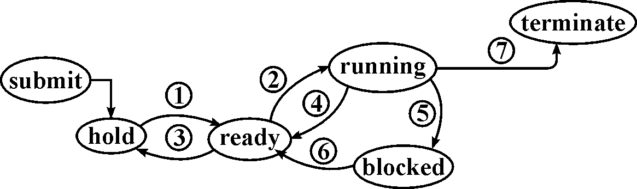

1.job scheduler：long-term scheduler.介入頻率低。增加multiprogramming degree.
I/O－bound, CPU-bound混合 → load balance.
2.process scheduler：short-term scheduler.介入頻率高。
又稱為dispatcher，執行context switching：PCB之save與restore.
3.medium-term scheduler：intermiate-level scheduler.
降低multiprogramming degree(避免發生Thrashing)，調整system load.
4.time out：於round-roubin排程法中，分配到的time quantum已用完。
5.start I/O或因P-operator (wait)等待〝進入critical section〞或等待〝other process所占用
的resource〞。
6.I/O completion或因other process執行V-operator (signal)而得以〝進入critical section〞
或取得〝other process所釋放的resource〞。
7.exit (completion)或error abort.
b. virtual machine：
Virtual machine：
Nonvirtual machine： Virtual machine：

Virtual machine：提供interface that is identical to the underlying bare hardware，而每一個
process is provided with a (virtual) copy of the underlying computer.
The resources of physical computer are shared to create the virtual machines.
CPU scheduling：share CPU.
virtual memory and memory management：share memory.
spooling and file system：virtual I/O devices.
Kernel控制hardware以create一組system calls, system program可以使用system calls或
hardware instructions,and in some ways these programs do not differentiate between these two.
application programs要存取hardware (memory, I/O, …)時，一定要經由Kernel的system
calls；雖是不同的machine, 但可藉由Kernel提供相同功能的system calls，故OS can be
used to make different machines appear to have the same characteristics.
多個process以為在不同的hardware上執行，但藉由virtual machine提供不同hardware
(OS)所提供的system calls，即virtual machine將不同computer的system calls對應(map)
到同樣的hardware上，使得real hardware只有一種，但各個process卻認為在不同的
hardware上執行。
Virtual machine：OS階層的multiprogramming.
須提供所有與（所虛擬之）real machine相關的OS功能，如：memory management,
I/O management, interrupt handler等等。
滿足不同使用者的需求：flexibility, convenience；Complete protection.
屬於〝應用程式〞，不支援任何系統功能；僅複製各machine之hardware，extented
machine而已。利用呈現各machine之system calls (kernel)，實現複製之功能。
Virtual machine：提供不同OS的system calls，讓process以為在不同的machine下工作。

c. virtual memory：
只把正執行的分頁（或分段）載入記憶體，其它部份仍停留在磁碟裏，分頁表（分段
表）記錄哪些分頁（分段）已載入記憶體‧
於DAT時，位址轉換失敗（尚未載入），發出內部中斷信號（page fault）給CPU，於
中斷服務程式中載入所需之分頁（分段）並更新分頁表（分段表），再重新執行發出
中斷的那道指令‧
程式可用的address space可以超過真正記憶體的memory space；程式的大小可以超過
真正記憶體的大小‧
虛擬記憶體不是真正記憶體，也不是磁碟記憶體，而是管理記憶體的軟硬體技術，
包含有DAT、內部中斷及中斷服務程式、檔案管理程式、排程程式（process scheduler）‧
d. working-set model(for thrashing problem.)
working set model：定義w(t , △t)為process執行時於〔t－△t , t〕的時距間
所參考使用到的page所形成的集合。
reference string：
3 5 6 5 7 1 2 1 5 4 5 3 6 7 8 6 7 6 7 6‧‧‧
| | | |
t₁ 7
6
7
W(t₁ , 6)＝{1 , 3 , 5 , 6 , 7}
W(t₂ , 7)＝{3 , 6 , 7 , 8}
WSSi：working set size of Pi。
Process P_{i}於時間t時之working set之元素(page)個數。
令D：total demand, D＝ΣWSS_{i}，F：系統中可分配的frame總數目
則當D＞F時：發生thrashing機率大，swap out一個process (medium-term scheduler)，
其frames由其它process瓜分。
當D＞F時：memory(及CPU)使用效率不彰，增加multiprogramming degree.
e. race condition(for critical section problem)：
可modifiable的sharable resource不能由兩個process同時使用 -- mutual exclusion。
必須一個process用完，另一process才能使用。
存取shared modifiable資料之程式段落必須一氣呵成，不與other process交錯執行
-- critical region (critical section)。
Critical section problem definition：演算法須滿足下述三個條件：
mutual exclusion、progress、bounded waiting。

3.（5%）There is a running process with partial of its page table below. The page size of the
system is 128 bytes. If the length of the logical address is 12 bits, what is the physical address
corresponding to the logical address 300？Explain your answer.
Page number | Frame number
0 | 4
1 | 2
2 | 0
3 | 5

【解答】
page offset：7 bits，2⁷ = 128 bytes。
300₁₆ = 0011 0000 0000₂ = 00110 0000000₂
故page number為6，此page尚未載入記憶體，存取300時會發生page fault。

若將題目改為”The page size of the system is 256 bytes”，則
300₁₆ = 0011 0000 0000₂ = 0011 00000000₂
故page number為3，此page載入記憶體frame 5，存取300時將位址轉換為500。

4.（10%）Generally, we can link several object programs together and load them to the memory
for execution. What kind of data (records) should be contained in the object program for linker
to link them, and how does a linking loader perform the linking？

【解答】
Linking：
transfer vactor：
Source code： Object code：
100： | 'SQRT' |  | 100： | JMP ××××
 |  |  | →
 | call SQRT |  |  | call 100
××××為SORT之載入address，稱之為轉移向量。
對程式的外部參考有效（浪費memory）；
對外部的資料參考則無助益，故此種系統只有一個data segment。
modification record：
EXTDET（external definition）：entry
宣告symbol為：在此區段內定義，但可使用於其它區段。
EXTRET（external reference）：external
宣告symbol為：於其它區段內定義，而於本區段內使用。

H record： H
Program(section) name, program length
Define record：
Col. 1 D
Col. 2-7 Name of external symbol defined in this control section
Col. 8-13 Relative address of symbol within this control section (hexadecimal)
Col. 14-73 Repeat information in Col. 2-13 for other external symbols
Refer record：
Col. 1 R
Col. 2-7 Name of external symbol referred to in this control section
Col. 8-73 Names of other external reference symbols
Modification record (revised)：
Col. 1 M
Col. 2-7 Starting address of the field to be modified, relative to the beginning of the
control section (hexadecimal)
Col. 8-9 Length of the field to be modified, in half-bytes (hexadecimal)
Col. 10 Modification flag (＋or－)
Col. 11-16 External symbol whose value is to be added to or subtracted from the
indicated field.

Linking loader two pass的做法：
資料結構：
ESTAB（external symbol table）：hashing table.
PROGADDR (program load address)：程式載入位址.
CSADDR (control section address).
Pass 1：建立ESTAR（指定位址給external symbol）
1.Get PROGADDR from OS.此即CSADDR之切值
2.逢control section (segment), name加入ESTAR，以當時之CSADDR為其值。
3.逢EXTDET (entry)定義之symbol, name加入ESTAB，出現在定義中之值加上
該section (segment)之值為此symbol之值。
4.control section長度(CSLTH)加上CSADDR為下一個control section之起始位址。
於pass 1結束時可列印出load map，供除錯之用：含segment name，外部變數name，
對應之address及length。
Pass 2：執行linking與relocation。
依RLD或modification record修飾記憶體之內含值。

5.（8%）What is a multi-threaded process？What are the advantages and disadvantages of user
threads and kernel threads？

【解答】
multithreading(多重工作線)：多重工作線是將一個程式分割成幾個小模組，每個模組都在
一個特定的工作線(thread)當中執行，這就宛如平行處理一般， 但是卻利用了CPU多工
的能力，表面上使用者並未感覺到多重管線的運作方式，但是執行的效率卻提高了，
這種技術適合應用在 CPU 導向的程式。\

Thread：Light weighted process
Different execution sequencing of the same code and data. That is, two threads of a process run
the same code and share the same data：PC、register set、stack。
Different thread of the same process are collectively called a task：cheap creation and context
switching、have similar problem（synchronization）as in shared-memory multiprocessing.
Heavy weight process（the ordinary process）：A single thread task，expensive creation and
context switching.
Thread：
efficiency：fast context switching、cheap creation、when one thread is blocked, other thread can
still proceed（even when we have only one process）‧
natural decomposition of work：one thread for one task‧
easy access to shared data‧
Thread is similar to a process：creation child thread、block and synchronize‧
User-level thread：
Implement thread within a user process，The user process "context switch" these threads by
itself，No OS intervention is required。
Very fast context switching，
Will block if one of the thread blocks in system call when the OS is single threaded, since
these threads are invisible to the scheduler (the OS only sees the user process)。
System-level thread：Schedule-able entity by the OS，relatively slow context switching。

The advantages of kernel-level threads over user-level threads are：
supports multiprocessors‧
possibly smoother scheduling, since the same scheduler（the kernel's）handles both threads and
other Unix processes‧
no special action needed to make blocking system call suspend only the calling thread, not all
threads of the process‧
as a consequence of the above, more efficient I/O and timer-based operations‧
The disadvantages are：
more expensive context switches between threads, at least when blocking on conditions and
mutexes，thread creation is more expensive。
由上面的比較可以清楚的發現 kernel-level 是一個比較好的選擇，也算是發展的趨勢。

For kernel threads, they have a small data structure and a stack. Switching between kernel threads
requires only save the data structure and stack of the old thread, and load the saved data structure
and stack for the new thread, and does not require changing memory access information.

A kernel may first save all the CPU registers（including program counter, stack pointer）and
the data structure of the old thread in the address space of the task containing the old thread, and
decide which thread will run next, then load all the CPU registers and the data structure of the
new thread, and continue to execute the new thread.
For user-level threads, hey contain a stack and a program counter, no kernel resources are
required. The kernel is not involved in scheduling these user-level threads. Switching among
them need only change the program counter and the stack pointer。

6.（10%）The instruction[ADD @ALPHA, @BETA] adds the value of @ALPHA to @BETA in
which @ALPHA and @BETA represent indirectly addressed data. Please explain how many
memory references are required in fetching and executing the instruction. Besides, page faults
may occur during the memory references. Explain also how many page fault may occur in worst
case for fetching and executing the instruction.

【解答】
fetch instruction：一次，
fetch operands：@ALPHA與@BETA，各一次，
回寫運算後結果：@BETA一次。
How many memory references共四次。
Instruction，@ALPHA，@BETA：都跨頁儲存，共有能發生六次page faults。

7.（15%）What schemes could an OS implement to prevent illegal uses(operations) or illegal
access to the memory, CPU, file system, and I/O system by a user process？(That is, what are
the possible protection schemes for an OS to protect these resources？) Explain the
implementation of these schemes respectively.

【解答】
dual mode：
monitor mode─可執行priviledged指令與一般指令。
user mode─僅能執行一般指令（nonpriviledged）。

application program─user mode下執行。
OS─monitor mode下執行。
SVC (supervisor) call－由user mode → monitor mode。
priviledged指令－I/O指令：避免race condition, deadlock.。
I/O driver由OS提供（user friendly）
－中斷禁能，致能指令：CLI, STI.
－change mode指令：設定IOPL之指令
user progr→SVC call→進入OS（利用trap）→進入monitor mode→使用I/O特權指令以
執行I/O
counter, timer：
time-sharing, time out interrupt－CPU protection.
watchdog timer.

memory protection：
fence register、bound register、base / limit register.
protection key：
process P之PCB：
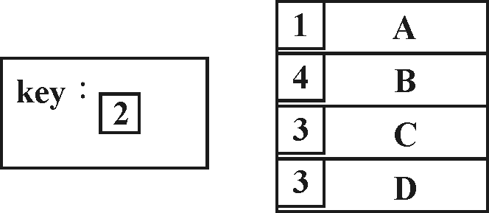

process P可存取
block E及block G
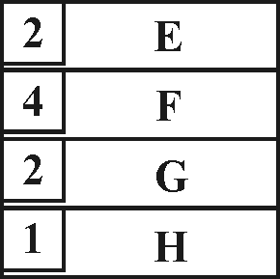

虛擬記憶體的segment table中可記載process對segment的存取控制（read only, execute
only, read / write等）。
file protection：improper access.
password：每一file有一password。
access control list：每一user有一access control list，記載對不同file的使用權：
read, write, execute, append, delete, list。
access control matrix：
row：file name.
column：user name.
entry：access right.
identity-dependent access：associate with each file and directory an access list, specifying the
user name and the types of access allowed for each user.
to condense the length of the access list：將user分類：owner, group, universe.

8.（7%）List all possible execution sequences of the statements A, B, C, and D in the following
program. Briefly explain how you get your answer.
Var S1：binary semaphore(initially 1)；
S2：binary semaphore(initially 0)；
S3：binary semaphore(initially 1)；

Process 1 | Process 2 | Process 3
wait(S2)； | wait(S1)； | wait(S1)；
wait(S3)； | B； | C；
A； | signal(S1)； | signal(S2)；
signal(S3)； |  | wait(S3)；
signal(S2)； |  | D；
 |  | signal(S3)；signal(S1)；

【解答】
wait：
if s == 0 then﹛add this process to s.l；blocked；﹜
else s = s－1；
signal：
if some process wait in s.l then﹛remove a process from s.l；wakeup；﹜
else s=s+1；
Process 1 | Process 2 | Process 3
wait(S2)； | wait(S1)； | wait(S1)；
wait(S3)； | B； | C；
A； | signal(S1)； | signal(S2)；1
signal(S3)； |  | wait(S3)；
signal(S2)； |  | D；
 |  | signal(S3)；signal(S1)；
Process 1要等到Process 3執行1 , 打開S2後才能執行, 故A只要在C之後即可執行。
Process 2與Process 3哪個先執行都可以，但若是Process 3先執行，須等C、D都做完，
才能執行B。
可能之執行順序：
BCDA、BCAD、CDBA、CDAB、CADB

9.（10%）Consider the following page reference string：3, 1, 4, 2, 1, 5, 1, 3, 4, 3, 5, 2
Three frames are used and these frames are initially empty. How many page faults would occur
for the optimal replacement algorithm and the second-chance replacement algorithm？Please
show the sequence of replacements for each algorithm.

【解答】
參考下列解法：
Conside the following page reference string：
1, 2, 3, 4, 2, 1, 5, 6, 2, 1, 2, 3, 7, 6, 3, 2, 1, 2, 3, 6
How many page faults would occur for the following replacement algorithm,
assuming 5 frames?
Remember that all frames are initially empty,
‧Second-chance algorithm
‧Optimal algorithm

【解答】
Second-chance：5個frames
page reference string：
1 2 3 4 2 1 5 6 2 1 2 3 7 6 3 2 1 2 3 6
frame 1： 1 1 1 1 1 1 1 7 7
frame 2： 2 2 2 2 2 2 2 2
frame 3： 3 3 3 6 6 6 6
frame 4： 4 4 4 3 3 3
frame 5： 5 5 5 5 1
page fault次數：9次‧

Optimal：5個frames
page reference string：
1 2 3 4 2 1 5 6 2 1 2 3 7 6 3 2 1 2 3 6
frame 1： 1 1 1 1 1 1 1
frame 2： 2 2 2 2 2 2
frame 3： 3 3 3 3 3
frame 4： 4 4 6 6
frame 5： 5 5 7
page fault次數：7次‧

91年 健康管理 資管 系統程式

1. 何謂本文交換(context switch)？何謂臨界區域(critical region)？
他們與中斷(interrupt)有何關聯？（15%）

【解答】
Context switching：Preparation and restoration of process status before and after switching
CPU among processes‧
Save the status：PC, register values --> PCB‧
Restore the status：PCB --> PC, register values‧
The efficiency of context switching is highly dependent on the hardware support。
處理轉換（Context Switch）：CPU從一Process轉換到另一個Process時，需儲存舊Process
的狀態（PCB），並載入新Process原先保存的狀態。
分散程式（Dispatcher）/*轉換新Process中間的步驟*/
（1）Switch context (PCB)、（2）Swicth to user mode、（3）Jump to proper location & restart。
處理單元控制區塊（Process Control Block，PCB）是作業系統儲存有關於處理單元之訊息
的地方。PCB內含有下列七種最重要的紀錄：
（1）處理單元的目前狀態（Current State），（Ready，Blocked…）。
（2）處理單元的識別名稱。
（3）處理單元的優先等級，即有關於排班的相關資訊。
（4）用以指明處理單元之記憶體位置的指標，即記憶體管理的相關資訊。
（5）只到所分得的資源之指標。
（6）記錄器暫存區。
（7）處理單元所花費於執行的時間。
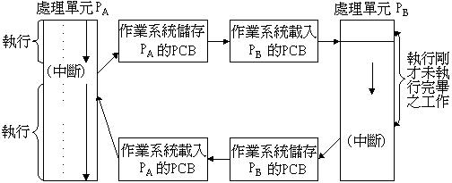

可modifiable的sharable resource不能由兩個process同時使用－mutual exclusion。
必須一個process用完，另一process才能使用。存取shared modifiable資料之程式段落
必須一氣呵成，不與other process交錯執行------critical region (critical section)。
Critical section problem definition：演算法須滿足下述三個條件：
mutual exclusion、progress、bounded waiting。

解決CS問題：
只要在CS前加上〝禁止中斷指令〞，離開CS後加上〝致能中斷指令〞即可。
因為process得以交錯執行（Context Switch），CPU一定有接受外部中斷的要求信號（I/O
data ready, timer的time out）。
但因〝禁止中斷〞，〝致能中斷〞指令屬於priviledged指令，程式於user mode中無法
執行priviledged指令，除peterson algorithm，Dekker aalgorithm外，解決CS的方法
有下述三類：hardware solution：設計指令、系統呼叫（supervisor call）、軟體中裝。

2. 試探討虛擬記憶體(virtual memory)與重疊(overlay)技術之異同。（10%）

【解答】
虛擬記憶體與overlay：
程式大小超過真正記憶體大小時，在這兩種技術下，程式仍可執行‧
虛擬記憶體：
程式所使用的logical address space，可以超過真正記憶體的physical address space‧
DAT對應用程式而言，是不自覺的動作‧
overlay：
程式所使用的logical address space，仍侷限於真正記憶體的physical address space‧
應用程式自行處理位址轉換或重疊的問題‧

3. 某一磁碟系統其平均延遲時間(average latency time)為8.5ms，而資料的傳輸速度為
100Mbytes/Sec。則置換(swap)一個1.2Mbytes的程式，所花費之時間為多少？（5%）

【解答】
題目沒給Seek time，視為0ms。
(1000ms/100M)*1.2M = 12ms，
花費之時間為：0+8.5+12 = 20.5ms。

4. 假設有三個並行處理之行程(process)P1、P2與P3，共用三項資源：R1、R2與R3，且
每項資源只有一個，現以P與V兩個運算指令來表示對各項資源之要求(P)與釋放(V)。
三個行程要求與釋放資源之順序如下：
P1 | P2 | P3
: | : | P(R1)
P(R1) | P(R3) | :
: | P(R1) | P(R3)
P(R2) | : | :
: | P(R2) | P(R2)
V(R1) | : | :
V(R2) | V(R2) | V(R3)
: | V(R1) | V(R2)
: | V(R3) | V(R1)
: | : | :

a. 請列出造成死結(deadlock)之必要條件。
b. 請就上述三個行程對資源之需求關係，繪出有向圖形(directed graph)，以說明本系統
是否會造成死結。
c. 若上述系統會造成死結，試修正三個程式中之一的資源需求順序(不改變原來程式之
邏輯意義)，以防止死結之發生。（15%）

【解答】
a. Deadlock之necessary condition：
mutual exclusion.、hold & wait.、no preemption.、circular wait.

Deadlock prevention：
mutual exclusion－virtual device；令dedicated resource→sharable resource。
hold & wait－hold全部需用之resource後，方可執行；需求新resource時，先release
已擁有之resource，再一齊request。
no preemption－若取不到所有求的resource，先release本身已推有之resource，以利他人，
可先不release，但若other process有request時，再release。
circular wait－resource以linear ordering編號request時依resource之編號由小而大依序
提出request；若新要求的resource編號為r_{i}，若已擁有編號大於r_{i}之resource，均應先
release.
b.
P1 | P2 | P3
: | : | P(R1)
P(R1) | P(R3) | :
: | P(R1) | P(R3) | 此時deadlock發生！
P(R2) | : | :
: | P(R2) | P(R2)
V(R1) | : | :
V(R2) | V(R2) | V(R3)
: | V(R1) | V(R2)
: | V(R3) | V(R1)
: | : | :
deadlock發生時之resource-allocation map：
P1
R1
P2
P3
R3
P2---R1---P3---R3形成Cycle，已發生deadlock！
c.
P1 | P2 | P3
: | : | P(R1)
P(R1) | P(R1) | :
: | P(R3) | P(R3)
P(R2) | : | :
: | P(R2) | P(R2)
V(R1) | : | :
V(R2) | V(R2) | V(R3)
: | V(R1) | V(R2)
: | V(R3) | V(R1)
: | : | :

5. 有三個行程，A、B與C，其到達時間(arrival time)分別為0、3與4；執行時間分別為
22、6與3。假設時間配額(time quantum)為4，請依下列排班(scheduling)原則分別計算
平均等待時間(average waiting time)與平均反轉時間(average turnaround time)。（20%）
a. First-Come, First-Served Schedulimg b. Round-Robin Scheduling
b. Shortest-Job-First Scheduling d. Shorstest-Remaining-Time-First Scheduling

【解答】
Suppose that the following processes arrive for execution at the times indicated. Each process
will run the listed amount of time.
Process Arrive Time Burst Time
P1 0 25
P2 0.8 18
P3 1.2 5
a. What is the turnaround time of each process using FCFS, SJF, SRTF（preemptive SJF）, and
RR（quantnm = 3）scheduling？
b. What is the waiting time of each process for each of scheduling algorithms in part a？

turnaround time=完成時間- 抵達時間，wait time：turnaround time - burst time‧
FCFS：
Process | Arrive  Time | Burst  Time |  | 0～  25 | 25～43 | 43～48 |  | Start  Time | End  Time | Turnaround  Time | Wait  Time
P1 | 0 | 25 |  | ▃▃ |  |  |  | 0 | 25 | 25 | 0
P2 | 0.8 | 18 |  |  | ▃▃ |  |  | 25 | 43 | 42.2 | 24.2
P3 | 1.2 | 5 |  |  |  | ▃▃ |  | 43 | 48 | 46.8 | 41.8
SJF：
Process | Arrive  Time | Burst  Time |  | 0～  25 | 25～30 | 30～48 |  | Start  Time | End  Time | Turnaround  Time | Wait  Time
P1 | 0 | 25 |  | ▃▃ |  |  |  | 0 | 25 | 25 | 0
P2 | 0.8 | 18 |  |  |  | ▃▃ |  | 30 | 48 | 47.2 | 29.2
P3 | 1.2 | 5 |  |  | ▃▃ |  |  | 25 | 30 | 28.8 | 23.8
SRTF：
Process | Arrive  Time | Burst  Time |  | 0～  0.8 | 0.8～  1.2 | 1.2～  6.2 | 6.2～  23.8 | 23.8～  48 |  | Start  Time | End  Time | Turnaround  Time | Wait  Time
P1 | 0 | 25 |  | ▃▃ |  |  |  | ▃▃ |  | 0 | 48 | 48 | 23
P2 | 0.8 | 18 |  |  | ▃▃ |  | ▃▃ |  |  | 0.8 | 23.8 | 23 | 15
P3 | 1.2 | 5 |  |  |  | ▃▃ |  |  |  | 1.2 | 6.2 | 5 | 0
RR：
Process | Arrive  Time | Burst  Time |  | 0 | 3 | 6 | 9 | 12 | 15～17 | 17～20  23～26  29～32  35～38  41～48 | 20～23  26～29  32～35  38～41 | Start  Time | End  Time | Turn-  around  Time | Wait  Time
P1 | 0 | 25 |  | ▃ |  |  | ▃ |  |  | ▃ |  | 0 | 48 | 48 | 23
P2 | 0.8 | 18 |  |  | ▃ |  |  | ▃ |  |  | ▃ | 3 | 41 | 40.2 | 22.2
P3 | 1.2 | 5 |  |  |  | ▃ |  |  | ▃ |  |  | 6 | 17 | 15.8 | 10.8

6. 何謂載入程式(Loader)？試簡述載入程式之功能？（10%）

【解答】
Loader：將經Linker連結成功之可執行程式載入主記憶體執行。

Loader主要功能：
Allocation：分配memory給各個object程式，即決定各程式進入點的address。
Linking：已知各程式的載入位址，各程式間彼此之reference可對應到正確的address。
Relocation：已知程式的載入位址，程式內使用到位址的地方可對應到正確的address。
Loading：已relocation, linking之程式移進main memory以便執行。

7. 試解釋編譯程式(Compiler)與直譯程式(Interpreter)有何差異？（10%）

【解答】
編譯程式（compiler）：輸入為高階語言所編寫的原始程式，輸出為對應之目的程式，程式
本身並未執行‧
程式執行時，不含翻譯時間；且可進行碼最佳化（code optimization），效率高‧
須經連結成可執行程式始能執行，操作不方便，但可支援多種高階語言合寫之系統，
適用於大系統之開發‧
直譯程式（interpreter）：輸入為高階語言所編寫的原始程式，輸出為程式之執行結果，
並未產生目的程式‧
邊翻譯邊執行，執行時間包括了翻譯時間；且無法進行碼最佳化，效率差‧
易學，操作方便（interactive，交談式），適用於初學者‧

8. 指令集仿效(Instruction-Set Emulation)通常是利用主電腦(host computer)的指令來執行被
模擬的目標電腦(target computer)的指令集。透過軟體模擬處理器抓取(fetch)、解碼(decode)
與執行(execute)指令的過程，並應用每一個指令模擬的結果到一個假想的目標電腦上，
因此可以用軟體來發展一個尚未建置的硬體結構或維護舊有的軟體之模擬器(emulator)。
依據上述描述，試提出你的構想及簡述如何設計此模擬器。（15%）

【解答】
Write a software simulator (emulator) for your instruction set architecture design. The emulator
should simulate the entire instruction set including Input/Output.
Initially, the emulator should either read the name of a file containing an image of memory in the
format described from the command line or should prompt for such a file name.
Next the emulator should initialize its simulated memory (64K bytes) with the contents of the
file. The emulator should initialize all registers to their power-up state -- probably this is just
that the PC (Program Counter) is set to zero.
Now, the main loop commences. The emulator must simulate all registers in and actions taken by
your architecture. For example, the main loop might set the IR (Instruction Register) to contain
the contents of the simulated memory at the location given by the PC. Then, the PC would be
incremented. Next, depending on the contents of the IR (i.e., depending on what is the current
instruction), various other operations would occur -- performing arithmetic or logical
operations, altering other registers, reading or writing the simulated memory, etc.
The emulator must also simulate the I/O (Input/Output) interface. It is acceptable to assume that
input and output are always ready. If you implement this approach, any attempt to read a
character will stall until a character is typed (if the input is buffer as a line, the input operation
will stall until a complete line is typed). Extra credit will be awarded for simulating the input
ready bit.
Because I/O is memory-mapped (i.e., is accessed via memory locations), it is probably
advantageous to write functions to allow reading and writing of memory. That way, any access
to an I/O device register location in memory can perform the correct I/O operation rather that
simply accessing the simulated memory location.

Your emulator must have the option of tracing your program's execution. In the simplest
approach, this would be displaying the PC of each emulated instruction before executing it.
More elaborate approaches might include displaying all registers before executing each
instruction, displaying only those registers that were modified before executing each
instruction, displaying all registers in a separate continually-updated window, perhaps
including the use of color to indicate which registers were modified, etc. These approaches
will be awarded extra credit.

91年暨南資工 計算機系統(OS) 詳解

1. Why is dual-mode a necessity for the resource protection？
How does it work？
Why do we need system calls？(15%)

【解答】
dual mode：
monitor mode─可執行priviledged指令與一般指令
user mode─僅能執行一般指令（nonpriviledged）
application program─user mode下執行。
OS─monitor mode下執行。
SVC (supervisor) call－由user mode→monitor mode
priviledged指令－I/O指令：避免race condition, deadlock.
I/O driver由OS提供（user friendly）
中斷禁能，致能指令：CLI, STI.
change mode指令：設定IOPL之指令
user progr→SVC call→進入OS(trap)→進入monitor mode→使用I/O特權指令以執行I/O

To ensure that incorrect program can’t cause other programs to execute incorrectly.
雙模保護（Dual Mode Protection）：
使用者模式（User Mode）。
監督者模式（Monitor Mode、Supervisor Mode、 System Mode 、Protect Mode ）。

作業系統通常在監督者模式下執行，而特權指令(Privileged Instruction)僅在監督者模式內

可以使用，例如暫停系統(Halt System)、打開/關閉中斷(Turn Interrupt On/Off)、轉換

模式(Change Mode)、所有的輸出/輸入指令…等均為特權指令。
軟體中斷：又稱為系統呼叫，system call，supervisor call(SVC call)，monitor call‧
應用程式(user mode)執行時，要求系統程式(OS，monitor mode)為之進行存取系統資源
的工作，如輸入輸出、中斷禁能致能、更改中斷向量等，以系統呼叫叫用OS所支援
的系統功能‧
應用程式(user mode)→SVC call→進入OS(trap)→進入monitor mode→使用特權指令
(如輸入輸出、中斷禁能致能指令)以執行I/O‧
CPU執行程式有兩種工作模式：
system mode：又稱為supervisor mode、monitor mode，系統程式於此mode下執行，
可執行能存取系統資源的特權(priviledged)指令‧
user mode：應用程式僅能於此mode下執行，不能執行特權指令‧

2. Explain what is a non-preemptive kernel. If we want to transform the kernel from
non-preemptive to preemptive, what problem must we solve？(10%)

【解答】
Kernel：System Kernel，像是程式與硬體的一個仲裁者．Kernel會為所有執行中的程式或
做記憶體管理等動作，並且確保它們都能夠合理的分享CPU的運算資源。除此之外，
Kernel還提供了一個介面讓剛剛提到的程式能透過Kernel與硬體溝通。

‧Scheduling algorithm：
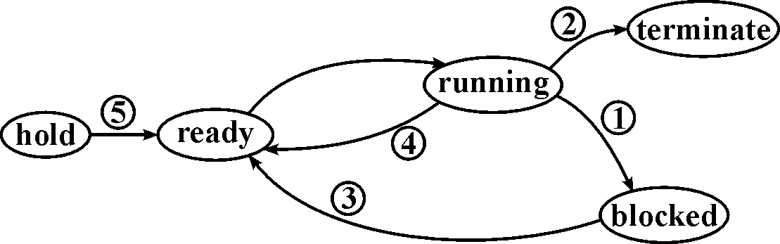

pre-emptive：，，，，狀態變遷時，均會執行process scheduler。
即令running中之process退回ready，再從ready queue (priority queue)中挑選－process
進入running狀態。
non-preemptive：僅在，會執行process scheduler.

作業系統的多工分為以下兩種：
（一）Non-Preemptive Multitasking (Cooperative Multitasking)：即「非優先權式多工」，
或稱為「非先佔式多工」、「協調式多工」。系統無法強制分配CPU時間。當一個
程式佔住了CPU時，除非它願意放出來，不然其它程式將無法執行。所以，要
達到多工，就要程式間彼此合作，不用CPU的時候，就把其釋放出來。
（二）Preemptive Multitasking：也就是所謂「優先權式多工」或是「先佔式多工」。
在這種模式底下，每個程式的執行時間係由「作業系統」來分配，一個程式的
時間使用完後，系統就會自動執行context switch，將CPU分配給下一個程式，
沒有一個程式能獨佔CPU時間。

To transform the non-preemptive kernel into a preemptive kernel：
You will change the system call mechanism from a simple function call to an interrupt
mechanism akin to current operating systems. Also, you will be required to add condition
variables to augment the synchronization primitives.
To implement preemptive scheduling, you need to use the timer interrupt mechanism.
Develop an interrupt handler that invokes scheduler. This interrupt will be triggered once
every 10ms.
Use a software interrupt to perform system calls. You are required to ensure that these system
calls perform correctly even in the presence of the timer interrupt.
The synchronization primitives for mutual exclusion: lock_acquire() and lock_release() should
continue to work in the presence of preemptive scheduling. You need to add condition
variable calls to the synchronization primitives.

只要有新程式進來（Hold→Ready）、先前Blocked的程式進來（Blocked→Ready）、正執行
之程式用完Time quantum（Run→Ready）均可由OS偵測到，以進行Context Switching。
各系統呼叫都使Reentrance：
process每次被呼叫，均會create對應之activation record，以儲存此process之環境參數、
local variables等等‧
於multiprogramming環境下，reentrance的process無須執行完，即可被另一job重新
呼叫，也可被多個job同時呼叫而互不相干‧
process執行過程不得modify self code，且每次被呼叫都有對應的activation record‧

3. Consider a system consisting of m resources of the same type, being shared by n processes.
Resources can be requested and released by processes only one at a time. Show that the system
is deadlock-free if the following two conditions hold：(10%)
(a) The maximum need of each process is between 1 and m resources.
(b) The sum of all maximum needs is less than m+n.

【解答】
Available〔j〕＝k：有k個resource r_{j}可使用
Max〔i〕〔j〕＝k：Process Pi最多可擁有k個resource r_{j}.
Allocation〔i〕〔j〕＝k：已經分配k個resource r_{j}給P_{i}
Need〔i〕〔j〕＝k：Process P_{i}未來還需要k個resource r_{j}
Request〔i〕〔j〕＝k：Process Pi正提出request，需求k個resource r_{j}。

(a). ΣMax_{i}＜m+n（i = 1～n）
(b). Max_{i}≧1 for all i
Proof：Need_{i} = Max_{i} - Allocation_{i}
If there exists a deadlock state then：
(c). ΣAllocation_{i} = m（i = 1～n）
Use (a) to get：ΣNeed_{i}+ΣAllocation_{i} =ΣMax_{i}＜m+n
Use (c) to get：ΣNeed_{i}+m＜m+n
Rewrite to get：ΣNeed_{i}＜n
This implies that there exists a process P_{i} such that Need_{i} = 0. Since Max_{i}≧1 it follows that P_{i}
has at least one resource that it can release. Hence the system cannot be in a deadlock state.

4. Explain the mechanism of paging.(5%)
Explain how the virtual memory is implemented by demand paging.(5%)

【解答】
paging：non-contiguous allocation. multiprogramming.
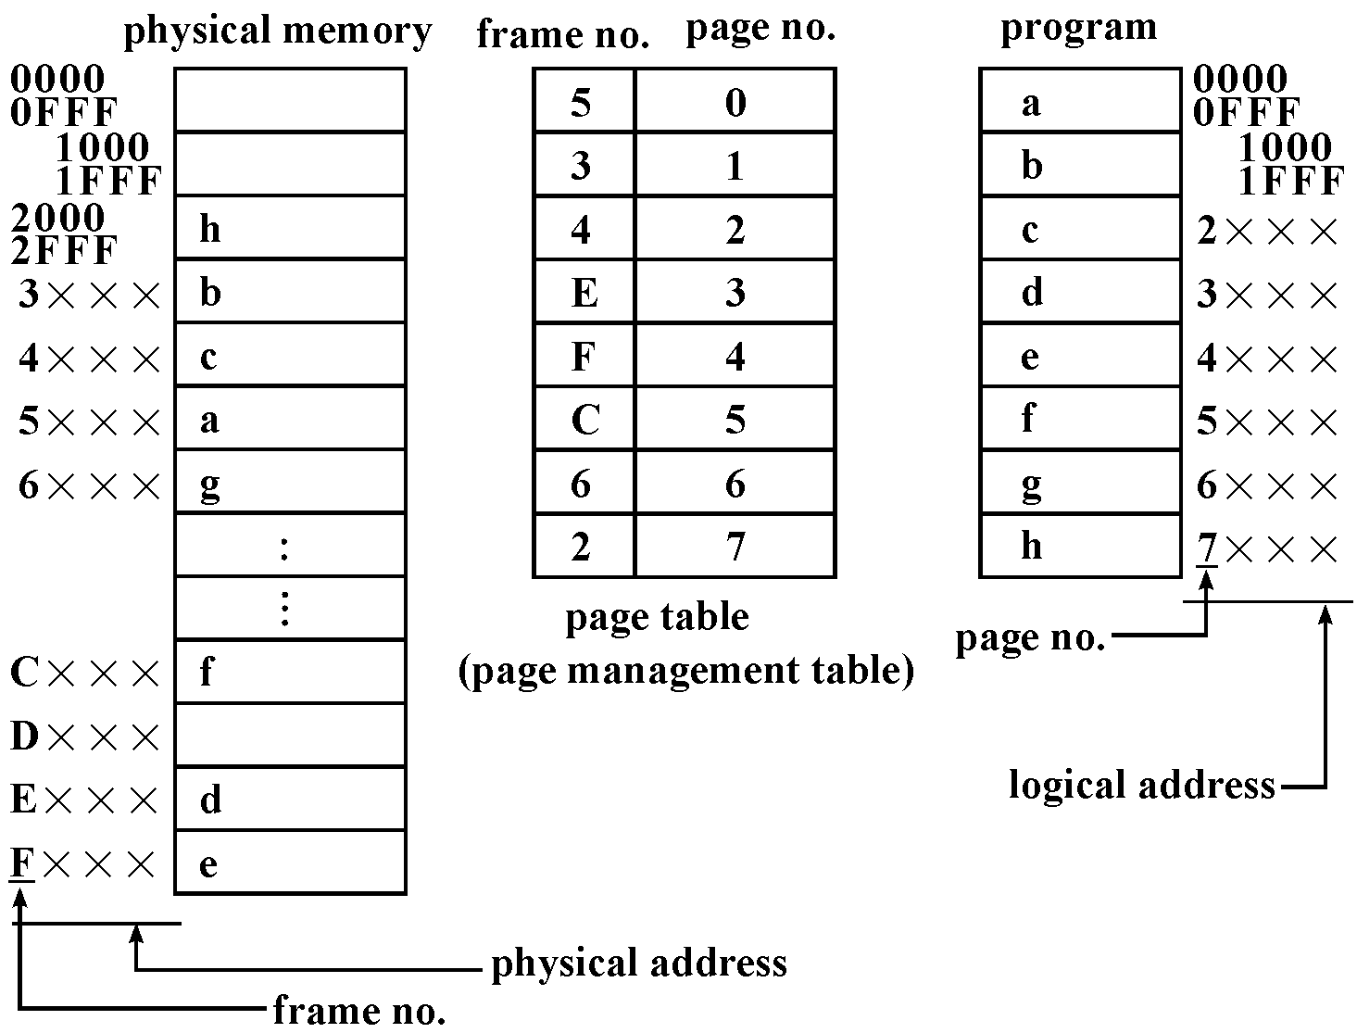

‧DAT：dynamic address translation.
logical address：5 A 7 C16
1 0 1 1010 0111 1100
↓
page table
↓
1100 1010 0111 1100→physical address：CA7C16
‧user program與data可使用的address稱為virtual address或logical address，整體範圍
稱為address space，address space分成等長的片段，稱為page，為2n bytes.
‧主記憶體稱為physical memory，位址稱為physical address，整體範圍稱為memory space，
memory space分成等長的片段（與page同樣大小），稱為frame或block.
‧page table記錄哪一個page載入哪一個frame.程式執行時利用page table進行
DAT：logical address→physical address. page table一般以associative memory (CAM)製作。
‧program的logical address雖是連續的，卻可載入不連續的fram而能正確地執行.
‧fragment：仍然有internal fragment.
‧毋須執行compaction. program code的relocation由page table動態處理之（DAT）。

‧demand paging.
‧只把正執行的page或segment載入memory，其它部份仍停留在disk裏，page table
記錄那些page己載入memory.
‧於DAT時，位址轉換失敗（尚未載入），發出內部中斷給CPU (page fault)，於中斷服務
程式（ISR）中，載入所須之page並更新page table，再重新執行發出中斷的那道指令。
‧program可使用的address space可以超過physical memory space.
program的program size可以超過physical memory的memory size.
‧virtual memory是管理memory的技術，包括有：
‧DAT , page fault.
‧memory management.
‧file handling.
‧I/O handling.
‧process scheduling.

5. Explain what is copy-on-write.(5%)

【解答】
執行檔的共享式寫入時拷貝(copy-on-write)分頁機制。這就是說多行程可以使用相同的
記憶體來執行。如果其中之一嘗式寫入那塊記憶體，那一頁(4KB的記憶體)會被拷貝到
其它地方去。寫入時拷貝有兩項好處: 增加速度及降低記憶體使用量。
各程式可使用copy-on-write pages上的資料，意即多個程式可以使用同一塊記憶體.
最初幾個程式共用一塊記憶體, 但當某個程式嘗試寫入這段記憶體時, 該page(4KB)就被
拷貝一份到別的地方, 以後該程式的那4KB就指向新的page. 如此一來可增加速度並
減少記憶體的使用。

91年暨南 資管 作業系統 試題詳解

1. Suppose a system contains four resources and five processes. Resource type A has 7 instances,
B has 7 instances, C has 11 instances, ans D has 10 instances. Consider the following snapshot
of a system；（15%）
Process | Current Allocation | Maximum Demand
 | A B C D | A B C D
P1 | 2 0 2 0 | 2 0 2 1
P2 | 0 1 4 3 | 2 4 7 3
P3 | 0 1 3 2 | 7 4 4 6
P4 | 2 1 1 1 | 2 2 3 2
P5 | 2 3 1 2 | 6 5 3 4
Answer the following questions using the banker’s algorithm：
a. Is the system in a safe state？Why or why not？
b. If a request from process P3 arrives for (1, 1, 0, 1), can this request be granted immediately？
Explain your answer.
c. If a request from process P4 arrives for (0, 1, 0, 1), can this request be granted immediately？
Explain your answer.

【解答】
參考下列這一題：10.
Consider the following snapshot of a system：
Allocation Max Available
A B C D A B C D A B C D
P0 0 0 1 2 0 0 1 2 1 5 2 0
P1 1 0 0 0 1 7 5 0
P2 1 3 5 4 2 3 5 6
P3 0 6 3 2 0 6 5 2
P4 0 0 1 4 0 6 5 6
Answer the following questions using the banker's algorithm：
（a）What is the content of the matrix Need？
（b）Is the system in a safe state？Please explain your reason.
（c）If a request from process P1 arrives for（0, 4, 2, 0）can the request be granted immediately？

【解答】
（a）Need = Max - Allocation
Allocation Max Available Need
A B C D A B C D A B C D A B C D
P0 0 0 1 2 0 0 1 2 1 5 2 0 0 0 0 0
P1 1 0 0 0 1 7 5 0 0 7 5 0
P2 1 3 5 4 2 3 5 6 1 0 0 2
P3 0 6 3 2 0 6 5 2 0 0 2 0
P4 0 0 1 4 0 6 5 6 0 6 4 2

（b）Safety Algorithm：
1.Work：長度為m，m種可用資源數量，令Work=Available‧
Finish：長度為n，n個process能否執行完畢之狀態，令Finish=False‧
2.找尋滿足下列條件之i：
a.Finisi[i]=False？ b.Need_{i}≦Work？
若沒有此種條件之i，Goto步驟4‧
3.Work=Work+Allocation_{i}
Finisi[i]=True，Goto步驟2‧
4.若所有process均能執行完畢(Finisi[i]=True for all i)，此狀態為safe state‧
可找到safe執行順序：P0, P3,（P1、P2、P4任一順序）或P3,（P0、P1、P2、P4任一順序），
﹍﹍﹍﹍，故此system in a safe state。

（c）Banker Algorithm：
1.Request_{i}≦Need_{i}，Goto步驟2，否則為error‧
2.Request_{i}≦Available，Goto步驟3，否則為error‧
3.假設接受Request_{i}：
Available=Available-Request_{i}
Allocation_{i}=Allocation_{i}+Request_{i}
Need_{i}=Need_{i}-Request_{i}
4.執行Safety Algorithm，以判斷接受Request_{i}後，是否還在safe state？
若是，則接受Request_{i}，分配資源給此process；若否，則不接受這個Request_{i}‧

假設接受Request：P1，for（0, 4, 2, 0）
則Allocation table1變為：
Need = Max - Allocation
Allocation Max Available Need
A B C D A B C D A B C D A B C D
P0 0 0 1 2 0 0 1 2 1 1 0 0 0 0 0 0
P1 1 4 2 0 1 7 5 0 0 7 5 0
P2 1 3 5 4 2 3 5 6 1 0 0 2
P3 0 6 3 2 0 6 5 2 0 0 2 0
P4 0 0 1 4 0 6 5 6 0 6 4 2

至少可找到一safe執行順序：P0, P2, P3, P1, P4，故此system in a safe state，接受Request，
分配資源給此P1。

2. What is the cause of thrashing？How does the system detect thrashing？Once it detect thrashing,
what can the system do to eliminate this problem？（15%）

【解答】
Thrashing：為使CPU utilization↑→ multiprogramming degree↑→ 每一process分配到的
frame數目↓→ page fault↑→ CPU idle time↑（因做page in / page out，均為ouerhead）
→CPU utilization↓，為了使CPU utilization↑→ 再增加degree…此之謂thrashing。即page
fault頻繁而CPU utilizatic極低。
原因：每一process分配到的frame數目不夠或replacement strategy選擇不當。

Working set model：定義w(t , △t)為process執行時於〔t－△t , t〕的時距間所參考使用到
的page所形成的集合。
reference string：
3 5 6 5 7 1 2 1 5 4 5 3 6 7 8 6 7 6 7 6‧‧‧
| | | |
t₁ 7
6
7
W(t₁ , 6)＝{1 , 3 , 5 , 6 , 7}
W(t₂ , 7)＝{3 , 6 , 7 , 8}
WSSi：working set size of P_{i}。
Process P_{i}於時間t時之working set之元素(page)個數。

令D：total demand, D＝ΣWSS_{i}，F：系統中可分配的frame總數目
則當D＞F時：發生thrashing機率大，swap out一個process (medium-term scheduler)，
其frames由其它process瓜分。
當D＞F時：memory(及CPU)使用效率不彰，增加multiprogramming degree。

PFF(page fault freguency)：
監督每一process的page fault frequency, PFF應介於上限（B₂）與下限(B₁)之間。
當PFF＞B₂：此process應增加frame數目。
當PFF＜B₁：此process可分出一些frame給其它process使用。

3. A computer has 4 page frames. The time of loading, time of last access, and the R and M bits for
each page are shown as below(the times are in clock ticks, the R bit is set whenever the page is
referenced(read or written), the M bit is set when the page ie writtem to (i.e. modified)).（15%）
Page | Loaded | Last Reference | R | M
0 | 125 | 280 | 1 | 0
1 | 230 | 260 | 0 | 0
2 | 120 | 285 | 1 | 1
3 | 170 | 270 | 0 | 1
a. Which page will LRU replace？Explain.
b. Which page will the second chance replace？Explain.
c. Which page will the enhanced second chance replace？Explain.

【解答】
a. Page 1（因其Last Reference為260）
b. Page 3（因Page 0與Page 2固然先進來，但其R bit為1）
c. Page 1（因其RM bits為00）

Least Recently Used (LRU)：
Replace the page that has not been used for the longest period of time.
LRU Implementations：
Counter implementation：
Every page entry has a counter.
Every time a page is referenced, increment a global counter and store it in the page counter.
For page replacement, select the page with the lowest counter (search for it).

Stack implementation：
Maintain a stack of page number in a double link list.
Move a referenced page to the top (locate and change pointers).
For page replacement, take the bottom page.

LRU Apprx：Second-Chance Algorithm
Second-Chance algorithm is actually a FIFO replacement algorithm with a small modification
that causes it to approximate LRU.
When a page is selected according to a FIFO order, we check its reference bit. If it is set (the
page was referenced), we clear it and look for another page.
Also called the clock algorithm.
In the worst case, when all bits are set, the pointer cycles through all of the pages, giving each
page a second chance and clearing its bit.
Requires hardware support for reference bit.

Enhanced Second-Chance
Considers both reference bit and modify bit.
We have the following four possible cases：
(0, 0) - neither recently used nor modified - best page to replace.
(0, 1) - not recently used but modified - not as good because we need to swap out a page,
but still better than used pages.
(1, 0) - recently used but unmodified.
(1, 1) - recently used and modified - the worst page to replace.

4. What is virtual memory？Describe how to implement virtual memory in a paging system.（15%）

【解答】
分頁法：不連續配置（non-contiguous allocation），支援multiprogramming‧
DAT：dynamic address translation‧
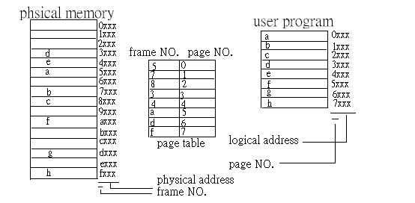

Logical address：6A7C——→ Physical address：DA7C‧
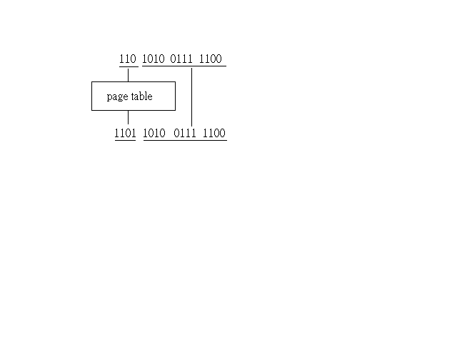

只把正執行的分頁（或分段）載入記憶體，其它部份仍停留在磁碟裏，分頁表記錄哪些
分頁已載入記憶體‧
於DAT時，位址轉換失敗（尚未載入），發出內部中斷信號（page fault）給CPU，於
中斷服務程式中載入所需之分頁並更新分頁表，再重新執行發出中斷的那道指令‧
程式可用的address space可以超過真正記憶體的memory space；
程式的大小可以超過真正記憶體的大小‧
虛擬記憶體不是真正記憶體，也不是磁碟記憶體，而是管理記憶體的軟硬體技術，包括有：
DAT , page fault.
memory management.
file handling.
I/O handling.
process scheduling.

Address space，分成等長的片段，稱為分頁（page）‧分頁的大小一般為2^{n}‧
主記憶體為physical memory，位址稱為physical address，整體範圍稱為memory space，
分成等長的片段（與分頁同樣大小），稱為frame或block‧
分頁表（page table 或page management table）記錄分頁載入哪一個frame，程式執行時
利用分頁表以進行DAT（logical address—→physical address）‧
程式的位址雖是連續的，卻可載入不連續的frame而能正確地執行‧

5. a. Describe the disk space allocation policy for FAT-based file systems, which are used in
MS-DOS and OS/2. Discuss its advantages and disadvantages.
b. Describe the disk space allocation policy for extent-based file systems, which are used in
Veritas file system. Discuss its advantages and disadvantages.
c. Describe the disk space allocation policy used in UNIX-based file system.(Hint：an inode is
used for each file.) Discuss its advantages and disadvantages.（30%）

【解答】
a. FAT的功用在記錄磁碟上面哪些檔案放置在哪些叢集(Clusters)上，或者是哪些叢集已經
存有檔案或尚未使用，當我們要寫入檔案的時候，電腦就可以根據這些記錄加以配置執行
檔案的存取與使用。
如果FAT遭到病毒破壞，電腦將會無法正確找出檔案位置，這些病毒稱為檔案型病毒。
FAT：file allocation table。
如同linked allocation，將pointer集中存放在table裏。
Directory： |  |  | FAT：
file | start |  | 0 |  | 5 |  | 10 | 12
jap | 3 |  | 1 |  | 6 | 10 | 11
 |  |  | 2 |  | 7 |  | 12 | 4
 |  |  | 3 | 6 | 8 | 0 | 13
 |  |  | 4 | 8 | 9 |  | 14
可以direct access。
a section of disk at the beginning of each partition is set aside to contain the FAT table.
有較多的磁頭移動：先到partition的開頭read FAT，找到block number，再移動磁頭to r/w
physical block。（所以cache FAT有其必要性）。
FAT中，the table entry indexed, by that block number can contains the block number of the next
block.

b. Each file system supports a method of representing space for files within the file system.
The two most common methods are：Extents、Indirect blocks。
Extents：
If the file system is using extents-based allocation, space is allocated within the inode for block
address locations for the data for the file. In most file systems, 15 extents addresses for the data
are used in the base inode, and the last address in the inode is linked to another inode, where an
additional 15 extent addresses are available. Examples of extent-based file systems are Veritas
VxFS, Sun QFS, SGI xfs, and Linux extfs-3.
Indirect Blocks：
With indirect block allocation, the last block of space allocated for a file points to the next
allocation. Thus, the base inode space is allocated for the data, and the last block of the
allocated data space points to the next allocated space. Indirect blocks were originally designed
for the UFS file system in 1970. At that time, disk drives were so slow that a seek was not
required to go back to the inode and allocate more space. File systems that support indirect
block allocation are Sun UFS, IBM JFS, and MS FAT-32.
Performance Comparison：
Indirect block allocation and read/write performance can be painfully slow compared to the
extent-based allocation method. For example, consider an application doing random reads and
writes. To find the block address for the record, a file allocated with indirect blocks must read
all of the data areas of the files for the record in question prior to reading the record. With
extent-based allocation, the file system can simply read the inodes in question, which will
make an enormous difference in performance. I am unaware of any new file systems using
indirect blocks for space allocation because of the huge performance penalties for random I/O.
Even for sequential I/O, the performance for indirect blocks is generally less than extent-based
file systems.

c. Indexed allocation：把linked allocation的pointer集中放在一個block－index block。
directory：
File | index block
Jap | 7

index block 7： |  | disk space：
3 |  | 0 | 1 | 2 | 3 | 4
6
10 |  | 5 | 6 | 7 | 8 | 9
12
4 |  | 10 | 11 | 12 | 13 | 14
8

可以direct access。
沒有external fragmentation，size declaration問題。
浪費儲存pointer的indexed block。
UNIX系統採用indexed allocation。
index block越小，對small file才沒有浪費（避免存一大堆NULL pointer）；
但對large file而言，當pointer存不進一個index block時，以下列方法解決：
linked scheme：多個index block串成linked list。
multilevel index：多一層index指向index block在哪裏？
combined scheme：如UNIX系統的inode。

Inode：12個direct block pointers。
1個single indirect block pointers。
1個double indirect block pointers。
1個triple indirect block pointers。

Inode：15個pointer；前12個指向direct block ── 48K。
single indirect block：1024個 ── 2²²。
double indirect blcok：1024×1024個 ── 2³²。
triple indirect block：(1024)³個 ── 2⁴²。
(block有4K bytes大小；pointer須使用4個bytes。)

6. Given two processes, the structure of each process is as following：
do{

flag[i] = true；
turn = i；
while(flag[j] && turn == j)；

Citical Section

flag[i] = false；

Remainder sectiom
}while(1)；
Determine whether it is a correct solution to the critical section problem. If your answer is yes,
prove the algorithm satisfied all three requirements for the critical-section problem. If not,
explain your answer.（10%）

【解答】
此為正確之演算法：Peterson演算法：
Critical section problem definition：演算法須滿足下述三個條件：
mutual exclusion、progress、bounded waiting。
‧turn變數之唯一性確保mutual exclusion；flag〔i〕，flag〔j〕確保progress。
‧mutual exclusion成立；i₃ , j₃ , 或j₃ , i₂ , i₃之順序不存在，P_{i}與P_{j}均在cs中不成立。
進入i₃之條件：flag〔j〕＝false或(turn＝j)為false。
進入j₃之條件：flag〔j〕＝false或(turn＝i)為false。
P_{i}與P_{j}已執行過i₀與j₀，故flag〔i〕與flag〔j〕均為true，由turn變數唯一，
故上述為矛盾。

‧Progress & bounded waiting：
‧P_{j}不在cs中，P_{i}欲進入：flag〔i〕＝false，flag〔j〕＝false，執行順序：
i₀ , i₁ , i₂ , i₃。（因flag〔j〕＝false，P_{i}可進入cs）。
‧若P_{j}已在cs中，P_{i}欲進入：flag〔i〕＝false, flag〔j〕＝true。
執行順序：…j₃…i₀ , i₁ , i₂，因flag〔j〕＝true，故在i₂的while loop中等候，無法進入cs，稍後等P_{j}離開cs…j₄‥，i₂ , i₃。（因flag〔j〕已被j₄設定為false）
‧P_{i}與P_{j}均不在cs中，但同時欲進入cs：flag〔i〕＝flag〔j〕＝false
執行順序：i₀ , i₁ , i₂ , j₀ , j₁ , j₂ → P_{i}進入cs。
i₀ , j₀ , j₁ , i₁ , … → P_{j}進入cs。
i₀ , j₀ , j₁ , j₁ , … → P_{i}進入cs。
i₀ , j₀ , i₁ , i₂ (P_{i}無法進入cs，i₂ loop)，j₁ , j₂ (P_{j}無法進入cs，j₂ loop)，
i₂，… → P_{i}進入cs。i₀ , j₀ , j₁ , j₂(P_{j}無法進入cs , j₂ loop) , i₁ , j₂,…
→P_{j}進入cs。

‧補充說明：
‧若P_{i}與P_{j}同時在cs，則flag〔i〕＝true(i₀)，flag〔j〕＝true(j₀)；
此時i₂與j₂ while loop之測試條件：
i₂：flag〔j〕&& turn＝j → turn＝j
j₂：flag〔i〕&& turn＝i → turn＝I
由turn變數之唯一性，P_{i}與P_{j}不可能同時在cs。
‧若去掉i₁之turn＝j與i₂ while loop之turn＝j，則peterson演算法變成了演算3(有deadlock)，
加入turn變數可破解deadlock。
‧若i₁～i₂與j₁～j₂不交錯，則i₂與j₂ while loop之測試條件：
i₂：flag〔j〕&& turn＝j → flag〔j〕
j₂：flag〔i〕&& turn＝i → flag〔i〕

91年雲科電資 計算機系統(OS) 詳解

1. Suppose we have a Simplified Instructional Computer (SIC) with instruction format, addressing
mode, and part of instructions listed in following Fig. SIC has 5 registers, A (accumulator),
X (index register), L (linkage register for subroutine call), PC (program counter), and SW (status
word), each with 3-byte length. Please assemble the following SIC source program to the
corresponding object program. The answer must also include the memory location allocated
to the object code and the symbol table used in the assembling process.(16%)
Instruction Format：Opcode (8 bits ) x (1 bit) Address (15 bits)
Addressing modes：(TA: Target Address )
Direct x=0 TA=address
Indirect x=1 TA=address+(x)

Memonic | Length (byte) | Opcode | Effect
ADD m | 3 | 18 | A←(A)+(m..m+2)
JLT m | 3 | 38 | PC←m if CC set to <
LDA m | 3 | 00 | A←(m..m+2)
LDX m | 3 | 04 | X←(m..m+2)
RSUB | 3 | 4C | PC←(L)
STA m | 3 | 0C | (m..m+2) ←(A)
TIX m | 3 | 2C | X←(X)+1;(X)：(m..m+2)
RESW | - | - | Reserve word space
WORD | - | - | Declare a word-sized constant

SUM START 4000
FIRST LDX ZERO
LDA ZERO
LOOP ADD TABLE, X
TIX COUNT
JLT LOOP
STA TOTAL
RSUB
TABLE RESW 2000 ；two thousand words
COUNT RESW 1
ZERO WORD 0
TOTAL RESW 1
END FIRST

【解答】
Symbol Table：
Symbol Name | Attribute | Data(Value) | Address(Value)
SUM | Segment Name |  | 4000₁₀=FA0₁₆
FIRST | Label | Target Address | 4000₁₀=FA0₁₆
LOOP | Label | Target Address | 4006₁₀=FA6₁₆
TABLE | Symbol Name | Data Address | 4021₁₀=FB5₁₆
COUNT | Symbol Name | Data Address | 6021₁₀=1785₁₆
ZERO | Symbol Name | 0 | 6024₁₀=1788₁₆
TOTAL | Symbol Name | Data Address | 6027₁₀=178B₁₆

0FA0： 04 1788
0FA3： 00 1788
0FA6： 18 8FB5
0FA9： 2C 1785
0FAC： 38 0FA6
0FAF： 0C 178B
0FB2： 4C －－
0FB5：
1785：
1788： 0
178B：

2. Immediate operands and literals are both ways of specifying an operand value in a source
statement. What is the difference between a literal and an immediate operand? What are the
advantages and disadvantages of each ? When might each be preferable to the other?
Please answer abriefly.(8%)

【解答】
‧Literal：
‧組合語言：看似〝immediate〞定址；機器語言：實際以〝memory direct〞定址。
‧儲存〝常數資料〞，雖以〝memory direct〞儲存，但不得做為destination operand
（不得被modify）。
‧immediate：operand在指令中，受指令格式限制其長度。
direct：operand在memory裏，長度不受限制。
‧literal table：pass 1建立，pass 2據以產生目的碼。
literal存放之位置：LTORG pseudo code。（可置放於與參考指令較近的位置，以便使用relative定址模式）。
‧
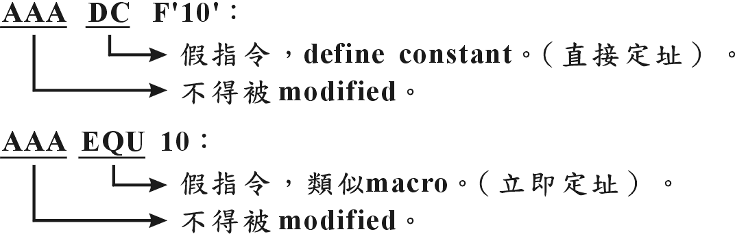

literal：直接定址，不得被modified

3. Consider the following fragment of assembler language：(12%)
CC START 0 Note:
EXTDEF EE 1)EXTDEF names symbols, called external symbols,
EXTREF FF defined in this control section and may be used
AA WORD 35 by other sections.
BB EQU AA+23-CC 2)EXTREF names symbols that are used in this
DD EQU 70 control section section and are defined elsewhere.
EE EQU DD+AA
Please use “relative”, “absolute”, or”neither”(specify one)to answer the following questions.
(1) Is AA relative, absolute, or neither? (4) Is DD relative, absolute, or neither?
(2) Is BB relative, absolute, or neither? (5) Is EE relative, absolute, or neither?
(3) Is CC relative, absolute, or neither? (6) Is FF relative, absolute, or neither?

【解答】
(1) relative
(2) absolute
(3) relative
(4) absolute
(5) relative
(6) neither

4. Suppose two jobs are being multi-programmed together. Job A uses a great deal of CPU time
and performs relatively little I/O. Job B performs many I/O operations, but requires very little
CPU time. Which of these two jobs should be given higher dispatching priority to improve the
overall system performance? Why? (7%)

【解答】
Job B：should be given higher dispatching priority。
CPU-bound：CPU-burst較長，uses a great deal of CPU time and performs relatively little I/O.
I/O-bound：CPU-burst較短，performs many I/O operations, but requires very little CPU time。
SJF排程：Short-Job-First，若可預知各process的下一個CPU burst time (predictable)，則SJF
為最佳排程演算法。
避免convoy effect：I/O-bound程式優先執行。
load balance：CPU與I/O均處於忙碌狀態，

5. What are the advantages of having several different classes of interrupts, instead of just one class
with flag bits to indicate the interrupt type?

【解答】
可讓CPU快速找到各個ISR的進入點。
中斷向量（vector）：不同的中斷原因，CPU有不同的處理方式，即須執行不同的中斷服務
程式（ISR：interrupt service routine），中斷向量用來讓CPU快速找到中斷服務程式的
進入點‧
各I/O設備各有其中斷向量，於中斷認知週期（interrupt acknowledge cycle）傳送給CPU‧
三種I/O方式：
Data ready的偵測 | Data transfer（資料搬動）
軟體 | 軟體 | Program controlled I/O
軟體 | 硬體 | 無此種I/O方式
硬體 | 軟體（即ISR） | 中斷I/O
硬體 | 硬體 | DMA I/O
中斷I/O：
I/O設備的data ready信號即中斷要求信號，於中斷服務程式中，進行資料之搬動‧
應用於即時（real-time）系統，如自動控制系統，飛彈導航系統等‧
反應快，但資料搬動如Polling I/O一般，由CPU執行程式進行，故速度慢‧

91年 成大 電機 系統程式

1. There is a technique called “Copy on Write” used for improving something in a virtual
memory system.
(a) Please explain the technique (the concept and the advantages or applications) of
“Coy on Write” in more details. (6%)
(b) Please show how to implement “Copy on Write” on a demand paging system.(6%)

【解答】
Copy-on-write has two benefits: increasing speed and decreasing memory use.
Copy-on-write allows multiple blocks of code (including different processes) to share a page
as long as none write to the page. If one process writes to the page, a new, writable copy of the
page is created in the address space of that process. This allows efficient copying of large
quantities of data.
Copy-on-Write：The Memory Manager implements an important optimization of memory sharing
called copy-on-write. There are several common scenarios in which a process might want to
use the same data as another process but keep any modifications it makes private to itself.
For example, if two or more processes start the same application and one process modifies the
data in the image, other processes should not see that modification. The obvious way to
accomplish this kind of private modification is to load multiple copies of the application into
memory; however, this strategy wastes space. Instead, the Memory Manager marks the
physical pages containing the image read-only and notes in an internal data structure that the
page is a copy-on-write page. When a process tries to modify the copy-on-write page, that
action will generate a page fault (because the page is read-only). The Memory Manager will
see that the process referenced a copy-on-write page and will copy the contents of the
copy-on-write page to another page that is private to the process that made the reference.
Then, when the faulting instruction restarts, the process can modify its private copy of the
page.
If the process is allowed to keep a copy of the page (as it is in current 4.4BSD semantics), the
page must be made copy-on-write. A copy-on-write page is one that is protected against being
written by being made read-only. If the process attempts to modify the page, the kernel gets a
write fault. The kernel then makes a copy of the page that the process can modify.
Unfortunately, the typical process will immediately try to write new data to its output buffer,
forcing the data to be copied anyway.
Processes can easily share memory, simply by having page table entries which map to the same
physical addresses. In order to implement the "copy-on-write" scheme , these page table
entries are marked as "read only", which will cause a page fault if the process attempts to write
to any of the shared addresses. The fault handler then determines that this is a shared page and
that a copy should be made whenever a process attempts to write to it.

2. In a multiprocessot system, there are n processes competing to enter the critical section. In the
following, several versions of codes for entering and leaving critical section are listed.
(I)：
disable-interrupt /* a hardware instruction to disable interrupt
{ critical section } /*Note: the execution of this critical section takes 5 minutes.
enable-interrupt /* a hardware instruction to disable interrupt
(II)：
while (test-and-set(lock)); /*a hardware instruction to test and set a memory
/*location (lock) atomically
{critical section} /*Note: the execution of this critical section takes 5 minutes
lock=false;

(III)：
wait(mutex); /*mutex is a semaphore with initial value 1
{critical section} /*Note:the execution of this critical section takes 5 minutes signal (mutex);

(a) Is version(I) a correct solution to meet the requirements of mutual exclusion? If no, please
explain why. If yes, please evaluate the method (any advantages or disadvantages).(4%)
(b) Is version (II) a correct solution to meet the requirements of mutual exclusion? If no,
please explain why. If yes, please evaluate the method (any advantages or disadvantages).
(4%)
(c) Is version (III) a correct solution to meet the requirements of mutual exclusion? If no,
please explain why. If yes, please evaluate the method (any advantages or disadvantages)
(4%)

【解答】
(I)：
CS的解法：可於CS前加上〝禁止中斷指令〞，離開CS後加上〝致能中斷指令〞。
因為process得以交錯執行，CPU一定有接受外部中斷的要求信號（I/O data ready,
timer的time out）。
但〝禁止中斷〞，〝致能中斷〞指令屬於priviledged指令，程式於user mode中無法執行
priviledged指令，故此種解法僅限於特定用途的電腦系統。
(II)：
test-and-set(lock)係hardware instruction，很難使用於高階語言之應用程式。
又是屬於busy-waiting，浪費CPU時間於等待進入CS。
test-and-set只能保証mutual exclusion與progress不能確保bounded。某些process可能會有
starvation現象。加入queue的排隊行為，才可保証bounded waiting。
(III)：
wait(s)：
S.Value＝S.Value－1；
if S.Value＜0 then {add this process to S.L；block；}
signal(s)：
S.Value＝S.Value＋1；
if S.Value≦0 then { remove a process P from S.L；wakeup (p)；}
使用wait, signal解決CS：
repeat
wait (lock)；
critical section；
signal (lock)；
remainder section；
until false；

3. Please draw a process state diagram indicating all the possible process state transtitions
due to the following events. (10%)
(a) a time slice expires. (b) an I/O completion interrupt is generated.
(c) a page fault occurs. (d) a job is selected by the long-term scheduler for execution.
(e) a process calls yield() to request reschedule.

【解答】

‧狀態變遷圖：

1.job scheduler：long-term scheduler.介入頻率低。增加multiprogramming degree.
I/O－bound, CPU-bound混合 → load balance.
2.process scheduler：short-term scheduler.介入頻率高。
又稱為dispatcher，執行context switching：PCB之save與restore.
3.medium-term scheduler：intermiate-level scheduler.
降低multiprogramming degree，調整system load.
4.time out：於round-roubin排程法中，分配到的time quantum已用完。
5.start I/O或因P-operator (wait)等待〝進入critical section〞或等待〝other process所占用的
resource〞。
6.I/O completion或因other process執行V-operator (signal)而得以〝進入critical section〞或
取得〝other process所釋放的resource〞。
7.exit (completion)或error abort.
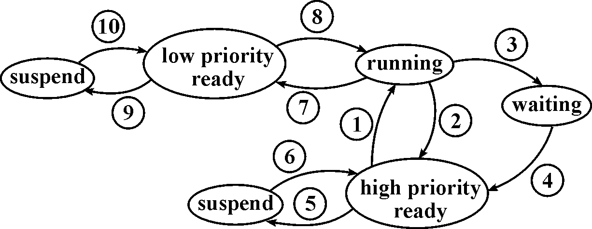

，：process scheduler.
，：job scheduler或〝resume〞
，：medium scheduler或〝suspend〞
：I/O request, P-operator.
：I/O completion, V-operator.
，：time out (timer interrupt).

process從running狀態進入waiting, ready或terminate狀態的原因：
‧EXIT SVC (正常completion).
‧error abort.
‧timer time out.
‧I/O request (start I/O operation).
‧resource request (等待〝free memory〞).
‧等待進入critical section (P-operator).

4. For each of the following questions, please select the best answer from the items listed below.
(1) is the data structure used to describe a file in Unix.
(2) A technique, typically implemented in a linker, used to reduce the size of a program space is
called .
(3) A shared library is quite often implemented as a for easy mapping to the address spaces
of the sharing processes.
(4) A table that DOS or Windows uses to locate files on a disk is called a (or an ) .
(5) is an operating system design approach which enables to run different copies of
operating systems simultancously on a single computer.
(6) A (or An) for a protection domain is a list of objects together with the operations allowed
on those objects.
(7) is the mechanism used in Unix to make a file system (a disk partition) accessible.
(8) is a technique that allows a part of the virtual address space of a process to be logically
associated with a file. (16%)
The possible answers:
(A)open (B)access list (C)overlay (D)mount
(E)dynamic linking (F)re-entrant code (G)capability list (H)recursive code
(I)relocating code (J)memory-mapped file (K)object code (L)FAT
(M)dynamic mapping (N)position independent code (O)access matrix
(P)virtual machine (Q)directory (R)protection bits
(S)NTFS (T)attach (U)virtual memory
(V)Java Virtual Machine (W)inode (X)page table

【解答】
(1) inode is the data structure used to describe a file in Unix.
所謂的Inode是一個單獨的儲存區(128 bytes), 用來描述某一個檔案的權限屬性、檔案
大小及檔案資料存放區塊(Data block)位置等資訊. 每個檔案在建立之時, 系統即會配置
一個專屬的 Inode, 其中含有代表該檔案的一個獨一無二的 inode number (inode 編號).
A UNIX file has a description which is stored in a stucture called an inode. The inode contains
information about file size, location, owner, time of creation, time of last access, etc. Most user
files are ordinary files. Directories are also represented as files and have an associated inode.
Devices are represented by special files. Character special files are used to represent devices
such as terminals while block special files are used for disk devices. The FIFO special files are
used for interprocess communication.
Figure below shows the inode structure of a typical file. In addition to descriptive information,
the inode contains pinters to the first few data blocks of the file. If the file is large, the indirect
pointer contains a pointer to a block of pointers to the file fragments.
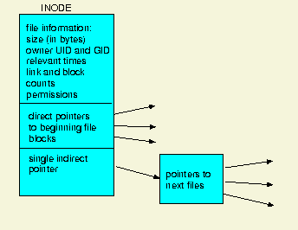

(2) A technique, typically implemented in a linker, used to reduce the size of a program space is
called dynamic linking.
Dynamic Link 指的是在執行時段(Run Time)才對所要呼叫的副程式進行鏈結(Linking)。
Dynamic linking defers much of the linking process until a program starts running. It provides
a variety of benefits that are hard to get otherwise：
Dynamically linked shared libraries are easier to create than static linked shared libraries.
Dynamically linked shared libraries are easier to update than static linked shared libraries.
The semantics of dynamically linked shared libraries can be much closer to those of unshared
libraries.
Dynamic linking permits a program to load and unload routines at runtine, a facility that can
otherwise be very difficult to provide.
There are a few disadvantages, of course. The runtime performance costs of dynamic linking
are substantial compared to those of static linking, since a large part of the linking process has
to be redone every time a program runs. Every dynamically linked symbol used in a program
has to be looked up in a symbol table and resolved. (Windows DLLs mitigate this cost
somewhat, as we describe below.) Dynamic libraries are also larger than static libraries, since
the dynamic ones have to include symbol tables.
(3) A shared library is quite often implemented as a memory-mapped file for easy mapping to the
address spaces of the sharing processes.
從系統取得一塊記憶體空間, 然後兩個 Process 可將此記憶體空間分別映射到自己的
定址空間中, 並當成檔案, 進而讀取或寫入資料, 以達到交換資料的目的. 特別要小心的
是, 用此種資料交換的方法必須謹慎處理同步的問題。
Memory-Mapped files：When more than two threads are running in same process, or when a
process starts more than two threads. Both threads are running in the process space of the same
process, this means that both the threads can share the same information. For example parent
process declares a variable ‘V1’ and creates two threads T1 and T2, then both T1 and T2 can
access V1 and change it’s value. But when two threads belong to two different process they
can not share any information. For this purpose we used pipes and sockets earlier and there are
some more techniques through which we can make two threads communicate. Among all the
techniques Memory-Mapped files are the most preferred one.
Conceptually memory-mapped file is a disk-based file that is loaded into the primary memory.
The OS can read and write into this file in a way which is very similar to reading and writing
from an ordinary file ( like the once you have been using to read and write information for
your programming assignments, a txt file for example).
There is one big difference however in memory-mapped file and ordinary file. Unlike
ordinary file a memory-mapped file can be accessed by two process at the same time, this is
done by mapping the file into their address spaces. There is one small problem here,
memory-mapped file are not protected against critical section problem. You have to use the
regular locking mechanism, mutex and semaphore ex., for managing the critical section
yourself.
Three steps to use memory-mapped files：
btain a handle to the file by creating or opening it ( equivalent to statement ifstream
in(in.txt) when you would open an ordinary file in C++ )。
Reserve virtual address space for the file。
Establish a mapping between the file and your virtual address space。
(4) A table that DOS or Windows uses to locate files on a disk is called a (or an ) FAT.
磁碟機在讀取資料時必須先讀取資料的所在位置。就像圖書館會建立目錄，來記錄書籍
存放的位置一樣，硬碟在儲存檔案時，也會先記錄檔案在磁碟機中的位置。而用來記錄
檔案位置的磁區，就稱為FAT（File Location Table）。

The File Allocation Table of contents of a computer disk which tells what sectors are used for
what file. The File Allocation Table (also know as FAT), is located in the first 63 sectors of a
bootable disk (floppy or hard). You visually cannot see this. The FAT follows the boot sector.
The FAT file system revolves around the File Allocation Table for which it is named. Each
logical volume has its own FAT, which serves two important functions: it contains the
allocation information for each file on the volume in the form of linked lists of allocation units
and it indicates which allocation units are free for assignment to a file that is being created or
extended.
(5) virtual machine is an operating system design approach which enables to run different copies
of operating systems simultancously on a single computer.
Nonvirtual machine： Virtual machine：

Process Process Process Process

Kernel Kernel Kernel Kernel

Hardware virtual machine

Hardware

programming interface
Virtual machine：提供interface that is identical to the underlying bare hardware，而每一個
process is provided with a (virtual) copy of the underlying computer‧
The resources of physical computer are shared to create the virtual machine：
CPU scheduling：share CPU‧
virtual memory and memory management：share memory‧
spooling and file system：virtual I/O devices‧
Kernel控制hardware以create一組system calls，system program可以使用system calls
hardware instructions，而程式無法(也沒有必要)區分何者為system calls？何者為
instructions？
應用程式要存取計算機資源時，須經由Kernel的system calls；雖然bare machine不相同，
但藉由Kernel提供相同的system calls，故OS can be used to make different machines
appear to have the same characteristics‧
多個process以為在不同的hardware上執行，但藉由virtual machine提供不同hardware(OS)
所提供的system calls，即virtual machine將不同的computer的system calls對應(map)到
同樣的hardware上，使得real hardware只有一種，但各個process卻以為在不同的hardware
上執行‧
(6) A (or An) access list for a protection domain is a list of objects together with the operations
allowed on those objects.
access control matrix：row：file name；column：user name；entry：access right.
因矩陣大而稀疏，不切實際，若區分行列(Row or Column)，可使用以下方式來實作：
控制表列(Access Control List)：以行為主(by column)，記錄一串可以取用某一物件的所有
領域。
資格表列(Capabilities)：以列為主(by Row)，此法對某Process，皆有一表列出其可使用的
所有物件，及對每一物件可行之操作。

(7) mount is the mechanism used in Unix to make a file system (a disk partition) accessible.
在Linux裡頭，如果要使用儲存週邊（MO、硬碟、光碟機等），就得先將它掛上（mount），
而當儲存設備掛上了之後，就可以把它當成一個目錄來作存取。
使用mount這個指令時，至少要先知道下列三種資訊：
1.mount的對象的檔案系統類型？（File system type）
2.mount的對象的裝置名稱？（/dev/????）
3.將裝置mount到哪個目錄去？
(8) memory mapped file is a technique that allows a part of the virtual address space of a
process to be logically associated with a file.
memory mapped files：
allow a part of the virtual address space to be logically associated with a section of a file.
Read/write to that memory region are then treated as read/write to the file, greatly simplifying
file use.
closing the file results in all the memory-mapped data being written back to disk and removed
from the virtual memory of the process.

5. For each of the following statements, please indicate TRUE or FALSE and briefly explain your
reason. (30 points)
(a) If grammar G is regular then G is a context-sensitive grammar.
(b) A compiler must generate assembly language code as object code.
(c) The compiler of programming language L can be implemented using L.
(d) Recursive-descent parsing technique can be used to parse LL(I) grammars.
(e) A compiler does not generate any object code for the for the following statement:
int fun A (char p1);
(f) Lexical analyzer is usually implemented with the concept of DFA.
(g) To accomplish the function of load-on-call, an absolute loader is required.
(h) There exists ambiguity in programming languages Java and C.
(i) Compiler manages a symbol table during program translation but assembler does not manage
any symbol table.
(j) A bootstrap loader is required to run stand-alone programs without an operating system.

【解答】
(a) If grammar G is regular then G is a context-sensitive grammar.
FALSE, regular grammar屬於context-free grammar。
Formal grammar：
Type 0：contracting context-sensitive (nonrestricted) production rule沒有任何限制，
允許消去symbol，即α→β的production rule中α的長度可大於β的長度。
α→β，α與β均屬於（N∪T）＊且α≠λ；Turing machine。
Type 1：noncontracting context-sensitive.
production rule限制右側（β）的長度（符號個數）至少與左側（α）相等。
α→β，α與β均屬於（NUT）＊－λ且|α|≦|β|
α至少含一nonterminal symbol；Phase-structure grammar, Linear bounded automata.
Type 2：context-free (CFG).
production rule限制左側只能有一個nonterminal symbol.
α→β，αN且β（N∪T）＊－λ；Pushdown Automata.

Type 3：regular grammar，context-free
production rule限制左右兩側最多僅有一個nonterminal symbol.
right linear： A→aB； aT
A→a ； A , BN
left linear： A→Ba； aT
A→a ； A , BN
Finite State machine.
(b) A compiler must generate assembly language code as object code.
FALSE, 可直接generate object code, 不一定要產生assembly code。
(c) The compiler of programming language L can be implemented using L.
TRUE。
可以cross compiler方式製作。
Cross compiler：Programming在某一個電腦系統上編譯其他系統程式的編譯器。例如
在Intel系統上編譯Motorola的系統的程式碼。使用Cross compiler的原因是因為該系統
尚未發展完全，或是該系統無法提供開發環境，例如個人數位助理(PDA)本身運算能力
或儲存空間有限。
(d) Recursive-descent parsing technique can be used to parse LL(I) grammars.
TRUE。
Parser：
Top-down parser：LL(l)文法
Recursive-descent parser，Predictive parser.
Bottom-up parser：LR(k)文法
simple LR(SLR)，canonical LR，lookahead LR (LALR)，Shift-reduce parser，
operator-precedence parser
(e) A compiler does not generate any object code for the for the following statement:
int fun A (char p1);
TRUE，如同組合語言之pseudo code或directive。
(f) Lexical analyzer is usually implemented with the concept of DFA.
TRUE。
A DFA（Deterministic Finite Automaton）M consists of an alphabetΣ，a set of states S，
a transition function T：S×Σ→S，a start state s0屬於S，and a set of accepting states A
包含於S‧
The language accepted by M，written L（M），is defined to be the set of strings of characters
c1c2…cn with each ci屬於Σsuch that there exit states s1＝T（s0，c1），s2＝T（s1，c2），…，
sn＝T（sn－1，cn）with sn an element of A（an accepting state）‧
(g) To accomplish the function of load-on-call, an absolute loader is required.
FALSE。
Absolute loader：
allocation：programmer做.
relocation：assembler做.
linking：programmer做.
loading：loader做.
loader毋須執行linking與relocation的功能，簡單，one-pass即可達成所有功能。
缺乏dynamic relocation的能力。

(h) There exists ambiguity in programming languages Java and C.
TRUE。
This ambiguity, known as the dangling else ambiguity, is found in many programming
languages, including C and Java. However, you should see that the parser can resolve that
ambiguity in a natural way that corresponds to a rule that you should have learned in your
study of C or Java.
(i) Compiler manages a symbol table during program translation but assembler does not manage
any symbol table.
FALSE。
Two-pass assembler：
pass-1：建立symbol table，內含被翻譯程式所定義之symbol name（label），及對應之
address, data type, data value，占用memory之length。
pass-2：利用pass 1所建立之symbol table以產生machine code。
Data Structures：
LC(location counter)：累計位置計數器。
machine operation table：static table；mnemonic code及對應之machine code，指令長度。
pseudo operation table：static table；pseudo code及對應程式之entry point。
symbol table：dynamic table；symbol name (label)及對應之address, value等。
(j) A bootstrap loader is required to run stand-alone programs without an operating system.
TRUE。
IPL：Initial Program Loader；Absolute Loader.
operator使用console上之按鈕將IPL輸入到main memory (RAM).
將IPL存在ROM中（BIOS），開機即執行.
Bootstrap loader：
藏在磁片中，此loader用以載入DOS到memory.
開機執行IPL，IPL讀入bootstrap loader, bootstrap load讀入DOS.

6. Design a non-recursive algorithm to perform in-order traversal of binary trees：
(a) Demonstrate your algorithm using an algorithmic language, programming language or
pseudo language. (10points)
(b) What is the time complexity of your algorithm? (2points)
(c) What is the space complexity of your algorithm? (2points)

【解答】
(a) 設計二元樹中序追蹤之非遞迴演算法‧
中序追蹤：
1‧初值設定：將樹根（指標）存入堆疊（push）‧
2‧while 堆疊不為空 do
2.1‧從堆疊取出（pop）一元素X‧
2.2‧switch（X）
2.3‧ ﹛
2.4‧ case X＝null：do nothing；break；
2.5‧ case X＝data：print；break；
2.6‧ case X＝指標：依序push X→right-child，X→data，X→left-child；
2.7‧ ﹜
3‧結束‧

前序追蹤：
2.6改為case X＝指標：依序push X→right-child，X→left-child，X→data；即可‧
後序追蹤：
2.6改為case X＝指標：依序push X→data，X→right-child，X→left-child；即可‧
(b) O(n)
time complexity：each procedure（inorder, preorder, postorder） performs constant work
at each node.
iterating over n elements in a tree can be done in O(n) steps, regardless of traversal method
(c) O(n)

7. Explain briefly the following terms. (2points each)
(a) Connected graph
(b) Spanning forest
(c) Loading factor (or loading density)

【解答】
(a) Connected graph
Definition：An undirected graph that has a path between every pair of vertices.
strongly connected graph：
Definition: A directed graph that has a path from each vertex to every other vertex.
相鄰（adjacent）與連接（connected）：
兩頂點有邊（edge）相連，稱為相鄰（adjacent）‧
於無向圖中，兩頂點有路徑（path）可通，此兩頂點稱為連接（connected）‧
connected component：無向圖中，所有connected的頂點與其對應的邊所形成之子圖‧
於有向圖中，兩頂點互有路徑可通，此兩頂點稱為強連接（strongly connected）‧
strongly connected component：有向圖中，強連接的頂點與其對應的邊所形成之子圖‧
(b) Spanning forest：
Definition: A spanning forest of a graph G is the union of all the spanning trees of each
connected component of G.
Theorem: Every finite simple graph has a spanning forest.
(c) Loading factor (or loading density)：
loading factor：雜湊空間的使用率：n/sb‧
n為資料筆數，b為bucket數目，s為每一bucket內所含之slot數目‧
n/sb越大，表示空間使用效率越高，而發生碰撞（或溢位）之可能性也隨之增加‧

91年南師 資教所資訊專業科目(OS) 詳解

1. What are the main functions of operating system? (16%)

【解答】
Operation system：
建立一個良好的〝發展程式〞的環境，以方便user存取computer的資源：
管理或控制hardware / software resource.
良好的人機介面(user friendly).
協助application program的開發。
管理(resource manager)與保護(protection)：
resource manager：process (processor), memory, device, information (file).
protection：base / limit register, access control, dual mode等等。

2. Compare the access speed：main memory, cache, disk, virtual disk, network. (5%)

【解答】
cache＞main memory＞virtual disk＞disk＞network
disk cache：可由OS處理（劃分主記憶體空間作為disk cache）；或由磁碟控制器（disk
controller）處理‧
disk cache內儲存最近曾被存取過的磁碟資料‧
當應用程式提出對磁碟存取要求（經由OS，supervisor call），若disk cache已有這筆資料，
則由cache存取‧
RAM disk：劃分主記憶體一段空間作為RAM disk‧開機時，將磁碟資料全部載入此段空間，
關機時，將資料存回磁碟‧
當應用程式提出對磁碟存取要求（經由supervisor call），則OS改由向RAM disk 存取‧
disk cache：locality，儲存最近曾被存取過的磁碟資料‧
這些資料可來自不同的disk，若miss，仍須到disk去存取‧
the contents of the disk cache are under the control of the OS‧
RAM disk：又稱為電子磁碟機、Virtual disk‧
無所謂hit，miss之問題，開始或結束磁碟機存取，須進行資料的載入或回存‧
the contents of the RAM disk are totally user controlled‧

3. What are the purposes of normalization on database? (12%)

【解答】
資料庫正規化的目的：消除資料重複與避免更新束縛(update anomalies)的問題。更新束縛指
的是由於資料庫結構本身的問題，造成難以對資料庫進行異動。
正規化法(Normalization)：
1.第一正規化(First Normal Form)：一筆記錄沒有重覆的資料項。
2.第二正規化(Second Normal Form)：已1NF，且記錄中每筆資料可由主鍵單一辨視，
但不能由部份主鍵來辨識。
3.第三正規化(Third Normal Fomr)：已2NF，且所有和主鍵無關之資料項彼此間獨立。
另外還有Boyce-Codd及第四、第五種正規化格式，但實務上不常發生。
Boyce-Codd正規化：將多個候選鍵中挑出一個決定因子作為主鍵。
4NF：去除多值相依性。 5NF：克服合併相依性。

用戶觀點
整理ER圖（Entity Relation diagram）
未經正規化的關連
移去重複關係
1NF的關連
移去部分依賴關係
2NF的關連
移去遞移關係
3NF的關連
移去多值相依關係
4NF的關連

1NF：第一正規形式‧
若且唯若relation所有的domain（定義域）只包含無法再分割的基本元素值（atomic
value），則此relation滿足1NF‧
2NF：第二正規形式‧
一個滿足1NF的relation，若且唯若每個非主鍵屬性〝完全功能相關〞於主鍵，則此relation
滿足2NF；主鍵若是單一屬性，則滿足1NF的relation，即滿足2NF‧
3NF：第三正規形式‧
一個滿足2NF的relation，若且唯若非主鍵的屬性在主鍵上不具有遞移性，則此relation
滿足3NF‧
BCNF：Boyce－Codd Normal Form‧
決定因素：若屬性Y完全功能相關於屬性X，則X為決定因素（X→Y）‧
若且唯若relation R的每一個決定因素皆為candidate key，則R滿足BCNF‧
4NF：第四正規形式‧
滿足BCNF的relation ，沒有multivalued dependence現象，則滿足4NF‧

91年中山 資工 作業系統與資料結構(OS) 詳解

1. Suppose that a moving-head disk contains 100 tracks(number 0 through 99) and that the head is
currently at track 0. We have the following requests in a queue：
10, 89, 73, 27, 75, 44, 77, 90, 9.
What is the total head movement needed to satisfy these requests for the following
disk-scheduling algorithms？(a) SSTF. (b) SCAN. (c) C-SCAN. (d) LOOK. (e) FCFS.（10%）

【解答】
FCFS：First Come First Service
request queue：98, 183, 37, 122, 14, 124, 65, 67
目前磁頭（read/write head）位置：53
53→98 ： 45
98→183 ： 85
183→37 ： 146
37→122 ： 85
122→14 ： 108
14→124 ： 110
124→65 ： 59
65→67 ： 2
67
合計：640
SSTF：Shortest Search Time First，request queue：同FCFS之例
目前磁頭位置：同FCFS之例
53 → 65 ： 12
65 → 67 ： 2
67 → 37 ： 30
37 → 14 ： 23
14 → 98 ： 84
98 →122 ： 24
122 →124 ： 2
124 →183 ： 59
183
合計：236
SCAN：request queue：同FCFS之例
目前磁頭位置：53磁軌，朝磁軌0移動。
53 → 37 ：
37 → 14 ：
14 → 0 ： 轉向
0 → 65 ：
65 → 67 ：
67 → 98 ：
98 → 122 ：
122 → 124 ：
124 → 183 ：
183 → max ： 轉向

C-SCAN：
53 → 65
65 → 67
67 → 98
98 →122
122 →124
124 →183
183 →max.
max.→0 ：回程中不執行read/write動作
0 → 14
14 → 37
LOOK：
53 → 37
37 → 14 ：立刻回頭，不scan到磁軌0.
14 → 65
65 → 67
67 → 98
98 →122
122 →124
124 →183
183 → ：若queue中沒有大於183的request，立刻回頭
C-LOOK：
53 → 65
65 → 67
67 → 98
98 →122
122 →124
124 →183 ：立即回頭，不scan到max
183 → 14 ：回程中不執行read/write動作
14 → 37
37 →

2. Assume we have a paged memory system with associative registers to hold the most active page
table entries.If the page table is normally held in memory, and memory access time is 1 us, what
is the effective access time if 85% of all memory reference find their entries in the associative
registers？How about 50%？（10%）

【解答】
hit ratio：85%, memory access time：1 us, associative register access time：0 us，
則effective access time：0.85*(1＋0)＋0.15*(1＋1) us。
若hit ratio：50%，則effective access time：0.5*(1＋0)＋0.5*(1＋1) us。

3. Consider the following page reference string：
1, 2, 3, 4, 2, 1, 5, 6, 2, 1, 2, 3, 7, 6, 3, 2, 3, 2, 1, 2, 3, 6
How many page faults would occur for the following replacement algorithms, assuming 3, 4, 5,
6 or 7 frames？a. LRU b. Optimal.（10%）

【解答】
‧Replacement strategy：
page fault時，main memory中找不到free的frame，則必須找到一暫時不用的page，將其回存在disk並更新page table，空出來的frame即可存放所須的page.
‧Optimal：選擇未來最長一段時間內不會reference到的page.
理論上的最佳值，用來比較實用方法之效率。
示列：reference string：7 , 0 , 1 , 2 , 0 , 3 , 0 , 4 , 2 , 3 , 0 , 3 , 2 , 1 , 2 , 0 , 1 , 7 , 0 , 1.
frame數：3.
 | 7 | 0 | 1 | 2 | 0 | 3 | 0 | 4 | 2 | 3 | 0 | 3 | 2 | 1 | 2 | 0 | 1 | 7 | 0 | 1
1. | 7 | 7 | 7 | 2 |  | 2 |  | 2 |  |  | 2 |  |  | 2 |  |  |  | 7
2. |  | 0 | 0 | 0 |  | 0 |  | 4 |  |  | 0 |  |  | 0 |  |  |  | 0
3. |  |  | 1 | 1 |  | 3 |  | 3 |  |  | 3 |  |  | 1 |  |  |  | 1
page fault：9次。

‧LRU(Least Recently Used)：選擇最久未被reference到的page.
示例：reference string：7 , 0 , 1 , 2 , 0 , 3 , 0 , 4 , 2 , 3 , 0 , 3 , 2 , 1 , 2 , 0 , 1 , 7 , 0 , 1.
frame數：3.
 | 7 | 0 | 1 | 2 | 0 | 3 | 0 | 4 | 2 | 3 | 0 | 3 | 2 | 1 | 2 | 0 | 1 | 7 | 0 | 1
1. | 7 | 7 | 7 | 2 |  | 2 |  | 4 | 4 | 4 | 0 |  |  | 1 |  | 1 |  | 1
2. |  | 0 | 0 | 0 |  | 0 |  | 0 | 0 | 3 | 3 |  |  | 3 |  | 0 |  | 0
3. |  |  | 1 | 1 |  | 3 |  | 3 | 2 | 2 | 2 |  |  | 2 |  | 2 |  | 7
page fault：12次

4. Suppose the following jobs arrive for processing at the tine indicated. Each job will run the listed
amount of time. What are the average turnaround time and the average waiting time for these
jobs by using the following scheduling algorithms？
a. Non-Preemptive Shorstest Job first. b. Preemptive Shorstest Job first.（12%）
Job | Arrival Time | Burst Time
1 | 0.0 | 8
2 | 0.5 | 5
3 | 1.0 | 2

【解答】
假設：
Process Arrive Time Burst Time
P1 0 25
P2 0.8 18
P3 1.2 5
turnaround time=完成時間- 抵達時間，wait time：turnaround time - burst time‧
SJF：Non-Preemptive Shorstest Job first
Process | Arrive  Time | Burst  Time |  | 0～  25 | 25～30 | 30～48 |  | Start  Time | End  Time | Turnaround  Time | Wait  Time
P1 | 0 | 25 |  | ▃▃ |  |  |  | 0 | 25 | 25 | 0
P2 | 0.8 | 18 |  |  |  | ▃▃ |  | 30 | 48 | 47.2 | 29.2
P3 | 1.2 | 5 |  |  | ▃▃ |  |  | 25 | 30 | 28.8 | 23.8

SRTF：Preemptive Shorstest Job first
Process | Arrive  Time | Burst  Time |  | 0～  0.8 | 0.8～  1.2 | 1.2～  6.2 | 6.2～  23.8 | 23.8～  48 |  | Start  Time | End  Time | Turnaround  Time | Wait  Time
P1 | 0 | 25 |  | ▃▃ |  |  |  | ▃▃ |  | 0 | 48 | 48 | 23
P2 | 0.8 | 18 |  |  | ▃▃ |  | ▃▃ |  |  | 0.8 | 23.8 | 23 | 15
P3 | 1.2 | 5 |  |  |  | ▃▃ |  |  |  | 1.2 | 6.2 | 5 | 0

5. a. In the following two-process solution for mutual exclusion, what is wrong with it？
repeat
flag[i] = true； ---(1)
while flag[j] do no-op； ---(2)
CS；
Flag[i] = false；
until false；
b. If we exchange the order of statements 1 and 2, will the algorithm be correct？（8%）

【解答】
a.
wrong，當兩個process同時想進入CS時，兩者於(1)(2)行交錯執行時，兩者被(2)行卡住，
進入Deadlock，都無法進入CS。
b. 一樣是wrong，當兩個process同時想進入CS時，兩者於(1)(2)行交錯執行時，兩者同時
進入CS，違背 mutual exclusion。

91年東華資工 作業系統與計組(OS) 詳解

1. (10%) What is Belady’s anomaly? If you have devised a new page-replacement algorithm that
you think may be optimal. In some contorted test cases, Belady’s anomaly occurs. Is the new
algorithm optimal? Explain your answer.

【解答】
‧Belady's anomaly：
分配到的frame數增加，page fault次數理應減少，但某些page-replacement algorithm
可能發生frame數增加page fault也隨之增加的怪異現象。
stack algorithm：以stack存page no，每當reference，就將此page no.移到stack的top.
替換時，選擇stack的bottom予以替換。
frame＝n即stack top有n個page存在memory frame，故frame＝n時所載入之pages
必然是frame＝n＋1時所載入pages之subset，不會發生Belady's anomaly。
Optimal策略與LRU策略均屬之。
Is the new algorithm optimal? NO

2. (10%) What is Inverted Page Table(IPT)? When a virtual memory system needs to use the IPT,
how to implement it ?

【解答】
反轉式分頁表（Inverted page table）：
one entry — each frame‧
sorted by frame no.，lookups occur on page no.‧
virtual address：
Pid p d
Pid p
frame no.
search

f d
physical address

以associative memory（CAM, content addressable memory）製作：
資料儲存的基本結構單元，可分為資料標識區(tag)與資料儲存區(對應的data)，其中
資料標識器指明資料所在的記憶體位址‧

Inverted Page Table：
With each process having its own page table, and with each page table consuming considerable
amount of memory…We use a lot of memory to keep track of memory.

Inverted page table has one entry for each real page of memory.

Lookup time is increased because it requires a search on the inverted table.

Hash table can be used to reduce this problem.

Of course, we should also use TLB.

In a virtual memory system, conventional page tables have an entry for every page in the virtual
address space. An inverted page table has only as many entries as there are pages in physical
memory, and uses a hash lookup to translate virtual addresses to physical addresses in nearly
constant time.

The entire virtual address space of each process is described in an auxiliary structure, typically
a B*-tree, that can efficiently store contiguous, sparse, or large address space descriptions.
This auxiliary structure may itself be paged to avoid permanently consuming physical memory
resources.
Inverted page tables are ideal for schemes that store information about objects in the high-order
bits of their address. Such schemes may perform poorly with conventional page tables as the
sparse address space may cause the page table structures to become so large as to compete with
the program working set for physical memory.

3. (5%) Propose two cases in which context switch is necessary?

【解答】
中斷發生，由被中斷程式轉向中斷服務程式執行；反之，亦然。
Multiprogramming系統中，切換程式執行時。
Multithresding系統中，切換thread執行時。類似multitasking；但多個threads可共用
activation record, threads切換時只須進行暫存器之save/restore即可。

處理轉換（Context Switch）：CPU從一Process轉換到另一個Process時，需儲存舊Process
的狀態（PCB），並載入新Process原先保存的狀態。
分散程式（Dispatcher）/*轉換新Process中間的步驟*/
（1）Switch context (PCB)。
（2）Swicth to user mode。
（3）Jump to proper location & restart。
處理單元控制區塊（Process Control Block，PCB）是作業系統儲存有關於處理單元之訊息
的地方。PCB內含有下列七種最重要的紀錄：
（1）處理單元的目前狀態（Current State），（Ready，Blocked…）。
（2）處理單元的識別名稱。
（3）處理單元的優先等級，即有關於排班的相關資訊。
（4）用以指明處理單元之記憶體位置的指標，即記憶體管理的相關資訊。
（5）只到所分得的資源之指標。
（6）記錄器暫存區。
（7）處理單元所花費於執行的時間。

Context switching：Preparation and restoration of process status before and after switching
CPU among processes‧
Save the status：PC, register values --> PCB‧
Restore the status：PCB --> PC, register values‧
The efficiency of context switching is highly dependent on the hardware support。

Context switch：
Heavy context such as address map, open file table need not be switched。
Only light context such as PC and SP need to be switched。
TLB, data and instruction caches need not be flushed。
因為一個Thread是一個小型的Process, 所以它必須有自己的PC (Program Counter),
Stack 和Register Set, 以儲存被context switch時, 相關registers的內容。

In multi-processing environments, a context switch is the management overhead encountered by
a processor when it suspends one process and a starts execution of another process. Obviously, in
computer processing environments, the goal is to have good design of the CPU and the
components of the computer system in order to reduce the context switch management overhead
or to have a processing load that works more efficiently and does not require too many context
switches.
A context switch is the computing process of storing and restoring the state of a CPU (the
context) such that multiple processes can share a single CPU resource. The context switch is an
essential feature of a multitasking operating system. Context switches are usually
computationally intensive and much of the design of operating systems is to optimize the use of
context switches.
Context switches usually involve the following steps, assuming process P1 is running on the CPU
and process P2 is the next process to run on the CPU：
Store the context of P1 somewhere in memory (usually on the stack of P1). The context of the
CPU will contain the value of registers such as the program counter, processor control and
general purpose registers.
Retrieve the context of P2 from memory (usually on the stack of P2).
Return to the location contained in the program counter (the line of code at which the original
process was interrupted).
Some CPUs contain logic to allow several hardware contexts to simultaneously exist,
eliminating the need to store and restore the CPU context to memory on context switch.

4. (5%) Propose two advantages of threads.

【解答】
Thread：
efficiency：
fast context switching、
cheap creation、
when one thread is blocked, other thread can still proceed(even only one process)‧
natural decomposition of work：one thread for one task‧
easy access to shared data‧

Thread：Light weighted process
Different execution sequencing of the same code and data. That is, two threads of a process run
the same code and share the same data：PC、register set、stack。
Different thread of the same process are collectively called a task：cheap creation and context
switching、have similar problem（synchronization）as in shared-memory multiprocessing.
Heavy weight process（the ordinary process）：A single thread task，expensive creation and
context switching.

The advantages of kernel-level threads over user-level threads are：
supports multiprocessors‧
possibly smoother scheduling, since the same scheduler（the kernel's）handles both threads and
other Unix processes‧
no special action needed to make blocking system call suspend only the calling thread, not all
threads of the process‧
as a consequence of the above, more efficient I/O and timer-based operations‧
The disadvantages are：
more expensive context switches between threads, at least when blocking on conditions and
mutexes，thread creation is more expensive。
由上面的比較可以清楚的發現 kernel-level 是一個比較好的選擇，也算是發展的趨勢。

5. (10%) Use critical regions to solve the producer-consumer problem.

【解答】
var buffer：shared record
pool：arry〔0‥n－1〕of item；
count, in, out：integer；
end；

procedure entry producer；
begin
repeat
…produce an item in nextp…
region buffer when count＜n
do begin
pool〔in〕：＝nextp；
in：＝in＋1 mod n；
count：＝count＋1；
end；
until false；
end；

procedure entry consumer；
begin
repeat
region buffer when count＞0
do begin
nextc：＝pool〔out〕；
out：＝out＋1 mod n；
count：＝count－1；
end；
…consume the item in nextc…
until false；
end；

Begin
parbegin
producer；
consumer；
parend；
end.

6. (5%) Why improper bad block management may invalidate disk scheduling algorithms?

【解答】
A hard disk may have some bad sectors and several approaches have been proposed to solve
this problem. Sector sparing is a method whereby the system keeps a small pool of spare disk
sectors and uses them in place of sectors that are detected as bad. Normally, formatting detects
and marks the bad sectors, sparing them out.
因disk scheduling algorithms判定讀取磁軌要求之先後順序，是依據磁軌之logical address，
但若該磁軌bad，被spare out，而以另一磁軌代替，此時disk scheduling algorithms以磁軌
之logical address，實際上被轉成a small pool of spare disk sectors之physical address，所以
造成Invalidate optimization by OS’s disk scheduling。

7. (5%) What is a capability list?

【解答】
‧fil protection：improper access.
‧password：每一file有一password。
‧access control matrix：
row：file name.
column：user name.
entry：access right.
‧access control list：每一user有一access control list，記載對不同file的使用權：
read, write, execute, append, delete, list。
‧identity-dependent access：associate with each file and directory an access list, specifying the user name and the types of access allowed for each user.
to condense the length of the access list：將user分類：owner, group, universe.
‧reliability：plysical damage.

因矩陣大而稀疏，不切實際，若區分行列(Row or Column)，可使用以下方式來實作：
控制表列(Access Control List)：
以行為主(by column)，記錄一串可以取用某一物件的所有領域。
資格表列(Capabilities)：
以列為主(by Row)，此法對某Process，皆有一表列出其可使用的所有物件，及對
每一物件可行之操作。

