91年高雄第一電機 數位設計詳解

1. (a). Design a 3-bit subtraction by using NAND gates only.

(b). Design a 3-bit look ahead adder by using NOR gates only.(16%)

【解答】
(a). 1-bit subtracter之真值表：X-Y-Z = D [B：借位]
X | Y | Z |  | D | B
0 | 0 | 0 |  | 0 | 0
0 | 0 | 1 |  | 1 | 1
0 | 1 | 0 |  | 1 | 1
0 | 1 | 1 |  | 0 | 1
1 | 0 | 0 |  | 1 | 0
1 | 0 | 1 |  | 0 | 0
1 | 1 | 0 |  | 0 | 0
1 | 1 | 1 |  | 1 | 1
Karnaugh map化簡：
D：
X YZ | 00 | 01 | 11 | 10
0 | 0 | 1 | 0 | 1
1 | 1 | 0 | 1 | 0
D = (X+Y+Z)(X+Y’+Z’)(X’+Y+Z’)(X’+Y’+Z)
B：
X YZ | 00 | 01 | 11 | 10
0 | 0 | 1 | 1 | 1
1 | 0 | 0 | 1 | 0
B = (Y+Z)(X’+Y)(X’+Z)

X
Y NAND
Z

X Y
Y’ NAND NAND
Z’ Z
NAND D
X’ X’
Y NAND NAND NAND B
Z’ Y

X’ X’
Y’ NAND NAND
Z Z

X Y Z X Y Z X Y Z 0

B D B D B D

(b).
Carry Lookahead Adder：以四位元為例‧
令 P_{i}=A_{i}'B_{i}+A_{i}B_{i}'=A_{i}⊕B_{i} A_{i} G_{i}
G_{i}=A_{i}B_{i} B_{i}
則 C_{i}=G_{i}+P_{i}G_{i-1}

故：C₀=G₀+P₀C_{i} P_{i}
C₁=G₁+P₁C₀=G₁+P₁（G₀+P₀C_{i}）=G₁+P₁G₀+P₁P₀C_{i}
C₂=G₂+P₂C₁=G₂+P₂G₁+P₂P₁G₀+P₂P₁P₀C_{i}
C₃=G₃+P₃C₂=G₃+P₃G₂+P₃P₂G₁+P₃P₂P₁G₀+P₃P₂P₁P₀C_{i}

A₃ G₃ C₃ C₃
B₃ P₃ C₂
P₃ S₃
A₂ G₂
B₂ P₂ C₁
P₂ S₂
A₁ G₁
B₁ P₁ C₀
P₁ S₁
A₀ G₀
B₀ P₀ C_{i}
C_{i} C_{i} P₀ S₀

因S_{i}=A_{i}⊕B_{i}⊕C_{i-1}，故S₀=A₀⊕B₀⊕C_{i}=P₀⊕C_{i}
S₁=A₁⊕B₁⊕C₀=P₁⊕C₀
S₂=A₂⊕B₂⊕C₁=P₂⊕C₁
S₃=A₃⊕B₃⊕C₂=P₃⊕C₂

僅使用四個NAND閘製作XOR閘：
A C

X F

B
D

2. (a). Design a 4x1 multiplexer using a tri-state buffer.
(b). Based on the result of (a), design a 16x1 multiplexer.

【解答】
(a). I₀ I₁ I₂ I₃

decoder
2¹ 0
2⁰ 1
2
3 F

(b)
I₀～I₃ 4x1
MUX

I₄～I₇ 4x1
MUX
4x1
MUX F
I₈～I₁₁ 4x1
MUX

I₁₂～I₁₅ 4x1
MUX

S₃ S₂ S₁ S₀

3. Design a decision circuit. There are 5 inputs, the output is one if any 3 or more of the 5 inputs
are high；otherwise, the output is zero.(10%)

【解答】
Truth table：
a | b | c | d | e |  | F |  | a | b | c | d | e |  | F
0 | 0 | 0 | 0 | 0 |  | 0 |  | 1 | 0 | 0 | 0 | 0 |  | 0
0 | 0 | 0 | 0 | 1 |  | 0 |  | 1 | 0 | 0 | 0 | 1 |  | 0
0 | 0 | 0 | 1 | 0 |  | 0 |  | 1 | 0 | 0 | 1 | 0 |  | 0
0 | 0 | 0 | 1 | 1 |  | 0 |  | 1 | 0 | 0 | 1 | 1 |  | 1
0 | 0 | 1 | 0 | 0 |  | 0 |  | 1 | 0 | 1 | 0 | 0 |  | 0
0 | 0 | 1 | 0 | 1 |  | 0 |  | 1 | 0 | 1 | 0 | 1 |  | 1
0 | 0 | 1 | 1 | 0 |  | 0 |  | 1 | 0 | 1 | 1 | 0 |  | 1
0 | 0 | 1 | 1 | 1 |  | 1 |  | 1 | 0 | 1 | 1 | 1 |  | 1
0 | 1 | 0 | 0 | 0 |  | 0 |  | 1 | 1 | 0 | 0 | 0 |  | 0
0 | 1 | 0 | 0 | 1 |  | 0 |  | 1 | 1 | 0 | 0 | 1 |  | 1
0 | 1 | 0 | 1 | 0 |  | 0 |  | 1 | 1 | 0 | 1 | 0 |  | 1
0 | 1 | 0 | 1 | 1 |  | 1 |  | 1 | 1 | 0 | 1 | 1 |  | 1
0 | 1 | 1 | 0 | 0 |  | 0 |  | 1 | 1 | 1 | 0 | 0 |  | 1
0 | 1 | 1 | 0 | 1 |  | 1 |  | 1 | 1 | 1 | 0 | 1 |  | 1
0 | 1 | 1 | 1 | 0 |  | 1 |  | 1 | 1 | 1 | 1 | 0 |  | 1
0 | 1 | 1 | 1 | 1 |  | 1 |  | 1 | 1 | 1 | 1 | 1 |  | 1
組合電路：
1.積項之和(卡諾圖化簡或列表法化簡)，最小項之和
2.和項之積(卡諾圖化簡或列表法化簡)，最大項之積
3.僅用NAND閘、僅用NOR閘
4.解碼器+OR閘(AND閘)、多工器(+NOT)
5.PLA，PAL、ROM，PROM，EPROM

4. Use JK flip flops to generate the following sequence.(10%)
2 → 4 → 5 → 7 → 6 → 0

【解答】
參閱以下說明：
示例：1‧繪電路之狀態圖(State Diagram)‧
0/0 e
.0/0
a 1/0 1/1
0/0
b
1/0
0/0 1/1
d
0/0 1/0
c
2‧繪狀態表(State Table)，已指定狀態：a：001，b：010，c：011，d：100，e：101‧
現在狀態 |  | 次一狀態 |  |  | 輸出
A B C |  | X=0 | X=1 |  | X=0 | X=1
0 0 1 |  | 001 | 010 |  | 0 | 0
0 1 0 |  | 011 | 100 |  | 0 | 0
0 1 1 |  | 001 | 100 |  | 0 | 0
1 0 0 |  | 101 | 100 |  | 0 | 1
1 0 1 |  | 001 | 100 |  | 0 | 1
3‧由激勵表，決定正反器輸入之布林函數‧
現在狀態 |  |  |  | 輸入 |  | 次一狀態 |  |  |  | 正反器輸入 |  |  |  |  |  |  | 輸出
A | B | C |  | X |  | A | B | C |  | J_{A} | K_{A} | J_{B} | K_{B} | J_{C} | K_{C} |  | Y
0 | 0 | 0 |  | 0 |  | x | X | X |  | x | x | x | x | x | x |  | X
0 | 0 | 0 |  | 1 |  | x | X | X |  | x | x | x | x | x | x |  | X
0 | 0 | 1 |  | 0 |  | 0 | 0 | 1 |  | 0 | x | 0 | x | x | 0 |  | 0
0 | 0 | 1 |  | 1 |  | 0 | 1 | 0 |  | 0 | x | 1 | x | x | 1 |  | 0
0 | 1 | 0 |  | 0 |  | 0 | 1 | 1 |  | 0 | x | x | 0 | 1 | x |  | 0
0 | 1 | 0 |  | 1 |  | 1 | 0 | 0 |  | 1 | x | x | 1 | 0 | x |  | 0
0 | 1 | 1 |  | 0 |  | 0 | 0 | 1 |  | 0 | x | x | 1 | x | 0 |  | 0
0 | 1 | 1 |  | 1 |  | 1 | 0 | 0 |  | 1 | x | x | 1 | x | 1 |  | 0
1 | 0 | 0 |  | 0 |  | 1 | 0 | 1 |  | x | 0 | 0 | x | 1 | x |  | 0
1 | 0 | 0 |  | 1 |  | 1 | 0 | 0 |  | x | 0 | 0 | x | 0 | x |  | 1
1 | 0 | 1 |  | 0 |  | 0 | 0 | 1 |  | x | 1 | 0 | x | x | 0 |  | 0
1 | 0 | 1 |  | 1 |  | 1 | 0 | 0 |  | x | 0 | 0 | x | x | 1 |  | 1
1 | 1 | 0 |  | 0 |  | x | X | X |  | x | x | x | x | x | x |  | X
1 | 1 | 0 |  | 1 |  | x | X | X |  | x | x | x | x | x | x |  | X
1 | 1 | 1 |  | 0 |  | x | X | X |  | x | x | x | x | x | x |  | X
1 | 1 | 1 |  | 1 |  | x | X | X |  | x | x | x | x | x | x |  | x
J_{A}=Σ(5,7)=Σ(5,7,13,15)=BX K_{A}=Σ(10)=Σ(2,6,10,14)=CX'
J_{B}=Σ(3)=Σ(1,3,5,7)=A'X K_{B}=Σ(5,6,7)=Σ(1,2,3,5,6,7,9,10,11,13,14,15)=C+X
J_{C}=Σ(4,8)=Σ(0,2,4,6,8,10,12,14)=X'
K_{C}=Σ(3,7,11)=Σ(1,3,5,7,9,11,13,15)=X Y=Σ(9,11)=Σ(9,11,13,15)=AX

5‧繪電路圖‧
狀態變數： 狀態變數：
A J_{A} Q A
A' 組合電路：
B 1.積項之和，最小項之和 K_{A} Q' A'
B' 2.和項之積，最大項之積
C 3.僅用NAND閘
C' 4.僅用NOR閘 J_{B} Q B
5.解碼器+OR閘(AND閘)
6.多工器(+NOT) K_{B} Q' B'
外加輸入： 7.PLA，PAL
X 8.ROM，PROM，EPROM
J_{C} Q C
J_{A}=BX K_{A}=CX'
J_{B}=A'X K_{B}= C+X K_{C} Q' C'
J_{C}=X K_{C}= X

Y=AX 輸出：Y

示例：使用T正反器，設計如下計數順序之計數電路(Counter)：
0→1→2→4→5→6‧
1‧繪狀態圖(State Diagram)‧

001 010

000 100

110 101

2‧繪狀態表(State Table)，狀態尚未指定‧
3‧繪狀態表(State Table)，已指定狀態‧
這兩個步驟，本題可省略‧
4‧由激勵表，決定正反器輸入之布林函數‧

現在狀態 |  |  |  | 次一狀態 |  |  |  | 正反器輸入
A | B | C |  | A | B | C |  | T_{A} | T_{B} | T_{C}
0 | 0 | 0 |  | 0 | 0 | 1 |  | 0 | 0 | 1
0 | 0 | 1 |  | 0 | 1 | 0 |  | 0 | 1 | 1
0 | 1 | 0 |  | 1 | 0 | 0 |  | 1 | 1 | 0
0 | 1 | 1 |  | x | x | x |  | x | x | X
1 | 0 | 0 |  | 1 | 0 | 1 |  | 0 | 0 | 1
1 | 0 | 1 |  | 1 | 1 | 0 |  | 0 | 1 | 1
1 | 1 | 0 |  | 0 | 0 | 0 |  | 1 | 1 | 0
1 | 1 | 1 |  | x | x | x |  | x | x | X
T_{A}=B，T_{B}=B+C，T_{C}=B'‧

5‧繪電路圖‧
A B C

Q Q Q
CLK CLK CLK
T_{A} T_{B} T_{C}

5. Design a sequential circuit to give the output high as the input data is “1011” using a state
machine method only and drawing a state diagram. (10%)

【解答】
本題之state diagram：
1/0
0/0
0/0 a 1/0 b 0/0 c 1/0 d 1/1 e
1/0
0/0 0/0
參閱下題之解法：
The state diagram of a control unit is shown in the following figure.It has five states,an input
X,and an output Y. Design the control by the one flip-flop per state method.

0/0 0/0
S₀ S₂
1/0 0/0
0/0 S₁ 1/0
1/0
S₄ 1/1 S₃ 1/1
0/0

D₀=X'S₀+X'S₂+X'S₄，D₁=XS₀，D₂=X'S₁，D₃=XS₁+XS₂+XS₃+XS₄，D₄=X'S₃，Y=XS₃+XS₄‧

S₀ S₁ S₂ S₃ S₄

Q_{A} Q_{A}' Q_{B} Q_{B}' Q_{C} Q_{C}' Q_{D} Q_{D}' Q_{E} Q_{E}'
↓CLK ↓CLK ↓CLK ↓CLK ↓CLK
D₀ D₁ D₂ D₃ D₄

可以SOP，POS，解碼器+OR(或AND)，多工器+NOT，
X PAL，PLA，ROM等任一方式實現下列布林函數： Y
S₀～S₄ D₀=X'S₀+X'S₂+X'S₄ ，D₁=XS₀ ，D₂=X'S₁，
D₃=XS₁+XS₂+XS₃+XS₄，D₄=X'S₃ ，Y=XS₃+XS₄‧

6. (a) What is “fan-out”？How to evaluate the number of “fan-out”？
(b) What is the noise margin of the logic signal？
(c) What is the “propagation delay”？How to estimate it？(12%)

【解答】
(a)
Fan-in：The number of inputs on a gate.
Fan-out：Total number of gate inputs driven by a gate output.
Number of fan-out = min(I_{OH}/I_{IH}，I_{OL}/I_{IL})
Determining the fanout of a logic gate is relatively simple to calculate.
1. Look up the maximum (source) current output IOH of the output gate and the maximum
current IIH (sink) input of each input connected to the output. Determine the number of
IIH's which will go into the IOH. This number is the HIGH level fanout of that chip.
2. Look up the maximum (sink ) current output IOL of the output gate and the maximum
IIL(source) current input of each input. Determine the number or IIL's which will go into
the IOL. This number is the LOW level fanout for that chip.
3. Whichever of the two fanouts is lower is the actual fanout for that chip.
(b)
Noise Margin：You may have noticed that for any particular logic family, the Voh is slightly
higher than the Vih at the input. Also, the Vol is slightly lower than Vil for the same family.
The difference in these levels is called the noise margin for that particular chip and is there
to provide a margin of safety. Any noise added onto the outputs signal ( and there is a _lot_ of
noise in microprocessor systems ) will not quickly push the logic levels of the output into the
uncertain region.
The larger the noise margin, the better...
(c)
When a logic inverter is operating in a circuit, the voltage applied to the input will make
transitions from “0” to “1” and from “1” to “0”. The inverted output will respond in kind;
but the response is not instantaneous. In fact, there is a slight delay called the propagation
delay, t_{pd} , which is the time interval required for the output to respond to the input. A measure
of the propagation delay for a given type of integrated circuit is an important characteristic of
that integrated circuit type. The following figure illustrates the concept of propagation delay.
The top waveform is a plot of voltage vs. time for the logic gate input as it makes first a “0” to
“1” transition, then a “1” to ”0” transition. The bottom waveform is a plot of the voltage vs.
time for the logic gate output as it responds to the input. The propagation delay is the time
the output lags behind the input in crossing the transition voltage between “0” and “1”.

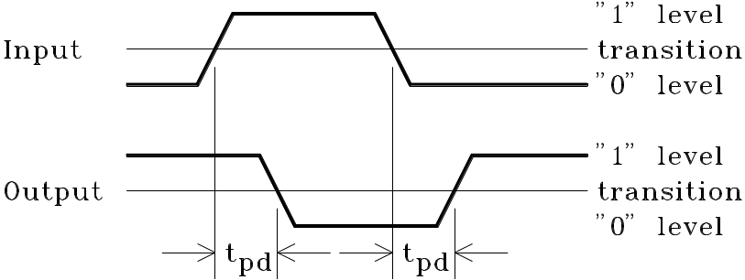

7. Find the state diagrams and sequential functions of the following circuits：
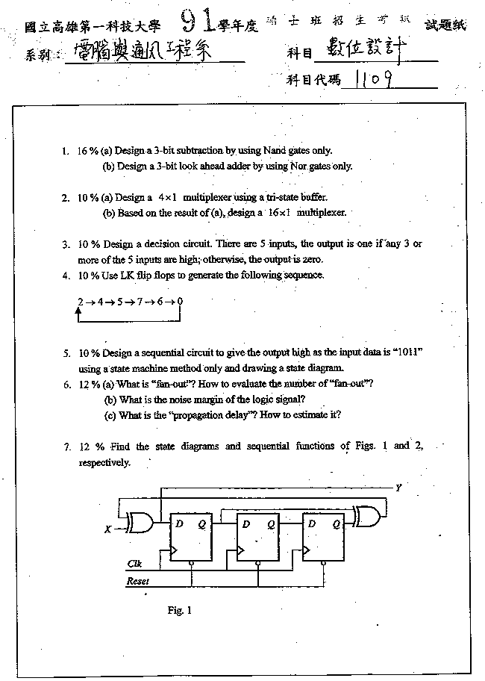

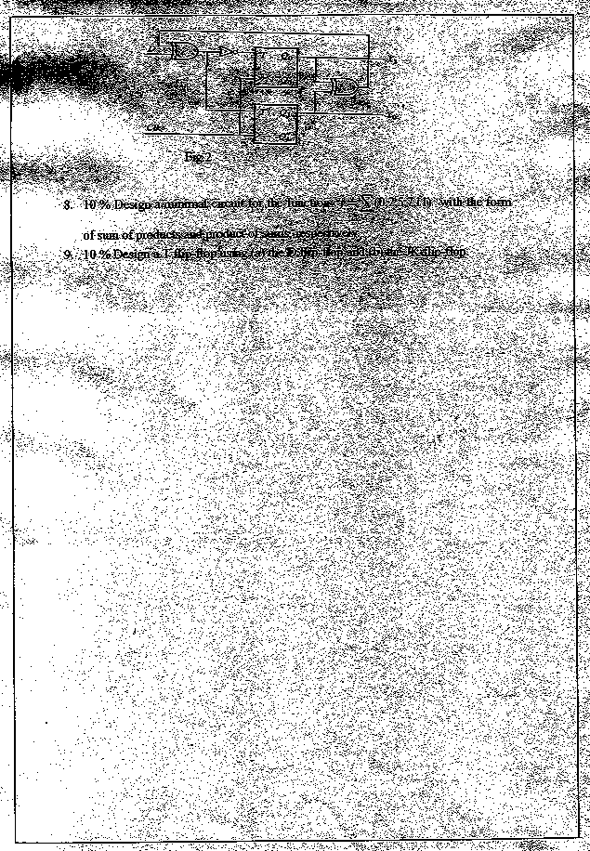

【解答】
序向電路分析，參閱下列說明：
1‧列出正反器輸入之布林函數‧
2‧繪狀態表(State Table)‧
3‧繪狀態圖(State Diagram)‧
示例1：

A B

Q Q' Q Q'
CLK CLK
J_{A} K_{A} J_{B} K_{B}

X

CLOCK

1‧列出正反器輸入之布林函數‧
J_{A}=B，K_{A}=B‧X'，J_{B}=X'，K_{B}=A⊕X
2‧繪狀態表(State Table)‧
現在狀態 |  | 外加輸入 |  | 正反器輸入 |  |  |  |  | 次一狀態
A | B | X |  | J_{A} | K_{A} | J_{B} | K_{B} |  | A | B
0 | 0 | 0 |  | 0 | 0 | 1 | 0 |  | 0 | 1
0 | 0 | 1 |  | 0 | 0 | 0 | 1 |  | 0 | 0
0 | 1 | 0 |  | 1 | 1 | 1 | 0 |  | 1 | 1
0 | 1 | 1 |  | 1 | 0 | 0 | 1 |  | 1 | 0
1 | 0 | 0 |  | 0 | 0 | 1 | 1 |  | 1 | 1
1 | 0 | 1 |  | 0 | 0 | 0 | 0 |  | 1 | 0
1 | 1 | 0 |  | 1 | 1 | 1 | 1 |  | 0 | 0
1 | 1 | 1 |  | 1 | 0 | 0 | 0 |  | 1 | 1

3‧繪狀態圖(State Diagram)‧
1
0 1
00 狀態B： 11
狀態A：
0 0 0

01 10 1
狀態C： 1 狀態D：

示例2：

X X S S
Y Y全加器
Z C D Q

1‧列出正反器輸入之布林函數‧
D=C=XY+YZ+XZ=XY+YQ+XQ
S=X⊕Y⊕Z=X⊕Y⊕Q
2‧繪狀態表(State Table)‧
現在狀態 | 外加輸入 |  |  | 正反器輸入 |  | 次一狀態 |  | 輸出
Q | X | Y |  | D |  | Q |  | S
0 | 0 | 0 |  | 0 |  | 0 |  | 0
0 | 0 | 1 |  | 0 |  | 0 |  | 1
0 | 1 | 0 |  | 0 |  | 0 |  | 1
0 | 1 | 1 |  | 1 |  | 1 |  | 0
1 | 0 | 0 |  | 0 |  | 0 |  | 1
1 | 0 | 1 |  | 1 |  | 1 |  | 0
1 | 1 | 0 |  | 1 |  | 1 |  | 0
1 | 1 | 1 |  | 1 |  | 1 |  | 1
3‧繪狀態圖(State Diagram)‧
10/1 10/0
00/0 01/1 01/0
11/0 11/1
0 1
狀態：進位為0 00/1 狀態：進位為1

第8題，第9題：網路下載之試題過於模糊，無法作答。

