Instruction on Mesh Model Display

School of Software, Tsinghua University

Yanzhe Yang, 2012013323

1. Environment

Python 3.5.0

2. Procedure

2.1 Start the server

Double click src/start-server-python2.bat or python3.bat.

Python 2/3 depends on version of Python, which can be checked via python -version.

2.2 Open the Browser

2.2.1 Open the Browser at <http://127.0.0.1:8000/main.html> or open the demo;

2.2.2 Overview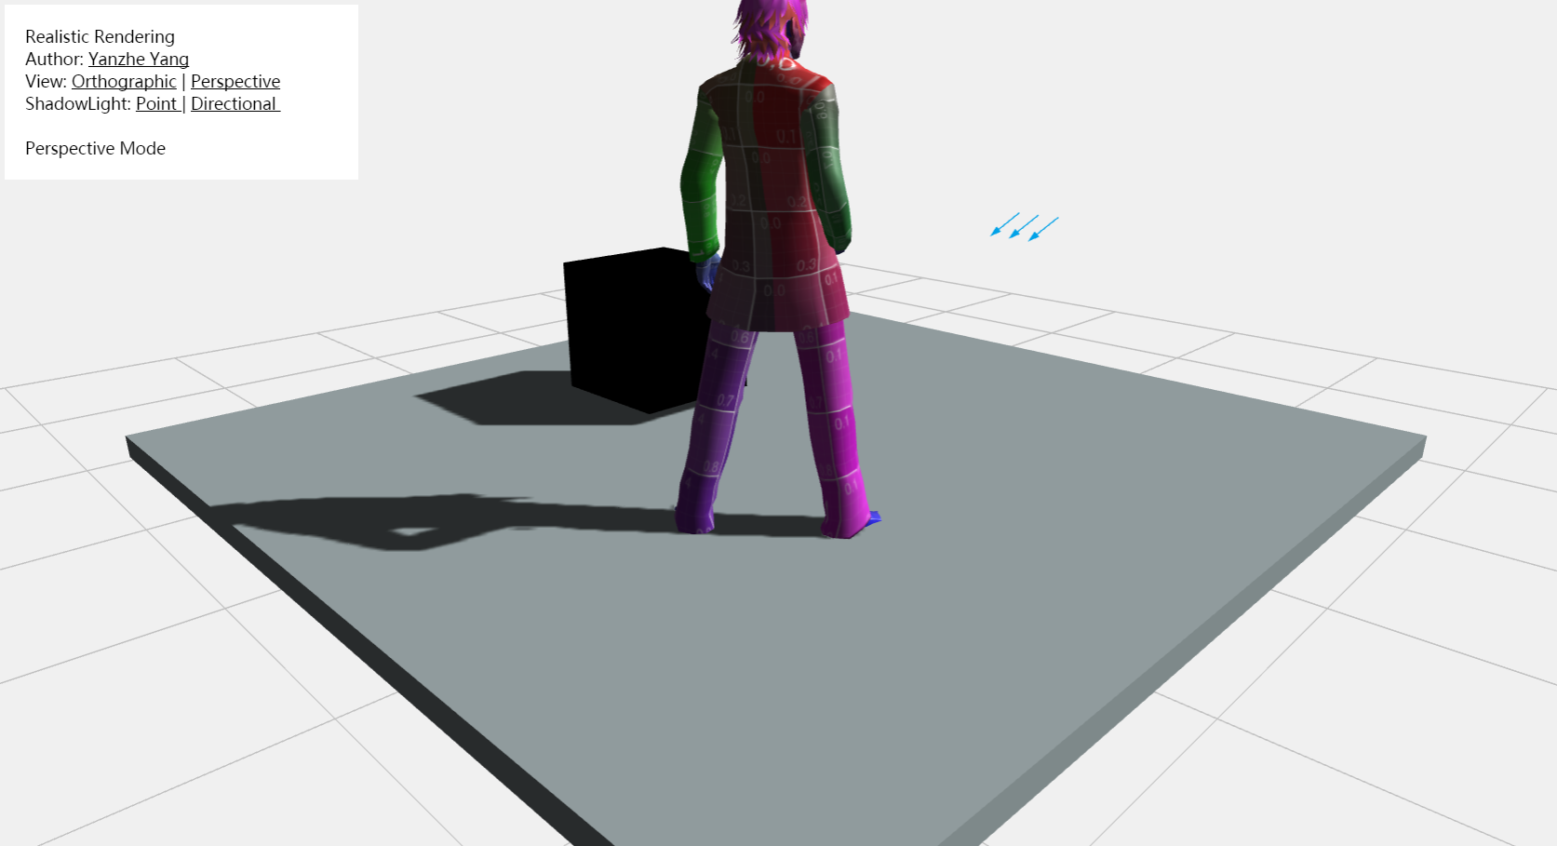

2.3 Operation

a. Rotation

Press the left button of the mouse and move in horizontal line. The rotation angle is relative to absolute mouse position in x;

b. Zoom

Roll the wheel in the mouse.

c. Translate

The direction buttons on the keyboard control the translation of the human model. Left and right buttons control left and right movements on axis x, while up and down buttons correspond to the movements on axis z. To move the model in vertical direction, you should use “+” or ”-“ in number zone.

d. Change the light and view mode

Click the links in toolbor.