HYCHIKA
Intelligence fuels Cleanliness

Spot Cleaner
BY101
User Manual
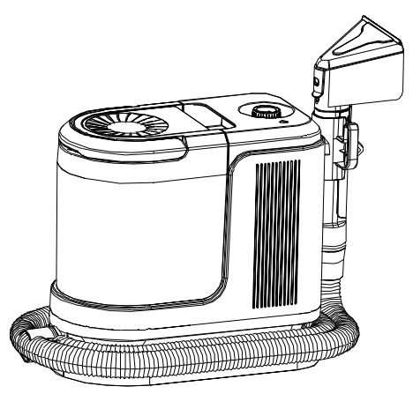
Thank you for Choosing HYCHIKA!
Please read this instruction manual carefully before use and retain it properly for future reference.

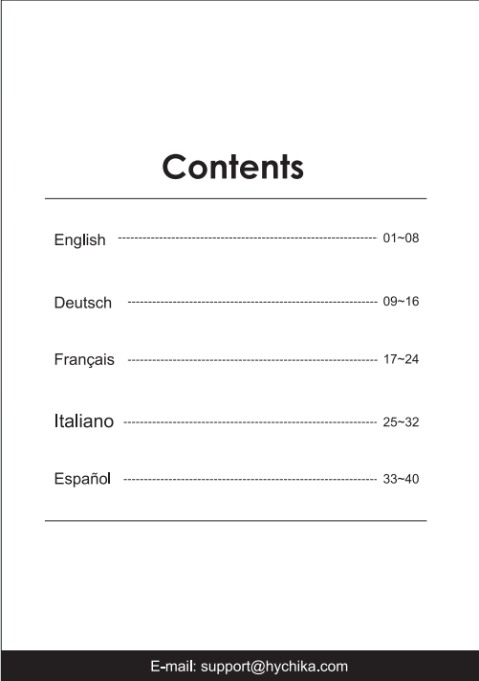

Thank You for Choosing HYCHIKA
Dear Valued Customer,
We are truly delighted you've chosen HYCHIKA! Your trust in our Spot Cleaner warms our hearts. It’s an honor to serve you, and we’re committed to delivering not just superior quality, but an effortless and joyful cleaning experience that brightens your days.
At HYCHIKA, crafting exceptional service is woven into our DNA. Your happiness guides everything we do. Whether you have questions about your purchase, need troubleshooting tips, or simply wish to share ideas, our dedicated team is here for you with a smile—ready to resolve any request with care and efficiency.
We cherish the connection we’ve built with you and will keep nurturing it through thoughtful innovations and heartfelt support. Here’s to many more moments of making your home sparkle, together!
With warmth and gratitude,
The HYCHIKA Team
Email:support@HYCHIKA.com
Safety Precautions
WARNING
To ensure safety, this product complies with all applicable standards and regulations (low voltage, electromagnetic compatibility and environmental directives, etc).
Read all instructions before using this product. Use only as described in this manual. When using electrical appliances, basic precautions should always be followed to reduce the risk of fire, electric shock, and personal injury, including the following:​

1. INTENDED USE & PERSONNEL SUPERVISION
- This appliance is not intended for use by persons (including children) with reduced physical, sensory, or mental capabilities, or lack of experience and knowledge. They may use it only under the direct supervision of a person responsible for their safety, or if they have been given proper instruction on its safe use.
- Children must be supervised at all times to ensure they do not play with the appliance. This is not a toy.
- Keep the appliance and its power cord out of the reach of children and pets when it is plugged in, operating, or cooling down.
- ELECTRICAL SAFETY & POWER CORD
- Power Connection:Always plug the appliance into a properly earthed (grounded) electrical outlet. Do not modify the plug.
- Power Cord Handling:

The power cord is long for user convenience. Never immerse the cord in water or let it contact liquids.

If the supply cord is damaged, it must be replaced by the manufacturer, its authorized service agent, or a similarly qualified person to avoid a hazard.

Do not run over, pull, carry by, or misuse the power cord. Do not use it as a handle, close a door on it, or pull it around sharp edges or corners.

Keep the cord away from heated surfaces.

To unplug, always grasp the plug itself, not the cord.
- General Electrical Precautions:
  - Do not handle the plug or appliance with wet hands.
  - Do not use the appliance if the cable or plug is damaged.
  - Do not leave the appliance unattended while it is connected to the power supply.
  - Turn off all controls and always unplug from the outlet: when not in use, before any cleaning, maintenance, or servicing, before connecting or disconnecting accessory tools, and after use.
- HIGH-TEMPERATURE & STEAM SAFETY
- DANGER – Risk of Severe Burns:During operation, this appliance produces high-temperature steam (exceeding 100°C). The steam, nozzle, steam hose, appliance surfaces, and ejected water are extremely hot both during and for a considerable time after use. Direct contact will cause severe burns.
  - Never direct the steam nozzle or ejected hot water towards yourself, other persons, pets, plants, or heat-sensitive surfaces.
- WARNING – Safe Handling:
  - Do not touch the nozzle, steam hose, or hot parts of the appliance during operation or for at least 30 minutes after switching off.
  - Always ensure the appliance has completely cooled down before moving, cleaning, or storing it.
- OPERATION & ENVIRONMENT
- Use & Location:
  - For indoor, dry use only. Use on a firm, level surface. Do not place it on unstable surfaces (e.g., tables, chairs) where it may fall.
  - The operating ambient temperature range is 0°C to 50°C.
  - Keep the appliance away from cigarette butts, lighters, or any open flame.
- Pre-Use Preparation:
  - Before use, remove all fragile items (e.g., glass, lamps) and objects that may block the suction channel (e.g., wires, paper, curtains) from the cleaning area.
  - Ensure the dirty water (sewage) tank is empty before starting. Empty it when full during use.
- During Use:
  - To prevent tripping, inform other people in the room when the appliance is in use. Be mindful of the cord and hose.
  - Keep hair, loose clothing, fingers, and all parts of the body away from openings and moving parts.
  - Do not place any object (or allow anyone) heavier than 10 kg on the appliance.
  - The filling aperture must not be opened during use. Refer to the "Operations" section of this guide for safe refilling instructions for the water reservoir (for pressurized models).
- Prohibited Actions:
  - Do not immerse the appliance in water or other liquids. Use it only on surfaces moistened by the cleaning process.
  - Do not direct liquids towards equipment containing electrical components.
  - Do not use to pick up: flammable/combustible liquids (e.g., gasoline), toxic materials (e.g., bleach, ammonia), burning or smoking materials (e.g., cigarettes, hot ashes), or hard/sharp objects (e.g., glass, nails, screws, coins).
  - Do not use in enclosed spaces filled with vapors from oil-based paint, paint thinner, moth proofing substances, flammable dust, or other explosive/toxic vapors.
  - Keep openings free of dust, lint, hair, or anything that may block airflow. Do not put any object into openings.
- MAINTENANCE, STORAGE & SERVICING
- If the appliance needs cleaning, do so only after it is unplugged and has completely cooled down.
- Do not place heavy or sharp objects on the machine.
- The power cord can be wound around the storage hook on the back of the main unit for neat storage.
- Do not disassemble this product. All servicing must be performed by authorized service technicians.
- Do not attempt to use or repair the appliance if it is not working correctly, has been dropped, shows visible damage, is leaking, has been left outdoors, or dropped into water. Contact an authorized service center.
- GENERAL
- Use the appliance and its accessories only as described in this guide and with manufacturer-recommended attachments.
- The plastic film from packaging can be dangerous. To avoid the risk of suffocation, keep it away from children and dispose of it immediately.

Product Description
Technical Specifications
Product Name | Spot cleaner | Model | BY101
Rated Voltage | 220-240V ~ 50-60Hz | Rated Power | 1800W
Power Cord Length | 5 m(16.4 ft) | Hose Length | 1.5m(4.9 ft)
Clear tank capacity | 1000mL | Sewer tank capacity | 1000mL
Noise | ≤83dB(A) | Classification of waterproof | IPX4
Boiler heating time | 30s | Operating ambient  temperature | 0-50℃

Product Overview
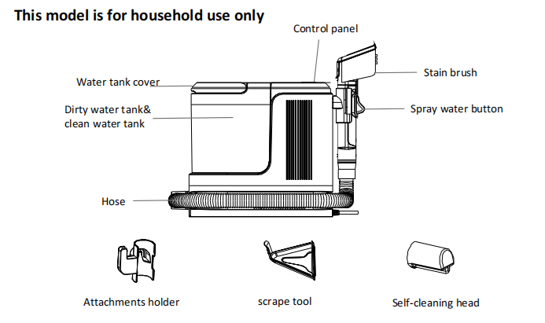
Key functions
Before use, insert the power plug into a standard socket with a voltage of 220~ 240V and a current capacity of at least 10A.
Power button | Control the device's on / off
Mode selector | Suction mode、steam mode、cold water mode、hot water mode

Operating Instructions
Preparation
- Before starting work, move the machine to the working position, connect the stain brush
with the handle. (Refer to Figure 1)
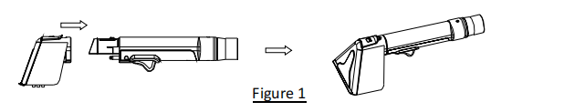
- Connect the hose with the host body. (Refer to Figure 2)
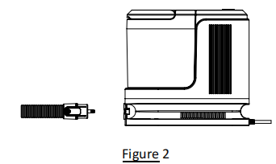
- Assemble the attachments holder.(Refer to Figure 3)
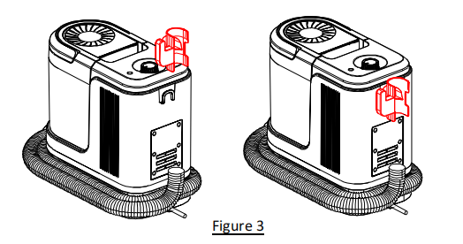
Usage
- Remove the whole water tank from the body, move the tank cover, open the clean water tank and fill with clean water until Max water lever. Install the water tank into the body. When the water tank is short of water, please fill it in time.(Refer to Figure 4)
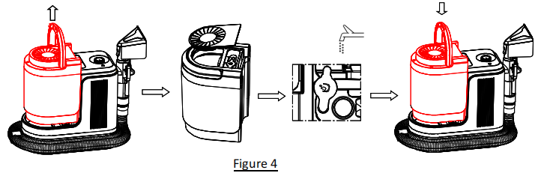
- Unwind the hose and power cord before handling. Plug in the socket+ Rotate the knob for starting the appliance. (Refer to Figure 6)
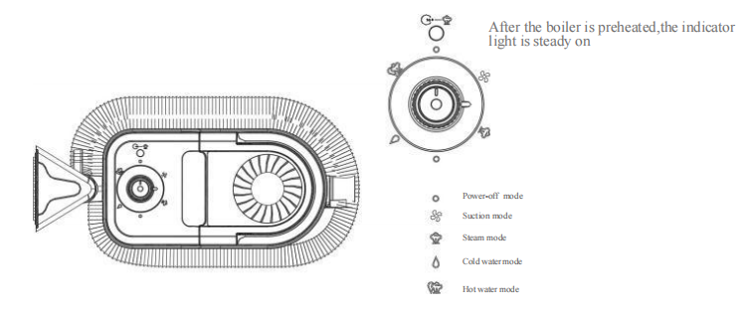
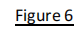
- This product features three temperature modes: "Cold Water" corresponds to room temperature water, "Hot Water" corresponds to 60°C water, and "Steam" corresponds to 100°C steam. Hot water quickly dissolves dirt and improves cleaning efficiency, while steam dissolves dirt more deeply for a thorough clean.
- Adjust the mode as needed. Hold the cleaning brush and press the "Water Spray" button on the bottom of the brush head—the nozzle will spray water continuously. Release the button to stop the spray.(Refer to Figure 7)
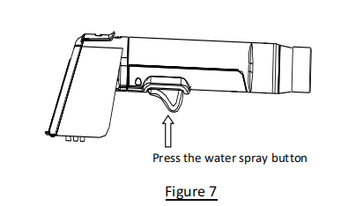
- For regular stains: Pour clean water into the clean water tank. Spray water onto the stained area of the fabric surface to moisten the stain. After spraying, wipe repeatedly with the cleaning brush to allow the stain and dirty water to be sucked into the dirty water tank. Repeat the suction several times to quickly clean the stain. It is recommended to clean once more with clean water afterward to prevent any cleaning solution residue in the fabric.
- For stubborn stains or deep cleaning: Set the machine to hot water or steam mode. Spray while cleaning, and use the included scrubbing head to scrub repeatedly 5–8 times. Suck the sewage into the sewage tank and repeat several times to quickly remove stains and achieve deep cleaning.
Replacement and use of the brush head
You can replace and use the brush head according to different usage scenarios and fabric materials:1. For fabrics with relatively hard textures (Such as cotton-linen, tech fabric sofas, and carpet fabrics), use the standard cleaning brush. The standard cleaning brush has stiff bristles and high bristle density,so it offers high cleaning efficiency.
- For hard flat-surface stains (e.8., on glass, marble tabletops, or floors),the multi-functional cleaning brush head will work more efficiently.(Refer to Figure 8)
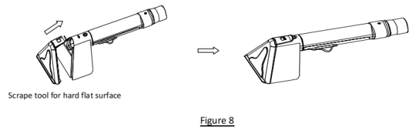

Cleaning and Maintenance
WARNING: Ensure that the unit is powered off and disconnected from the power supply.
Clean the sewage tank
- To maintain optimal performance, clean the wastewater tank immediately after use. If the tank contains excessive wastewater,the product's suction capacity will decrease. When the water level reaches or approaches the maximum capacity line, promptly empty the tank. After removing the wastewater tank from the main unit,drain all accumulated wastewater and debris,then thoroughly rinse and clean the interior with clean water.
- Sewage tank disassembly method: Pull the sewage tank straight, and the sewage tank can be disassembled as a whole. Then, press the release button of the sewage tank cover,open the cover, and clean the sewage tank.(Refer to Figure 9)
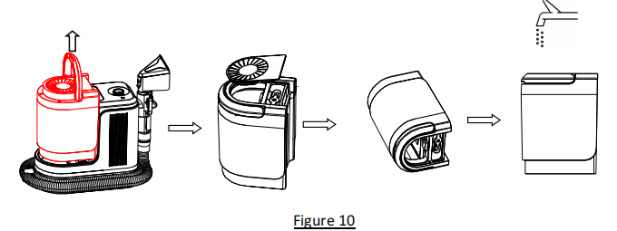
Clean the brush
Cleaning the appliance after each use is advised to prolong its service life and promote hygiene.(Refer to Figure 10)
When the cleaning brush is entangled with hair or blocked by dirt, please clean and maintain it promptly.
- When the cleaning brush is entangled with hair, use a tool to remove the hair or dirt from the bristles.
- When the cleaning brush pipe is blocked, remove the transparent cover above the cleaning brush and use chopsticks or other tools to clean the air duct inside the cleaning brush handle.
- If the spray hole on the brush head becomes clogged (e.g., no water flow or water spray scatters), carefully use a pin or needle to clear the blockage.
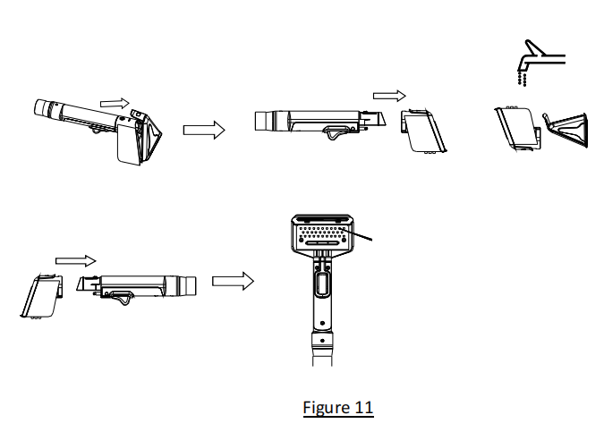
Clean the Pipeline
- Install the self-cleaning brush head to the handle, open the machine, and start the machine to clean the pipe at the same time by pressing the water spray button;(Refer to Figure 11)

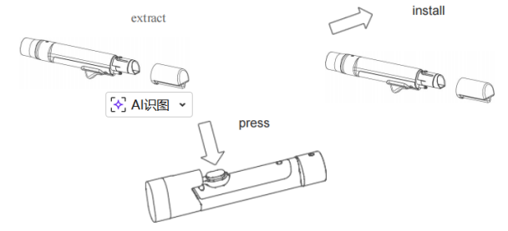

Troubleshooting Guide
If you notice any abnormalities during use, please refer to the table below.

Abnormal condition | Possible cause | Processing method
The stain brush can t spray water | The nozzle is blocked, the water tank is low, the internal water pipe is blocked or the water pipe is broken | Remove the nozzle blockage with a fine needle.Add water to the water tank promptly.Contact the merchant or after-sales service.
Noise anomaly | The product suction port is blocked or large garbage 1ssucked in motor failure | Clean the blockage Contact the merchant or after-sales service
The suction is weak or does not absorb water | Too much sewage in the sewage tank clogs the suction port | Clean the sewage tank promptly Clear blockages promptly
The machine is malfunctioning or not working | The ambient temperature is too high or to0o low | Keep the machine in a suitable ambient temperature  (O℃-50℃)
Hot water fails to reach the set temperature | Slow boiler heating,Boiler fails to heat,Temperature drop in hose water pipe | Contact the seller or after-sales service

DECLARATION OF CONFORMITY
Object of the declaration:
Product Spot Cleaner
Mode/ type BY101
Asin B0GDCZ7BWK
Manufacture Suzhou JinWuYang Electrical Technology Co., Ltd
Address 5th Floor, Building 4, No. 268 Mayun Road, High tech Zone, Suzhou City, Jiangsu Province, China
European Representative CET PRODUCT SERVICE SP. Z O.O.
Address Ul. Dluga 33 102 Zgierz 95-100 Polen
Brand HYCHIKA BETTER TOOLS FOR BETTER LIFE
Brand Owner ZOKING GLOBAL (HONG KONG) LIMITED
Address ROOMS 1318-19, HOLLYWOOD PLAZA,MONGKOK, KOWLOON,HONG KONG
This declaration is issues under the sole responsibility of the brand owner
The object of the declaration described above is in conformity with the relevant Union harmonization legislation :
2014/35/EU The Low Voltage Directive
2014/30/EU The Electromagnetic Compatibility Directive
2011/65/EU The Restriction of Hazardous Substances Directive
1907/2006/ EU The REACH Regulation
2019/1021/EU The POP Regulation
Conformity is shown by compliance with the applicable requirements of the following documents:
EN 60335-1:2012+A11:2014+A13:2017+A1:2019+A2:2019+A14:2019+A15:2021+A16:2023
EN IEC 55014-1:2021
EN IEC 55014-2:2021
EN IEC 61000-3-2:2019+A1:2021+A2:2024
EN 61000-3-3:2013+A1:2019+A2:2021
The CE markings as shown below can be affixed on the product after preparation
of necessary conformity documentation, as stipulated in CE Marking
Directive 93/68/EEC.
Harmonized standards: CE
Date of issue: February 01,2025
Name: ZOKING GLOBAL (HONG KONG) LIMITED
Address:ROOMS 1318-19, HOLLYWOOD PLAZA,MONGKOK,KOWLOON,HONG KONG
Authorizing Person: Spencer Tang
Position: QA Director, ZOKING GLOBAL (HONG KONG) LIMITED
Signature:

DECLARATION OF CONFORMITY
Object of the declaration:
Product Spot Cleaner
Mode/ type BY101
Asin B0GDDKS6ZJ
Manufacture Suzhou JinWuYang Electrical Technology Co., Ltd
Address 5th Floor, Building 4, No. 268 Mayun Road, High tech Zone, Suzhou City, Jiangsu Province, China
British Representative CET Product Service Ltd.
Address Beacon House Stokenchurch Business Park, Ibstone Rd, Stokenchurch High Wycombe HP14 3FE UK
Brand HYCHIKA BETTER TOOLS FOR BETTER LIFE
Brand Owner ZOKING GLOBAL (HONG KONG) LIMITED
Address ROOMS 1318-19, HOLLYWOOD PLAZA,MONGKOK, KOWLOON,HONG KONG
This declaration is issues under the sole responsibility of the brand owner
The object of the declaration described above is in conformity with the relevant Union harmonization legislation :
2014/35/EU The Low Voltage Directive
2014/30/EU The Electromagnetic Compatibility Directive
2011/65/EU The Restriction of Hazardous Substances Directive
1907/2006/ EU The REACH Regulation
2019/1021/EU The POP Regulation
Conformity is shown by compliance with the applicable requirements of the following documents:
EN 60335-1:2012+A11:2014+A13:2017+A1:2019+A2:2019+A14:2019+A15:2021+A16:2023
EN IEC 55014-1:2021
EN IEC 55014-2:2021
EN IEC 61000-3-2:2019+A1:2021+A2:2024
EN 61000-3-3:2013+A1:2019+A2:2021
The CE markings as shown below can be affixed on the product after preparation
of necessary conformity documentation, as stipulated in CE Marking
Directive 93/68/EEC.
Harmonized standards: CE
Date of issue: February 01,2025
Name: ZOKING GLOBAL (HONG KONG) LIMITED
Address:ROOMS 1318-19, HOLLYWOOD PLAZA,MONGKOK,KOWLOON,HONG KONG
Authorizing Person: Spencer Tang
Position: QA Director, ZOKING GLOBAL (HONG KONG) LIMITED
Signature:

Manufacturer：Suzhou JinWuYang Electrical Technology Co., Ltd
ADD：5th Floor, Building 4, No. 268 Mayun Road, High tech Zone, Suzhou City, Jiangsu Province, China
Email:support@HYCHIKA.com
European Representative:
CET PRODUCT SERVICE SP. Z O.O.
Ul. Dluga 33 102 Zgierz 95-100 Polen
Tel: +4971416432236
Email：info@cetproduct.com
British Representative：
CET Product Service Ltd.
Beacon House Stokenchurch Business Park, Ibstone Rd, Stokenchurch High Wycombe HP14 3FE UK
Tel：+44 7419325266
Email: info@cetproduct.com

Made in China

认证标识
CE 垃圾桶 回收标

