参数：

num_filt_1 = 15 # Number of filters in first conv layer

num_filt_2 = 8 # Number of filters in second conv layer

num_filt_3 = 8 # Number of filters in thirs conv layer

num_fc_1 = 40 # Number of neurons in hully connected layer

max_iterations = 20000

batch_size = 100

dropout = 0.5 # Dropout rate in the fully connected layer

regularization = 1e-4

learning_rate = 2e-3

input_norm = False

**From2012：**

输入涨跌（-1，1）：

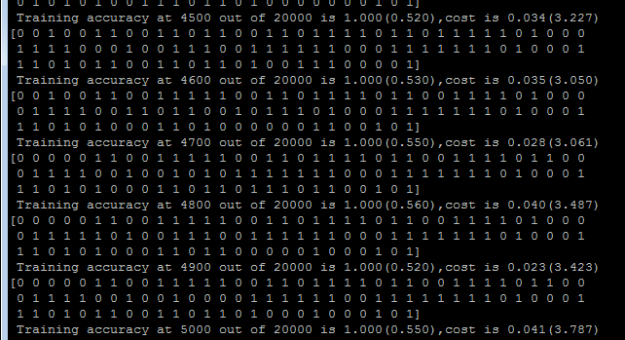

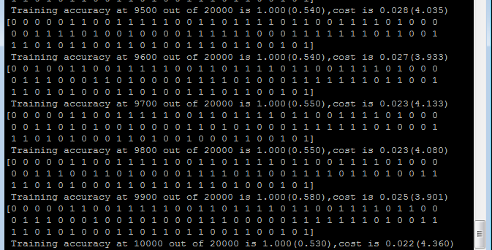

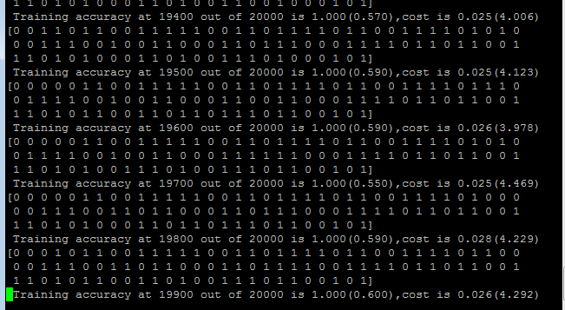

输入股价差：

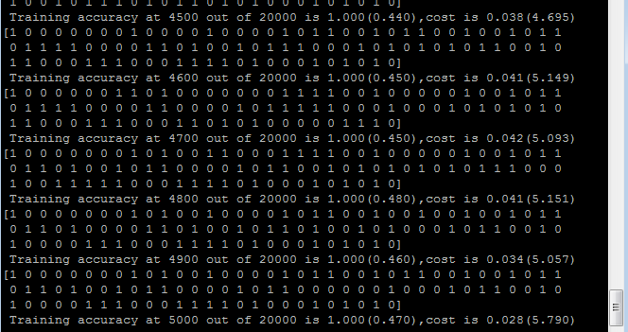

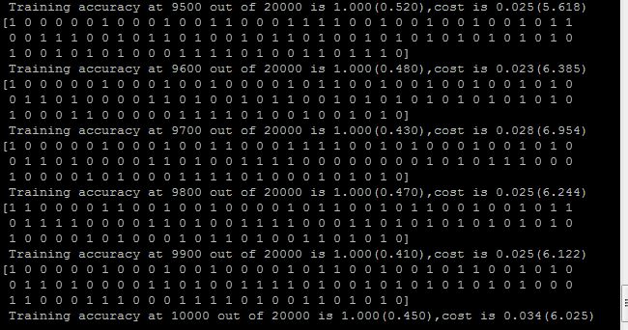

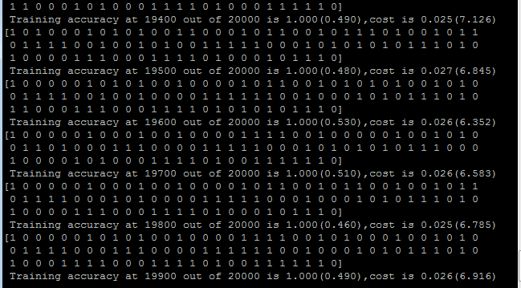

输入涨跌幅：

