cwt_accuracy.m：
How run the code：
When running the "cwt_accuracy.m" code and using the preset data path:
- If you comment out the code in lines 194 and 203, the program will calculate the detection performance based on the raw data and give the result "Detection performance based on raw data".
- Conversely, if you comment out the code in lines 195 and 204, the program will evaluate the detection performance based on the R ratio and output the result "Detection performance based on R-ratio".

Running result:
Detection performance based on raw data:
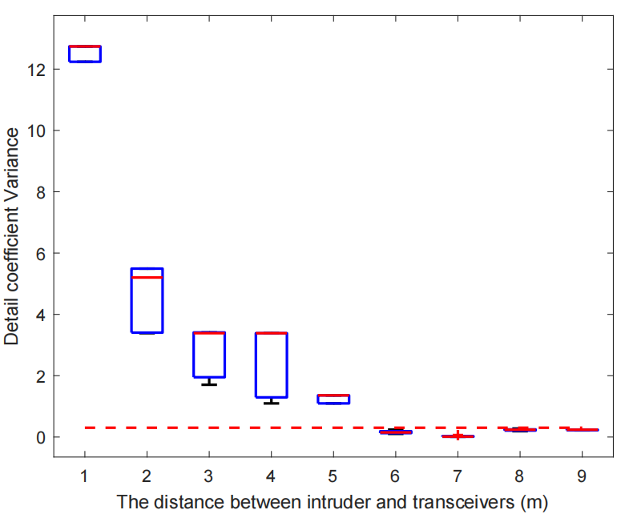
Detection performance based on R-ratio:
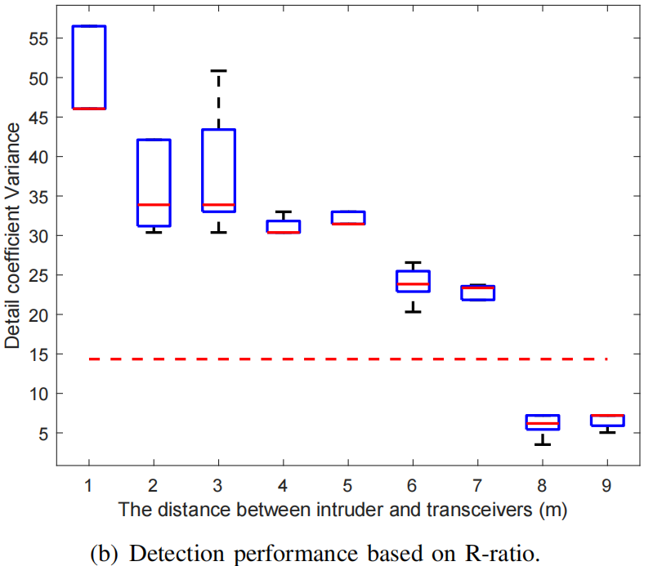
fft_power_sum_ratio.m
How run the code：
When running the "fft_power_sum_ratio" code and using the preset data path:
- By running the data in the three subfolders of the rss_data/corridor folder separately and commenting out the code in lines 162, you can obtain the detection results for the distances between transceivers in the corridor environment of 1 meter, 2 meters, and 3 meters. After combining and plotting the detection results corresponding to these three different distances, you can reproduce Figure 19(a) in the paper.
- By running the data in the three subfolders of the rss_data/meeting folder separately and commenting out the code in lines 161, you can obtain the detection results for the distances between transceivers in the corridor environment of 1 meter, 2 meters, and 3 meters. After combining and plotting the detection results corresponding to these three different distances, you can reproduce Figure 19(b) in the paper.

Running result:
Corridor:(1m,2m,3m)
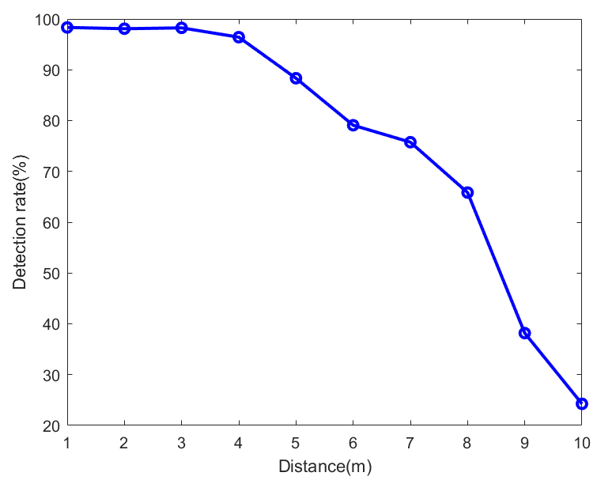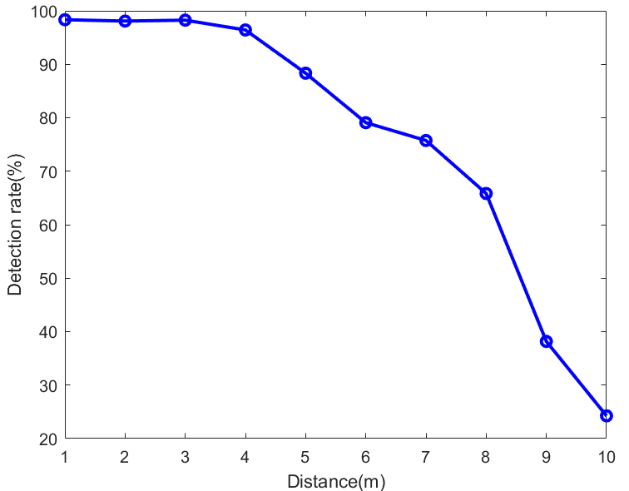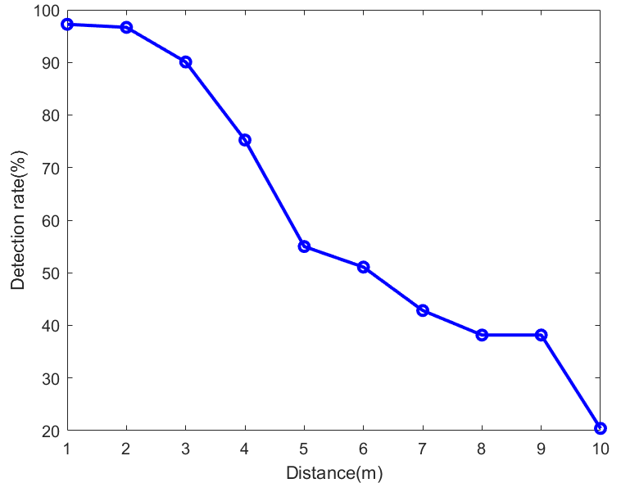
Meeting:(1m,2m,3m)
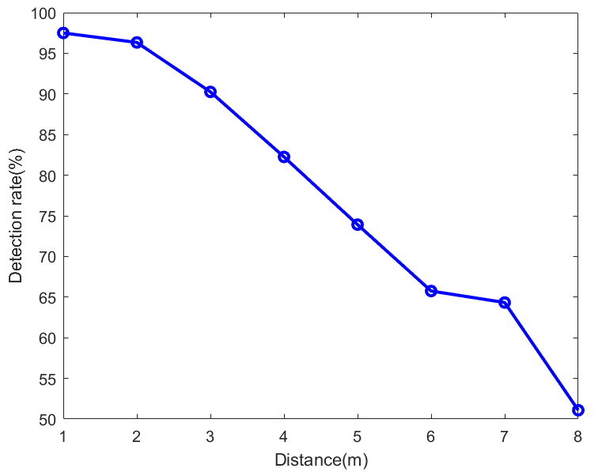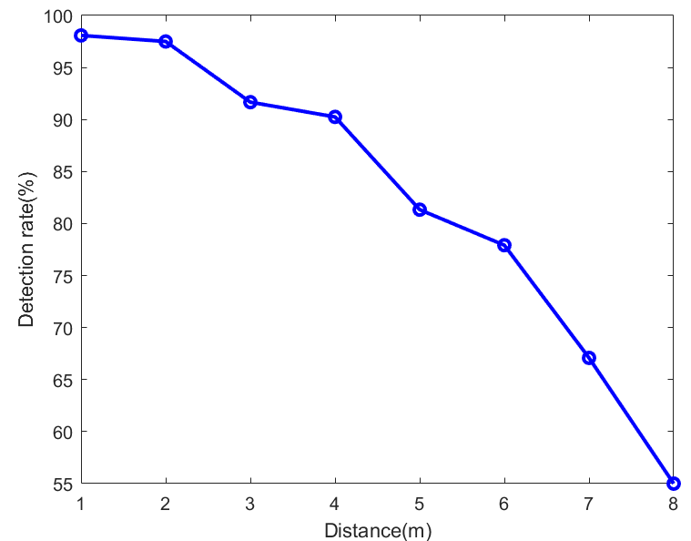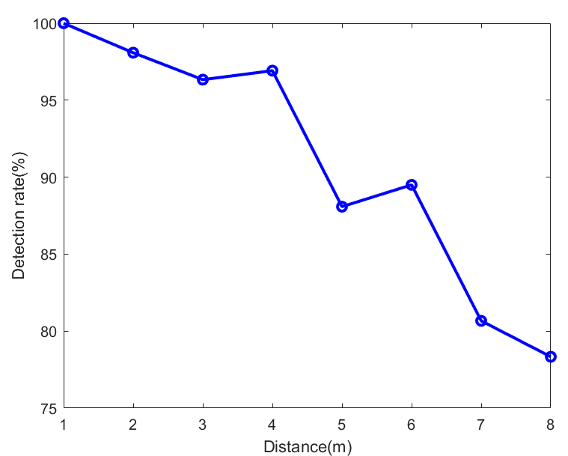

Result_draw.m:
How run the code：
By running the fft_power_sum_ratio.m script and processing the volunteer data and angle data in the preset path, we can obtain a series of experimental results. These results will be stored in the rss_data/volunteer and rss_data/angle folders in the form of .mat files. Later, we can load and use these data for plotting in the result_draw.m file.

Running result:
