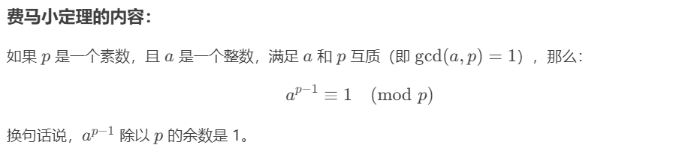

证明：[费马小定理](https://blog.csdn.net/qq_61832536/article/details/131625774?ops_request_misc=%257B%2522request%255Fid%2522%253A%2522e4ee94528e8ee79591da1dee8d9af407%2522%252C%2522scm%2522%253A%252220140713.130102334..%2522%257D&request_id=e4ee94528e8ee79591da1dee8d9af407&biz_id=0&utm_medium=distribute.pc_search_result.none-task-blog-2~all~top_positive~default-1-131625774-null-null.142%5ev102%5epc_search_result_base3&utm_term=%E8%B4%B9%E9%A9%AC%E5%B0%8F%E5%AE%9A%E7%90%86&spm=1018.2226.3001.4187)

$a^{p-2}$ 即是a的逆元

快速幂：

