离线打包构建修改

### 1. buildingContext.js修改

distDir、deployDir修改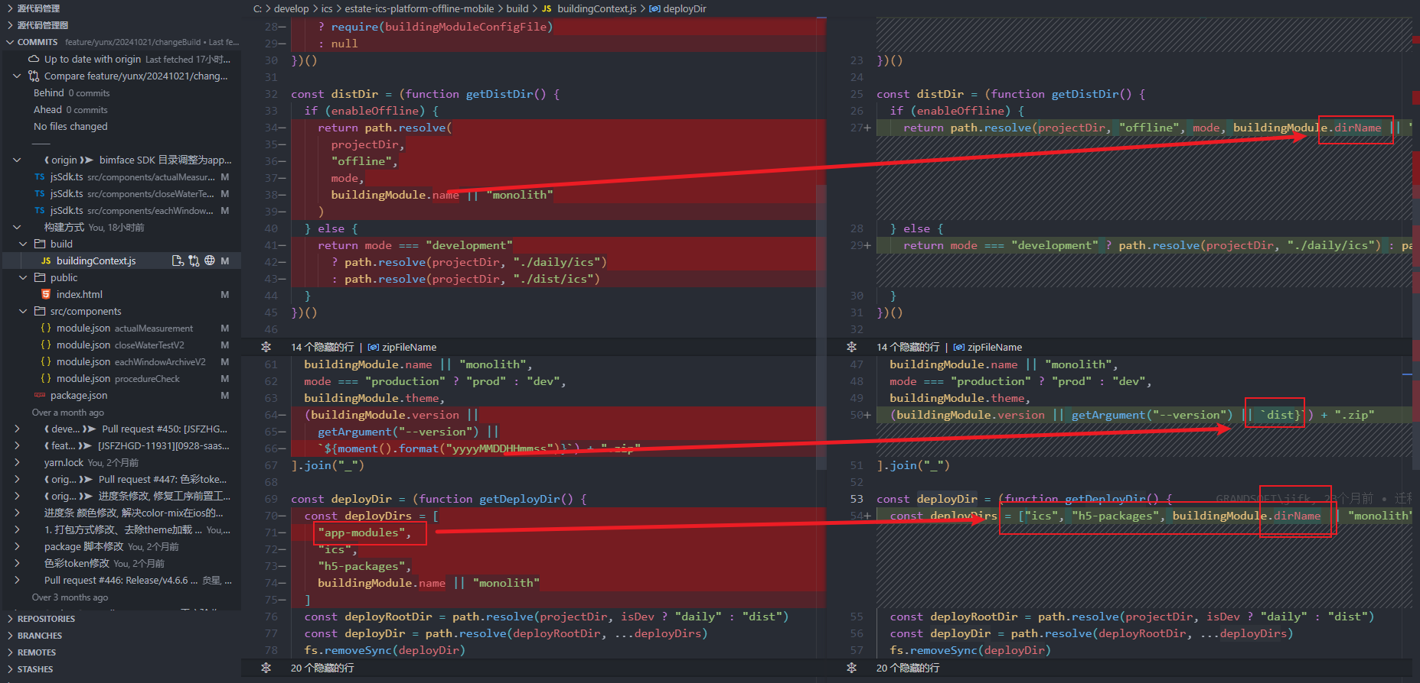

### 2. module.json 修改

新增dirName目录参数, 对应值需要与模块的参数配置一致

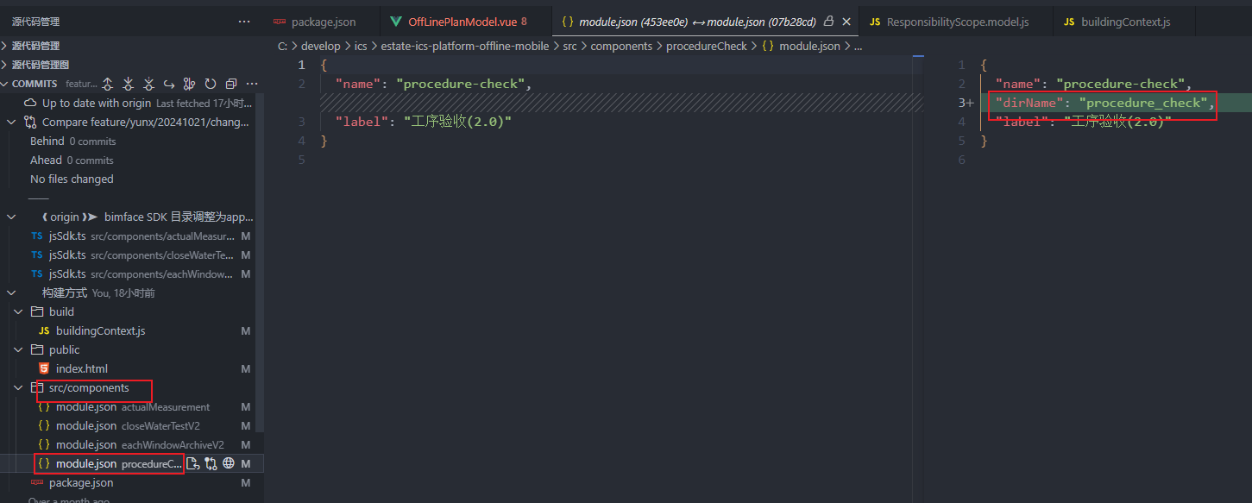

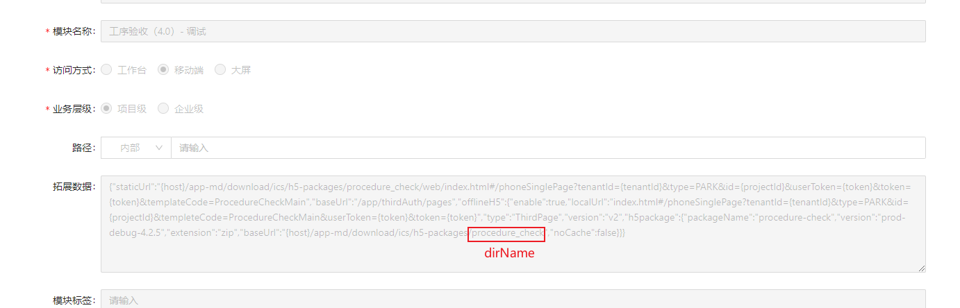

### 取消一个模块打正式包和debug包

统一打一个包, vConsole调试由模块的扩展参数中, url的参数控制

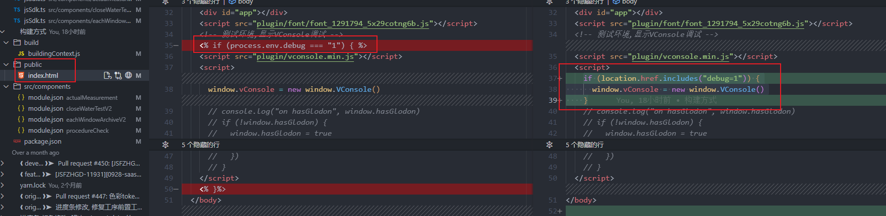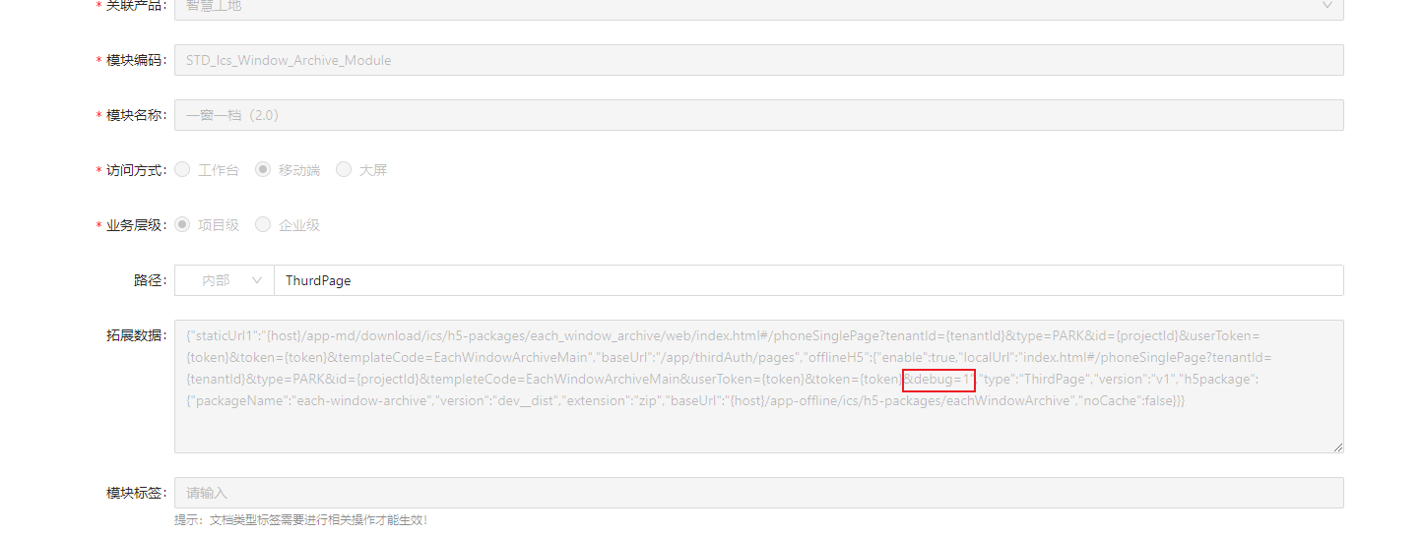

if (location.href.includes("debug=1")) {

window.vConsole = new window.VConsole()

}

### package.json 打包命令修改

json 打包命令修改

{

"select:procedure-check": "node ./build/selectModule.js --module=procedure-check --version=dist",

"select:actual-measurement": "node ./build/selectModule.js --module=actual-measurement --version=dist",

"select:each-window-archive": "node ./build/selectModule.js --module=each-window-archive --version=dist",

"select:close-water-test": "node ./build/selectModule.js --module=close-water-test --version=dist",

"build:dev-single": "yarn build:dev@offline --mode=development --offline=offline",

"build:prod-single": "yarn build:prod@offline --mode=production --offline=offline",

"build:dev": "yarn select:procedure-check && yarn build:dev-single && yarn select:actual-measurement && yarn build:dev-single && yarn select:each-window-archive && yarn build:dev-single && yarn select:close-water-test && yarn build:dev-single",

"build:prod": "yarn select:procedure-check && yarn build:prod-single && yarn select:actual-measurement && yarn build:prod-single && yarn select:each-window-archive && yarn build:prod-single && yarn select:close-water-test && yarn build:prod-single",

}

新增模块选择命令

select:procedure-check

单个打包 build:dev-single build:prod-single

测试环境打包 build:dev

生产环境打包 build:prod

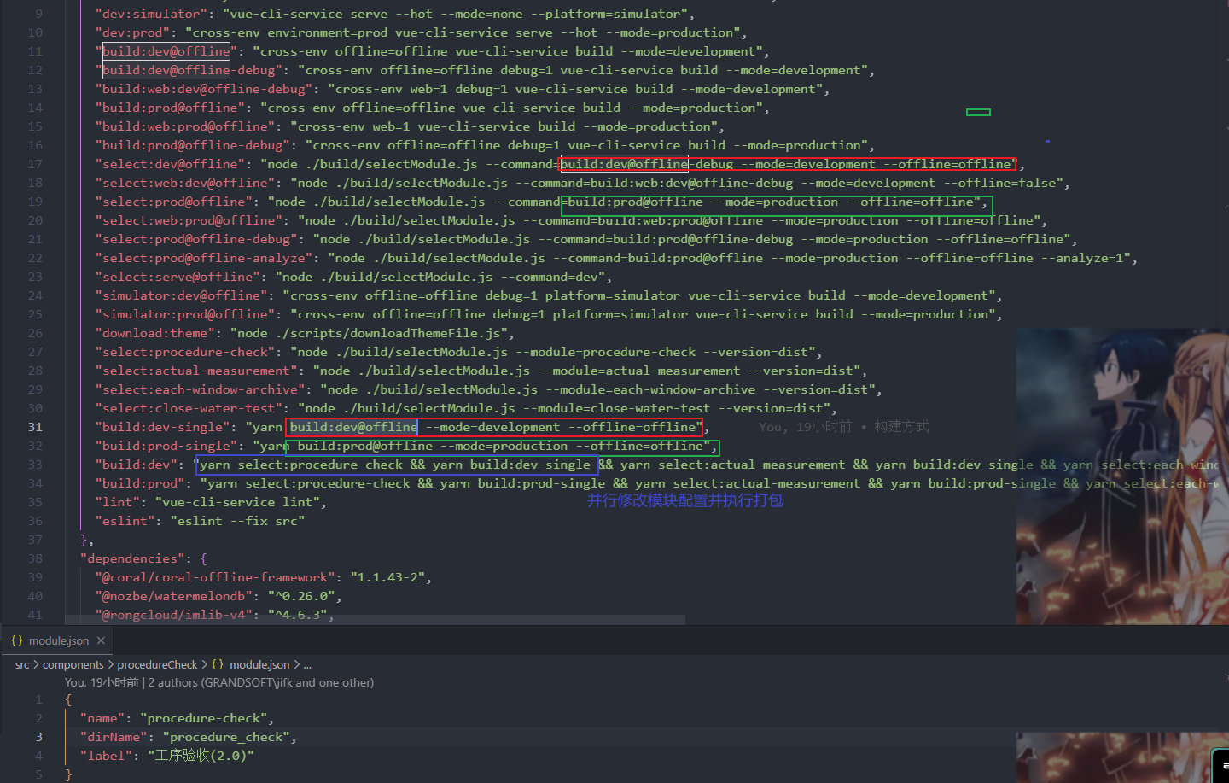

### 5. 模块的扩展参数修改

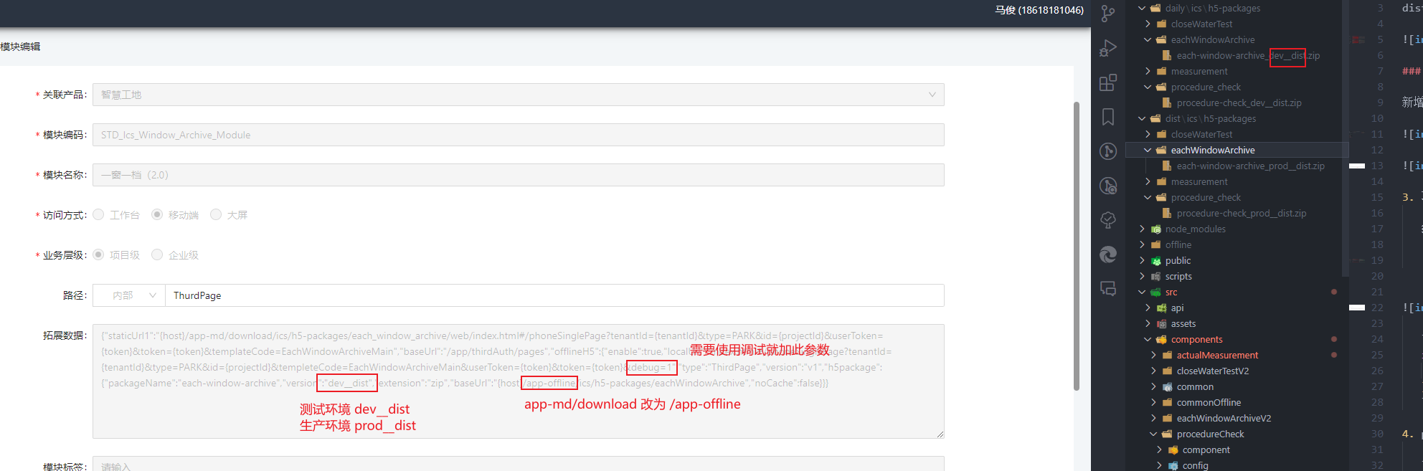

### jenkins构建

jenkins仓库

<http://jenkins.glodon.com/job/esplatform/job/estate-offline-product/>

代码合并到develop没有触发自动构建的话, 手动执行一下对应的jenkins任务

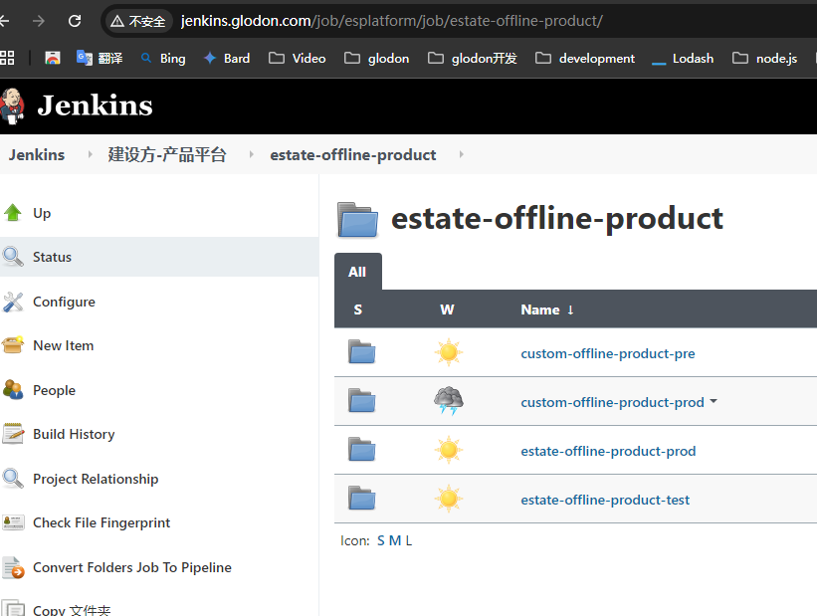

镜像

<http://jenkins.glodon.com/job/esplatform/job/estate-web-image-build/job/web-image-build-custom/job/estate-app-offline/>

