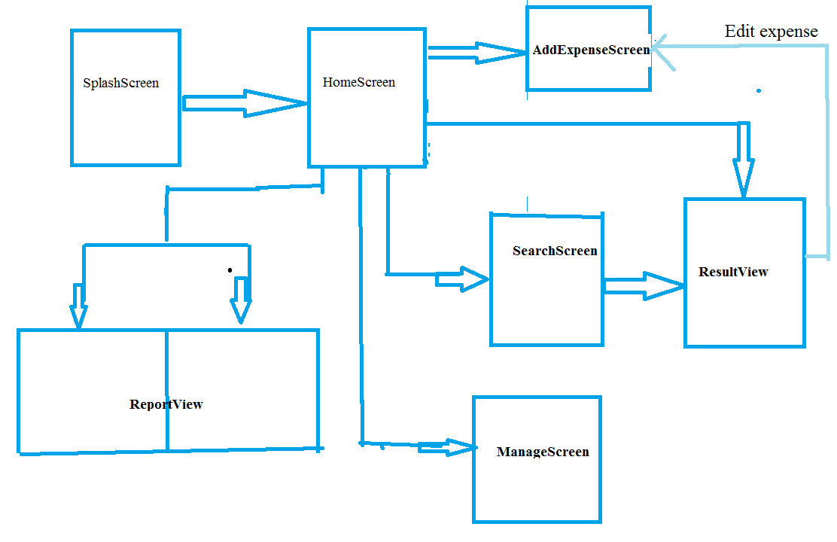

This is the flow of the program, the name above should be the name of each Activity.

- **Splash Screen is** the animated screen that appears when the program start up. We just need to design a picture for it cause previously I’ve done it. So we do it later.

- **HomeScreen** shows these information:

~ The daily expenses, the total expense for today

~ The weekly expenses, total expense for this week. Calculated from Monday to

Sunday which also includes last month’s expense. Eg ( Mon 25 Feb 2013 – Sun 3

March 2013)

~ The monthly expenses, total expense of this month. From 1st to the last day of this

month.

~ These information is stored in the shared preference

~ Whenever the three expense row is clicked, the app will go to

ResultScreen which show the expenses that are added.

~ Four buttons. ‘Add Expense’ go to AddExpenseScreen, ‘Manage Account’ goes to ManageScreen, ‘Report’ goes to ReportView, and ‘Search’ goes to SearchScreen

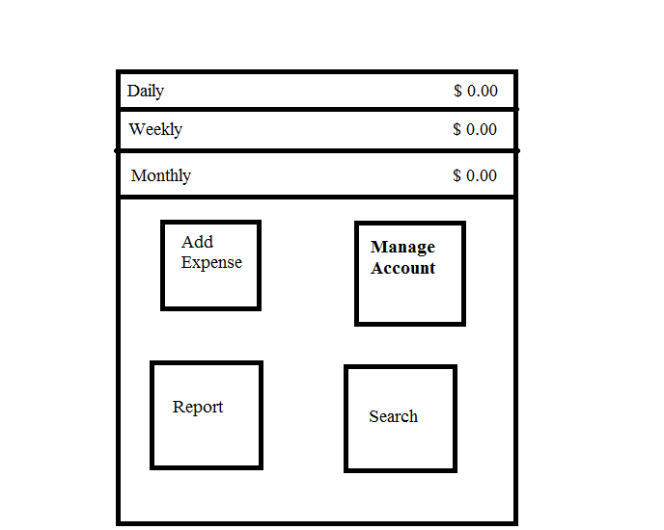

Figure 1: HomeScreen

- **AddExpenseScreen** is used add an expense record, we will use SQLiteDatabase to store the records. The preference in HomeScreen will also be updated.

~ Amount: Only allows digit inputs, default is $0.

~ Date: Default value is today’s date.

~ Name: name of the item. Eg chicken rice

~ Category: The category of the expense. Eg. Food & Drink, HouseHold

~ SubCategory: Subset of the category. subcategory for Food & Drink would be lunch, breakfast, dinner .....

~ Notes: Text information, for extra info/description

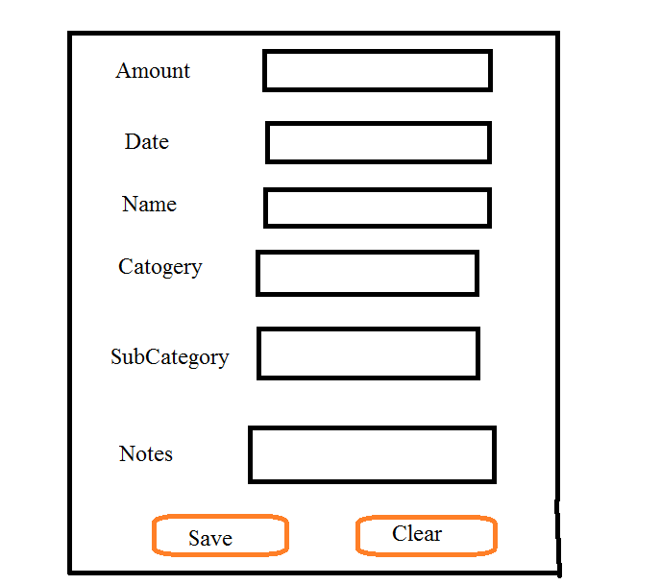

**AddExpenseScreen**

**SearchScreen** is used to search the records in the database. Will go to ResultView to show the result query. At least one of the field is required.

~ Date: from what date to what date. Default today to today

~ Name: name lor

~ category: there’s a option ‘All’, the subcategory will be disable if All is choosen. Default = all

~ subCategory: also have an ‘All’ option. Default is disable or All

~ Search: submit for query, goes to ResultView

~ Clear: clear all to default value

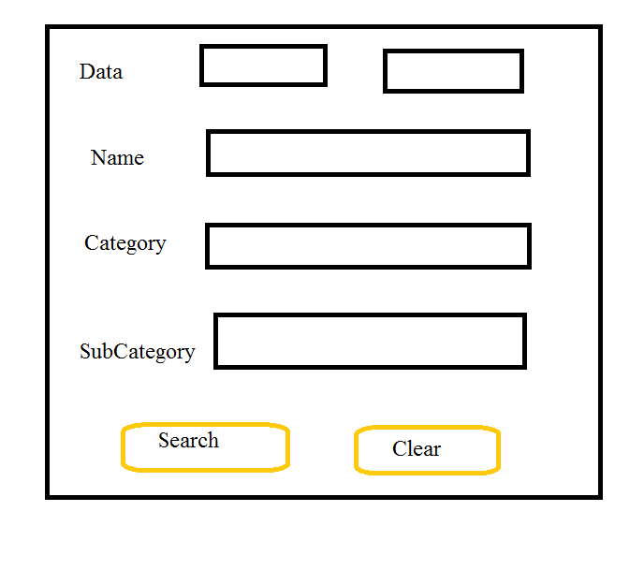**SearchScreen**

**ResultView** displays the result from either the Activity in HomeScreen (When one of the three type expense is clicked) or the query from SearchScreen

~ Date: the date range

~ Records count: number of records found

~ In bottom part which shows the expense info is a scrollable screen. Shows:

~ icon: the category icon

~ name

~ date added

~ price

~ category & subcategory

If the expense is clicked, it will goes to AddExpenseScreen which will loads the values so that it can be edit.

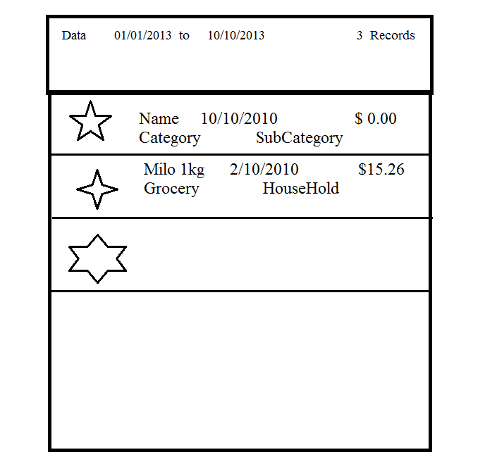

**ResultView**

**ManageScreen** is used to edit the settings for the main category and subcategory.

~ In the Top part:

~ Choose: to select the main category

~ Icon: Change the icon for the main category

~ The ‘A.’ Is To rename the main category name

~ ‘+’ button to add a sub category

~ ‘-‘ button to delete the main category, an alert box will appear for confirmation

~In the middle part shows the sub category of the current main category selected.

Able to rename and remove the sub category

~ In the bottom part is able to add a new main category.

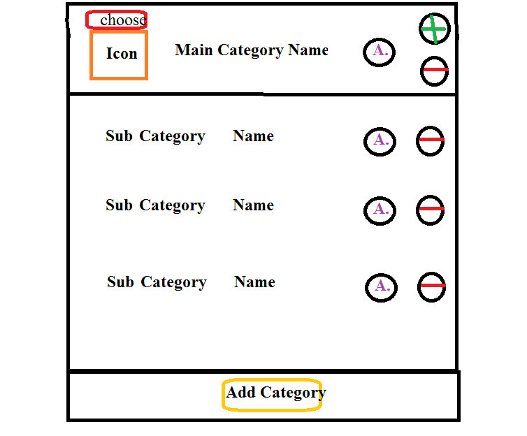

**MangeScreen**

**ReportView** is used to show graphical data, there is two type of result, bar chart and pie chart. The top right button will show the current selected view is in bar chart. The two buttons on the top right is clickable, used to interchange between pie and bar view.

~ Bar Chart is used to show the comparison data. In the top left corner is able to select ‘Year’, ‘Month’ and ‘Week’.

~ Year will group the total expense by year, each bar represent a year the text will also change to something like 2010 ~ 2013. The arrow button will be disable

~ Month: group by month, a bar a month, text: Jan 2012 ~ Dec 2012. Arrow button to change the year.

~Week: group by week, the week of this month, text: Feb 2013. Arrow Button changes the month

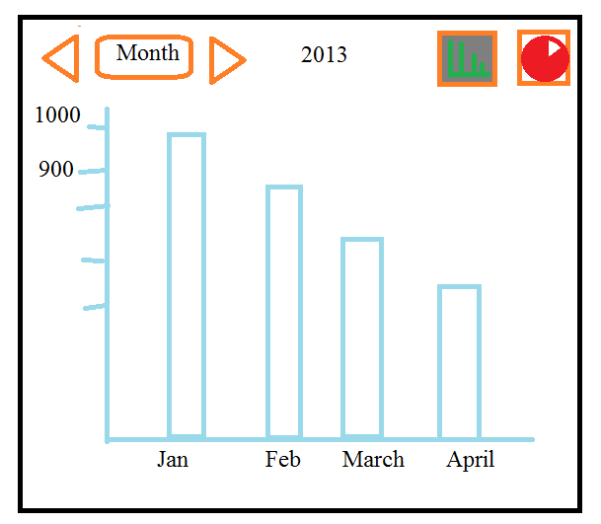

**ReportView – Bar Chart**

The pie chart is used to display break down results of week, month, and year. The text shows the range of the selected date, Top left icon will be change to show pie chart is selected.

~ percentage of the category is shown

~ in the bottom part show the main category name and the corresponding colors. Able to scroll.

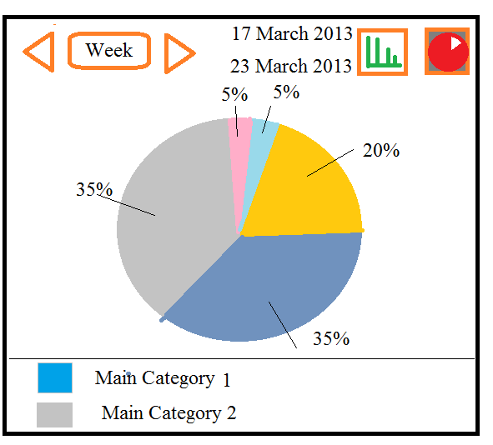

**ReportView – Pie Chart**