# Background

Pink noise or 1/f noise has been proved to widely exist in many scenarios. It fundamentally describes the energy description – lower frequencies tend to have larger amount of energy than high frequencies. And thus, this phenomenon is also called energy law. The ubiquity of this phenomenon has been proved in a wide range of applications. For example, 1/f noise is universal on electronic components, which leads to great amount of engineering effort to overcome it [1]. It is also proved that 1/f noise exists in music, with loudness inversely proportional to the pitch [2]. Even in human cognition, 1/f noise has been found, which affects spatial and temporal memory errors [3].

This report aims to demonstrate existence of 1/f noise, specifically in the form of ambient acoustic noise. Our environment is saturated by sound, resulted from natural vibrations, for e.g., thunder, wind, rains, etc. and human activities e.g., speaking, hammering, engine running etc. The same as previous findings in music, energy law applies in these ambient acoustic noise, with the loudness inversely proportional to the frequency of the noise. Through a series of data collection, visualization and analysis, this report demonstrates that 1/f noise exists in the environment noise of three locations – an apartment, a crossing of the street, and a classroom. These three locations are only a small subset of examples that we picked with different environment noise profiles. No doubt that 1/f noise can be found in many other locations.

# Hardware and Software

We used the built-in microphone of a Macbook Pro 13” for sound recording and processing. The sampling rate was configured at 44100 Hz. The recorded sound was used for FFT computation with a window size of 1024 data points. This report considers only the magnitude of the FFT computation. The FFT computation results were stored in CSV files for further analysis. Offline data analysis was done with Excel and the XLSTAT toolbox.

# Data Collection Procedure

To prove the ubiquity of 1/f noise, we collected 1 hour of background sound at three locations – an apartment, a crossing of the street, and a classroom. The 1 hour’s data collection results in 21,600 frames of FFT results collected from each location. These frames are averaged, and the results were used for analysis.

# Results

The background sound signals collected from all three locations exhibit noise energies inversely proportional to the frequency. Figure 1 shows examples of 10 seconds of time-series signals collected from the three locations. X axis is the time axis, while Y axis is the frequency axis ranging from 0 Hz to 22.05KHz. Just based on the three example

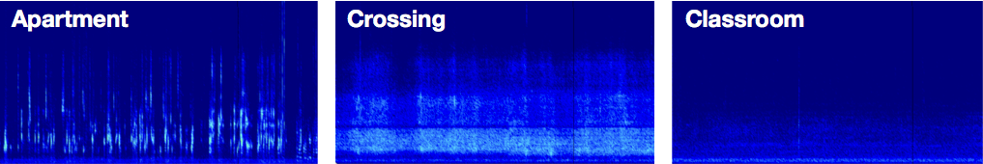

Figure 1 Time-series signals collected from three locations

Figure 2 shows energy spectrograms of the background sound signals collected from the three locations.

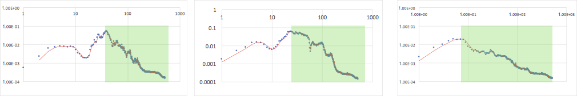

Figure 2. Energy spectrograms. From left to right: apartment, crossing, classroom.

The three spectrograms indicate 1/f noise across certain frequency ranges, highlighted in green. For example, in the signals collected from the apartment, 1/f noise exists only above 1.7kHz frequency. In a quiet classroom, the 1/f noise exists above 0.7kHz. In a noisy crossing, it was above 1.8 kHz.

It also demonstrates strong correlation when we fit the spectrograms of the collected signals to the p1*(X^p2) function. The fitted equations of the model, and their correlations scores are shown in table 1.

|  |  |  |
| --- | --- | --- |
| **Equations of the model** | **R2** | **Location** |
| Y1 = 1359.64525829485*(X1^-2.84671673186012) | 0.91 | Apartment |
| Y1 = 0.0833542947588511*(X1^-0.988107388801361) | 0.91 | Classroom |
| Y1 = 6.27341186865181*(X1^-1.43207532328287) | 0.92 | Crossing |

# References

1. Robert Kiely. Understanding and Eliminating 1/f Noise.
2. M. Gardner, Sci. Am. 238 (1978) 16.
3. David L. Gilden, Thomas Thornton, and Mark W. Mallon. "1/f noise in human cognition." Science 267, no. 5205 (1995): 1837.