# Background

Water pollution has been a significant problem, especially in developing countries where around 3.2 million children die each year as a result of unsafe drinking water and poor sanitation [1]. For areas where clean water is not accessible, it is also impossible to use professional water detecting equipment which are often very expensive. As a result, researchers have been working on information and communication technologies for development (ICT4D), including water quality detection, aiming to improve the accessibility of technologies in developing countries. This assignment aimed to develop a color sensor to quantify the water pollution level using LEDs. When LEDs are charged inversely, the time it takes to discharge relates to how much light they receive. The more photons they collect, the higher photocurrent they allow which cause a faster discharge. A nice tutorial can be found on SparkFun’s tutorial page [2]. Colored LEDs filter out other colors but their own colors, which provides us sensors that can be sensitive to only certain color components in the water.

# Hardware and Software

Figure 1 shows the setup of the measuring system. A red LED is bounded with a green LED. They are connected to an Arduino Nano. Four LED pins are connected to four digital pins on the Arduino, allowing us to control the output voltage and function mode in software. It is also possible to add more LEDs with different colors. However, we picked red and green for a proof of concept and to be optimized for sensing only certain types of air pollutions (e.g., red and green colored water caused by alga).

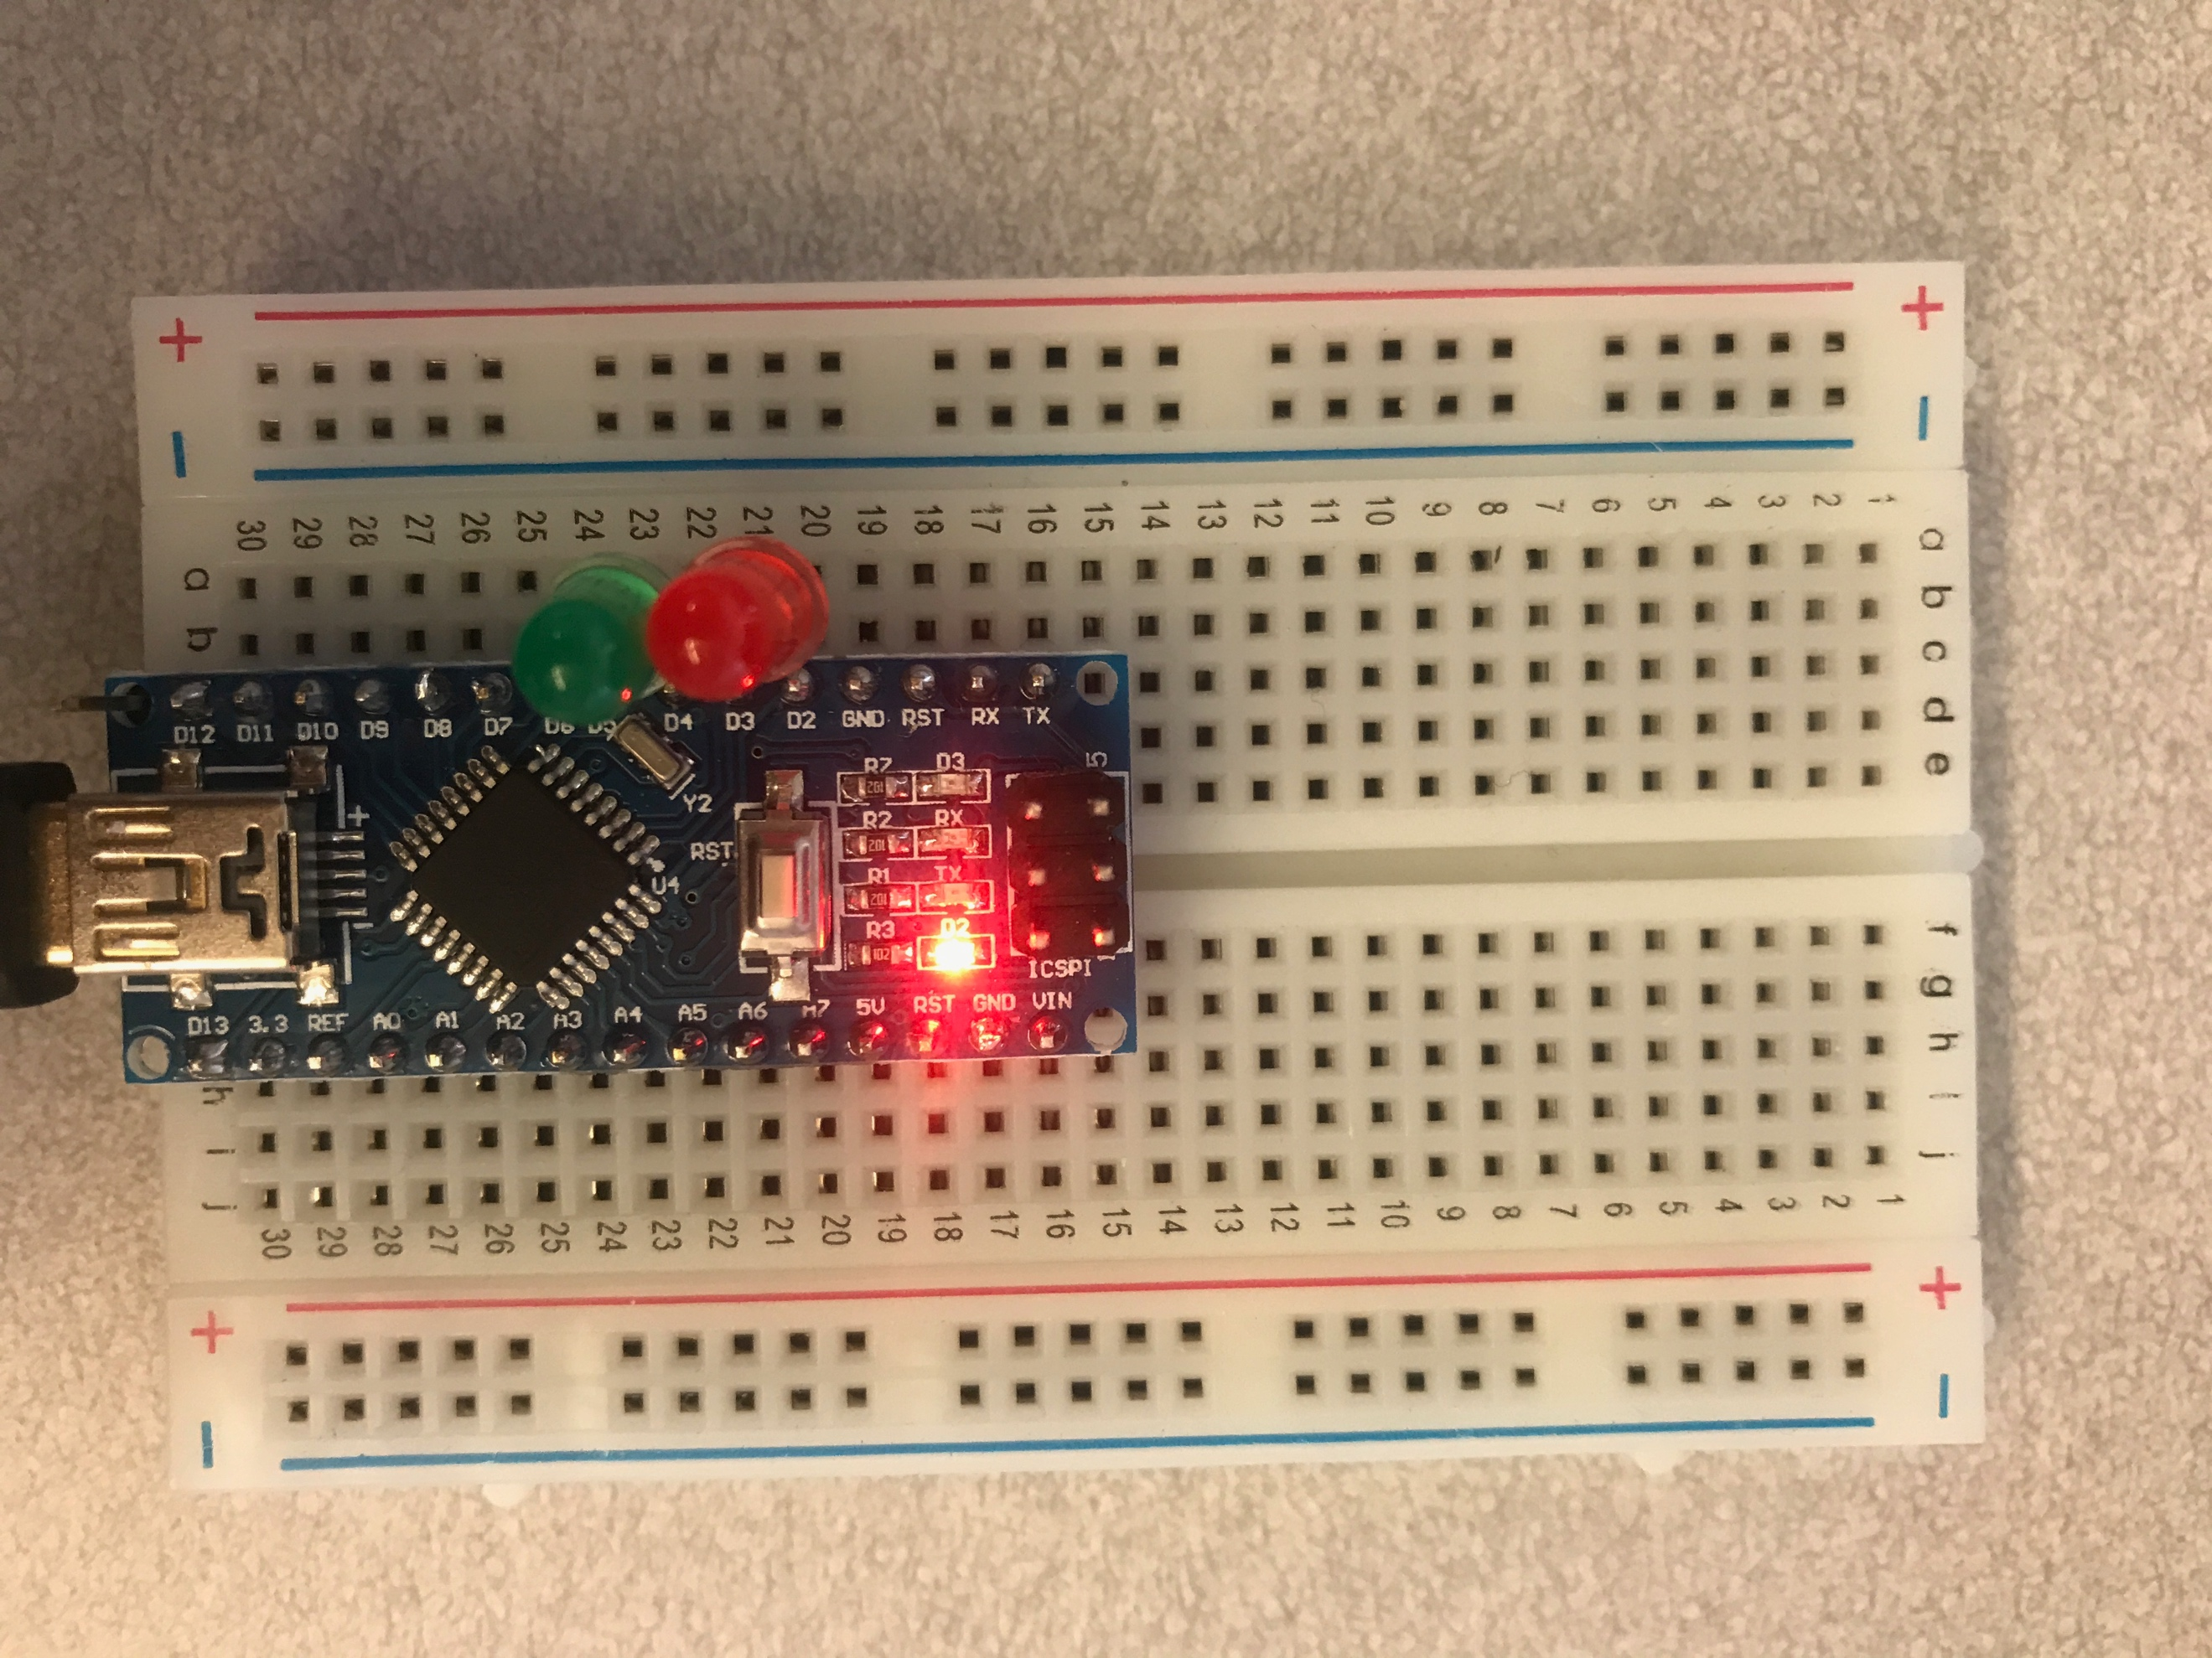

Figure 1. Hardware setup.

To measure the pollution level, we first get a sample of the water in a transparent container (see Figure 2). Then we turns on the flash on the phone and attach it against one side of the container, while keeping the sensor LEDs on the opposite side. Measurements can then be read on a laptop screen (see Figure 2).

In the Arduino firmware, the P side of LEDs are set to be OUTPUT LOW the whole time. To measure how much light an LED receives, we first set the N side of it to HIGH. Then we change it to INPUT mode and flip the voltage to LOW. This sets the N side of the LED to be floating and the charge can be only discharged by the photocurrent. The light intensity then can be calculated by counting how long it takes until the N side of the LED measures LOW. Please refer to the code attached in the Appendix section for more details.

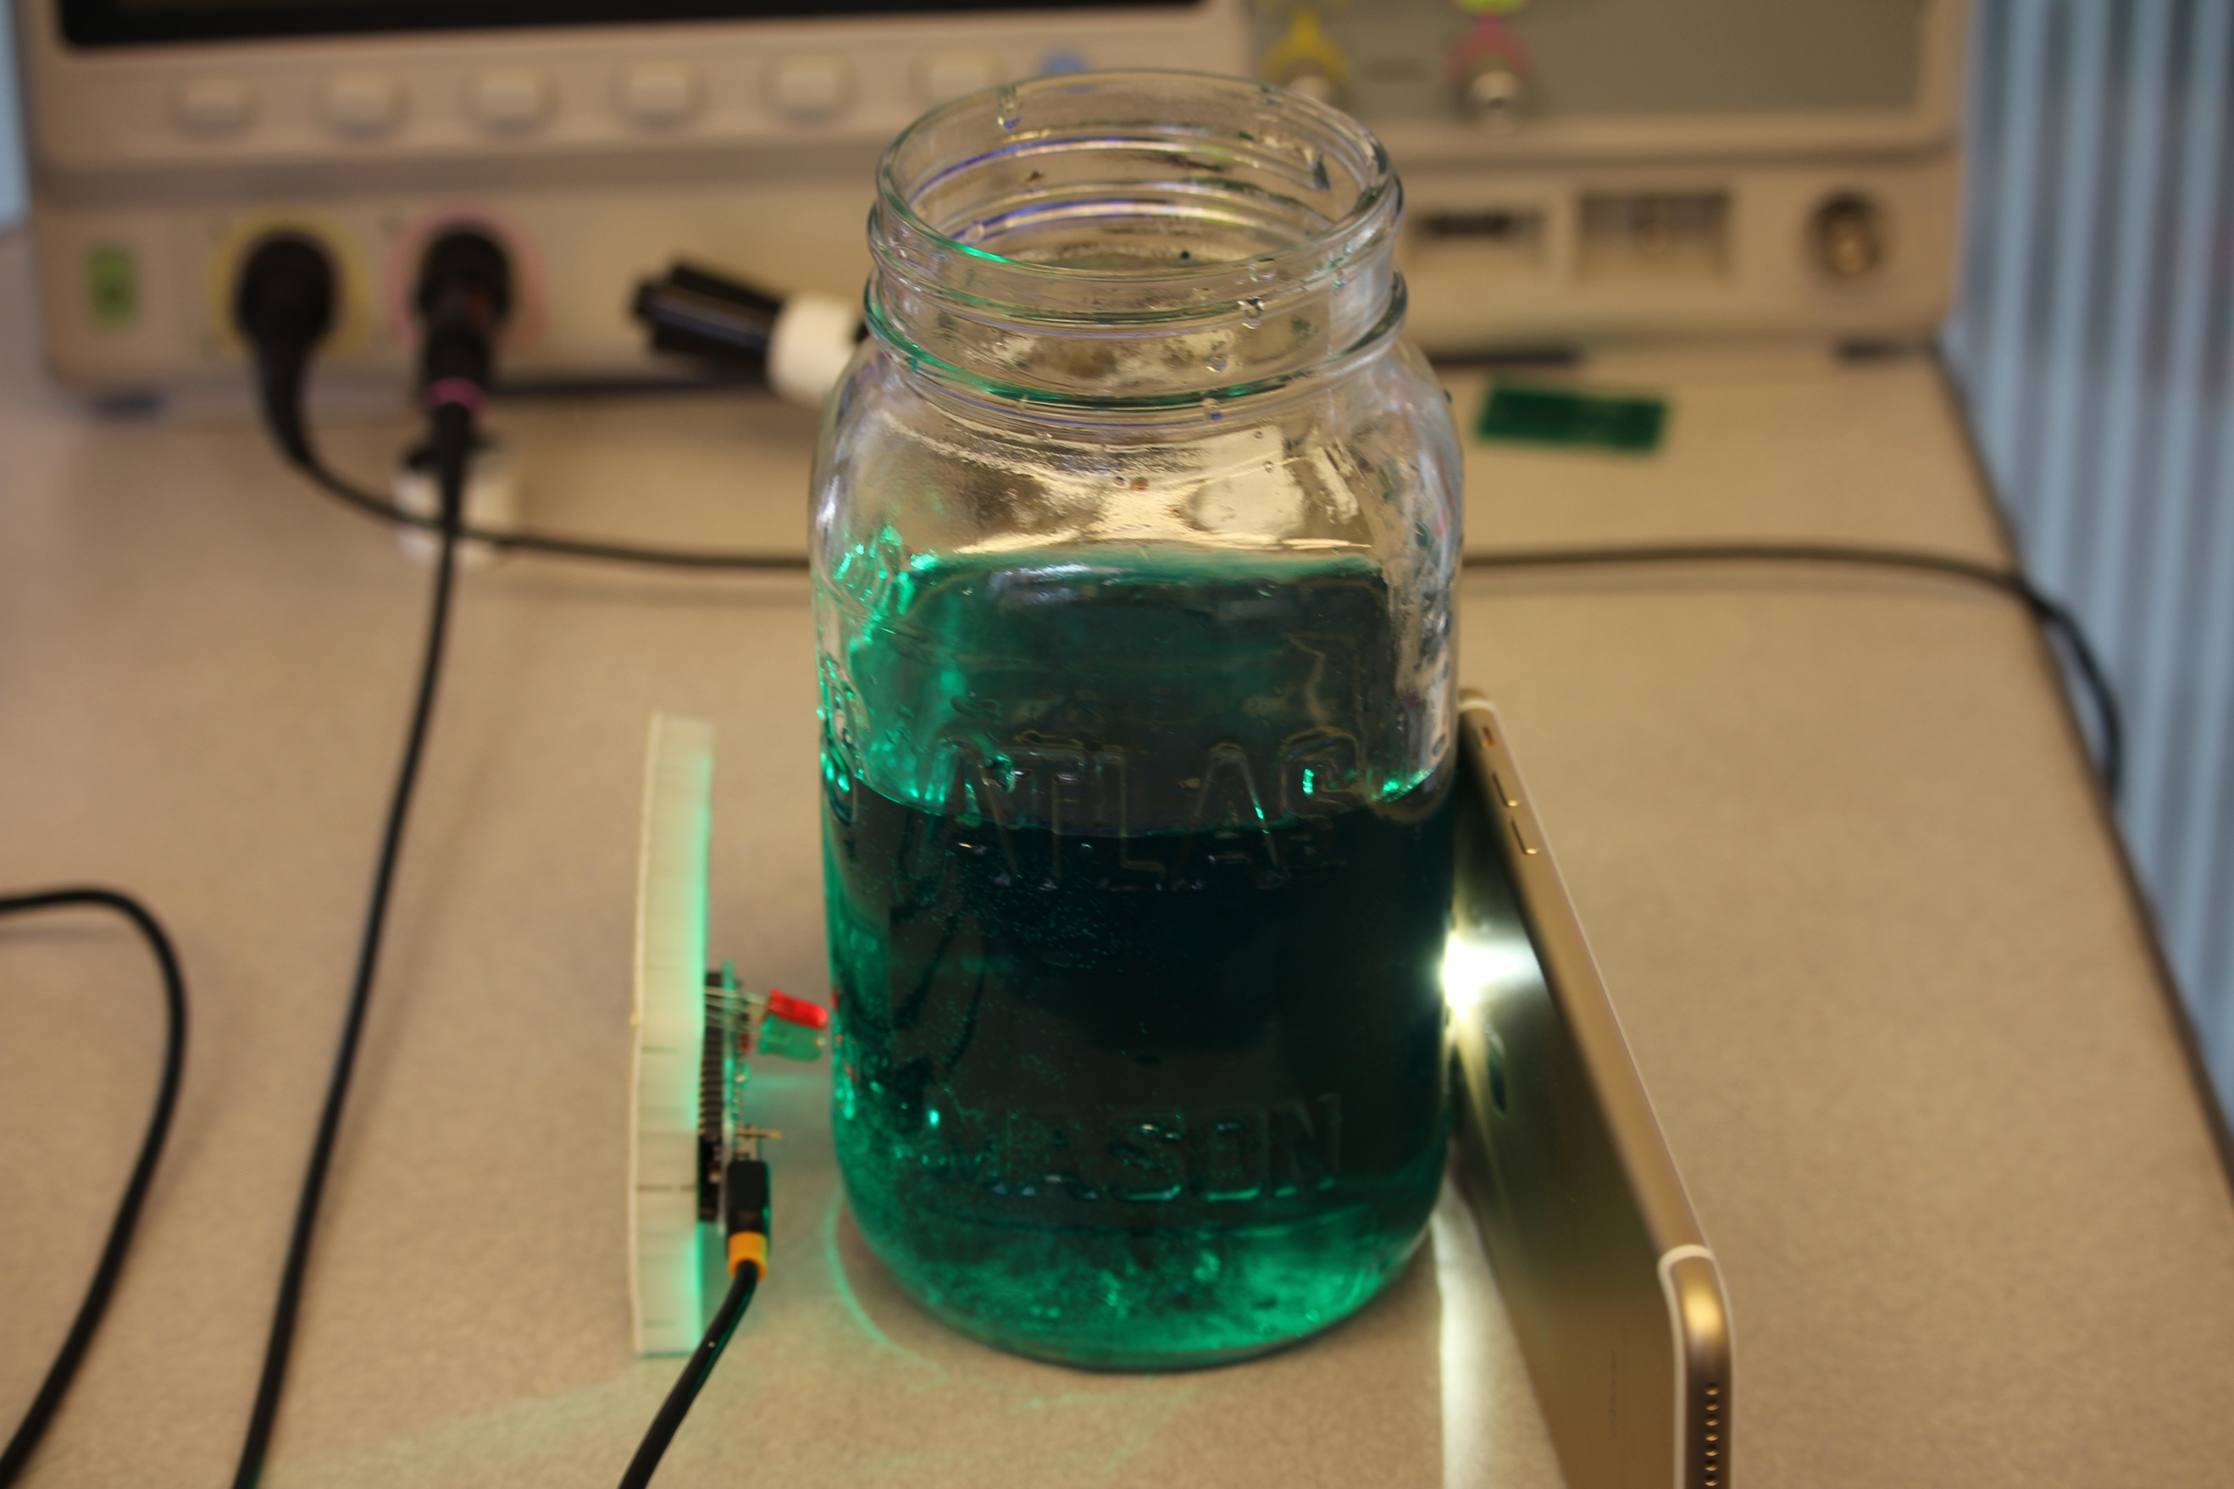

Figure 2. How to measure.

# Results

Figure 3 shows the measurements with water of different colors. These measurements can also be found in the attached CSV files. As we can see from the result, the intensity of the received red and green channel reflect the color of the water. It is even possible to detect the same colors with different levels. This promising results shows the feasibility of a low-cost water pollution level detector.

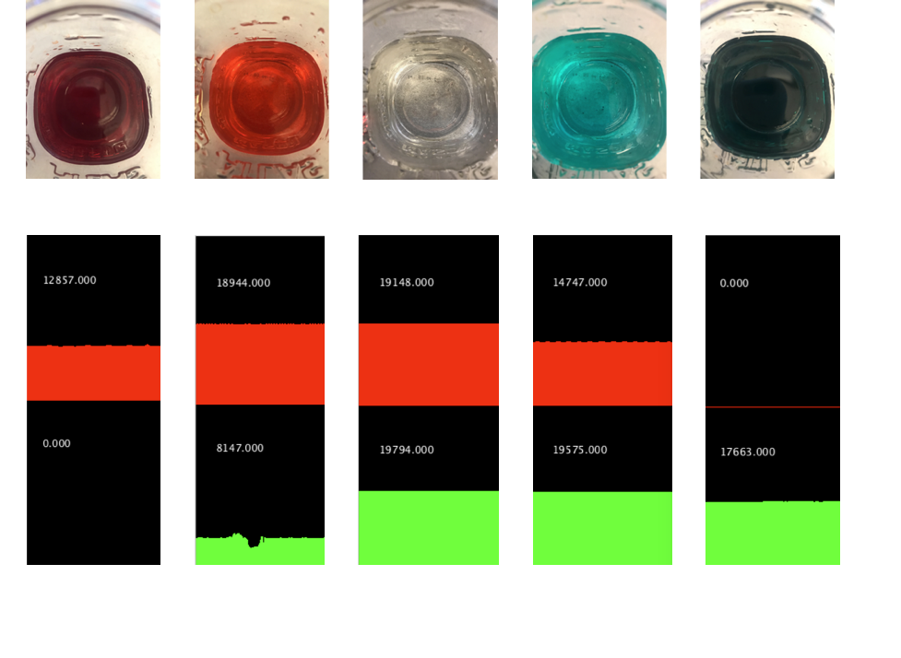

Figure 3. Measurements on waters with different colors.

# Reference

1. <https://www.ecomena.org/water-pollution/>
2. <https://www.sparkfun.com/news/2161>