Group SE24-2FT
University Souvenir Store Application

A0042253U – Ang Hao Yang

A0150308R – Chen Yao

A0148606B – Gao Haijun
A0148376U – Nguyen Bui An Trung

A0148625Y – Srishti

A0150388B – Tran Ngoc Hieu

© 2016 NUS. The contents contained in this document may not be reproduced in any form or by any means, without the written permission of ISS, NUS other than for the purpose for which it has been supplied.
- UML Domain Diagram:
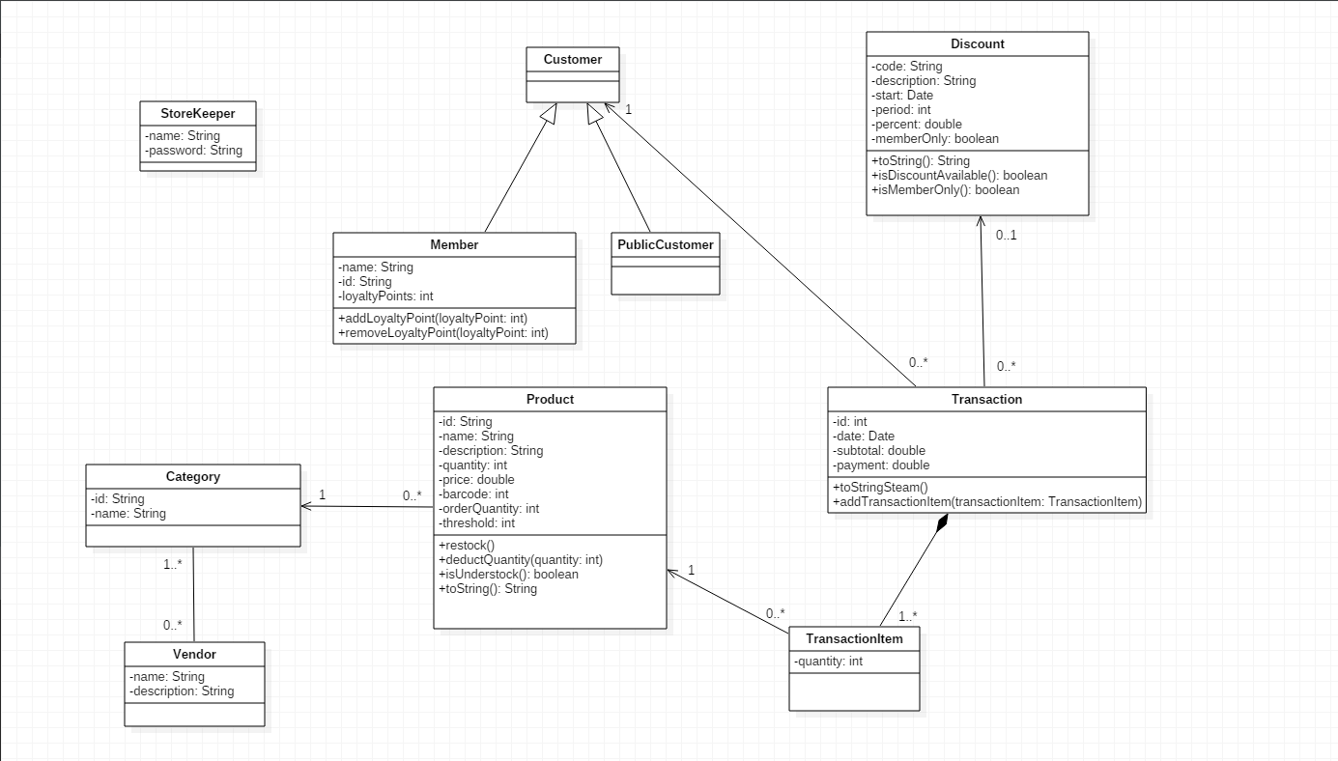

- Assumption in Requirement Spec:
- Deletion/Update records:
These features are not mentioned in Requirement Spec, so they are not included in the application. One of the possible reasons is to keep the integrity of data and Storekeeper should not be allowed to delete/modify data.

One more reason is that data of each object has dependency to each other, so we cannot delete/modify them via application. For example, we cannot delete category STA because there is dependency of product STA/1 and STA/2. The feature to delete/modify data can only be implemented after we get clear requirement from user.

- Input to the System:
All input in the system will be done via the GUI of the application.

- Loyalty Points:
As per requirement, the dollar-to-point value and point-to-dollar redemption value are hard-coded in the system. The current setting for them are:
- Dollar-to-point: $10 spent = 1 additional point
- Point-to-dollar: 1 redeemed point = $5 worth

These settings are fictional setting only and can be changed upon requested.

The loyalty point added per transaction will be calculated based on the Subtotal amount (amount before Discount).

The redeemed value cannot be more than the total amount after discount. For example, if the amount after discount is $99.7 and customer has 100 points. He/she can only redeem maximum 19 points worth of $95 and top-up cash $4.7. This requirement is not mentioned in the Spec, but it is to protect the customer from rounding down their Loyalty Point.

- Check and replenish inventory:
There is no specific requirement on the detail of the Purchase Order so this application will immediate top-up the quantity of those products below threshold. This is assumed that product will arrive immediately after we generate Purchase Order.

- Receipt Printer
Receipt will be printed to screen for Storekeeper to verify. Because the printer hardware was not available, the printer class will simply print out text to console and another dialog will be printed to screen. Once the hardware is configured properly, the printer class can be modified to passing the Receipt content to printer.

- Bar-code Reader
Due to unavailability of bar-code reader hardware, storekeeper need to input the Product ID, Membership ID manually in the application.

There is no specific requirement about bar-code of the Product. However, if bar-code reader can translate bar-code to Product ID, this implicitly means that the bar-code is unique for each product. Hence, we implement a validation of unique bar-code when storekeeper add new product.

- Vendor data
There is no specific requirement to add new Vendor data. Our assumption is that Vendor data will be populated from other application or from external system.

Currently, Vendor class will be linked to Category class but it’s not being used inside the application. There is no requirement to display list of Vendor inside the Report. One possible use of the Vendor object is when we generate Purchase Order when inventory fall below threshold. For the time being, we can use JUnit test to ensure that data is loaded correctly.

