2008年12月大学英语六级(CET-6)真题试卷

Part Ⅰ Writing (30 minutes)
注意：此部分试题在答题卡1上。
Directions: Directions: For this part, you are allowed 30 minutes to write a short essay entitled How To Improve Student's Mental Health?. You should write at least 150 words following the outline given below.
1.大学生的心理健康十分重要
2.因此，学校可以……
3.我们自己应当……
How To Improve Student's Mental Health?

Part II Reading Comprehension (Skimming and Scanning) (15minutes)
Directions: In this part, you will have 15 minutes to go over the passage quickly and answer the questions on Answer Sheet 1.For questions 1-7, choose the best answer from the four choices marked [A], [B], [C] and [D]. For questions 8 -10, complete the sentences with the information given in the passage.
Directions: In this part, you will have 15 minutes to go over the passage quickly and answer the questions on Answer Sheet 1. For questions 1-7, choose the best answer from the four choices marked [A], [B], [C] and [D]. For questions 8-10, complete the sentences with the information given in the passage.
Supersize Surprise
Ask anyone why there is an obesity epidemic and they will tell you that it’s al down to eating too much and burning too few calories. That explanation appeals to common sense and has dominated efforts to get to the root of the obesity epidemic and reverse it. Yet obesity researchers are increasingly dissatisfied with it. Many now believe that something else must have changed in our environment to precipitate(促成) such dramatic rises in obesity over the past 40 years or so. Nobody is saying that the “big two” – reduced physical activity and increased availability of food – are not important contributors to the epidemic, but they cannot explain it all.
Earlier this year a review paper by 20obesity experts set out the 7 most plausible alternative explanations for the epidemic. Here they are.
1.Not enough sleep
It is widely believed that sleep is for the brain, not the body. Could a shortage of shut-eye also be helping to make us fat?
Several large-scale studies suggest there may be a link. People who sleep less than 7 hours a night tend to have a higher body mass index than people who sleep more, according to data gathered by the US National Health and Nutrition Examination Survey. Similarly, the US Nurses’ Health Study, which tracked 68,000 women for 16 years, found that those who slept an average of 5 hours a night gained more weight during the study period than women who slept 6 hours, who in turn gained more than whose who slept 7.
It’s well known that obesity impairs sleep, so perhaps people get fat first and sleep less afterwards. But the nurses’ study suggests that it can work in the other direction too: sleep loss may precipitate weight gain.
Although getting figures is difficult, it appears that we really are sleeping less. In 1960 people in the US slept an average of 8.5 hours per night. A 2002 poll by the National Sleep Foundation suggests that the average has fallen to under 7 hours, and the decline is mirrored by the increase in obesity.
2. Climate control
We humans, like all warm-blooded animals, can keep our core body temperatures pretty much constant regardless of what’s going on in the world around us. We do this by altering our metabolic(新陈代谢的) rate, shivering or sweating. Keeping warm and staying cool take energy unless we are in the “thermo-neutral zone”, which is increasingly where we choose to live and work.
There is no denying that ambient temperatures(环境温度) have changed in the past few decades. Between 1970 and 2000, the average British home warmed from a chilly 13C to 18C. In the US, the changes have been at the other end of the thermometer as the proportion of homes with air conditioning rose from 23% to 47% between 1978 and 1997. In the southern states – where obesity rates tend to be highest – the number of houses with air conditioning has shot up to 71% from 37% in 1978.
Could air conditioning in summer and heating in winter really make a difference to our weight?
Sadly，there is some evidence that it does-at least with regard to heating. Studies show that in comfortable temperatures we use less energy.
3. Less smoking
Bad news: smokers really do tend to be thinner than the rest of us, and quitting really does pack on the pounds, though no one is sure why. It probably has something to do with the fact that nicotine is an appetite suppressant and appears to up your metabolic rate.
Katherine Flegal and colleagues at the US National Center for Health Statistics in Hyattsville, Maryland, have calculated that people kicking the habit have been responsible for a small but significant portion of the US epidemic of fatness. From data collected around 1991 by the US National Health and Nutrition Examination Survey, they worked out that people who had quit in the previous decade were much more likely to be overweight than smokers and people who had never smoked .Among men, for example, nearly half of quitters were overweight compared with 37% of non-smokers and only 28%of smokers.
4. Genetic effects
Yours chances of becoming fat may be set, at least in part, before you were even born. Children of obese mothers are much more likely to become obese themselves later in life. Offspring of mice fed a high-fat diet during pregnancy are much more likely to become fat than the offspring of identical mice fed a normal diet. Intriguingly, the effect persists for two or three generations. Grandchildren of mice fed a high-fat diet grow up fat even if their own mother is fed normally-so you fate may have been sealed even before you were conceived.
5. A little older…
Some groups of people just happen to be fatter than others. Surveys carried out by the US national center for health statistics found that adults aged 40 to 79 were around three times as likely to be obese as younger people. Non-white females also tend to fall at the fatter end of the spectrum: Mexican-American women are 30% more likely than white women to be obsess, and black women have twice the risk.
In the US, these groups account for an increasing percentage of the population. Between 1970 and 2000 the US population aged 35 to 44 grew by43%.the proportion of Hispanic-Americans also grew, from under 5% to 12.5% of the population, while the proportion of black Americans increased from 11% to12.3%.these changes may account in part for the increased prevalence of obesity.
6. Mature mums
Mothers around the world are getting older. in the UK, the mean age for having a first child is 27.3,compared with 23.7 in 1970 .mean age at first birth in the US has also increased, rising from 21.4 in 1970 to 24.9 in 2000.
This would be neither here nor there if it weren’t for the observation that having an older mother seems to be an independent risk factor for obesity. Results from the US national heart, lung and blood institute’s study found that the odds of a child being obese increase 14% for every five extra years of their mother’s age, though why this should be so is not entirely clear.
Michael Symonds at the University of Nottingham, UK, found that first-born children have more fat than younger ones. As family size decreases, firstborns account for a greater share of the population. In 1964, British women gave birth to an average of 2.95 children; by 2005 that figure had fallen to 1.79. In the US in1976, 9.6% of woman in their 40s had only one child; in 2004 it was 17.4%. this combination of older mothers and more single children could be contributing to the obesity epidemic.
7. Like marrying like
Just as people pair off according to looks, so they do for size. Lean people are more likely to marry lean and fat more likely to marry fat. On its own, like marrying like cannot account for any increase in obesity. But combined with others—particularly the fact that obesity is partly genetic, and that heavier people have more children—it amplifies the increase form other causes.
1. What is the passage mainly about?
A) Effects of obesity on people’s health
B) The link between lifestyle and obesity
C) New explanations for the obesity epidemic
D) Possible ways to combat the obesity epidemic
2. In the US Nurse’ Health Study, women who slept an average of 7 hours a night_______.
A) gained the least weight
B) were inclined to eat less
C) found their vigor enhanced
D) were less susceptible to illness
3. The popular belief about obesity is that___________.
A) it makes us sleepy
B) it causes sleep loss
C) it increases our appetite
D) it results from lack of sleep
4. How does indoor heating affect our life?
A) it makes us stay indoors more
B) it accelerates our metabolic rate
C) it makes us feel more energetic
D) it contributes to our weight gain
5. What does the author say about the effect of nicotine on smokers?
A) it threatens their health
B) it heightens their spirits
C) it suppresses their appetite
D) it slows down their metabolism
6. Who are most likely to be overweight according to Katherine Fergal’s study?
A) heavy smokers
B) passive smokers
C) those who never smoke
D) those who quit smoking
7. According to the US National Center for Health Statistics, the increased obesity in the US is a result of_______.
A) the growing number of smokers among young people
B) the rising proportion of minorities in its population
C) the increasing consumption of high-calorie foods
D) the improving living standards of the poor people
8. According to the US National Heart, Lung and Blood Institute, the reason why older mothers’ children tend to be obese remains __________.
9. According to Michael Symonds, one factor contributing to the obesity epidemic is decrease of ___________.
10. When two heavy people get married, chances of their children getting fat increase, because obesity is _____________.
Part III Listening Comprehension (35 minutes)
Section A
Directions: In this section, you will hear 8 short conversations and 2 long conversations. At the end of each conversation, one or more questions will be asked about what was said. Both the conversation and the questions will be spoken only once. After each question there will be a pause. During the pause, you must read the four choices marked [A], [B], [C] and [D], and decide which is the best answer. Then mark the corresponding letter on Answer Sheet 2 with a single line through the centre.
11. A) He is quite easy to recognize
B) He is an outstanding speaker
C) He looks like a movie star
D) He looks young for his age
12. A) consult her dancing teacher
B) take a more interesting class
C) continue her dancing class
D) improve her dancing skills
13. A) the man did not believe what the woman said
B) the man accompanied the woman to the hospital
C) the woman may be suffering from repetitive strain injury
D) the woman may not followed the doctor’s instructions
14. A) they are not in style any more
B) they have cost him far too much
C) they no longer suit his eyesight
D) they should be cleaned regularly
15. A) he spilled his drink onto the floor
B) he has just finished wiping the floor
C) he was caught in a shower on his way home
D) he rushed out of the bath to answer the phone
16. A) fixing some furniture
B) repairing the toy train
C) reading the instructions
D) assembling the bookcase
17. A) urge Jenny to spend more time on study
B) help Jenny to prepare for the coming exams
C) act towards Jenny in a more sensible way
D) send Jenny to a volleyball training center
18. A) The building of the dam needs a large budget
B) The proposed site is near the residential area
C) The local people feel insecure about the dam
D) The dam poses a threat to the local environment
Questions 19 to 21 are based on the conversation you have just heard.
19. A. It saw the end of its booming years worldwide
B. Its production and sales reached record levels.
C. It became popular in some foreign countries
D. Its domestic market started to shrink rapidly.
20. A. They cost less. C. They were in fashion.
B. They tasted better. D. They were widely advertised.
21. A. It is sure to fluctuate. C. It will remain basically stable.
B. It is bound to revive. D. It will see no more monopoly
Questions 22 to 25 are based on the conversation you have just heard.
22. A. Organising protests C. Acting as its spokesman.
B. Recruiting members D. Saving endangered animals.
23. A. Anti-animal-abuse demonstrations B. Anti-nuclear campaigns
C. Surveying the Atlantic Ocean floor D. Removing industrial waste.
24. A. By harassing them. C. By taking legal action.
B. By appealing to the public D. By resorting to force.
25. A. Doubtful C. Indifferent.
B. Reserved D. Supportive
Section B
Directions: In this section, you will hear 3 short passages. At the end of each passage, you will hear some questions. Both the passage and the questions will be spoken only once. After you hear a question, you must choose the best answer from the four choices marked [A], [B], [C] and [D]. Then mark the corresponding letter on Answer Sheet 2 with a single line through the centre.
Passage One
Questions 26 to 28 are based on the passage you have just heard.
26. A. The air becomes still. C. The clouds block the sun.
B. The air pressure is low. D. The sky appears brighter.
27. A. Ancient people were better at foretelling the weather.
B. Sailors’ saying about the weather are unreliable.
C. People knew long ago how to predict the weather.
D. It was easier to forecast the weather in the old days.
28. A. Weather forecast is getting more accurate today.
B. People can predict the weather by their senses
C. Who are the real experts in weather forecast.
D. Weather changes affect people’s life remarkably
Passage Two
Questions 29 to 31 are based on the passage you have just heard.
29. A. They often feel insecure about their jobs.
B. They are unable to decide what to do first.
C. They feel burdened with numerous tasks every day.
D they feel burdened with numerous tasks every day
30. A. Analyze them rationally. C. Turn to others for help.
B. Draw a detailed to-do list. D. Handle them one by one.
31. A. They have accomplished little. C. They have worked out a way to relax.
B. They feel utterly exhausted. D. They no longer feel any sense of guilt.
Passage Three
Questions 32 to 35 are based on the passage you have just heard.
32. A. Their performance may improve.
B. Their immune system may be reinforced
C. Their blood pressure may rise all of a sudden.
D. Their physical development may be enhanced.
33. A. Improved mental functioning C. Speeding up of blood circulation
B. Increased susceptibility to disease D. Reduction of stress-related hormones
34. A. Pretend to be in better shape. C. Turn more often to friends for help
B. Have more physical exercise. D. Pay more attention to bodily sensations.
35. A. Different approaches to coping with stress.
B. Various causes for serious health problems.
C. The relationship between stress and illness.
D. New finding of medical research on stress.
Section C
Directions: In this section, you will hear a passage three times. When the passage is read for the first time, you should listen carefully for its general idea. When the passage is read for the second time, you are required to fill in the blanks numbered from 36 to 43 with the exact words you have just heard. For blanks numbered from 44 to 46 you are required to fill in the missing information. For these blanks, you can either use the exact words you have just heard or write down the main points in your own words. Finally, when the passage is read for the third time, you should check what you have written.
One of the most common images of an advanced, Western-style culture is that of a busy, traffic-filled city. Since their first (36) on American roadways, automobiles have become a (37) of progress, a source of thousands of jobs and an almost inalienable right for citizens’ personal freedom of movement. In recent (38) our “love affair” with the car is being (39) directly to the developing world, and it is increasingly (40) ____ __ that this transfer is leading to disaster.
American’s almost complete dependence on automobiles has been a terrible mistake. As late as the 1950s, a large (41) of the American public used mass transit. A (42) of public policy decisions and corporate scheming saw to it that countless (43) and efficient urban streetcar and intra-city rail systems were dismantled. (44) ___________________________________________________. Our lives have been planned along a road grid—homes far from work, shopping far from everything, with ugly stretches of concrete and blacktop in between.
Developing countries are copying Western-style transportation systems down to the last detail. (45)
Pollution control measures are either not strict or nonexistent, leading to choking clouds of smog. Gasoline still contains lead, which is extremely poisonous to humans. (46) ___________________________________________________________________.
In addition to pollution and traffic jams, auto safety is a critical issue in developing nations.
Part IV Reading Comprehension (Reading in Depth) (25 minutes)
Section A
Directions: In this section, there is a short passage with 5 questions or incomplete statements. Read the passage carefully. Then answer the questions or complete the statements in the fewest possible words. Please write your answers on Answer sheet 2.
Questions 47 to 51 are based on the following passage.
One of the major producers of athletic footwear, with 2002 sales of over $10 billion, is a company called Nike, with corporate headquarters in Beaverton, Oregon. Forbes magazine identified Nike’s president, Philip Knight, as the 53rd-richestman in the world in 2004. But Nike has not always been a large multimillion-dollar organization. In fact, Knight started the company by selling shoes from the back of his car at track meets.
In the late1950s Philip Knight was a middle-distance runner on the University of Oregon track team, coached by Bill Bowerman. One of the top track coaches in the U.S., Bowerman was also known for experimenting with the design of running shoes in an attempt to make them lighter and more shock-absorbent. After attending Oregon, Knight moved on to do graduate work at Stanford University; his MBA thesis was on marketing athletic shoes. Once he received his degree, Knight traveled to Japan to contact the Onitsuka Tiger Company, a manufacturer of athletic shoes. Knight convinced the company’s officials of the potential for its product in the U.S. In 1963 he received his first shipment of Tiger shoes, 200 pairs in total.
In 1964, Knight and Bowerman contributed $500 each to from Blue Ribbon Sports, the predecessor of Nike. In the first few years, Knight distributed shoes out of his car at local track meets. The first employees hired by Knight were former college athletes. The company did not have the money to hire “experts”, and there was no established athletic footwear industry in North America from which to recruit those knowledgeable in the field. In its early years the organization operated in an unconventional manner that characterized its innovative and entrepreneurial approach to the industry. Communication was informal; people discussed ideas and issues in the hallways, on a run, or over a beer. There was little task differentiation. There were no job descriptions, rigid reporting systems, or detailed rules and regulations. The team spirit and shared values of the athletes on Bowerman’s teams carried over and provided the basis for the collegial style of management that characterized the early years of Nikes.

47. While serving as a track coach, Bowerman tried to design running shoes that were _____________________.
48. During his visit to Japan, Knight convinced the officials of the Onitsuka Tiger Company that its product would have____________________________________.
49. Blue Ribbon Sports as unable to hire experts due to the absence of____________________ in North America.
50. In the early years of Nike, communication within the company was usually carried out____________.
51. What qualities of Bowerman’s teams formed the basis of Nike’s early management style?
_______________________________________________________________.
Section B
Directions: There are 2 passages in this section. Each passage is followed by some questions or unfinished statements. For each of them there are four choices marked [A], [B], [C] and [D]. You should decide on the best choice and mark the corresponding letter on Answer Sheet 2 with a single line through the centre.
Passage One
Questions 52 to 56 are based on the following passage.
Sustainable development is applied to just about everything from energy to clean water and economic growth, and as a result it has become difficult to question either the basic assumptions behind it or the way the concept is put to use. This is especially true in agriculture, where sustainable development is often taken as the sole measure of progress without a proper appreciation of historical and cultural perspectives.
To start with, it is important to remember that the nature of agriculture has changed markedly throughout history, and will continue to do so .medieval agriculture in northern Europe fed, clothed and sheltered a predominantly rural society with a much lower population density than it is today. It had minimal effect on biodiversity, and any pollution it caused was typically localized. In terms of energy use and the nutrients（营养成分）captured in the product it was relatively inefficient.
Contrast this with farming since the start of the industrial revolution. Competition from overseas led farmers to specialize and increase yields. Throughout this period food became cheaper, safe and more reliable. However, these changes have also led to habitat（栖息地）loss and to diminishing biodiversity.
What’s more, demand for animal products in developing countries is growing so fast that meeting it will require an extra 300 million tons of grain a year by 2050.yet the growth of cities and industry is reducing the amount of water available for agriculture in many regions.
All this means that agriculture in the 21stcentury will have to be very different from how it was in the 20th.thiswill require radical thinking. For example, we need to move away from the idea that traditional practices are inevitably more sustainable than new ones. We also need to abandon the notion that agriculture can be “zero impact”. The key will be to abandon the rather simple and static measures of sustainability, which centre on the need to maintain production without increasing damage.
Instead we need a more dynamic interpretation, one that looks at the pros and cons（正反两方面）of all the various way land is used. There are many different ways to measure agricultural performance besides food yield: energy use, environmental costs, water purity, carbon footprint and biodiversity. It is clear, for example, that the carbon of transporting tomatoes from Spain to the UK is less than that of producing them in the UK with additional heating and lighting. But we do not know whether lower carbon footprints will always be better for biodiversity.
What is crucial is recognizing that sustainable agriculture is not just about sustainable food production.
52. How do people often measure progress in agriculture?
A) By its productivity C) By its impact on the environment
B) By its sustainability D) By its contribution to economic growth

53. Specialisation and the effort to increase yields have resulted in________.
A) Localised pollution C) competition from overseas
B) the shrinking of farmland D) the decrease of biodiversity

54. What does the author think of traditional farming practices?
A) They have remained the same over the centuries
B) They have not kept pace with population growth
C) They are not necessarily sustainable
D) They are environmentally friendly

55. What will agriculture be like in the 21st century
A) It will go through radical changes
B) It will supply more animal products
C) It will abandon traditional farming practices
D) It will cause zero damage to the environment
56 What is the author’s purpose in writing this passage?
A) To remind people of the need of sustainable development
B) To suggest ways of ensuring sustainable food production
C) To advance new criteria for measuring farming progress
D) To urge people to rethink what sustainable agriculture is
Passage Two
Questions 57 to 61 are based on the following passage.
The percentage of immigrants (including those unlawfully present) in the United states has been creeping upward for years. At 12.6 percent, it is now higher than at any point since the mid1920s.
We are not about to go back to the days when Congress openly worried about inferior races polluting America’s bloodstream. But once again we are wondering whether we have too many of the wrong sort newcomers. Their loudest critics argue that the new wave of immigrants cannot, and indeed do not want to, fit in as previous generations did.
We now know that these racist views were wrong. In time, Italians, Romanians and members of other so-called inferior races became exemplary Americans and contributed greatly, in ways too numerous to detail, to the building of this magnificent nation. There is no reason why these new immigrants should not have the same success.
Although children of Mexican immigrants do better, in terms of educational and professional attainment, than their parents UCLA sociologist Edward Telles has found that the gains don’t continue. Indeed, the fouth generation is marginally worse off than the third James Jackson, of the University of Michigan, has found a similar trend among black Caribbean immigrants, Tells fears that Mexican-Americans may be fated to follow in the footsteps of American blacks-that large parts of the community may become mired（陷入）in a seemingly permanent state of poverty and Underachievement. Like African-Americans, Mexican-Americans are increasingly relegated to (降入)segregated, substandard schools, and their dropout rate is the highest for any ethnic group in the country.
We have learned much about the foolish idea of excluding people on the presumption of the ethnic/racial inferiority. But what we have not yet learned is how to make the process of Americanization work for all. I am not talking about requiring people to learn English or to adopt American ways; those things happen pretty much on their own, but as arguments about immigration hear up the campaign trail, we also ought to ask some broader question about assimilation, about how to ensure that people , once outsiders , don’t forever remain marginalized within these shores.
That is a much larger question than what should happen with undocumented workers, or how best to secure the border, and it is one that affects not only newcomers but groups that have been here for generations. It will have more impact on our future than where we decide to set the admissions bar for the latest ware of would-be Americans. And it would be nice if we finally got the answer right.
57. How were immigrants viewed by U.S. Congress in early days?
A) They were of inferior races.
B) They were a Source of political corruption.
C) They were a threat to the nation’s security.
D) They were part of the nation’s bloodstream.
58. What does the author think of the new immigrants?
A) They will be a dynamic work force in the U.S.
B) They can do just as well as their predecessors.
C) They will be very disappointed on the new land.
D) They may find it hard to fit into the mainstream.
59. What does Edward Telles’ research say about Mexican-Americans?
A) They may slowly improve from generation to generation.
B) They will do better in terms of educational attainment.
C) They will melt into the African-American community.
D) They may forever remain poor and underachieving.
60. What should be done to help the new immigrants?
A) Rid them of their inferiority complex.
B) Urge them to adopt American customs.
C) Prevent them from being marginalized.
D) Teach them standard American English.
61. According to the author, the burning issue concerning immigration is_______.
A) How to deal with people entering the U.S. without documents
B) How to help immigrants to better fit into American society
C) How to stop illegal immigrants from crossing the border
D) How to limit the number of immigrants to enter the U.S.

Part V Cloze （15 minutes）
Directions: There are 20 blanks in the following passage. For each blank there are four choices marked [A], [B], [C]and [D] on the right side of the paper. You should choose the ONE that best fits into the passage. Then mark the corresponding letter on Answer Sheet 2 with a single line through the centre.

Individuals and businesses have legal protection for intellectual property they create and own. Intellectual proper__62__from creative thinking and may include products, __63__, processes, and ideas. Intellectual property is protected__64__ misappropriation(盗用).Misappropriation is taking the Intellectual property of others with our__65__ compensation and using it for monetary gain.  Legal protection is provided for the __66__of intellectual property. The three common types of legal protection are patents, copyrights, and trademarks.  Patents provide exclusive use of inventions. If the US patent office __67__ a patent, it is confirming that the intellectual property is __68__. The patent prevents others from making, using, or selling the invention without the owner’s__69__ for a period of 20 years.  Copyrights are similar to patents __70__that they are applied to artistic works. A copyright protects the creator of an __72__artisitic or intellectual work, such as a song or a novel. A copyright gives the owner exclusive rights to copy, __72__ display, or perform the work.. The copyright prevents others from using and selling the work, the __73__ of a copyright is typically the lifetime of the author__74__an additional 70 years.  Trademarks are words, names, or symbols that identify the manufacturer of a product and__75__it from similar goods of others. A service mark is similar to a trademark__76__is used to identify services. A trademark prevents others from using the__77__or a similar word, name, or symbol to take advantage of the recognition and__78__of the brand or to create confusion in the market place. __79__registration, a trademark is usually granted for a period of ten years. It can be__80__for additional ten-year periods indefinitely as__81__as the mark’s use continues. | 62. [A]retrieves [B]deviates  [C]results [D]departs  63.[A]services [B]reserves  [C]assumptions [D]motions  64. [A]for [B] with  [C]by [D]from  65. [A] sound [B] partial  [C] due [D] random  66. [A] users [B] owners  [C] masters [D] executives  67. [A] affords [B] affiliates  [C] funds [D] grants  68. [A] solemn [B] sober  [C] unique [D] universal  69. [A] perspective [B] permission  [C] conformity [D] consensus  70. [A] except [B] besides  [C] beyond [D] despite  71. [A] absolute [B] alternative  [C] original [D] orthodox  72. [A] presume [B] stimulate  [C] nominate [D] distribute  73. [A] range [B] length  [C] scale [D] extent  74. [A] plus [B] versus  [C] via [D] until  75. [A] distract [B] differ  [C] distinguish [D] disconnect  76. [A] or [B] but  [C] so [D] whereas  77. [A] identical [B] analogical  [C] literal [D] parallel  78. [A] ambiguity [B] utility  [C] popularity [D] proximity  79. [A] from [B] over  [C] before [D] upon  80. [A] recurred [B] renewed  [C] recalled [D] recovered  81. [A] long [B] soon  [C] far [D] well
Part VI Translation (5 minutes)
Directions: Complete the sentences by translating into English the Chinese given in brackets.
82. He designed the first suspension bridge, which_______________________(把美观与功能完美地结合起来)。
83．It was very dark, but Mary seemed to __________________________________ (本能地知道该走哪条路)
84. I don’t think it advisable that parents__________________________ (剥夺孩子们的自由) to spend their spare time as they wish.
85. Older adults who have a high level of daily activities have more energy and____________________________
（与不那么活跃的人相比死亡率要低）。
86. Your resume should attract a would-be boss’s attention by demonstrating______________________________
（为什么你是某个特定职位的最佳人选）。

2008年12月大学英语六级(CET-6)参考答案

范文：
Students’ mental health has been playing an increasingly important role in our day-to-day life. Indeed, it is widely accepted that it has gained growing popularity among persons in all walks of life. There is a general discussion today about the issue of disorder in brains. Obviously, it is necessary that effective actions should be taken to prevent problems. Authorities in universities play a critical role in the situation. To begin with, schools, such as colleges or universities, can provide chances for the young men to ease their attention. What’s more, some are physically strong, but psychological problems are able to bring potential threats. Teaches may have a chance to find them in advance. Besides, specialists in this field are to be required to make full preparation for cases in time. Facing the crisis, experts can deal with it in a professional way, which means they have more or better opportunities to save us than others. (学校)
From the factors mentioned above, we may safely draw the conclusion that we can free ourselves from mental illness by taking certain precautions. For example, if you have pains or puzzles in mind, finding a friend to express these is a good way to release pressure. Certainly, there is little doubt that further attention will be paid to the issue.（我们）
快速阅读：
1. D) Possible ways to combat the obesity epidemic
2. A. gained the least weight
3. B. it causes sleep loss
4. D. It contributes to our weight gain.
5. C. It suppresses their appetite.
6. D. Those who quit smoking.
7. B. the rising proportion of minorities in its population
8. not entirely clear
9. family size
10. partly genetic
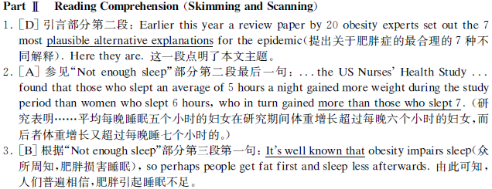

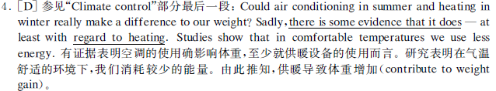
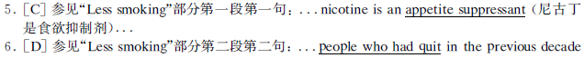
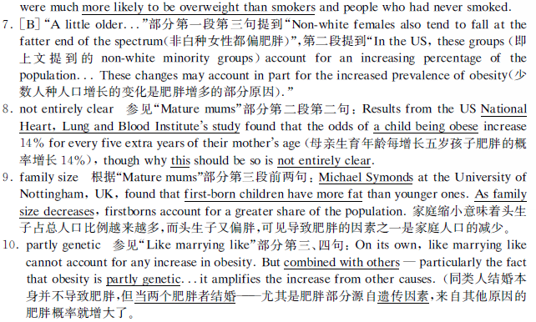

听力
11. A) He is quite easy to recognize.
12. C) Continue her dancing class.
13. D) The woman may not have followed the doctor’s instructions.
14. C) They no longer suit his eyesight.
15. D) He rushed out of the bath to answer the phone.
16. D) Assembling the bookcase.
17. A) Urge Jenny to spend more time on study.
18. C) The local people feel insecure about the dam.
19. B) Its production and sales reached record levels.
20. A) They cost less.
21. C) It is bound to revive.
22. A) Organising protests.
23. C) Anti-nuclear campaigns.
24. A) By harassing them.
25. D) Supportive.
26. B) The air pressure is low.
27. C) People knew long ago how to predict the weather.
28. B) People can predict the weather by their senses.
29. D) They feel burdened with numerous tasks every day.
30. B) Draw a detailed to-do list.
31. A) They have accomplished little.
32. A) Their performance may improve.
33. B) Increased susceptibility to disease.
34. D) Pay more attention to bodily sensations.
35. C) The relationship between stress and illness.
36．appearance
37．symbol
38．decades
39．exported
40．apparent
41．percentage
42．combination
43．convenient
44．Our air quality now suffers from the effects of pollutants emitted directly from our cars.
45．The problems caused by motorized vehicles in the West are often magnified in developing nations.
46．Movement in some cities comes to a virtual standstill as motorized traffic competes with bicycles and pedestrians.

仔细阅读
47. lighter and more shock-absorbent
48. the potential in the U.S.
49. established athletic footwear industry
50. informally
51. The team spirit and shared values of the athletes
52. B. By its sustainability
53. D. the decrease of biodiversity
54. C. They are not necessarily sustainable.
55. A. It will go through radical changes.
56. D. To urge people to rethink what sustainable agriculture is.
57. A. They were of inferior races.
58. B. They can do just as well as their predecessors.
59. D. They may forever remain poor and underachieving.
60. C. Prevent them from being marginalized.
61. B. how to help immigrants to better fit into American society.

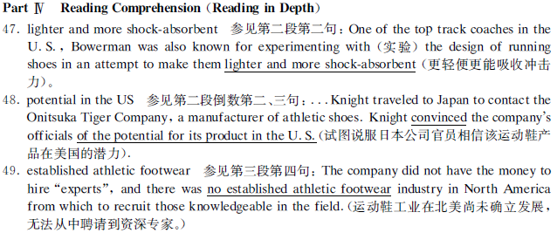
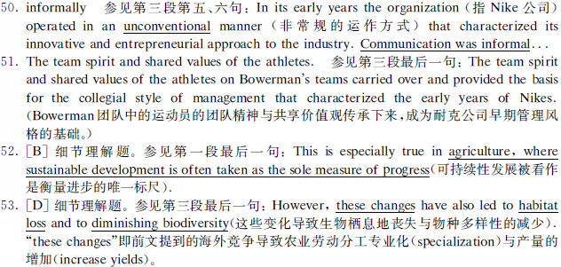

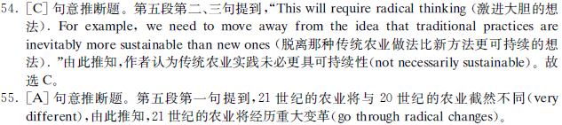
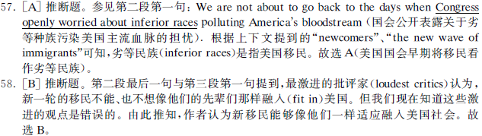
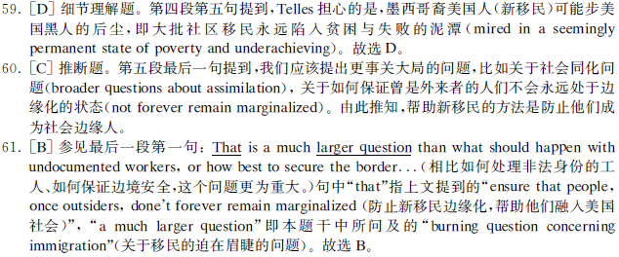
完形
62 C results
63 A services
64 D from
65 C due
66 B owners
67 D grants
68 C unique
69 B permission
70 A except
71 C original
72 D distribute
73 B length
74 A plus
75 C distinguish
76 B but
77 A identical
78 C popularity
79 D Upon
80 B renewed
81 A long


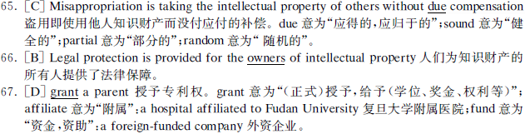



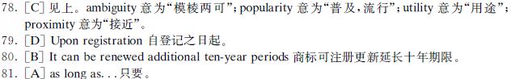

翻译
82 which combined beauty and function perfectly
83 know which way to take by instinct.
84 deprive their children of freedom
85 a lower death rate compared with those who don't
86 why you are the best candidate for a certain position

2008年12月英语六级真题听力原文

Part III Listening Comprehension (35 minutes)
Section A
Directions: In this section, you will hear 8 short conversations and 2 long conversations. At the end of each conversation, one or more questions will be asked about what was said. Both the conversation and the questions will be spoken only once. After each question there will be a pause. During the pause, you must read the four choices marked A), B), C) and D), and decide which is the best answer. Then mark the corresponding letter on Answer Sheet 2 with a single line through the centre.

Now let’s begin with the eight short conversations:

11. M: I’m asked to pick up the guest speaker Bob Russel at the airport this afternoon, do you know what he looks like?
W: Well, he’s in his sixties, he stands out, he’s bald, tall and thin and has a beard.
Q: What do we conclude from the woman’s remarks about Bob Russel?

12. M: I am considering dropping my dancing class. I am not making any progress.
W: If I were you, I stick with it. It’s definitely worth time and effort.
Q: What does the man suggest the woman do?

13. W: You see I still have this pain in my back, this medicine the doctor gave me was supposed to make me feel better by now.
M: Maybe you should’ve taken it three times a day as you were told.
Q: What do we learn from the conversation?

14. M: Frankly, when I sat the back of the classroom, I can’t see the words on the board clearly.
W: Well, you’ve been wearing those same glasses as long as I’ve known you. Why not get a new pair? It wouldn’t cost you too much.
Q: What does the woman imply about the man’s glasses?

15. W: How come the floor is so wet? I almost slipped, what happened?
M: Oh, sorry! The phone rang the moment I got into the shower, anyway, I’ll wipe it up right now.
Q: Why was the floor wet according to the man?

16. M: The instructions on the package say that you need to some assembly yourself. I’ve spent all afternoon trying in vain to put this bookcase together.
W: I know what you mean, last time I tried to assemble a toy train for my son and I almost gave up.
Q: What does the man find difficult?

17. M: I’m getting worried about Jenny’s school work. All she talks about these days is volleyball games and all she does is practice, training and things like that.
W: Her grades on the coming exams will fall for sure. It’s high time we talk(ed) some sense to her.
Q: What are the speakers probably going to do?

18. W: Do you understand why the local people are opposed to the new dam up the river?
M: They are worried about the potential danger if the dam should break. The river is very wide above the proposed site.
Q: What do we learn from the conversation?
Now you’ll hear the two long conversations:
Conversation One
W: Mr. White, what changes have you seen in the champagne market in the last ten to fifteen years?
M: Well the biggest change has been the decrease in sales since the great boom years of the 1980s when champagne production and sales reached record levels.

W: Which was the best year?
M: Well the record was in 1989 when 249 million bottles of champagne was sold. The highest production level was reached in 1990 with a total of 293 million bottles. Of course since those boom years sales have fallen.
W: Has the market been badly hit by the recession?
M: Oh certainly, the economic problems in champagnes’ export markets that’s Europe, the United States, Japan, and of course the domestic market in France, the economic problems have certainly been one reason for the decrease in champagne sales.
W: And the other reasons?
M: Another important factor has been price. In the early 90s, champagne was very overpriced, so many people stop buying it. Instead they bought sparkling wines from other countries, in particular from Australia and Spain. And then there was another problem for champagne in the early 90s.
W: What was that?
M: There was a lot of rather bad champagne on the market. This meant the popularity of good sparkling wines increased even more. People was surprised by their quality and of course they were a lot cheaper than champagne.
W: Do you think the champagne market will recover in the future?
M: Oh, I’m sure it will. When the economic situation improves, I believe the market will recover.

Questions 19 to 21 are based on the conversation you have just heard.

19. What does the man say about champagne in the 1980s?
20. Why did sparkling wines become more popular than champagne in the early 90s?
21. What does the man think of the champagne market in the future?

Conversation Two
W: Right, well, in the studio this morning, for our interview spot is Peter Wilson. Peter works for Green Peace. So, Peter, welcome.
M: Thanks a lot. It’s good to be here.
W: Great! Now, Peter, perhaps you can tell us something about Green Peace and your job there.
M: Sure. Well, I’ll start by telling you roughly what Green Peace is all about. I actually work in London for the Green Peace organization. We’ve been going for a few decades and we’re a non-violent, non-political organization. We’re involved in anti-nuclear activity, conservation and protection of animals and protection and support of our eco-system. I’m the action organizer and arrange any protests.
W: Right! A pretty important role, Peter. What sort of protest would you organize?
M: Well, recently we’ve been involved in anti-nuclear campaigns. I, personally arranged for the demonstration against radioactive waste dumping in the Atlantic Ocean. We’ve got a few small Green Peace boats that we harass the dumping ship with.
W: Say? Hold on, Peter. I thought you said your organization was non-violent. What do you mean by "harass"?
M: Well, we circle round and round the ships and get in the way when they try to dump the drums of nuclear waste in the sea. We talk to the men and try to change, you know, yell at them to stop. We generally make ourselves as much of a nuisance as possible.
M: Well, people may think differently of your methods, but there’s no doubt you’re doing a great job. Keep it up and good luck. And thanks for talking with us.

Questions 22 to 25 are based on the conversations you have just heard.
22. What is the man’s chief responsibility in the Green Peace organization?
23. What has Green Peace been involved in recently?
24. How does Green Peace try to stop people from dumping nuclear waste?
25. What is the woman’s attitude towards the Green Peace’s campaigns?

Section B
Directions: In this section, you will hear 3 short passages. At the end of each passage, you will hear some questions. Both the passage and the questions will be spoken only once. After you hear a question, you must choose the best answer from the four choices marked A), B), C) and D). Then mark the corresponding letter on Answer Sheet 2 with a single line through the centre.
Passage One
To find out what the weather is going to be, most people go straight to the radio, television, or newspaper to get an expert weather forecast. But if you know what to look for, you can use your own senses to make weather predictions. There are many signs that can help you. For example, in fair weather the air pressure is generally high, the air is still and often full of dust, and far away objects may look vague. But when the storm is brewing, the pressure drops, and you are often able to see things more clearly. Sailors took note of this long ago, and came up with the saying, “The farther the sight, the nearer the rain.” Your sense of smell can also help you detect the weather changes. Just before it rains, odors become stronger, this is because odors are repressed in a fair high pressure center. When a bad weather low moves in, air pressure lessens and odors are released. You can also hear an approaching storm. Sounds bounce off heavy storm clouds and return to earth with increased force. An old saying describes it this way, “Sounds traveling far and wide a stormy day will be tied”. And don’t laugh at your grandmother if she says she can feel a storm coming. It is commonly known that many people feel pains in their bones or joints while the humidity rises, the pressure drops, and bad weather is on the way.

Questions 26 to 28 are based on the passage you have just heard:

26. Why does the speaker say we can see far away objects more clearly as a storm is approaching?
27. What does the speaker want to show by quoting a couple of old sayings?
28. What does the passage mainly talk about?

Passage Two

Many days seem to bring numerous tasks and responsibilities. All of which apparently must be tackled right away. You spend a day putting out files, but by the end of the day, you haven’t accomplished any of the really important things you set out to do. In desperation, you draft a “to-do” list, but most days, you can make little progress with it. When you look at the list each morning, a big fat cloud of doom is right at the top. Those difficult, complex, important tasks, that are so crucial to get done, and so easy to avoid. Plenty of us create a “to-do” list to address feelings of being overwhelmed, but we rarely use these tools to their best effect. They wind out being guilt-provoking reminders of the fact that will over-committed and losing control of our priorities. According to Timothy Pikle, a professor of psychology at Carlton University in Ottawa, people often draw up a “to-do” list, and then that’s it. The list itself becomes the day’s achievement, allowing us to feel we’ve done something useful without taking on any real work. In fact, drawing up the list becomes a way of avoiding the work itself. Too often, the list is seen as the accomplishment for the day, reducing the immediate guilt of not working on the tasks at hand by investing energy in the list, says Pikle. When a list is used like this, it’s simply another way in which we lie to ourselves.

Questions 29 to 31 are based on the passage you have heard.

29. What is the problem that troubles many people nowadays according to the speaker?
30. According to the speaker, what too many people do to cope with their daily tasks?
31. According to psychologist Timothy Pikle, what do people find by the end of the day?

Passage Three
In many stressful situations, the body’s responses can improve our performance. We become more energetic, more alert, better able to take effective action. But when stress is encountered continually, the body’s reactions are more likely to be harmful than helpful to us. The continual speeding up of bodily reactions and production of stress related hormones seem to make people more susceptible to heart disease. And stress reactions can reduce the disease fighting effectiveness of the body’s immune system, thereby increasing susceptibility to illnesses ranging from colds to cancer. Stress may also contribute to disease in less direct ways by influencing moods and behavior. People under stress may become anxious or depressed, and as a result may eat too much or too little, have sleep difficulties or fail to exercise. These behavioral changes may in turn be harmful to the health. In addition, people are more likely to pay attention to certain bodily sensations such as aches and pains when they are under stress and to think that they’re sick. If the person were not under stress, the same bodily sensations might not be perceived as symptoms and the person might continue to feel well. Some researchers have suggested that assuming the role of a sick person is one way in which certain people try to cope with stress. Instead of dealing with the stressful situation directly, these people fall sick. After all, it is often more acceptably in our society to be sick and to seek medical help than it is to admit that one can not cope with the stresses of life.

Questions 32 to 35 are based on the passage you have just heard.

32. What does the speaker say about people who encounter stress once in a while?
33. What does the speaker say frequent stress reactions may lead to?
34. What are people more likely to do when they are under stress?
35. What does the passage mainly talk about?

Section C
Directions: In this section, you will hear a passage three times. When the passage is read for the first time, you should listen carefully for its general idea. When the passage is read for the second time, you are required to fill in the blanks numbered from 36 to 43 with the exact words you have just heard. For blanks numbered from 44 to 46 you are required to fill in the missing information. For these blanks, you can either use the exact words you have just heard or write down the main points in your own words. Finally, when the passage is read for the third time, you should check what you have written.

Now listen to the passage:

One of the most common images of an advanced, Western-style culture is that of a busy, traffic-filled city. Since their first（36）appearance on American roadways, automobiles have become a（37）symbol of progress, a source of thousands of jobs and an almost inalienable right for citizens’ personal freedom of movement. In recent（38）decades, our “love affair” with the car is being（39）exported directly to the developing world, and it is increasingly（40）apparent that this transfer is leading to disaster.
American’s almost complete dependence on automobiles has been a terrible mistake. As late as the 1950s, a large（41）percentage of the American public used mass transit. A（42）combination of public policy decisions and corporate scheming saw to it that countless（43）convenient and efficient urban streetcar and intra-city rail systems were dismantled（拆除）.（44）Our air quality now suffers from the effects of pollutants emitted directly from our cars. Our lives have been planned along a road grid — homes far from work, shopping far from everything, with ugly stretches of concrete and blacktop in between.
Developing countries are copying Western-style transportation systems down to the last detail.（45）The problems caused by motorized vehicles in the West are often magnified in developing nations. Pollution control measures are either not strict or nonexistent, leading to choking clouds of smog. Gasoline still contains lead, which is extremely poisonous to humans.（46）Movement in some cities comes to a virtual standstill as motorized traffic competes with bicycles and pedestrians.
In addition to pollution and traffic jams, auto safety is a critical issue in developing nations.

