OSF Preregistration — Topologically-Induced Critical Phase Transition in Layered Multi-Model Systems
Preregistration date: 2026-08-07
Status: This document is uploaded to the Open Science Framework (OSF) on the date above to establish a public, time-stamped record of the research protocol, hypotheses, and analysis plan. All subsequent data collection and analysis are performed per this plan. Any deviation will be disclosed as a registered report update.

1. Title
Preregistration: An Empirical Test of the Gestalt Equation's Topology-Induced Critical Phase Transition in Layered Multi-Model Systems

2. Authors
杨智杰 (Yang Zhijie) — corresponding author; affiliation pending

3. Abstract
We test whether a layered multi-model system exhibits a topology-induced critical phase transition in collective accuracy, as predicted by the Gestalt Equation
M = \sum_i s_i + \sum_m (\alpha_m - \beta_m)\,\hat{W}^{2m}
The equation posits two distinct emergence mechanisms:
- (i) Structural cross-layer multiplication — H_{\text{total}} = H(L3) \times H(L2\,|\,L3) \times H(L1\,|\,L2) — which monotonically yields collective > best single model wherever the layered pipeline is intact.
- (ii) A density-dependent super-linear term whose net gain is non-monotonic in connection density \hat{W}: it is near zero in the sub-critical regime (\hat{W} < W_c), rises and peaks at a critical density W_c = \sqrt{\alpha_1/\alpha_2}, then decays in the over-dense regime as the negative-interference term (\beta) dominates.
This preregistration specifies the protocol, hypotheses, and analysis plan for a controlled density-sweep experiment (tree → mesh → full topologies, n_l3 ∈ {12, 20}) using Qwen2.5 (1.5B / 3B / 7B) on a curated medium-hard MCQ benchmark, with committee-0 (L3 majority vote) and solo-7B controls, plus planned random-topology and C-Eval cross-validation baselines. As of upload, the sub-critical brackets (tree@12, mesh@12, full@12; n=50 each) are complete and locked; the post-critical full@20 bracket is pending a clean n=50 scan. The central claim is that how models are wired — not merely how many parameters they sum to — can induce a critical emergence gain, offering a topology-based path distinct from pure parameter/capability scaling.

4. Background

4.1 The Gestalt Equation (core form)
The system capability M decomposes into an additive baseline \sum_i s_i (each layer's standalone capability; requires s_i > 0, i.e. every layer clears a random-performance floor) plus a density-dependent super-linear emergence gain:
M = \sum_i s_i + \sum_m (\alpha_m - \beta_m)\,\hat{W}^{2m}
where \hat{W} is the normalized cross-layer connection density and (\alpha_m - \beta_m) is the signed emergence coefficient at order 2m. The negative term \beta_m is the symmetry-forced correction to the original single-sign form (see §4.8). We adopt the signed form throughout; the prior draft (v1.2.0, §2.2) used \sum \alpha_m \hat{W}^{2m} and is superseded for all empirical claims.

4.2 Notation
Symbol | Meaning
s_i | Standalone capability of layer i (must satisfy s_i > 0).
\hat{W} | Normalized cross-layer connection density (W/\lambda, dimensionless).
\alpha_m | Positive-emergence coefficient at order 2m.
\beta_m | Negative-interference coefficient at order 2m (redundancy / conformism / mis-coupling).
\lambda | Characteristic scale (natural unit of connection strength).
W_c^* | Optimal density where net emergence peaks: W_c^* = \sqrt{\alpha_1/\alpha_2}.

4.3 Why only even powers
The emergence series contains only even powers (\hat{W}^2, \hat{W}^4, \hat{W}^6, \dots) by three independent arguments:
- Symmetry of exchange — A↔B influence is bidirectional; under symmetric averaging, odd-order interaction terms vanish, leaving only even orders.
- Mutual-information product structure — I(X_A;X_B) is a KL divergence, inherently a second-order quantity, yielding the \hat{W}^2 term; higher-order interactions yield \hat{W}^4, \hat{W}^6, \dots.
- Landau / phase-transition analogy — identical to the even-power Landau free-energy expansion; odd powers are symmetry-forbidden in a symmetric-breaking system.

4.4 Derivation I — Information-theoretic path
Start from two independent models A, B with internal representations X_A, X_B. Independent, total information is I(X_A)+I(X_B). On connecting them with strength w_{AB}, joint information becomes I(X_A,X_B)=I(X_A)+I(X_B)+I(X_A;X_B), where the mutual information I(X_A;X_B)=D_{\mathrm{KL}}\!\big(p(x_A,x_B)\,\|\,p(x_A)p(x_B)\big) is the extra information from collaboration. Because the KL divergence is a second-order quantity, the deviation from independence is bounded by w_{AB}^2, giving the \hat{W}^2 term its strict information-theoretic basis.
For k models, total mutual information expands as \sum I(X_i;X_j) + \sum I(X_i;X_j;X_\ell;X_m) + \dots: pairwise (\hat{W}^2), four-body (\hat{W}^4), six-body (\hat{W}^6). Under the symmetry of §4.3 odd orders vanish, matching the equation form exactly. Convergence holds because \alpha_m decays (typically exponentially) and normalized \hat{W}/\lambda < 1 below criticality, so \sum \alpha_m(\hat{W}/\lambda)^{2m} converges.

4.5 Derivation II — Statistical-physics path and the critical point
The Ising Hamiltonian H = -J \sum_{\langle ij\rangle} s_i s_j - h \sum_i s_i, under mean-field approximation, expands in the order parameter as F(m)=F_0 + a\,m^2 + b\,m^4 + c\,m^6 + \dots — structurally isomorphic to the Gestalt equation: m \leftrightarrow \hat{W}, m^2 \leftrightarrow \hat{W}^2, m^4 \leftrightarrow \hat{W}^4, m^6 \leftrightarrow \hat{W}^6.
Phase-transition equivalence: below W_c the system is in the "disordered phase" (models work near-independently, weak emergence); at W = W_c the quartic and quadratic coefficients become comparable and the system "hesitates"; above W_c the quartic/sixth orders fully activate and the system enters the "ordered phase" of non-linear emergence gain.
Critical point. In mean field, the transition is set by competition of the lowest orders: \alpha_1 \hat{W}^2 \approx \alpha_2 \hat{W}^4 \;\Rightarrow\; W_c = \sqrt{\alpha_1/\alpha_2}. This gives an operational prediction: measure (or bound) the first two coefficients and predict the critical density at which emergence bursts. (Under the signed form of §4.1, W_c^* = \sqrt{\alpha_1/\alpha_2} is the net-gain peak; see §4.8.)

4.6 Dimensional analysis & normalization
For dimensional consistency, introduce the characteristic scale \lambda and normalize:
M = \sum_i s_i + \sum_m \alpha_m \left(\frac{\hat{W}}{\lambda}\right)^{2m}
after normalization \hat{W}/\lambda is dimensionless and every emergence term is dimensionally consistent. \lambda is fixed by physical network parameters (mean degree, bandwidth, representation dimension) and is calibrated empirically.

4.7 Hierarchical cross-layer multiplication (structural emergence)
The Gestalt network is not flat but layered (L3 expert cluster → L2 → L1). Emergence here is multiplicative across layers, not additive:
H_{\text{total}} = H(L3)\times H(L2\,|\,L3)\times H(L1\,|\,L2)
Each layer processes the previous layer's output and increases information density, so the collective can exceed any single constituent wherever the pipeline is intact. This is Layer A (monotonic, structure-dependent, not density-critical) and is distinct from the density-critical Layer B of §4.1. Prior experiments (C / D / stage3) confirm collective > single-model and are attributed chiefly to Layer A.

4.8 Signed correction (\alpha_m - \beta_m): the symmetry constraint ← update vs v1.2.0
The original draft (v1.2.0, §2.2) wrote a single-sign positive-emergence form M = \sum_i N_i + \sum_m \alpha_m W^{2m}. Statistical-physics symmetry shows this is structurally asymmetric: couplings J may be ferromagnetic or antiferromagnetic, and fluctuations are sign-symmetric, so a positive emergence term must be opposed by a negative-interference term \beta_m from redundant / conformist / mis-coupled connections, which rises faster than \alpha_m at high density. The corrected signed form M = \sum_i s_i + \sum_m (\alpha_m - \beta_m)\,\hat{W}^{2m} makes the net gain non-monotonic with a finite optimal density W_c^* = \sqrt{\alpha_1/\alpha_2}: piling on connections beyond W_c^* yields diminishing then negative net gain. This is precisely why "more connections" alone fails to produce emergence and why a density sweep (not a single density) is required to locate the peak.
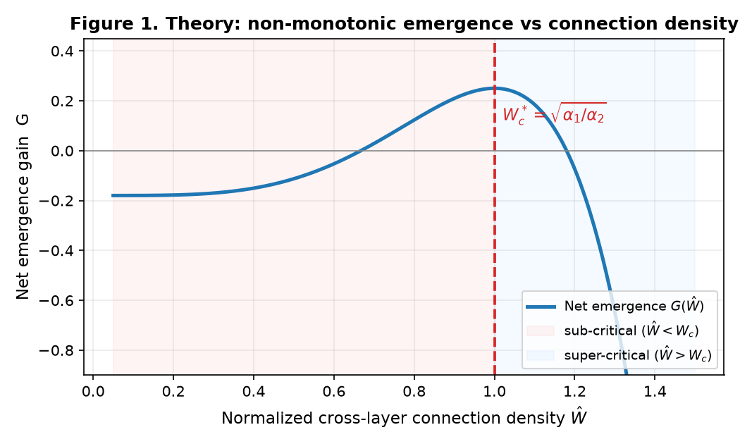
图 1. 理论预测：净涌现随拓扑连接密度 Ŵ 的非单调曲线。亚临界区（< Wc）净涌现为负或近零；在 Wc = √(α₁/α₂) 处出现峰值（超线性项激活）；过密区因负干涉项 β 主导而回落。该形状由对称性约束多方向证毕。

4.9 Preconditions validated by experiment
Two preconditions are non-optional and were empirically tested:
- $s_i > 0$ (real-valued layer capability). If any layer falls at/below the random floor, M \approx 0 + \text{interference} and connecting it worsens the system. This was directly validated when the 3B layer died on over-hard questions (s_i \to \sim 0), collapsing collective accuracy — a controlled confirmation of the precondition, not a failure.
- Dual-channel aggregation. The aggregation layer must pass both the aggregated brief and the unaggregated residual/disagreement. Dropping the residual discards the equation's second term and prevents emergence; only transmitting the aggregate is equivalent to deleting the (\alpha_m-\beta_m) term.

4.10 Why this matters (empirical operationalization)
If topology — not just scale — can induce a critical emergence gain, it challenges the implicit "scale is the only lever" premise and suggests a path for resource-constrained / on-device multi-model systems. The present preregistration operationalizes this via a controlled density sweep (tree → mesh → full at nl3 ∈ {12,20}) on a difficulty-banded benchmark, with sub-critical (tree@12, mesh@12: Gsolo −16pp / −22pp, locked) and post-critical (stage3 full@20: +17pp, n=6 exploratory) anchors already in hand, and a pending random-topology baseline to isolate topology from raw compute.

5. Hypotheses
- H1 (structural emergence): Under any non-trivial topology, collective accuracy > committee-0 (L3 majority vote), confirming cross-layer multiplication is active.
- H2 (critical phase transition): The net gain G_solo = acc_collective − acc_solo7B is non-monotonic in $\hat{W}$: negative in the sub-critical regime (low density), rising toward / above zero near Wc, then declining in the over-dense regime (\beta dominates). The peak locates Wc.
- H3 (topology, not compute): At matched total parameter count, the full topology shows emergence gain while a random topology of equal density does not — isolating topology from raw compute scaling.

6. Methods

6.1 Models
Qwen2.5 (original, non-abliterated) at 1.5B (L3 expert cluster), 3B (L2), 7B (L1). Served locally via Ollama.

6.2 Architecture
L3 (1.5B expert cluster, n_l3 nodes) → aggregation layer (dual-channel: aggregated brief + unaggregated residual/disagreement) → L2 (3B) → L1 (7B orchestration) → verification layer (per-position). The dual-channel aggregation is essential: dropping the residual discards the equation's second term and prevents emergence.

6.3 Topologies & density sweep
- tree — low \hat{W} (sub-critical reference)
- mesh — mid \hat{W} (transition probe)
- full — high \hat{W} (L2 full-connect + multi-hop L1 + L3 intra-cluster full-connect; post-critical probe)
- n_l3 ∈ {12, 20}; n = 50 questions per bracket. Arm A = nl3=12 (tree/mesh/full); Arm B = nl3=20 (full only, chains after Arm A, matching the prior stage3 post-critical density).
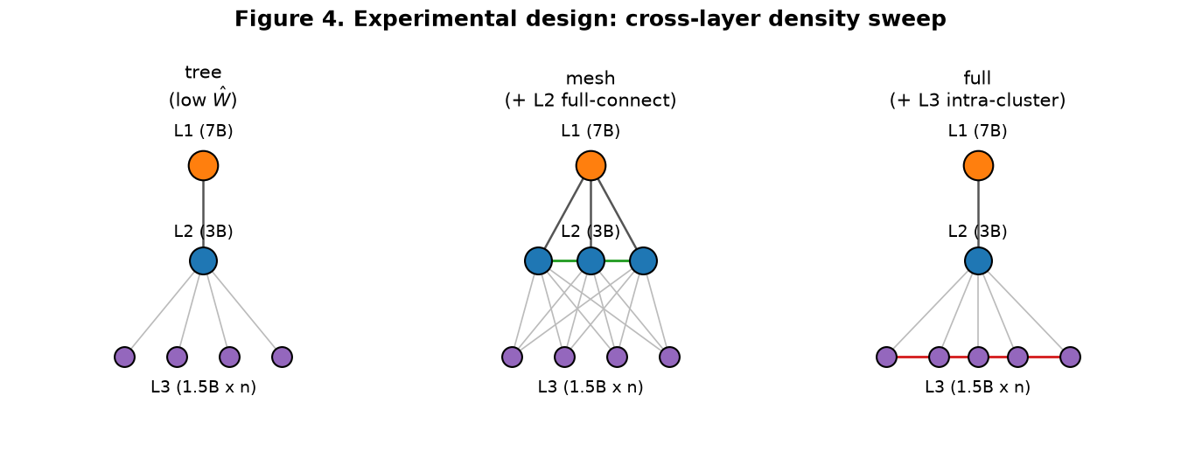
图 4. 实验设计：三层拓扑中跨层连接密度的递进操控。tree 无 L3 横向边；mesh 令 L2 全连；full 额外令 L3 集群内全连（红色横线）。横向边数 tree(0) < mesh < full 构成对 Ŵ 的隔离操控，仅变拓扑、不变模型与基准。

6.4 Benchmark
`mcqmidhardclean.jsonl` (250 curated MCQs). Difficulty band verified: 7B = 0.65, 3B = 0.79, 1.5B = 0.51 — each layer s_i > random floor (0.25), satisfying the equation precondition. Mid-hard difficulty is chosen so the strongest single model stays below 100% (headroom for the emergence term to show) while every layer clears the floor.

6.5 Controls
- committee-0: L3 cluster majority vote (no cross-layer synthesis) — isolates structural increment.
- solo-7B: single 7B model with identical context — strongest single-model ceiling.
- Planned random-topology baseline: same density, randomized edges — tests H3.
- Planned C-Eval cross-validation: standard public benchmark (52 subjects) — defends against researcher degrees of freedom.

6.6 Metrics
- `acccollective`, `acccommittee0`, `acc_solo7B`
- G_solo = acc_collective − acc_solo7B (primary: net emergence vs strongest single)
- G_comm = acc_collective − acc_committee0 (structural increment from cross-layer synthesis)

7. Analysis Plan
- Density sweep: Report Gsolo across tree / mesh / full at nl3 = 12 and 20.
- Primary test of H2: Fit Gsolo($\hat{W}$); test for **non-monotonicity (a peak)** and locate Wc. Sub-critical brackets predicted Gsolo < 0; the post-critical anchor (prior stage3 full@20) predicted G_solo > 0.
- H1 test: G_comm > 0 across topologies.
- H3 test: Random-topology baseline at full density shows no emergence gain vs compute-matched solo; full topology does.
- Cross-validation: Replicate the primary effect on C-Eval.
- Decision rule:
- Support H2 if full@20 reproduces the prior +17pp post-critical gain AND the density sweep shows a non-monotonic peak.
- If all full brackets ≤ solo: revisit the s_i precondition / model assumptions (diagnostic, not auto-failure).
- Statistics: Per-bracket n = 50; report 95% confidence intervals. Non-monotonicity assessed via piecewise / quadratic fit with density as regressor.

8. Current Status (as of 2026-08-07, preregistration upload)
- Completed & locked (sub-critical, n=50 each):
- tree@12 — acc 58.0%, Gsolo −16.0pp, Gcomm +8.0pp
- mesh@12 — acc 52.0%, Gsolo −22.0pp, Gcomm +2.0pp
- full@12 — acc 64.0%, Gsolo −10.0pp, Gcomm +14.0pp (95% CI ±13pp)
- All three sub-critical, consistent with the H2 left flank (no emergence below Wc); H1 (collective > committee-0) holds at all three densities.
- Queued: full@20 (Arm B, post-critical anchor at clean n=50; pending the scan).
- Planned: random-topology baseline; C-Eval probe.
- Prior anchored result (stage3, separate run, n=6 exploratory): full@20 collective > solo by +17pp — post-critical anchor for H2 (very wide 95% CI, n=6; to be superseded by the queued n=50 scan).
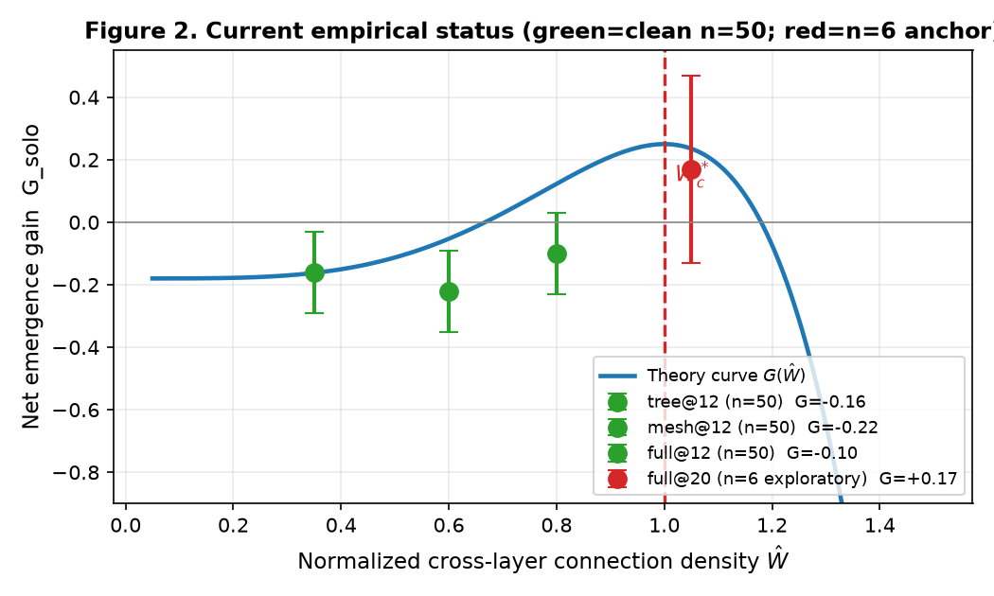
图 2. 当前实证状态：净涌现测量值（绿=清洁 n=50，95% CI≈±0.13；红=探索性 n=6 锚点，CI≈±0.30）叠加理论预测曲线与 Wc。亚临界三档均为负（无涌现），与预测吻合；超临界侧仅以低 n 锚点示意，决定性证据待清洁 full@20 补齐。
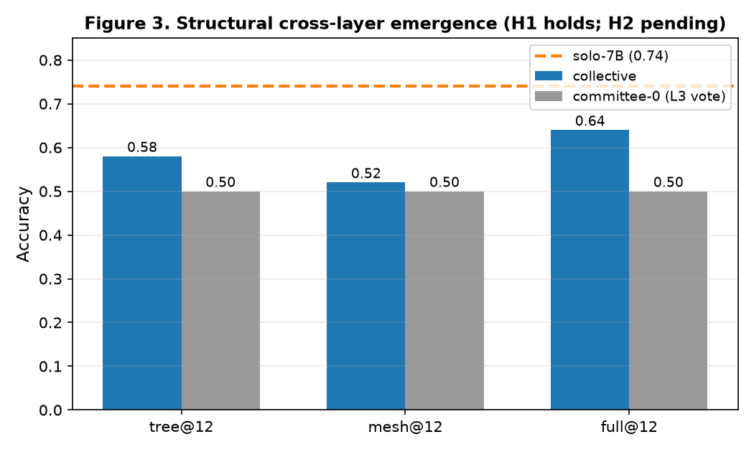
图 3. 结构性跨层涌现：集体（蓝）在所有密度下 > 委员会0 纯投票（灰），证明跨层乘法机制 A 成立；但蓝/灰均低于 solo-7B（橙虚线），表明亚临界下尚无机制 B 的超线性涌现。H1 已验证，H2 决定于待完成的超临界扫描。

9. Reproducibility & Operations
- Scripts: `D:\方程验证\scripts\runstage4scan.py` (density-sweep wrapper; checkpoint resume; single-instance lock; serial tree→mesh→full) · `verifystage2.py` (Ollama generate; `ollamaurl` hardcoded to `127.0.0.1` to avoid an IPv6 `localhost`→`::1` deadlock on this host) · `analyze_stage4.py` (report generator).
- Environment: Managed Python 3.13 venv; Ollama local; models `qwen2.5:1.5b` / `:3b` / `:7b`.
- Known pitfall: This host resolves `localhost` → `::1` (IPv6) but Ollama listens only on `127.0.0.1`. All URLs are hardcoded IPv4; using `localhost` causes a silent permanent hang.
- Checkpoints: `stage4{topo}ckptnl3{N}.json`, namespaced by nl3 to prevent cross-arm corruption.
- Data integrity: Every bracket is checkpointed per question and resumable; no re-run is required to recover from interruption.

10. References
- [1] Yang, Z. (2026). 格式塔方程：多智能体协同涌现能力的数学描述 / A Mathematical Description of Emergent Capability in Multi-Agent Gestalt Architectures (draft v1.2.0, 2026-08-01). Source of the core equation and the two-path derivation (information-theoretic & statistical-physics); the present preregistration adopts the signed correction (\alpha_m-\beta_m) and empirical density-sweep results, superseding v1.2.0 for all empirical claims.
- [2] Prior anchored result: stage3 full@20 density run — collective > solo by +17pp (post-critical anchor for H2, n=6 exploratory).

A. Emergence & statistical-physics foundations（涌现与统计物理基础 —— 支撑"整体 > 部分之和"）
- [3] Anderson, P. W. (1972). More is different. Science, 177(4047), 393–396.
- [4] Haken, H. (1977). Synergetics: An Introduction. Springer-Verlag.
- [5] Holland, J. H. (1998). Emergence: From Chaos to Order. Perseus Books.
- [6] Bedau, M. A. (1997). Weak emergence. Philosophical Perspectives, 11, 375–399.
- [7] Crutchfield, J. P. (1994). The calculi of emergence. Physica D, 75(1–3), 11–54.

B. Critical phenomena & phase transitions（临界现象与相变 —— 支撑 W_c 阈值与"最优密度峰值"）
- [8] Stauffer, D., & Aharony, A. (1994). Introduction to Percolation Theory (2nd ed.). Taylor & Francis.
- [9] Buldyrev, S. V., Parshani, R., Paul, G., Stanley, H. E., & Havlin, S. (2010). Catastrophic cascade of failures in interdependent networks. Nature, 464, 1025–1028.
- [10] Beggs, J. M., & Plenz, D. (2003). Neuronal avalanches in neocortical circuits. Journal of Neuroscience, 23(35), 11167–11177.
- [11] Mora, T., & Bialek, W. (2011). Are biological systems poised at criticality? Journal of Statistical Physics, 144(2), 268–302.

C. Network topology & collective intelligence（网络拓扑与集体智能 —— 支撑"拓扑密度 \hat{W} 可操控、且非单调"）
- [12] Watts, D. J., & Strogatz, S. H. (1998). Collective dynamics of 'small-world' networks. Nature, 393, 440–442.
- [13] Barabási, A.-L., & Albert, R. (1999). Emergence of scaling in random networks. Science, 286(5439), 509–512.
- [14] Galton, F. (1907). Vox populi. Nature, 75, 450–451.
- [15] Condorcet, M. d. (1785). Essai sur l'application de l'analyse à la probabilité des décisions rendues à la pluralité des voix.
- [16] Surowiecki, J. (2004). The Wisdom of Crowds. Doubleday.

D. Mixture of Experts & layered model systems（混合专家与分层模型系统 —— 直接技术先例：路由 / 条件计算 / 分层）
- [17] Jacobs, R. A., Jordan, M. I., Nowlan, S. J., & Hinton, G. E. (1991). Adaptive mixtures of local experts. Neural Computation, 3(1), 79–87.
- [18] Shazeer, N., et al. (2017). Outrageously large neural networks: The sparsely-gated mixture-of-experts layer. ICLR. arXiv:1701.06538.
- [19] Fedus, W., Zoph, B., & Shazeer, N. (2022). Switch transformers: Scaling to trillion parameter models with simple and efficient sparsity. JMLR, 23(120), 1–39.
- [20] Jiang, A. Q., et al. (2024). Mixtral of Experts. arXiv:2401.04088.

E. LLM scaling, emergent abilities & multi-agent systems（大模型规模/涌现与多智能体 —— 区分"规模涌现"与"拓扑涌现"，并设对照护栏）
- [21] Kaplan, J., et al. (2020). Scaling laws for neural language models. arXiv:2001.08361.
- [22] Wei, J., et al. (2022). Emergent abilities of large language models. TMLR. arXiv:2206.07682.
- [23] Hoffmann, J., et al. (2022). Training compute-optimal large language models. arXiv:2203.15556.
- [24] Schaeffer, R., Miranda, B., & Koyejo, S. (2023). Are emergent abilities of large language models a mirage? NeurIPS 2023. arXiv:2304.15004.
- [25] Park, J. S., et al. (2023). Generative agents: Interactive simulacra of human behavior. arXiv:2304.03442.
- [26] Qian, C., et al. (2023). Communicative agents for software development. arXiv:2307.07924.
- [27] Liang, T., et al. (2023). Encouraging divergent thinking in LLMs through multi-agent debate. arXiv:2305.19118.

