- test case
1.1 issues
Step to find the bugs:
- When you begin to register, you need to fill the necessary information,and then register. You will get a confirm email when you finish the form.when you log in the email try to confirm the register.when you click the link in the email, it does not work.

1.2the register test case
Test case | Test scenario
1.register
2.add the email value | Test the formation of the email
3.add the passwords
4.confirm the passwords | Test the difference of the two values
5.confirm email when you finish
6.log in the email
7.click the link in the email | Test the link

b.Some detail of the website still need to fix.

- Improvement
a.The website should be beautified.for example the register page is too simple.
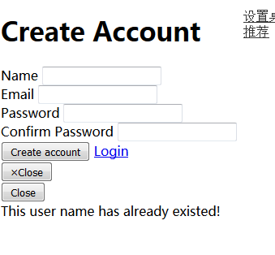

B. The image is not the same size

C. Add the button for download

D.title and description on uploads

E.drag and drop media to vault

- Work flow of the website

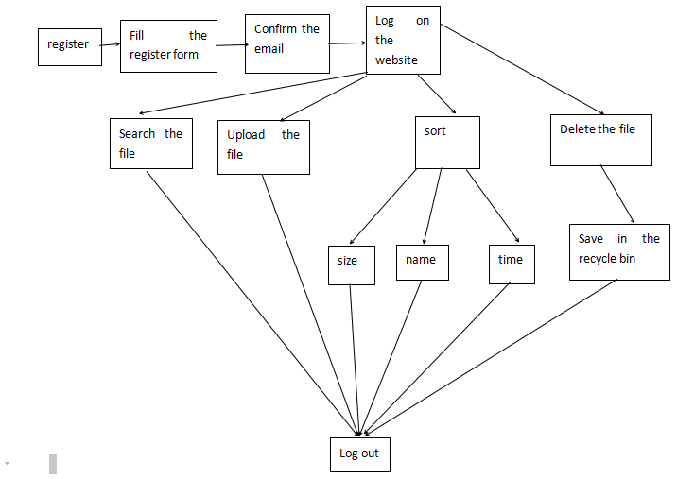

- Questionnaire
After finish the application, we invite 100 people to try to use it and give us some feedback by questionnaire.
a.Are you male or female
◎male
◎female
b.which category below includes you age
◎20 or younger
◎21-29
◎31-41
◎41 or older
c.which of the following devices do you own?
◎Android phone
◎iphone
◎windows laptop
◎Imax
d.which one you prefer to store on the Internet
◎radio
◎video
◎image
e.How easy is it find the Information you are looking for in our website?
◎extremely easy
◎very easy
◎moderately easy
◎slight easy
◎Not at all easy
f.how likely are you to recommend our website to others
◎extremely likely
◎very likely
◎moderately likely
◎slightly likely
◎Not at all likely
g.What changes would most improve our website

The result of the research shown below:

male | 64% |  |  | female | 36%
20 or younger | 18% | 21-30 | 64% | 31-40 | 12% | 41 or older | 6%
Android phone | 30% | iphone | 56% | Windows laptop | 69% | imax | 31%
radio | 14% | video | 34% | image | 52%
Extremely easy use | 64% | Moderately easy | 21% | Slightly easy | 15% | Not at all easy | 0
Extremely likely to recommend | 34% | Moderately likely | 58% | Slightly likely | 5% | Not at all | 3%

- write the team blog of the week 10
