- Team blog
Everyone in our group should write the group blog.In the last week(week 8)is my turn to write the team blog. I write something that week our group member have down. It shown in the following:
Our group start to programming the project this week.we work really like a team. we book a room in library and divide the work into small pieces, everyone take one of it to do.This week our team focus on release one. We plan to do the interface of the website include log in page,and homepage.we also create database to management user account. Moreover, we also intend to complete some functions, like searching,dropping, uploading and downloading the video,music and text.

In order to managing the user account,we will create user to accounts for logging in, the normalization of user name and password,and log in with verified email address.

In addition, for the purpose of monitor media file,we write title and description on uploads,create folder, rename item and folder, sort media, and search media.All of members work hard on their own part,they are willing to spend time on this project. We are learning from the project.

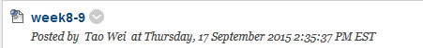

- User story
Our team leader Yang arrange the task and ask every team member to think out several user story before we began the project. Firstly, I start to brainstorming. Then I find out several good ideas and then I put forward my ideas in the group meeting. My ideas past through the group selected and finally it showed up in our user story list.

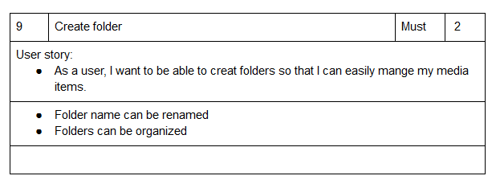

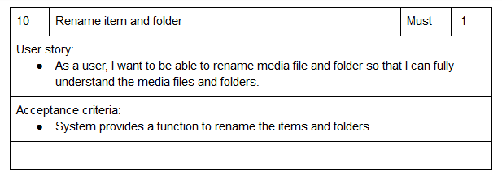
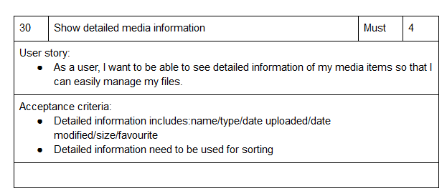
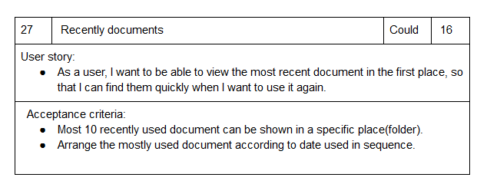
- Black test
When my team member who design the website have down their job, I will test the website’ function and to make sure it is usable.I will try to find the bugs and find somewhere it can be improved.mediavault.wicp.net. This is the link of our website. Standing as the client, I try to use all of the functions. Inputting some of information to sign up the website and try to upload and download of the files.At first time, I was trying this website,it has lots of bugs.However, the website can be operated normally.

- Documentation of release and sprint plan
In this task, I work with Qi Wu to do the documentation of the release and sprint plan, and update the release plan1.
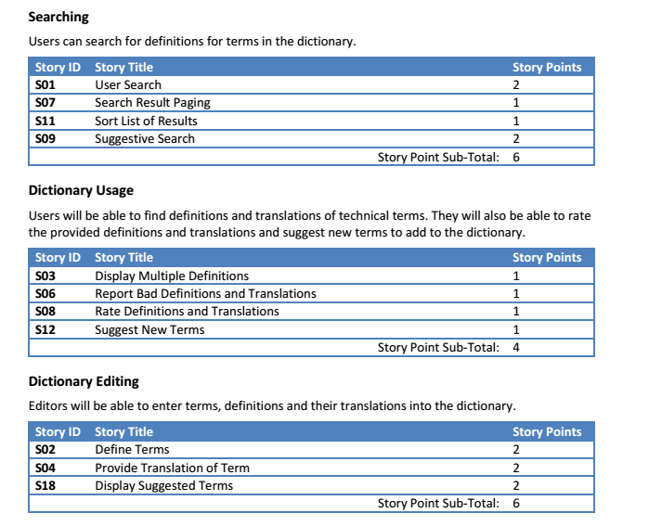

- Meeting idea,peer review and client contact.
Our group have meeting twice a week. All of our team member show up and discuss the project.Therefore we think out tons of fantastic ideas. When we make some change of user story or other things in the project.Wu Qi and me will try to contact with our client via email to let them know the project in time.In addition, we wrote the peer review last week to client as well.