**第一个模型 从地理的角度衡量一种语言对周边的影响**

The most darkest is the English as a mother tongue area；

The lighter color is the area as a second language where the propagation factor is greater than 0.5.

The lightest color is the area as a second language where the propagation factor is less than 0.5.

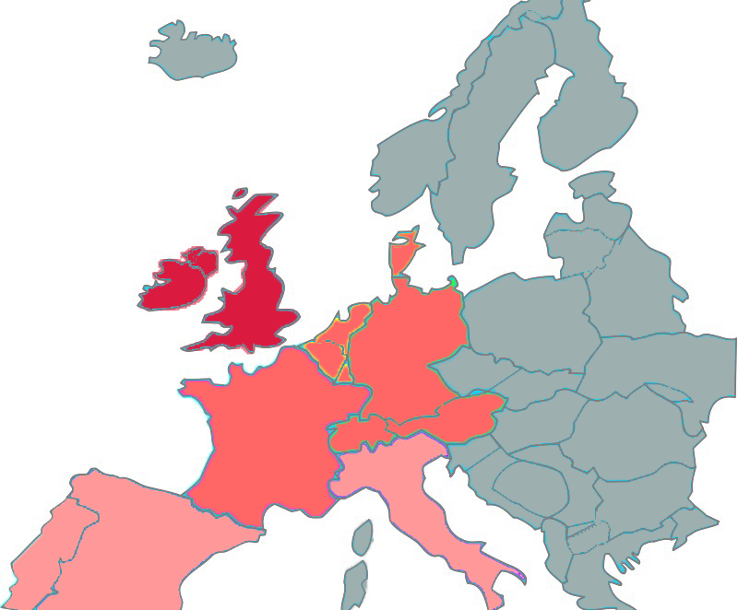

Distribution of English in this area

**第二个模型 从经贸关系的角度衡量一种语言对周边的影响**

下图表示，各个经济体的母语作为其余经济体第二语言的总人口的预测值。（2017、2030和2050）

The figure below shows the predictions of the total population of each economy‘s mother tongue as the second language of the remaining economies. (2017, 2030 and 2050)

由于我们的考量范围局限在前十大经济体（只包含美、英），所以英语作为最广泛的第二语言，在图中总量小于汉语。

As we consider the scope of the limitations of the top ten economies (containing only the United States, Britain), so English as a the most widely used second language, the total is less than the Chinese.

为了更清楚的表示出第二语言的分布，我们以德国为例，下图展示了德国第二语言的分布情况。

To show more clearly the distribution of second languages, let's take Germany as an example. The figure below shows the distribution of second languages in Germany.

明显可看出，中、美作为德国前两大外贸合作伙伴，其母语在德国的影响力也很大。欧盟各国之间的外贸关系十分稳健。

Obviously, China and the United States, as the two largest foreign trade partners in Germany, have a very strong influence in their native languages in Germany. The foreign trade relations between EU countries are very steady.

**第三个模型 预测未来五十年母语人口和总说话人口的变化**

下图是按母语人口数排序，土耳其语的排名从第16跃居第9，其余语言次序基本没有变化。

分析原因在于，土耳其在地缘上与中东地区相毗邻，有大量的难民和战争移民迁入；并且在中东地区经济较为发达，移民拉力因子更大。

The figure below is sorted by the number of native speakers, ranking Turkish from No. 16 to No. 9, the rest of the language sequence remained unchanged.

The reason for this analysis is that Turkey is geographically close to the Middle East, has a large number of refugees and war immigrants, and has a relatively developed economy in the Middle East.

|  |  |  |  |  |
| --- | --- | --- | --- | --- |
| **Ranking** | **Country** | **L1** | **L2** | **Total(Million)** |
| 1 | Chinese | 889.32 | 205.35 | 1094.67 |
| 2 | Spanish | 675.00 | 490.88 | 1165.88 |
| 3 | English | 378.07 | 662.2 | 1040.27 |
| 4 | Indic | 677.98 | 406.62 | 1084.60 |
| 5 | Portuguese | 236.22 | 27.26 | 263.48 |
| 6 | Bengali | 224.34 | 4.27 | 228.61 |
| 7 | Russian | 160.66 | 28.6 | 189.26 |
| 8 | Japanese | 131.45 | 33.83 | 165.28 |
| 16 | Turkish | 123.48 | 6.09 | 129.57 |
| 9 | Javanese | 100.28 | 29.88 | 130.16 |
| 12 | Korean | 90.33 | 8.43 | 98.76 |
| 13 | French | 89.64 | 412.4 | 502.04 |
| 10 | German, Standard | 74.19 | 134.6 | 208.79 |
| 20 | Italian | 65.66 | 34.21 | 99.87 |

Sort by native language

下图是按说话人总说排序，法语的排名从第13跃居第5。原因在于，法国位于欧洲的中心枢纽在欧洲使用广泛。并且由于早期殖民法语在非洲具有相当的影响力，并且非洲母语繁多法语作为一种通用语十分流行。

The figure below is based on the speaker's total ranking, French ranked fifth from No. 13. The reason is that France's central hub in Europe is widely used in Europe. And because early colonial French was quite influential in Africa, with many native languages in Africa, French was very popular as a common language

西班牙语超过汉语跃居第1。原因在于，中国由于计划生育政策的影响人口在呈下降趋势。并且西语在拉丁美洲作为一种通用语十分流行。

Spanish overtook Chinese as number one. The reason is that the population in China is declining due to the influence of the family planning policy. And Spanish as a common language is very popular in Latin America.

|  |  |  |  |  |
| --- | --- | --- | --- | --- |
| **Ranking** | **Country** | **L1** | **L2** | **Total(Millon)** |
| 2 | Spanish | 675.00 | 490.88 | 1165.88 |
| 1 | Chinese | 889.32 | 205.35 | 1094.67 |
| 4 | Indic | 677.98 | 406.62 | 1084.60 |
| 3 | English | 378.07 | 662.2 | 1040.27 |
| 13 | French | 89.64 | 412.4 | 502.04 |
| 5 | Portuguese | 236.22 | 27.26 | 263.48 |
| 6 | Bengali | 224.34 | 4.27 | 228.61 |
| 10 | German, Standard | 74.19 | 134.6 | 208.79 |
| 7 | Russian | 160.66 | 28.6 | 189.26 |
| 8 | Japanese | 131.45 | 33.83 | 165.28 |
| 9 | Javanese | 100.28 | 29.88 | 130.16 |
| 16 | Turkish | 123.48 | 6.09 | 129.57 |
| 20 | Italian | 65.66 | 34.21 | 99.87 |
| 12 | Korean | 90.33 | 8.43 | 98.76 |

Sort by total language

**第四个模型 从未来50年全球人口和人口迁移模式，分析语言地理分布的变化**

迁出语言区

|  |  |  |  |
| --- | --- | --- | --- |
| **Language** | **2030** | **2040** | **2050** |
| **Spain** | -188679407 | -506374081 | -1363004344 |
| **Bengalese** | -57773179 | -83922632 | -122146396 |
| **Hindi** | -55004383 | -80693486 | -118380360 |
| **Mandarin** | -2663441 | -3423167 | -4399599 |
| **Javanese** | -1495159 | -1954538 | -2555060 |

迁入语言区

|  |  |  |  |
| --- | --- | --- | --- |
| **Language** | **2030** | **2040** | **2050** |
| **Japanese** | 6474 | 4026 | 2504 |
| **Portugese** | 1050739 | 1520537 | 2175086 |
| **Russi** | 1991541 | 2347963 | 2758025 |
| **German** | 2165123 | 2523628 | 2983475 |
| **English** | 17563763 | 21778180 | 27465015 |
| **Turkey** | 14716642 | 21269438 | 30737424 |

**第五个模型 六个办公室**

由于已经在纽约和上海建立了办公室，剩下的六个办公室分别建立在排名3-8的语言区的中心热点城市（首都/语言发源地首都）。

The company already has offices in New York and Shanghai, so the six offices are located in the central hot city (the capital of the birthplace of language) of the 3-8 language in the ranking.

|  |  |  |  |
| --- | --- | --- | --- |
| Ranking | Language | L1(a hundred million) | Score |
| 1 | **English** | **44.6** | **0.889** |
| 2 | **Mandarin chinese** | **96.0** | **0.411** |
| 3 | **French** | **8.1** | **0.337** |
| 4 | **Spanish** | **47.3** | **0.329** |
| 5 | **Arabic** | **29.5** | **0.273** |
| 6 | **Russian** | **14.9** | **0.244** |
| 7 | **German** | **9.3** | **0.191** |
| 8 | **Japanese** | **12.5** | **0.133** |
| 9 | **Portuguese** | **21.5** | **0.119** |
| 10 | **Hindustani** | **29.8** | **0.117** |

**选择**

**第六个模型 全球通信性质的变化的角度 分析是否可减少办公室数**

衡量互联网水平：分母是互联网主机数，分子是互联网用户数

$$\frac{E_{host}}{E}=Internet$$

衡量移动通信水平：分母是，分子是最大值

$$\frac{M}{M_{max}}=Mobile$$

比较办公室所在国家i的通信水平，用如下公式衡量：U1=u2=0.5

$$μ_{1}{Internet}_{i}+{μ_{2}Mobile}_{i}={Communication}_{i}$$

|  |  |  |  |  |
| --- | --- | --- | --- | --- |
| Ranking | Language | Internet | Mobile | Communi |
| 1 | **Arabic** | **0.020** | **0.048** | **0.022** |
| 2 | **Spanish** | **0.150** | **0.046** | **0.130** |
| 3 | **German** | **0.308** | **0.098** | **0.266** |
| 4 | **French** | **0.381** | **0.057** | **0.316** |
| 5 | **Russian** | **0.364** | **0.238** | **0.339** |
| 6 | **Japanese** | **0.650** | **0.126** | **0.545** |