Summary

Our goal is to investigate trends in global languages and set standards for setting up international offices for major multinational companies, selecting six or fewer international offices for them to speak in English and one or more other languages.

1. The first model only considers the geographical factor. The model divides the selected zone into multiple language areas. Countries in the language area use the same language as their native language. In this model ,we called the original capital of a language in the language area as topical city. Connect topical cities, abstracted them as a graph model.The standard of connection in the model is that two language areas can be connected by land adjacent to each other. We use the distance measure of the definition of the transmission factor, the transmission factor as a weight measure of a language in different regions of the distribution.

2. Merely considering the geographical factors is not comprehensive. In the second model, we consider economic and trade relations. Countries with the top nine global economies ranked as the nine largest economies and each economy has its own native language as an independent language area. By using the model to predict the influencing factors among the economies, we can get the proportion of using different languages as the second language in a language area, and then get the distribution of the second language in a region.

3. We use the gray prediction model to predict the total number of native speakers of the 20 most spoken languages in the next 50 years. According to different situations, using the first model and the second model, we can calculate the total population as the second language in the top 20 languages. The total number of speakers in the total language is predicted by adding to the total number of native speakers in the top 20 languages.

4. By establishing a population migration model, we analyze the changes in the geographical distribution of languages. In other words, we predict the net immigration of the population in the next 50 years through a gray prediction model. A positive number indicates that this language area is the destination of immigrants; if negative, this area is the source of immigrants.

5. In order to open six international offices, it is necessary to assess the impact of the language(Assessment Level). We have developed indicators that include geography, economics, communication, knowledge and media, and diplomacy. Moreover, each indicator includes several minor indicators. Due to the subjectivity of this issue, we use analytic hierarchy process to determine the weight of each indicator, resulting in a three-tiered hierarchy. The model calculates the international influence of different languages as a basis for setting up an office.

6. With the development of communication, distance is no longer the linguistic gap.We consider assessing the level of communications in different countries to determine whether the country needs an international office. The higher the level of communication , the more convenient the communication, the less the weight of establishing an office, and vice versa.

Introduction

Restatement of the problem

In order to expand its international business, a multinational service company needs to set up international offices in different languages to understand the needs of different customers and promote the development of the company.

We mainly face five questions:

1. Simulate the distribution of speakers in various languages over time.

2. Predict the changes in the total number of native speaker speakers, speakers and other languages in the next 50 years and whether the current top ten languages will be replaced by another in the future.

3. Predict the global population and migration patterns to determine the geographical distribution of languages.

4. Choose six international offices for the multinational service company.

5. Judging by the nature of global communications, the number of international offices opened can be reduced whether or not.

To this end, we have established a geographic and economic and trade relations model to solve the distribution of language speakers. Predict the total number of native speakers and speakers in the next 50 years by using the gray prediction model and compare with the current situation. Use population migration model to determine the geographical distribution of language. The use of AHP to determine the five major indicators as the basis for the selection of six major international offices. Judging the level of communication among countries judge whether the number of international offices opened can be reduced.

Model one: Prediction of language speakers' distribution

Introduction

We mainly consider the establishment of a geographic distribution graphic model and a economic trade relations model to solve the problem of simulating speaker distribution over time in different languages.

Assumptions

Assume that the distance between countries is based on the distance of the capital.

Assume that capitals will not change in all countries in 2017-2025.

Assume that all countries will not be let go by irresistible factors such as war during 2017-2025.

Symbol Table1 .

|  |  |
| --- | --- |
| Symbol | Definition |
| Constant | |
| R | Earth radius |
| $${MLat}_{i}$$ | Latitude of language area i |
| $${MLon}_{i}$$ | Longitude of language area j |
| $$C_{ij}$$ | The angle between language area i and language area j from the Earth's center of the globe |
| $$D_{ij}$$ | The distance between language area i and language area j |
| $$D_{max}$$ | The maximum distance value of two language areas |
| $$α_{ij}$$ | A coefficient that measures the impact ratio of language zone j using language i as a second language. |
| Variables | |
| $$P_{i}$$ | The population of the language area i. |
| $$P_{ij}$$ | The population of language area j use language i as the second language. |

Each language area generally uses its own native language as the common language of the language area, so the language is generally distributed in the language area. The model directly indicates the native language distribution of each language area. This model focuses on geographical distribution, and defines the principle that the neighborhood is the minimum and the distance is the minimum. According to the calculation of the distance of each language interval, it examines whether each language area is adjacent or not, and uses the other language area in the X area as the Second language ratio. And multiplied by the number of people in the language zone to obtain the number of second language learners who learned the language in other language zones and determine the distribution of the second language .

The model starts from the distance between the capitals of various countries. Through Google Earth, we can accurately locate the longitude and latitude. According to the latitude and longitude of two points and distance conversion formula (1) to get the distance $D_{ij}$ between different countries:

$C_{ij}$ =sin(${MLat}_{i}$)*sin(${MLat}_{j}$)*cos(${MLon}_{i}$- ${MLon}_{j}$)+cos(${MLat}_{i}$)*cos(${MLat}_{j}$) $D_{ij}$ 
= $\frac{R*Arccos(C_{ij})*Pi}{180}$ (1)

Find the minimum distance between capitals of different countries through the shortest path algorithm. If you need to calculate the number of countries in which you want to learn j as a second language, then you need to define a second-language propagation factor(2) as a weight.

$α_{ij}$ = $1-\frac{D_{ij}}{D_{\max_{ij}}}$ (2)

The model imitate the population of language area i in different period that as the base number of the learning language j multipling the propagation factor (2) and use it as the second language population of language j at different periods.

$P_{ij}$ = ${P_{i}α}_{ij}$ (3)

Finally, the number of second language learners who learn j language in other language regions is obtained to determine the distribution of j language as the second language.

Model testing

We chose western Europe, southern European countries and Denmark(The reason for considering Denmark is that Denmark borders Germany.)and excluding Greece. Since Britain, France, Portugal, Spain, Denmark and Italy have their own separate native languages, the capitals of each country are taken as six points on the graph model respectively. As the Netherlands and Belgium are both native Dutch speakers, Germany, Switzerland and Austria are German native speakers. Therefore, the Netherlands and Belgium are translated into a Dutch-speaking region and Germany, Switzerland and Austria into one German-speaking region. The Netherlands, Germany The capital as two points on the graph model. In other words, the map model is calculated on the basis of eight language zones. The figure model as shown below.

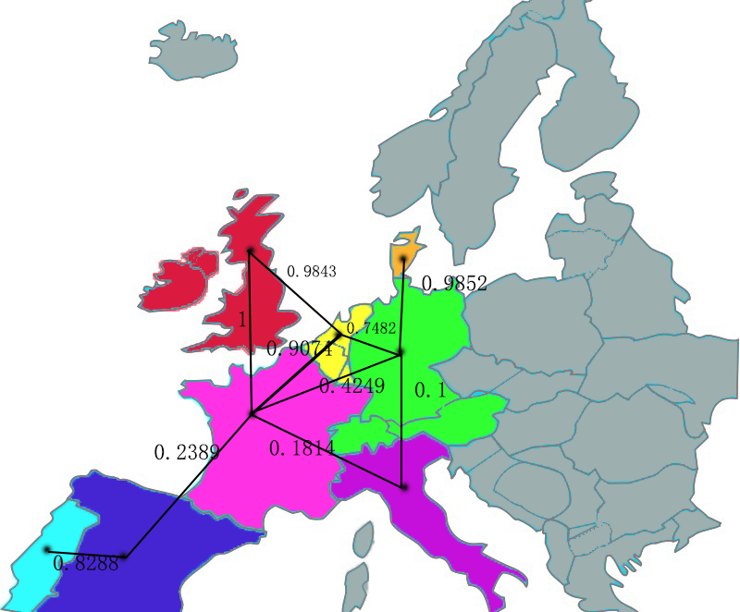

Portugal



Spain



Italy



France



Dutch area



United Kingdom



Denmark



C:\Users\lenovo\AppData\Roaming\Tencent\Users\277172705\QQ\WinTemp\RichOle\ANZ82W`NYSR)~J$XALQ@9)4.pngGerman area

First, we use the formula (1) (2) to calculate the propagation factor in the second language as shown in the figure as a weight.( The weight has been marked on the map.)

Second, we found the number of people in the eight language regions from 2017 to 2050 on the website and obtained the total number of people who use them as a second language respectively according to the formula (2) (3) .( On the following table shows the second language population.)

From this we can get the distribution of language areas in other language areas. Let's take English as an example. (The most deep color is the English as the native language area；The lighter color is the area as a second language where the propagation factor is greater than 0.5；The lightest color is the area as a second language where the propagation factor is less than 0.5.)

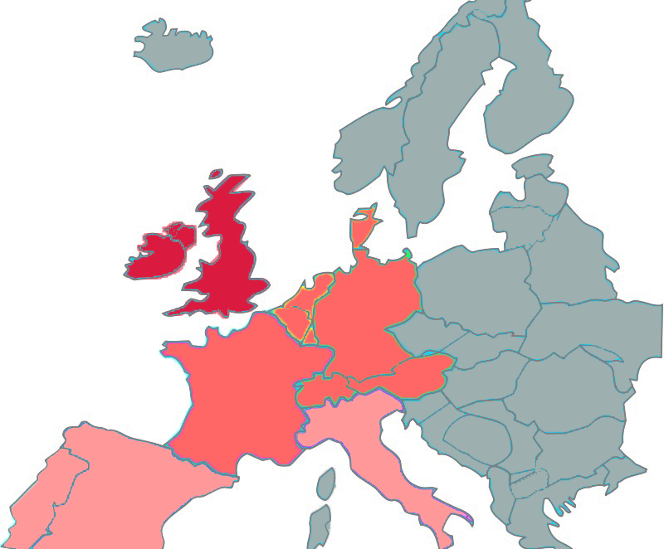

Distribution of English in this area

Thus, we can see the distribution of English , The distribution of other languages can be derived from the analysis process one by one.

Symbol Table2.

|  |  |
| --- | --- |
| Symbol | Definition |
| Constant | |
| $$ω_{mn}$$ | $Language area$ m ‘s total imports of $language area$ n's share |
| Variables | |
| $$P_{m}$$ | $$The population of language area m$$ |
| $$P_{mn}$$ | Number of native speakers who use the language m as the native language of the $language area$ n as the second language |

Economic development is a strong pillar of the country. Economic and trade relations are an important measure of the economic influence of a country or region on other countries. Our model II focuses on economic and trade relations, synthesizes rankings on different websites, and measures the share of one economy's exports to other economies and the population of the economy. Improve maximum density subgraphs, build our strongest economic impact model, and measure the total number of second language learners through this model.

First determine the population of n economies, logarithm it and define it as $\log{P_{n_{econ}}}$. The data obtained easily eliminate heteroscedasticity problems ; the same time, take the logarithm, the variable flexibility. It is obtained by multiplying the share of exports of the n economies in m economies

$P_{mn}$ = $\log{P_{n}}$ $ω_{mn}$* (4)

Through the proportion of different languages in the region , and then get the distribution of speakers in various languages in the region.

Model testing

After our careful choice, there are mainly six major economies, namely the United States, the European Union, China, Russia, Japan and India. Among them, the four major countries in the EU have the higher economic strength, and in the model they are regarded as independent economies, namely Britain, Germany, France and Italy. In other words, there are nine major economies in the model.

The figure below shows the predictions of the total population of each economy‘s mother tongue as the second language of the remaining economies. (2017, 2030 and 2050)

To show more clearly the distribution of second languages, let's take Germany as an example. The figure below shows the distribution of second languages in Germany.

Obviously, China and the United States, as the two largest foreign trade partners in Germany, have a very strong influence in their native languages in Germany. The foreign trade relations between EU countries are very steady.

Conclusion and analysis

As we consider the scope of the limitations of the top ten economies (containing only the United States, Britain), so English as a the most widely used second language, the total is less than the Chinese.

Model Three——Predict the total number of native speakers and speakers over the next 50 years.

We have obtained data from our native-speaking population in the top 20 languages for the past 50 years (these statistics are available every 5 years). Since only the data with the statistical years are separated are collected every 5 years, there is no strong connection between the resettlement data and Linear Regression model can not be used. Since the neural network model needs to consider too many factors, the model is more complex and we do not consider it. In view of current situation, we devise a Grey Forecasting Model to get data with higher reliability. The advantage of using Grey Forecasting Model is that we can get more reliable results with lacking accessible data, which perfectly fitted with our current situation.

Indruction

Using native-speaker population data from the 20 most spoken languages of the past 50 years, a gray prediction model is used to predict the number of native speakers of the 20 languages predicted over the next 50 years. Due to the lack of the total number of data in the past years can not be directly predicted, consider the model one or two, respectively, calculated the top 20 languages as the second language population. And add it to the total number of native speakers in each of its linguistic countries as a projection of the total population.

Correlation Degree Analysis

Calculation of Correlation Coefficient

First, select a reference sequence as shown below:

$x_{0}$ = $\left\{x_{0}\left(k\right)|k=1,2,…,\left.n\right\}\right.$ =($x_{0}\left(1\right),x_{0}\left(2\right),…,x_{0}(n)$)

And the other group of sequence is,

$x_{i}$ = $\left\{x_{i}\left(k\right)|k=1,2,…,\left.n\right\}\right.$ =($x_{i}\left(1\right),x_{i}\left(2\right),…,x_{i}(n)$) , i = 1 ,…, m

Then the correlation degree of $x_{i}$ to $x_{0}$ is,

$r_{i}$ = $\frac{1}{n}\sum_{k=1}^{n}{ξ_{i}(k)}$

in which,

$ξ_{i}(k)$ = $\frac{{}_{s}^{min} {}_{t}^{min}|x_{0}\left(t\right)-x_{s}\left(t\right)|+ρ{}_{s}^{max} {}_{t}^{max}|x_{0}\left(t\right)-x_{s}\left(t\right)|}{|x_{0}\left(t\right)-x_{s}\left(t\right)|+ρ{}_{s}^{max} {}_{t}^{max}|x_{0}\left(t\right)-x_{s}\left(t\right)|}$

Thus, we use $r_{i}$ to describe the correlation degree between $x_{i}$ and $x_{0}$, namely to describe the influence on $x_{0}$ caused by the change of $x_{i}$.

In grey forecasting, we try to find and grasp the law of development of the native language population data in 20 languages over the past 50 years data and at last

make a scientific quantitative prediction for the future condition of the system by raw data processing and grey model building. Currently, the gray forecasting model GM (1,1) is the main application of grey forecasting, but GM (1,1) model is applicable to sequences with strong exponentially, and can only describe the monotonous process of change.T he numbers of people prediction model is a dynamic time-varying system with some random volatility, and therefore it is more suitable for us to use Verhulst model for non-monotonic swing development sequence.

Model Solution

We define $x^{\left(0\right)}$ as the original data sequence of the population of top 20 languages’s native luanguage in year 1962-2016:

*x*(0) = (*x*(0) (1), *x*(0)(2)，…,*x*(0) (*n*))

Then we can get the whitened equation of Verhulst model,

$\frac{{dx}^{(1)}}{dt}$ +a $x^{(1)}$ (t)=b,

in which the X(1) is the accumulated generating operation sequence of *x*(0).After that, we use the least square methods (LSM) to get the parameter a and b as:

$${}_{u}^{∧}={{(a,b)}^{T}=(B^{T}B)}^{-1}B^{T}Y$$

in which,

*B = Y =*

*z*(1)(*k*) = 0.5*x*(1)(*k*) + 0.5*x*(1)(*k* -1)

The respective time response sequence of Verhulst model is:

$x^{(1)}$ (k+1)= ${(x}^{(0)}$ (1)- $\frac{b}{a}$) $e^{-ak}$ + $\frac{b}{a}$, *k =* 1,2,3,…,*n-1*

And we can get the reduced ${\hat{x}}^{\left(0\right)}$ by repeated decreasing:

${\hat{x}}^{\left(0\right)}\left(k+1\right)={\hat{x}}^{\left(1\right)}\left(k+1\right)-{\hat{x}}^{\left(1\right)}(k)$, *k =* 1,2,…,*n*

Model testing

We test our model by residual analysis. Define gray forecast sequence as,

$${\hat{x}}^{\left(0\right)}=({{\hat{x}}_{1}}^{\left(0\right)},{{\hat{x}}_{2}}^{\left(0\right)},…,{{\hat{x}}_{n}}^{(0)})$$

and residual sequence as

$ε^{\left(0\right)}$ =(${{X_{1}}^{\left(0\right)}-{\hat{x}}_{1}}^{\left(0\right)}$, ${{X_{2}}^{\left(0\right)}-{\hat{x}}_{2}}^{\left(0\right)},…,{{X_{n}}^{\left(0\right)}-{\hat{x}}_{n}}^{\left(0\right)}$)

Then, we get relative error sequence: $Δ=(|\frac{E_{1}}{{X_{1}}^{\left(0\right)}}|,|\frac{E_{1}}{{X_{2}}^{\left(0\right)}}|,…,|\frac{E_{1}}{{X_{n}}^{\left(0\right)}}|)$

Finally, we get the Average relative error sequence as shown below:

${}_{Δ}^{-}$ = $\frac{1}{n}\sum_{k=1}^{n}{Δ_{k}}$

Results and Conclusions

Geographical model is a country's impact on many countries, and economic and trade relations model is the impact of many countries on a country. In the first 20 languages, the distribution of second language in English, French and Spanish is fragmented and has a wide range of influence, mainly because other countries study them as a second language and are native speakers of other countries Influence, so use the geographic model to get to learn their second language population. The other languages are basically only used by their own countries and They have a relatively small impact on other countries. This is mainly due to the influence of other countries on their own country. Therefore, the economic and trade relations model is adopted.

According to the gray forecast data, as shown below.

The figure below is sorted by the number of native speakers, ranking Turkish from No. 16 to No. 9, the rest of the language sequence remained unchanged.

The reason for this analysis is that Turkey is geographically close to the Middle East, has a large number of refugees and war immigrants, and has a relatively developed economy in the Middle East.

|  |  |  |  |  |
| --- | --- | --- | --- | --- |
| **Ranking** | **Country** | **L1** | **L2** | **Total(Million)** |
| 1 | Chinese | 889.32 | 205.35 | 1094.67 |
| 2 | Spanish | 675.00 | 490.88 | 1165.88 |
| 3 | English | 378.07 | 662.2 | 1040.27 |
| 4 | Indic | 677.98 | 406.62 | 1084.60 |
| 5 | Portuguese | 236.22 | 27.26 | 263.48 |
| 6 | Bengali | 224.34 | 4.27 | 228.61 |
| 7 | Russian | 160.66 | 28.6 | 189.26 |
| 8 | Japanese | 131.45 | 33.83 | 165.28 |
| 16 | Turkish | 123.48 | 6.09 | 129.57 |
| 9 | Javanese | 100.28 | 29.88 | 130.16 |
| 12 | Korean | 90.33 | 8.43 | 98.76 |
| 13 | French | 89.64 | 412.4 | 502.04 |
| 10 | German, Standard | 74.19 | 134.6 | 208.79 |
| 20 | Italian | 65.66 | 34.21 | 99.87 |

Sort by native language in the next fifty years

The figure below is based on the speaker's total ranking, French ranked fifth from No. 13. The reason is that France's central hub in Europe is widely used in Europe. And because early colonial French was quite influential in Africa, with many native languages in Africa, French was very popular as a common language

Spanish overtook Chinese as number one. The reason is that the population in China is declining due to the influence of the family planning policy. And Spanish as a common language is very popular in Latin America.

|  |  |  |  |  |
| --- | --- | --- | --- | --- |
| **Ranking** | **Country** | **L1** | **L2** | **Total(Millon)** |
| 2 | Spanish | 675.00 | 490.88 | 1165.88 |
| 1 | Chinese | 889.32 | 205.35 | 1094.67 |
| 4 | Indic | 677.98 | 406.62 | 1084.60 |
| 3 | English | 378.07 | 662.2 | 1040.27 |
| 13 | French | 89.64 | 412.4 | 502.04 |
| 5 | Portuguese | 236.22 | 27.26 | 263.48 |
| 6 | Bengali | 224.34 | 4.27 | 228.61 |
| 10 | German, Standard | 74.19 | 134.6 | 208.79 |
| 7 | Russian | 160.66 | 28.6 | 189.26 |
| 8 | Japanese | 131.45 | 33.83 | 165.28 |
| 9 | Javanese | 100.28 | 29.88 | 130.16 |
| 16 | Turkish | 123.48 | 6.09 | 129.57 |
| 20 | Italian | 65.66 | 34.21 | 99.87 |
| 12 | Korean | 90.33 | 8.43 | 98.76 |

Sort by total language in the next fifty years

Model four——Predict the geographical distribution from the population and population migration patterns.

Assumption

Assuming a positive inflow, it indicates that the language area is the destination of the immigrant. Assuming the hypothesis is negative inflow, it indicates that the language zone is the source of the immigrants, so that the migration pattern of the population can be analyzed.

Data

1.We have found the global population of the United Nations for the next 50 years.

|  |  |  |  |
| --- | --- | --- | --- |
| **Country** | **2030** | **2040** | **2050** |
| **Spain** | -188679407 | -506374081 | -1363004344 |
| **Bengalese** | -57773179 | -83922632 | -122146396 |
| **Hindi** | -55004383 | -80693486 | -118380360 |
| **Mandarin** | -2663441 | -3423167 | -4399599 |
| **Javanese** | -1495159 | -1954538 | -2555060 |

|  |  |  |  |
| --- | --- | --- | --- |
| **Country** | **2030** | **2040** | **2050** |
| **Spain** | -188679407 | -506374081 | -1363004344 |
| **Bengalese** | -57773179 | -83922632 | -122146396 |
| **Hindi** | -55004383 | -80693486 | -118380360 |
| **Mandarin** | -2663441 | -3423167 | -4399599 |
| **Javanese** | -1495159 | -1954538 | -2555060 |

2.The World Bank has provided net emigration of all countries over the past 50 years, and we use the gray prediction model to predict the net immigration of the population over the next 50 years.

Symbol Table3 .

|  |  |
| --- | --- |
| Symbol | Definition |
| $$m_{i}$$ | Net migration of a country with i language as the mother tongue. |
| $M_{i}$ | Summation of net migration of all countries in which language i is the native language. |
| $$W_{ij}$$ | The total pull factor is the direction of immigration. |
| $$α_{ij}$$ | Geographical Rally Factor |
| $$ω_{ij}$$ | Economic Rally Factor |
| $$β_{α}$$ | The weight of influencing geographical rally factor. |
| $$β_{ω}$$ | The weight of the economic pull factor. |
| $$P_{ij}$$ | $$\text{The migrated population of Language area i to language area j .}$$ |

$m_{i}$ represents the net migration of a country in which i language is the native language. The displaced people do not change their mother tongue, but learn to move into the foreign language as a second language, thereby affecting the language of the country they move to. $M_{i}$ is used to determine the migration pattern (source or destination) of the speaker in the i language.

$M_{i}$ = m1+ m2 + …..+ $m_{n}$

“n” represents the number of countries in which language i is the mother tongue.

The total tension factor($W_{ij}$) represents the direction of immigration, from a geopolitical and economic point of view. Including geo-tension factor and economic tension factor. Among them, the weights $β_{α}$ and $β_{ω}$ determine the two factors in $W_{ij}$ share.

$${W_{ij}=β}_{α}×α_{ij}+{β_{ω}×ω}_{ij}$$

Language area i represents the source of immigrants. The language zone j is the destination of immigrants. $P_{ij}$ denotes the migrated population from the language zone i to the language zone j.

$P_{ij}$ = $W_{ij}×M_{i}$

Through the statistics to move out of the language area, into the language area, only consider the direction of moving into the language zone, calculated top14 languages.

Model five

Overview

In a multilingual and globalized society, language is the prerequisite for us to be able to communicate with others and to allow us to participate in the social, cultural and economic activities. Which languages are most useful? Now a large multinational service company with offices in New York City, the United States and Shanghai, China, is expanding to establish six international offices in different countries around the world. Which languages will you use in these six offices? This will be problems we will solve in this model.

The model uses analytic hierarchy to measure the "usefulness" of a language, and we define a language proficiency index that assigns weights. Broadly speaking, there are five main factors that affect the usefulness of the language. They are:

1. geography
2. economy
3. exchange
4. knowledge and media
5. diplomacy

In a narrow sense, the five factors are each measured by different indicators (see the following table). In other words, the Language Proficiency Index (PLI) uses 17 indicators to evaluate the language's influence, which is called weight. The index assesses the usefulness of language for the whole of humanity and not for a single individual affected by any geographical environment, human circumstances or personal preferences. This index also fails to measure the beauty and value of language and its associated culture.

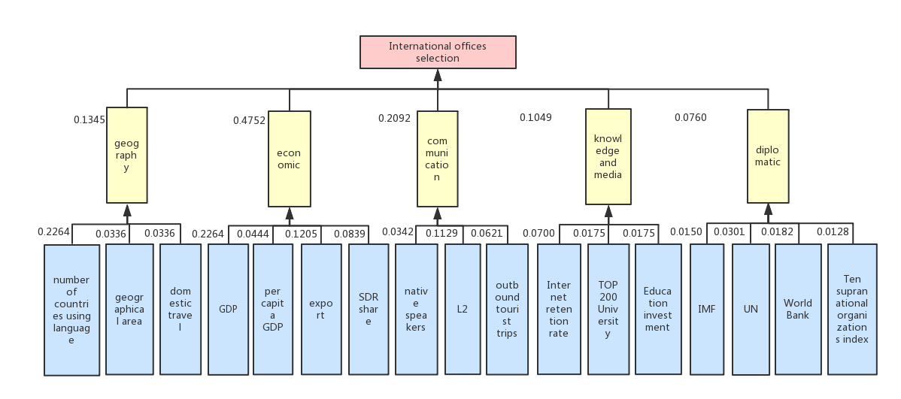Then we conduct sensitivity analysis on our model, analyze different results and find better parameters for the desired result. In summary, our model is a viable and reasonable model with technical and data support. Due to its subjectivity, the data can be flexibly applied after training.

Reasons for choosing seventeen indicators

The Language Proficiency Index (PLI) is the measure of linguistic influence. In this model we use five factors to measure PLI: geography, economics, communication, knowledge and media, and diplomacy. But why use these five factors?

First of all, the correlation between the five factors is very low, and each factor can be separated as the influence index of PLI.

(a)Geography: Geospatial distances play its role of spatial isolation and are more likely to be spoken by the same or neighboring countries in the same language. Three indicators represent geography, namely geographical area, number of neighboring countries and number of languages used respectively.

(b)Economy: The influence of economies through their own economic power affects the setting of national language policies and the establishment of language training systems in other language regions. At the same time, the economy affects people's choice of language learning, so as to promote the speed and scope of the spread of a certain language. There are four indicators on behalf of the economy, namely, national GDP, GDP per capita, exports, foreign exchange.

(c) Exchange :The exchange of languages promotes the development of languages, the number of native speakers and the number of second language users, and they are important indicators of linguistic influence. At the same time, with the rapid development of tourism, language exchange and learning are promoted, and the influence of a certain language is also expanded. In other words, the number of native speakers, the number of second language users and the number of people who travel abroad are indicators of the exchange factor.

(d) Knowledge and media :With the rapid development of the Internet, the Internet has made the Earth a global village. Internet users are increasing day by day, increasing the possibility of people in different countries in their communication and exchange, thereby expanding the influence of languages in different countries. At the same time, the level of education is a measure of the people's likelihood of learning different languages. The model uses the global top200 university rankings and pedagogical investment as an indicator to measure the level of education and hence the "usefulness" of a language. The diplomacy of a country influences the learning of the second language of the country, in which we judge the languages of each language based on the countries joining the International Monetary Fund, the permanent members of the UN, the countries that have joined the World Bank, and the ten international coalitions "Usefulness."

Solution steps

When we try to obtain the weight of the five aspects of the first-level evaluation and the weight of 17 second-level evaluation criteria, subjective judgment is ill-considered. So we choose the Analytic Hierarchy Process (AHP) as the way to combine the weighting coefficients of all the indicators in the evaluation system.

Obtain the index weights

• Determine the judging matrix. We use the pairwise-comparison method and 1–9 method of AHP to construct the judging matrix A = ($a_{ij}$):

$a_{ij}$ = $a_{ik}a_{kj}$,

where $a_{ij}$ is set according to the 1–9 method.

• Calculate the eigenvalues and eigenvectors. The greatest eigenvalue $λ_{max}$ of matrix A has corresponding eigenvector u = ${ (u_{1}, . . . , u_{n})}^{T}$. Then we normalize u by

$x_{i}$ = $\frac{u_{i}}{Σj^{uj}}$

• Do a consistency check. The indicator of consistency is

CI= $\frac{ λ_{max}-n}{n-1}$,

where n is the dimension of the matrix.

The expression of consistency ratio is

CR= $\frac{CI}{RI}$.

Having confirmed the weighting coefficients of all the indicators in the evaluation system, now we quantify the importance of … .

${CW}_{i}$ denotes the weight of criteria level factor i, where ${AW}_{j}$ is the weight of secondary critical level factor j for the ith critical level, mi denotes the total number of secondary critical factors, and $F_{j}$ denotes the secondary critical level factor.

The evaluation grade $Y_{1}$ should be

$Y_{1}$ = $\sum_{i=1}^{5}{{CW}_{i}}\sum_{j=1}^{mi}{{AW}_{j}F_{j}}$

Results and analysis

We obtain the following results:

• Judging matrix:

A =

$$\left[\begin{matrix}1 & 1/4 & 1/2 & \begin{matrix}1 & 3\end{matrix} \\ 4 & 1 & 3 & \begin{matrix}4 & 5\end{matrix} \\ 2 & 1/3 & 1 & \begin{matrix}2 & 3\end{matrix} \\ \begin{matrix}1 \\ 1/3\end{matrix} & \begin{matrix}1/4 \\ 1/5\end{matrix} & \begin{matrix}1/2 \\ 1/3\end{matrix} & \begin{matrix}\begin{matrix}1 \\ 1\end{matrix} & \begin{matrix}1 \\ 1\end{matrix}\end{matrix}\end{matrix}\right]$$

• Weight vector of criteria level:

CW ={5,9,7,3,3}

• Weight vector of components level:

${AW}_{1}$ ={0.5,0.25,0.25}

${AW}_{2}$ ={0.45,0.1,0.25,0.2}

${AW}_{3}$ ={0.2,0.4,0.3}

${AW}_{4}$ ={0.5,0.25,0.25}

${AW}_{5}$ ={0.2,0.4,0.2,0.2}

For this level, CI =0.0304, CR =1.12, satisfying the criterion for consistency of CI/RI < 0.1.

The rankings of language proficiency in the top ten countries by AHP are shown in the following table：

|  |  |  |  |
| --- | --- | --- | --- |
| Ranking | Language | L1(a hundred million) | Score |
| 1 | **English** | **44.6** | **0.889** |
| 2 | **Mandarin chinese** | **96.0** | **0.411** |
| 3 | **French** | **8.1** | **0.337** |
| 4 | **Spanish** | **47.3** | **0.329** |
| 5 | **Arabic** | **29.5** | **0.273** |
| 6 | **Russian** | **14.9** | **0.244** |
| 7 | **German** | **9.3** | **0.191** |
| 8 | **Japanese** | **12.5** | **0.133** |
| 9 | **Portuguese** | **21.5** | **0.119** |
| 10 | **Hindustani** | **29.8** | **0.117** |

Conclusion

From the above analysis, we can draw the following conclusion: Since New York and Shanghai have established their international offices. Therefore, the establishment of international offices no longer exists in the countries of use of the two areas. We only consider the establishment of an international office in the language area ranked 3-8 in the table above, and the specific locations will be established as topical in the center of the language area: Paris, Madrid, Jeddah, Moscow, Munich and Tokyo.

Model six

Considering the communication level of the countries where hotspots are located in each center separately and comparing with the selected office locations to determine whether there is a need to reduce the number of offices.

|  |  |
| --- | --- |
| Symbol | Definition |
| $$N_{host}$$ | Internet hosts |
| $$N_{p}$$ | Internet users |
| $$L_{internet}$$ | Internet level |
| $$N_{Telepthone}$$ | Telephone users |
| $$M_{max}$$ | Maximum telephone users |
| $$L_{Telepthone}$$ | Mobile communication level |
| $$w_{internet}$$ | The weight of Internet level |
| $$w_{Telepthone}$$ | The weight of mobile communication level |
| $$L_{communication}$$ | Communication level |

We use two evaluation methods, the first used to measure the Internet level：

$L_{internet}$ = $\frac{N_{host}}{N_{p}}$

The second used to measure the level of mobile communications:

M= $N_{Telepthone}$

$L_{mobile}$ = $\frac{M}{M_{max}}$

Comparing the level of communications in country i where the international office is located is measured by the following formula:

$w_{internet}$ =0.8, $w_{mobile}$ =0.2

$L_{communication}=w_{internet}L_{internet}$ + $w_{Telepthone}L_{Telepthone}$

Using the above formula, we get the rankings of the top ten languages only considering the level of communications, as shown in the following table:

|  |  |  |  |  |
| --- | --- | --- | --- | --- |
| Ranking | Language | Internet | Mobile | Communication |
| 1 | **Arabic** | **0.020** | **0.048** | **0.022** |
| 2 | **Spanish** | **0.150** | **0.046** | **0.130** |
| 3 | **German** | **0.308** | **0.098** | **0.266** |
| 4 | **French** | **0.381** | **0.057** | **0.316** |
| 5 | **Russian** | **0.364** | **0.238** | **0.339** |
| 6 | **Japanese** | **0.650** | **0.126** | **0.545** |

Conclusion and analysis

In the above table, the communication levels of the six selected international offices in Model 5 are arranged. The higher the level is, the more network communication is made. From the perspective of saving the cost of a company, it can be deleted.

Conclusions

In order to solve this transnational corporation's problem, the team needs to describe the model that investigates the development trend of the global language and the choice of international offices. We will resolve each sub-issue one by one.

To solve the problem of simulating the distribution of speakers in various languages over time, the team established a model that measures the distribution of a language in different regions and the distribution of a second language in a region based on two factors of geography and economic and trade relations. To solve the problem of predicting the total number of native speakers and speakers over the next 50 years, the team used gray prediction models to obtain results. In order to solve the problem of the change of geographical distribution of language, the team established a model of population migration and obtained the change of geographic distribution in different languages. MNCs need our design model to establish six international offices. To do this, we choose AHP AHP method to model the language proficiency index of the top ten languages as a factor to determine the influence of language, select the office and take the national communication Based on the level of development, in order to save company costs, minimize the number of international offices.

Sensitivity Analysis

Strengths and Weakness

Strengths

We propose six models for different issues.

In Model 1, we reasonably quantify the effect of language geographically on the periphery and analyze the case of Europe. Compared with the real data, the results of our model are accurate.

In Model 2, we consider the nine major economies in the proportion of bilateral trade, our model is scientific and rational.

In Model 3, according to the characteristics of the first 14 languages, we use different models to separately calculate the population as the second language because our forecast result has certain reliability.

In Model 4, we only consider the two dominant and important factors, geo-economy, but the invisible factors such as history and culture are not considered.

We directly predict population data in the future world in the UN database and inevitably the errors in the data.

In Model 5, we use AHP to analyze more influencing factors, and our model results are comprehensive.

Gray prediction model is more suitable for such a small sample of world immigration data, less relevant data, relative to the linear programming, neural network and other prediction models.

Weakness

We directly predict population data in the future world in the UN database and inevitably the errors in the data.

In Model 6, we only consider the host and cell phone communication in these two factors, ignoring the use of other less communication methods, the model results have some errorsReferences.

To: Chief Operating Officer of the company

From: Team 88596

Data: February 12，2018

Subject/Re: Advice for opening additional overseas offices

This memo is our team's response to the question of opening an additional overseas office. This memo describes the background will be the first global language distribution then discuss the choice of the location of overseas offices on that basis. Third, consider changes in global communications, analysis of different overseas offices set up in the long-term and short-term.

Judging from the survey of global languages, there are over 6,000 different languages ​​in the world today, but one third of the languages ​​have fewer than 1,000 speakers. In addition, users of the top 15 languages ​​add up to more than half of the global population. In a multilingual and globalized society, language is the prerequisite for us to be able to communicate with others and to allow us to participate in the social, cultural and economic activities. Companies want to be truly international companies, the establishment of additional international offices for the company's long-term development is necessary.

So which languages ​​are the most "useful"? The answer to this question is the one I will give advice. Our team, based on the combination of geography, economics, communication, knowledge and media, and diplomatic skills, evaluates the global language and finally lists the **top 10 most powerful languages** ​​in the world. They are **English, Mandarin, French, Spanish, Arabic, Russian, German, Japanese, Portuguese and Hindi** respectively.

English is now the de facto common language throughout the world: she is the dominant language in three G7 countries (United States, United Kingdom, Canada), and the legacy of the British Empire gives English a global reach. Mandarin Chinese is ranked second, but its value is only half. French ranks third with its outstanding position in international politics. The fourth and fifth respectively are Spanish and Arabic. The top six languages are exactly the six official languages of the United Nations, and they are still in the top six even excluding the diplomatic impact. The four remaining languages of the top ten, two from the BRICS (Portuguese-Brazil, Hindi-India) and two from the official languages (German and Japanese) of two economic powers.

So it is wise to decide the location of international offices based on the global distribution of strong languages. Because the company already has offices in New York and Shanghai, we recommend setting up an office in the language area ranked 3-8. Because some language zones are made up of several countries with native languages, the city in which the office is located should be the central city of the language zone. In German, for example, Germany, Austria and Switzerland are all German-speaking countries. Germany, as one of the most influential countries, selected the capital of Germany as the hotspot city in the German-speaking area. **So these six offices are located in Paris, Madrid, Jeddah, Moscow, Munich and Tokyo.**

In addition, we separately assessed the communications level of the countries in which the above six offices are located, from low to high respectively to Saudi Arabia, Spain, Germany, France, Russia and Japan. At present, only Japan's communication level is above average. Forecasts show that communication levels in Germany, France and Russia will be above average over the next 10 years. So in the short term, five other offices, with the exception of Japan, will be given priority in the short term to saving client company resources; in the long run, Russia, France and Germany can be gradually phased out.

At the same time, in order to ensure the business level in these areas, it is necessary to establish a sound network office system and set up a host internet in hot spots to directly communicate with the headquarters. Gradually establish multi-layer network hub. This will greatly improve the company's operational efficiency and reduce the company's operating costs.

Above all is the result and suggestion of our team on the issue of opening an additional international office.