FINAL EVALUATION REPORT
ProofLens
Robust AI-Generated Image Detection Under Realistic Post-Processing
Evaluation item | Final configuration
Selected model | E2-on-SID (DINOv2 base, final two blocks fine-tuned)
Evaluation date | 1 September 2026
Primary test set | 1,006 images: 953 authentic and 53 AI-generated
Decision threshold | 0.905192 after validation-only temperature calibration
Artifact status | ONNX export passed 32-image PyTorch parity verification

Overall finding: ProofLens achieved strong clean and transformation-robust ranking performance. The main remaining risk is threshold calibration under unseen-generator domain shift, not transformation robustness on the held-out primary test set.

1. Executive summary
ProofLens is a research prototype that distinguishes AI-generated images from authentic images while testing whether its predictions survive realistic redistribution. The final model was selected using validation performance, calibrated without test-set fitting, evaluated on held-out clean and transformed data, and exported to ONNX for the local demonstration.
On the held-out primary test partition, the model reached 0.9974 clean ROC AUC and 0.9971 family-macro robust ROC AUC. At the calibrated operating threshold, it produced 14 false positives and 2 false negatives. The strongest limitation appeared on a separate unseen-generator partition: ranking remained strong at 0.9638 ROC AUC, but 36.56% of AI-generated images fell below the fixed threshold.

2. Evaluation design
The evaluation separates model selection, calibration, and final reporting. Checkpoint selection uses validation clean and robust ROC AUC only. Temperature scaling and the operating threshold are fitted on validation predictions. The held-out test results are then reported once using that frozen model and calibration.
Evaluation slice | Scale | Purpose
Clean test | 1,006 | Measures discrimination before an added evaluation transform
Canonical robustness | 14 conditions | JPEG, blur, resize, noise, color jitter, and center crop
Generator holdout | 11,000 | 10,000 AI-generated and 1,000 authentic images from a shifted partition
Secondary stress | 4 conditions | WebP quality 80/50 and screenshot-style 1440/1080 redistribution
Export parity | 32 images | Compares PyTorch and ONNX probabilities before publication

Dataset caution: the primary held-out test set is strongly imbalanced, so ROC AUC, precision, recall, and raw error counts should be read together.

3. Primary results
Metric | Result | Interpretation
Clean ROC AUC | 0.9974 | Excellent clean-image ranking
Macro robust ROC AUC | 0.9971 | Average across six transformation families
Worst-condition ROC AUC | 0.9966 | JPEG quality 30
Unseen-generator ROC AUC | 0.9638 | Strong ranking despite domain shift
Accuracy | 98.41% | 990 correct classifications out of 1,006
Precision | 78.46% | Affected by 14 false positives and class imbalance
Recall | 96.23% | 51 of 53 AI-generated images detected
F1 score | 86.44% | Thresholded balance of precision and recall

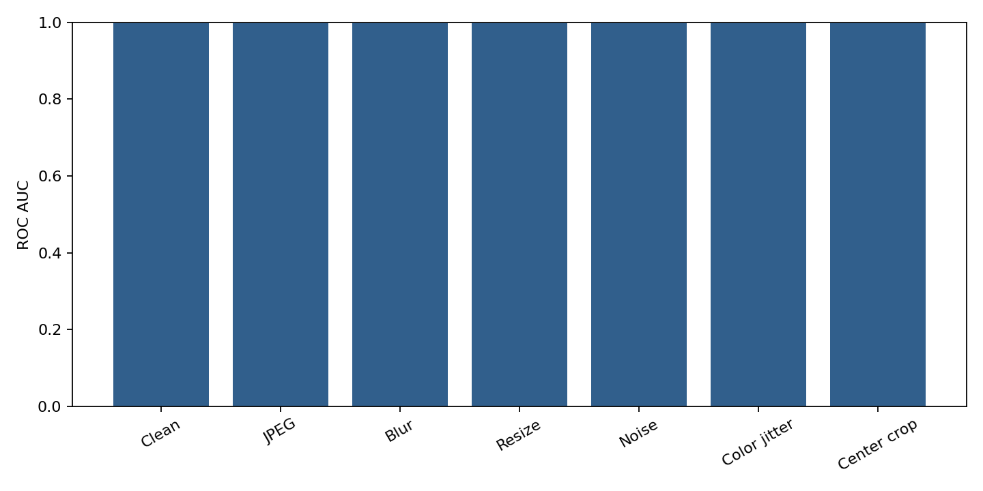
Figure 1. Clean and transformation-family ROC AUC summary.

4. Robustness by transformation
All canonical transformation conditions preserved ROC AUC above 0.9965. Thresholded error counts remain low and are distributed across families rather than concentrated in one operation. Heavy JPEG compression is the clearest observed weakness, but its error rate is still 2.09% on the primary test images.
Condition | Family | ROC AUC | Errors
JPEG quality 30 | JPEG | 0.9966 | 21 / 1,006 (2.09%)
Center crop 80% | Crop | 0.9970 | 18 / 1,006 (1.79%)
JPEG quality 50 | JPEG | 0.9968 | 18 / 1,006 (1.79%)
Resize 0.25x | Resize | 0.9970 | 18 / 1,006 (1.79%)
Resize 0.5x | Resize | 0.9970 | 18 / 1,006 (1.79%)
Blur sigma 0.5 | Blur | 0.9973 | 17 / 1,006 (1.69%)
JPEG quality 90 | JPEG | 0.9974 | 17 / 1,006 (1.69%)
Blur sigma 1.0 | Blur | 0.9971 | 16 / 1,006 (1.59%)
Blur sigma 2.0 | Blur | 0.9971 | 16 / 1,006 (1.59%)
Color jitter 20% | Color | 0.9973 | 16 / 1,006 (1.59%)
JPEG quality 70 | JPEG | 0.9972 | 15 / 1,006 (1.49%)
Noise sigma 0.02 | Noise | 0.9978 | 14 / 1,006 (1.39%)
Noise sigma 0.10 | Noise | 0.9970 | 14 / 1,006 (1.39%)
Noise sigma 0.05 | Noise | 0.9973 | 11 / 1,006 (1.09%)

5. Secondary redistribution stress tests
Stress condition | ROC AUC | Mean absolute probability shift
WebP quality 80 | 0.9971 | 0.0108
WebP quality 50 | 0.9967 | 0.0175
Screenshot 1440 | 0.9965 | 0.0220
Screenshot 1080 | 0.9965 | 0.0221

6. Error-case analysis

6.1 Primary held-out errors
The clean primary test partition produced 16 errors: 14 authentic SID images were classified as AI-generated, and 2 AI-generated images were classified as authentic. The false negatives came from flux-pro-v1.1 (1 of 3 examples) and stable-diffusion-v35-medium (1 of 1 example). These generator-specific subsets are too small for comparative claims.
Failure indicator | Count | Observation
False positives | 14 | Authentic images classified as AI-generated
False negatives | 2 | AI-generated images classified as authentic
Highest condition errors | 21 | JPEG quality 30
Lowest condition errors | 11 | Gaussian noise sigma 0.05

6.2 Unseen-generator calibration shift
Most important limitation: The unseen-generator partition retained 0.9638 ROC AUC, but the fixed threshold produced 3,656 false negatives and 19 false positives. Therefore, 36.56% of unseen AI-generated images fell below the selected operating threshold.
This is a calibration-transfer failure rather than a collapse in ranking. The model still tends to rank generated images above authentic images, but the probability distribution shifts downward on the unseen domain. Future work should broaden validation coverage, evaluate domain-aware calibration, and report operating points designed for high-recall screening.

7. Deployment verification
Verification item | Result
Selected checkpoint | E2-on-SID
Export format | ONNX
Parity sample | 32 held-out images
Maximum logit difference | 0.00002551
Maximum probability difference | 0.00000131
Required tolerance | 0.0001
Parity result | PASS

The final Gradio application uses the calibrated ONNX model and analyzes each image exactly as uploaded. End-to-end checks classified a held-out authentic image as Authentic, a held-out generated image as AI-generated, and a heavily JPEG-compressed generated image as AI-generated while also flagging visible compression.

8. Limitations and responsible interpretation
Limitation | Implication
Class imbalance | The primary test set contains far more authentic than generated images, so accuracy alone is insufficient.
Generator shift | A threshold calibrated on one distribution does not transfer perfectly to unseen generator families.
Processing inference | Compression and blur can leave visible signals, but crop, recolor, and rescale history may be unknowable from one final image.
Research scope | The score is model evidence, not forensic proof, and must not independently determine authorship or penalties.

9. Conclusion
ProofLens meets the prototype objective of maintaining strong discrimination after realistic post-processing. Clean, canonical-transformation, and secondary stress-test AUC values are consistently high, and the ONNX deployment faithfully reproduces PyTorch probabilities. The final evidence also identifies the correct next research priority: improving probability calibration and recall under unseen-generator domain shift.

Appendix A. Video narration summary
We evaluated ProofLens on a held-out test set of 1,006 images. On clean images, the model achieved a ROC AUC of 99.74%. At the validation-selected threshold, it reached 98.41% accuracy, 78.46% precision, 96.23% recall, and produced 14 false positives and 2 false negatives.
Across JPEG compression, blur, resizing, cropping, color adjustment, and noise, the macro robust ROC AUC was 99.71%. Even the weakest tested condition, heavy JPEG compression, achieved 99.66% ROC AUC. WebP and screenshot stress tests also remained above 99.64% ROC AUC.
On unseen-generator data, ranking remained strong at 96.38% ROC AUC, but the fixed threshold missed 36.56% of generated images. This shows that calibration transfer is the model's main limitation. Finally, the ONNX export passed a 32-image parity test with a maximum probability difference of approximately 0.0000013.
Overall, ProofLens demonstrates strong clean and transformation-robust performance, but its results should support human review rather than be treated as forensic proof.

Appendix B. Evidence files
Evidence | Repository or local artifact path
Final metrics | artifacts/reports/sid-comparison-final/metrics.json
Robustness table | artifacts/reports/sid-comparison-final/robustness.csv
Stress metrics | artifacts/reports/sid-comparison-stress/stress-metrics.json
Error analysis | docs/reports/error-analysis.md
Export parity | artifacts/export/export_report.json
Model card | docs/model-card.md

