When Databases Become the Agent's Scratchpad
BranchBench, from Columbia University, is the first benchmark that asks whether branchable databases can keep up with AI agents that fork, mutate, and evaluate state thousands of times over — and finds that today's systems force a hard choice between fast branching and fast reads.
For most of their history, databases have been treated as a passive place to store facts: you write rows, you read them back, and the interesting logic lives in the application on top. Branching — keeping several divergent copies of a database alive at once — was a niche convenience, mostly for developers who wanted a throwaway copy to test a migration or reproduce a bug. A handful of branches a day was plenty.
Autonomous AI agents break that assumption. An agent that plans by trial and error does not commit to a single line of reasoning; it explores. It forks the current state, tries a speculative action, checks whether the result improved, and either keeps that path or throws it away and backtracks. When the underlying state is a relational database, every one of those speculative steps is a branch — and a single agent run can create thousands of them. The database stops being a passive store and becomes the agent's scratchpad.
A team from Columbia University argues that this shift deserves to be measured rather than assumed. Their paper, "BranchBench: Aligning Database Branching with Agentic Demands," builds the first systematic benchmark for branchable relational databases under agentic workloads, runs five representative workloads against production systems, and reaches a blunt conclusion: no system available today can support these workloads at scale. Every design is fast at one thing and slow at the other.
Paper: https://arxiv.org/abs/2604.17180 — Code: https://github.com/ElaineAng/db-fork
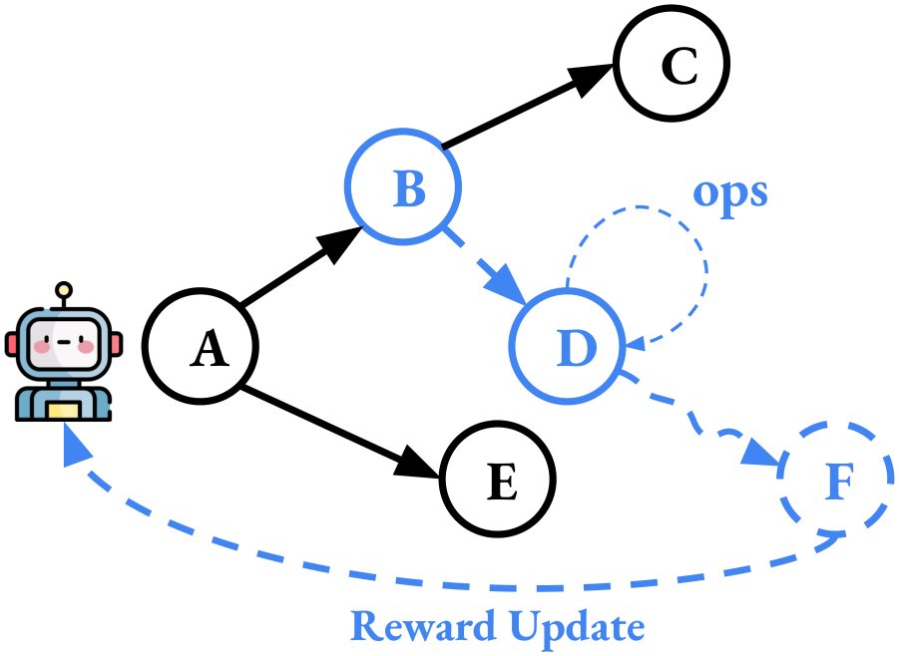
Figure 1. Agentic exploration as a tree of database branches. Starting from state A, an agent forks hypothetical actions (B, D, F), runs operations on each branch, evaluates the outcomes, and propagates a reward signal back to decide which paths to keep and which to prune. Every node in this tree is a live database branch.

Why agentic branching is a different problem
It is tempting to think databases already solved this. Relational systems have long offered nested transactions and savepoints — ways to roll part of a transaction back without discarding all of it. But these mechanisms are transient: a savepoint exists only inside one in-flight transaction and disappears when it commits or aborts. An agent needs the opposite. Its speculative states must persist, be revisited later, run concurrently with sibling branches, and occasionally be compared against one another. Nested transactions give none of that persistent, concurrent, branch-per-hypothesis isolation.
A newer generation of "branchable" databases does offer persistent branches, and several are now in production. But they were designed around human tempo — a developer opening a branch now and then — not around an agent that instantiates, mutates, and discards branches at machine speed. The open question the paper sets out to answer is simple to state and hard to measure: when you push these systems into the high-frequency, high-fanout regime that agents demand, where do they break?

A benchmark built around the branch-mutate-evaluate loop
BranchBench reduces agentic exploration to four primitive operations — Branch (fork a new state), Mutate (change data on that branch), Evaluate (read or query to score the branch), and Prune (discard a dead-end branch) — and composes them into a branch-mutate-evaluate loop run by many parallel workers. A parameterized framework controls the shape of the exploration tree: how wide each node fans out, how deep the tree goes, and the mix of operations at each step. Turning those knobs lets one benchmark express workloads as different as a flat, wide simulation sweep and a deep, narrow Monte Carlo Tree Search.
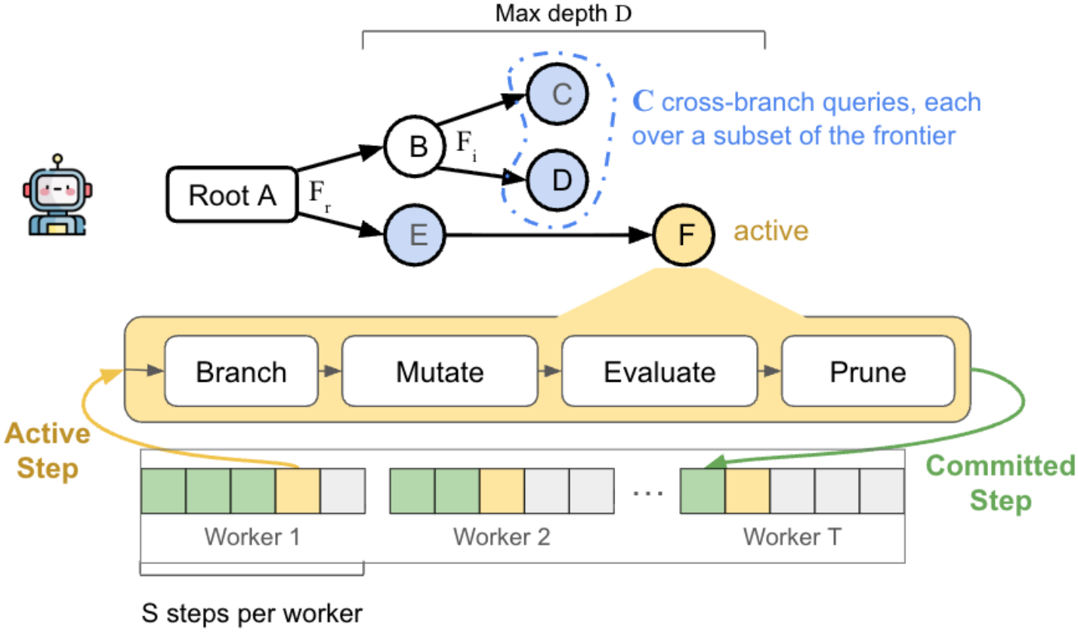
Figure 2. Architecture of the BranchBench macrobenchmark. An exploration tree (top) is driven by parallel workers (bottom), each of which repeatedly runs the Branch → Mutate → Evaluate → Prune loop. Tree fanout, maximum depth D, cross-branch query count, and per-step operation mix are all parameters, so a single harness can reproduce many agentic workload shapes.
On top of this loop the authors define five workloads drawn from real agentic use: agentic software engineering, failure reproduction, data curation, Monte Carlo Tree Search, and open-ended simulation. Each becomes a macrobenchmark that measures end-to-end cost, while a companion set of microbenchmarks isolates the latency of individual lifecycle operations — creating a branch, connecting to it, deleting it — so a system's total cost can be attributed to specific causes rather than left as one opaque number.

The systems under test
BranchBench evaluates a spread of designs that sit at different points in the space: Neon and Xata (storage-layer copy-on-write built on Postgres), Tiger Data, DoltgreSQL (a git-like content-addressed storage engine that versions the whole database), a plain file-copy strategy, and a transaction-based PostgreSQL baseline. The two systems that anchor most of the analysis are Neon, representing the fast-branching camp, and Dolt, representing the fast-data-operations camp — and the contrast between them is where the central finding lives.

One tension, two failure modes
The headline result is a structural trade-off, not a tuning problem. Systems optimized for cheap, instant branching pay for it on reads: as branches deepen, their read latency climbs by up to 5–4000×. Systems optimized for fast data operations pay the opposite price: creating and switching branches costs 25–1500× more than on the fast-branching systems. You can have quick branches or quick reads, but no evaluated system gives you both — and the agentic workloads need both at once.
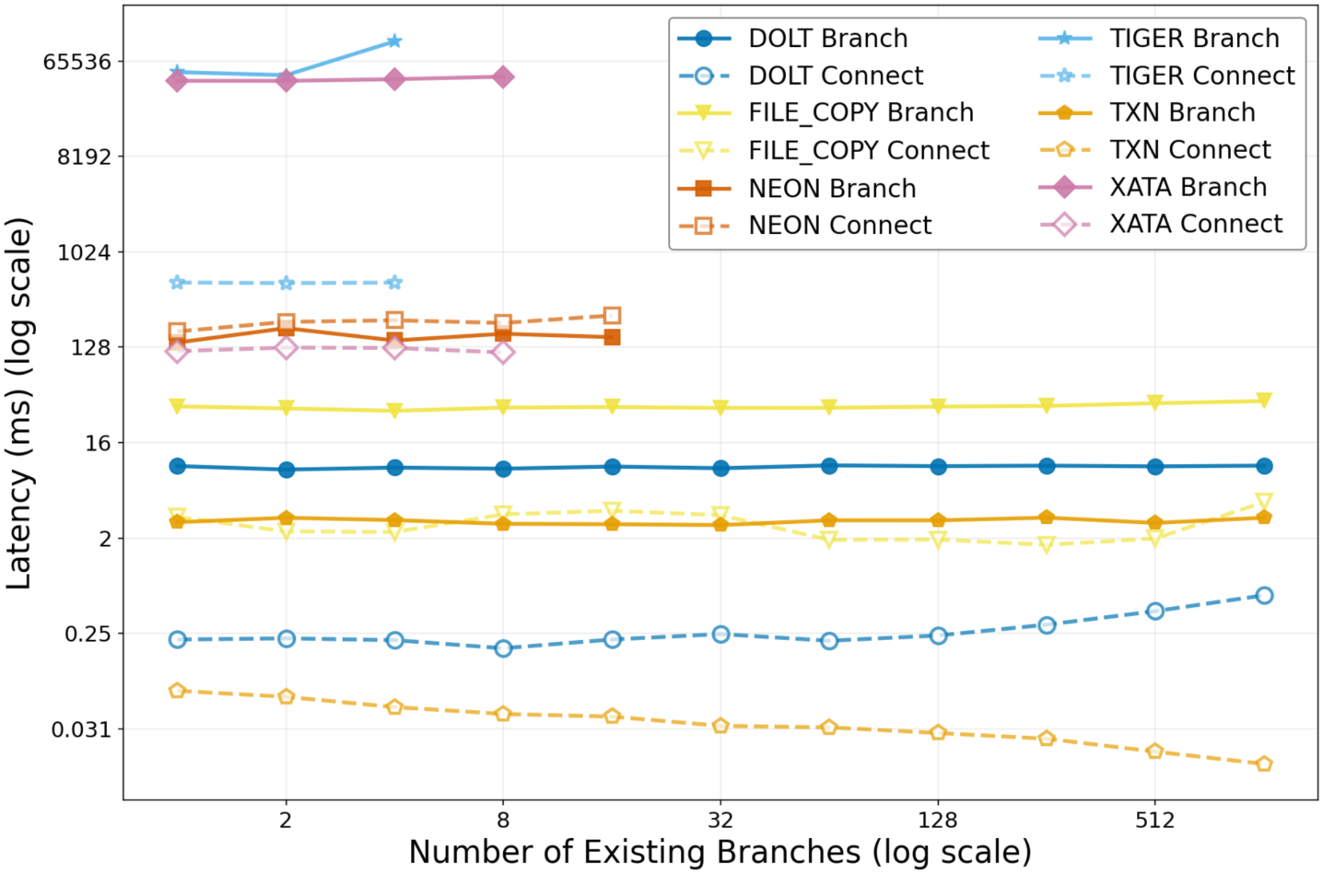
Figure 3. Branch-creation and connect latency as the number of existing branches grows (both axes log scale). The lines are strikingly flat: for every system, the cost of making the n-th branch barely changes with n. The systems separate by a factor of thousands in absolute cost — Dolt and TXN branch in single-digit milliseconds, while Tiger and Xata sit near a full second — but each stays on its own horizontal band. Branch creation is cheap-and-constant or expensive-and-constant, never a scaling wall.
The end-to-end picture makes the trade-off concrete. Running the same five workflows on Dolt and Neon, Dolt's total time is dominated by data operations — the blue bars — because its content-addressed reads get expensive, ballooning to 1234.2s on the simulation workload. Neon runs the same workflows in a fraction of the time (176.5s on simulation, and tens of seconds on the rest), because its reads stay cheap. But Neon's speed is not free: it spends over 43× more storage overhead than Dolt on the software-engineering workflow, and its cloud service caps out at 20 concurrent branches.
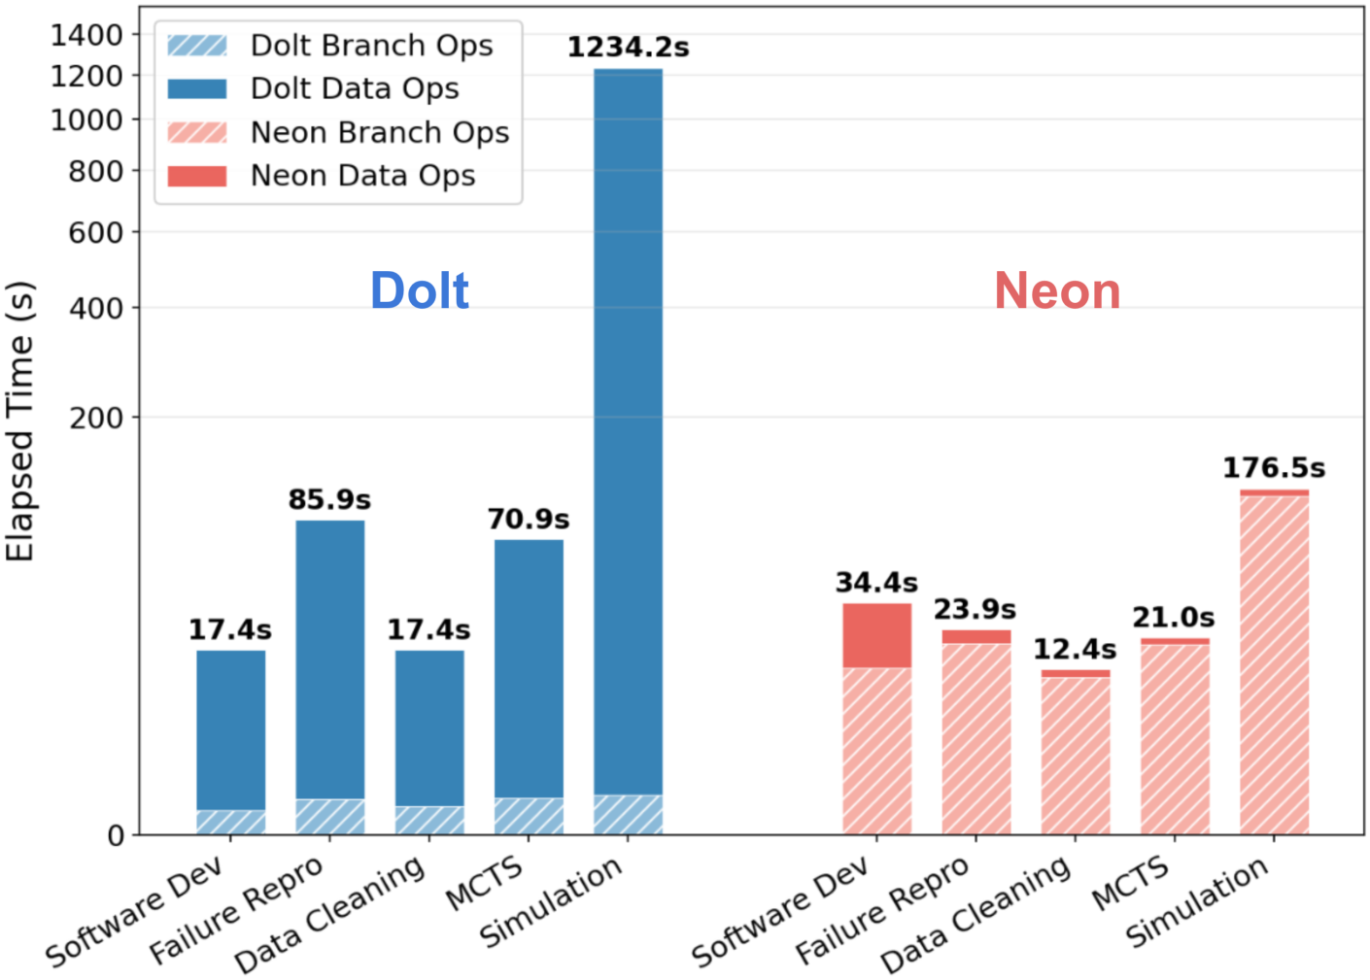
Figure 6. End-to-end latency for each workflow on Dolt (blue) versus Neon (red), split into branch operations (hatched) and data operations (solid). Dolt's total is dominated by data operations and spikes to 1234.2s on Simulation; Neon completes the same workflows far faster (e.g. 176.5s on Simulation), but at the cost of much higher storage use and a hard 20-branch cloud limit.
The microbenchmark heatmaps show that this tension is per-operation, not an artifact of any single workload. Reading the left panel — where red means Neon is more expensive and blue means Dolt is — Dolt wins decisively on branch operations (creating, connecting, and deleting branches are hundreds to over a thousand times cheaper) but loses badly on reads, which are up to thousands of times slower. Neon shows the mirror image. The trade-off is baked into the storage design of each system, which is why no amount of workload tuning escapes it.
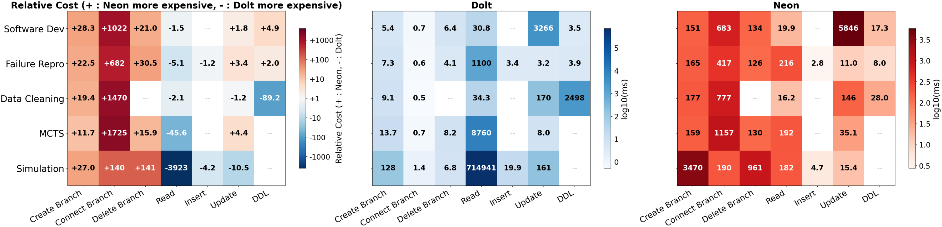
Figure 7. Median latency per operation across systems. Left: relative cost, where + (red) means Neon is more expensive and − (blue) means Dolt is. Dolt's branch operations (Create/Connect/Delete) are far cheaper, but its Read cost explodes — up to 3923× worse on Simulation — while Neon shows the opposite profile. Middle and right panels give the absolute log-scale latencies for Dolt and Neon. The branch-versus-read trade-off holds operation by operation, not just in aggregate.

How far the two camps scale
The trade-off also sets a ceiling on concurrency. Neon's aggregate read throughput scales near-linearly as you add concurrent branches — right up to the 20-branch limit its cloud service imposes. Dolt has no such external cap, but its throughput plateaus at just 4 branches, so adding more branches stops buying more work done. Many of the agentic workloads the paper characterizes need well beyond 20 concurrent branches, which is why the authors conclude that neither end of the spectrum supports the full set at scale.
Table 1. End-to-end latency (seconds) per workflow on the two anchor systems, from Figure 6 (mini configuration). Dolt's cost is dominated by reads and blows up on Simulation; Neon is consistently faster on wall-clock time but pays in storage and a 20-branch concurrency ceiling.
Workflow | Dolt (s) | Neon (s)
Software Dev | 17.4 | 34.4
Failure Repro | 85.9 | 23.9
Data Cleaning | 17.4 | 12.4
MCTS | 70.9 | 21.0
Simulation | 1234.2 | 176.5

What it means and what it does not
The practical message for anyone building agent infrastructure on a branchable database today is to match the system to the shape of the exploration. If your agent branches rarely but reads heavily, a fast-data system like Dolt is the safer bet; if it branches constantly and reads in short bursts within a modest concurrency budget, a fast-branching system like Neon fits better. But BranchBench's larger point is that this is a compromise, not a solution — every current system leaves one half of the agentic workload starved.
It is worth being precise about the scope of the claim. BranchBench measures a specific, well-defined family of branch-mutate-evaluate workloads on a specific set of production systems; it is a characterization of where today's designs break, not a proof that fast branching and fast reads are fundamentally irreconcilable. What it does establish is a concrete, reproducible gap — and a parameterized yardstick for measuring it. The authors read that gap as motivation for branch-native database systems designed from the ground up for the speculative, high-frequency exploration that agents demand, rather than branchable databases retrofitted from tools built for human developers.
Either way, the reframing is the contribution worth keeping: as agents take over more of the reasoning loop, the database is no longer a passive store they read from but an active state space they search through — and benchmarks, not intuitions, should tell us which systems are ready for that.

