Teaching an LLM What OS Knobs Mean: How TuxBot Makes Online Tuning Safe
Columbia University and IBM Research propose the first semantic-aware framework for online OS tuning — a 153.3% average gain across 13 workloads, at roughly $0.20 per session
A modern Linux kernel exposes more than a thousand tunable parameters — knobs, in the vernacular: scheduler time slices, busy-poll durations, CPU power states, memory and I/O policies. Getting them right by hand is hopeless, so the field has leaned on automatic tuners. For the past decade the dominant recipes have been Bayesian optimization and reinforcement learning: treat each parameter as a number, probe, watch a single scalar metric, and pick the next step.
The trouble is that these tuners have no notion of what a parameter means. To them, disabling busy-poll and lengthening a time slice are just two numbers changing, with no semantic relationship between them. But on a machine serving live traffic those knobs are coupled — scheduler, power, memory, and I/O settings interact — and a configuration that is numerically valid can be semantically nonsensical, pushing the system into a region it cannot easily climb back out of.
This paper from Columbia University and IBM Research introduces TuxBot: the first semantic-aware, LLM-based framework for online operating-system tuning. Instead of treating knobs as isolated numbers, it lets a large language model reason about what those knobs mean together, so it can make live-host adjustments that are effective, safe, and cheap at once.

What "no semantics" actually breaks
The paper opens with an uncomfortable observation: traditional tuners don't merely run slowly — they can drive a system into failure while it still looks healthy. Running MLOS (a strong Microsoft autotuner) on Memcached, a latency-sensitive in-memory cache, under a 500,000-QPS load, the authors watched it repeatedly select configurations no human operator would try on a live service: busy-poll values of 600–975, shallow C-states, 50-ms time slices.
What makes these configurations dangerous is their disguise. Throughput looks close to normal, yet tail latency — p99, the 99th-percentile response time — spikes by more than 47×. If you only watch a coarse metric like throughput, you never notice that the system has slipped into a queue-dominated metastable failure, the kind of state it cannot recover from on its own.
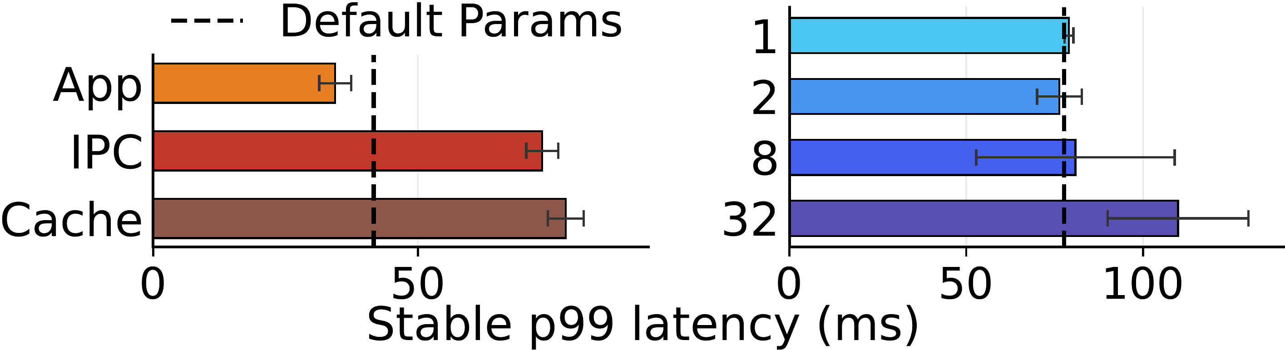
Figure 1. Two failure modes of MLOS. Left: on the Wikipedia workload, tuning against the true application metric (App) pushes p99 below the default, but swapping in low-level proxies like IPC or Cache Miss makes p99 worse than the default. Right: on TPC-C, as the tuning surface grows from 1 to 32 parameters, p99 rises instead of falling — a larger tuning surface makes it easier to break the system.
The figure names two core difficulties. First, the real application-level metric is often unavailable, leaving only proxies like IPC or cache-miss rate — and optimizing a proxy yields roughly 2× worse p99. Second, more knobs is harder, not easier: growing PostgreSQL's tuning surface from 1 to 32 knobs degrades p99 by 50%. Classic tuners are fragile on both counts.

The TuxBot framework
TuxBot's central idea is to translate the tuning problem into a semantic description a language model can read — what the current goal is, which knobs are in play, what the telemetry readings look like, and what the last few steps did — and then let the model propose the next move. The pieces form a closed loop.
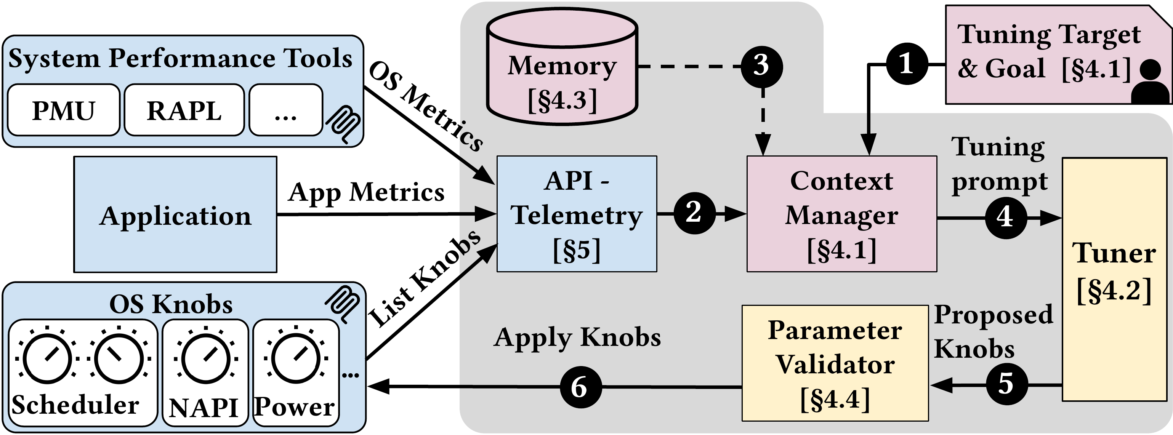
Figure 2. System overview of TuxBot. System performance tools (PMU, RAPL, and others) and the application feed OS and app metrics into API-Telemetry; a Context Manager fuses the tuning goal, telemetry, and a cross-session Memory into a tuning prompt for the Tuner; the Tuner's proposed knobs pass through a Parameter Validator for type and constraint checks before anything reaches the host.
You can read the diagram by following the numbers: ① the user states a tuning goal; ② telemetry aggregates system and application signals; ③ the memory module supplies prior summaries; ④ the context manager assembles the prompt; ⑤ the tuner proposes candidate knobs; ⑥ the validator checks them before they land. Three design choices carry the weight: cost-aware dual-loop control, an explicit cross-session memory, and a typed, validated actuation interface.
Paper: https://arxiv.org/abs/2605.15026 · Code: https://github.com/Columbia-DAP-Lab/TuxBot

Dual-loop control: fast and cheap at the same time
Online tuning carries an inherent tension. You want to be fast — reacting to load jitter on a millisecond-to-second scale — and you want to be smart, thinking hard when a decision is genuinely complex. But making a heavyweight reasoning model deliberate on every single step is both slow and expensive. TuxBot resolves this with a dual-loop design.
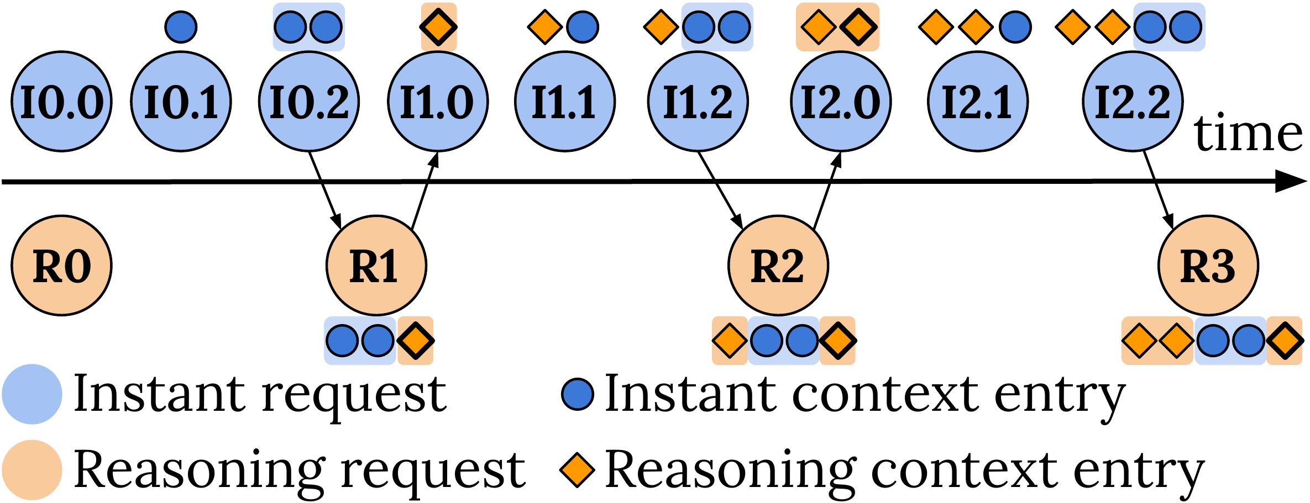
Figure 3. TuxBot's dual-loop control. A fast Instant loop (blue: I0.0, I0.1, …) continuously makes low-latency, low-cost corrections; a slower Reasoning loop (orange: R0, R1, …) fires only when a decision needs deeper thought and injects its conclusions as reasoning context entries into later Instant decisions. The two loops share context, keeping expensive reasoning off every control step.
The thing to watch is how the two timelines interleave: the Instant loop ticks densely to stay reactive, while the Reasoning loop intervenes sparingly, spending compute only where it matters. The paper measures the Instant loop at a steady 1.0–2.6 s regardless of knob count, while Reasoning latency grows from 8.1 to 15.8 s as parameters multiply — and precisely because that cost is pulled out of every step, the whole system stays both reactive and cheap. A full steady-state tuning session costs about $0.20 in model calls.

How well does it work
The authors evaluate TuxBot on 13 workloads across five benchmark suites (including Memcached, PostgreSQL Wikipedia, TPC-C, Silo, Sysbench OLTP-RW, and Xapian), co-tuning up to 41 Linux parameters, and compare against MLOS, Bayesian optimization, DQN, and Q-Learning.
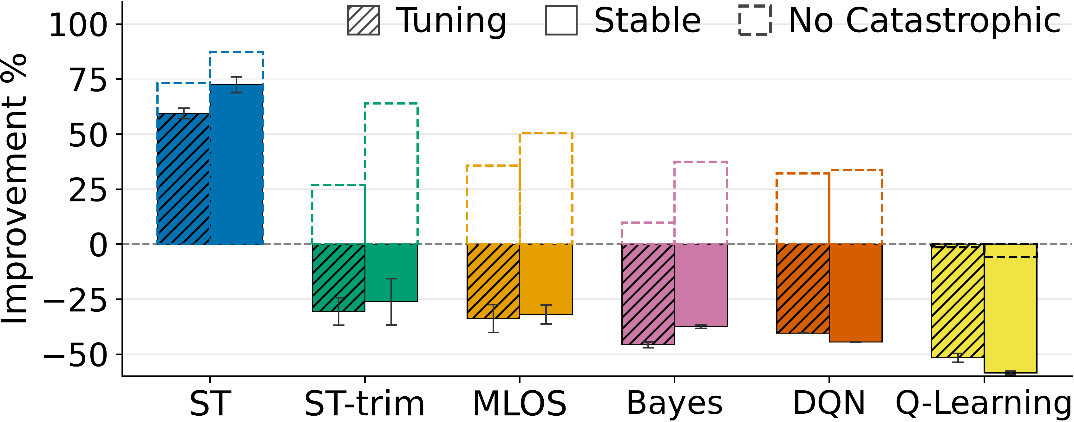
Figure 4. Aggregate improvement over default parameters. ST — TuxBot's semantic tuner — stays positive in both the tuning phase (hatched) and the stable phase (solid), while ST-trim, MLOS, Bayes, DQN, and Q-Learning generally fall below zero in the stable phase. Dashed outlines show results with catastrophic runs excluded; even then the baselines barely reach positive territory, whereas TuxBot never fell into catastrophe to begin with.
Overall, TuxBot improves performance by 153.3% on average over the strongest non-LLM baseline, MLOS. More telling is its robustness: restricted to system-level metrics, with no access to direct application metrics, TuxBot still beats baselines that do get application metrics by 93.7 percentage points, while sidestepping the queue-dominated metastable failures that sink the other tuners.
The paper also characterizes process safety through a bad-window rate — the fraction of time during tuning when performance is clearly degraded. Excluding catastrophic runs, TuxBot's P50 bad-window rate is 16.9%, well below MLOS's 28.8% and its own ablation TuxBot-Trim at 29.7%; it is also less variable (11.1% vs. MLOS's 25.1%) and steadier than MLOS on 12 of 13 workloads. In other words, the dual-loop design doesn't just improve the endpoint — it makes the entire online journey smoother.
Table 1. Headline numbers (relative to MLOS / default parameters).
Metric | TuxBot | Baseline
Avg. improvement over MLOS | +153.3% | —
Edge on system-only metrics | +93.7 pts | baselines get app metrics
P50 bad-window rate (no catastrophic) | 16.9% | MLOS 28.8%
Process variability | 11.1% | MLOS 25.1%
Cost per tuning session | ~$0.20 | —
Co-tuned knobs | up to 41 | —

The more knobs, the more semantics matters
As noted earlier, classic tuners tend to get worse as the parameter count grows. TuxBot sets out to show the opposite: if you genuinely understand how knobs couple, a larger tuning surface should yield larger — not smaller — gains.
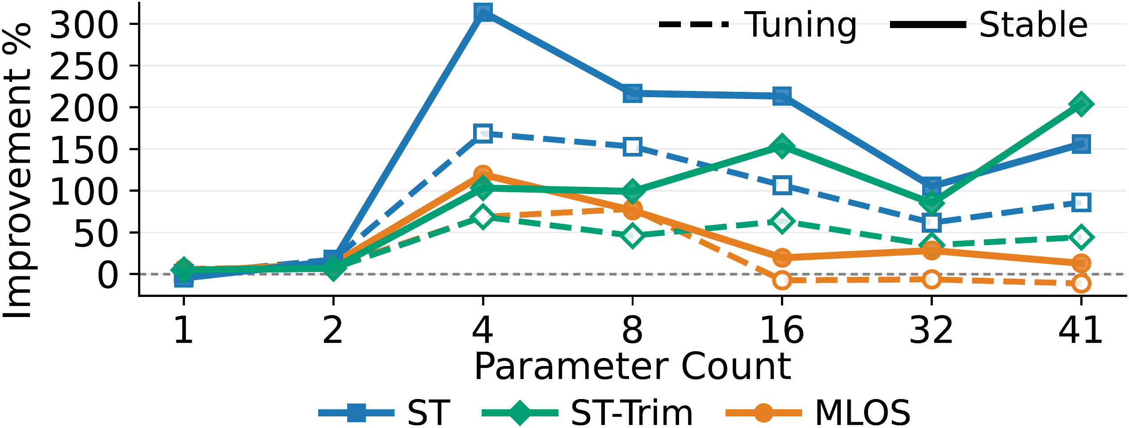
Figure 5. Aggregate improvement as the co-tuned knob set grows from 1 to 41 parameters. In the stable phase (solid lines), blue ST (TuxBot) sits above ST-Trim and MLOS throughout, peaks above 300% around four parameters, and stays ahead even in the 41-parameter high-dimensional space; MLOS (orange) falls off — and even goes negative — as parameters accumulate.
The figure backs the paper's claim: reasoning about knobs as one coupled semantic system is what lets a tuner cash in on a large tuning surface. Treat them as unrelated numbers and more parameters only make the search harder to control.

Takeaway and boundaries
TuxBot's central conclusion is clean: what online OS tuning really lacks is not a stronger numerical search but an understanding of what the parameters mean. Give a language model that semantics, pair it with a typed and validated safety interface, and it can deliver large, safe, low-cost performance gains on live hosts — 153.3% on average across 13 workloads, about $0.20 per session, co-tuning up to 41 parameters.
The approach comes with premises worth stating. It relies on the model already carrying substantial prior knowledge of Linux subsystems; the evaluation centers on caching and OLTP-database workloads; and the dual-loop design introduces a dependence on an external model API and its (admittedly low) call cost. These are the honest boundaries the paper marks — and the natural questions to keep asking as semantic tuning is pushed toward a wider range of systems.

