When a Code Agent Finds the Right Code — and Fails Anyway
TrajEval decomposes agent trajectories into search, read, and edit stages and surfaces a failure mode that Pass@1 hides entirely: Coherence Collapse.
Today's code agents — LLM systems that autonomously read code, edit it, and run tests to fix real software issues — are genuinely capable. On SWE-bench Verified, a benchmark of human-verified GitHub issues, they resolve 65–70% of tasks. The tempting assumption is that the failures come from the agent not finding the right place to change: a localization problem.
That assumption has never really been tested, and the reason is practical. The standard metric, Pass@1, returns a single bit — did the agent fix the bug or not — and says nothing about where along the way it went wrong. An entire trajectory of dozens of tool calls collapses into that one outcome.
This paper from AWS AI Labs and Monash University introduces TrajEval, a training-free framework that decomposes an agent's execution trace into three stages and scores each one against the task's reference patch. Applied to 16758 trajectories, it produces a counterintuitive result: when capable models fail, they mostly are not failing to find the code. They reach it, they even edit the right place — and then they destroy their own progress. The authors name this failure Coherence Collapse.
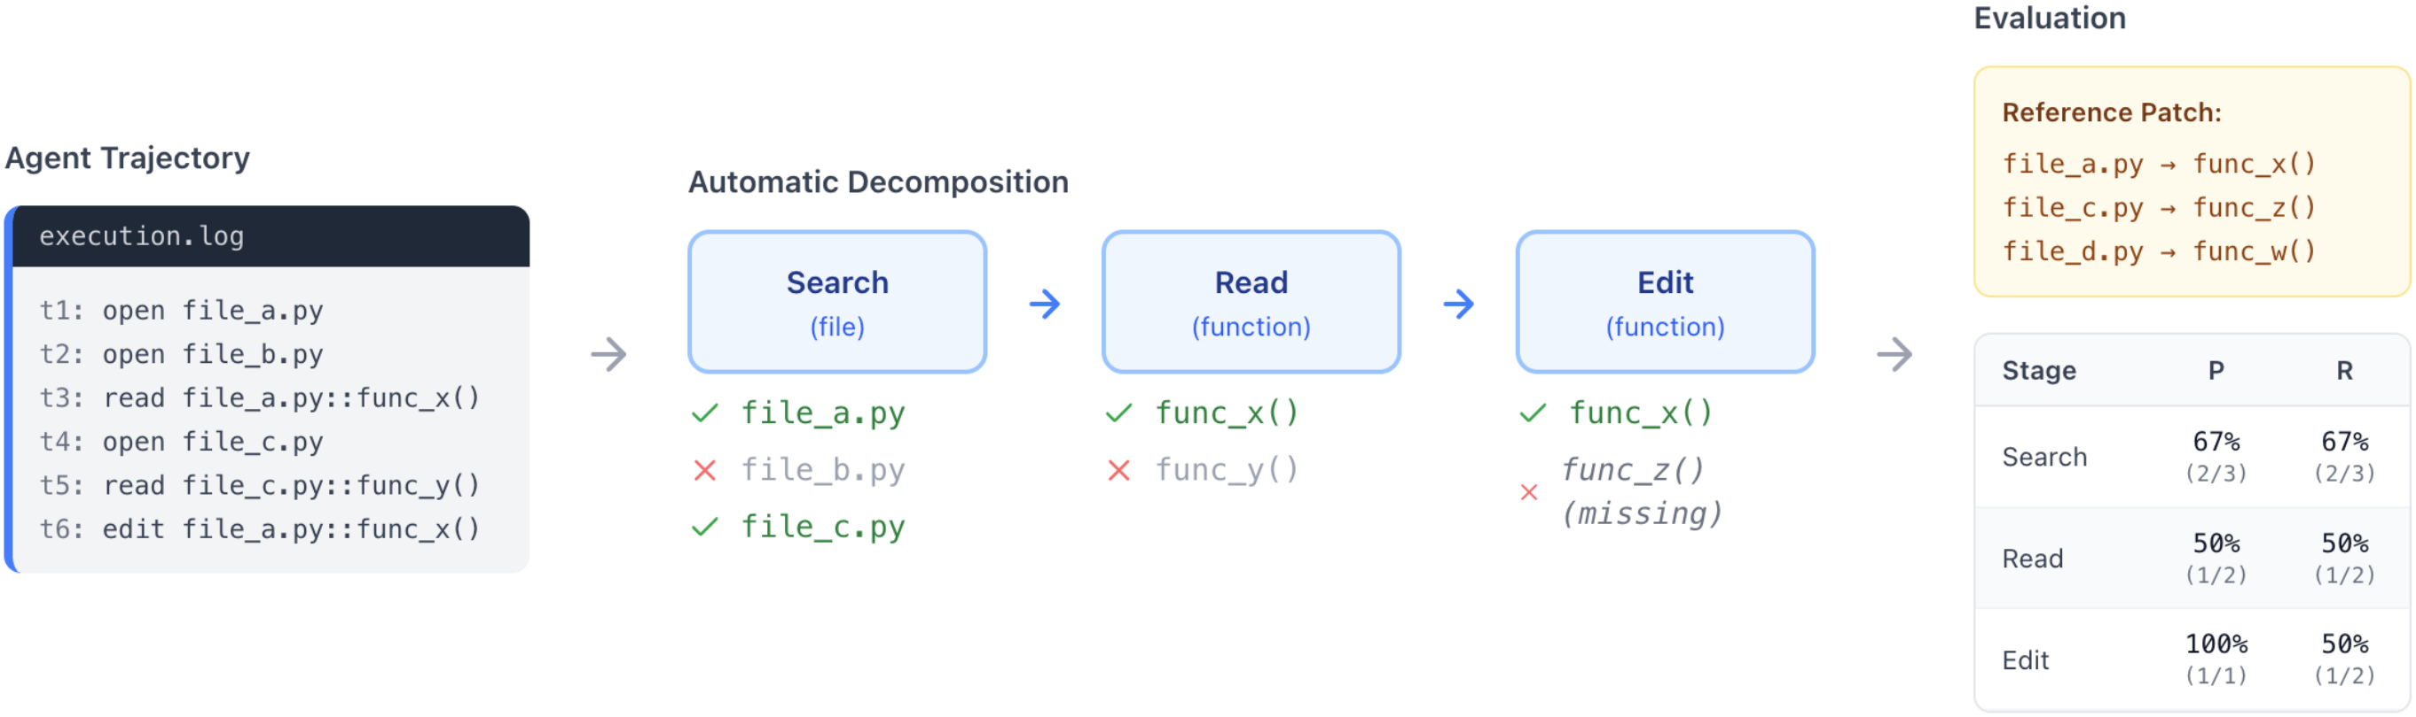
Figure 1: Overview of the TrajEval framework. Each agent execution trace is automatically decomposed into three stages — Search (file-level), Read (function-level), and Edit (function-level) — and compared against the reference patch (the gold change) to yield stage-wise precision (P) and recall (R).
Paper: https://arxiv.org/abs/2603.24631

The problem: Pass@1 shows the outcome, not the cause
Compressing a multi-step task into a single number costs you the process. This mirrors the tension that once motivated process supervision for chain-of-thought reasoning: judging only the final answer cannot tell a lucky guess from a sound derivation. Code agents have reached the same juncture — to understand why one fails, you have to look at what it actually did.
TrajEval's leverage point is that every task ships with a reference patch specifying exactly which files and which functions must change. Aligning an agent's trajectory to that patch turns an unstructured tool-use log into structured, checkable signals.

The method: one trajectory, six numbers
As Figure 1 shows, TrajEval aligns the agent's behavior to the reference patch at three granularities. Search asks, at the file level, whether it located the relevant files. Read asks, at the function level, whether it actually inspected the relevant function bodies. Edit asks, at the function level, whether it modified the correct functions. Each stage yields a precision (efficiency — did it wander?) and a recall (coverage — did it reach the targets it had to change?).
A single pass/fail outcome thus expands into a six-number profile that pinpoints which stage the agent got right and which one broke. Feature extraction runs in time linear in trajectory length; function extraction is hybrid (tree-sitter parsing with a regex fallback) and supports Python, Java, JavaScript, and TypeScript.
The authors run TrajEval at scale: 16758 trajectories spanning three agent architectures (SWE-Agent, OpenHands, and the bash-only LiveSWEAgent) and seven models, from GPT-5 and GPT-5-mini to the Qwen3 family. Beyond SWE-bench Verified, they also evaluate the multilingual PolyBench Verified, to check whether the findings are specific to Python or to SWE-bench.

The core finding: failure happens after reaching the code
First, the authors partition every failed trajectory (Pass@1 = 0) into four mutually exclusive stages using a 0.5 recall threshold: Search (never opens enough relevant files), Read (opens files but misses the relevant functions), Edit-Target (reaches the right code but modifies the wrong location), and Edit-Quality (reaches and edits the right location yet still produces an incorrect patch). That last bucket is a residual no localization-stage signal can explain.
The result overturns the localization story. On SWE-Agent and OpenHands, 60–69% of capable-model failures land in Edit-Quality — the agent reached and edited the correct functions and still shipped a wrong patch. On SWE-Agent, GPT-5's Edit-Quality share is 68.1% and GPT-5-mini's is 69.1%. Localization is simply not the bottleneck for these models.
Decomposing that Edit-Quality residual further (n=914) yields five themes across nine sub-types. The single largest is Coherence Collapse: the agent reaches the correct code, often edits it, but its final patch abandons or breaks its own earlier progress. It accounts for 39.7% of Edit-Quality failures.
Table 1: Taxonomy of Edit-Quality failures (n=914, SWE-Agent on SWE-bench Verified). Sub-types are mutually exclusive. Coherence Collapse is the largest single theme.
Theme | Sub-type | n | Share
Coherence Collapse | Confused Thrashing | 266 | 29.1%
Coherence Collapse | Near-Correct Corrupted | 97 | 10.6%
Semantic Error | Wrong Branch Point | 170 | 18.6%
Semantic Error | Partial Understanding | 67 | 7.3%
Intra-File Mislocalization | Wrong Function in File | 161 | 17.6%
Scope/Completeness | Incomplete Fix | 64 | 7.0%
Execution Gap | Understood But No Edit | 16 | 1.8%
Coherence Collapse has two sub-types. Confused Thrashing (29.1%) is when the agent makes at least 3 edit attempts on the correct file, none of which survive into the final diff. Near-Correct Corrupted (10.6%) is when an intermediate edit overlaps the gold patch by more than 50% of tokens and is then overwritten or corrupted by a later edit. The second is the striking one: in 5 EXACT cases, the agent produced a patch byte-identical to the gold reference and then deleted it later in the trajectory.

This is not just long-context degradation
A natural worry is that Coherence Collapse is merely context degradation on long trajectories. Figure 2 rules that out. In aggregate, the Coherence Collapse rate does grow with length — from 22% in the shortest quartile to 64% in the longest (ρ = 0.32) — but the two sub-types dissociate sharply.
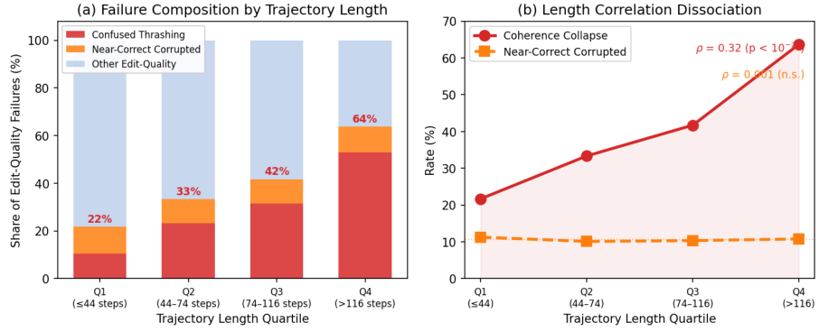
Figure 2: Trajectory length versus Coherence Collapse. (a) Failure-theme composition by trajectory-length quartile; (b) the dissociation — Confused Thrashing scales with length (ρ = 0.34) while Near-Correct Corrupted is flat (ρ = 0.001).
As Figure 2(b) shows, Confused Thrashing grows with length (ρ = 0.34), while Near-Correct Corrupted is essentially length-independent (ρ = 0.001). Longer trajectories produce more intervening steps before corruption, but not a greater probability of corruption. That dissociation is the evidence that Coherence Collapse is a distinct failure mode rather than a symptom of a long context.

Falsifiable predictions, and recoverable failures
The authors then validate the 97 Near-Correct Corrupted trajectories at the diff-hunk level: 30/97 (31%) reconstruct the gold patch's hunks at the EXACT+NEAR level, and 96/97 (99%) target the gold patch's code region rather than incidentally overlapping it. These failures were, in a real sense, already solved.
That motivates a direct intervention: an edit-commit checkpoint. If an intermediate edit already passes the existing test suite, freeze it, and the corrupting edit that follows never lands. The authors re-submitted the 5 EXACT intermediate edits to the official SWE-bench Docker harness — all 5 pass — a deployable existence proof rather than a hypothetical.
They also propose a reference-free consensus variant. For each instance, take the files viewed by at least N of the 6 non-GPT-5 models as a consensus set, and feed that back to the agent as a confirmatory signal. Re-running GPT-5 end-to-end on all 500 instances lifts Pass@1 from 66.0% to 69.0% — a +3.0 point gain (McNemar's p = 0.08, a directional result below the α = 0.05 threshold). The authors report it honestly as directional rather than dressing it up as significant.
The conclusion also survives cross-validation. On the multilingual PolyBench Verified, Coherence Collapse remains the largest theme (32.3%); JavaScript (42.1%) even exceeds the SWE-bench Python baseline (39.7%) and Java (36.3%) is comparable — so this is not a Python- or benchmark-specific artifact. A second annotator's independent labeling of the three-class distinction agrees substantially (κ = 0.80, 90% raw agreement).

Takeaway: the frontier bottleneck has moved
The paper reframes the hard problem for code agents. For capable models, the bottleneck is no longer finding the right code — it is not destroying the fix once found. Coherence Collapse is a distinct, recoverable failure mode, and trajectory-level analysis is precisely what makes it visible and fixable.
The method has honest boundaries. TrajEval uses the reference patch as a projection: it measures where an agent operates, not whether the code it writes is correct, and a valid fix that takes a different implementation path registers as low-recall by design. It is a complement to Pass@1, not a replacement.
For anyone building agents, the practical lesson is direct: when your agent keeps failing a hard task, do not reflexively strengthen retrieval or widen the context window — it may have found the right code long ago and simply failed to hold onto the edit it already got right. Adding a checkpoint that freezes any edit once it passes the tests, or using cross-model consensus to confirm the location of a change, are both directions you can try today without retraining anything. The deeper shift is methodological: when an outcome metric cannot explain a failure, unrolling the full trajectory and checking it stage by stage often reveals exactly the recoverable failures that a single score quietly swallows.

