SAGE: Grounding User Simulators in Real Business Knowledge to Stress-Test AI Agents
Columbia University and Arklex.ai propose a top-down, bottom-up user simulator that uncovers up to 33% more agent bugs than existing methods
Conversational AI agents are increasingly deployed to talk to real customers: a sales assistant that answers product questions, a shopping bot that searches a catalog and places orders. But how do you know one of these agents actually works across the messy, multi-turn conversations it will face in production? The honest answer today is that you hire people to talk to it. Human evaluation is slow, expensive, and hard to scale to every product update.
The obvious shortcut is to simulate the users. If a language model can role-play a customer, it can hold thousands of conversations overnight and flag where the agent breaks. The catch is that most simulated users are generic. They act like an abstract "user" rather than a specific person shopping for a specific product from a specific company, so the conversations they produce are neither very realistic nor very good at surfacing the bugs that matter.
A new paper from Columbia University and Arklex.ai, "SAGE: A Top-Down Bottom-Up Knowledge-Grounded User Simulator for Multi-turn Agent Evaluation," argues that the missing ingredient is business knowledge. Its core claim is simple: ground the simulated user in who the customer really is and what the company's agent actually knows, and the resulting conversations become far more human-like — and far better at exposing where the agent fails. In the authors' experiments, SAGE identifies up to 33% more agent bugs than existing methods.
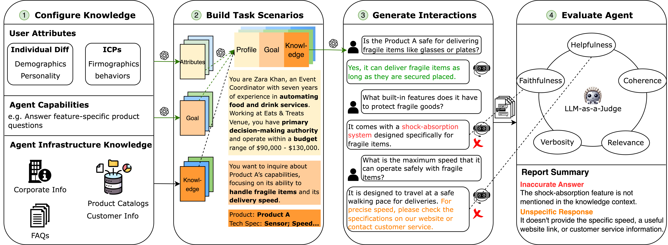
Figure 1. An overview of SAGE's four stages: configure knowledge (top-down user attributes and bottom-up agent infrastructure), build a task scenario (profile + goal + relevant knowledge), generate a multi-turn interaction with the target agent, and evaluate each turn with an LLM-as-a-Judge to surface unique bugs.
Paper: https://arxiv.org/abs/2510.11997 · Code: https://github.com/arklexai/arksim

Why generic simulated users miss the point
Real agents live in specialized business settings, and user behavior there is shaped by two things a generic simulator ignores. The first is who the user is — their role, demographics, budget, and purchasing potential. An event coordinator with a $90,000–$130,000 budget asks different questions than a casual browser. The second is what company-specific information the user is after — the products, specs, policies, and FAQs that only exist inside one particular business. A simulator that knows neither produces plausible-sounding chatter that rarely pushes the agent into its blind spots.
SAGE's answer is to feed the simulator both kinds of knowledge, from two directions. Top-down knowledge captures who the customer is: individual differences (demographics and Big Five personality traits) plus Ideal Customer Profiles (ICPs) — the firmographics and buying behaviors a company uses to describe its target buyers. Bottom-up knowledge captures what the agent is built on: its infrastructure, meaning the corporate information, product catalogs, customer records, and FAQs the agent relies on to answer questions.

How SAGE works: four stages
The framework runs in four stages, shown in Figure 1. First, configure knowledge: assemble the top-down user attributes and the bottom-up agent infrastructure, and translate the agent's advertised capabilities (e.g., "answer feature-specific product questions") into candidate user goals. Second, build a task scenario by combining a concrete user goal, the relevant slice of infrastructure knowledge, and a coherent user profile. A clustering-based selection step keeps the chosen knowledge diverse yet relevant, so the simulator does not fixate on the same few facts.
Third, generate the interaction: the simulated user and the target agent hold a multi-turn conversation in a shared environment. Fourth, evaluate: an LLM-as-a-Judge scores every agent turn on five dimensions — helpfulness, coherence, verbosity, relevance, and faithfulness — on a 0-to-4 scale. Any turn scoring below 2 is kept and summarized into a unique, actionable bug statement. The output is not a single opaque score but a list of concrete failures an engineer can act on.
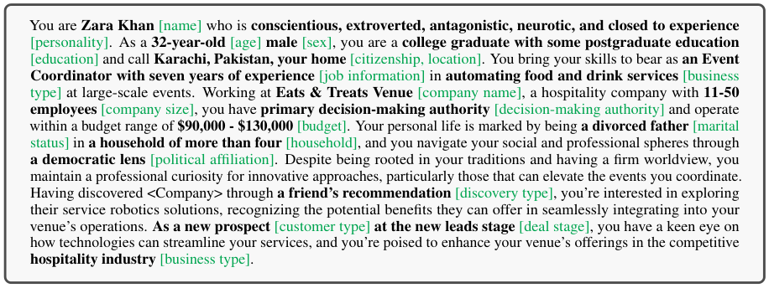
Figure 3. A generated user profile. SAGE turns abstract attributes — name, personality, job, company size, budget, deal stage — into a coherent persona (in green, the attribute each phrase encodes), which then drives realistic, goal-directed questions.
Figure 3 shows what "grounding" looks like in practice. Instead of a faceless user, SAGE builds a persona — here, an event coordinator named Zara Khan with a specific budget, decision-making authority, and buying stage — and lets those attributes drive the conversation. The persona is not decoration: it determines which questions get asked and how persistently, which is exactly what makes the resulting test conversations resemble real ones.

Does grounding actually help?
The authors test SAGE on two production, customer-facing agents: a RAG-based sales agent for a robotics company and a Shopify tool-augmented shopping agent that integrates 13 APIs. They run 150 interactions per condition per use case and compare against 150 real, logged human–agent conversations (filtered to 3–15 turns). Two ablations isolate the contributions: "w/o ICP" removes the top-down customer profile, and "w/o Agent-Infra" removes the bottom-up infrastructure knowledge.
On lexical diversity — a proxy for how varied and human-like the language is — SAGE lands closest to the real-human reference on nearly all metrics. On the RAG sales agent, SAGE reaches an MTLD (Measure of Textual Lexical Diversity) of 86.05, essentially matching the human reference of 86.84, and ahead of both ablations. But the headline result is about finding bugs, summarized in the table below.
Table 1. Average count of unique bugs found over five runs (standard deviation in parentheses). Grounding the simulator in business knowledge surfaces far more agent failures — and SAGE even finds more than real human testers.
Condition | RAG Sales Agent | Tool-Augmented Shopping Agent
w/o ICP | 29.0 (1.78) | 14.4 (2.10)
w/o Agent-Infra | 13.6 (1.02) | 13.0 (1.02)
SAGE | 38.6 (1.24) | 18.0 (1.62)
Human testers | 14.0 (2.60) | –
Two things stand out. First, SAGE finds the most bugs by a wide margin: 38.6 unique bugs on the RAG agent versus 29.0 without ICP and just 13.6 without infrastructure knowledge, and 18.0 versus 14.4 on the shopping agent. Second, SAGE (38.6) finds substantially more bugs than the real human testers in this study (14.0) — a scalable simulator surfacing more failures than the humans it is meant to stand in for.
The ablation also tells a clear mechanistic story: removing bottom-up infrastructure knowledge causes the largest collapse in bugs found (38.6 → 13.6 on the RAG agent). The reason is intuitive — knowing the product catalog and FAQs lets the simulated user ask specific, retrieval-targeting questions that actually probe what the agent knows, rather than staying vague. Removing top-down ICP knowledge hurts too, lowering both realism and bug discovery.
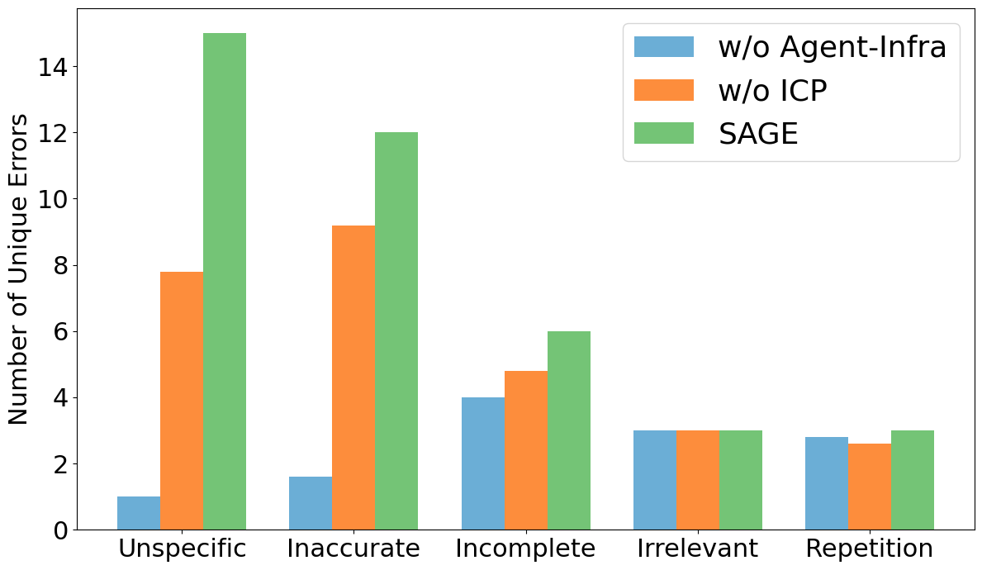
Figure 2. Unique errors by category for the RAG sales agent. Full SAGE (green) surfaces the most "Unspecific" and "Inaccurate" errors, precisely the categories where specific, knowledge-grounded questions expose weak agent answers.
Figure 2 breaks the bugs down by category. The biggest gaps between SAGE and the ablations appear in "Unspecific" and "Inaccurate" responses — the failure modes you only trigger when the user asks a pointed, knowledge-grounded question. For categories like "Irrelevant" or "Repetition," where grounding matters less, the three conditions are close. That pattern is consistent with the paper's thesis rather than a blanket win everywhere.
Human evaluation backs up the realism claim. On a 3-point scale, raters judged SAGE conversations as more human-like (2.58) and more coherent (2.85) than both ablations, approaching the real-human reference of 2.90 on human-likeness. The authors also validate their automatic bug-finder: the LLM-as-a-Judge reached a precision of 0.73, recall of 0.74, and F1 of 0.73 against expert annotations, low-scoring turns genuinely contained bugs 94% of the time, and inter-annotator agreement (Fleiss' Kappa) was 0.85.

Why it matters, and where the limits are
The practical takeaway is encouraging for anyone shipping conversational agents: much of the evaluation work currently done by hand can be done by a simulator, provided the simulator is grounded in the same business knowledge the agent lives in. Because SAGE returns a categorized list of unique bugs rather than a single score, its output drops naturally into a debugging loop. The authors also show the recipe generalizes across simulator backbones, testing gpt-4.1, gpt-5, gemini-2.5-flash, Qwen2.5-7B, and Llama-3.3-70B.
The boundaries are worth stating plainly. The study covers two English-language, customer-facing commercial agents; whether the gains transfer to other domains, languages, or non-commercial tasks is an open question. The evaluation leans on LLM-as-a-Judge, which is validated here but still an approximation of human judgment. And grounding requires access to a company's ICPs and infrastructure knowledge — readily available to a business testing its own agent, less so to an outside evaluator. Even with those caveats, SAGE makes a convincing case that the path to trustworthy agent evaluation runs through real business knowledge, not more generic simulated chatter.

