Data at the Speed of Thought: Rethinking How We Explore Data in the AI Era
Eleven researchers across databases, AI, visualization, and HCI map the challenges and open directions for human-centered interactive data systems
For decades, working with data followed a tidy script: you knew what was in your tables, you wrote a query, and you looked at the answer. Interactive analysis tools, dashboards, and visualizations were built on that foundation — well-defined schemas, stable metadata, and a query-then-explore workflow where you generally knew which questions you could ask.
AI is quietly dismantling that foundation. Analysis today increasingly means large-scale, heterogeneous, multimodal data — text, images, audio, video, documents — that is mostly unstructured and only weakly labeled. On top of it sit foundation models such as large language models (LLMs) and vision-language models (VLMs), which are powerful but non-deterministic: they can be wrong, biased, or confidently misleading. When the data no longer arrives in neat tables and the models themselves inject uncertainty, the old workflow starts to break.
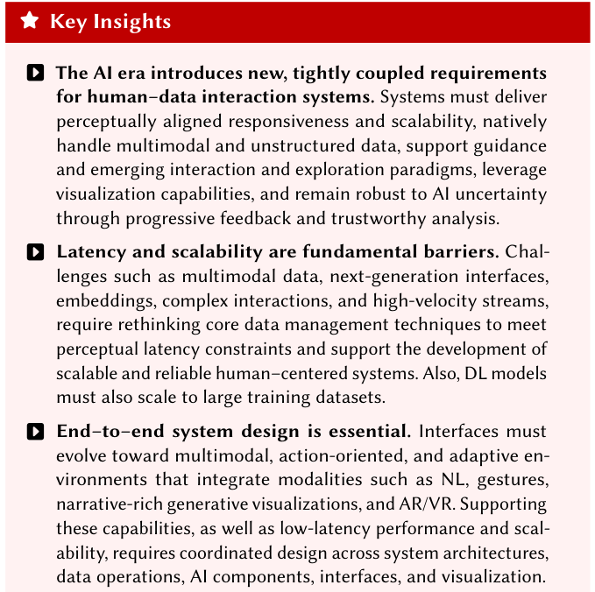
Figure 1a. The paper's headline arguments (part 1): the AI era imposes new, tightly coupled requirements on human-data interaction systems; latency and scalability are fundamental barriers; and end-to-end system design is essential.
A new perspective paper, “Human-Data Interaction, Exploration, and Visualization in the AI Era: Challenges and Opportunities,” takes that break seriously. Written by eleven researchers spanning databases, AI, information visualization, and human-computer interaction (HCI), it is not an empirical study but a shared research agenda — an argument that interactive, human-centered data systems can no longer be assembled from independently optimized parts, and a map of what to build instead.
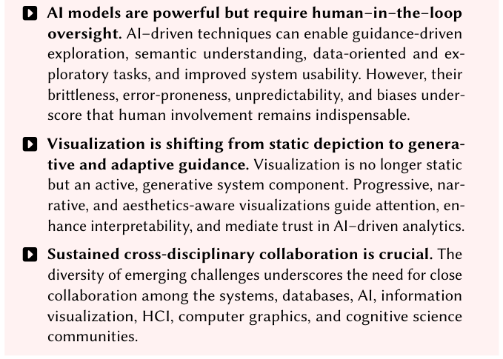
Figure 1b. The paper's headline arguments (part 2): AI models need human-in-the-loop oversight; visualization is becoming an active, generative component; and sustained cross-disciplinary collaboration is crucial.
Paper: https://arxiv.org/abs/2603.05542

Why the old workflow is breaking
Two forces are pulling interactive data systems out of their comfort zone. The first is the data itself. Modern pipelines have to ingest multimodal and unstructured content at high velocity, and much of the interesting information lives in formats — video, free text, images — that traditional schema-driven systems were never designed to query directly. The second is the model layer. Foundation models can summarize, suggest, and interpret, but they also propagate errors, encode bias, and resist verification. That combination raises a question the paper keeps returning to: when the machine's output is uncertain, how do you keep a human meaningfully in control of the analysis?
The authors frame this as an inflection point rather than an incremental upgrade. The requirements — responsiveness, scalability, native handling of unstructured data, support for new interaction paradigms, and robustness to AI uncertainty — are not independent knobs. They are tightly coupled, which is why the paper argues they cannot be met by optimizing data management, AI, and interaction in separate silos.

The interface is a system constraint, not an afterthought
One of the paper's central moves is to reframe the user interface. Historically, systems treated a visualization as little more than a SQL query generator — the interface produced database workloads, and the database's job was to serve them quickly. The authors trace a shift toward treating the interface's own demands — perceptual responsiveness, interaction patterns, the need for partial results — as first-class constraints that motivate new classes of data-management problems, from novel APIs and indexing schemes to approximation strategies that are explicitly aware of human perception. Abstractions like Mosaic point in this direction.
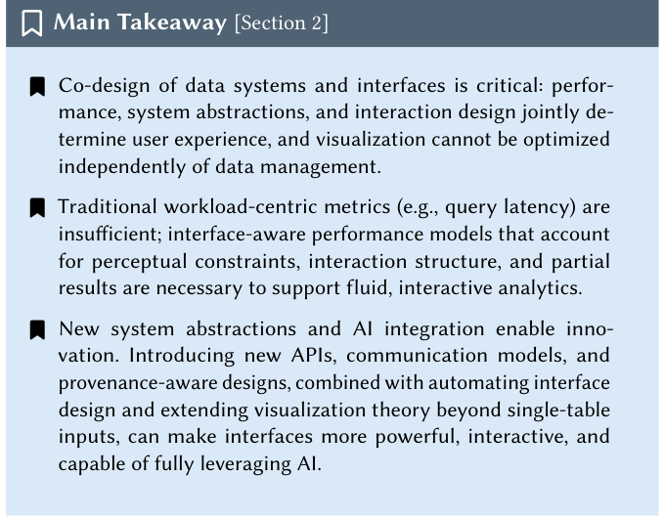
Figure 2. Co-designing data systems and interfaces. Traditional workload-centric metrics such as query latency are insufficient; the paper argues for interface-aware performance models that account for perceptual constraints, interaction structure, and partial results.
The takeaway for Section 2 makes the co-design argument concrete: performance, system abstractions, and interaction design jointly determine the user experience, so visualization cannot be optimized independently of the data layer beneath it.

Queries at the speed of human thought
If there is a single number to remember from this paper, it is a latency gap. Interactive analysis needs response times aligned with human cognition — on the order of milliseconds — because delays of even a few seconds measurably change behavior: analysts make fewer observations and drift toward whatever data is fast to load, inheriting its biases. Yet most data-management systems are tuned for order-of-second responses. Closing that roughly thousand-fold gap, without simply throwing away accuracy, is one of the paper's core challenges.
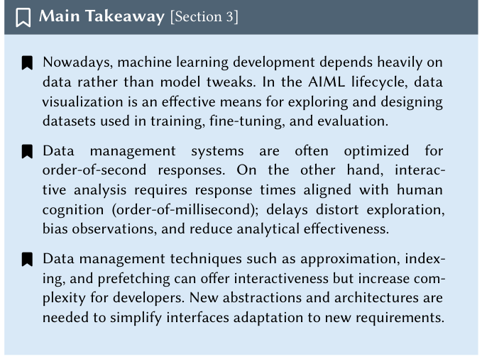
Figure 3. Queries at the speed of human thought. Machine learning has become data-centric, so exploring and designing datasets matters as much as tuning models — but interactive exploration requires order-of-millisecond responses, while data systems are typically optimized for order-of-second latencies.
Techniques like approximation, indexing, and prefetching can buy interactivity, but they add complexity for developers and don't automatically fit new interfaces. The paper argues this is exactly why the field needs new abstractions rather than more one-off optimizations.

Visualization has a scalability blind spot
The paper surfaces a pointed observation about its own community. Only about 2% of papers at IEEE VIS — the field's flagship visualization conference — use a keyword related to scalability, far below sibling domains like databases and simulation where handling large data is a central preoccupation. The authors read this as a genuine gap: as datasets grow, visualization research has not made scaling a first-class concern, and even the question of how to measure whether a visualization system is “scalable” remains unsettled.
Deep learning, interestingly, reframes even visualization design itself. The authors note that a trained graph neural network (GNN) can optimize arbitrary differentiable layout objectives on graphs it has never seen, and that generative adversarial networks (GANs) can optimize non-smooth objectives from only pairwise “which layout is better” comparisons — a path toward modeling human aesthetic preference directly rather than hand-coding it.

Exploring what you can't yet name
Multimodal data creates a distinctive problem the authors call a query formulation barrier: with a large video collection, you can't query what you don't know exists, but you also can't discover what's queryable without prohibitively expensive manual inspection. This is where VLMs earn their place. By proposing zero-shot query suggestions and autocompletion-style querying grounded in semantic understanding of the content, they shift the interaction from query-then-explore to explore-with-guidance.
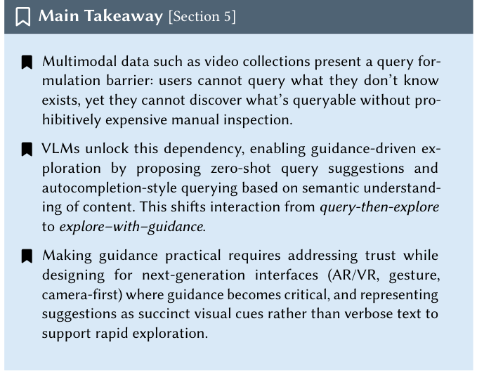
Figure 4. Multimodal exploration with model guidance. Vision-language models can propose queries a user wouldn't know to ask, shifting interaction from query-then-explore to explore-with-guidance — provided the system handles trust and presents suggestions as compact visual cues.
Making that guidance practical, the paper notes, means addressing trust and designing for next-generation interfaces — AR/VR, gesture, camera-first — where suggestions are best represented as succinct visual cues rather than verbose text, so exploration stays fast.

What it means — and where it stops
The through-line is a design stance: interactive human-centered systems can no longer be built by optimizing data management, AI, and interaction in isolation. They have to be co-designed end to end, treating performance, human reasoning, and machine intelligence as interconnected. In that picture, visualization stops being a passive display at the end of the pipeline and becomes an active, adaptive component that guides attention, supports sensemaking, and helps calibrate trust in AI-assisted analysis.
It is worth being clear about what this paper is and isn't. It is a vision-and-challenges piece, not an empirical evaluation — it introduces no new dataset or system, instead organizing prior work across human-AI collaboration, human-centered data management, visual analytics, and AI-with-visual-analytics, and pointing to benchmarks such as IDEBench for interactive cross-filtering workloads. Its value is in the framing and the agenda, not in a headline benchmark win. The authors are also candid that meeting these goals depends on sustained collaboration across databases, AI, visualization, HCI, computer graphics, and cognitive science — a requirement that is easy to state and hard to sustain. Read that way, the paper is less a solution than a well-drawn map of the problem the field now has to solve together.

