Can We Automatically Generate the Real Questions That Break AI Agents?
PQR: a framework for eliciting QA-agent failures that are both diverse and realistic
The hardest part of evaluating an LLM-based question-answering (QA) agent — an AI assistant that answers user questions — is usually not scoring it, but finding the questions that actually make it fail. Designing test cases that both resemble real users and expose the system's weaknesses typically takes a lot of manual effort, which is expensive and hard to scale.
Most automated approaches take an adversarial route. Jailbreak methods such as PAIR and TAP use predefined strategies to break a model, but they often produce arbitrary, near-gibberish queries that no real user would ever type. Those queries trigger failures without much diagnostic value, because real users simply do not ask that way. A second line of work, prompt refinement (e.g., GEPA, ACE), optimizes attack prompts to be more effective, but tends to elicit the same kind of failure over and over — good at breaking the model, poor at diversity.
Researchers from Columbia University, UC San Diego, Walmart, and Arklex.ai propose PQR, which braids these two lines together. It couples a query-refinement module and a prompt-refinement module in a single iterative loop to generate user queries that trigger failures while staying realistic and diverse. The key idea is to let the two modules cover each other's blind spots: query refinement drifts toward shallow, unrealistic variants, while prompt refinement drifts toward repetitive output.
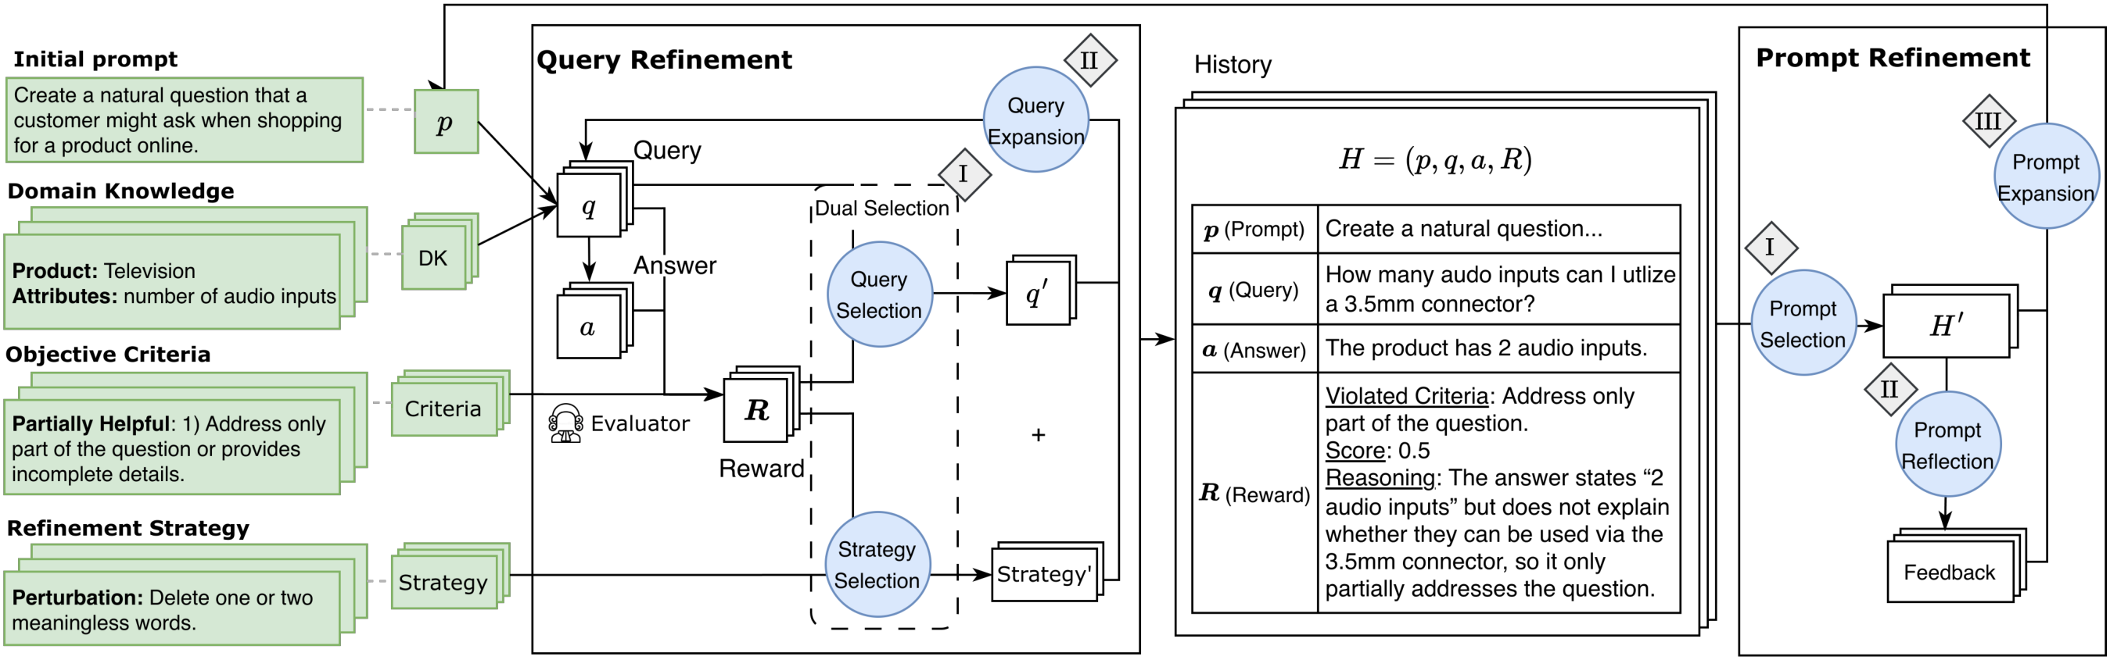
Figure 1. Overview of PQR. The framework iteratively searches for realistic, diverse, failure-triggering user queries through two modules: query refinement explores diverse query variations via rewrites, while prompt refinement aggregates prior feedback to derive new strategies for generating failure-inducing yet realistic queries.
Paper: https://arxiv.org/abs/2605.16551

The problem: meaningful failures are expensive to find
In practice, engineers hand-craft test cases to expose objective violations — cases where the agent is not helpful enough (helpfulness) or not safe enough (safety). This is costly, hard to scale, and poorly suited to fast iterative development. More importantly, adversarial methods only ask whether a model can be made to fail; they overlook a more valuable question: what do the queries look like that carry a genuine shopping intent yet still stump the agent?
Realistic user queries matter because failures triggered by genuine intent reveal an agent's practical weaknesses, not just a contrived attack surface. A system that only breaks on gibberish but handles real users is diagnostically very different from one that fumbles ordinary shopping questions.

The method: two modules in an iterative loop
PQR (Prompt–Query Refinement) has two complementary modules that alternate inside one loop.
The query-refinement module performs localized rewrites, using beam search over two families of strategies to explore diverse variants: perturbation (small edits at the character, word, and sentence level) and role-playing (assigning different personas, tones, and scenarios). To bound the exponential growth of variants, it uses dual selection, jointly filtering high-quality queries and effective strategies. Each query is scored by an LLM-as-a-Judge reward.
The prompt-refinement module handles global strategy through a selection–reflection–expansion loop: it selects failure-inducing prompts, reflects on realism-related and objective-related feedback (violation, compliant, and criterion-specific signals), then expands along three parallel directions — exploitation (amplifying strategies that already work), exploration (probing under-explored failure modes), and examination. This reflection step is what keeps the generated queries balanced between hitting a weakness and sounding like a real person.

Setup: an e-commerce QA agent
The authors apply PQR to detecting an e-commerce QA agent's unhelpful responses. As domain knowledge, they curate 100 products across four categories: vacuums, diapers, sofas, and televisions. The QA agent is built on qwen3-8b; refinement is evaluated with two models, gpt-5-mini and gemma3-27b. Real shopper–agent interactions across the same 100 products serve as a human reference baseline.

Results: higher failure rate at lower cost
Evaluated with gpt-5-mini, PQR reaches the highest unhelpfulness rate (UHR) of 56.32% while using the lowest cost (×1 relative token consumption). It uncovers 23%–78% more unhelpful responses than the baselines. Crucially, it ranks in the top two across every realism and diversity metric — exactly filling the gap that each single paradigm leaves open. Query-refinement methods (TAP, PAIR) approach human diversity but score poorly on realism; prompt-refinement methods (GEPA, ACE) produce realistic query lengths but low diversity. By combining both, PQR sits closest to real shopper behavior.
Table 1. Automatic evaluation with gpt-5-mini (vs. human baseline). UHR is the unhelpfulness rate (higher is better), Cost is relative token consumption (lower is better), Realism is human-likeness, and MTLD is a diversity metric. Best values in bold.
Method | Type | UHR ↑ | Cost ↓ | Realism | MTLD (diversity)
GEPA | Prompt refinement | 45.60% | ×1.3 | 3.81 | 50.33
ACE | Prompt refinement | 39.58% | ×1.1 | 2.66 | 80.68
TAP | Query refinement | 33.38% | ×1.6 | 2.31 | 197.02
PAIR | Query refinement | 31.57% | ×2.8 | 1.83 | 159.95
PQR | This work | 56.32% | ×1 | 3.66 | 92.40
Human | Reference | — | — | 4.51 | 88.90

Human evaluation: leading on both realism and relevance
In a human evaluation on a 3-point Likert scale, three expert annotators rated PQR highest on realism (2.50) and tied for best on relevance (2.68) — whether the query is actually about the product. This suggests that adding prompt refinement improves realism, while query refinement preserves topical relevance: together they lift the sense of realism without sacrificing relevance. To check that the automatic metrics are trustworthy, the authors align the LLM-as-a-Judge scores with human experts, reporting Spearman ρ = 0.75 for helpfulness and ρ = 0.73 for realism.
Table 2. Human evaluation on a 3-point Likert scale (annotator agreement in parentheses).
Method | Realism ↑ | Relevance ↑
GEPA | 2.24 | 2.21
ACE | 1.66 | 2.48
TAP | 1.55 | 2.68
PAIR | 1.51 | 2.55
PQR | 2.50 | 2.68
Human | 2.69 | 2.71

Implications and limitations
PQR's core contribution is coupling query refinement and prompt refinement inside one iterative loop, producing failure-triggering queries that are simultaneously diverse and realistic — more efficient and more human-like than either paradigm alone. The framework is black-box and agent-agnostic, which points toward scalable evaluation of deployed agents well beyond e-commerce. It is worth noting the boundaries, too.
The main experiments focus on the unhelpfulness objective in an e-commerce QA setting; a safety objective is studied only in the appendix. Evaluation relies on LLM judges, which correlate strongly with human ratings but are not identical to human judgment, so generalizing these conclusions to other domains and objectives will need careful validation. Even so, PQR offers a scalable, more human-like path to evaluating agents that does not depend entirely on expensive hand-crafted test cases.

