Quantifying Trust: Turning AI-Agent Risk Into an Insurable Financial Product
The Agentic Risk Standard (ARS) adds an underwriting-and-settlement layer to agentic payments — and a 5,000-episode simulation cuts user losses by up to 61% while keeping the underwriter solvent.
Most work on trustworthy AI tries to make the model itself better behaved — less biased, more robust, more interpretable. Those are all properties of what happens inside the model. But once an AI agent is turned loose in an open environment and, crucially, connected to money, the question a user actually cares about changes. It is no longer "is the model well-calibrated?" but "did the task complete without costing me?" Trust becomes an outcome, measured end-to-end, not an internal property.
That shift matters now because agents are starting to transact autonomously: paying for services, moving funds, executing multi-step jobs on a user's behalf. And because agent behavior is inherently stochastic, product-level harms — a job that silently fails, a misaligned action, an outright loss of funds — cannot be fully engineered away by model-internal safeguards. There is a real gap between model-level reliability and the user-facing assurance a paying customer expects — and when an autonomous transaction goes wrong today, the user typically has no recourse at all.
This paper, from researchers at Microsoft Research, Columbia University, Google DeepMind, Stanford University, t54.ai, and Virtuals ACP, proposes to close that gap with a tool every other high-stakes industry already uses: insurance. Finance, healthcare, and logistics never rely on trust alone — they price uncertain outcomes into manageable, underwritten risk. The authors introduce the Agentic Risk Standard (ARS), a transaction-layer settlement standard that unifies risk assessment, underwriting, escrow, collateral, and compensation into one framework, so that a user receives predefined, contractually enforceable payouts when an agent fails.
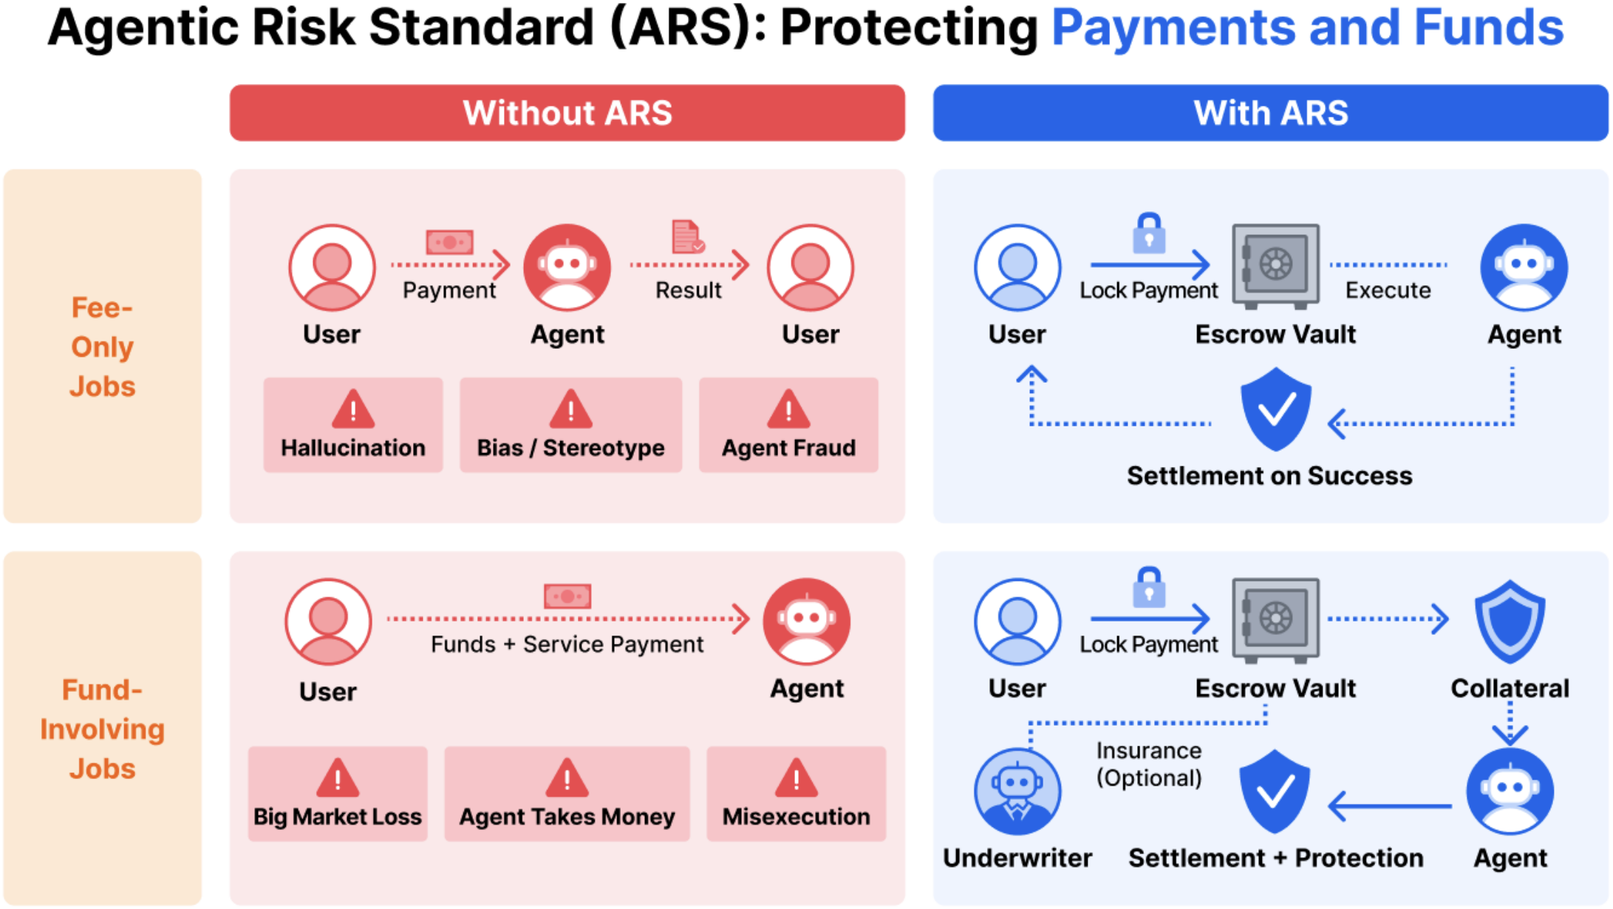
Figure 1. Without ARS (left), a user prepays the agent — and in fund-moving jobs also hands over execution capital — exposing them to non-delivery, misexecution, fraud, and market loss with no recourse. With ARS (right), the service fee is locked in an escrow vault and released only on a successful evaluation; for fund-moving jobs the user can optionally buy underwriting coverage while the provider posts collateral before principal is released. Trust moves from "trust the model" to enforceable guarantees over outcomes.
Paper: https://arxiv.org/abs/2604.03976 · Code: https://github.com/t54-labs/AgenticRiskStandard

The problem: reliability isn't the same as assurance
Existing trustworthy-AI research has made real progress on bias mitigation, robustness, and interpretability. But all of these are model-internal properties, and none of them give a user a defined remedy when a deployed agent causes material harm. A more robust model still fails some fraction of the time; when that failure moves money, the loss lands entirely on the user. ARS starts from the premise that this residual risk is not a bug to be eliminated but a cost to be priced and covered — the same stance an insurer takes toward any stochastic process.

How ARS works: two tracks through the job lifecycle
ARS mediates every job through a fixed lifecycle — creation, agreement binding, risk assessment, a collateral decision, execution, and post-transaction resolution — among three parties: the requestor (the user), the business agent (the service provider), and, when funds are at stake, an underwriter. The mechanism splits into two tracks depending on whether the job only involves a service fee or also moves the user's principal.
The simpler fee track handles jobs where only the service fee is at risk. The user locks the fee in an escrow vault before any work begins. The business agent then submits execution evidence, an evaluator checks it, and only if the evidence passes is the fee released to the provider; if it fails, the fee is refunded to the user. Escrow alone already removes the "pay first, hope for delivery" exposure.
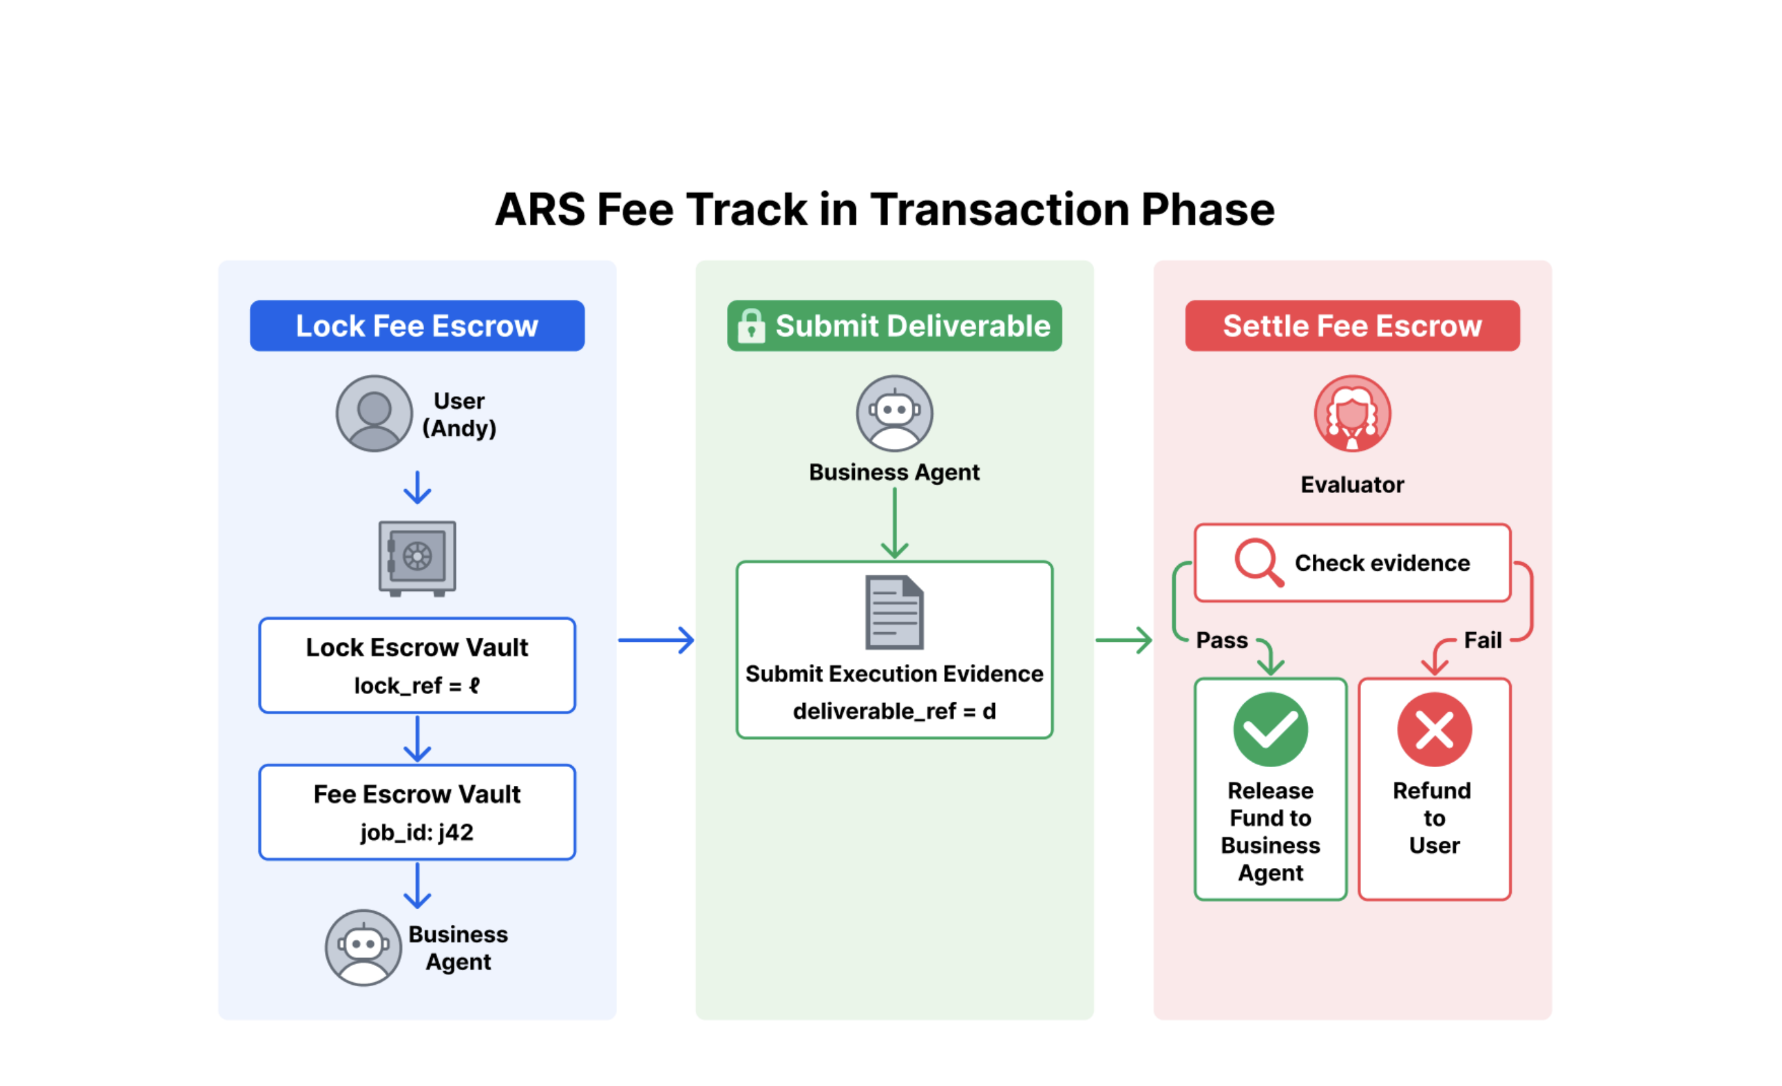
Figure 3. The ARS fee track. The service fee is locked in an escrow vault (left) before execution; the business agent submits execution evidence (center); an evaluator checks it and settles the escrow (right) — releasing the fee to the provider on a pass, refunding the user on a fail.
The principal track is where the financial machinery comes in. When execution involves the user's own funds, ARS adds an underwriter. The business agent requests coverage; the underwriter assesses the job's failure probability, decides whether to approve, and sets two numbers: a collateral requirement the provider must post and a premium the user pays for coverage. If the user pays and the provider posts collateral, the job runs under protection: on success, funds settle to the provider; on a covered failure, forfeited collateral plus underwriter reimbursement restore the user. If the user declines coverage, the transaction still runs — but the user bears all downside, exactly as today.
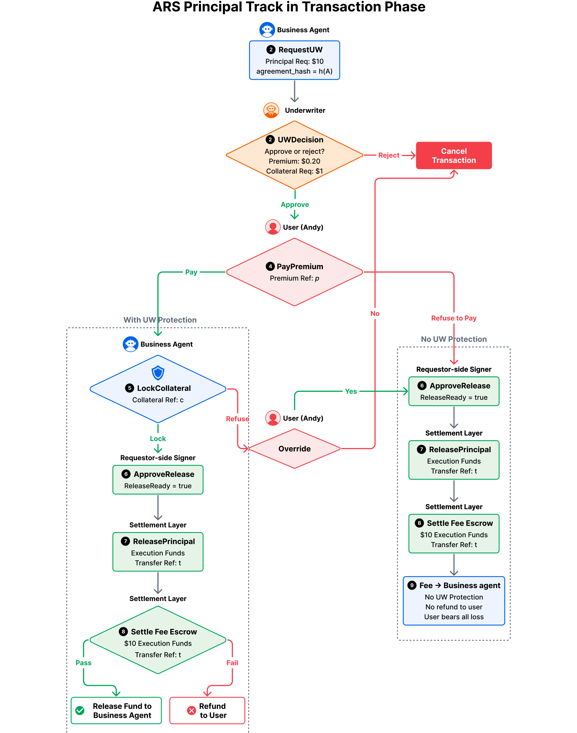
Figure 4. The ARS principal track. The underwriter approves or rejects coverage and prices a premium and collateral (top). With coverage (left branch), the provider locks collateral and a covered failure triggers a refund to the user; without coverage (right branch), the user bears all loss. This is the branch that converts stochastic agent risk into a priced, enforceable guarantee.
Underneath, the pricing is deliberately actuarial. The underwriter never sees the true failure probability directly; it observes a noisy estimate through a channel with false-positive rate f_p and false-negative rate f_n, giving an effective estimate p̂ = p(1 − f_n) + (1 − p)f_p. Collateral is sized with a sigmoid schedule of that estimate, D = σ(p̂)·M, and the premium is priced off the residual exposure with a loading factor λ, Π = p̂·(1 − σ(p̂))·M·(1 + λ). The loading factor λ is the knob that decides how much margin the underwriter charges above the actuarially fair price — and, as the experiments show, it is the whole ballgame.

Does it actually protect users? A 5,000-episode simulation
To test the mechanism, the authors build a minimal agent-based sandbox where requestors, business agents, and an underwriter interact through the ARS-mediated lifecycle over 5,000 episodes with a fixed random seed. Each episode draws a transaction size M from a log-normal distribution (µ = 4.0, σ = 1.2, a heavy right tail of occasionally large jobs) and a failure probability p from a Beta(1.5, 8.5) distribution with mean 0.15 — a market of mostly reliable but occasionally risky providers. The environment is intentionally stylized: it stress-tests the mechanism under controlled uncertainty rather than calibrating real-world rates.
The headline result: relative to a no-underwriting baseline, ARS reduces mean realized user loss by up to 61% (at zero loading), and loss reduction stays positive across the entire premium-loading sweep — even expensive underwriting still nets user protection, tapering to 24% at full loading. A second, quieter benefit comes from the collateral requirement itself: because posting collateral deters the riskiest transactions before they ever execute, ARS prevents roughly 15–20% of failure events from happening at all, regardless of how the premium is priced. Users are protected on two fronts at once.
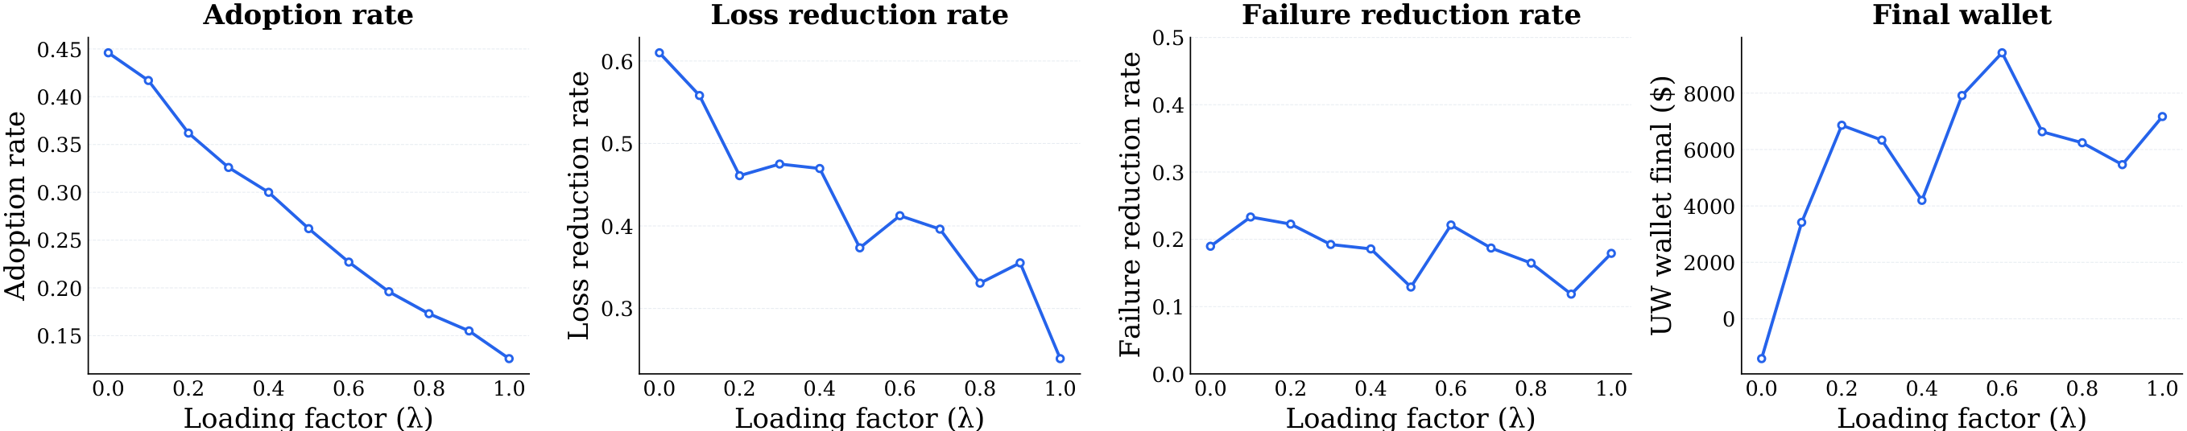
Figure 7. Sweeping the premium loading factor λ. As λ rises, adoption falls monotonically (left) — coverage gets more expensive, so fewer users buy it. Loss reduction (center-left) and failure reduction (center-right) stay positive throughout. The underwriter's final wallet (right) starts insolvent at λ = 0, turns positive at λ = 0.1, and peaks near λ = 0.6.

The central tension: protecting users vs. keeping the underwriter solvent
The loading sweep exposes the mechanism's core tradeoff. Raise λ and each policy earns more margin, but fewer users adopt: adoption falls from 0.446 at λ = 0 down to 0.126 at λ = 1.0. Solvency, by contrast, is non-monotone. At zero loading the actuarially fair premium simply cannot cover the tail of large losses, and the underwriter goes insolvent — a final wallet of −$1,412. A small positive loading fixes this: the wallet turns positive at λ = 0.1 ($3,419) and peaks near λ = 0.6 at $9,431. Crucially, you cannot buy solvency by cranking λ ever higher — beyond the peak, falling adoption and the shifting risk mix of who still buys coverage erode the wallet again.
In other words, a healthy ARS market needs a loading factor that is positive but moderate: enough margin to survive the heavy tail, not so much that it prices out the users it is meant to protect. The mechanism is robust to imperfect risk estimation too — the authors sweep the false-positive and false-negative rates of the underwriter's noisy channel and find loss reduction persists across most of that space, though the wallet suffers badly in the worst corner where the underwriter systematically misses real failures.
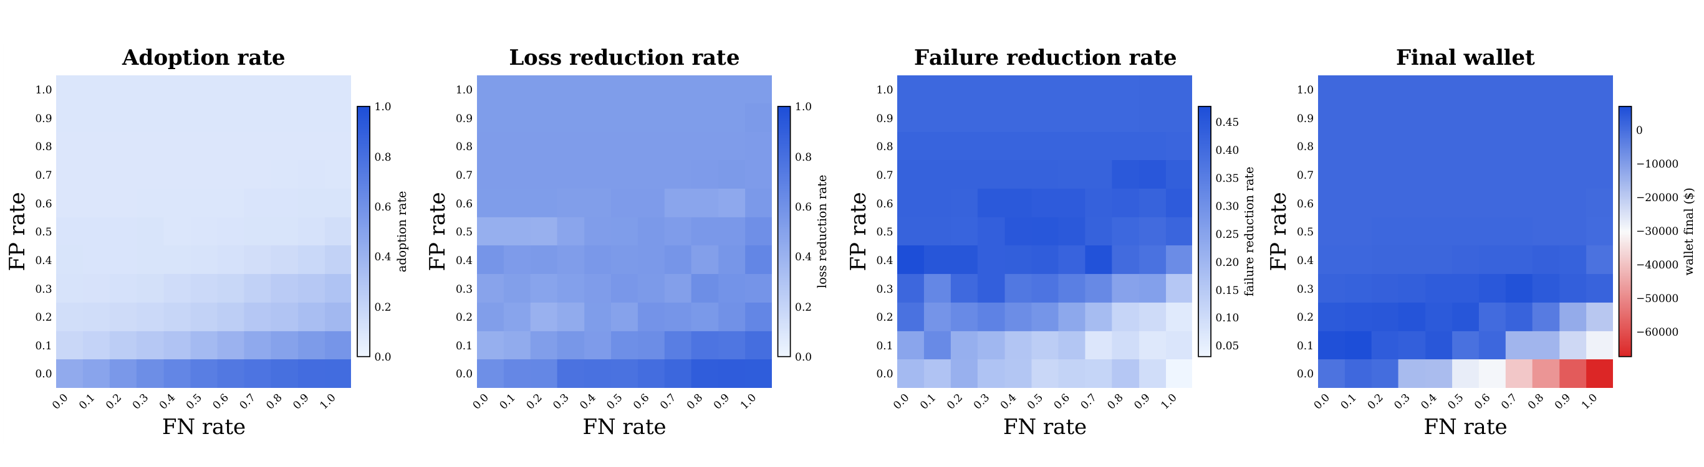
Figure 8. Robustness to noisy risk assessment: each panel sweeps the underwriter's false-negative rate (x-axis) against its false-positive rate (y-axis). Loss reduction and failure reduction stay positive across most of the space; the underwriter's final wallet (right) only collapses into the red in the bottom-right corner — high false-negatives, where real failures are systematically underpriced.

The numbers at a glance
Table 1. Effect of the premium loading factor λ across the 5,000-episode simulation.
Loading factor λ | Adoption rate | User-loss reduction | Underwriter final wallet
0.0 | 0.446 | 61% (peak) | −$1,412 (insolvent)
0.1 | — | positive | $3,419
0.6 | — | positive | $9,431 (peak)
1.0 | 0.126 | 24% | positive
Failure events deterred by collateral: roughly 15–20% across the sweep, largely independent of λ.

Why it matters — and where the boundary is
The larger idea here is a reframing: treating agent reliability not only as a model property to be improved but as a financial risk to be underwritten. That gives users something model-level safety alone cannot — enforceable, priced protection with defined recourse — while the same collateral requirement screens out the riskiest activity and keeps the underwriting market economically sustainable. ARS is designed as a modular transaction-layer interface, meant to sit alongside upstream authorization and downstream payment rails rather than replace them; the paper shows how it composes with authorization protocols like AP2 and privacy-preserving credential systems.
The honest boundary: the evidence is a stylized simulation, not a live market. The transaction sizes and failure rates are drawn from chosen distributions rather than measured from deployed agents, and the environment abstracts away much of the messiness of real fraud, disputes, and adversarial behavior. What the simulation does establish is a mechanism-design result — that an underwriting-and-collateral layer can, in principle, cut user losses substantially while remaining solvent under a moderate loading factor. Turning that into real-world premiums and collateral schedules is the work ahead. But as a demonstration that trust in AI agents can be engineered as a priced, enforceable product rather than left as an implicit hope, ARS is a concrete and reproducible starting point — and the reference implementation is open source.

