Agent Training Needs More Than a Container: Inside DeepSeek’s DSec
How a heterogeneous sandbox platform scales stateful execution without giving up isolation or latency
An AI agent does not simply answer a prompt. It may inspect a repository, edit files, run tests, call tools, and keep the resulting state alive across a long interaction. Each run therefore needs a sandbox: an isolated execution environment that contains the agent’s files, processes, memory, and permissions. At small scale, a container can look like the whole answer. At training scale, it becomes only one piece of the system.
DeepSeek Elastic Compute (DSec) is the infrastructure DeepSeek-AI built for that larger problem. A production-scale unit spans about 160 nodes and serves about 3 million sandboxes per day; across production, the platform supports more than 380,000 concurrent sandboxes and more than 5,000 creations per second. Individual training jobs may request as many as 32,000 sandboxes, so bursts, placement, retained state, and interference all become first-class design constraints.
The paper’s central argument is architectural: effective agent training needs an elastic execution platform, not a single favored runtime. DSec places FnCall, containers, microVMs, and full VMs behind one SDK, then coordinates scheduling, environment data, memory reclamation, CPU quality of service, and rollout lifecycle at cluster scale.
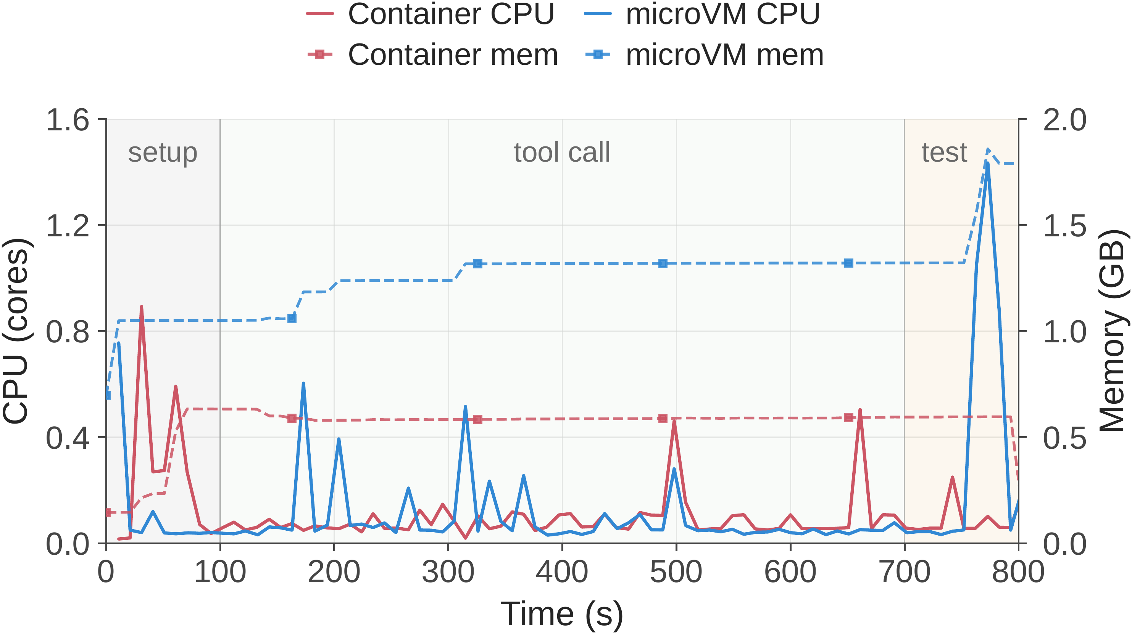
Figure 3. A representative sandbox run. CPU demand arrives in bursts during setup, tool calls, and testing, while memory and accumulated state remain resident between bursts.
Paper: https://arxiv.org/abs/2609.22978

Why agent workloads strain conventional infrastructure
Agent sandboxes combine properties that are individually familiar but awkward together. Creation demand is bursty; environments can be large and rarely reused; CPU utilization is intermittent; and filesystem plus memory state must survive throughout a rollout. This makes aggressive CPU overcommit attractive, but memory cannot simply be discarded when an agent pauses. The isolation requirement also varies: a lightweight function call and an untrusted security exploit should not pay for—or receive—the same boundary.
The trace in Figure 3 makes the mismatch visible. CPU repeatedly falls close to idle, yet memory stays allocated and rises as the interaction accumulates state. A scheduler that looks only at instantaneous CPU will miss the persistent footprint; a platform that reserves every requested core exclusively will waste much of the machine. DSec’s design tries to exploit the gap without letting best-effort work slow latency-sensitive agent steps.

One interface, several isolation boundaries
The libdsec Python SDK presents one sandbox API while the control plane chooses the lightest backend that satisfies a workload’s needs. FnCall uses pre-created containers for short calls; Docker containers cover common repository tasks; Firecracker microVMs add a stronger kernel boundary; and full VMs support the heaviest isolation and GPU virtualization cases. Cluster-level services handle identity, placement, and worker health, while node-local Edge and Aether components manage lifecycle and sessions.
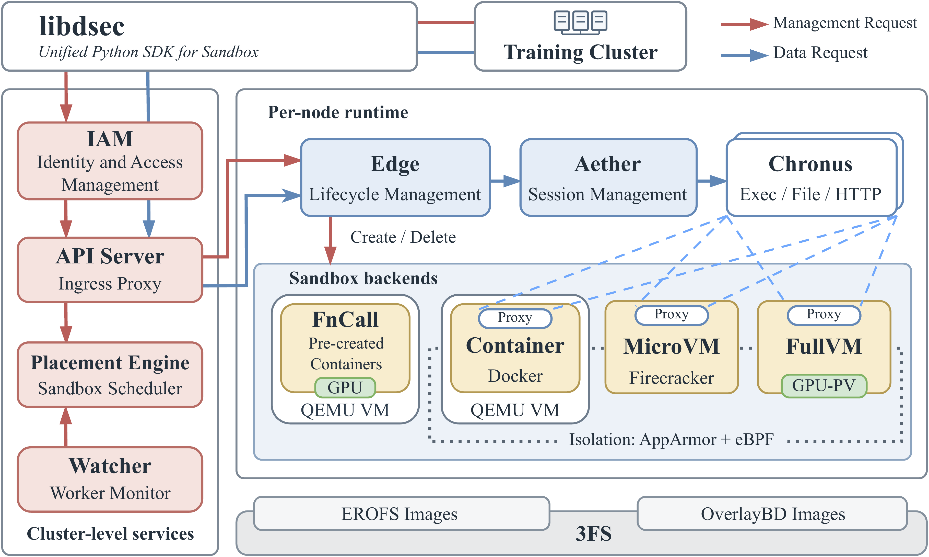
Figure 1. DSec’s architecture separates cluster-level placement from per-node lifecycle management and exposes FnCall, container, microVM, and full-VM backends through a unified SDK.
This heterogeneity matters because isolation is treated as a workload property, not a platform-wide constant. Management traffic and sandbox data take separate paths, and proxies mediate access for container and VM sandboxes. Together, the backends form a controlled menu of isolation costs.

Load environment data when it is needed
Conventional image pulling is a poor fit when images are large but each task touches only a fraction of them. DSec stores immutable environment layers in 3FS and assembles them with EROFS or OverlayBD. Metadata remains local, while file data can be fetched lazily. Independently versioned layers also let the system compose a base operating system, tools, dependencies, and task data without repeatedly unpacking nearly identical archives.
In an 8,192-container burst across a 10-node evaluation cluster, on-demand EROFS completed in about 35 minutes, essentially matching cached local Docker, while cold eager pulling took more than 60 minutes. Per-node disk writes fell from more than 1,600 GB to about 700 GB, approximately 57% less. The graph also shows why the benefit is operational, not just a final-time statistic: eager pulling sustains a much larger write storm.
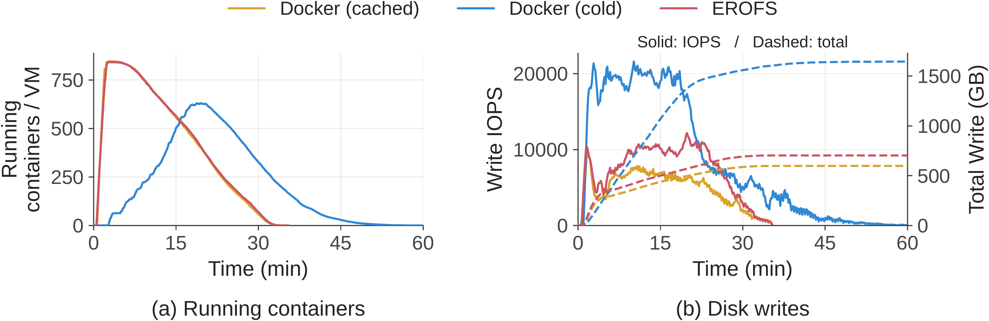
Figure 10. Under an 8,192-container burst on 10 nodes, EROFS reaches full throughput in about 35 minutes while avoiding the prolonged disk-write load of cold Docker pulling.
Composable mounting shows a similar pattern. Extracting tar archives took 79 minutes; mounting EROFS layers took 45 minutes, a 1.76× speedup. The mounted layers generated 5.5× less total disk-write traffic and cut peak throughput by 3.4×.

Reclaim memory without erasing the rollout
Dense microVM hosting creates a different problem. The guest’s state must remain available, but identical read-only pages should not be replicated across every VM. DSec uses virtio-pmem to share the host page cache for immutable data. It combines this with DAMON for guided reclamation and balloon free-page reporting, which returns guest pages that are no longer useful to the host.
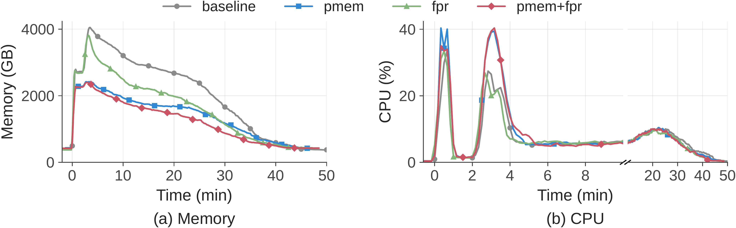
Figure 12. In a real agentic RL workload, virtio-pmem reduces peak host memory by 40.2%; free-page reporting lowers time-integrated memory use by 21.2%. Their combination produces the lowest overall memory curve.
The two mechanisms solve different parts of the footprint. Sharing immutable pages cuts the peak; free-page reporting recovers memory over the lifetime of the sandbox. Their combination therefore does more than either mechanism alone, while the CPU curves remain similar enough to support the paper’s claim that the saving does not come from simply suppressing work.

Protect the agent from noisy neighbors
CPU overcommit is useful only if background work does not disrupt the interaction loop. DSec marks best-effort tasks with SCHED_IDLE and combines that policy with core scheduling. SCHED_IDLE lowers priority, while core scheduling prevents best-effort threads on sibling hardware threads from interfering with latency-sensitive work.
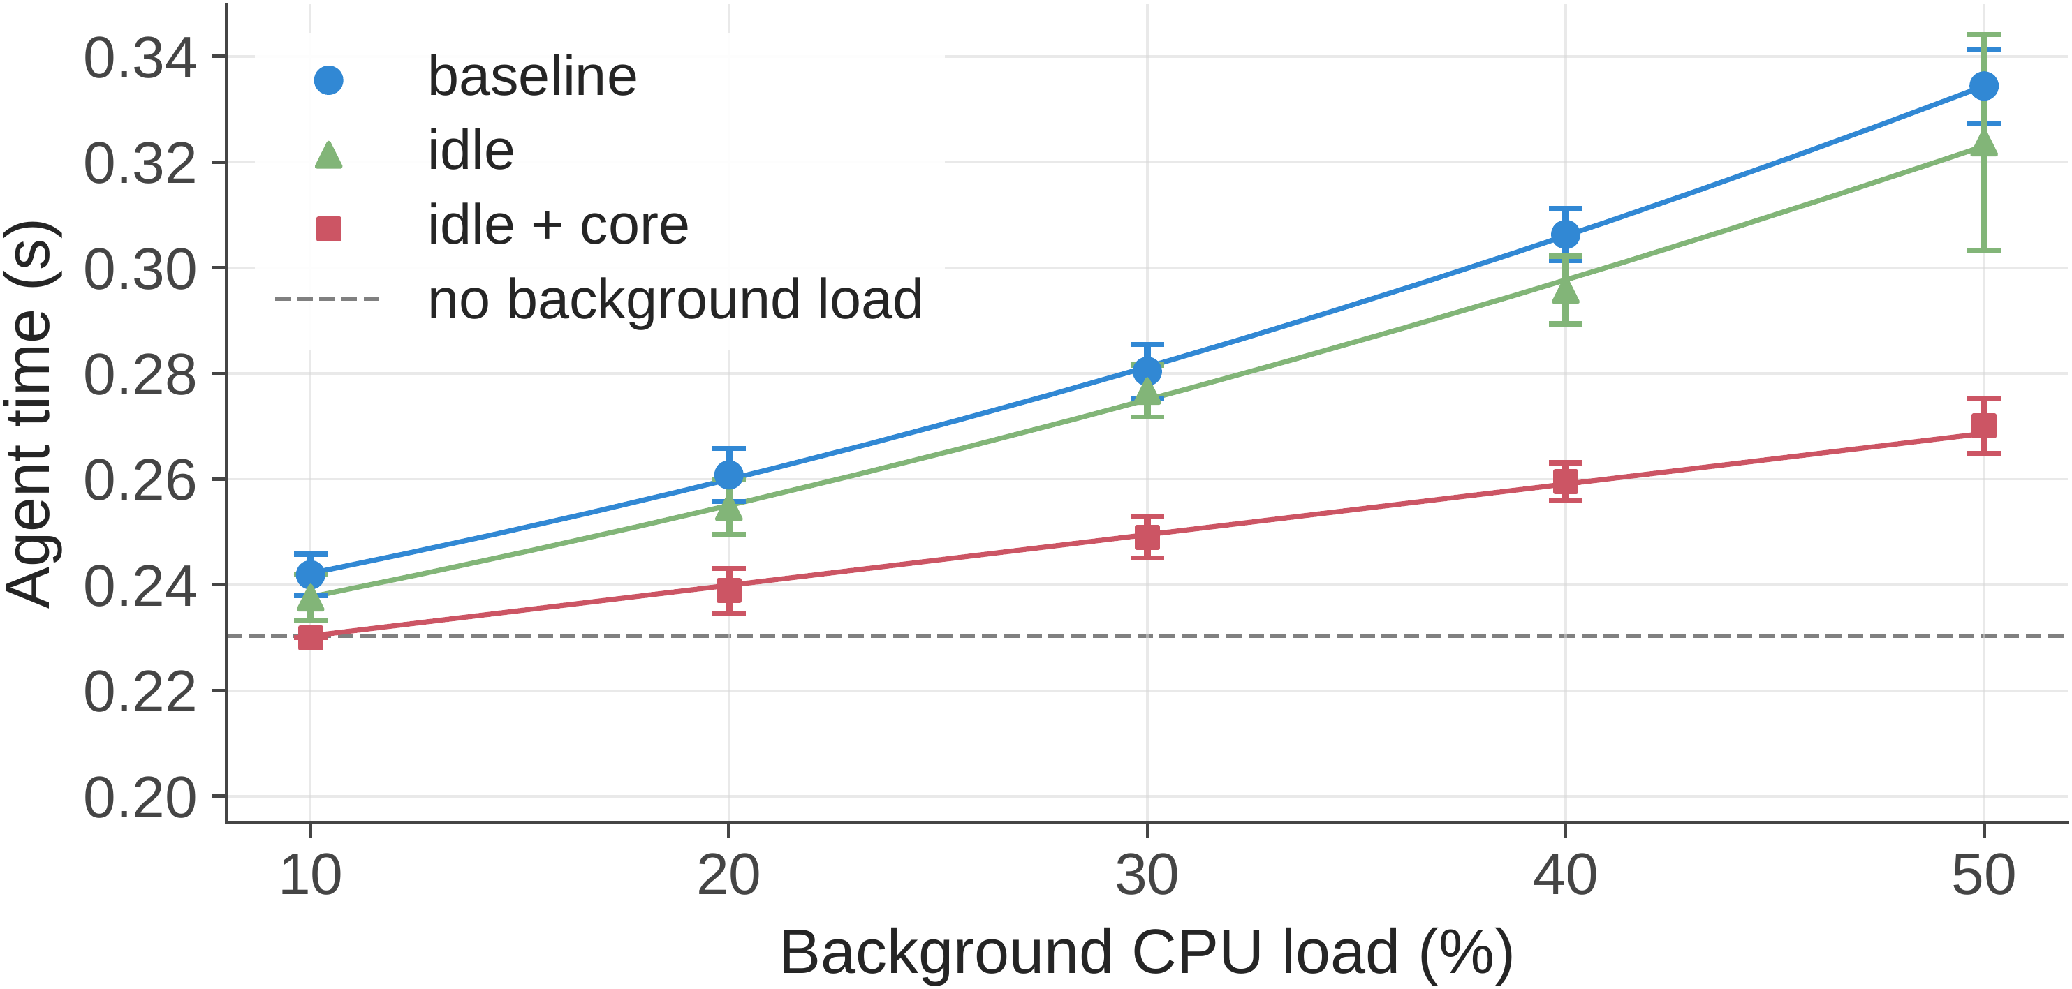
Figure 13. At 50% background CPU load, unprotected agent-step latency rises 45.2%; SCHED_IDLE plus core scheduling limits the increase to 17.3%. SCHED_IDLE alone improves latency by at most 3.4%.
The comparison is a useful systems lesson: a scheduler hint by itself is not enough when simultaneous multithreading leaves a shared-core interference path. The paired policy keeps latency close to the no-co-location baseline at lighter loads and bends the curve substantially at heavier loads.

The evidence at a glance
Table 1. Selected quantitative results reported in the paper.
System question | Comparison | Reported result
Image delivery | On-demand EROFS vs. eager cold pull | ~35 vs. >60 minutes; ~700 vs. >1,600 GB writes per node; ~57% less
Workspace provisioning | EROFS mount vs. tar extraction | 45 vs. 79 minutes; 1.76× faster; 5.5× less total writes; 3.4× lower peak throughput
MicroVM memory | virtio-pmem and free-page reporting | 40.2% lower peak; 21.2% lower time-integrated use
CPU isolation at 50% load | Unprotected vs. SCHED_IDLE + core scheduling | 45.2% vs. 17.3% latency inflation

What the results do—and do not—establish
The paper evaluates real RL training and evaluation workloads, including internal software-engineering tasks, SWE-bench, Terminal-Bench, security exploits, and production traces. That breadth supports the claim that the design is operational rather than hypothetical. The reported operating points—up to 3,200 containers or 800 microVMs on one node—are nevertheless demonstrations under DeepSeek’s hardware and workload mix, not universal capacity guarantees.
Several boundaries remain. The paper does not compare downstream model quality against another sandbox platform, and some workload details are internal. The benefit of each mechanism depends on image locality, interaction shape, memory pressure, and the acceptable isolation boundary. DSec also integrates lifecycle events with reinforcement learning to preserve rollout state and mitigate environment-side reward hacking, but the paper’s strongest quantitative evidence concerns infrastructure efficiency and latency rather than a standalone measurement of that safety effect.

The broader takeaway
DSec’s contribution is less a new sandbox primitive than a way to make many primitives behave like one elastic service. The platform matches isolation to the task, separates metadata from lazily loaded data, preserves state while reclaiming idle resources, and coordinates sandbox lifecycle with the training loop. For teams scaling agentic training, the practical message is clear: the execution environment has become part of the learning system itself.

