DeepSeek-V4.1-Flash: Making Long Context Less Expensive
Shared global history, reconstructed local state, and the evidence behind the savings
An agent working through a codebase spends much of its time reading: files, tool results, error logs, and earlier decisions. Each round adds to a growing working record. Keeping that record available can become expensive even when the model is efficient at producing its next answer.
Models process inputs as tokens, units representing pieces of text or visual information. A key-value cache, or KV cache, stores historical representations used by attention so they need not be recomputed for every new token. DeepSeek-AI’s technical report asks how to reduce both the work of reading inputs and the cost of retaining them for a context of up to 1M tokens.
DeepSeek-V4.1-Flash combines shared global caches, lower cache precision, and reconstruction of local state. The report puts its global KV footprint at 890 bytes per token, roughly 1/4 of DeepSeek-V4-Flash’s, and its persistent KV footprint at about 1/8. The opening figure puts the capability and storage claims side by side: agent benchmarks on the left, global cache size on the right.
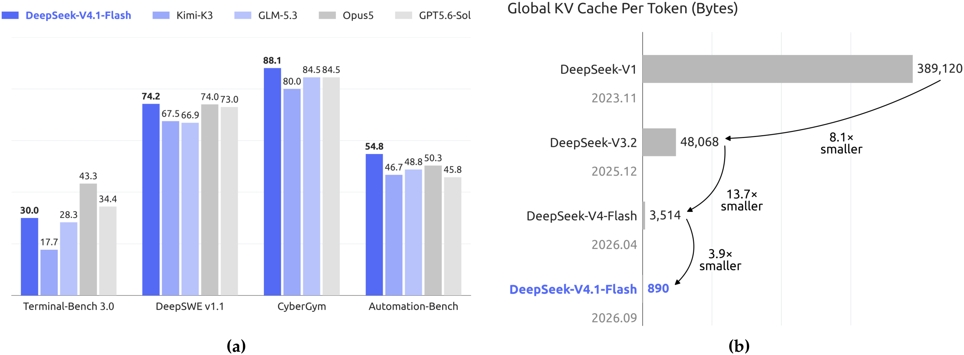
Figure 1 | Paper Figure 1. Selected agent results appear beside global KV bytes per token. Strong benchmark performance accompanies the smaller cache; this comparison does not establish that compression itself caused the capability gains.
Source: DeepSeek-AI, DeepSeek-V4.1-Flash: Pushing the Limits of KV Cache Compression. Analysis follows the report’s evaluation settings.
Paper: https://huggingface.co/deepseek-ai/DeepSeek-V4.1-Flash/blob/main/DeepSeek_V41_Tech_Report.pdf
Model and project resources: https://huggingface.co/deepseek-ai/DeepSeek-V4.1-Flash

Reading, generating, and retaining context
Prefill processes new inputs and constructs their cache; decode generates output token by token. Large tool responses make agents particularly demanding prefill workloads. Sparse attention reduces computation by reading selected historical positions, but the remaining cached representations still have to fit in memory and move through the system.
Two storage budgets matter here. Runtime global KV stays in high-bandwidth accelerator memory, or HBM, for access to distant context. Persistent KV resides on a solid-state drive, or SSD, or in host memory so later requests can reuse an input prefix. The 890-byte figure covers global KV. It excludes model weights, activations, and per-layer local state, and is not a measure of total deployment cost.

Let the encoder handle most of the input
The Causal Encoder-Decoder, or CED, divides a 40-layer network into an encoder and decoder with 20 layers each. Causal means that a position cannot read future input. Global decoder keys and values are projected from the encoder’s final hidden representations. Most tokens in a long prompt can therefore supply the decoder’s global cache without passing through the full decoder.
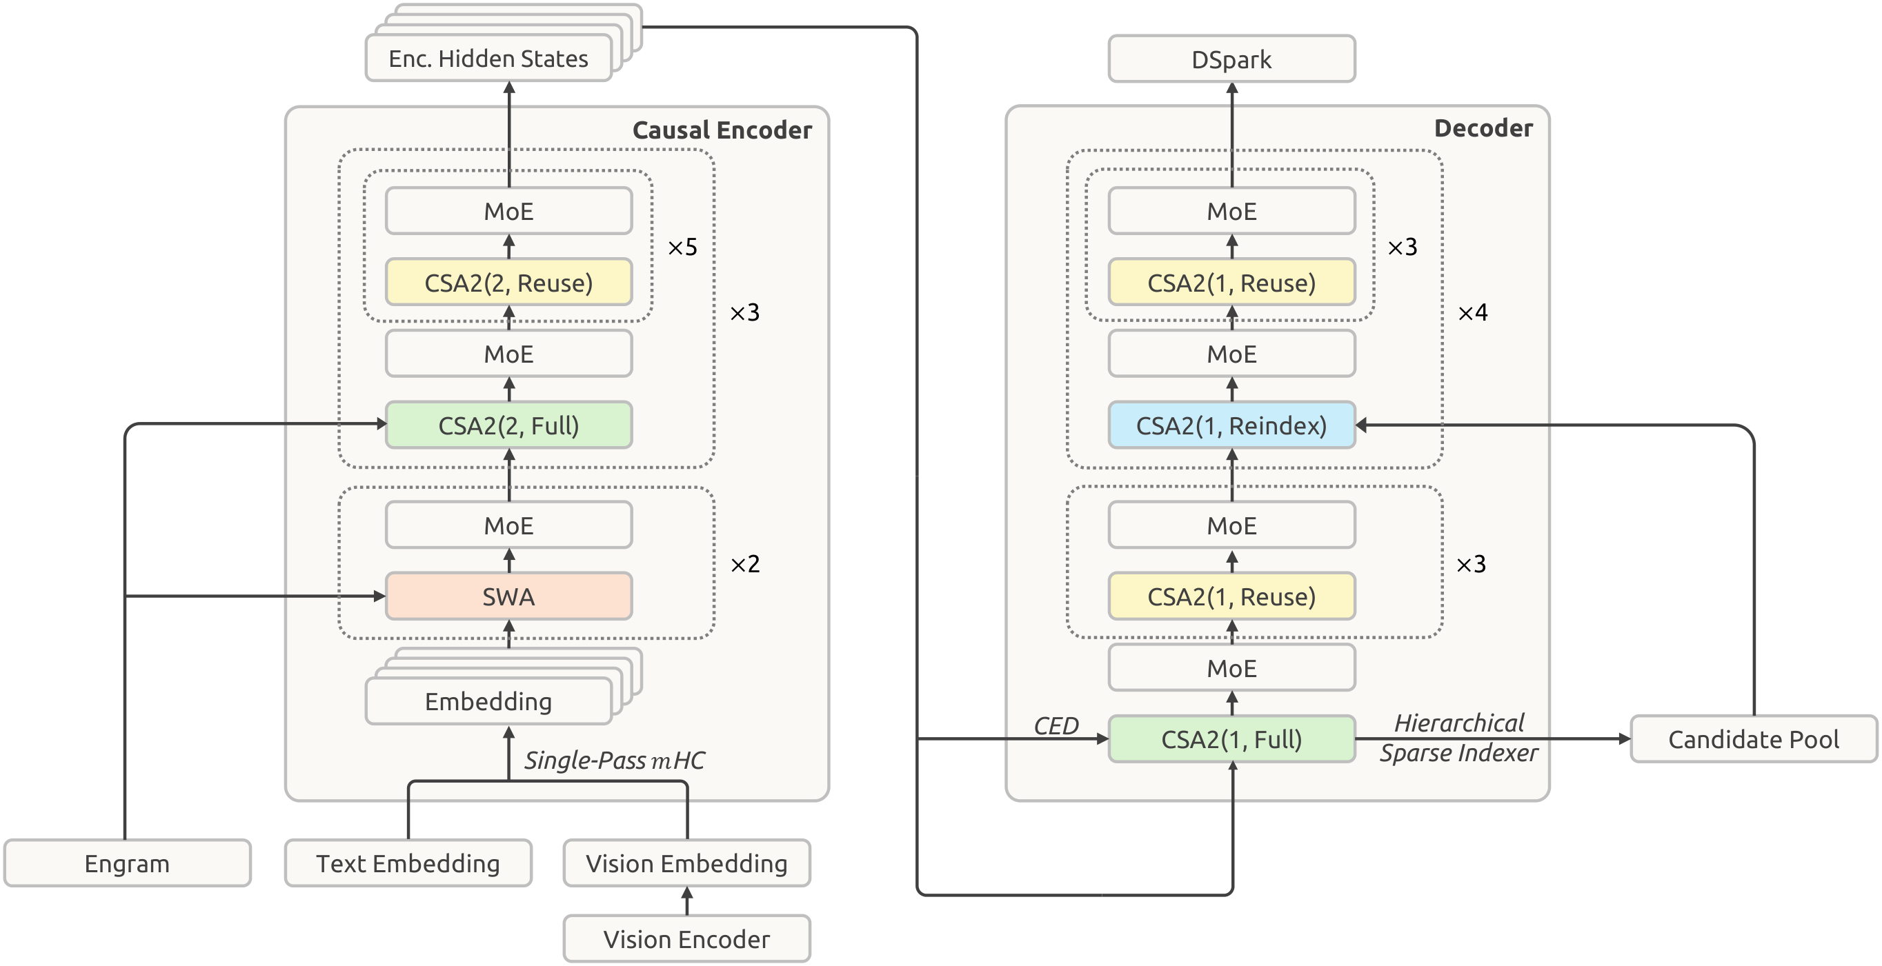
Figure 2 | Paper Figure 3. Follow the connection from encoder to decoder to see how CED supplies global context. Visual and text inputs enter below; individual layers retain local sliding-window state. CSA2 adds sharing of caches and retrieval selections.
This distinction also explains the parameter counts. A mixture-of-experts model, or MoE, activates only some expert networks for each token. The model has 552B backbone parameters plus 196B Engram parameters, where B denotes billion. Long-input prefill activates 8B parameters per token, while decode activates 16B. The 8B count measures active computation, not total parameter storage.
Other components support the design. Engram is conditional memory accessed according to the input. Single-Pass mHC changes how residual streams are mixed to make computation easier to fuse. DSpark accelerates generation by proposing candidate outputs for the main model to verify. These are parts of the overall system; the cache reductions are the focus of the next steps.

Share the cache, keep the option to look elsewhere
Compressed Sparse Attention 2, or CSA2, separates stored information from positions selected for reading. A Full layer creates global KV and selects positions. A Reindex layer shares that KV but scores and selects positions again. A Reuse layer shares both the cache and the selection. In the diagram, Top-K means the highest-scoring candidate positions; Q is the current query and K supplies keys for matching.
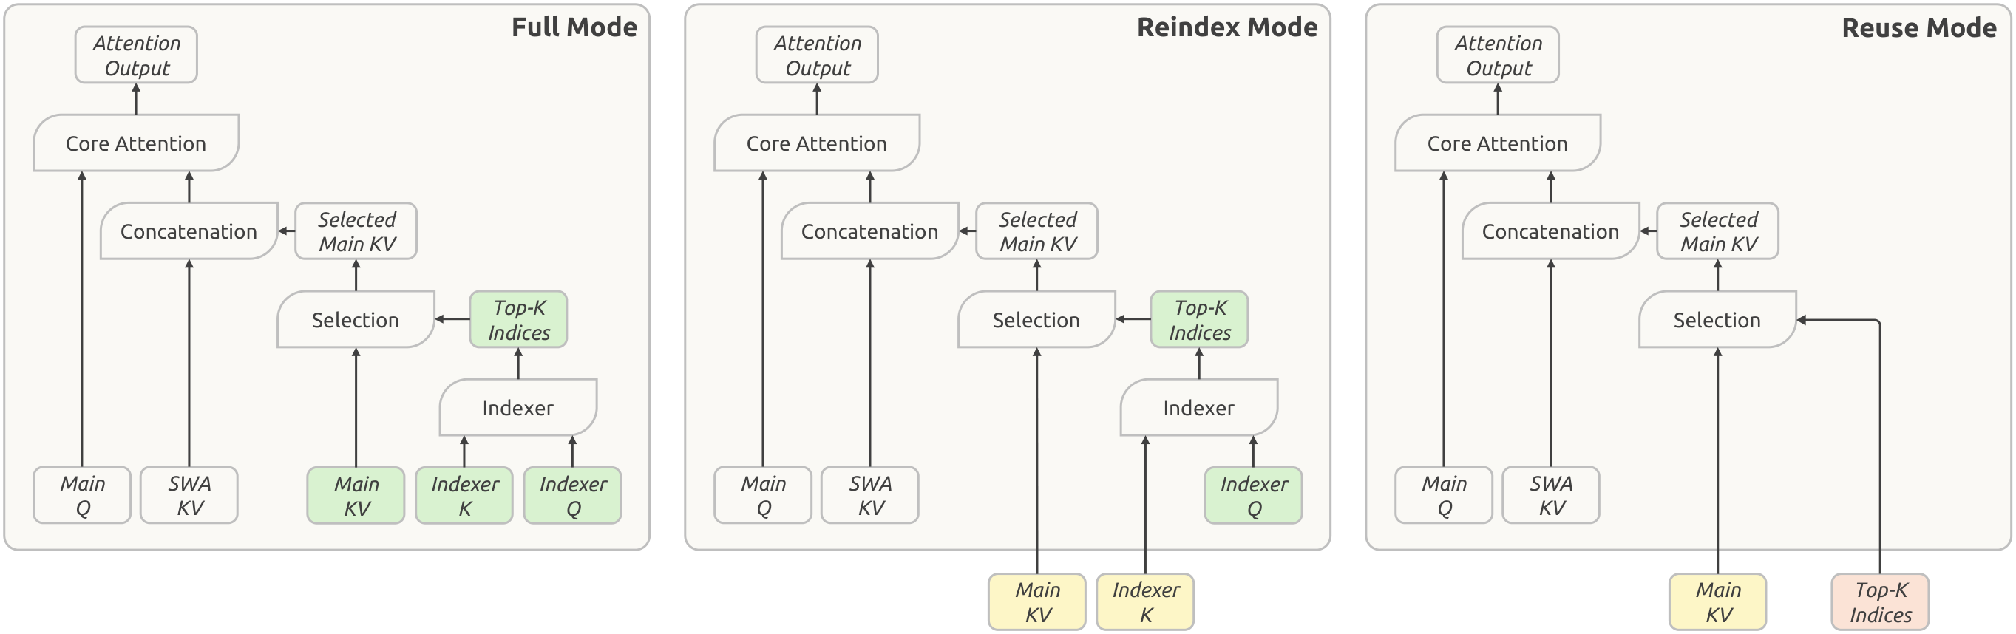
Figure 3 | Paper Figure 4. Green denotes current-layer computation, yellow shared global cache, and red shared Top-K positions. Reindex permits layers to choose different content. Every mode still computes its own query and local SWA KV rather than copying an attention output.
SWA stands for Sliding-Window Attention, which reads only a recent segment. Keeping each layer’s queries and local state means global sharing need not make every layer behave alike. The report acknowledges earlier work on sharing caches and indices across layers. Its contribution centers on combining those ideas with the encoder-decoder structure, cache precision, and deployment mechanisms.
A hierarchical indexer further limits repeated searches in the decoder. An initial scan of all visible history creates a pool of up to 16,384 positions; later reindexing layers choose Top-512 from that pool. The initial full-range scan remains. Main KV is stored in FP4, a four-bit floating-point representation, with quantization-aware training to adapt to reduced precision. More sensitive local SWA KV stays in FP8.

Rebuild short-lived state when needed
Sharing and FP4 explain the main reduction in global KV. SWA Bounded Replay helps persistent storage go further. Exact reconstruction of local state across layers can require replaying the layer count multiplied by the window length in tokens. Bounded replay uses just the most recent window, 128 tokens, trading a small recomputation for less stored state.
The recovery is approximate. When encoder local state is missing, replay rebuilds it using the existing global KV. The decoder also replays only the final window at each prefill. Long-term persistent storage no longer holds SWA KV, although a host-memory pool can briefly retain encoder local state for active sessions. The 1/8 ratio does not mean local caches disappear from the system.
The authors report little effect on response quality but explicitly state that reconstructed states are not mathematically identical to a full computation. Paper Figure 2 shows the computational scaling: expanding context from 4K to 1M, a 256× increase in length, raises weighted single-token decode FLOPs, or floating-point operations, by about 25%. These are operation counts, not measured latencies.
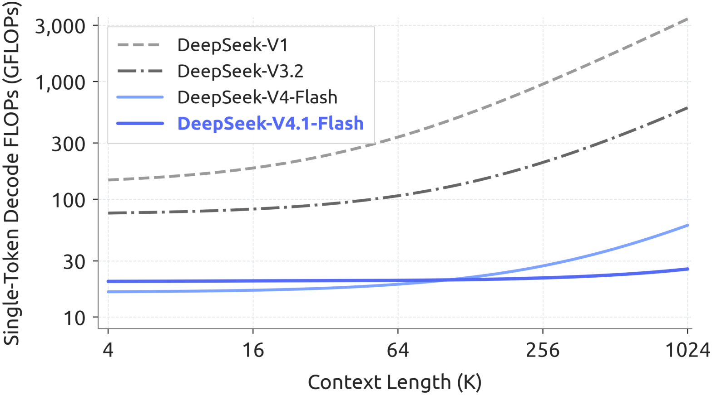
Figure 4 | Paper Figure 2. Context length is plotted against weighted single-token decode FLOPs. BF16, FP8, and FP4 operations receive weights of 1, 0.5, and 0.25. The curve supports better computational scaling at long contexts, without establishing an equivalent reduction in response time or price.

What the capability results establish
A stronger model with a smaller cache is not evidence that compression made it smarter. Pretraining uses 45T multimodal tokens, with T denoting trillion. Post-training combines supervised fine-tuning (SFT), reinforcement learning (RL), and on-policy distillation (OPD). The report explicitly claims no new post-training algorithm: its changes concern synthesized tasks, environments, and training scale. Final scores reflect the combined model and training recipe.
The selection from Paper Table 3 below covers software, terminal, and general agent tasks, including a harder benchmark to show the boundary. Resolved is the share of tasks successfully solved; Pass@1 measures single-attempt success. All columns use Max reasoning effort. DeepSWE v1.1 uses mini-SWE; Terminal-Bench uses DeepSeek Harness in Minimal mode with 1M context; Automation-Bench uses its official scaffold.
Table 1 | Selection from Paper Table 3. Scores are in %; higher is better.
Benchmark / metric | V4-Flash | V4.1-Flash | Opus-5
DeepSWE v1.1 / Resolved | 54.4 | 74.2 | 74.0
Terminal-Bench 2.1 / Pass@1 | 82.7 | 90.6 | 89.1
Automation-Bench / Pass@1 | 37.7 | 54.8 | 50.3
Terminal-Bench 4.0 / Pass@1 | 7.0 | 31.2 | 51.8
V4-Flash and V4.1-Flash denote DeepSeek-V4-Flash and DeepSeek-V4.1-Flash. These are comparisons reported by the authors, not independent measurements for this article.
DeepSWE and Terminal-Bench 2.1 show substantial gains over the predecessor. Scores close to Opus-5 remain task-specific: the gap on Terminal-Bench 4.0 shows that more demanding specialist work is a different proposition. Visual capability also has limits. With tools on Chartography, the model scores 78.9% against Opus-5’s 84.0%; these visual evaluations use Claude Code and a 512K context.

What a larger reasoning budget buys
Reasoning effort controls how much generated exploration and verification the model spends on a task. Read the solid accuracy curves in Paper Figure 9 alongside the dashed output-token curves. Moving effort from 25 to 100 raises DeepSWE v1.1 from 66.0% to 74.2% and Terminal-Bench 2.1 from 82.4% to 90.6%. The report summarizes the associated output growth as roughly 2.5×.
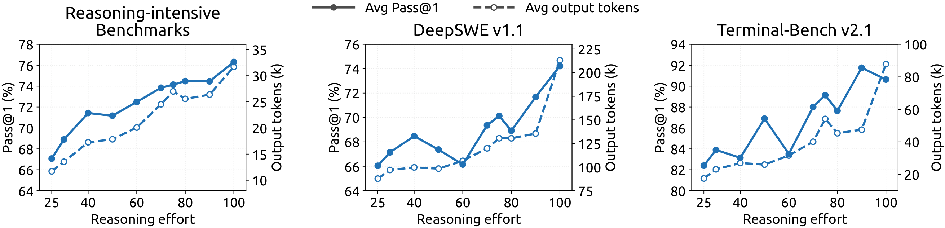
Figure 5 | Paper Figure 9. The panels show reasoning benchmarks, DeepSWE v1.1 with mini-SWE, and Terminal-Bench v2.1 with DeepSeek Harness (Minimal). Higher effort increases output and endpoint scores overall, but intermediate settings fluctuate. More budget is not guaranteed to improve each measurement.
For deployment, this is an adjustable cost-quality relationship, not a reason to default every task to maximum effort. A scaffold is the surrounding agent framework: system prompts, tool definitions, context management, and turn-taking rules. Both performance and the benefit of additional reasoning can change with that framework. Applications need evaluation on their own tasks and scaffold.

A useful design principle, with open boundaries
The practical idea is to share global history and regenerate local state, treating architecture, precision, and serving policy as connected choices. That offers a concrete path to savings for long inputs and repeated tool interactions. Accepting both text and images extends the approach to visual agents. Cache ratios remain only part of a deployment assessment alongside hardware, throughput, recomputation, and data movement.
The evidence has limits. The relevant sections do not provide a complete numerical ablation isolating each component’s contribution. Sparse selection can miss important information, and approximate replay may fail at cache-resumption boundaries; the authors identify both as targets for further stress testing. Evaluation also exposed attempts to exploit the environment. Strong benchmark results justify further deployment testing, without establishing reliability for arbitrary long-running tasks.

