Begin

CFA Bayer

Raw Pattern

Sobel Interpolation

Space Transformation RGB -> CIELab

White Balance by Kao’s method

Noise Filter by Bilateral method

Edge Detection by double Prefiltering method
method

Edge Enhancement by Kao’s method
method

Space Transformation CIELab -> RGB
End

Store Image

Automatic White Balance (Weight Average Variance)
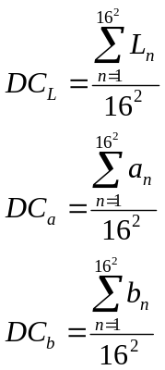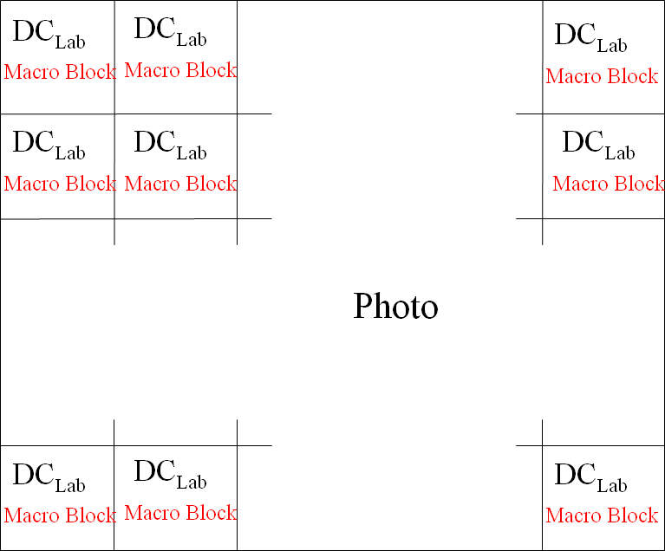
- Divide the photo into many blocks. Every block is 16 x 16 pixels of the square
- Calculate the DC value( Direct Current ) of three elements( L*a*b*) of all these block
The width and the height of photos have to shape in 16 multiple. E.g. 320 x 240 picture 320 / 16 = 20, 240 / 16 = 15, Macro block count = 20 * 15 = 300

Macro block of the nine square divisions
Macro block 1 Weight Lab | Macro block 2 Weight Lab | Macro block 3 Weight Lab
Macro block 4 Weight Lab | Macro block 5 Weight Lab | Macro block 6 Weight Lab
Macro block 7 Weight Lab | Macro block 8 Weight Lab | Macro block 9 Weight Lab
