DSP Spring 2009
04/10 Midterm I Chapter 1~4.7(100%)
1.(25%) Briefly answer the following questions:
(a)(5%) Explain the concept of the "Impulse invariance".

(b)(5%) The impulse response (frequencye response) of a LTI system can be derived using an impuse as the input. It also can be estimated by using a white noise as the input. Explain how.

(c)(7%) Consider a LTI system with the impuse response h[n]. For a deterministic input signal x[n], the output y[n] satisfies y[n]=x[n]*h[n], i.e., Y(e^{jω})=X(e^{jω})H(e^{jω}). Any similar I/O relation(s) for a random input signal x[n](2%)? Prove your statement(s)(5%).

(d)(5%) The impulse respopnse of the ideal lowpass filter is . Derive the impuse response of a highpass filter with

(e)(3%) Show the decimator y[n]=x[Mn] is not a time-invariant system.

2.(10%) Consider a LTI system with the impulse response h[n]:
(a)(4%) For what kind of input signal x[n], -∞<n<∞, the system would simply produce a output as a scaled input y[n]=Cx[n], -∞<n<∞? Prove your answer and derive the constant C.
(b)(6%) Derive the output for the input signal .
3.(10%) A LTI system is characterized by: y[n]-5y[n-1]+6y[n-2]=3x[n-1]+5x[n-2] with initial conditions: y[-1]=11/6, y[-2]=37/36.
(a)(5%) Derive the zero-input response of this system.

(b)(5%) Derive the output for a causal input sequence x[n]=2^{-n}u[n].

4.(10%) When the input to a LTI system is x[n]=(1/2)^{n}u[n]+2^{n}u[-n-1], the output is y[n]=6(1/2)^{n}u[n]-6(3/4)^{n}u[n]
(a)(5%) Find the impulse response of the system.

(b)(5%) State your reason(s) for choosing the ROC in (a). Is the system stable? Is it causal?

5.(10%) Consider the system shown in Figure I, where and L>2. The input X_{c}(jΩ) is as shown in Figure II. Sketch X(e^{jω}), V(e^{jω}), W(e^{jω}), Y(e^{jω}) and Y_{c}(jΩ).
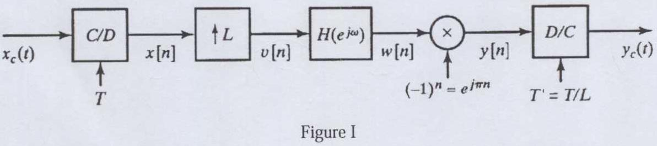
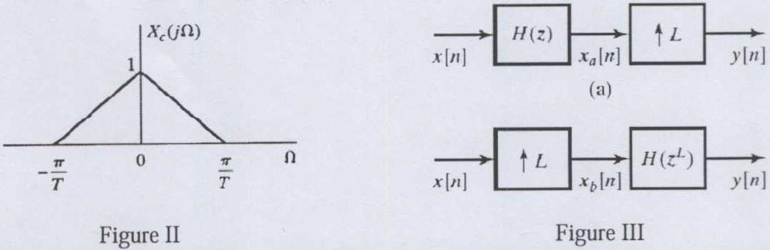
6.(15%) The polyphase decomposition of a filter h[n] in the z-transform domain can be written as with polyphase components e_{k}[n]=h[nM+k].
(a)(5%) Show the two systems in Figure III are equivalent.

(b)(5%) Based on the polyphase decomposition, please draw an efficient implementation of an interpolation system(an expander with an anti-imaging LPF).

(c)(5%) Demonstrate the efficiency (in reducing computational complexity) of your implementation.

7.(20%) Figure IV shows a decimator of downsampling factor M folowed by an expander of upsampling factor L. Figure V shows the decimator and expander are switched position.
(a)(10%) Please show that y1[n]=y2[n] iff L and M are relatively prime (hint: compare the outtputs in frequency domain).

(b)(5%) Design a sampling rate converter by a factor 5/8 to resample the 16kHZ sampled speech at 10 KHz. Write a script of MATLAB command(s) to implement yiour design.

(c)(5%) For the system in Figure VI, find an expression for Y(e^{jω}) in terms of X(e^{jω})
