國立交通大學電子工程研究所九十六級王盛弘9611842
DSP Spring 2009
HW #1 (120%) Due: 03/20
[MATLAB WARM-UP]
1. (15%) Given x[n]=[3 -2 6 8 -1]; h[n]=[ 2 5 0 -5 2 -3 1]; Please find y[n]=x[n]*h[n] by the following three methods:

0
3
-2
6
8
-1
x[n]
0
2
h[n]
5
0
-5
2
-3
1
0
h[-n]
2
5
0
-5
2
-3
1
Move, Multiply, Sum

(1) Find y[n] by the direct convolution of x[n] and h[n];
第一種方法直接呼叫函數輔助計算，其y[n]序列如下，

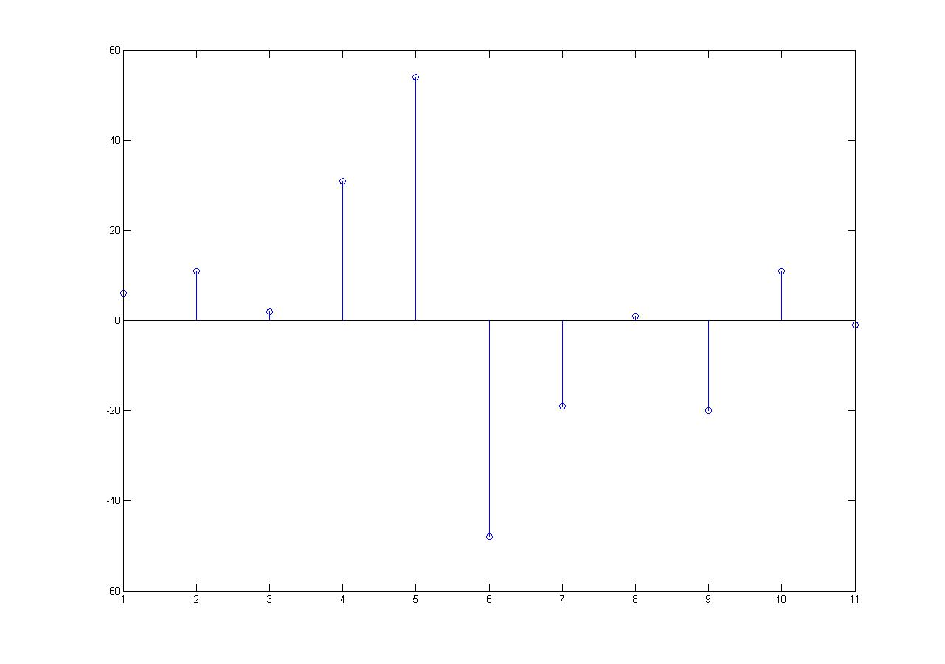
(2) Decompose x[n] into impulses with different delays, then produce y[n] by doing the linear combination of the impulse-wise convolution with h[n].
已知x[n]=[3 -2 6 8 -1]以及h[n]=[ 2 5 0 -5 2 -3 1]，
故將x[0]=[3 0 0 0 0], x[1]=[0 -2 0 0 0], x[2]=[0 0 6 0 0], x[3]=[0 0 0 8 0], x[4]=[0 0 0 0 -1]，依序和h[n]分別做旋積。

(3) Do the vector-wise convolution y=Hx, where x, y represent the input, output vector respectively, where H represents the matrix formed by components of h[n]. (Plot y[n] and compare whether the results in these methods are the same.)(Hint: MATLAB commands: plot、conv、在執行vector加法時，各vector的長度需相等，若有長度不等之處，請直接補零至相同長度)
可參考II-25
Vector-wise

已知x[n]=[3 -2 6 8 -1]以及h[n]=[ 2 5 0 -5 2 -3 1]，
故將x[0]=3, x[1]=-2, x[2]=6, x[3]=8, x[4]=-1，依序和h[n]分別做旋積。
其結果為
y1 =
6 15 0 -15 6 -9 3

y2 =
-4 -10 0 10 -4 6 -2

y3 =
12 30 0 -30 12 -18 6

y4 =
16 40 0 -40 16 -24 8

y5 =
-2 -5 0 5 -2 3 -1
而此長度不一，所以將y1到y5的長度補齊，再全部加總，便得到和(a)一樣的值。

2. (15%) As defined in Q1, x[n] is now the system input and h[n] represents the impulse response of the system. Therefore, y[n]=x[n]*h[n] is the system output.
x=[3 -2 6 8 -1];
h=[2 5 0 -5 2 -3 1];
y=conv(x,h);
%(a)
x1=fft(x,64);
h1=fft(h,64);
y1=fft(y,64);
stem(abs(y1));
%(b)
figure();
subplot(2,1,1);stem(abs(x1));
subplot(2,1,2);stem(abs(h1));
%(c)
figure();
subplot(2,1,1);stem((abs(x1.*h1)));
subplot(2,1,2);stem(abs(fft(y,64)));
(1) Plot the 64-point magnitude response of y[n](Hint: fft).
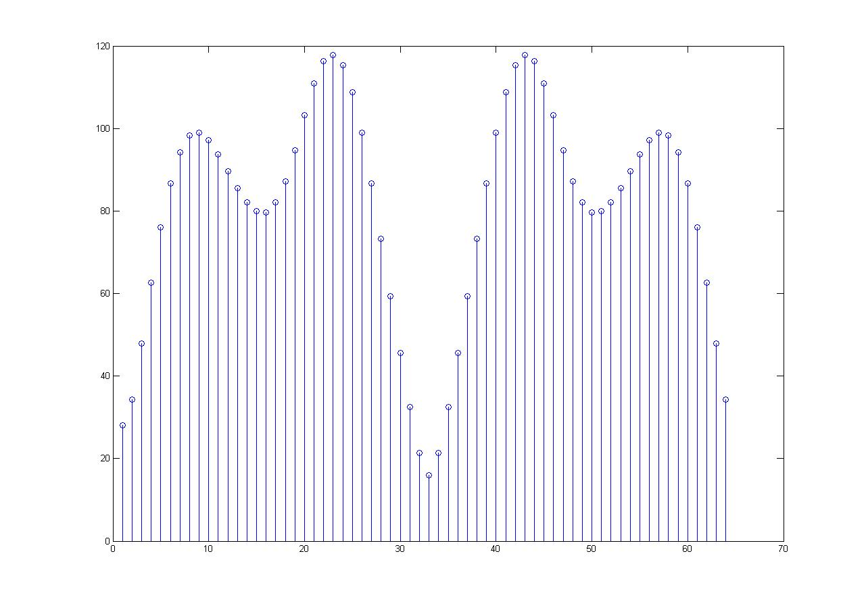
(2) Also plot the 64-point magnitude response of x[n] and h[n].
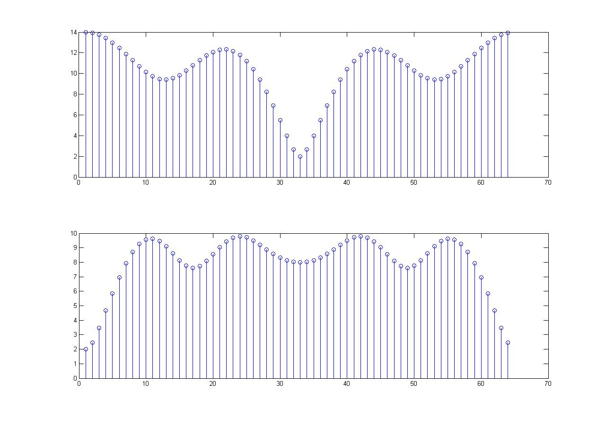
(3) Please verify the relation of those magnitude responses (of y[n], x[n] and h[n]) in frequency domain. (Hint: MATLAB commands: (.*)表示矩陣(向量)元素相乘、fft(x , numbers of point)、在執行元素乘法時，各vector的長度需相等)
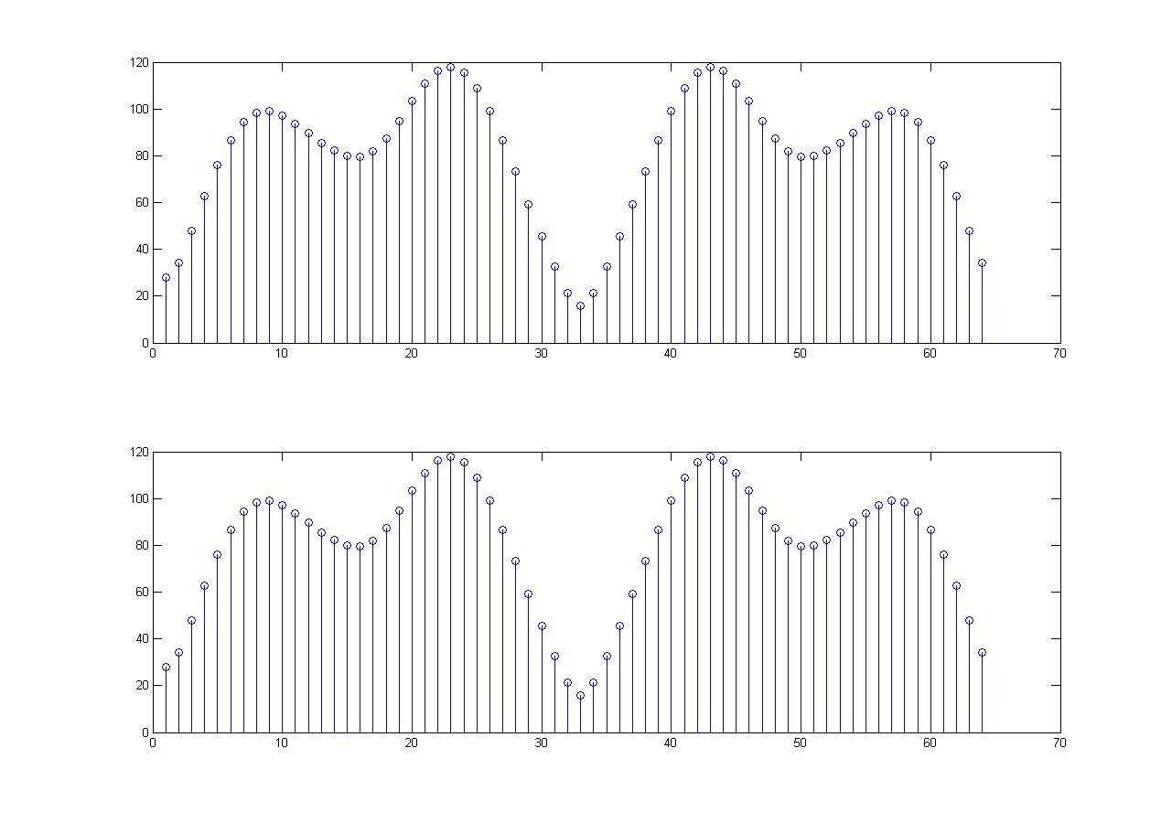
[TEXTBOOK PROBLEMS]
3. (20%) 2.30
For each of the following systems, determine whether the system is (1) stable, (2) causal, (3) linear, and (4) time invariant.
(a)
(1)穩定，因為其輸出值的範圍為，故輸出保證不會發散。
(2)因果，因為輸出只和目前的輸入有關。
(3)線性，因為會是一個常數項，
假設，

(4)時變，，若
(b)
(1)穩定
(2)非因果，如因為輸出和未來的輸入有關。
(3)線性
(4)時變，
(c)
(1)穩定，因為，所以
(2)因果
(3)線性
(4)時變
(d)
(1)不穩定
(2)非因果，因為需要未來的值
(3)線性，，

(4)線性，讓

4. (10%) 2.41
A linear time-invariant system has frequency response

The input to the system is a periodic unit-impulse train with period N=16; i.e.,

Find the output of the system.
輸入
其傅立葉轉換為

所以，輸入的頻率表示式也是一個週期的脈衝，一共有16個頻率脈衝，其範圍為
從上圖可得知，我們可得到該LTI是一個低通濾波器，於是乘上一個相位因子
-6π/16
-2π/16
0
2π/16
6π/16
ω
|H(e^{jω})|
|X(e^{jω})|
輸出的傅立葉轉換(Fourier transform)為

所以該輸出的序列為

5. (10%) 2.42 (a), (b)
Consider the system in Figure P2.42-1.
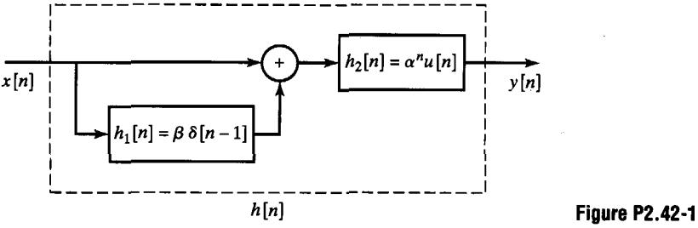
(a) Find the impulse response h[n] of the overall system.

令h[n]為整個系統的impulse response

由上式比較中可得知

(b) Find the frequency response of the overall system.
從(a)所得到的h[n]其Fourier transform

其中，以及P62的Table 2.3

(c) Specify a difference equation that relates the output y[n] to the input x[n].
由(b)可得知，

交叉相乘後得到

(d) Is this system causal? Under what condition would the system be stable?
從(a)可得知

故此系統是穩定的，由於系統是穩定的，所以，其Fourier transform是存在的，因此，其穩定的條件如同(b)部份的frequency response一樣，即：若便穩定
6. (20%) 2.44 (a), (b), (d), (e)
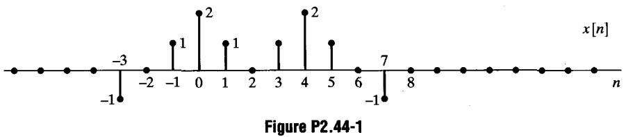
Let denote the Fourier transform of the signal x[n] shown in Figure P2.44-1. Perform the following calculations without explicitly evaluating :
(a) Evaluate

(b) Evaluate （）

(d) Evaluate

針對n=0

(e) Determine and sketch the signal whose Fourier transform is
令y[n]為一未知的序列，則

所以
(f) Determine and sketch the signal whose Fourier transform is
0
2
1
3
-4
-1
由
而
取其反轉換，得

0
2
-1/2
1/2
1
-4
4
1/2
-1/2
7. (20%) 2.56
Consider a system S input x[n] and output y[n] related according to the block diagram in Figure P2.56-1.
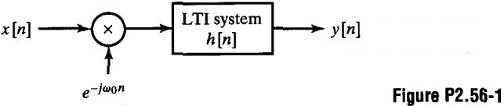
The input x[n] is multiplied by , and the product is passed through a stable LTI system with impulse response h[n].
(a) Is the system S linear? Justify your answer.

令則

其及分別為及的響應，所以，該系統為線性
(b) Is the system S time invariant? Justify your answer.
令，則

因此，該系統為時變。
(c) Is the system S stable? Justify your answer.
由於的magnitude會被鎖在1的範圍內，以及h[n]是穩定的，所以，對於該LTI系統來說，x[n]將產生一個有限的輸入，而其輸出y[n]便也會是有限的，所以，該系統是穩定的。
(d) Specify a system C such that the block diagram in Figure P2.56-2 represents an alternative way of expressing the input-output relationship of the system S. (Note: The system C does not have to be an LTI system.)
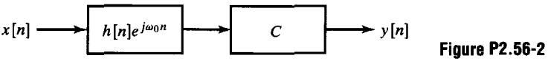
我們將y[n]改寫

所以該系統C應該要乘上
8. (10%) 2.66 (a), (b) (Ref. MATLAB command: filtfilt)
Consider the cascade of discrete-time systems in Figure P2.66-1. The time-reversal systems are defined by the equations and . Assume throughout the problem that x[n] and are real sequences.
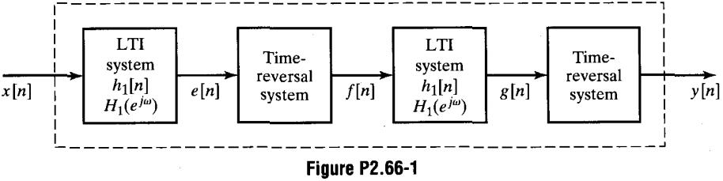

(a) Express , , and in terms of and .

(b) The result from Part (a) should convince you that the overall system is LTI. Find the frequency response of the overall system.
由於可得到

(c) Determine an expression for the impulse response h[n] of the overall system in terms of .
取的逆轉換，可得到

