3.6
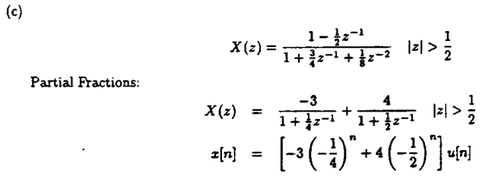
ROC include unit circle, Fourier transform exists

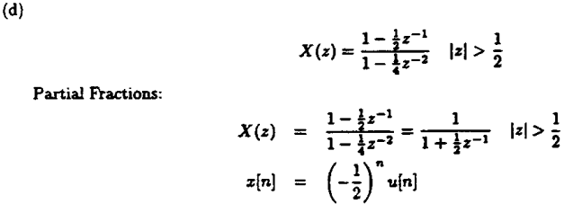
ROC include unit circle, Fourier transform exist

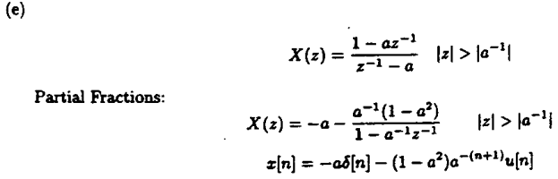
or
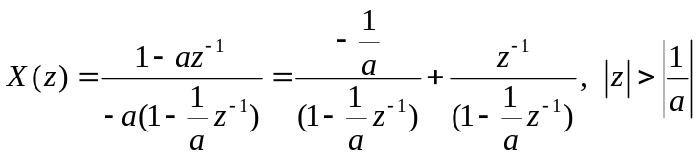
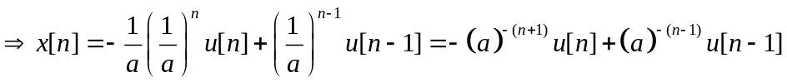
Fourier transform exist if 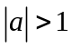
===================================================================

3.7
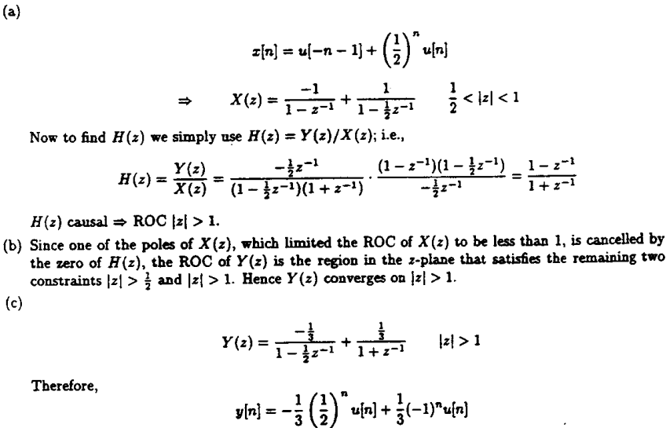
===================================================================
3.41
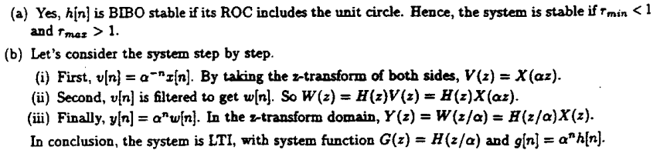
Linear, but not TI!!
===================================================================

3.44
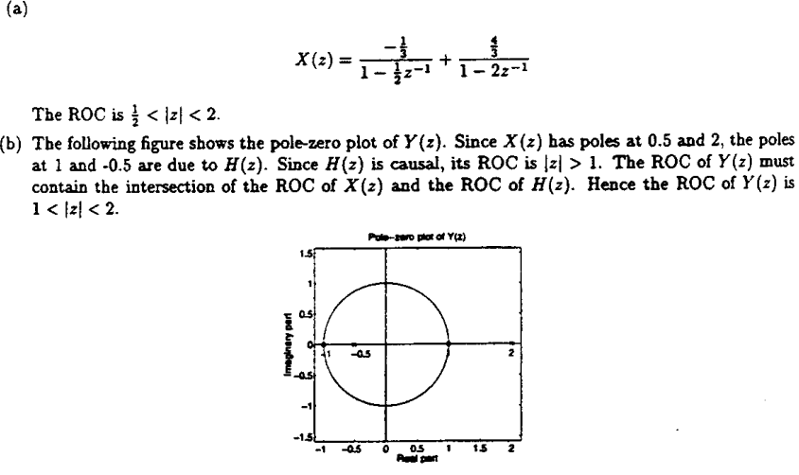
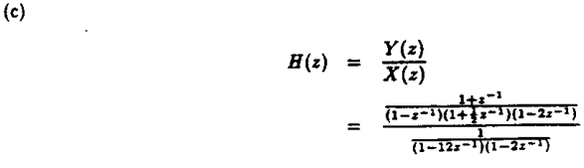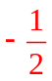
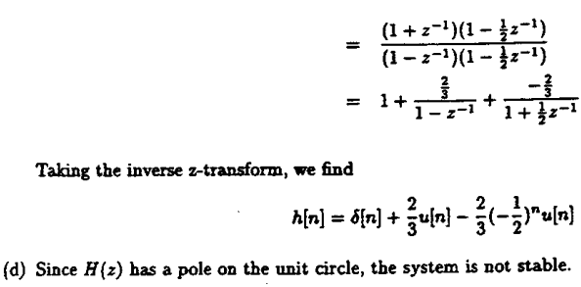
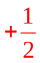
===================================================================

3.46
