國立交通大學電子工程研究所九十六級王盛弘9611842
DSP Spring 2009
HW #2 (100%) Due: 03/31
[MATLAB EXERCISE]
1. (25%) Considering the constant coefficients difference equation of a causal system y[n] = 0.25y[n-2]+3x[n-1]-x[n-2], please answer the following questions:
(1) Find its transfer function, and show the pole-zero plot of this system. (zplane)
經過紙上運算，得到轉移函數H(z)為
在matlab輸入zplane( [0 3 -1], [1 0 -0.25]);得到
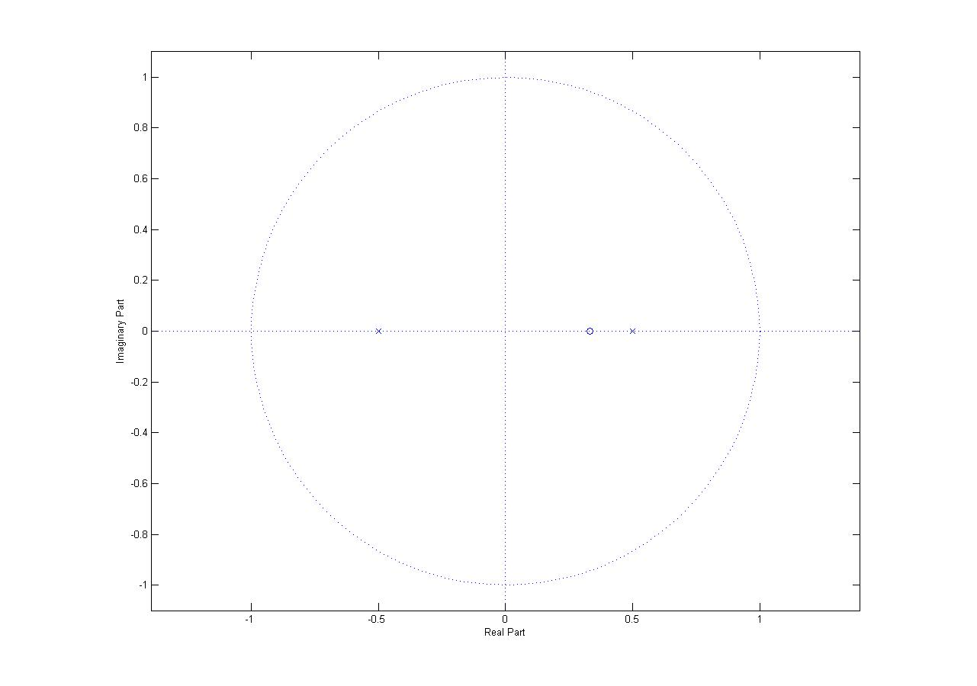
經由手動化簡後得到，和上圖吻合，其零點為，而極點為0.5與-0.5。
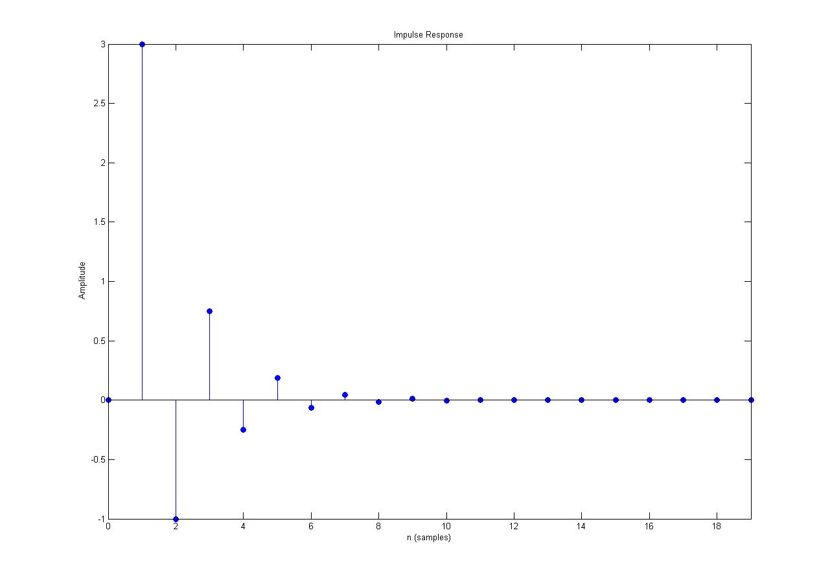
(2) Specify its R.O.C. and plot the first 20 samples of the corresponding impulse response. (impz)
由題意所知該系統為causal，然而causal的系統其ROC要包含無限，所以ROC為
(3) Find its inverse system ，plot its magnitude and phase response for . (freqz)
因為，所以
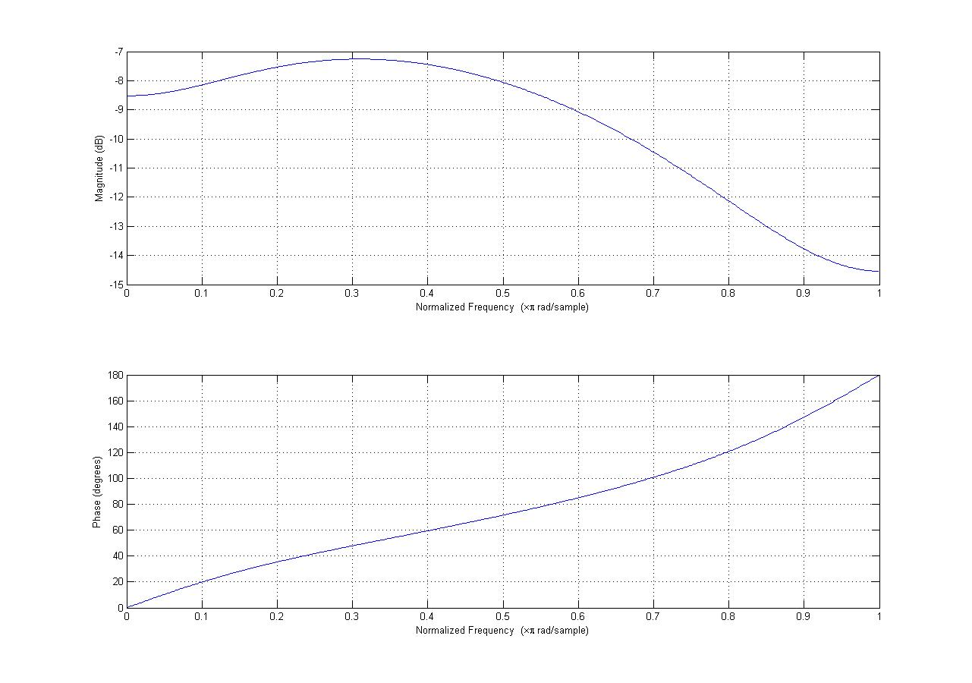
(4) Verify the relationships between the magnitude responses, phase responses of the system H and its inverse system .
由下圖的response可知道兩者的振幅與相位皆呈現以X軸為對稱的關係
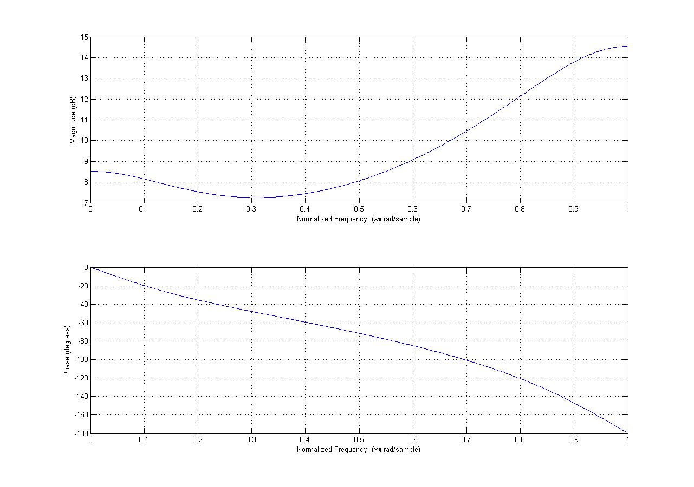
(5) Are H and H_{i} both stable? Verify your answer. (Hint: MATLAB commands: zplane; impz; freqz)
由於H(z)的ROC為，其包含了單位圓，所以H(z)穩定，而H_{i}(z)的ROC為，也是包含單位圓，所以兩者皆穩定！
[TEXTBOOK PROBLEMS]
2. (15%) 3.6 (c)(d)(e) (just choose one method)
Following are several z-transforms. For each, determine the inverse z-transform using both methods-partial fraction expansion and power series expansion-discussed in Section 3.3. In addition, indicate in each case whether the Fourier transform exists.
經由P104的表可查得其轉換Z轉換式
(a)

經由查表後得到

(b)
經由查表後得到

(c)

(d)

(e)

3. (15%) 3.7
The input to a causal linear time-invariant system is

The z-transform of the output of this system is

(a) Determine H(z), the z-transform of the system impulse response. Be sure to specify the region of convergence.

經由題意可知H(z)要為causal，故其ROC為
(b) What is the region of convergence for Y(z)?
由於X(z)的極點被限制為小於1，而Y(z)的剩餘兩個限制為以及，故其ROC為
(c) Determine y[n].

4. (12%) 3.41
In Figure P3.41, h[n] is the impulse response of the LTI system within the inner box. The input to system h[n] is v[n], and the output is w[n]. The z-transform of h[n], H(z), exists in the following region of convergence:

(a) Can the LTI system with impulse response h[n] be BIBO stable? If so, determine inequality constraints on and such that it is stable. If not, briefly explain why.
是的，如果其ROC包含單位圓，則該系統會穩定，所以，如果以及成立則該系統會穩定。
(b) Is the overall system (in the large box, with input x[n] and output y[n]) LTI? If so, find its impulse response g[n]. If not, briefly explain why.
（1）第一步，令，由取兩邊的z轉換，
（2）第二步，v[n]濾波後得到w[n]，所以
（3）最後，，在z轉換的頻域中，
總結來說，該系統為L但不是TI，其system function為及
(c) Can the overall system be BIBO stable? If so, determine inequality constraints relating α, r_{min}, and r_{max} such that it is stable. If not, briefly explain why.
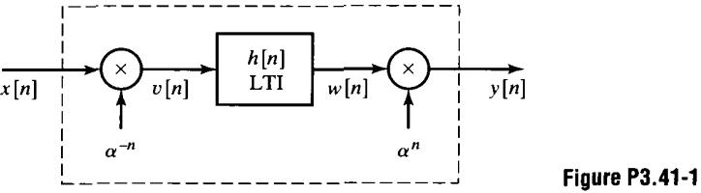
G(z)的ROC範圍為，針對系統穩定的要求，其要滿足以及。
5. (12%) 3.44
When the input to a causal LTI system is

the z-transform of the output is

(a) Find the z-transform of x[n]

經由查表後得到
經由查表後得到

(b) What is the region of convergence of Y(z)

zplane([1 1 0 0], [1 -5/2 1/2 1]);
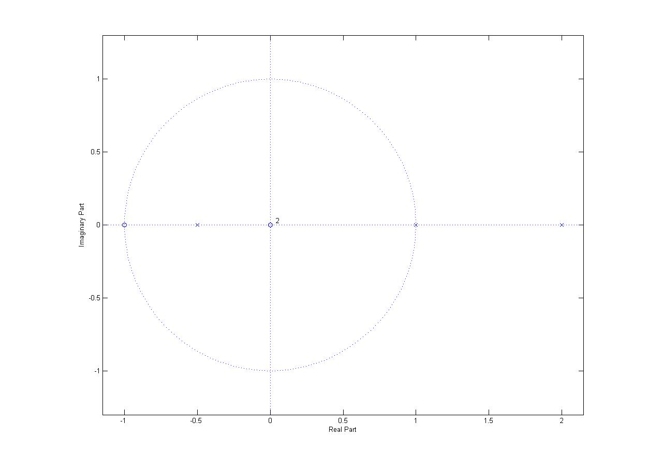
故H(z)其極點為1以及-0.5，由題目所知H(z)為causal系統，因為causal的系統其ROC要包含無限，所以H(z)的ROC為，而Y(z)的ROC則要取在X(z)的ROC以及H(z)的ROC中的交集部份，所以Y(z)的ROC為，下圖藍色部份為X(z)的ROC。
(c) Find the impulse response of the system.
0
1
2
0.5

取其反Z轉換

(d) Is the system stable?
不穩定，因為其中一個極點在單位圓上。
6. (21%) 3.46
The signal y[n] is the output of an LTI system with impulse response h[n] for a given input x[n]. Throughout the problem, assume that y[n] is stable and has a z-transform Y(z) with the pole-zero diagram shown in Figure P3.46-1. The signal x[n] is stable and has the pole-zero diagram shown in Figure P3.46-2.
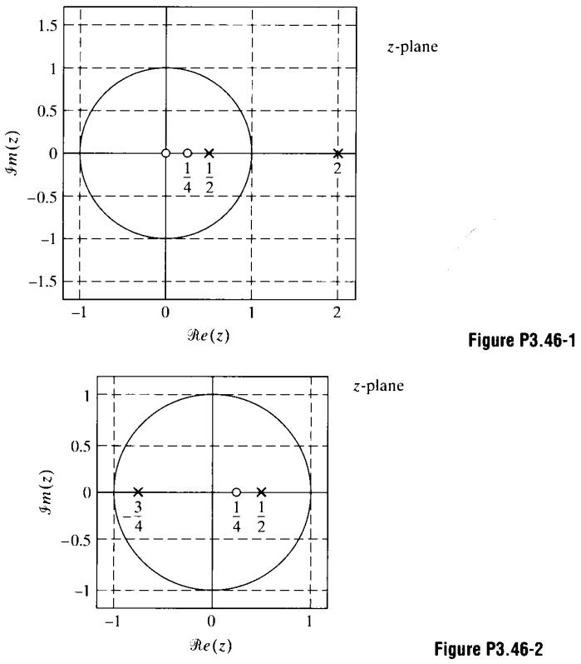
(a) What is the region of convergence, Y(z)?
由於題目要求Y(z)是穩定的，所以其ROC必須要包含單位圓，所以其ROC為
(b) Is y[n] left sided, right sided, or two sided?
由於其ROC為一個環狀圓，所以為two sided
(c) What is the ROC of X(z)?
由於題目要求X(z)是穩定的，所以其ROC必須要包含單位圓，而因為要取最外面的極點，所以其ROC為。
(d) Is x[n] a causal sequence? That is, does x[n]=0 for n<0?
由於X(z)的ROC包含無限，所以X(z)沒有正的z乘冪，意即都是負的z乘冪，也就是沒有未來的輸入，只有過去和現在的輸入，所以x[n]=0 for n<0，所以x[n]是causal。
(e) What is x[0]?

由於X(z)的ROC為，故為right-side，即為，所以其轉換為

(f) Draw the pole-zero plot of H(z), and specify its ROC.
由P3.46-1可知，

然而

將zplane([1 3/4], [1 -2])輸入matlab之後，得到
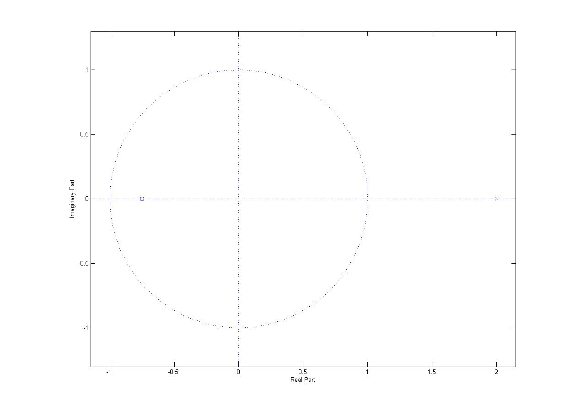
其H(z)的極點為2以及無限，零點為-0.75以及0，假設若希望H(z)是穩定的，則其ROC要包含單位圓，故
(g) Is h[n] anticausal? That is, does h[n]=0 for n>0?
是的，由於H(z)的ROC沒有包含無限，所以，H(z)沒有負的z乘冪，意即都是正的z乘冪，也就是會有未來的輸入，所以h[n]=0 for n>0，所以h[n]是anti-causal。

